2nd order waves

Here it is summarized and briefly explained the 2nd order wave theory (Stokes) and the 2nd order wave GENERATION theory (Madsen, 1971) contained in the matlab file WGen2ord.m.

A clear distinction is made between WAVE theory and wave GENERATION theory. The former one will be used in DualSPHysics to calculate the theoretical or target wave that is used in AWAS to correct the wave paddle displacement or compare the waves propagated in DualSPHysics with the theoretical ones (even in case the 1st order wave generation technique is used). The latter one consists of an approximated and “limited” 2nd order wave generation technique.

### 2nd order wave theory (Stokes)

The second order wave theory is expressed adding a second non-linear term to the Airy’s formula for monochromatic waves. Looking at our SPHERIC2015 paper, the water surface elevation is expressed by:

$$η\left(x,t\right)=c·\sinh\left(kd\right)\cos\left(ωt-kx+δ\right)+ \sum_{n=1}^{∞}{c_{n}sinh⁡(k_{n}d)e^{-k_{n}x}sin⁡(ωt)}$$

where

$$c·\sinh\left(kd\right)=\frac{H}{2}$$

neglecting the second term that represents the near field solution, the resulting water surface elevation is expressed as:

$η\left(x,t\right)=\frac{H}{2}cos\left(ωt-kx+δ\right)$***?? sin or cos??***

where δ is an initial random phase, ω=2*i*f with f=1/T.

This is re-written in matlab as: H/2*cos(2*pi*f*time(i)-kL*x+ph0)

To consider 2nd order waves, a second component has to be added to the linear one. The resulting water surface elevation is (line 79 matlab file):

eta_inc(i,1)=H/2*cos(2*pi*f*time(i)-kL*x+ph0)+(kL*H^2)/16*((3*((coth(kL*d))^3))-coth(kL*d))*cos(4*pi*f*time(i)-2*kL*x+2*ph0);

So, the only 2nd order component is (line 84 matlab file):

eta_inc2(i,1)=+(kL*H^2)/16*((3*((coth(kL*d))^3))-coth(kL*d))*cos(4*pi*f*time(i)-2*kL*x+2*ph0);

The expression of the horizontal and vertical orbital velocities are (lines 80 and 81 matlab file):

u_inc(i,1)=H/2*2*pi*f*cosh(kL*(d+z))*(cos(2*pi*f*time(i)-kL*x+ph0))/sinh(kL*d)+3/4*(pi*H/L)^2*C*cosh(2*kL*(d+z))*(cos(4*pi*f*time(i)-2*kL*x+2*ph0))/sinh(kL*d)^4;

v_inc(i,1)=-H/2*2*pi*f*sinh(kL*(d+z))*(sin(2*pi*f*time(i)-kL*x+ph0))/sinh(kL*d)-3/4*(pi*H/L)^2*C*sinh(2*kL*(d+z))*(sin(4*pi*f*time(i)-2*kL*x+2*ph0))/sinh(kL*d)^4;

Where in green is reported the second order term. C stays for the wave celerity (line 62 matlab file), that is formally the same at 1st and 2nd order approximation.

C=g*T/(2*pi)*tanh(kL*d);

Using all the above reported expression, the target 2nd order waves can be estimated in DualSPHysics and used both for further comparison or AWAS.

### 2nd order wave GENERATION theory (Madsen, 1971)

At the present stage, we refer to an approximate solution from Madsen (1971) to generate waves using a 2nd order wave GENERATION theory.

Using a linear wave generation theory (1st order), as reported in our SPHERIC 2015 paper, the piston displacement is calculated as:

$$e(t)=\frac{S_{0}}{2}cos⁡(ωt+δ)$$

where

$$\frac{H}{S_{0}}=\frac{2\sinh^{2}(kd)}{\sinh\left(kd\right)\cosh\left(kd\right)+kd}$$

I have only formally modified this expression in matlab with the purpose to have a more general approach for 2nd order wave generation.

In matlab the 1st order wave generation term is expressed by (line 69):

e1(i,1)=0.5*s0*sin(2*pi*f*time(i)+ph0)

where (line 38 matlab)

s0=H/m1; %piston max Stroke

m1=4*(sinh(kL*d)^2)/(sinh(2*kL*d)+2*kL*d);

Following Madsen (1971), to generate at 2nd order, an extra term must be added. This term is equal to (line 70 matlab):

e2(i,1)=o2*sin(4*pi*f*time(i)+2*ph0);

where (line 40 matlab)

o2=(H^2)/(32*d)*(3*cosh(kL*d)/(sinh(kL*d)^3)-2/m1);

Then the piston displacement, for regular waves, is the summation of both terms:

e(i,1)=e1(i,1)+e2(i,1);

The use of Madsen (1971) approximation has a limitation that has to be checked every time (lines 42-45 matlab):

% check for Madsen (1971) theory Madcrit < Madlim

Madlim=8*pi*pi/3

Madcrit=H*L*L/d^3

In DualSPHysics we can add a WARNING message if this condition is not fulfilled.

### Plot and data saving

Finally the matlab generates a plot with velocities, water surface elevation and paddle displacement as in the following figure. In this way, is easy to see the differences between 1st and 2nd order wave theories and 1st and 2nd order wave generation theories.

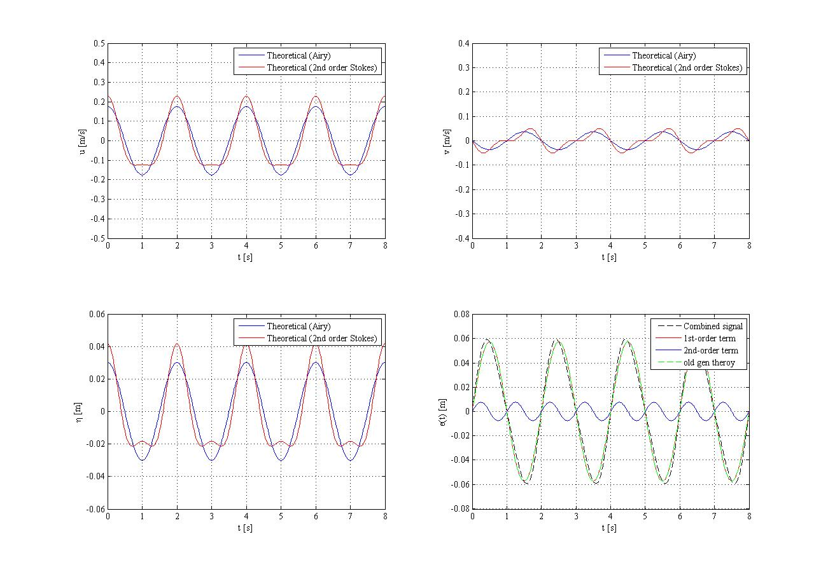

Also a .txt file is created with all the time series. See lines 151-158 of matlab file.

NOTE: all the input have to be inserted at lines from 12 to 31 of the Matlab file.