Agentic QA
LangSmith & AI Quality Engineering Handbook
Architecture, tracing, datasets, deterministic evaluation, experiments, A/B comparison, and retrieval quality

Scope
This handbook documents what we have learned and implemented in the Agentic QA project so far, plus the immediate evaluation roadmap. Code is labeled as implemented, current baseline, or planned. The focus is on testing the AI application itself from the beginning, not only testing the software it will eventually generate.

Project stack: Python + LangGraph + LangChain + Pydantic + pytest + Playwright + LangSmith

Contents
- 1. Why AI applications need a quality system from day one
- 2. How LangSmith fits our Agentic QA architecture
- 3. Core LangSmith concepts: traces, datasets, evaluators, experiments
- 4. Setup and configuration lessons, including EU region and workspace ID
- 5. Tracing the current LangGraph application
- 6. Evaluation strategy: deterministic first, semantic judges later
- 7. Requirement Analyzer evaluation architecture
- 8. Shared deterministic evaluator code
- 9. Local terminal evaluation script
- 10. Creating the LangSmith Requirement Analyzer dataset
- 11. LangSmith target, adapter, evaluators, and case_pass
- 12. Reading LangSmith experiment results
- 13. A/B comparison in our engineering context
- 14. Repository Retrieval evaluation design
- 15. Retrieval metrics: Top-1, Precision@K, Recall@K
- 16. Retrieval evaluation code and unit tests
- 17. Creating and running the LangSmith retrieval experiment
- 18. What our real V1 retrieval runs taught us
- 19. Measuring V1 -> V2 -> V3 instead of relying on intuition
- 20. Future evaluation: LLM-as-a-judge, MCP/tool trajectories, generated tests
- 21. CI/CD and regression gates
- 22. Troubleshooting and debugging checklist
- 23. Recommended next steps
- Appendix A. Evaluation-oriented repository layout
- Appendix B. Glossary

1. Why AI applications need a quality system from day one
Traditional software is largely deterministic: the same input, code version, and environment are expected to produce the same result. LLM-based applications add probabilistic behavior, prompt sensitivity, model-version changes, retrieval variation, tool-selection decisions, and multi-step trajectories. That means ordinary unit tests are necessary but not sufficient.
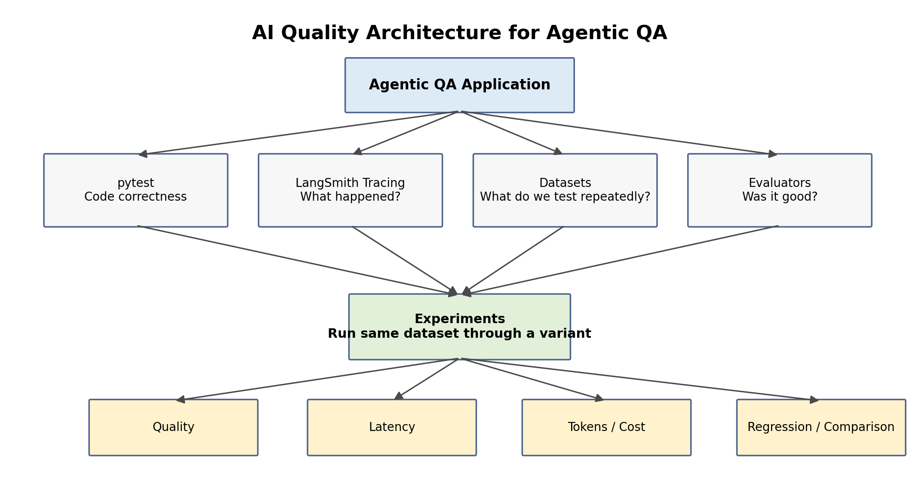
Figure 1. Quality architecture we are building around the Agentic QA application.
Core principle
Every important AI component should have its own observable behavior, reusable evaluation dataset, explicit metrics, and regression history. Full-agent quality is built on component quality.

Question | Best tool in our current stack
Does Python code behave correctly? | pytest + type checking + Pydantic
What happened during an AI run? | LangSmith tracing
Which examples should be rerun repeatedly? | LangSmith dataset
Did the output satisfy our expectations? | Deterministic evaluator or later LLM judge
How did model/prompt/retriever version A compare with B? | LangSmith experiment comparison
Why did a failed case fail? | Open experiment row -> inspect trace

2. How LangSmith fits our Agentic QA architecture
LangSmith is not replacing pytest, LangGraph, or our own evaluation logic. It provides observability and an experiment platform around them. We deliberately keep evaluation rules in our Python code so they remain testable, version-controlled, and reusable outside LangSmith.
Our quality stack
Agentic QA application
|
+-- pytest / mypy / Pydantic
| -> deterministic software correctness
|
+-- LangSmith tracing
| -> what happened during execution
|
+-- evaluation datasets
| -> repeatable AI regression cases
|
+-- shared Python evaluators
| -> explicit quality rules
|
+-- LangSmith experiments
-> execute variants, record metrics, latency, traces

We considered Langfuse and DeepEval. Langfuse is attractive for vendor-neutral/self-hosted observability. DeepEval is attractive as a pytest-style AI evaluation framework. For this project, LangSmith is the simplest first platform because the orchestration layer is already LangGraph/LangChain. We can add another framework later only if it solves a real unmet requirement.

3. Core LangSmith concepts
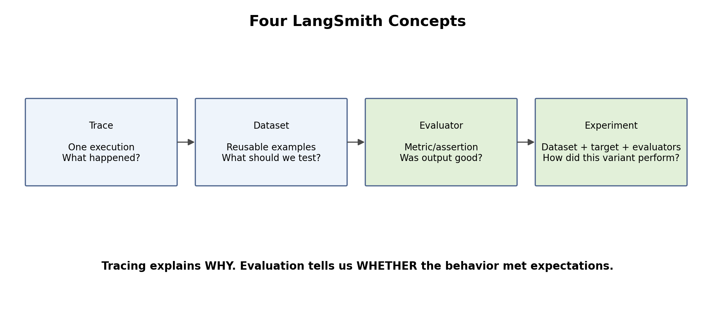
Figure 2. Trace, Dataset, Evaluator, and Experiment are different concepts.

Trace
One execution of the application. It answers: what happened, which operations ran, what inputs/outputs were observed, how long they took, and where an error occurred.

Dataset
A reusable collection of evaluation examples. It answers: what cases should we rerun whenever a model, prompt, retriever, or agent policy changes?

Evaluator
A function or judge that converts actual output + reference expectations into one or more quality scores.

Experiment
A run of a target implementation over a dataset with evaluators. It produces comparable metrics and links each evaluation result back to its trace.
Important distinction
Tracing explains WHY a run behaved the way it did. Evaluation tells us WHETHER it met the expected quality bar.

4. Setup and configuration lessons
We encountered two useful real-world configuration problems: .env loading and region/workspace authorization. They are worth documenting because observability tooling is only useful if its configuration is deterministic.

4.1 Environment variables
.env for our EU LangSmith workspace
LANGSMITH_TRACING=true
LANGSMITH_API_KEY=...
LANGSMITH_PROJECT=agentic-qa-dev
LANGSMITH_ENDPOINT=https://eu.api.smith.langchain.com
LANGSMITH_WORKSPACE_ID=<actual-workspace-id>

The project already used Pydantic Settings, but Pydantic reading values from .env does not necessarily mean arbitrary libraries see those values through os.environ. LangSmith automatic tracing reads LANGSMITH_* environment variables. We therefore added python-dotenv loading so the process environment contains them.
Load .env into process environment
from dotenv import load_dotenv
load_dotenv()

Debugging lesson
OpenAI settings can work through Pydantic while LangSmith tracing still sees None. Verify os.getenv("LANGSMITH_TRACING") rather than assuming .env was exported.

Safe verification without printing the secret
import os
from dotenv import load_dotenv
load_dotenv()
print("TRACING:", os.getenv("LANGSMITH_TRACING"))
print("PROJECT:", os.getenv("LANGSMITH_PROJECT"))
print("ENDPOINT:", os.getenv("LANGSMITH_ENDPOINT"))
print("WORKSPACE:", os.getenv("LANGSMITH_WORKSPACE_ID"))
print("HAS KEY:", bool(os.getenv("LANGSMITH_API_KEY")))

4.2 Region
Our LangSmith UI is eu.smith.langchain.com, therefore our ingestion endpoint must be the EU API endpoint. When we initially sent traces to the default US endpoint, LangSmith returned HTTP 403.
LangSmith UI | Region | API endpoint
smith.langchain.com | GCP US | https://api.smith.langchain.com
eu.smith.langchain.com | GCP EU | https://eu.api.smith.langchain.com
apac.smith.langchain.com | GCP APAC | https://apac.api.smith.langchain.com
aws.smith.langchain.com | AWS US | https://aws.api.smith.langchain.com

4.3 Organization ID is not Workspace ID
We initially copied the Organization ID into LANGSMITH_WORKSPACE_ID. These are different concepts. The workspace ID must be the actual workspace/tenant identifier. The practical symptom was repeated 403 Forbidden ingestion errors even after the environment variables were present.

5. Tracing the current LangGraph application
Once tracing is enabled, we can inspect a requirement run as a hierarchy rather than only a final JSON state.
Current analyzer trace concept
QAState
requirement
|
v
analyze_requirement
|
v
LLMRequirementAnalyzer.analyze()
|
v
ChatOpenAI
|
v
RequirementAnalysis
|
v
QAState.requirement_analysis

When reading a trace, inspect Input, Output, child runs, latency, token/model metadata, and errors. If an experiment later reports a failed evaluator score, the trace is where we diagnose whether the issue originated in the prompt, model behavior, retrieval context, or downstream processing.

5.1 Metadata and tags
We should tag workflow runs with version information so historical traces remain useful after code changes.
Recommended workflow metadata
from langchain_core.runnables import RunnableConfig
config: RunnableConfig = {
"run_name": "agentic_qa_workflow",
"tags": ["dev", "retrieval-v1"],
"metadata": {
"model": settings.llm_model,
"retrieval_version": "v1-keyword",
"application": "agentic-qa",
},
}
result = workflow.invoke(
{"requirement": requirement},
config=config,
)

Recommended next instrumentation
Trace architectural operations, not every helper. Good spans: requirement analysis, repository retrieval, AST lookup, MCP action, generated-test execution. Avoid turning _build_query_terms(), _score_file(), etc. into separate spans unless debugging a specific issue.

6. Evaluation strategy: deterministic first, semantic judges later
A common AI-testing failure is using an LLM judge for everything. We deliberately use deterministic checks whenever correctness can be expressed mechanically, because deterministic evaluators are cheaper, reproducible, explainable, and easy to unit-test.
Quality question | Evaluator type
interaction_surface == api? | Deterministic code
HTTP 400 preserved in expected outcome? | Deterministic code
Required artifact retrieved in top K? | Deterministic information-retrieval metric
Did the analyzer invent unsupported assumptions? | Potential LLM judge later
Is a TestDesign risk-based and sufficient? | Human rubric + LLM judge later
Did the agent choose a sensible tool trajectory? | Trajectory evaluator later

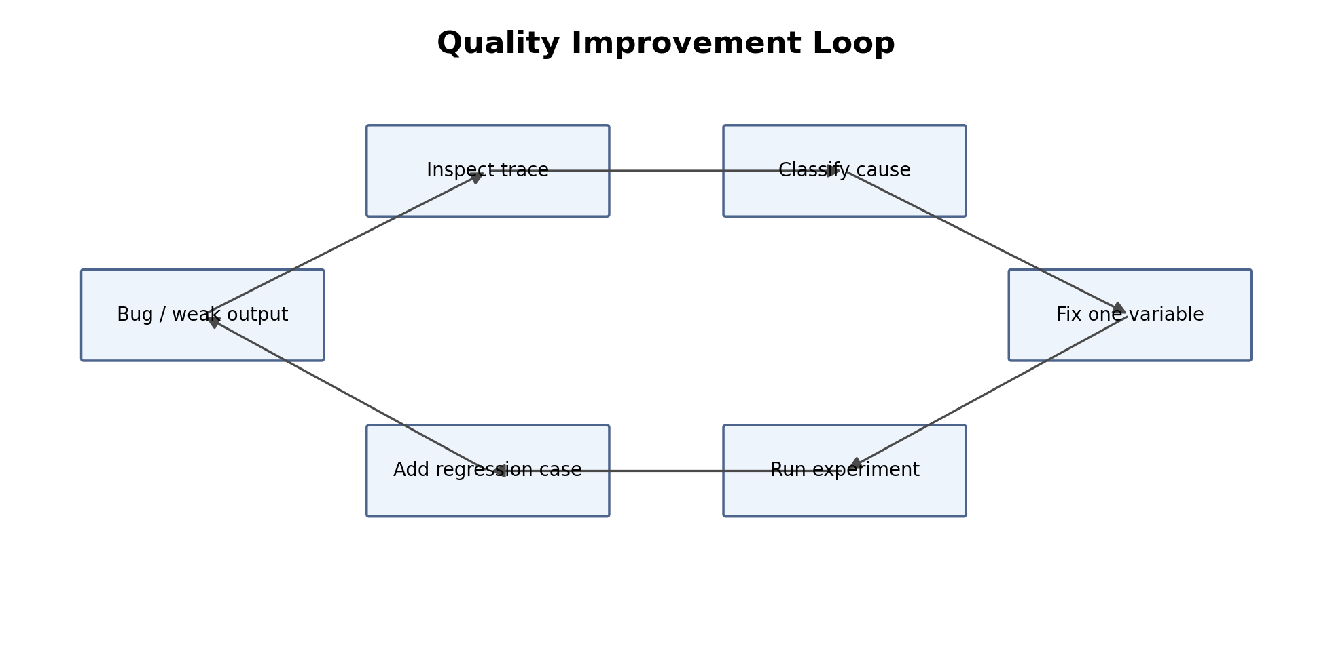
Figure 3. A useful failure becomes a permanent regression case.

7. Requirement Analyzer evaluation architecture
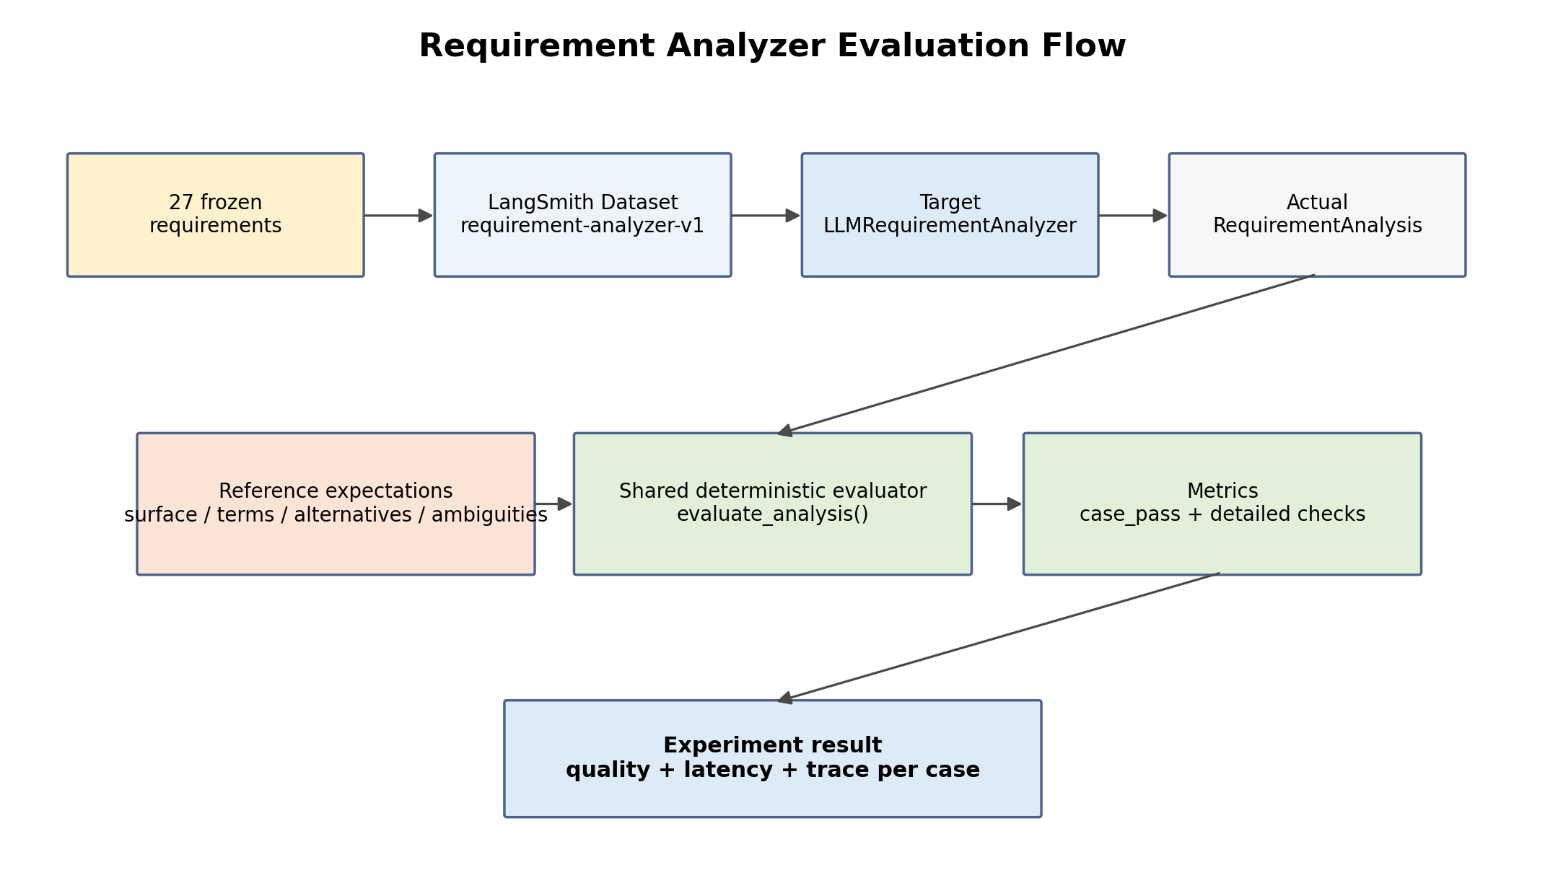
Figure 4. The first component-level AI regression suite in this project.
We already had a 27-case Requirement Analyzer regression suite before LangSmith. LangSmith did not replace it. Instead we moved the reusable evaluation rules into a shared module and used the same logic in both the terminal evaluator and LangSmith experiments.
Current baseline
The 27-case dataset is treated as a frozen regression set. A green 100% result means all configured deterministic checks passed; it does not mean the model is universally 100% accurate.

8. Shared deterministic evaluator code
The refactor moved CheckResult, term matching, alternative matching, and evaluate_analysis() out of scripts/evaluate_requirement_analyzer.py into src/agentic_qa/evals/requirements/evaluator.py. This prevents the local runner and LangSmith evaluator from drifting apart.
src/agentic_qa/evals/requirements/evaluator.py - reusable helpers
from dataclasses import dataclass
from agentic_qa.evals.requirements.cases import (
RequirementEvaluationCase,
)
from agentic_qa.models import RequirementAnalysis
@dataclass
class CheckResult:
name: str
passed: bool
message: str
def contains_terms(
values: list[str],
terms: list[str],
) -> bool:
text = " ".join(values).lower()
return all(
term.lower() in text
for term in terms
)
def contains_alternatives(
values: list[str],
alternatives: list[list[str]],
) -> bool:
text = " ".join(values).lower()
return all(
any(
alternative.lower() in text
for alternative in group
)
for group in alternatives
)

Core deterministic evaluator
def evaluate_analysis(
analysis: RequirementAnalysis,
case: RequirementEvaluationCase,
) -> list[CheckResult]:
results: list[CheckResult] = []
results.append(
CheckResult(
name="interaction_surface",
passed=(
analysis.interaction_surface
== case.expected_surface
),
message=(
f"expected={case.expected_surface.value}, "
f"actual={analysis.interaction_surface.value}"
),
)
)
if case.required_condition_terms:
results.append(
CheckResult(
name="condition_terms",
passed=contains_terms(
analysis.conditions,
case.required_condition_terms,
),
message=(
"required terms="
f"{case.required_condition_terms}"
),
)
)
if case.required_condition_alternatives:
results.append(
CheckResult(
name="condition_concepts",
passed=contains_alternatives(
analysis.conditions,
case.required_condition_alternatives,
),
message=(
"accepted alternatives="
f"{case.required_condition_alternatives}"
),
)
)
if case.required_outcome_terms:
results.append(
CheckResult(
name="outcome_terms",
passed=contains_terms(
analysis.expected_outcomes,
case.required_outcome_terms,
),
message=(
"required terms="
f"{case.required_outcome_terms}"
),
)
)
if case.required_outcome_alternatives:
results.append(
CheckResult(
name="outcome_concepts",
passed=contains_alternatives(
analysis.expected_outcomes,
case.required_outcome_alternatives,
),
message=(
"accepted alternatives="
f"{case.required_outcome_alternatives}"
),
)
)
if case.require_ambiguities is not None:
has_ambiguities = bool(analysis.ambiguities)
results.append(
CheckResult(
name="ambiguities",
passed=(
has_ambiguities
== case.require_ambiguities
),
message=(
"expected ambiguities="
f"{case.require_ambiguities}, "
"actual count="
f"{len(analysis.ambiguities)}"
),
)
)
return results

required_*_terms represent stable facts such as HTTP codes. required_*_alternatives represent one semantic concept with acceptable lexical variants. This is how we avoid false failures from harmless wording differences while still preserving explicit contracts.

9. Local terminal evaluation script
The terminal script remains useful for fast local runs and JSON artifacts. Its responsibility is orchestration, reporting, and file output - not evaluation rules.
Cleaned local runner - abbreviated printing but full architecture
import json
from pathlib import Path
from langchain_openai import ChatOpenAI
from agentic_qa.config import settings
from agentic_qa.evals.requirements.cases import CASES
from agentic_qa.evals.requirements.evaluator import evaluate_analysis
from agentic_qa.requirements.llm_analyzer import LLMRequirementAnalyzer
def main() -> None:
if settings.openai_api_key is None:
raise RuntimeError("OPENAI_API_KEY is not configured.")
if not settings.llm_model:
raise RuntimeError("LLM_MODEL is not configured.")
model = ChatOpenAI(
model=settings.llm_model,
api_key=settings.openai_api_key,
)
analyzer = LLMRequirementAnalyzer(model=model)
total_checks = 0
passed_checks = 0
machine_results: list[dict[str, object]] = []
for case in CASES:
analysis = analyzer.analyze(case.requirement)
checks = evaluate_analysis(
analysis=analysis,
case=case,
)
for check in checks:
total_checks += 1
if check.passed:
passed_checks += 1
machine_results.append(
{
"case": case.name,
"requirement": case.requirement,
"analysis": analysis.model_dump(mode="json"),
"checks": [
{
"name": check.name,
"passed": check.passed,
"message": check.message,
}
for check in checks
],
}
)
score = passed_checks / total_checks if total_checks else 0.0
output_dir = Path("evaluation_results")
output_dir.mkdir(parents=True, exist_ok=True)
with (output_dir / "latest.json").open("w", encoding="utf-8") as file:
json.dump(
{
"model": settings.llm_model,
"passed_checks": passed_checks,
"total_checks": total_checks,
"score": score,
"cases": machine_results,
},
file,
indent=2,
)
if __name__ == "__main__":
main()

10. Creating the LangSmith Requirement Analyzer dataset
We upload our existing CASES into a LangSmith dataset named requirement-analyzer-v1. The reference output intentionally does not contain an exact expected RequirementAnalysis object. It contains evaluation constraints, because exact natural-language phrasing would be too brittle.
scripts/create_langsmith_requirement_dataset.py
from langsmith import Client
from agentic_qa.evals.requirements.cases import CASES
DATASET_NAME = "requirement-analyzer-v1"
def main() -> None:
client = Client()
if client.has_dataset(dataset_name=DATASET_NAME):
print(f"Dataset '{DATASET_NAME}' already exists. Skipping creation.")
return
dataset = client.create_dataset(
dataset_name=DATASET_NAME,
description="Regression dataset for the Agentic QA Requirement Analyzer.",
metadata={
"component": "requirement_analyzer",
"version": "v1",
},
)
examples = []
for case in CASES:
examples.append(
{
"inputs": {
"requirement": case.requirement,
},
"outputs": {
"expected_surface": case.expected_surface.value,
"required_condition_terms": case.required_condition_terms,
"required_condition_alternatives": case.required_condition_alternatives,
"required_outcome_terms": case.required_outcome_terms,
"required_outcome_alternatives": case.required_outcome_alternatives,
"require_ambiguities": case.require_ambiguities,
},
"metadata": {
"case_name": case.name,
},
}
)
client.create_examples(
dataset_id=dataset.id,
examples=examples,
)
if __name__ == "__main__":
main()

Why this reference format?
We want to test semantic contracts such as surface=api, required HTTP code 400, and accepted condition concepts. We do not want exact string equality against a full LLM-generated object.

11. LangSmith target, adapter, evaluators, and case_pass

11.1 Target function
System under test for the experiment
def target(
inputs: dict[str, Any],
) -> dict[str, Any]:
analysis = analyzer.analyze(
inputs["requirement"]
)
return {
"analysis": analysis.model_dump(
mode="json"
),
}

11.2 Why reconstruct a RequirementEvaluationCase?
LangSmith stores JSON-compatible dictionaries. Our shared evaluator expects a RequirementEvaluationCase Pydantic object. The adapter converts the dataset reference dictionary back into the domain type expected by evaluate_analysis(). This is serialization/deserialization plumbing, not a second evaluation engine.
LangSmith adapter inside evaluate_requirement_analyzer_langsmith.py
def case_from_reference_outputs(
inputs: dict[str, Any],
reference_outputs: dict[str, Any],
) -> RequirementEvaluationCase:
return RequirementEvaluationCase(
name="langsmith_case",
requirement=inputs["requirement"],
expected_surface=InteractionSurface(
reference_outputs["expected_surface"]
),
required_condition_terms=reference_outputs.get(
"required_condition_terms", []
),
required_condition_alternatives=reference_outputs.get(
"required_condition_alternatives", []
),
required_outcome_terms=reference_outputs.get(
"required_outcome_terms", []
),
required_outcome_alternatives=reference_outputs.get(
"required_outcome_alternatives", []
),
require_ambiguities=reference_outputs.get(
"require_ambiguities"
),
)

11.3 Detailed metrics evaluator
One evaluator emits multiple detailed feedback metrics
def requirement_analysis_evaluator(
inputs: dict[str, Any],
outputs: dict[str, Any],
reference_outputs: dict[str, Any],
) -> list[dict[str, Any]]:
analysis = RequirementAnalysis.model_validate(
outputs["analysis"]
)
case = case_from_reference_outputs(
inputs,
reference_outputs,
)
checks = evaluate_analysis(
analysis=analysis,
case=case,
)
return [
{
"key": check.name,
"score": check.passed,
"comment": check.message,
}
for check in checks
]

11.4 Overall case_pass evaluator
Overall per-case regression signal
def case_pass_evaluator(
inputs: dict[str, Any],
outputs: dict[str, Any],
reference_outputs: dict[str, Any],
) -> dict[str, Any]:
analysis = RequirementAnalysis.model_validate(
outputs["analysis"]
)
case = case_from_reference_outputs(
inputs,
reference_outputs,
)
checks = evaluate_analysis(analysis, case)
passed = all(check.passed for check in checks)
failed_checks = [check.name for check in checks if not check.passed]
return {
"key": "case_pass",
"score": passed,
"comment": (
"all checks passed"
if passed
else "failed checks: " + ", ".join(failed_checks)
),
}

11.5 Running the experiment
LangSmith experiment
results = client.evaluate(
target,
data=DATASET_NAME,
evaluators=[
requirement_analysis_evaluator,
case_pass_evaluator,
],
experiment_prefix="requirement-analyzer",
max_concurrency=2,
metadata={
"model": settings.llm_model,
"component": "requirement_analyzer",
"analyzer_version": "v1",
},
)

12. Reading LangSmith experiment results
The experiment UI shows Input, Reference Outputs, actual Outputs, evaluator columns, latency, and links to traces. In our first successful experiment we confirmed columns such as case_pass, interaction_surface, condition_*, outcome_*, and ambiguities.
Cell value | Meaning
1.00 | Evaluator ran and passed
0.00 | Evaluator ran and failed
No feedback | That metric was not applicable / evaluator did not emit it for this case

For example, require_ambiguities=None means the ambiguities evaluator is intentionally skipped for that case. No feedback is therefore not a failure.
Failure workflow
case_pass = 0 -> locate the red detailed metric -> open row -> compare input/reference/actual output -> open trace -> diagnose prompt/model/data/retrieval cause.

13. A/B comparison in our engineering context
Here A/B comparison means an offline controlled experiment, not splitting live website traffic. We run the same frozen dataset through two variants, change one important variable, and compare metrics.
Controlled A/B comparison
Same 27 requirements
|
+----+----+
| |
Variant A Variant B
model X model X
prompt v1 prompt v2
| |
+----+----+
|
same evaluators
|
compare quality / latency / cost

Good comparison | Why
A = model X + prompt v1; B = model Y + prompt v1 | Measures model change
A = model X + prompt v1; B = model X + prompt v2 | Measures prompt change
A = V1 retriever; B = V2 retriever on same dataset | Measures retrieval architecture change

Avoid confounding
Do not change model, prompt, temperature, retrieval logic, and dataset simultaneously. If B improves, you would not know which change caused it.

14. Repository Retrieval evaluation design
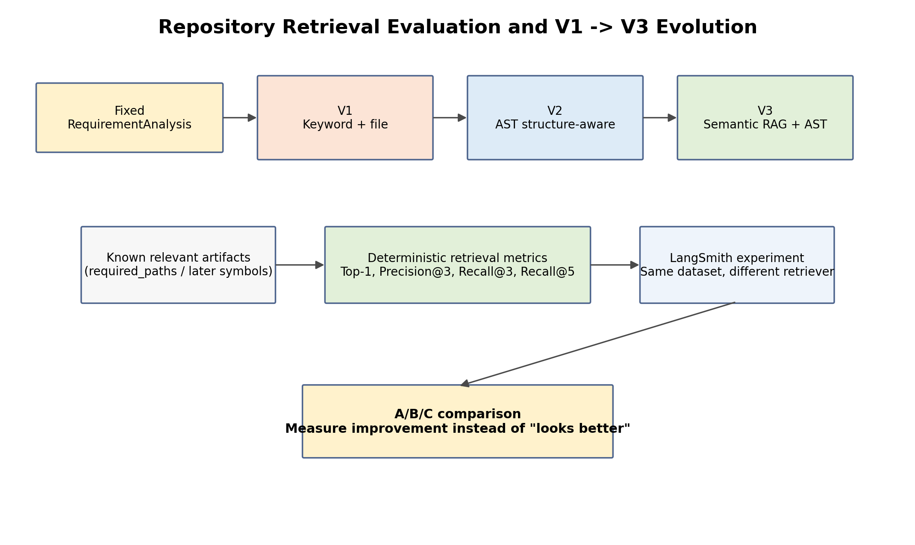
Figure 5. Retrieval evaluation isolates the retriever and keeps the dataset stable across V1/V2/V3.
The critical design choice is to feed a fixed RequirementAnalysis into the retriever evaluation. If we start from raw requirement text, a Requirement Analyzer mistake could cause a retrieval failure and we would blame the wrong component.
Component isolation
Wrong for component evaluation:
Raw requirement -> analyzer -> retriever -> score
Preferred:
Known RequirementAnalysis -> retriever -> score

Our first retrieval dataset uses the three Todo cases already tested manually: complete existing todo, create todo, and mark existing task as done. The third case deliberately uses different vocabulary (task/done vs todo/complete) to expose lexical weakness.

15. Retrieval metrics: Top-1, Precision@K, Recall@K

15.1 Top-1 relevant
Boolean metric: is the first retrieved artifact one of the known relevant artifacts? This is useful but insufficient because it says nothing about the rest of the context.

15.2 Precision@3
Among the first 3 retrieved artifacts, what fraction is relevant? Precision measures context cleanliness. Irrelevant context wastes tokens and may confuse generation.
Top 3 = [A relevant, D irrelevant, B relevant]
Precision@3 = 2 / 3 = 0.67

15.3 Recall@3 / Recall@5
Of all known relevant artifacts, what fraction was found within the first K results? Recall matters because missing an existing Page Object or fixture can cause generated tests to invent methods or duplicate setup.
Relevant = {A, B, C}
Top 3 = [A, D, B]
Recall@3 = 2 / 3 = 0.67
Top 5 = [A, D, B, E, C]
Recall@5 = 3 / 3 = 1.00

Interpretation
Recall answers "did we miss useful context?" Precision answers "how much useless context did we inject?" Our generation agent needs both.

16. Retrieval evaluation code and unit tests

16.1 Evaluation cases
src/agentic_qa/evals/retrieval/cases.py
from pydantic import BaseModel, Field
from agentic_qa.models import InteractionSurface, RequirementAnalysis
class RetrievalEvaluationCase(BaseModel):
name: str
analysis: RequirementAnalysis
required_paths: list[str] = Field(default_factory=list)
CASES = [
RetrievalEvaluationCase(
name="complete_existing_todo",
analysis=RequirementAnalysis(
feature="Todo management",
operation="Complete an existing todo",
objective="Verify that a user can complete a todo that already exists.",
actors=["User"],
conditions=["A todo already exists."],
expected_outcomes=[
"The user is able to complete the existing todo."
],
ambiguities=[],
interaction_surface=InteractionSurface.UNKNOWN,
),
required_paths=[
"tests/test_todo_completion.py",
"pages/todo_page.py",
"tests/conftest.py",
],
),
# create_todo ...
# mark_task_as_done ...
]

16.2 Metrics implementation
src/agentic_qa/evals/retrieval/evaluator.py
from dataclasses import dataclass
from agentic_qa.retrieval.models import RepositoryContext
@dataclass
class RetrievalMetrics:
top1_relevant: bool
precision_at_3: float
recall_at_3: float
recall_at_5: float
def calculate_retrieval_metrics(
context: RepositoryContext,
required_paths: list[str],
) -> RetrievalMetrics:
retrieved_paths = [item.path for item in context.items]
required = set(required_paths)
return RetrievalMetrics(
top1_relevant=bool(
retrieved_paths
and retrieved_paths[0] in required
),
precision_at_3=_precision_at_k(
retrieved_paths, required, 3
),
recall_at_3=_recall_at_k(
retrieved_paths, required, 3
),
recall_at_5=_recall_at_k(
retrieved_paths, required, 5
),
)
def _precision_at_k(
retrieved_paths: list[str],
relevant_paths: set[str],
k: int,
) -> float:
if k <= 0:
raise ValueError("k must be greater than zero.")
top_k = retrieved_paths[:k]
hits = sum(path in relevant_paths for path in top_k)
return hits / k
def _recall_at_k(
retrieved_paths: list[str],
relevant_paths: set[str],
k: int,
) -> float:
if not relevant_paths:
return 1.0
top_k = retrieved_paths[:k]
hits = sum(path in relevant_paths for path in top_k)
return hits / len(relevant_paths)

16.3 Unit-test the evaluator before trusting LangSmith
tests/unit/test_retrieval_evaluator.py
def test_calculates_retrieval_metrics() -> None:
context = RepositoryContext(
query_terms=[],
items=[
make_item("a.py"),
make_item("unrelated.py"),
make_item("b.py"),
make_item("c.py"),
],
)
metrics = calculate_retrieval_metrics(
context=context,
required_paths=["a.py", "b.py", "c.py"],
)
assert metrics.top1_relevant is True
assert metrics.precision_at_3 == 2 / 3
assert metrics.recall_at_3 == 2 / 3
assert metrics.recall_at_5 == 1.0

Testing principle
pytest tests the evaluator itself. LangSmith uses the evaluator after we trust its formulas. Evaluation code is production code for our quality system and deserves its own tests.

17. Creating and running the LangSmith retrieval experiment

17.1 Dataset creation
scripts/create_langsmith_retrieval_dataset.py
from langsmith import Client
from agentic_qa.evals.retrieval.cases import CASES
DATASET_NAME = "repository-retrieval-v1"
def main() -> None:
client = Client()
dataset = client.create_dataset(
dataset_name=DATASET_NAME,
description="Repository retrieval regression dataset for Agentic QA.",
metadata={
"component": "repository_retrieval",
"dataset_version": "v1",
},
)
examples = [
{
"inputs": {
"analysis": case.analysis.model_dump(mode="json"),
},
"outputs": {
"required_paths": case.required_paths,
},
"metadata": {
"case_name": case.name,
},
}
for case in CASES
]
client.create_examples(
dataset_id=dataset.id,
examples=examples,
)

17.2 Target
V1 retrieval target
provider = KeywordRepositoryContextProvider(
repository_path=settings.target_repository,
top_k=8,
)
def target(
inputs: dict[str, Any],
) -> dict[str, Any]:
analysis = RequirementAnalysis.model_validate(
inputs["analysis"]
)
context = provider.retrieve(analysis)
return {
"repository_context": context.model_dump(
mode="json"
)
}

17.3 LangSmith retrieval evaluator
Deterministic retrieval feedback
def retrieval_evaluator(
outputs: dict[str, Any],
reference_outputs: dict[str, Any],
) -> list[dict[str, Any]]:
context = RepositoryContext.model_validate(
outputs["repository_context"]
)
required_paths = reference_outputs["required_paths"]
metrics = calculate_retrieval_metrics(
context=context,
required_paths=required_paths,
)
return [
{"key": "top1_relevant", "score": metrics.top1_relevant},
{"key": "precision_at_3", "score": metrics.precision_at_3},
{"key": "recall_at_3", "score": metrics.recall_at_3},
{"key": "recall_at_5", "score": metrics.recall_at_5},
]

17.4 Experiment
results = client.evaluate(
target,
data=DATASET_NAME,
evaluators=[retrieval_evaluator],
experiment_prefix="repository-retrieval-v1",
metadata={
"retriever": "keyword",
"retrieval_version": "v1",
},
)

18. What our real V1 retrieval runs taught us
We ran three requirements through the real application before building the retrieval dataset. These runs give us empirical reasons to build V2 and V3.
Requirement | Observed V1 behavior | Lesson
Complete an existing todo | Correct completion test ranked first; Page Object and fixture found | Keyword retrieval works well when vocabulary aligns
Create a new todo | Relevant Page Object/test found, but analyzer changed "todo" to "todo list" | Component boundaries matter; analyzer quality can affect downstream retrieval
Mark an existing task as done | Correct test ranked first mostly because of generic "existing"; Page Object matched "done" inside placeholder text | Correct result can be returned for the wrong lexical reason

The third case was the clearest V1 limitation. Requirement vocabulary task/mark/done does not match repository vocabulary todo/complete. V1 cannot understand those semantic equivalences. It also returns snippets around the first lexical match, which can select an irrelevant line such as the placeholder "What needs to be done?" instead of complete_todo().
Why we freeze V1
Do not spend excessive effort adding hand-written synonyms, stemming, or complex scoring. V1 has proven the interface and exposed its limitations. V2 should solve structure; V3 should solve semantic mismatch.

19. Measuring V1 -> V2 -> V3 instead of relying on intuition
The retrieval dataset should remain stable while the implementation changes. This turns architecture evolution into controlled experiments.
Planned experiment series
Dataset: repository-retrieval-v1
Experiment A:
KeywordRepositoryContextProvider
-> file-level keyword retrieval
Experiment B:
StructuredRepositoryContextProvider
-> AST / symbol-level retrieval
Experiment C:
HybridRepositoryContextProvider
-> semantic RAG + AST exact lookup

Version | Expected improvement | Still weak at
V1 keyword/file | Basic file discovery | Semantic mismatch, symbol precision, snippet quality
V2 AST structure-aware | Methods/tests/fixtures as retrieval units; better code snippets | Synonyms and conceptual vocabulary mismatch
V3 semantic RAG + AST | Semantic similarity + exact symbol verification | Higher cost/complexity; needs stronger eval dataset

When V2 returns symbols rather than only files, each symbol should still preserve source path metadata. That lets us keep the current file-level metrics for backwards comparison while adding symbol-level expected artifacts later.

20. Future evaluation: LLM judges, MCP/tool trajectories, generated tests

20.1 LLM-as-a-judge
Use only when the question is genuinely semantic or subjective. Examples: whether ambiguities are useful, whether a TestDesign is sufficient and risk-based, whether generated code preserves business intent, or whether a repair changed the test only to make it pass.
Safe adoption sequence
Human-reviewed examples -> explicit rubric -> LLM judge -> compare judge decisions against human labels -> only then use the judge as a trusted metric.

20.2 Agent trajectory evaluation
Potential full-agent trajectory checks:
- Did retrieval happen before code generation?
- Was MCP used when live UI knowledge was necessary?
- Did the agent reuse an existing Page Object instead of inventing one?
- Did it call AST exact lookup before referencing an uncertain method?
- Did it classify a product defect instead of rewriting a valid test?
- Did it retry only when repair was justified?

20.3 Generated test quality
Generated automation eventually needs deterministic code checks (parses, imports, pytest collection, lint/mypy, locator policy, no hard sleeps), behavioral execution, and semantic/risk-based review. A passing generated test is not automatically a correct test.

21. CI/CD and regression gates
Once datasets become stable, evaluation should be part of change validation. We should not immediately block every commit on probabilistic metrics; first collect baseline distributions and identify stable thresholds.
Suggested progression:
1. pytest + mypy + ruff -> hard CI gates now
2. deterministic Requirement Analyzer experiment -> report on PR
3. retrieval metrics -> report V1/V2 comparison
4. after stable baselines, fail CI on severe regression thresholds
5. semantic/LLM judge metrics remain advisory until calibrated

Useful experiment metadata includes Git commit, model, prompt version, retrieval version, dataset version, and environment. This makes regressions reproducible rather than anecdotal.

22. Troubleshooting and debugging checklist
Symptom | Likely cause / check
LANGSMITH_* values are None | python-dotenv not loaded or environment not exported
403 posting to api.smith.langchain.com while UI is EU | wrong region endpoint
403 after adding workspace ID | organization ID used instead of workspace ID, or key/workspace mismatch
No feedback in an evaluator cell | metric not emitted for that example; may be expected
Everything looks green but only surface was checked | verify full reference_outputs were uploaded and all evaluator columns exist
LangSmith result differs from local evaluator | shared evaluation logic duplicated or adapter reconstructed case incorrectly
Retriever quality appears good but generated code invents methods | file-level evaluation is too coarse; add symbol-level V2 metrics

23. Recommended next steps
- Implement and run the repository-retrieval-v1 LangSmith dataset/experiment using the three frozen Todo cases.
- Record the V1 baseline: Top-1, Precision@3, Recall@3, Recall@5, latency.
- Implement V2 AST structure-aware indexing for classes, methods, tests, and pytest fixtures - no locators yet.
- Run the exact same retrieval dataset against V2 and compare experiments.
- Add symbol-level expected artifacts after V2 stabilizes.
- Implement V3 semantic retrieval only after V2 metrics show what structure alone cannot solve.
- Then move evaluation to TestDesign, MCP exploration/tool use, code generation, and failure analysis.
Quality rule for the project
Every meaningful AI defect or weakness that we understand should become a regression example whenever practical. The goal is a growing quality corpus, not repeated prompt tweaking.

Appendix A. Evaluation-oriented repository layout
agentic-qa/
├── src/agentic_qa/
│ ├── graph/
│ ├── requirements/
│ ├── retrieval/
│ └── evals/
│ ├── requirements/
│ │ ├── cases.py
│ │ └── evaluator.py
│ └── retrieval/
│ ├── cases.py
│ └── evaluator.py
│
├── scripts/
│ ├── evaluate_requirement_analyzer.py
│ ├── create_langsmith_requirement_dataset.py
│ ├── evaluate_requirement_analyzer_langsmith.py
│ ├── create_langsmith_retrieval_dataset.py
│ └── evaluate_repository_retrieval_langsmith.py
│
├── tests/unit/
│ ├── test_keyword_repository_provider.py
│ ├── test_retrieval_evaluator.py
│ └── ...
│
├── sample_automation/
│ ├── pages/
│ ├── tests/
│ └── README.md
│
└── evaluation_results/

Responsibility separation is intentional: cases.py says WHAT quality examples exist; evaluator.py says HOW quality is measured; scripts execute locally or through LangSmith; pytest verifies the evaluation code itself.

Appendix B. Glossary
Term | Meaning in this project
Trace | One observed execution, including nested runs/spans
Run / span | One operation inside a trace, such as an LLM call or retriever
Dataset | Frozen/reusable evaluation examples
Reference outputs | Expected constraints or labels attached to a dataset example
Target | Implementation under evaluation
Evaluator | Function/judge producing one or more quality metrics
Experiment | Target executed against dataset + evaluators
A/B comparison | Offline comparison of two controlled variants on the same dataset
case_pass | All configured deterministic Requirement Analyzer checks passed for that example
Precision@K | Relevant retrieved items / K
Recall@K | Relevant retrieved items found in top K / total known relevant items
LLM-as-a-judge | Model-based semantic evaluator, to be calibrated against human judgments
Trajectory evaluation | Evaluation of sequence of agent/tool decisions, not only final output

End of handbook - current quality baseline before Repository Retrieval V2

