RAID 0 (block level striping, no parity bits, no mirroring)
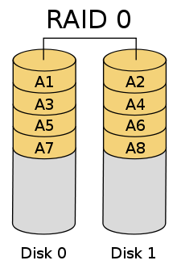

RAID 1 (mirroring, no parity bits, no striping)
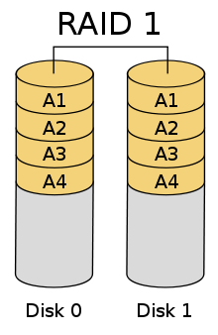

RAID 2 (bit level striping, error correcting parity bits)
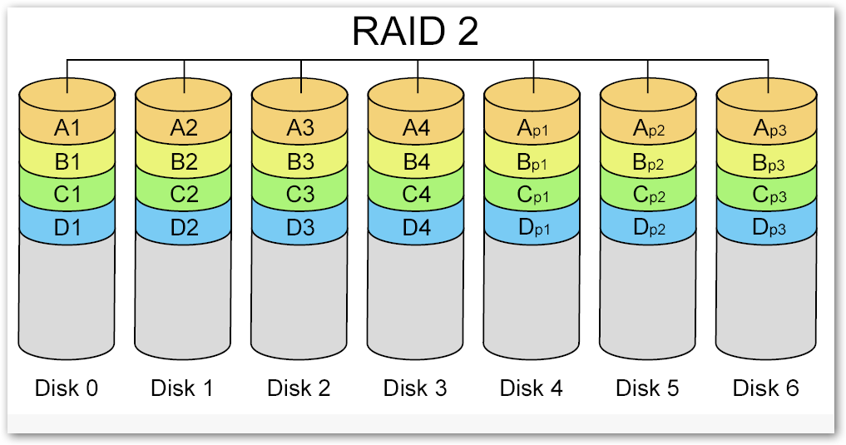

RAID 3 (byte level striping, dedicated parity disk)
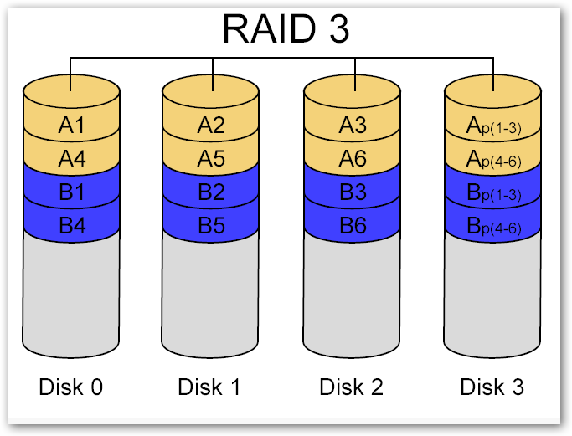

RAID 4 (block level striping, dedicated parity disk)
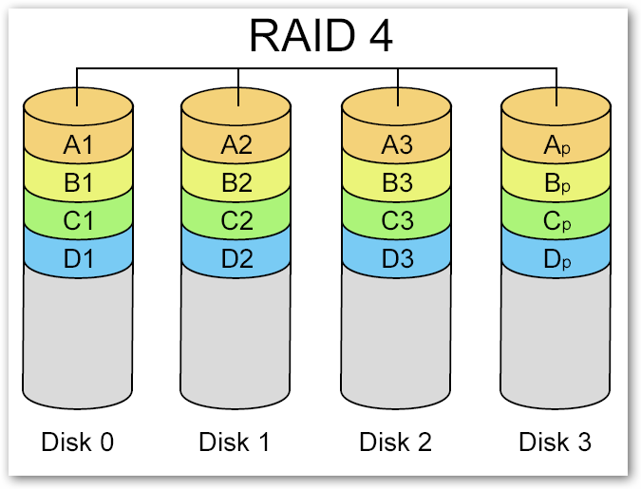

RAID 5 (block level striping, distributed parity)
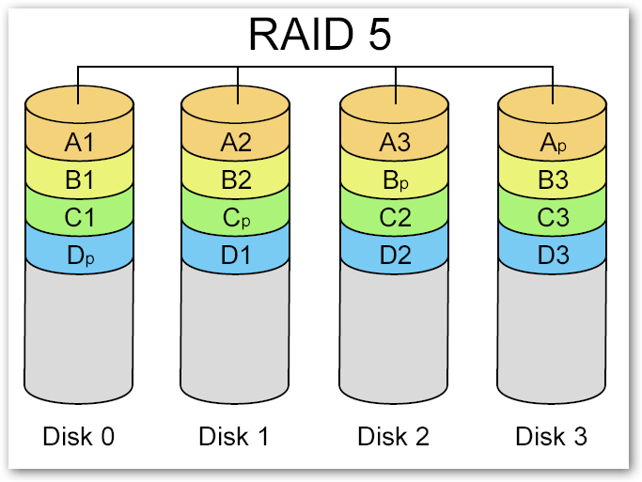

RAID 6 (block level striping, double parity bits, distributed parity disks)
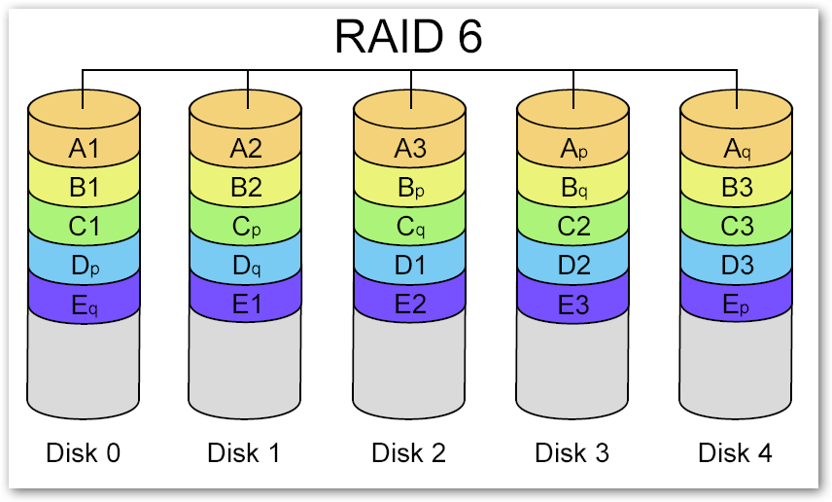

RAID 0+1 or RAID 01
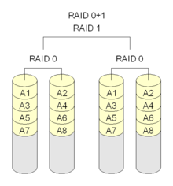

RAID 1+0 or RAID 10
