|  |  |
| --- | --- |
| **Pre-AP® Computer Science** | **Lab 06B**  **Practice/Perform Major Java Assignment** |
| **The Random Graphics Program** | **50, 60, 70, 80, 90, 100 & 110 Point Versions** |
| **Assignment Purpose:**  The purpose of this program is to demonstrate knowledge of generating **random** values and using them with graphics. | |

For this lab assignment you are provided with a grid of two rows by four columns. Each cell in the grid needs some graphics object to be drawn. It will be necessary to use methods of the *Expo* class to complete this assignment. The use of the grid is intentional. One cell will be done for you as an example. In the other 7 cells you will need to display random graphics shapes that must stay within the boundaries of the cell. This becomes a test of your knowledge about generating random values in the proper range. You will not get full credit if the shapes are drawn outside the cell boundaries.

|  |  |
| --- | --- |
| **Lab 06B Student Version** | **Do not copy this file, which is provided.** |
| **// Lab03st.java**  **// This is the student, starting version of Lab03 which is divided into 8 cells.**  **// The first cell -- "Draw Random Points" -- is provided as an example.**  **// Students need to complete the other 7 cells on their own.**  **import java.awt.*;**  **import java.applet.*;**  **public class Lab03st extends Applet**  **{**  **public void paint(Graphics g)**  **{**  **// Draw Grid**  **Expo.drawLine(g,250,0,250,650);**  **Expo.drawLine(g,500,0,500,650);**  **Expo.drawLine(g,750,0,750,650);**  **Expo.drawLine(g,0,325,1000,325);**    **// Draw 10,000 Random Points**  **for (int count = 1; count <= 10000; count++)**  **{**  **Expo.setRandomColor(g);**  **int x = Expo.random(5,245);**  **int y = Expo.random(5,320);**  **Expo.drawPoint(g,x,y);**  **}**    **// Draw 1000 Random Lines**    **// Draw 1000 Random Rectangles**    **// Draw 500 Random Triangles**    **// Draw 100 Random Initials**    **// Draw 500 Random Stars with a constant radius of 30 and a random # of points**    **// Draw 1000 Random Circles with random radii**  **// Draw 250 Random Arcs with 2 random radii, random start and random finish**  **}**  **}** | |

**Current Output of Lab03st.java**

At the beginning, the output is a 4 by 2 grid, with the “Draw Random Points” cell done for you.

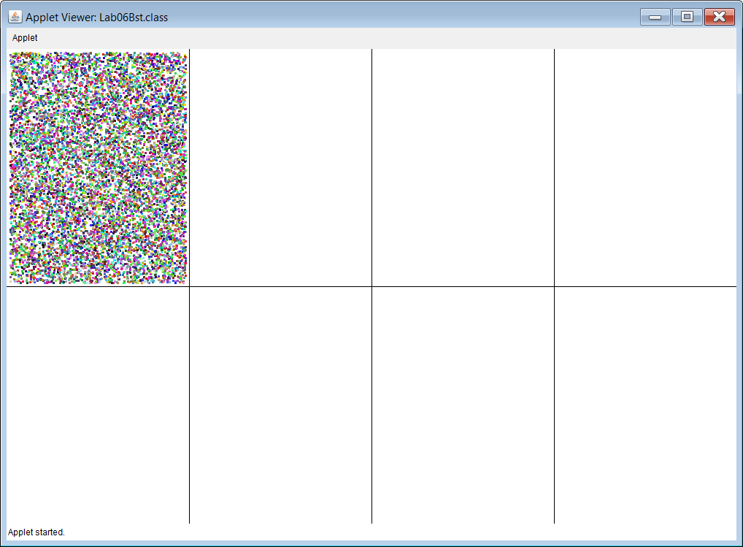

**50, 60, 70, 80, 90, 100 & 110-Point Version Specifics**

The 50-point version displays 2 of the cells on the next page (Random Points, and 1 other).

The 60-point version displays 3 of the cells on the next page (Random Points, and 2 others).

The 70-point version displays 4 of the cells on the next page (Random Points, and 3 others).

The 80-point version displays 5 of the cells on the next page (Random Points, and 4 others).

The 90-point version displays 6 of the cells on the next page (Random Points, and 5 others).

The 100-point version displays 7 of the cells on the next page (Random Points, and 6 others).

The 110-point version displays ALL 8 of the cells on the next page.

The cell with *Points* displays **10,000** random colored points at random locations.

This part is provided to use as an example.

The cell with *Lines* displays **1000** random lines.

The Lines have random colors.

Both ends of the line have random x and y coordinate locations.

The cell with *Rectangles* displays **1000** random “filled-in” rectangles.

The Rectangles have random colors.

Both the upper-left-hand corner and the lower-right-hand corner of the rectangle have

random **x** and **y** coordinate locations.

The cell with *Triangles* displays **500** random “filled-in” triangles.

The Triangles have random colors.

All 3 corners of the triangle have random **x** and **y** coordinate locations.

This means the triangles are scalene, NOT equilateral.

The cell with *Initials* displays YOUR initials **100** times.

Your Initials have random colors.

The bottom-left-hand corner of your first initial has random **x** and **y** coordinate locations.

*It is possible that your initials are partially inside the grid cell, and partially outside.*

*If this happens, you will only get partial credit. To fix this, and get full credit,*

*you need to adjust something in your random numbers.*

The cell with *Stars* displays **500** random “filled-in” stars.

The Stars have random colors.

The Stars have a random number of points. (Between **5** and **10**)

All Stars have a **radius** of **30**.

The center of each Star has a random **x** and **y** coordinate location.

*It is possible that even though the center of the Star is inside the grid cell, the points may be sticking outside the cell. If this happens, you would only get partial credit. To fix this, and get full credit,*

*you need to adjust something in your random numbers.*

The cell with *Circles* displays **1000** random circles.

The Circles have random colors.

The Circles have a random **radius** which ranges from **0** to **75** pixels.

The center of each Circle has a random **x** and **y** coordinate location.

*It is possible that even though the center of the Circle is inside the grid cell; its edge may actually be outside the cell. If this happens, you would only get partial credit. To fix this, and get full credit,*

*you need to adjust something in your random numbers.*

The cell with *Filled Arcs* displays **250** random arcs.

The Arcs have random colors.

The Arcs have a random *horizontal radius* which ranges from **0** to **75** pixels.

The Arcs have a random *vertical radius* which ranges from **0** to **75** pixels.

The *center* of each Arc has a random **x** and **y** coordinate location.

The degree measures for the **start** and **finish** values are also both random.

*It is possible that even though the center of the Filled Arc is inside the grid cell; its edge may actually be outside the cell. If this happens, you would only get partial credit. To fix this, and get full credit,*

*you need to adjust something in your random numbers.*

**110-Point Version Output**

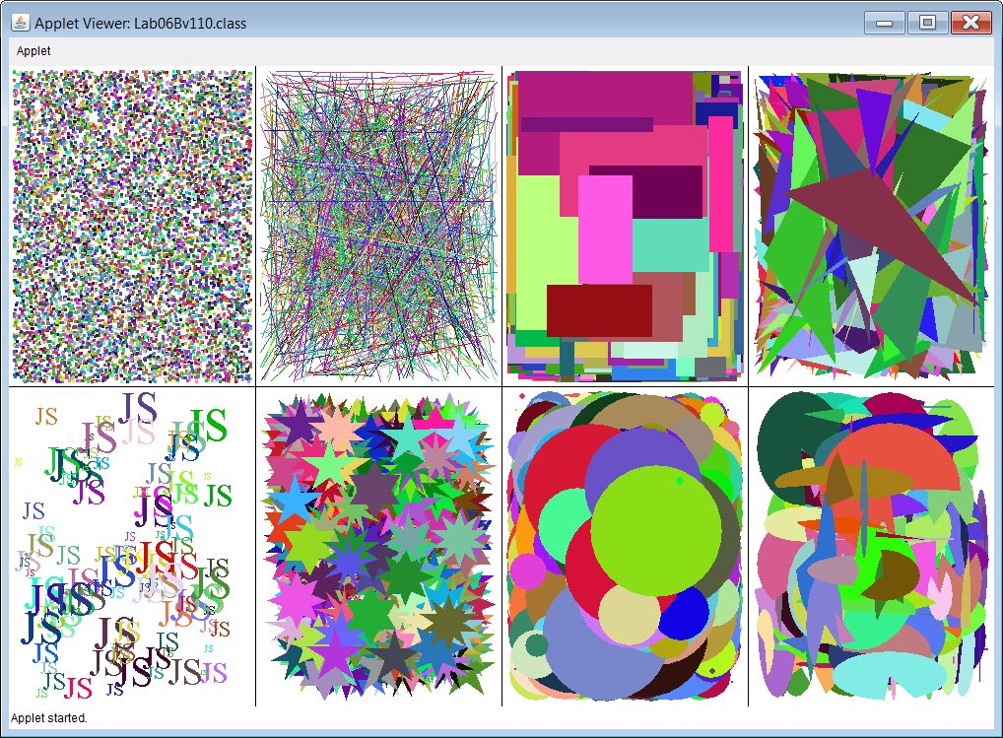

The 110 Point version requires that all 8 cells are finished and nothing goes outside of its cell.

Partial credit can be earned if some initials, stars, circles or arcs are partially outside of their cell.

No credit is earned if a shape is completely outside of its respective cell.