
+
Azure Expert | .NET Tech Lead
| Software Architect | Cloud Architect | Full Stack | DevOps | InfoSec

.NET Tech Lead | Software Architect | Cloud Architect
Sergii Yarovyi

SUMMARY STATEMENT


Senior Software Engineer / Wolters Kluwer
The Hague / August 2015 - June 2024
- Introduced an innovative approach for IaC, establishing a reusable and structured framework that enhanced stability and productivity company wide.
- Led the cloud transformation of core Authentication service, optimizing for security and scalability.
- Reduced application TCO by 30% by delivering a multi-tenant, horizontally scalable authentication platform.
- Decreased time to production to 10 minutes by introducing continuous deployment, trunk-based development, and fully automated quality and security analysis pipelines.
- Served as Security Champion, embedding security best practices into the software development lifecycle and facilitating communication with the security team.
- Secured deliveries with encryption and implemented self-extracted encrypted packaging that resulted in decrease of delivery accidents by 99%
Designed, implemented, and maintained numerous services including core authentication service and permit to work system used by Microsoft, BP, Shell, Total. Worked across back-end, front-end, operations, processes, and security.
.
Tech Lead, Platform Architect / Wolters Kluwer
Alphen aan den Rijn / June 2024 - Present
- Redesigned system architecture to a microservices model, enabling faster deployment cycles and achieving elite DORA maturity level.
- Improved developer experience by reducing cognitive load through simplified service design and tooling
- Managed Platform Engineering team, increasing deployment frequency by 100x across the organization.
Led the design and implementation of a scalable multi-tenant SaaS platform on Microsoft Azure, transitioning multiple legacy single-tenant services and teams to a modern, cloud-native architecture.
EXPERIENCE
- Architecture
- Software design, system design
- Problem solving
- Leadership, mentoring
- Information security, DevSecOps
- Distributed Systems
- Microservices, serverless, SaaS
- Cloud native, Azure, AWS
- DevOps, terraform, pulumi
- SAFe, ITIL, kandban, scrum
- OpenID Connect (OIDC), OAuth, Identity Server, SCIM, IAM
- C#, typescript, bash, PowerShell
- reactjs, angular, vuejs
Master / Mechanical Engineering
ZNTU 2005– 2010
EDUCATION
SKILLS
+31685270147
sergii.yarovyi@mail.com
Leiden, Netherlands
linkedin.com/in/syarovyi
iarovyi.github.io
Curious and high-agency problem solver with 14+ years of experience designing and implementing cloud-native, scalable software architectures. A broad generalist across backend, frontend, operations, processes, and security, with deep expertise in .NET and Azure stacks.


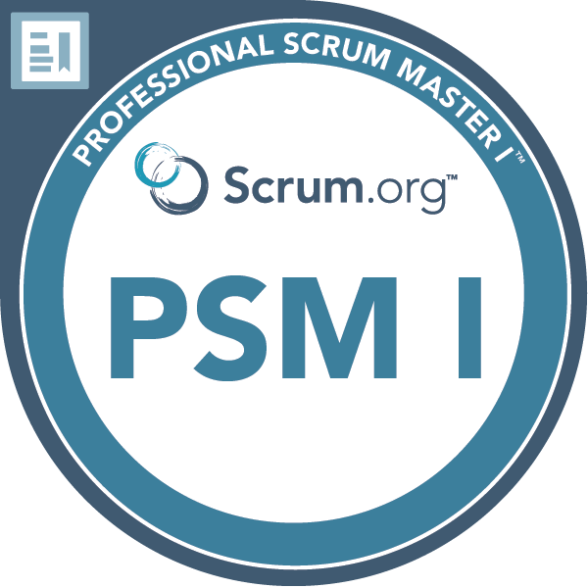
+
Full stack .NET Engineer / Softheme
Kyiv / Feb 2013 - Sep 2015
Programmed backup, replication, and recovery protection software for Dell Storage Group.
Software Engineer / EPAM
Kraków / Sep 2014 - Aug 2015
- Successfully launched the project as a solo contributor, handling both technical implementation and stakeholder communication.
- Scaled the team, recruiting and onboarding new engineers.
Delivered accounting system for biggest investment bank of Switzerland.
- Azure Solutions Architect Expert
- Azure Cosmos DB Developer Specialty
- Professional Scrum Master I
- Professional Scrum Product Owner I
- ITIL Foundation
CERTIFICATIONS


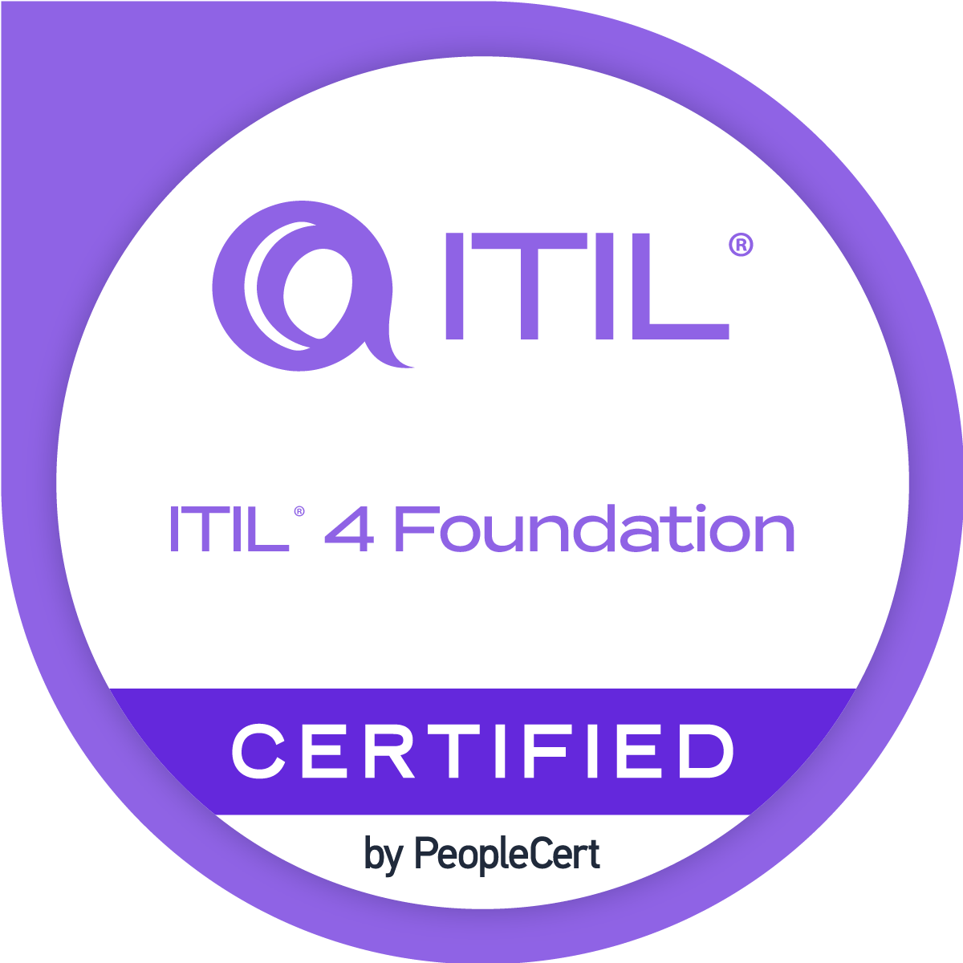
- English
- Dutch (A2)
- Ukrainian
- Russian
LANGUAGES


Frontend Developer / Creatio
Kyiv / Feb 2012 - Jan 2013
- Build a library of core UI components used across platform.
Developed web CRM platform with graphical workflow based on BPMN notation.

Junior .NET Engineer / IT-Dimension
Zaporizhzhia / Mar 2011 - Feb 2012
Created mobile applications and forum web crawler project.
AWARDS
INNOEXPO Hackathon
The Hague / 2017
Produced idea, gathered a team, coded and won competition.

