--https://nces.ed.gov/ccd/stnfis.asp

--In 2008, Which STATE/STATES has an ENROLLment that is more than WASHINGTON but less than GEORGIA?

SELECT STATE, ENROLL

FROM education

WHERE YEAR = '2008' AND

ENROLL >

(SELECT ENROLL

FROM education

WHERE STATE = 'WASHINGTON' AND YEAR = '2008')

AND ENROLL <

(SELECT ENROLL

FROM education

WHERE STATE = 'GEORGIA' AND YEAR = '2008')

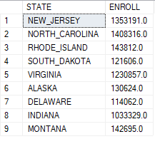

--Return a list of columns that contain "_HI_M" (Hispanic - Male demographic)

select COLUMN_NAME

from INFORMATION_SCHEMA.COLUMNS

where COLUMN_NAME like '%_HI_M%'

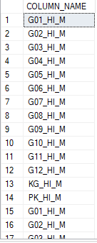

--Create new table from the query results of all enrolment numbers from pre k to 12th grade from every state

SELECT STATE,G01_HI_M,G02_HI_M,G03_HI_M,

G04_HI_M,G05_HI_M,G06_HI_M,

G07_HI_M,G08_HI_M,G09_HI_M,

G10_HI_M,G11_HI_M,G12_HI_M,

KG_HI_M,PK_HI_M

INTO HI_M_DEMO

FROM education

WHERE YEAR = 2010;

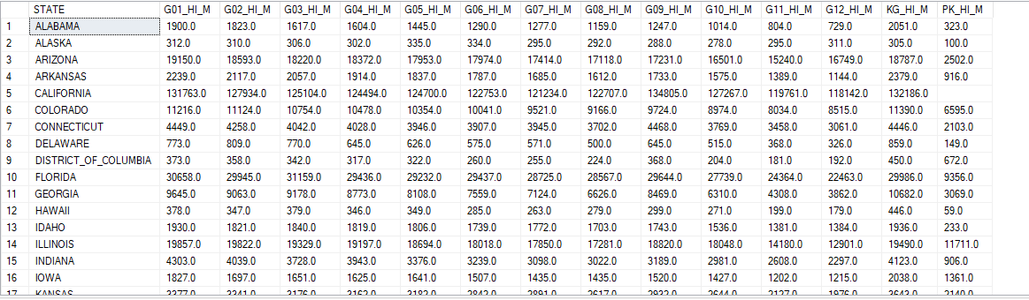

--returns the average number of 12th grade hispanic males students in 2010

SELECT

STATE = CASE GROUPING(STATE) WHEN 1 THEN 'AVG' ELSE STATE END,

G12_HI_M = AVG( CAST(replace([G12_HI_M], ' ', '') AS FLOAT) )

FROM HI_M_DEMO

GROUP BY ROLLUP(STATE)

