Document information
Info | Content
Keywords | <keyword 1>, <keyword 2>
Abstract | <Abstract text>
Revision history
Rev | Date | Description
1.0 | 2009-08-21 | Initialize

Introduction
This document describes structure of source code in project, test cases and procedure of testing USB Audio Class on LPC1343.

Source Code Structure
The source code structure in project is compliant with current structure of LPC1700CMSIS. See “LPC17xx_SoftwareDevelopmentToolchain” document for more details.
Entire LPC1343 USB Audio Class demonstration resides under “.\Examples\USBDEV\USBAudioMicroPhone” folder with structure described as following:
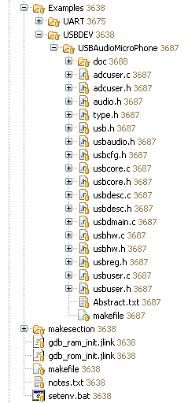
- Source Code Structure in LPC1343 USB Audio Class project
This folder contains:
- USB hardware layer:
  - usbreg.h
  - usbhw.h
  - usbhw.c
- USB configuration:
  - usbcfg.h
- USB core:
  - usb.h
  - usbcore.h
  - usbcore.c
- USB description:
  - usbdesc.h
  - usbdesc.c
- USB Audio Class:
  - usbaudio.h
  - adcuser.h
  - adcuser.c
- USB user:
  - usbuser.h
  - usbuser.c
- USB main application:
  - usbmain.c

How to build
Pls. refer to “LPC17xx_SoftwareDevelopmentToolchain” for more details.

Using Flash Magic
The latest Flash Magic can be downloaded at:
http://www.flashmagictool.com/
According to LPC1343 UM, state of P0_3 should be sampled at LOW level to switch bootloader to UART mode. So this pin must be connected to GND before each programming session with Flash Magic.
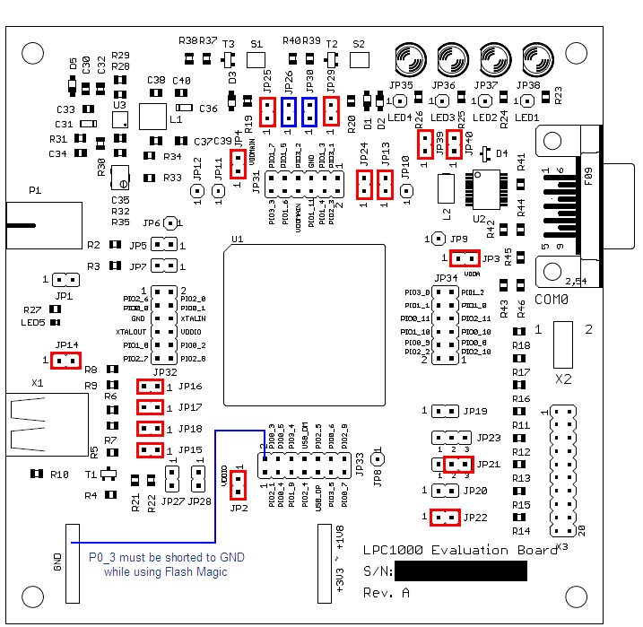
- P0_3 wiring while using Flash Magic
The UART speed of 57600 when using in Flash magic is verified.
During programming, this dialog may appear, click “yes” to confirm:
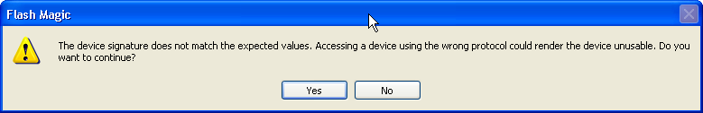
- Device signature confirm

Testing procedure

Hardware requirement:
This project is verified on LPC1000 Evaluation Board.
These following jumpers should be shorted: JP14, JP15, JP16, JP17, JP2, JP22, JP21(2-3), JP3, JP13, JP24, JP39, JP40, JP4, JP25, JP29.
During Flash programming, these jumpers should be shorted and removed when normally operating:
- JP26.
- JP30.

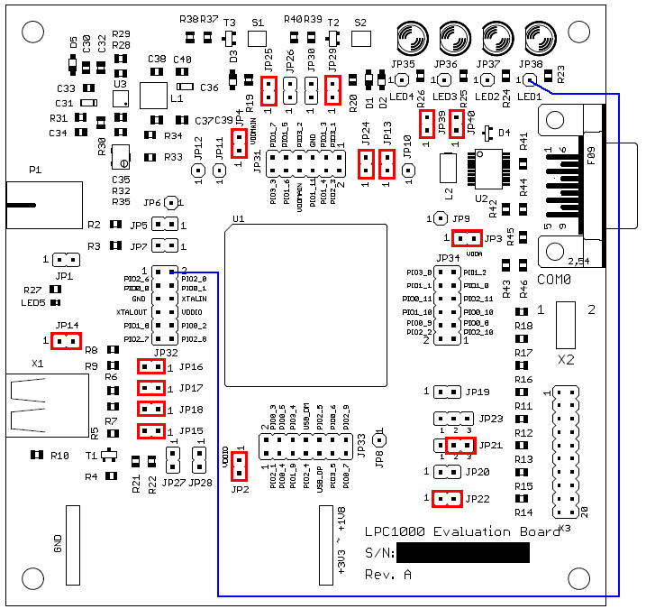
- LPC1000 Evaluation board jumper configuration.

OS Support
- This device was tested on Windows XP SP2.
- All tests in this section were completely tested on Windows XP SP2.

USB Audio Class Test
Once plugged-in, the USB Audio will appear in Device Manager like this:
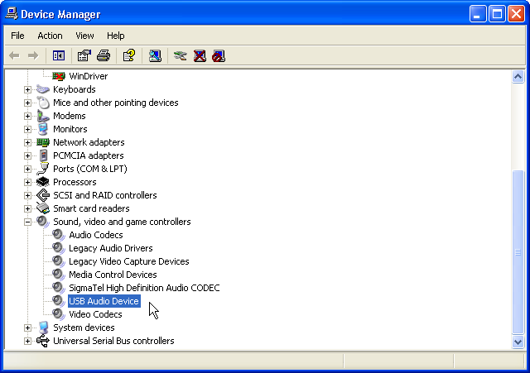
- USB Audio in device manager.
Open Volume Control, go to Options→Properties.
In “Mixer device” List Box, select”NXP LPC1343 MICInput”
Check in “Capture” check box. Press “OK”
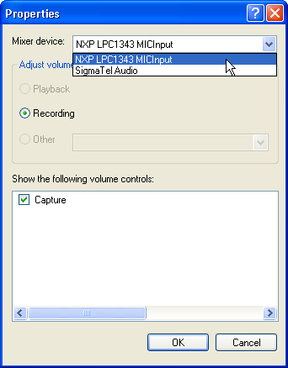
- Select Audio Device

Open “Sound Recorder”, Go to Edit → Audio Properties, check if “NXP LPC1343 MICInput” is the default device of Sound Recording. Press “OK”
Press “Record” Button to start capture audio data from our composite device
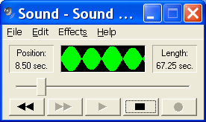
- Recording Audio Data
Note that this audio device only generates sin wave at fixed frequency. We can stop recording and replay to hear the sound.

- Legal information

  - Definitions
Draft — The document is a draft version only. The content is still under internal review and subject to formal approval, which may result in modifications or additions. NXP Semiconductors does not give any representations or warranties as to the accuracy or completeness of information included herein and shall have no liability for the consequences of use of such information.
  - Disclaimers
General — Information in this document is believed to be accurate and reliable. However, NXP Semiconductors does not give any representations or warranties, expressed or implied, as to the accuracy or completeness of such information and shall have no liability for the consequences of use of such information.
Right to make changes — NXP Semiconductors reserves the right to make changes to information published in this document, including without limitation specifications and product descriptions, at any time and without notice. This document supersedes and replaces all information supplied prior to the publication hereof.
Suitability for use — NXP Semiconductors products are not designed, authorized or warranted to be suitable for use in medical, military, aircraft, space or life support equipment, nor in applications where failure or malfunction of a NXP Semiconductors product can reasonably be expected to result in personal injury, death or severe property or environmental damage. NXP Semiconductors accepts no liability for inclusion and/or use of NXP Semiconductors products in such equipment or applications and therefore such inclusion and/or use is for the customer’s own risk.
Applications — Applications that are described herein for any of these products are for illustrative purposes only. NXP Semiconductors makes no representation or warranty that such applications will be suitable for the specified use without further testing or modification.
  - Licenses
Purchase of NXP <xxx> components
<License statement text>
  - Patents
Notice is herewith given that the subject device uses one or more of the following patents and that each of these patents may have corresponding patents in other jurisdictions.
<Patent ID> — owned by <Company name>
  - Trademarks
Notice: All referenced brands, product names, service names and trademarks are property of their respective owners.
<Name> — is a trademark of NXP B.V.

Index

D
Dummy index entry 3

Contents

1. Introduction 3
2. Source Code Structure 3
3. How to build 4
4. Using Flash Magic 4
5. Testing procedure 5
5.1 Hardware requirement: 5
5.2 OS Support 6
5.3 USB Audio Class Test 6
6. Legal information 10
6.1 Definitions 10
6.2 Disclaimers 10
6.3 Licenses 10
6.4 Patents 10
6.5 Trademarks 10
7. Index 11
8. Contents 12
9. Contents 13

Contents

1. Introduction 3
2. Source Code Structure 3
3. How to build 4
4. Using Flash Magic 4
5. Testing procedure 5
5.1 Hardware requirement: 5
5.2 OS Support 6
5.3 USB Audio Class Test 6
6. Legal information 10
6.1 Definitions 10
6.2 Disclaimers 10
6.3 Licenses 10
6.4 Patents 10
6.5 Trademarks 10
7. Index 11
8. Contents 12
9. Contents 13

