I am done with .net core(3.1) sign-in api. Code is in the following git repository;-

<https://github.com/iarunkverma/.netcoreSignInApi>

I used **jwt token based authentication** to secure the api.

There are two api controller in Application

* AuthenticateController (<http://localhost:49588/api/authenticate>)
* WeatherforecastController(<http://localhost:49588/weatherforecast>) it is default controller generated by .net, I made it secure by putting [Authorize] attribute.

To get the token you need to sent a **post request** to AuthenticateController with username(admin) and password(admin123) parameters. As in the below image.

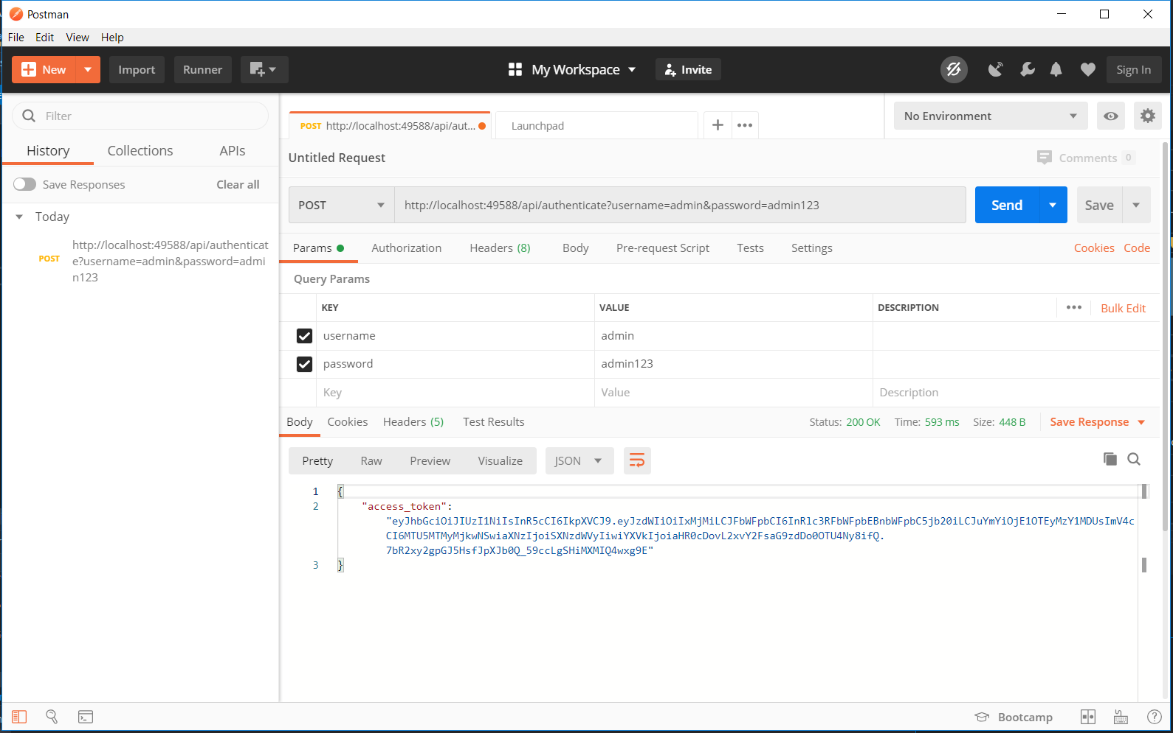

After getting the token you can pass this token as the **bearer token** to access the Weatherforecast api. See the below image.

