Deadly Viruses in Human History: A Timeline, Comparative Analysis, and Medical Interventions

Abstract
This paper explores the most dangerous viruses in human history, analyzing their impact through a historical timeline, comparative metrics, and medical interventions. It examines pandemics from antiquity to the modern era, highlighting how scientific advancements have mitigated viral threats.

Introduction
Viruses have shaped human history by causing widespread mortality, societal disruption, and economic collapse. The term 'dangerous' encompasses factors such as mortality rate, total death toll, and global influence. This paper provides a chronological overview of major viral outbreaks, compares their severity, and evaluates the evolution of medical science in combating these pathogens.

Timeline of Viral Pandemics
165 AD: Antonine Plague
541 AD: Justinian Plague
1347-1351: Black Death
1520: Smallpox in Americas
1918: Spanish Flu
1981: HIV/AIDS identified
1976: First Ebola outbreak
2003: SARS outbreak
2019: COVID-19 pandemic
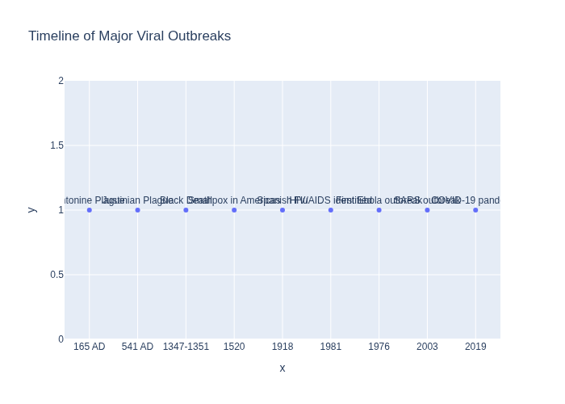

Comparative Analysis
The table below compares major viruses by death toll and mortality rate.
Virus | Death Toll (millions) | Mortality Rate (%)
Smallpox | 500.0 | 30
Spanish Flu | 50.0 | 2.5
HIV/AIDS | 40.0 | Untreated ~100
Ebola | 0.011 | 50
COVID-19 | 7.0 | 1
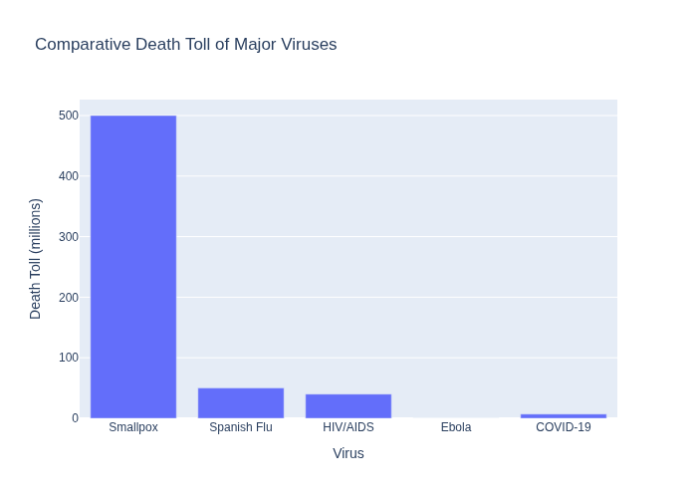

Medical Interventions
Medical interventions evolved from rudimentary quarantine measures to advanced genomic surveillance. Key milestones include Jenner's smallpox vaccine (1796), Pasteur's rabies vaccine (1885), the development of antiretroviral therapy for HIV in the 1990s, and mRNA vaccines for COVID-19 in 2020.

Lessons Learned
History underscores the importance of global cooperation, rapid vaccine development, and public health infrastructure. Future preparedness relies on AI-driven drug discovery, genomic monitoring, and equitable healthcare access.

References
1. Frontiers in Microbiology (2020). Pandemics Throughout History.
2. MDPI (2024). Evolution of Virology: Science History through Milestones.
3. Mayo Clinic (2023). History of Infectious Disease Outbreaks and Vaccines Timeline.
4. History.com (2023). Pandemics That Changed History.

