ACADEMIC TASK-3 PORTFOLIO
Israel Asante-Kobia | CSE121 | Orientation to Computing-II
GitHub: github.com/iasantekobia4 | LinkedIn: linkedin.com/in/israel-asante-kobia-614708187
City: Kumasi | Address: AF-0501-7381 | Phone: +233559368321

1. Career Goal
My goal is to become a Certified Ethical Hacker, a Data Science Expert, and a Business Leader who can use technology to secure systems, analyse information, and build sustainable ventures.
2. Academic Planning
- Year 1: strengthen cybersecurity fundamentals, Python, Linux, and networking.
- Year 2: focus on ethical hacking, practical lab work, and first portfolio projects.
- Year 3: specialise in cloud security, advanced certifications, and internship experience.
3. Skills to Acquire
- Cybersecurity: ethical hacking, network security, threat analysis.
- Data Science: data analysis, statistics, data visualisation.
- Business: marketing, leadership, business development, communication.
- Tools: Python, Excel, Linux, Git, Nmap, Wireshark.
4. Professional Certifications
- Introduction to Cyber Security
- Data Science Foundations Fundamentals
- Certified Ethical Hacker (CEH)
- Future targets: CompTIA Security+, AWS Security, OSCP
5. Video CV Summary
I will present myself with confidence, explain my growth journey, and highlight my 3-year roadmap clearly in one minute.
6. GitHub Portfolio
- Repository: github.com/iasantekobia4
- Projects to upload: Password Strength Checker, Network Scanner, Data Dashboard
- Each project should include a README, screenshots, and a short explanation of what it demonstrates.
7. Three-Year Gantt Roadmap
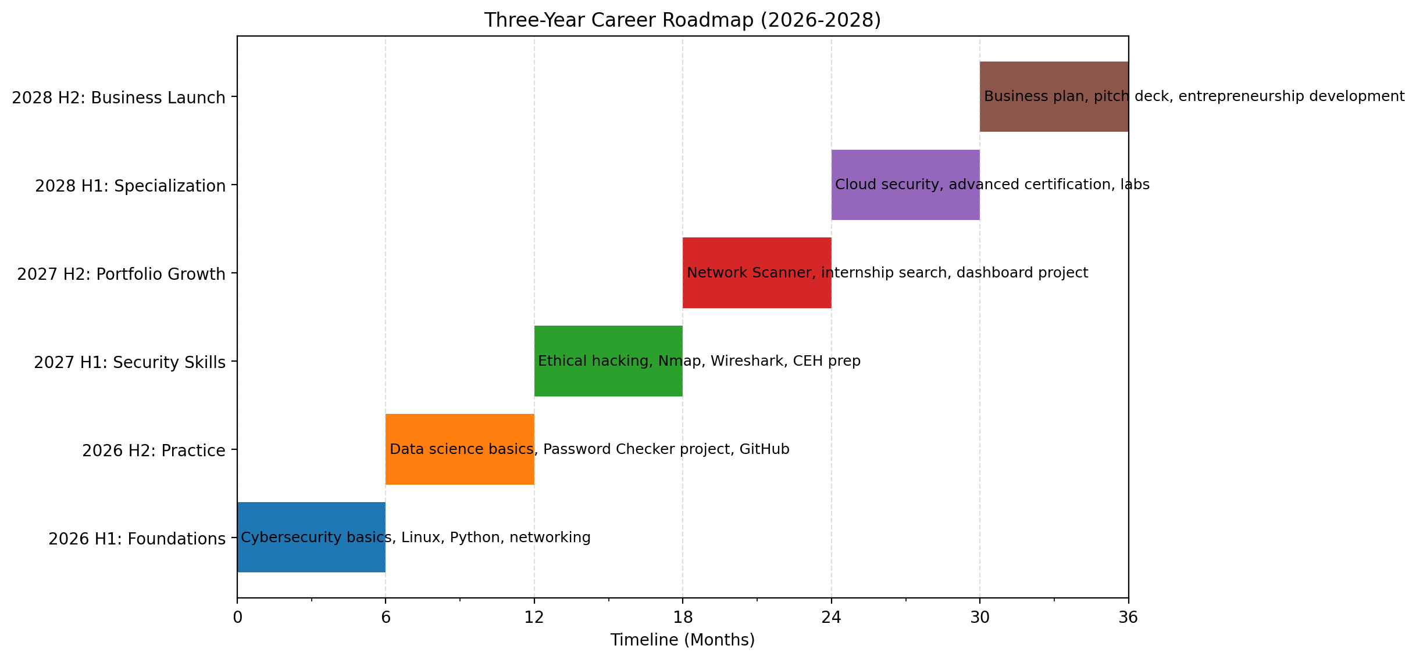
8. CA3 Scheme Alignment
- Career Goals: clearly stated and linked to cybersecurity, data science, and business growth.
- Academic Planning: structured over three years with feasible milestones.
- Skills Plan: technical and business skills included.
- Certifications: completed certificates and future targets listed.
- Visual Appeal: clean layout, professional CV, and roadmap chart.

Prepared for submission and presentation.

9. Portfolio Project Snapshot
- Password Strength Checker: demonstrates cybersecurity awareness and Python logic.
- Network Scanner: demonstrates basic network enumeration and security monitoring.
- Data Dashboard: demonstrates data analysis, visualisation, and business insight.

This portfolio is ready to submit, present, and upload to GitHub.

