Computational Private Information Retrieval in Blockchain
Integrating Computational PIR with Blockchain: Design, Implementation and Application
Artur Iasenovets
Address of Author (University’s Research Institution or School) Chongqing 400065

Abstract 3
1. Introduction 4
1.1 Cyber threat intelligence 4
1.2 Hyperledger Fabric in CTI sharing 4
1.3 Private information retrieval 5
1.4 Research contributions 5
1.5 Organization of The Paper 7
2. Preliminaries 7
2.1 Standardized CTI sharing formats 7
2.2 Implications for developing a multi-slot encoder 8
2.3 Private Information Retrieval basics 8
2.3.1 Algebraic foundations of the BGV scheme 9
2.3.2 Ciphertext slot packing 10
2.4 Why we choose Hyperledger Fabric? 10
3. Literature Review 11
3.1 Related works on privacy in blockchain CTI sharing 11
3.2 Related works on multi-channel architecture 11
3.3 Related works on ciphertext packing and encoding 12
3.4 Related works on FHE and PIR applications for privacy 13
4. Methodology 14
4.1 Multi-Channel Architecture for BGV support 14
4.2 Multi-slot encoding approach 15
4.3 CPIR-enabled CTI retrieval workflow 17
4.3.1 Stage 1: Ledger initialization 18
4.3.2 Stage 2: Metadata discovery 19
4.3.3 Stage 3: Private information retrieval 20
4.3.4 Stage 4. Local decryption and reconstruction 22
4.4 Collusion threat model and security analysis 23
4.4.1 Collusion threat model 23
4.4.2 Security analysis 23
5. Performance analysis 24
5.1 Implementation 24
5.2 Performance metrics 25
5.3 Observed results 25
5.3.1 Encryption latency 26
5.3.2 Decryption latency 27
5.3.3 Query Size (KB) 28
5.3.4 Evaluation Latency 29
5.3.1 End-To-End Latency 30
5.4 Comparative analysis 31
5.5 Real-life applications 32
5.6 Limitations 33
6. Conclusion 33
7. References 35

Abstract
Cyber Threat Intelligence (CTI) sharing improves collaborative defense but exposes sensitive organizational interests through query leakage. Existing blockchain-based CTI frameworks employ access control, anonymity tokens, or information-theoretic PIR (IT-PIR), which either restrict data utility or require multiple non-colluding servers. To address these limitations, we present the first on-chain implementation of Computational PIR (CPIR) for private CTI querying within a Hyperledger Fabric network, leveraging the BGV homomorphic encryption scheme. Our system introduces three innovations: (i) on-chain CPIR query execution, eliminating reliance on external trusted components; (ii) adaptive multi-slot encoding, which packs variable-length JSON CTI records into fixed-width ciphertext slot windows for efficient retrieval; and (iii) a multi-channel blockchain architecture, dynamically mapping cryptosystem parameters to channel-specific record sizes for scalability and performance isolation. We prototype the system and benchmark encryption, homomorphic query evaluation, and decryption under diverse ring sizes and CTI record configurations. Results show millisecond-level query latency with full query confidentiality and better throughput compared to prior approaches constrained by scalar encoding or differential disclosure. This work demonstrates a practical pathway for privacy-preserving, scalable CTI collaboration using blockchain and advanced cryptography.
Keywords: CTI Sharing, CPIR, Hyperledger Fabric.

Introduction

Cyber threat intelligence
Cyber Threat Intelligence (CTI) is a structured form of cybersecurity information aimed at providing organizations with critical insights about emerging and existing cyber threats [1]. Such intelligence typically includes data about malicious indicators, tactics, techniques, and procedures used by cyber adversaries, enabling organizations to proactively manage their cybersecurity posture in alignment with internationally recognized frameworks such as the National Institute of Standards and Technology (NIST) Cybersecurity Framework [2], and the EU Directive on security of network and information systems [3].
Sharing CTI between organizations significantly enhances their collective defense capabilities and situational awareness [4], [5]. When one entity experiences a cyber-attack, the knowledge gained can aid other entities in managing similar cyber-threats [1], [6]. This collective approach underscores the importance of sharing CTI [1]. To ensure efficient interoperability [7], CTI is commonly shared in standardized formats, such formats will be discussed in Section 2.
Although these organizations collaborate, the inherent sensitivity of CTI, coupled with the strategic nature of cybersecurity data [8], presents critical privacy and confidentiality challenges [9], [10] in its dissemination and querying process. We can assume a semi-trusted environment where adversaries or even peer organizations may potentially collude against each other by observing its query patterns to make an assumption about recently conducted cyber-attack. For example, one of the previous works addressed this issue by developing a non-attributable CTI exchange approach with distributed ledger technology [11].

Hyperledger Fabric in CTI sharing
Hyperledger Fabric [12] is a permissioned blockchain framework designed for enterprise environments where participants are known and verified. Unlike public blockchains such as Bitcoin [13] or Ethereum [14], Fabric operates under an identity-based trust model, where each member of the network is authenticated through a Membership Service Provider (MSP).
Sharing CTI across organizations introduces significant requirements for integrity (no forged or altered intel), availability (many copies prevent data loss) and traceability (who added what). Especially in threat intelligence sharing, where trust and data integrity are big challenges, blockchain offers a way for multiple parties to contribute and retrieve intel in a verifiable manner [15]. Fabric provides these guarantees inherently through properties, such as immutability, auditability, decentralized trust and identity-aware access control. These properties make Fabric specifically suitable for the backend role of CTI sharing framework.
Fabric also implements a modular architecture, separating the functions of transaction execution, ordering, and validation. Instead of Ethereum’s smart-contracts [14], Fabric uses programs called “chaincode”, that are typically written in Go, Node.js, or Java and are run on the peers to handle transactions. Chaincode defines the ledger’s data model and the rules for modifying it. We later define available chaincode methods in Section 4.
However, conventional permissioned blockchain implementations are not enough to address sophisticated threat models involving colluding participants and solely don’t guarantee confidentiality of the data or requests made. Given such limitations, a cryptographic technique that can enforce query confidentiality while still leveraging the advantages of permissioned blockchain is required.

Private information retrieval
Private information retrieval (PIR) protocols [16] enable users to privately retrieve records from a database without revealing which item is being retrieved to the database holder or any observers. PIR protocols can be broadly classified into two main categories of Information-Theoretic (IT-PIR) and Computational PIR (CPIR), later we describe the difference between the two in Section 2.
Under our threat model which is specified in Section 4, the possibility of peers colluding explicitly violates the non-collusion assumption necessary for IT-PIR, making it impractical. Hence, this work implements CPIR using on lattice-based cryptographic schemes based on computational hardness assumptions of Learning With Errors (LWE) and Ring Learning With Errors (RLWE) [17], [18].
However, despite the strength of CPIR techniques, during conducted process of literature review in Section 3, we have found no papers that explore potential of such techniques in blockchain-based privacy-oriented CTI sharing frameworks, especially in permissioned ledger environments where collusion threats between participants are realistic and critical.

Research contributions
This research introduces a novel end-to-end CTI-sharing methodology that integrates CPIR within a Hyperledger Fabric blockchain. Our goal is to enable network organizations to securely store, share and query CTI data. Crucially, we ensure that participants querying specific records do not reveal their interests to other network members. To achieve this, we use lattice-based Brakerski-Gentry-Vaikuntanathan (BGV) homomorphic encryption scheme and its primitives from an open-source Go cryptographic library “Lattigo” [19], such as key generation, encryption, encoding and decoding of polynomials, and evaluator to base our CPIR implementation upon.
The main contributions of this work are as follows:
- BGV-based CPIR as Fabric chaincode: We present, to the best of our knowledge, the first fully on-chain implementation of Computational PIR (CPIR) based on the BGV scheme, integrated as a Hyperledger Fabric chaincode for private CTI sharing.
- Adaptive Multi-Slot Encoding for JSON-Structured CTI Records: We introduce a dynamic packing algorithm that converts variable-length JSON CTI records into fixed-width byte-aligned slot windows inside the plaintext polynomial database (PTDB).
- Multi-Channel Architecture for Parameter Optimization: We designed, to the best of our knowledge, the first multi-channel architecture in Hyperledger Fabric that maps BGV parameter constraints to ledger-level data partitioning tailored for distinct CTI data formats.
- Collusion-Resilient Privacy Model: We formalize an “any-two-organization collusion” threat model and prove that our design maintains query privacy under this stronger adversarial assumption. Privacy relies solely on decisional-RLWE hardness, meaning even if all but the client colludes (i.e., majority of Fabric peers), they learn nothing beyond ciphertext size and timing. This contrasts with prior CTI-sharing systems that assume honest-but-curious peers or rely on channel-level isolation.
- Comprehensive Performance Evaluation with Open Metrics: We conduct Fabric-native PIR benchmark suite, isolating client and chaincode overheads across encryption, homomorphic evaluation, and decryption stages.

Collectively, these contributions facilitate the secure, privacy-preserving, and efficient sharing of actionable CTI within a realistic threat model where collusion among consortium participants is possible. Through systematic performance benchmarking and security analysis, this research also provides a detailed understanding of operational trade-offs, enabling organizations to deploy blockchain-integrated CPIR systems tailored to their specific security and performance requirements.

Organization of The Paper
The rest of the paper is organized as follows: Sect. 2 provides the necessary background for the proposed methodology. Section 3 reviews related work. Section 4 details the proposed methodology. Section 5 discusses the methodology and compares it with the related work, highlighting the advantages and advancements of our work, and Sect. 6 concludes the paper.

Preliminaries
In this section, we introduce necessary background knowledge for a reader to understand the problem of private CTI sharing using CPIR: CTI standardized formats, PIR and BGV scheme basics for CPIR implementation, slot-packing strategy and permissioned blockchain capabilities for CTI sharing.

Standardized CTI sharing formats
Given the heterogeneous nature of CTI producers and consumers, interoperability is a major challenge. To address this, international standards bodies and open-source communities have introduced structured formats and delivery mechanisms that enable machine-readable CTI exchange and automated integration with security tools. One of the most widely adopted formats is Structured Threat Information eXpression (STIX), which is an OASIS standard [20] that defines a JSON-based schema to represent CTI objects such as indicators, adversary profiles, and aligned with MITRE ATT&CK [21] attack patterns. STIX 2.1 is now the de facto format for structured threat intelligence sharing across platforms. In search of alternatives, Malware Information Sharing Platform (MISP) [22] introduced the MISP Core Format, which is a JSON schema used by the for sharing IOC-centric events, often including contextual metadata such as sightings, tags, and taxonomies. It prioritizes simplicity and interoperability across community-driven sharing initiatives. For delivery mechanism there is a protocol named Trusted Automated Exchange of Intelligence Information (TAXII), which is a protocol complementing STIX [23], designed for secure, automated transport of CTI objects between trusted partners over HTTPS. Using the TAXII standard with a blockchain has been proposed to ensure privacy, data integrity and interoperability in CTI sharing [24], [25]. So, in essence, TAXII is the delivery mechanism, while STIX and MISP Core format are the content formats.

Implications for developing a multi-slot encoder
Public and private sources, often referred to as CTI feeds [26], [27], [28], [29], [30] typically distribute information in structured formats mentioned above, which encapsulate multiple fields: cryptographic hashes, malware family identifiers, threat actor references, and contextual metadata. These records are variable-length JSON objects, often ranging from 60 to over 250 bytes when serialized.
This size variability has direct implications for our encoding strategy which we later specify in Section 4. Unlike scalar PIR use cases where each query returns a single integer, here we need to retrieve an entire CTI record in JSON format per query and each such record occupies a contiguous set of plaintext slots inside a polynomial. The size of these slot windows and the maximum number of records per ciphertext is constrained by the algebraic structure of the BGV scheme, as discussed next.

Private Information Retrieval basics
As we have already mentioned in Section 1, PIR protocols are classified into 2 main categories:
- Information-Theoretic (IT-PIR): This variant relies on multiple non-colluding servers to ensure unconditional query privacy through information-theoretic guarantees [16], [31], [32], [33], [34]. Formally, for a database $D=\{d_{0}​,d_{1}​,…,d_{n-1}​\}$ stored across $k$ servers, the client queries subsets of these servers such that no single server (or subset fewer than a predefined threshold) can deduce the client's selection index.
- Computational PIR (CPIR): Alternatively, CPIR schemes rely on computational hardness assumptions to achieve query privacy with only a single server [35], [36], [37], [38], [39], [40], [41], [42], [43], [44], [45]. In CPIR, the database is viewed as a vector $D=\{d_{0}​,d_{1}​,…,d_{n-1}​\}$. To privately retrieve an item at index $i$, the client generates a selection vector $v_{i}$​ defined as $v_{i}​=(0,…,0,1,0,…,0)$ where the position of the "1" corresponds to the desired record at index $i$, and encrypts it homomorphically as $c_{q}​={Enc}_{pk}​(v_{i}​)$ where ${Enc}_{pk}$ denotes encryption with the user’s public key $pk$. The server then evaluates the encrypted query homomorphically against the plaintext database $c_{r}=c_{q}​⋅D={Enc}_{pk}​(d_{i}​)$. This computation results in an encrypted response $c_{r}$​, which is returned to the client. Upon receiving the response, the client decrypts it using their secret key $sk$: $d_{i}={Dec}_{sk}​(c_{r}​)$, obtaining the desired database entry $d_{i}$ without exposing index $i$.
Lattice-based homomorphic encryption schemes, such as Brakerski/ Fan-Vercauteren (BFV), Brakerski-Gentry-Vaikuntanathan (BGV), and CKKS [46], [47], [48] have emerged as foundational technologies for practical CPIR implementations. For example, SealPIR [49] is based on Fan-Vercauteren FHE cryptosystem (FV) [46] to homomorphically evaluate encrypted queries against plaintext databases. Similarly, our approach utilizes the BGV scheme, providing efficient plaintext polynomial operations necessary for embedding complex JSON-structured Cyber Threat Intelligence (CTI) records into a homomorphic framework.
The Brakerski–Gentry–Vaikuntanathan (BGV) [47] homomorphic encryption scheme provides the cryptographic foundation for our system. Its algebraic structure is based on polynomial rings with modular coefficients and is designed to support homomorphic addition and multiplication operations on encrypted data. Crucially, it enables batching, which allows multiple data elements to be packed into a single ciphertext. This makes BGV particularly well-suited for PIR scenarios, where efficient retrieval of structured data is essential.

Algebraic foundations of the BGV scheme
The BGV scheme operates over two polynomial rings:
- Ciphertext Ring ($R_{q}$):
$$R_{q}=Z_{q}\left[X\right]/X^{N}+ 1$$
where:
- $Z_{q}$: Integers modulo $q$, the ciphertext modulus.
- $X^{N}+ 1$: The polynomial defining the quotient ring structure.
- $N=2^{\log{N}}$: The polynomial (ring) degree where N is some power of 2, (e.g., N=8192 for log N = 13), it also sets the number of SIMD slots available for data packing.
- Plaintext Ring ($R_{t}$):
$$R_{t}=Z_{t}[X]/X^{N}+ 1$$
where:
- $Z_{t}$: Integers modulo the plaintext modulus $t$, chosen as $t=65537$.
Thus, every plaintext message is represented as a polynomial $m(X)∈R_{t}$​, and every ciphertext as an element in $R_{q}^{k}$​, where $k≥2$ is the ciphertext size (two polynomials in the BGV case).

Ciphertext slot packing
Ciphertext packing is a foundational technique in lattice-based homomorphic encryption, enabling multiple data values to be evaluated simultaneously in SIMD-style slots. Early systems typically relied on scalar encoding, where each ciphertext encodes only a single message component. In Section 3 we review more recent systems that have leveraged multi-slot packing to improve throughput and amortize the computational cost of encryption and evaluation across multiple records.
In this work, each slot corresponds to one byte of a serialized CTI record and satisfies $0≤byte≤255⊂Z_{T}$. Given $N$ slots and a record length of $s$ bytes, the number of records that can be packed into a single plaintext database polynomial (PTDB) satisfies:
$$numRecords≤⌊\frac{N}{s}​⌋$$
where slots per record is determined by the maximum serialized size of any record. Thus, the choice of ring dimension $N$ determines both database capacity and evaluation cost. These constraints determine the encoding strategy and produce feasibility matrix in Section 4.

Why we choose Hyperledger Fabric?
Hyperledger Fabric introduces the concept of channels, which are logically separate sub-ledgers shared only by a subset of organizations. Channels allow data isolation within the same network without deploying multiple independent blockchains. Each channel maintains its own chaincode, ledger state, and endorsement policies.
In our design, this feature is repurposed to address a cryptographic scalability challenge: the BGV homomorphic encryption scheme imposes strict constraints on the number of slots per ciphertext and, consequently, on the size of CTI records that can be packed within a single polynomial. To accommodate diverse record sizes without sacrificing efficiency, we map distinct BGV parameter sets to dedicated Fabric channels. The complete architecture design and parameterization strategy are shown later in Section 4.

Literature Review
Prior to our work, a number of research efforts and systems have explored sharing threat intelligence via decentralized platforms, and some have touched on privacy preservation. In this section, we investigate previous works and outline how our approach differs.

Related works on privacy in blockchain CTI sharing
Several works have proposed using blockchains for CTI sharing. Gong and Lee proposed BLOCIS [50], a blockchain framework to share threat data with Sybil-attack resistance. Their framework collects CTI by a procedure validated through smart contracts and stores information about the metainformation of data in a blockchain network.
Dunnett et al. [51] have introduced a blockchain-based CTI sharing framework that facilitates trusted, verifiable, and differential CTI exchange between producers and consumers. The term “differential" pertains to the producer’s capability to manage the extent of information shared with consumers. Within this framework, CTI producers can partition CTI data into distinct groups, each containing sensitive information that can be selectively and differentially shared with CTI consumers. However, differential sharing is about limiting data content. PIR methods do not limit content, instead it protects how that content is accessed.
Huff et al. [11] proposes a “distributed ledger for non-attributable CTI sharing” using token-based anonymous authentication. In their scheme, entities share intel and query it using anonymous tokens, so that queries can’t be linked to identities.
Allouche et al. [52] in TRADE introduces access control smart contracts to enforce who can see what intel, focusing on anonymity of sharing while maintaining accountability. These approaches often ensure that certain sensitive data is either abstracted or only accessible to certain roles, but they typically do not hide the act of querying data from the ledger.

Related works on multi-channel architecture
Hyperledger Fabric’s multi-channel architecture allows partitioning participants across isolated ledgers and consensus domains, making it a powerful tool for privacy and performance segmentation. Several domains have leveraged this design pattern:
Liu et al. [53] designed a multi-channel Fabric network for secure vehicle data exchange. They isolate IoV stakeholders (e.g., manufacturers, insurers) into separate channels, ensuring data confidentiality and governance per group. Notably, they integrate Hyperledger Caliper benchmarks to evaluate cross-channel performance and confirm scalability and privacy isolation benefits.
Thakkar et al. [54] conducted empirical studies on Fabric, demonstrating that splitting workloads across multiple channels can significantly increase throughput and reduce contention. Their work shows that optimal channel sizing and resource allocation can dramatically (up to 16×) enhance performance, providing key guidelines for multi-channel deployment planning.
Wu et al. [55] designed a Drift Plus Penalty Algorithm (DPPA) and a Transaction Worst-case Delay Algorithm (TWDA) based on peer node random scheduling using the Lyapunov optimization framework to counter complex malicious cooperation between peer groups on different channels which can greatly affect the security and efficiency of the entire network architecture.

Related works on ciphertext packing and encoding
Zhao et al.’s Hermes [56] system integrates FHE into SQL engines by introducing a novel data model that packs multiple tuples per ciphertext and embeds auxiliary encrypted statistics to enable updates and aggregations in place. Hermes employs homomorphic slot masking, shifting, and rewriting to reconcile ciphertext immutability with mutable relational semantics, achieving up to 1,600× throughput gains in encryption and 30× faster inserts compared to per-tuple baselines. While Hermes showcases the power of multi-slot packing for relational queries, it assumes fixed-width tuple representations and lacks support for semi-structured JSON objects or PIR workflows.
Krastev et al. [57] addressed the programmability challenges of HE in large applications through Fhelipe, a tensor compiler that automatically selects data layouts and packs tensors into ciphertext slots for performance optimization. By analyzing layout trade-offs and noise growth constraints, Fhelipe simplifies FHE programming for neural networks and large tensor workloads while improving efficiency by up to 18.5× over prior compilers. Although Fhelipe advances automation for layout optimization, its focus remains on linear algebra kernels rather than selective retrieval in structured data contexts.
Burton et al. [58] presented Respire, a lattice-based PIR protocol that achieves significant communication reductions of up to 5.9× over prior schemes for databases containing millions of small records. Respire achieves this through query compression and response packing techniques based on ring-switching, enabling both single-record and batched retrievals with high throughput (200–400 MB/s). This work demonstrates the critical role of packing-aware designs for minimizing bandwidth but primarily targets uniform, small-sized records rather than variable or structured data objects.
Henry et al. [59] introduced a multi-block IT-PIR construction that decouples PIR block size from record length, enabling efficient retrieval of variable-length records without inflating communication or computation costs beyond that of single-block retrieval. Their approach allows a fixed, communication-optimal block size while supporting heterogeneous record structures, making it especially suitable for privacy-preserving content delivery such as e-books or media files. While this model improves throughput through multi-block queries, its design focuses on IT-PIR and SPIR protocols and does not leverage ciphertext-level packing optimizations.

Related works on FHE and PIR applications for privacy
Suštroněk et al. [60] explores fully homomorphic encryption (FHE) for CTI analysis, but focus on off-chain processing rather than private retrieval problem.
Tan et al. [61] in “PIR-based Vehicular LBS” uses computational PIR to ensure privacy in vehicular queries without revealing the requested data.
Chakraborty et al. [62] in “BRON” uses blockchain integrated with PIR protocols leveraging ZKP for securely accessing stored HR data.
Mazmudar et al. [63] in “Peer2PIR” integrates PIR into IPFS for private queries in distributed file sharing systems, achieving effective solution against query leakage in public IPFS networks and moderate communication overhead.
Hameed et al. [64] recently introduced DEBPIR, a decentralized business process management model with PIR, claiming to be the “first” to incorporate PIR into a blockchain-based model. In DEBPIR, a smart contract on Fabric uses a k-out-of-N Oblivious Transfer protocol [65] to let participants retrieve information based on certain conditions privately. This demonstrates that the research community is just starting to explore on-chain PIR.
Hence, there is no existing CTI blockchain solution that has directly integrated a CPIR protocol for private queries. Our approach of performing homomorphic encrypted queries against threat intel data stored on-chain allows organizations to leverage the shared threat intelligence without revealing its interests or incident details to other participants. We believe it could foster greater participation among companies which might be more willing to query a joint CTI database if they know their queries remain confidential.

Methodology

Multi-Channel Architecture for BGV support
While implementing a PIR-compatible blockchain-based CTI-sharing system, we observed that one fixed homomorphic configuration could not efficiently support all record formats. In particular, longer CTI records which contain full-length MD5 and SHA-256 hashes often exceeded the slot capacity available under smaller rings (e.g., N = 13). Experiment parameter groups are specified in Table 5.1.X.
Table 5.1.X. Experiment parameter groups
Category | Parameter | Default Value | Variation Range | Notes
BGV Scheme Settings | LogN | 13 (8192 slots) | [13, 14, 15] | Ring polynomial degree
BGV Scheme Settings | LogQ | [54] | [54], [54,54] | Ciphertext modulus chain
BGV Scheme Settings | LogP | [54] | [54] | Key-switching modulus
BGV Scheme Settings | PlaintextModulus (T) | 65537 | Fixed | Plaintext modulus
BGV Scheme Settings | RingType | Conjugate-Invariant | Fixed | Provides 8192 slots
PTDB Configuration | SlotsPerRecord | 224 (auto-adaptive) | [128 – 512] | Determined by record length
PTDB Configuration | Encoding Method | JSON→bytes→uint64 slots | JSON
Database Settings | numRecords | 100 | [16 – 128] | Database scalability
Database Settings | maxJSONLen | ~217 bytes | up to ~2048 bytes (2 KB) | Max length of JSON records
Database Settings | baseSize | ~113 bytes | [57 – ~120]
Blockchain Setup | Organizations × Peers | 3 org × 2 peers each | Fixed | Fabric network configuration
Blockchain Setup | Consensus | Raft | Solo, Raft
Blockchain Setup | TLS | Enabled | Enabled / Disabled | Security settings
Node Infrastructure | CPU (cores) | 2 cores | [1 – 8 cores] | Performance scaling
Node Infrastructure | RAM | 4 GB | [2 – 16 GB] | Memory scaling
Node Infrastructure | Network | Localhost | LAN / WAN (50ms RTT) | Latency impact

To address this, we designed a multi-channel architecture, where different Hyperledger Fabric channels are instantiated to support different BGV parameter sets, tailored for distinct CTI data formats. We define the following three logical channels in our network: (1) channel_mini, which supports compact CTI records with minimized metadata (e.g., excluding SHA-256). Designed for maximum scalability and low latency. Deployed with LogN = 13, allowing up to 128 records per PIR request when maximum JSON record length is $\max_{i}\left|{\text{JSON}}_{i}\right|≤64$ bytes and 16 records when $\max_{i}\left|{\text{JSON}}_{i}\right|≤512$ bytes. Then (2) channel_mid, which supports records with moderate detail, including both MD5 and truncated SHA hashes. Balancing between data richness and query cost. Uses intermediate ring sizes (LogN = 14), allowing up to 256 records per PIR request when $\max_{i}\left|{\text{JSON}}_{i}\right|≤64$ bytes and 32 records when $\max_{i}\left|{\text{JSON}}_{i}\right|≤512$ bytes. Finally, (3) channel_rich supports full-length JSON records (e.g., 224+ bytes) that contain full hashes and full threat classification details. Requires larger rings (LogN = 15), allowing up to 512 records per PIR request when $\max_{i}\left|{\text{JSON}}_{i}\right|≤64$ bytes and 64 records when $\max_{i}\left|{\text{JSON}}_{i}\right|≤512$ bytes.
Each channel maintains an independent plaintext polynomial database (PTDB) and BGV parameter configuration. PIR queries are evaluated separately per channel, ensuring modularity and privacy isolation. The full system operates over a common Fabric network, but ledger data remains logically partitioned per channel. Figure 4.2.1 illustrates this architecture.
Figure 4.2.1: Multi-Channel CPIR Architecture with BGV-Parameterized Channels
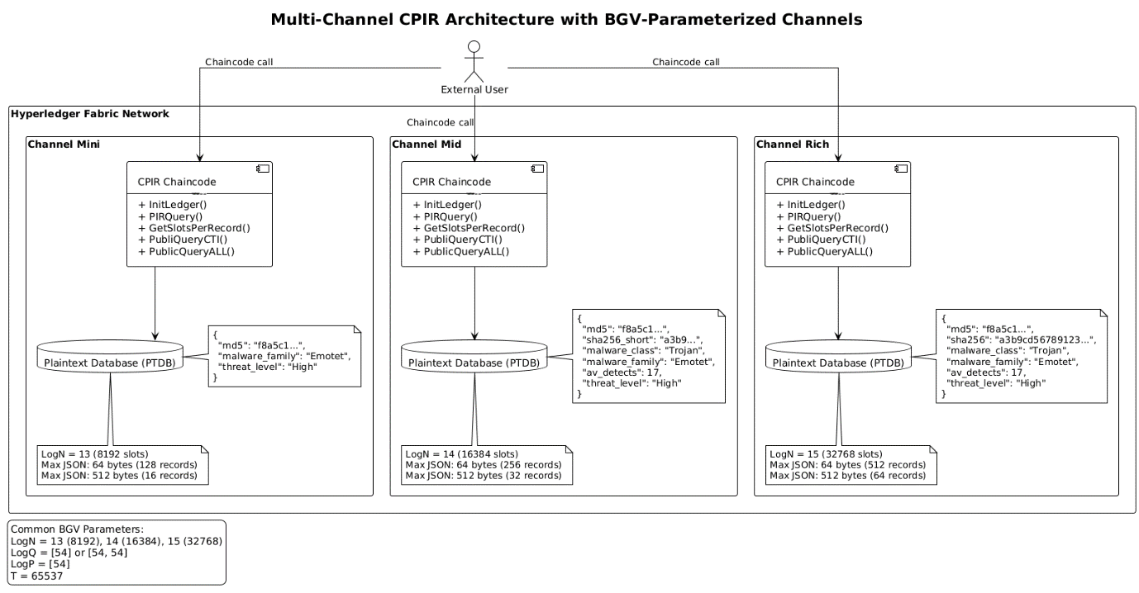
This multi-scheme design directly supports experimental flexibility. It allows us to test PIR evaluation time under diverse record formats, while reusing the same on-chain logic as later shown in Section 5. Furthermore, the separation into channels simplifies future extensions, such as adaptive privacy levels or compliance-aware deployments.

Multi-slot encoding approach
The diagram in Figure X illustrates the process of constructing the Plaintext Threat Database (PTDB) using a multi-slot encoding approach that maps JSON-structured Cyber Threat Intelligence (CTI) records into a polynomial representation suitable for homomorphic encryption under the BGV scheme. This process is essential for enabling privacy-preserving query execution in our CPIR-enabled CTI sharing architecture and consists of 4 steps below.
Figure 4.2.2: PTDB Construction
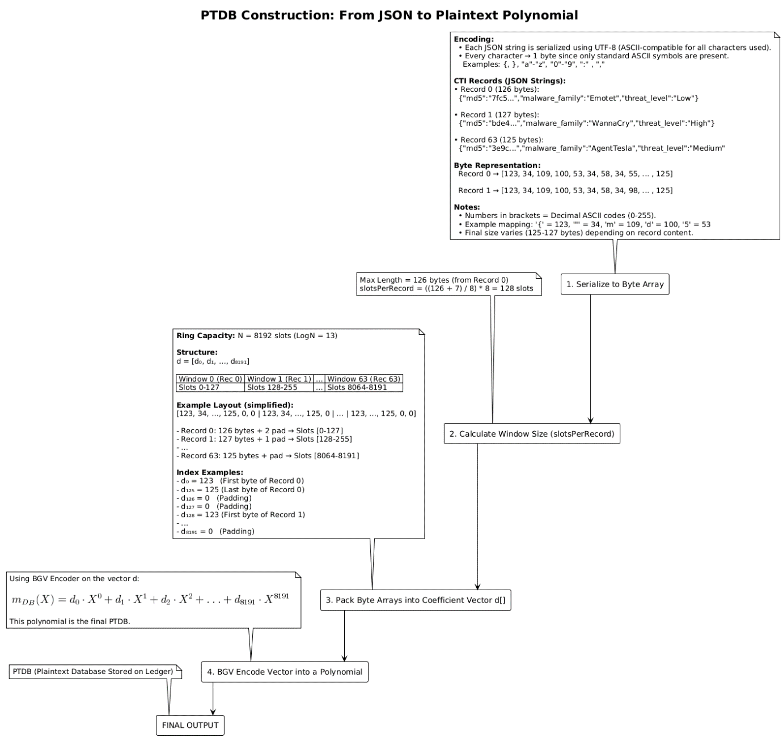

Step 1: Prepare CTI records
The process begins with CTI records formatted as JSON strings, which encapsulate fields such as md5, malware_family, and threat_level. These fields exhibit variable lengths depending on their content, typically ranging between 120–130 bytes per record. To maintain compatibility with BGV’s plaintext encoding, each JSON string undergoes UTF-8 serialization, producing a byte array where each character corresponds to its ASCII value in the range [0, 255]. For example, the string {"md5":"..."} translates to a sequence like [123, 34, 109, …].

Step 2: Byte serialization and slot allocation
Initially, each CTI record is represented as a JSON-formatted string and serialized into a byte array. This byte array is then divided into 8-bit segments and packed into uint64 slots within a plaintext polynomial. Each byte corresponds exactly to one polynomial coefficient in the plaintext ring $R_{t}$:
$$m_{DB}​(X)=\sum_{i=0}^{N-1}{d_{i}}X^{i}$$
Since JSON records vary in length, we adopt a multi-slot encoding approach where each record occupies a fixed-width “window” of slots. The number of slots per record (slotsPerRecord or simply s) is calculated based on the maximum JSON length observed across all records:
$$\text{slotsPerRecord}=\left\lceil \frac{\max_{i}\left|{\text{JSON}}_{i}\right|}{8}\right\rceil ×8$$
For example, if the maximum length of JSON record is 217 bytes, then we allocate:
$$\left\lceil \frac{217}{8}\right\rceil =28 ⇒ 28×8=\boxed{224 \text{slots}\text{/}\text{record}}$$
We also highlight 2 main constrains that we discovered during our experiments, the first one is ring capacity constraint which governs the maximum number of records we can encode. This constraint can be defined as:
$$numRecords×slotsPerRecord≤N$$
where any configuration violating this constraint should cause the system to reject the database. For example, if we have logN=13 giving us 8192 slots in total and slots per record = 224, we can pack at most $⌊\frac{8192}{224}​⌋=36 records$.
The second one is record size constraint which dictates that not every combination of N, slots per record, and number of records is feasible due to limitations imposed by the structure and encoding size of CTI records. As we have mentioned in Section 2, each CTI record includes multiple structured fields, such as cryptographic hashes (MD5, SHA-256), malware classification, detection counts, and threat severity, which, when serialized into JSON and encoded into slots, yields a base size between approximately 113 and 125 bytes, depending on the content. The baseSize denotes the number of bytes required to represent a minimal record excluding padding. Since each record is encoded into slotsPerRecord plaintext slots (each carrying 1 byte), we must enforce the second constraint:
$$slotsPerRecord≥baseSize$$
Otherwise, the record cannot be fully encoded, and decryption will fail. For example, even though logN = 13 gives us 8192 slots and theoretically allows 128 records at slotsPerRecord = 64, this configuration is not feasible in our experimental setup because the record base size (~113 bytes) exceeds the slot budget. Therefore, only combinations that satisfy $numRecords⋅slotsPerRecord≤2^{\log{N}} and slotsPerRecord≥baseSize$ are marked as feasible in the Figure 4.2.2. These constraints also drive our multi-channel architecture, optimizing configurations based on CTI record structure and ring capacity.
Figure 4.2.2: Experimental Matrix of feasible configurations
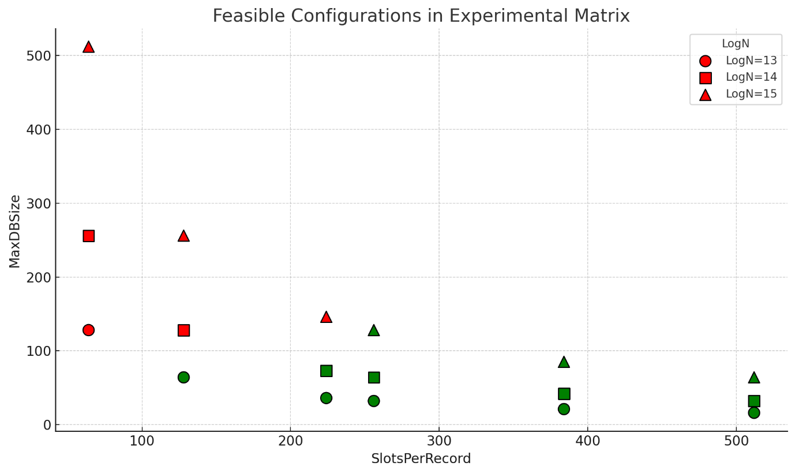
This design ensures that entire CTI objects can be retrieved in a single PIR query without additional post-processing or slot rotations, reducing query complexity and maintaining correctness under BGV homomorphisms. In contrast to prior packing techniques in PIR and FHE compilers which we have already discussed in Section 3, our method aligns slot allocation with the structural variability of JSON data, achieving both communication efficiency and application-specific retrieval guarantees in privacy-preserving CTI sharing.

CPIR-enabled CTI retrieval workflow
The PIR system is intended to be deployed within a permissioned Hyperledger Fabric network as a REST-accessible chaincode service. This chaincode exposes a set of callable methods used to initialize the encoded database, retrieve parameters, and query records either publicly or privately. We demonstrate 4 workflow stages of our CPIR-enabled CTI retrieval in Hyperledger Fabric in Sections 4.3.1-4.3.4. Totally, there are 2 clients from organisations A and B, chaincode and ledger components, such as Ledger Initialization, Metadata Discovery, Private Information Retrieval and Local Decryption and Reconstruction.
Before we proceed, it should be mentioned that our smart-contract implementation of CPIR protocol retrieves threat records by their index within a packed database, not by content such as hash. Therefore, we make a minimal assumption that the client is aware of the index corresponding to the CTI record of interest, which may be determined off-chain without compromising privacy, as long as the encrypted PIR vector itself reveals no information to the executing peers. In this setup, peers cannot determine which record the client requested — even if they collude. The full system assumptions are summarized in Section 5.

Stage 1: Ledger initialization
The ledger initialization stage in the CPIR-enabled CTI retrieval workflow, as depicted in Figure 4.3.X, orchestrates the setup of a homomorphically encoded database within the Hyperledger Fabric ledger. This process begins when a client invokes the InitLedger(n, maxJsonLength, channel) function, specifying the number of records (n), the maximum JSON record length (maxJsonLength), and the target channel. Based on the channel, the chaincode dynamically selects the cryptographic parameters through createParams(), setting the ring dimension $N=2^{\log{N}}$ (where $\log{N}∈\{13,14,15\}$), ciphertext modulus $\log{Q}=\left[54\right]$, and plaintext modulus $T=65537$. Next, generateRecords() synthesizes CTI records in JSON format, each constrained to maxJsonLength bytes. The procedure then computes the slot allocation per record via calcSlotsPerRec(), using $\text{slotsPerRecord}=\left\lceil \frac{\max_{i}\left|{\text{JSON}}_{i}\right|}{8}\right\rceil ×8$ ensuring byte-aligned mapping into BGV slots. The system validates packing feasibility through validateRingCapacity(), verifying that $requiredSlots=n⋅slotsPerRecord≤N$ otherwise, the initialization request is rejected. For each record, packRecordsLoop() embeds its byte representation into a contiguous slot window within the polynomial plaintext $m_{DB}​(X)=\sum_{i=0}^{N-1}{d_{i}}X^{i}$ where each coefficient $d_{i}∈[0,255]$. Finally, the packed polynomial is encoded and stored on the ledger as PTDB, forming the cryptographically structured database state for subsequent PIR queries.

Figure 4.3.X: Ledger Initialization stage
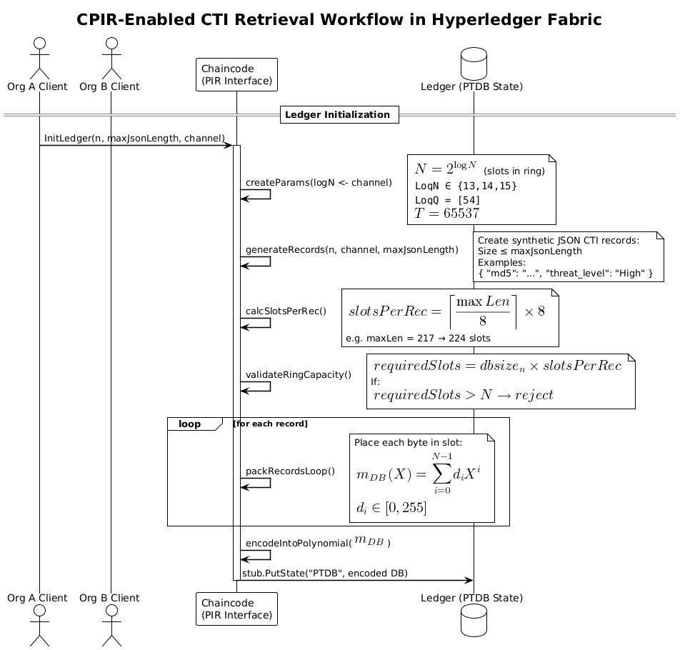
This multi-step initialization ensures tight coupling between ledger persistence and homomorphic packing constraints, enabling efficient privacy-preserving retrieval under BGV semantics.

Stage 2: Metadata discovery
During the metadata discovery stage illustrated in Figure 4.3.X., clients obtain essential structural information about the encrypted database stored on the Hyperledger Fabric ledger. After ledger initialization, a client invokes two chaincode functions sequentially. First, publicQueryALL() retrieves the total number of CTI records by accessing the state variable "PTDB" through the Fabric stub API (stub.GetState("PTDB")). The chaincode responds with totalRecords = n, which is critical for constructing a selection vector of appropriate length during PIR query formation. Subsequently, the client calls getSlotsPerRecord(), which returns the precomputed packing parameter slotsPerRecord = s by reading "slotsPerRecord" from the ledger state. This parameter determines how many BGV slots are allocated to encode each JSON CTI record in the plaintext polynomial database. Metadata parameters n and s serve as the foundation for building the homomorphic selection vector $m_{q}​\left(X\right)$ and validating that the PIR request aligns with ledger packing constraints.
Figure 4.3.X: Metadata Discovery stage
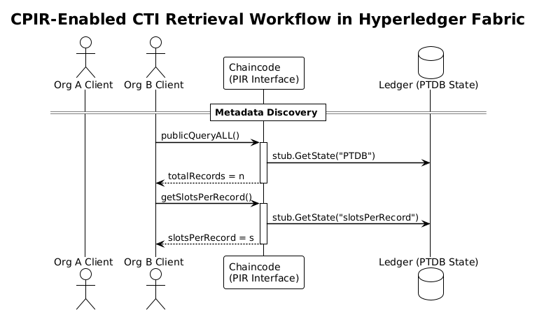
By separating metadata retrieval from full PIR evaluation, this stage ensures that query generation remains lightweight and deterministic while preserving database confidentiality.

Stage 3: Private information retrieval
Private information retrieval stage consists of two steps, as shown in Figure 4.3.3.
Step 1: Client-Side Query Encoding and Encryption. To initiate a PIR request, the client must construct a selection vector indicating the desired record and encrypt it under the BGV scheme. Suppose the client wishes to retrieve record $i∈\{0,1,…,n-1\}$, where n is the total number of records, and each record occupies $s∈N$ slots in the plaintext polynomial.
The client constructs a binary selection vector $v∈\{0,1\}$of length $N$, such that:
$$v=\{\begin{matrix}1 if j∈\{i⋅s,i⋅s+1,…,i⋅s+s-1 \\ 0 otherwise\end{matrix}\}$$
This means that only the slots corresponding to record i are marked with 1s; all others remain 0. The selection vector v is then encoded into a plaintext polynomial $m_{q}(X)∈R_{t}$ using the BGV encoder, where each coefficient stores one entry of v.
$$m_{q}\left(X\right)=v_{0}​+v_{1}​X+v_{2}​X^{2}+⋯+v_{N-1}X^{N-1}$$
As you might have already noticed, the plaintext database polynomial and the selection vector are encoded using the same strategy:
$$m_{q}​\left(X\right)=\sum_{i=0}^{N-1}{v_{i}}X^{i}=v_{0}​+v_{1}​X+v_{2}​X^{2}+⋯+v_{N-1}X^{N-1}$$
The polynomial $m_{q}\left(X\right)$ is encrypted with the recipient's public key $pk$ to produce a ciphertext:
$${ct}_{q}={Enc}_{pk}(m_{q})∈R_{q}^{2}$$
which is then Base64-encoded and sent to the blockchain node.
Step 2. Server-Side Homomorphic Evaluation. Upon receiving the encrypted query c, the server evaluates it homomorphically against the plaintext database PTDB. The PTDB is itself a plaintext polynomial where the entire CTI dataset is linearly packed $m_{DB}​\left(X\right)∈R_{t}, m_{DB}​\left(X\right)= \left[{rec}_{0}\left|{rec}_{1}\right|…{rec}_{n-1}\right]$, such that each record occupies a contiguous window of s coefficients.
The PIR evaluation consists of a single homomorphic multiplication operation:
$${ct}_{r}=Eval({ct}_{q}⋅m_{DB})=Enc(v⋅m_{DB}​)$$
Because the encrypted selector vector contains zeros outside the targeted slot range, multiplication isolates the desired record under encryption, leaving other coefficients masked to zero. Resulting ciphertext ${ct}_{r}∈R_{q}^{2}$​ contains an encrypted version of the queried record and is returned to the client after Base64-encoding.

Figure 4.3.X: Private information retrieval stage
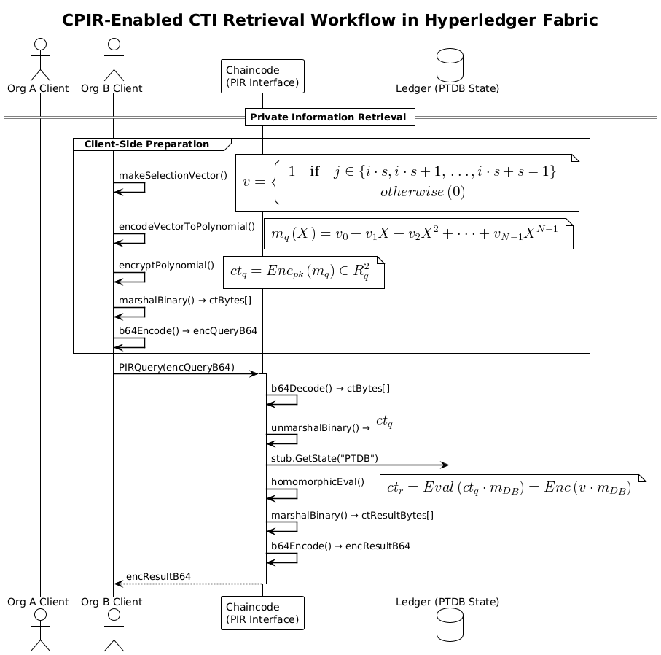

Stage 4. Local decryption and reconstruction
Finally, last stage process is depicted in Figure 4.3.X. After receiving the encrypted response ${ct}_{r}$, the client decrypts it using their secret key $sk$, producing the plaintext polynomial $m'(X)={Dec}_{sk}\left({ct}_{r}\right)∈R_{t}$ This polynomial contains zero values in all slots except those corresponding to the queried record i.
The client determines the slot interval with non-zero coefficients:
$$j∈[i⋅s,(i+1)⋅s-1)$$
Let $u∈Z_{T}^{s}$ ​ be the slice of coefficients from the interval above:
$$u=({m^{'}}_{i⋅s}​,{m^{'}}_{i⋅s+1}​,…,{m^{'}}_{\left(i+1\right)⋅s-1}​)​$$
Each coefficient $(m_{j}^{'​})∈[0,255]⊂Z_{t}$ represents one byte of the JSON string for the record. The vector u is decoded back into a byte array and interpreted as a UTF-8 JSON string representing the original CTI record:
$${record}_{i}​=UTF8Decode(u)$$
If the record occupies fewer than s bytes, padding zeros are automatically stripped during reconstruction.
Figure 4.3.X: Local decryption and reconstruction stage
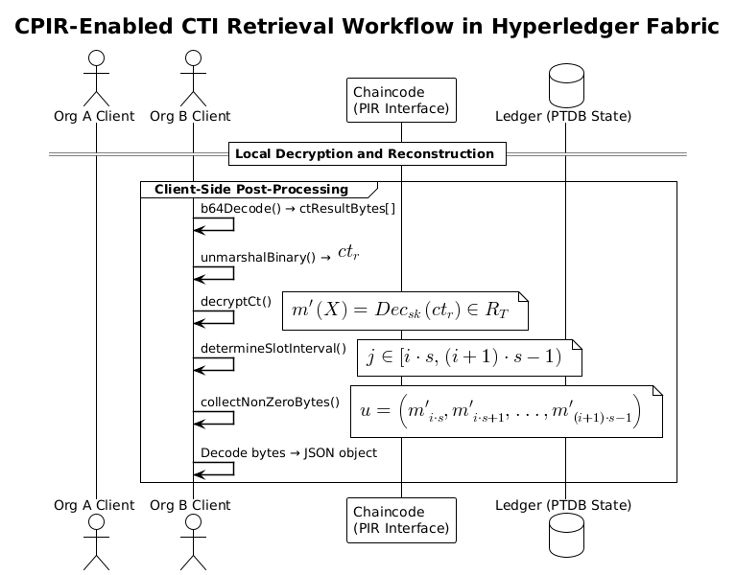

Collusion threat model and security analysis

Collusion threat model

Security analysis

Performance analysis
In this section, we discuss the practical execution of our proposed system. We start with the implementation details in “Implementation” section followed by the performance metrics’ description in “Performance metrics” section. We discuss and analyze the observed results in “Observed results” section. Furthermore, we compare our system’s performance with the state-of-the-art models in “Comparative analysis” section. Finally, we also notify some challenges faced in our system in “Limitations” section.

Implementation
We implement in a three-organizational consortium blockchain environment in Hyperledger Fabric. Setting up a three-organization consortium blockchain with Hyperledger Fabric involves defining the network configuration, setting up chain code, configuring organizations, deploying the network, interacting with the network using SDKs, and monitoring the network’s health and performance. We show the system assumptions in Table 5.1.X. The steps for implementation are as follows.
Table 5.1.X. System Assumptions for CPIR in Permissioned Blockchain
Aspect | Assumption / Constraint
Participants and Nodes | Hyperledger Fabric network includes 3 organizations, each operating 2 peer nodes, totaling 6 blockchain nodes in one channel.
Threat Model and Collusion | Assumes possible collusion between any two organizations. No non-collusion assumption is made, ruling out traditional multi-server PIR schemes.
Dataset Replication | All peers maintain a full replica of the synthetically generated (but realistic) CTI dataset, ensuring availability and data redundancy.
Performance Priority | Design is latency-focused. Computational and bandwidth costs are considered secondary to fast query response times.
On-Chain vs Off-Chain Logic | Query encryption is done off-chain by the client. Homomorphic evaluation (PIR query execution) is handled fully on-chain via Fabric chaincode.
Privacy Requirement | Query patterns must remain confidential, even under collusion. Neither individual peers nor coalitions can infer which CTI record is being accessed.
Index Knowledge Assumption | Clients are assumed to know the index of the desired CTI record (e.g., via public metadata or shared lookup). Queries operate over record indices, not hashes or keys.

Performance metrics
The performance metrics of our system are split into two groups, such as Cryptosystem metrics and Hyperledger Caliper benchmarks, as show in Table 5.2.X. Cryptosystem metrics include encryption, evaluation and decryption latency, full end-to-end cycle latency, query size and noise budget growth.
Table 5.2.X. Quality Metrics
Metric | Test Level | Description | How Measured or Calculated | Where collected
Cryptosystem Metrics
Encryption Latency (ms) | Unit / micro-bench | Time to generate a single PIR query ciphertext on the client. | time.EncryptQueryBase64 around a tight loop. | Off-chain (client)
Query Size (KB) | Unit | Size of Base-64 query payload sent to the server. | len(encQueryB64)/1024. | Off-chain (client)
Eval Latency (ms) | Integration | Time that chaincode spends in pirQuery (cipher × plain multiplication). | Wall-clock inside chaincode or time.Since() in Go CC; return as custom metrics field. | Off-chain (client)
Decryption Latency (ms) | Unit | Time to decrypt and decode PIR result on the client. | DecryptResult with time.Since(). | Off-chain (client)
End-To-End Cycle (enc, eval, dec) (ms)
Noise Budget (bits) | Unit / analytical | Remaining noise after one evaluation. | rlwe.Noise(params, sk, ct) (client side) or GetRLWENoise() if added to CC. | Off-chain preferred (client decrypts), optional on-chain if exposed.
Hyperledger Caliper benchmarks
Server Throughput (QPS) | Load / system | PIR requests handled per second by a peer under load. | External load-gen (wrk, hey) ÷ total elapsed. | Hybrid: load runner off-chain, execution inside CC.
Ledger Footprint (MB) | System / storage | Disk space used by PTDB + JSON world-state. | Host filesystem du -sh <leveldb/ledgers> . | On-peer, measured externally (shell on peer container).
CPU Utilization (%) | Load / system | Average CPU load of peer during PIR burst. | docker stats or pprof sampling. | On-peer, collected externally.
Memory Peak (MB) | Load / system | Peak RAM of peer while handling PIR. | docker stats --no-stream, parse RSS peak. | On-peer, collected externally.
Scalability Factor (Δt/ΔN) | Analytical | Slope of Eval-latency vs. database size (Nrec). | Linear regression of latency samples for N = 10…1000. | Hybrid: latency gathered (on- or off-chain), regression off-chain.

Observed results
In sections 5.3.1-5.3.4 we will show off-chain cryptosystem metrics, such as encryption, evaluation, decryption and end-to-end cycle latency for 3 distinct logN values (13-15) as well as noise budget growth. For each logN value, we will iterate over every feasible slotsPerRecords and numRecords. Selection process of feasible configurations is explained in the Experimental matrix in Section 4. In sections 5.3.5-5.3.X we will run an on-chain Hyperledger Caliper benchmarks set.

Encryption latency
This section examines the client-side encryption latency during PIR query construction as a function of two application-level parameters, database size (numRecords) and packing granularity (slotsPerRecord) under three cryptographic configurations defined by logN ∈ {13, 14, 15}, corresponding to ring dimensions N=8192, 16384, and 32768 slots, respectively.
The results summarized in Figure 5.3.X indicate that encryption latency for PIR query construction is dominated by the ring dimension (logN), while variations in database size (dbSize) have no significant effect despite variations in numRecords. Each curve corresponds to a fixed logN value (13, 14, 15), and the x-axis represents the number of CTI records, ranging from 16 to 128. However, when scaling logN from 13 → 14 → 15, the latency increases superlinearly at each step $6.1514 ms​→ 9.8232 ms→30.6055 ms$.
Figure 5.3.X: Client Encryption Latency vs Database Size
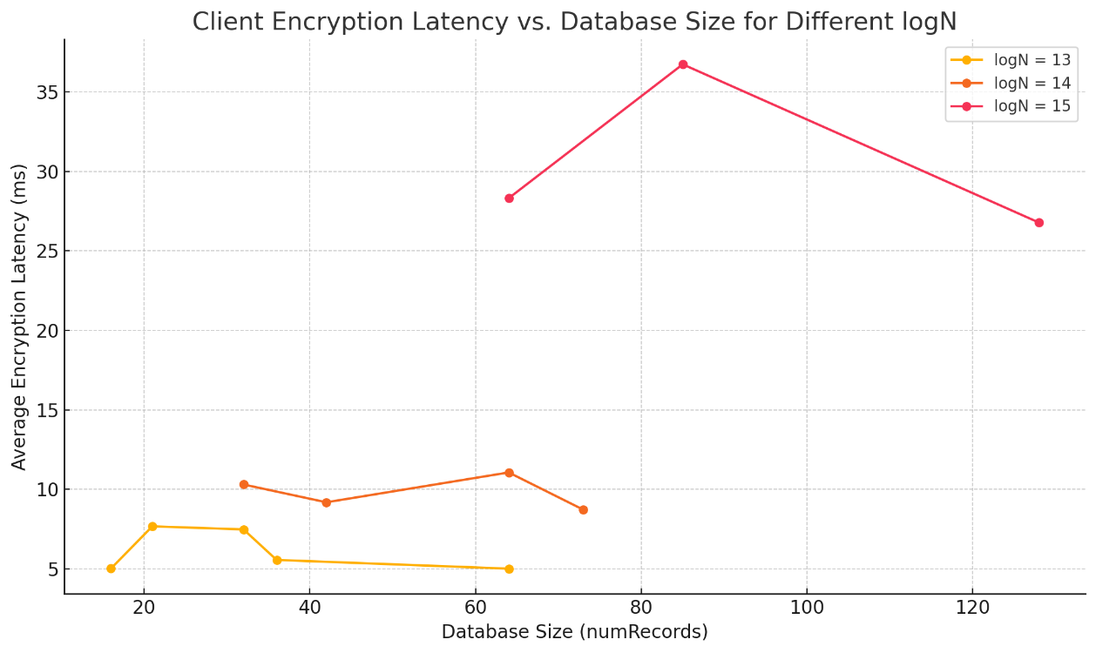
Similarly, the Figure 5.3.X illustrates that variation in slotsPerRecord also shows no significant effect on encryption latency for any fixed logN. While slotsPerRecord determines how many consecutive slots are set to 1 in the query vector (and thus how many slots are "active"), the BGV scheme encrypts the entire vector of size N, regardless of how many slots are non-zero. Each curve corresponds to a fixed logN value (13, 14, 15), and the x-axis represents the number of slots allocated to a single CTI record, ranging from 128 to 512.
Figure 5.3.X: Client Encryption Latency vs SlotsPerRecord

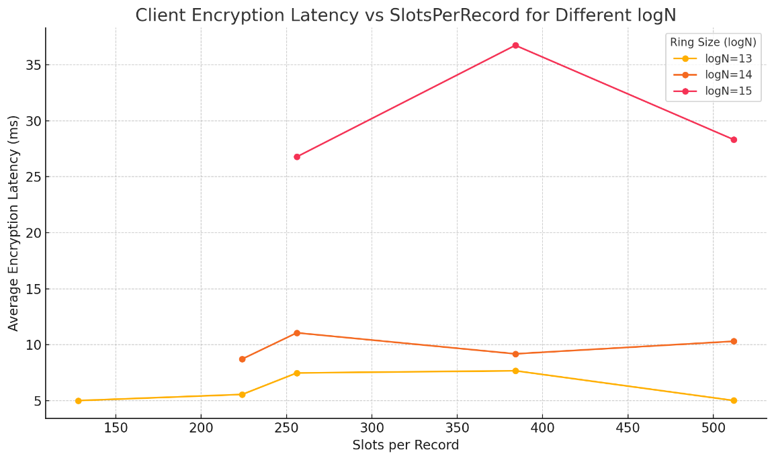
Figures 5.3.X(a) and 5.3.X(b) confirm that encryption latency is insensitive to query density and depends almost exclusively on the chosen ring size. While slotsPerRecord controls how many consecutive slots correspond to a record, the BGV encoder packs and encrypts the entire polynomial of size N in every query.

Decryption latency
Figure 5.3.X shows that client-side decryption latency is primarily influenced by the ring dimension parameter logN, and not by the database size (numRecords). As logN increases from 13 to 15, latency rises significantly—due to the growth in ring size $N=2^{\log{N}}$, which directly affects the cost of polynomial operations during decryption. This is expected, as BGV decryption complexity scales with O(N log N).
In contrast, varying the number of records in the database has negligible effect. This is because PIR responses are single ciphertexts containing all slots; decryption always processes the full vector, regardless of how many slots contain actual data.
Figure 5.3.X: Client Decryption Latency vs Database Size
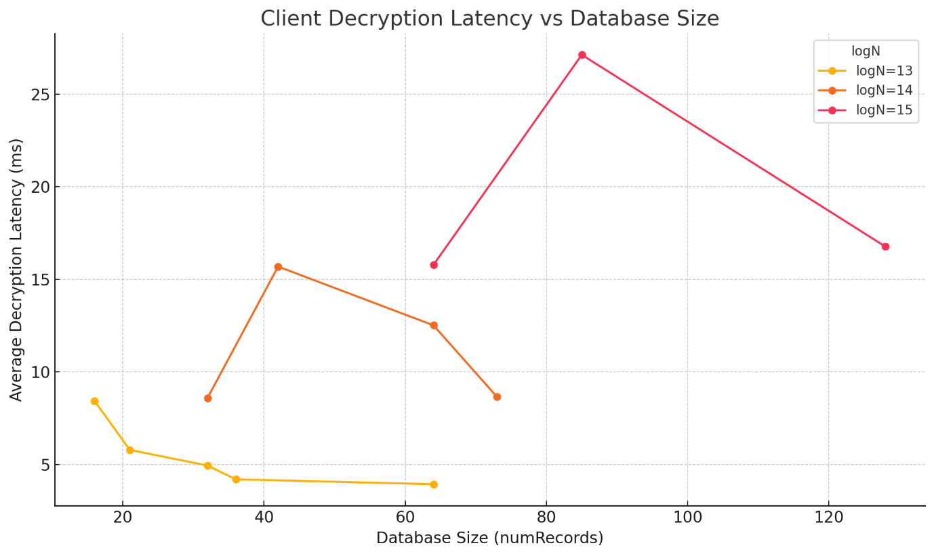
These results highlight a key trade-off: larger logN enables more records but increases client-side computation, while smaller rings reduce latency but limit capacity. Efficient system design must balance these factors based on expected database size and latency requirements
Figure 5.3.X: Client Decryption Latency vs SlotsPerRecord
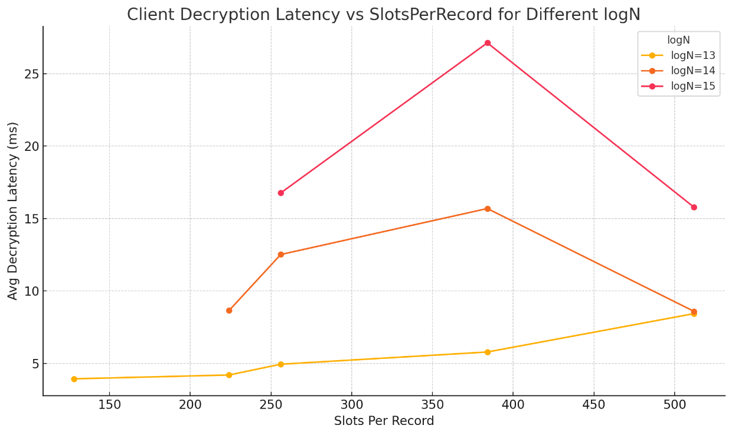

Query Size (KB)
Figure 5.3.X illustrates the relationship between the BGV ring parameter logN and the size of the PIR query (in kilobytes). Each data point corresponds to the average query size measured over 30 epochs at fixed settings for dbSize, slotsPerRecord, and target index. The x-axis denotes the logarithmic ring dimension logN, which defines the total number of plaintext slots as $N=2^{\log{N}}$. The y-axis shows the Base64-encoded ciphertext size of a single query in kilobytes.
Figure 5.3.X: Query Size vs LogN
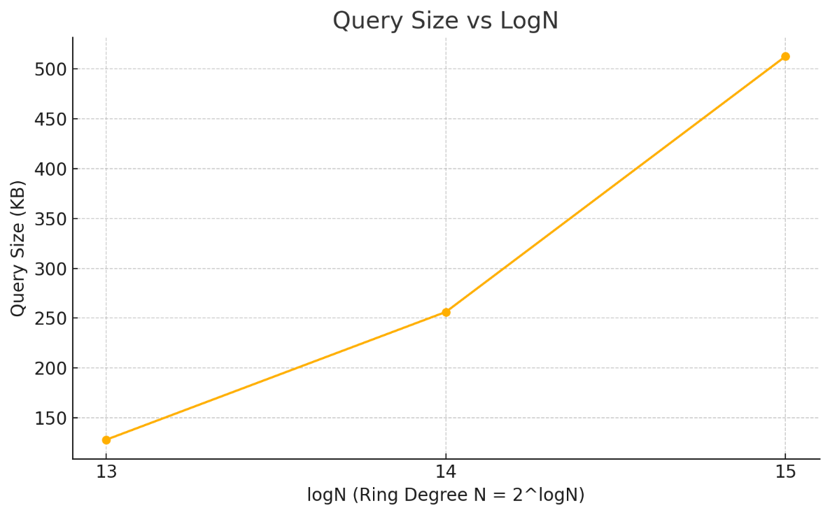
We observe that the query size scales linearly with the ring dimension: for logN = 13, the size is approximately 128 KB; for logN=14, it doubles to 256 KB; and for logN=15, it reaches 512 KB. Notably, other factors such as dbSize and slotsPerRecord (maxJsonLength) have no observable impact on ciphertext size. This knowledge allows the system designer to predict query bandwidth usage solely based on cryptographic parameters, and to budget network resources accordingly.

Evaluation Latency
Fig. X illustrates the latency distribution for PIR queries across different parameter sets, including ring dimension (logN), database size, and slots allocated per record. The number of slots per record grows proportionally with the maximum JSON record length, influencing packing efficiency and evaluation cost. We observe that configurations with higher slotsPerRecord (e.g., 512 slots) result in increased latency variance due to sparse packing, while configurations closer to optimal packing (128–256 slots) achieve lower and more consistent query times. This confirms that slots-per-record tuning is critical for achieving efficient SIMD encoding in the BGV scheme, as excessive padding increases multiplicative overhead without improving throughput.
Figure 5.3.X: PIR Evaluation Latency
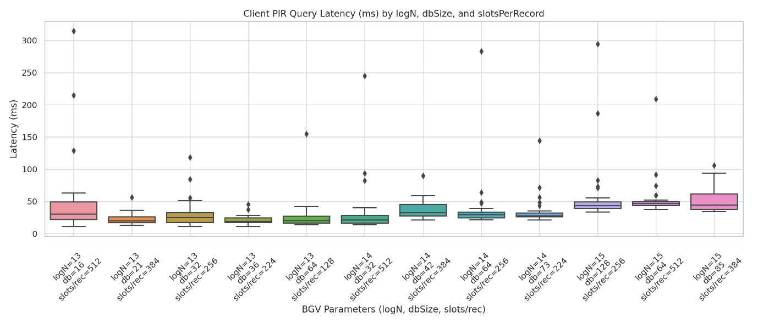

End-To-End Latency
To assess the practical efficiency of our BGV-based PIR system, we measured the end-to-end latency of client queries across multiple configurations varying in ring dimension (logN), database size, and record length. Each query involves three phases: encryption (client-side key switching and ciphertext generation), evaluation (homomorphic multiplication on the server), and decryption (client-side decoding). Figure X presents the average latency decomposition across 30 epochs per configuration.
Figure 5.3.X: End-to-End PIR Latency
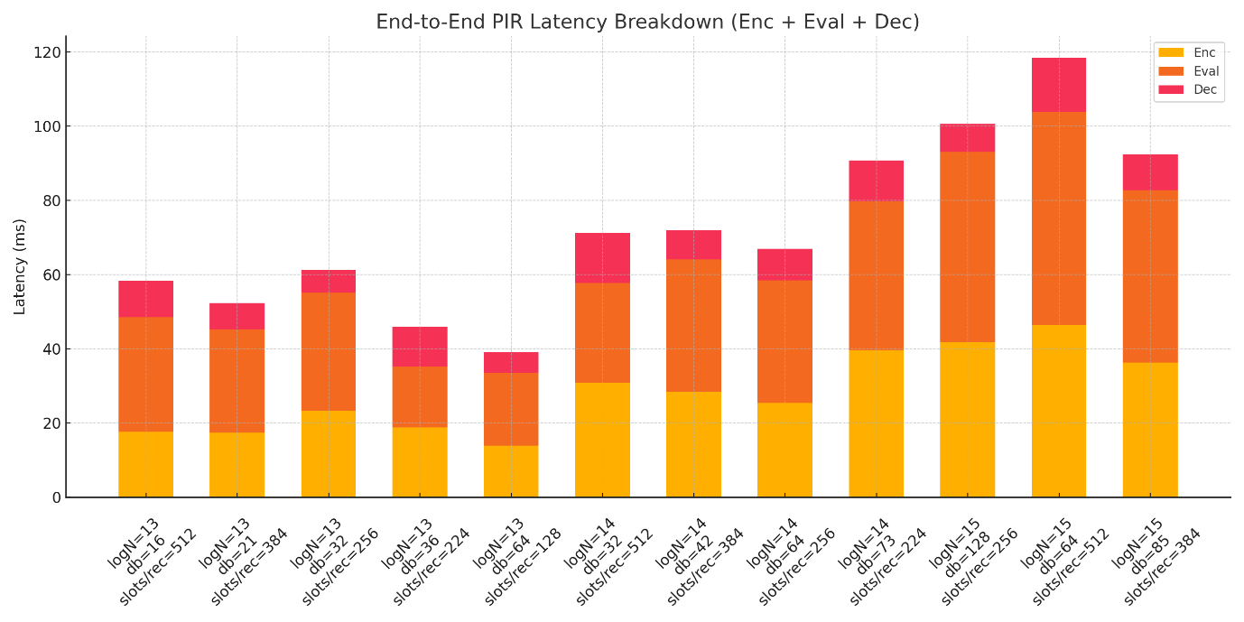
Results indicate that evaluation dominates total cost, accounting for 60–80% of the end-to-end time, especially at higher logN values where ciphertext size and plaintext packing depth increase computational complexity. Encryption remains relatively lightweight, scaling modestly with ring size, while decryption contributes minimally (<10 ms) due to efficient SIMD decoding. Notably, configurations with slotsPerRecord ≥ 512 introduce additional overhead in both encryption and evaluation, as the packed polynomial becomes denser. Overall, our architecture achieves query completion times below 150 ms for the largest configuration tested, demonstrating practical feasibility for privacy-preserving CTI retrieval in consortium blockchain environments.

Comparative analysis
Our system is the first to apply CPIR for private CTI sharing on a blockchain. Unlike prior works that rely on access control, anonymity tokens, differential sharing or IT-PIR, our approach ensures query privacy while preserving full data utility and robustness against collusion threat model. For comparative analysis, we selected key works on privacy in CTI sharing, including Gong & Lee [50], Dunnett et al. [51], Huff et al. [11], Allouche et al. [52], BRON [62], and DEBPIR [64]. Table 5.4.X. summarizes their privacy techniques, use of multi-channel architecture, and support for variable-length multi-slot encoding.
Table 5.4.X. Experiment parameter groups (settings)
Reference | Privacy Methods | Multi-Channel Architecture | Variable-Length Multi-Slot Encoding
Gong & Lee – BLOCIS [50] | None (Access validation only) | ✗ | ✗
Dunnett et al. [51] | Differential Privacy | ✗ | ✗
Huff et al. [11] | Token-based anonymity | ✗ | ✗
Allouche et al. – TRADE [52] | Access Control via Smart Contracts | ✗ | ✗
Kumar et al. – BRON [62] | IT-PIR + ZKP | ✗ | ✗
Kumar et al. - DEBPIR [64] | IT-PIR (OT-based) | ✗ | ✗
Our Work (CPIR-Enabled CTI Sharing) | CPIR (HE-based) | ✓ | ✓

Our approach differs from prior CTI sharing frameworks in three key ways. First, we employ CPIR with homomorphic encryption, removing the need for multiple non-colluding servers common in IT-PIR schemes. Second, we introduce adaptive multi-slot encoding, enabling complete JSON-based CTI objects to fit within a single ciphertext for efficient retrieval—unlike earlier methods that assume fixed-size or scalar records. Third, by leveraging multi-channel architecture mapped to cryptosystem parameters, we achieve scalability and performance isolation not addressed in previous works. These contributions together provide strong query privacy with practical efficiency for collaborative CTI sharing.

Real-life applications
Our proposed CPIR-enabled multi-channel architecture for private CTI sharing addresses a critical need in collaborative cybersecurity. In real-world scenarios, organizations participating in an Information Sharing and Analysis Center (ISAC) or consortium can leverage our system to query shared threat intelligence without revealing the nature of their security incidents or interests. For example, a financial institution detecting a suspicious domain can privately verify whether it matches known malicious indicators in the shared database without alerting competitors or attackers monitoring the ledger. Similarly, managed security service providers (MSSPs) can enhance incident response workflows by fetching related indicators or malware signatures without disclosing client-specific queries.
The multi-channel architecture allows tuning cryptosystem parameters to match varying CTI object sizes (e.g., lightweight IoCs vs. rich behavioral reports) while isolating organizational or regional data segments for scalability. This flexibility makes our framework suitable for both small-scale industry partnerships and large, cross-sector sharing networks. When integrated with existing CTI platforms such as MISP or TAXII, our system ensures interoperability while adding strong query privacy guarantees absent in current solutions.

Limitations
Despite its benefits, our system inherits limitations common to homomorphic encryption and blockchain technologies. First, computational overhead remains significant compared to plaintext queries, especially for large ciphertexts or complex packing strategies, though our adaptive multi-slot encoding mitigates this by reducing the number of ciphertexts per query. Second, storage and ledger growth can challenge scalability in long-running CTI networks, necessitating pruning strategies or off-chain storage for historical data. Third, key management and trust assumptions in CPIR-based frameworks require careful governance to prevent misuse or key compromise. Finally, post-quantum resilience remains an open challenge for lattice-based schemes like BGV, which underpins our implementation. While parameter selection provides some security margin, migration to NIST-standardized post-quantum HE primitives will be a necessary future enhancement.

Conclusion
This paper presents the first CPIR-enabled blockchain framework for private CTI sharing, combining computational PIR with adaptive multi-slot encoding and multi-channel architecture for performance scalability. Unlike existing solutions based on access control, anonymity tokens, or IT-PIR, our approach guarantees query confidentiality without compromising data utility or collusion resistance. By mapping Fabric channels to cryptosystem parameters, we achieve performance isolation across heterogeneous CTI datasets, while our encoding strategy enables efficient retrieval of variable-length JSON records in a single PIR response. Experimental evaluation demonstrates the practicality of our design, achieving privacy-preserving retrieval with acceptable latency across multiple parameter configurations.
In future work, we aim to integrate zero-knowledge proofs for query integrity, self-sovereign identity for participant authentication, and post-quantum secure HE schemes to enhance robustness against emerging threats. Overall, our system lays the groundwork for trust-preserving CTI collaboration, encouraging broader adoption of decentralized intelligence sharing in critical sectors.

References
[1] C. S. Johnson, M. L. Badger, D. A. Waltermire, J. Snyder, and C. Skorupka, “Guide to Cyber Threat Information Sharing,” National Institute of Standards and Technology, Gaithersburg, MD, Oct. 2016. doi: 10.6028/nist.sp.800-150.
[2] National Institute of Standards and Technology, “The NIST Cybersecurity Framework (CSF) 2.0,” National Institute of Standards and Technology, Gaithersburg, MD, Feb. 2024. doi: 10.6028/nist.cswp.29.
[3] “Directive - 2022/2555 - EN - EUR-Lex.” Accessed: Jul. 18, 2025. [Online]. Available: https://eur-lex.europa.eu/legal-content/EN/TXT/PDF/?uri=CELEX:32022L2555
[4] “A Systematic Literature Review on Cyber Threat Intelligence for Organizational Cybersecurity Resilience.” Accessed: Jul. 18, 2025. [Online]. Available: https://www.mdpi.com/1424-8220/23/16/7273
[5] L. O. Nweke and S. Wolthusen, “Legal Issues Related to Cyber Threat Information Sharing Among Private Entities for Critical Infrastructure Protection,” in 2020 12th International Conference on Cyber Conflict (CyCon), May 2020, pp. 63–78. doi: 10.23919/CyCon49761.2020.9131721.
[6] W. Tounsi and H. Rais, “A survey on technical threat intelligence in the age of sophisticated cyber attacks,” Comput. Secur., vol. 72, pp. 212–233, Jan. 2018, doi: 10.1016/j.cose.2017.09.001.
[7] K. Rantos, A. Spyros, A. Papanikolaou, A. Kritsas, C. Ilioudis, and V. Katos, “Interoperability Challenges in the Cybersecurity Information Sharing Ecosystem,” Computers, vol. 9, no. 1, Art. no. 1, Mar. 2020, doi: 10.3390/computers9010018.
[8] C. Doerr, “Cyber Threat Intelligences Standards–A High Level Overview,” TU Delft CTI Labs, 2018.
[9] F. Sadique, K. Bakhshaliyev, J. Springer, and S. Sengupta, “A System Architecture of Cybersecurity Information Exchange with Privacy (CYBEX-P),” in 2019 IEEE 9th Annual Computing and Communication Workshop and Conference (CCWC), Jan. 2019, pp. 0493–0498. doi: 10.1109/CCWC.2019.8666600.
[10] G. Fisk, C. Ardi, N. Pickett, J. Heidemann, M. Fisk, and C. Papadopoulos, “Privacy Principles for Sharing Cyber Security Data,” in Proceedings of the 2015 IEEE Security and Privacy Workshops, in SPW ’15. USA: IEEE Computer Society, May 2015, pp. 193–197. doi: 10.1109/SPW.2015.23.
[11] P. Huff and Q. Li, “A Distributed Ledger for Non-attributable Cyber Threat Intelligence Exchange,” presented at the Security and Privacy in Communication Networks. 17th EAI International Conference, SecureComm 2021, Virtual Event, September 6–9, 2021, Proceedings, Part I, Nov. 2021. Accessed: Jul. 18, 2025. [Online]. Available: https://eudl.eu/doi/10.1007/978-3-030-90019-9_9
[12] “A Blockchain Platform for the Enterprise — Hyperledger Fabric Docs main documentation.” Accessed: Jul. 18, 2025. [Online]. Available: https://hyperledger-fabric.readthedocs.io/en/release-2.5/
[13] S. Nakamoto, “Bitcoin: A Peer-to-Peer Electronic Cash System”, Accessed: Jul. 18, 2025. [Online]. Available: https://bitcoin.org/bitcoin.pdf
[14] V. Buterin, “Ethereum: A Next-Generation Smart Contract and Decentralized Application Platform.”, Accessed: Jul. 18, 2025. [Online]. Available: https://ethereum.org/content/whitepaper/whitepaper-pdf/Ethereum_Whitepaper_-_Buterin_2014.pdf
[15] D. Chatziamanetoglou and K. Rantos, “Cyber Threat Intelligence on Blockchain: A Systematic Literature Review,” Computers, vol. 13, no. 3, Art. no. 3, Mar. 2024, doi: 10.3390/computers13030060.
[16] B. Chor, E. Kushilevitz, O. Goldreich, and M. Sudan, “Private information retrieval,” J ACM, vol. 45, no. 6, pp. 965–981, Nov. 1998, doi: 10.1145/293347.293350.
[17] O. Regev, “On lattices, learning with errors, random linear codes, and cryptography,” in Proceedings of the thirty-seventh annual ACM symposium on Theory of computing, in STOC ’05. New York, NY, USA: Association for Computing Machinery, May 2005, pp. 84–93. doi: 10.1145/1060590.1060603.
[18] C. Peikert, “Lattice Cryptography for the Internet,” 2014, 2014/070. Accessed: Jul. 18, 2025. [Online]. Available: https://eprint.iacr.org/2014/070
[19] “Lattigo v6.” Aug. 2024.
[20] “STIX Version 2.1,” OASIS Open. Accessed: Jul. 19, 2025. [Online]. Available: https://www.oasis-open.org/standard/stix-version-2-1/
[21] “MITRE ATT&CK®.” Accessed: Jul. 23, 2025. [Online]. Available: https://attack.mitre.org/
[22] “MISP Standard,” MISP Standard. Accessed: Jul. 19, 2025. [Online]. Available: https://www.misp-standard.org/
[23] “TAXII Version 2.1,” OASIS Open. Accessed: Jul. 19, 2025. [Online]. Available: https://www.oasis-open.org/standard/taxii-version-2-1/
[24] “Secure exchange of cyber threat intelligence using TAXII and distributed ledger technologies - application for electrical power and energy system | Proceedings of the 16th International Conference on Availability, Reliability and Security.” Accessed: Jul. 19, 2025. [Online]. Available: https://dl.acm.org/doi/abs/10.1145/3465481.3470476
[25] “Secure and Efficient Exchange of Threat Information Using Blockchain Technology.” Accessed: Jul. 19, 2025. [Online]. Available: https://www.mdpi.com/2078-2489/13/10/463
[26] “MalwareBazaar | Malware sample exchange.” Accessed: Jul. 18, 2025. [Online]. Available: https://bazaar.abuse.ch/
[27] “Threat Group Cards: A Threat Actor Encyclopedia.” Accessed: Jul. 18, 2025. [Online]. Available: https://apt.etda.or.th/cgi-bin/aptgroups.cgi
[28] “FAQ - Triage.” Accessed: Jul. 18, 2025. [Online]. Available: https://tria.ge/docs/faq/
[29] any.run, “ANY.RUN - Interactive Online Malware Sandbox.” Accessed: Jul. 18, 2025. [Online]. Available: https://any.run/
[30] Wazuh, “VirusTotal integration - Malware detection · Wazuh documentation.” Accessed: Jul. 18, 2025. [Online]. Available: https://documentation.wazuh.com/current/user-manual/capabilities/malware-detection/virus-total-integration.html
[31] A. Beimel, Y. Ishai, E. Kushilevitz, and J.-F. Raymond, “Breaking the O(n1/(2k-1)) Barrier for Information-Theoretic Private Information Retrieval,” in Proceedings of the 43rd Symposium on Foundations of Computer Science, in FOCS ’02. USA: IEEE Computer Society, Nov. 2002, pp. 261–270.
[32] D. Demmler, A. Herzberg, and T. Schneider, “RAID-PIR: Practical Multi-Server PIR,” in Proceedings of the 6th edition of the ACM Workshop on Cloud Computing Security, in CCSW ’14. New York, NY, USA: Association for Computing Machinery, Nov. 2014, pp. 45–56. doi: 10.1145/2664168.2664181.
[33] C. Devet, I. Goldberg, and N. Heninger, “Optimally Robust Private Information Retrieval,” in 21st USENIX Security Symposium (USENIX Security 12), Bellevue, WA: USENIX Association, Aug. 2012, pp. 269–283. [Online]. Available: https://www.usenix.org/conference/usenixsecurity12/technical-sessions/presentation/devet
[34] I. Goldberg, “Improving the Robustness of Private Information Retrieval,” in 2007 IEEE Symposium on Security and Privacy (SP ’07), May 2007, pp. 131–148. doi: 10.1109/SP.2007.23.
[35] C. Aguilar-Melchor, J. Barrier, L. Fousse, and M.-O. Killijian, “XPIR : Private Information Retrieval for Everyone,” Proc. Priv. Enhancing Technol., 2016, Accessed: Jul. 24, 2025. [Online]. Available: https://petsymposium.org/popets/2016/popets-2016-0010.php
[36] Z. Brakerski and V. Vaikuntanathan, “Efficient Fully Homomorphic Encryption from (Standard) LWE,” in 2011 IEEE 52nd Annual Symposium on Foundations of Computer Science, Oct. 2011, pp. 97–106. doi: 10.1109/FOCS.2011.12.
[37] C. Cachin, S. Micali, and M. Stadler, “Computationally Private Information Retrieval with Polylogarithmic Communication,” in Advances in Cryptology — EUROCRYPT ’99, J. Stern, Ed., Berlin, Heidelberg: Springer, 1999, pp. 402–414. doi: 10.1007/3-540-48910-X_28.
[38] Y.-C. Chang, “Single Database Private Information Retrieval with Logarithmic Communication,” in Information Security and Privacy, H. Wang, J. Pieprzyk, and V. Varadharajan, Eds., Berlin, Heidelberg: Springer, 2004, pp. 50–61. doi: 10.1007/978-3-540-27800-9_5.
[39] C. Dong and L. Chen, “A Fast Single Server Private Information Retrieval Protocol with Low Communication Cost,” in Computer Security - ESORICS 2014, M. Kutyłowski and J. Vaidya, Eds., Cham: Springer International Publishing, 2014, pp. 380–399. doi: 10.1007/978-3-319-11203-9_22.
[40] C. Gentry and Z. Ramzan, “Single-Database Private Information Retrieval with Constant Communication Rate,” in Automata, Languages and Programming, L. Caires, G. F. Italiano, L. Monteiro, C. Palamidessi, and M. Yung, Eds., Berlin, Heidelberg: Springer, 2005, pp. 803–815. doi: 10.1007/11523468_65.
[41] A. Kiayias, N. Leonardos, H. Lipmaa, K. Pavlyk, and Q. Tang, “Optimal Rate Private Information Retrieval from Homomorphic Encryption,” Proc. Priv. Enhancing Technol., vol. 2015, no. 2, pp. 222–243, Jun. 2015, doi: 10.1515/popets-2015-0016.
[42] E. Kushilevitz and R. Ostrovsky, “Replication is not needed: single database, computationally-private information retrieval,” in Proceedings 38th Annual Symposium on Foundations of Computer Science, Oct. 1997, pp. 364–373. doi: 10.1109/SFCS.1997.646125.
[43] H. Lipmaa, “First CPIR Protocol with Data-Dependent Computation,” in Information, Security and Cryptology – ICISC 2009, Springer, Berlin, Heidelberg, 2010, pp. 193–210. doi: 10.1007/978-3-642-14423-3_14.
[44] H. Lipmaa and K. Pavlyk, “A Simpler Rate-Optimal CPIR Protocol”.
[45] X. Yi, M. G. Kaosar, R. Paulet, and E. Bertino, “Single-Database Private Information Retrieval from Fully Homomorphic Encryption,” IEEE Trans. Knowl. Data Eng., vol. 25, no. 5, pp. 1125–1134, May 2013, doi: 10.1109/TKDE.2012.90.
[46] J. Fan and F. Vercauteren, “Somewhat Practical Fully Homomorphic Encryption,” 2012, 2012/144. Accessed: Jul. 18, 2025. [Online]. Available: https://eprint.iacr.org/2012/144
[47] Z. Brakerski, C. Gentry, and V. Vaikuntanathan, “Fully Homomorphic Encryption without Bootstrapping,” 2011, 2011/277. Accessed: Jul. 18, 2025. [Online]. Available: https://eprint.iacr.org/2011/277
[48] “Homomorphic Encryption for Arithmetic of Approximate Numbers,” in Lecture Notes in Computer Science, Cham: Springer International Publishing, 2017, pp. 409–437. doi: 10.1007/978-3-319-70694-8_15.
[49] S. Angel, H. Chen, K. Laine, and S. Setty, “PIR with compressed queries and amortized query processing,” 2017, 2017/1142. Accessed: Jul. 18, 2025. [Online]. Available: https://eprint.iacr.org/2017/1142
[50] S. Gong and C. Lee, “BLOCIS: Blockchain-Based Cyber Threat Intelligence Sharing Framework for Sybil-Resistance,” Electronics, vol. 9, no. 3, Art. no. 3, Mar. 2020, doi: 10.3390/electronics9030521.
[51] K. Dunnett, S. Pal, G. D. Putra, Z. Jadidi, and R. Jurdak, “A Trusted, Verifiable and Differential Cyber Threat Intelligence Sharing Framework using Blockchain,” in 2022 IEEE International Conference on Trust, Security and Privacy in Computing and Communications (TrustCom), Dec. 2022, pp. 1107–1114. doi: 10.1109/TrustCom56396.2022.00152.
[52] Y. Allouche, N. Tapas, F. Longo, A. Shabtai, and Y. Wolfsthal, “TRADE: TRusted Anonymous Data Exchange: Threat Sharing Using Blockchain Technology,” Mar. 24, 2021, arXiv: arXiv:2103.13158. doi: 10.48550/arXiv.2103.13158.
[53] Y. Liu, Y. Feng, and K. Sakurai, “Hyperledger Fabric-Based Multi-Channel Structure for Data Exchange in Internet of Vehicles,” Electronics, vol. 14, no. 3, 2025, doi: 10.3390/electronics14030572.
[54] P. Thakkar, S. Nathan, and B. Viswanathan, “Performance Benchmarking and Optimizing Hyperledger Fabric Blockchain Platform,” in 2018 IEEE 26th International Symposium on Modeling, Analysis, and Simulation of Computer and Telecommunication Systems (MASCOTS), Sep. 2018, pp. 264–276. doi: 10.1109/MASCOTS.2018.00034.
[55] O. Wu et al., “An optimal scheduling algorithm considering the transactions worst-case delay for multi-channel hyperledger fabric network,” Parallel Comput., vol. 117, p. 103041, Sep. 2023, doi: 10.1016/j.parco.2023.103041.
[56] D. Zhao, “Hermes: High-Performance Homomorphically Encrypted Vector Databases,” Jun. 05, 2025, arXiv: arXiv:2506.03308. doi: 10.48550/arXiv.2506.03308.
[57] A. Krastev, N. Samardzic, S. Langowski, S. Devadas, and D. Sanchez, “A Tensor Compiler with Automatic Data Packing for Simple and Efficient Fully Homomorphic Encryption,” Proc. ACM Program. Lang., vol. 8, no. PLDI, pp. 126–150, Jun. 2024, doi: 10.1145/3656382.
[58] A. Burton, S. J. Menon, and D. J. Wu, “Respire: High-Rate PIR for Databases with Small Records,” in Proceedings of the 2024 on ACM SIGSAC Conference on Computer and Communications Security, Salt Lake City UT USA: ACM, Dec. 2024, pp. 1463–1477. doi: 10.1145/3658644.3690328.
[59] R. Henry, Y. Huang, and I. Goldberg, “One (Block) Size Fits All: PIR and SPIR with Variable-Length Records via Multi-Block Queries,” NDSS Symposium. Accessed: Jul. 24, 2025. [Online]. Available: https://www.ndss-symposium.org/ndss2013/ndss-2013-programme/one-block-size-fits-all-pir-and-spir-variable-length-records-multi-block-queries/
[60] J. J. Sustronk, “Analysing Cyber Threat Intelligence Data Using Fully Homomorphic Encryption”, Accessed: Jul. 21, 2025. [Online]. Available: https://essay.utwente.nl/93355/1/Sustronk_MA_EEMCS.pdf
[61] Z. Tan, C. Wang, M. Zhou, and L. Zhang, “Private information retrieval in vehicular location-based services,” in IEEE World Forum on Internet of Things, WF-IoT 2018 - Proceedings, Institute of Electrical and Electronics Engineers Inc., May 2018, pp. 56–61. doi: 10.1109/WF-IoT.2018.8355189.
[62] G. Kumar, R. Saha, M. Gupta, and T. H. Kim, “BRON: A blockchained framework for privacy information retrieval in human resource management,” Heliyon, vol. 10, no. 13, p. e33393, Jun. 2024, doi: 10.1016/j.heliyon.2024.e33393.
[63] M. Mazmudar, S. Veitch, and R. A. Mahdavi, “Peer2PIR: Private Queries for IPFS,” Nov. 26, 2024, arXiv: arXiv:2405.17307. doi: 10.48550/arXiv.2405.17307.
[64] G. Kumar, R. Saha, M. Conti, and T. H. Kim, “DEBPIR: enhancing information privacy in decentralized business modeling,” Complex Intell. Syst., vol. 11, no. 7, p. 290, May 2025, doi: 10.1007/s40747-025-01868-y.
[65] “Oblivious transfer,” Wikipedia. May 26, 2025. Accessed: Jul. 21, 2025. [Online]. Available: https://en.wikipedia.org/w/index.php?title=Oblivious_transfer&oldid=1292423635

