Tamara Plante, Iana Setrakova, Médérick Blouin

Team 6

**Library Management System**

Table of Contents

Input forms 2

Member Registration 2

Book Entry 3

Reports 4

Inspiration 4

Top 10 Borrowed Books 5

Borrowing Statistics 6

# Input forms

## Member Registration

Stores library members’ personal details for the membership management functionality.

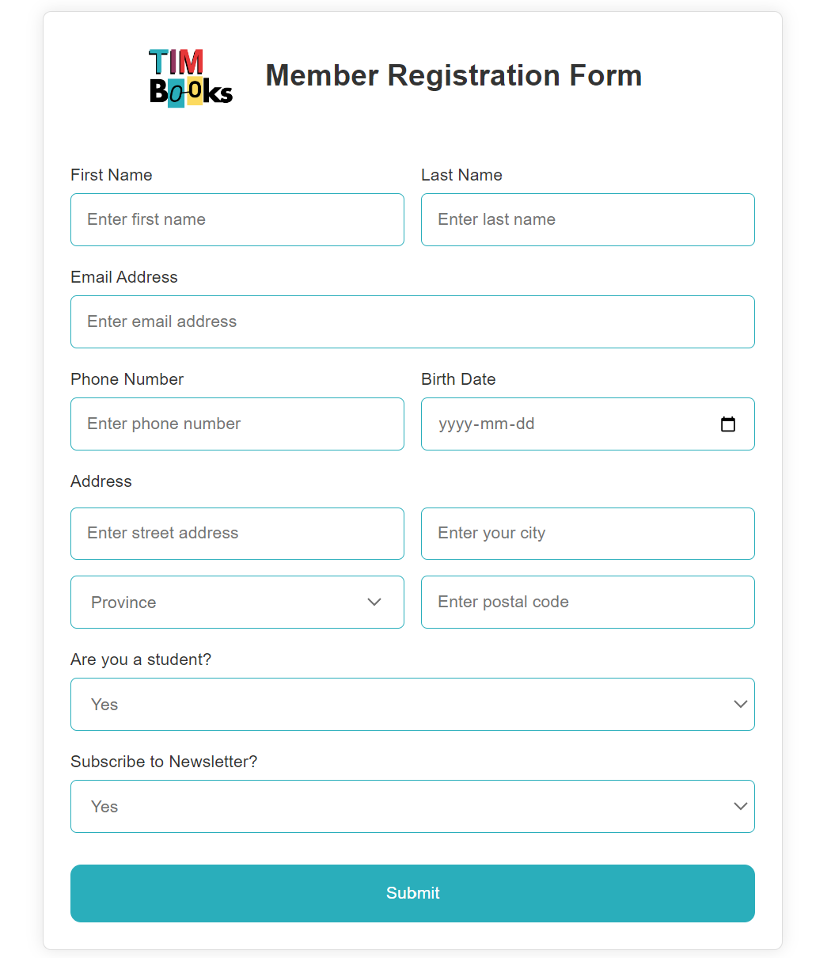

## Book Entry

Stores information about each book for the catalogue management functionality.

# Reports

## Inspiration

This report served as the primary inspiration for the structure of the book catalogue in the database. The book data schema includes essential details such as ISBN, category (referred to as “Subject” in the image below), summary, publisher information, the book location, and if the eBook is available. To simplify the database, we opted not to include certain codes like LCCN, barcodes and book code numbers.

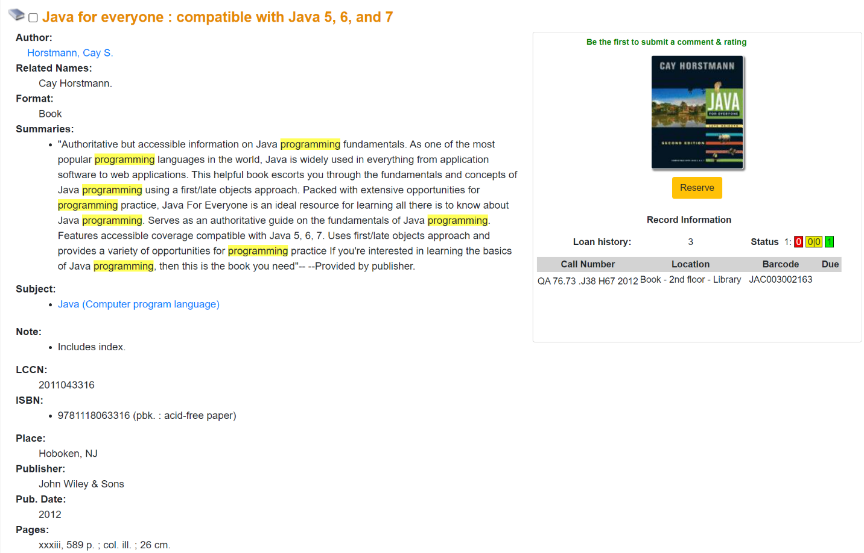

## Top 10 Borrowed Books

This report presents the top 10 most borrowed books from our library over the past year, showcasing the popular titles, their authors, categories, and brief descriptions.

|  |  |  |  |  |
| --- | --- | --- | --- | --- |
| Rank | Title | Author(s) | Category | Description |
| 1 | To Kill a Mockingbird | Harper Lee | Classic Fiction | A timeless novel set in the American South, addressing racial injustice through the eyes of young Scout Finch. |
| 2 | The Great Gatsby | F. Scott Fitzgerald | Classic Fiction | A novel capturing the decadence and disillusionment of the Jazz Age, centered around the enigmatic Jay Gatsby. |
| 3 | Pride and Prejudice | Jane Austen | Classic Romance | A beloved romance novel featuring the headstrong Elizabeth Bennet and the aloof Mr. Darcy in Regency-era England. |
| 4 | The Catcher in the Rye | J.D. Salinger | Coming-of-Age | A coming-of-age novel narrated by the rebellious teenager Holden Caulfield, navigating adolescence and societal expectations. |
| 5 | Harry Potter and the Sorcerer's Stone | J.K. Rowling | Fantasy | The first book in the acclaimed Harry Potter series, introducing readers to the magical world of Hogwarts School of Witchcraft and Wizardry. |
| 6 | The Hobbit | J.R.R. Tolkien | Fantasy | An adventurous tale of Bilbo Baggins, a hobbit who embarks on a quest with dwarves to reclaim their homeland from a dragon. |
| 7 | The Hunger Games | Suzanne Collins | Young Adult | The first book in the dystopian trilogy, following Katniss Everdeen's journey in a post-apocalyptic society governed by a brutal annual event. |
| 8 | The Da Vinci Code | Dan Brown | Mystery | A gripping mystery thriller involving symbology, secret societies, and the quest for the Holy Grail. |
| 9 | The Alchemist | Paulo Coelho | Inspirational | A philosophical novel about a shepherd named Santiago on a quest for treasure, exploring themes of destiny and personal legend. |
| 10 | The Girl with the Dragon Tattoo | Stieg Larsson | Mystery | A compelling crime thriller featuring investigative journalist Mikael Blomkvist and hacker Lisbeth Salander. |

## Borrowing Statistics

This report presents borrowing statistics from our library system over the past year, providing insights into the borrowing trends and preferences of our members. A substantial number of members are currently students (43%), and they represent 59% of all book loans.

##### Borrowing

* Total Borrowed Items: 1,500
* Printed Books: 975 items (65%)
* eBooks: 525 items (35%)
* Items Borrowed by Students: 896 (59%)

##### Student Statistics

* All Members: 938
* Students: 406 (43%)
* Non-Students: 532 (57%)

