Dividing New York into Economic Zones

Daniel Ahern

July 7, 2019

Introduction
When establishing a location for a restaurant or any other type of business, one important consideration is co-tenancy of complementary establishments. Traffic generators, such as a movie theatre, complement nearby restaurants, as in "dinner and a movie".
In an economically viable area, there is sure to be some ratio of industries that complement each other. By analyzing those ratio's, we can find opportunities for unserved markets.
There is something called the Starbucks principle: a Starbucks in the neighborhood is just one indication that the property is a good buy. Backed up by a study from real estate website Zillow, homes located within a quarter-mile of a Starbucks increased in value by 96% between 1997 and 2014.
Franchises like Starbucks' primary R&D expense is dedicated to gathering information and making predictions on the long-term value and appreciation of a property. We don't have the real estate research capabilities of Starbucks, we'll use a Starbucks locations as a proxy in order to find the most economically viable areas.
We'll group areas of high density of starbucks locations, and then analyze each of those locations for types of establishment in the surrounding areas to confirm that the location is indeed a dynamic (and presumably economically successful) neighborhood.
Anyone opening a brick-and-mortor business would be interested in using this kind of tool as one indication of competition in the market.

Data
We're grabbing data from the foursquare API.
We start with a map of all Starbucks locations in NY. We get this data by looping through through the five boroughs of NY and using the /v2/venues/explore endpoint to search by 'near'.
After we have all relevant Starbucks locations, we'll work to group them by distance into clusters.
We'll further use the /v2/venues/explore endpoint to check all significant locations around each Starbucks in a cluster, group them together, and confirm that each cluster represents a dynamic economic zone with appropriate amenities by finding the surrounding venues and their categories.

First, we create a map of all Starbucks returned by searching specifically for Starbucks in NY. There are 363 stores returned by Foursquare, although, if you check google maps, you'll see that there may be more than that.

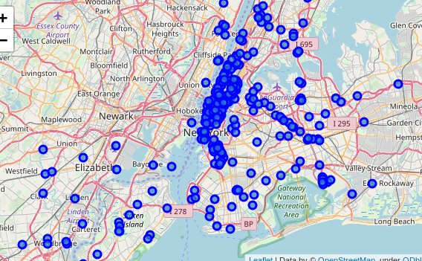

I go through 3 iterations of density-based clustering in order to narrow in on our economic zones:

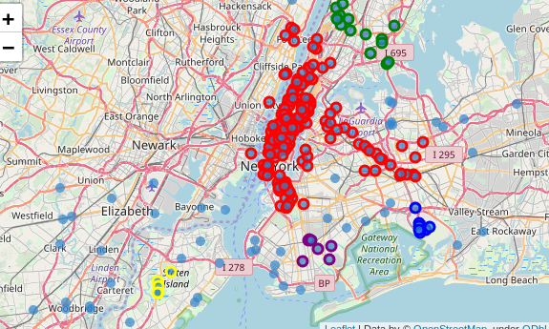

We get 4 useful clusters out of this first iteration. Manhattan is far too dense for the cluster parameters we used on this first iteration to be useful, so we iterate with new parameters:

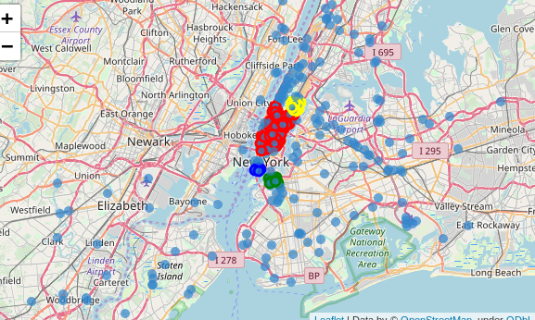

Great! Manhattan gets divided up into 4 distinct clusters, but we're missing what appears to be a corridor to the east:

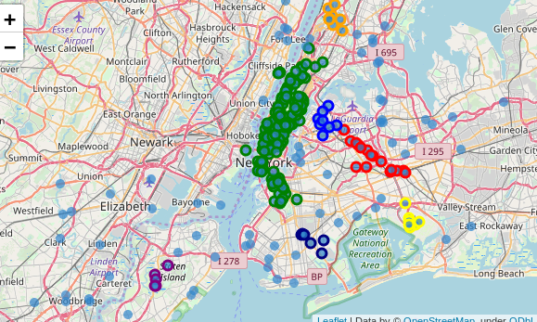

A third iteration with different parameters divides the corridor into two zones, so we'll use those in our final analysis:
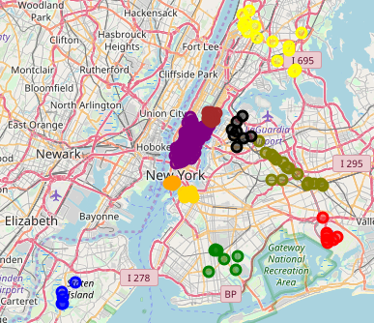
Here are all our economic zones. For now, we're assuming that any one of these regions is an are in a high foot traffic zone with consumers with disposable income.

To further analyze each economic zone, we've searched on Foursquare for surrounding venues

Results
We've identified the following zones with the traffic and economy able to support a retail business and the number of venues in its immediate vicinity:

 | name | # venues
zone
0 | JFK airport | 28
1 | Staten Island | 1
2 | the Bronx | 84
3 | East Brooklyn | 65
4 | Lower Manhattan | 260
5 | Wall St | 31
6 | Mid Manhattan | 43
7 | Brooklyn near Wall St | 23
8 | Queens Blvd | 59
9 | Broadway and Queens | 129

Discussion

Limitations OR Advantages of Foursquare Data?
Foursquare uses an algorithm to return results based on feedback from Foursquare users. This limitation may be expressed as an advantage: there may be more establishments in an area, but, if Foursquare does not return those establishments in the results of a query, it may be that this establishment is under-performing and may be taken out by competition.

The outlyer, Staten Island
Staten Island is an outlier with only a single venue in the area of type "Park". If you look closely on the map, you'll also see a mall. Further investigation should be done to determine if this is a promising place to open a business.

Queens Blvd
Examining this 'by hand', by looking at the map, we can see that Queens Blvd is a bit of an outlier. All other zones are grouped together closely in a circle, while the Queens Blvd zone is grouped together in a linear fashion. A quick wikipedia search confirms the obvious hypothesis that this zone is clustered around a major thoroughfare. Traffic in this area is probably dominated by cars and should be further investigated if the prospective business needs more foot traffic.

JFK airport
One of the economic zones turns out to be an airport. A prospective location buyer would need to take that into consideration if considering a venue in an airport.

Wall St and Brooklyn near Wall St
These are probably a single economic zone divided by a easily passable geographic obstacle.

Recommendations
Any business that relies on a dynamic and economically viable neighborhood to return value to shareholders should consider any of these 9 groups after a more thorough analysis, and perhaps can consider the 'Staten Island' zone after careful consideration of their niche.
There are, of course, other types of business - there is a business that is intended to serve a community need while providing the sole proprietor with employment; this type of business may consider cheapest options and ability to bootstrap rather than volume of customers; manufacturing plants and distribution points could find better opportunities on more cost-effective grounds. These zones do not apply to those businesses.
In addition, a prospective business owner may wish to take in account:
- demographics
- psychographics
- site quality
  - visibility
  - access
- traffic generators

Conclusion
In this study, we found dynamic economic zones with enough traffic to support a retail business by clustering Starbucks locations and then checking surrounding venues.
Placing a business is more of an art than a science and a single study like this cannot be the sole facet of such a decision. However, we have identified several regions of heavy foot traffic and provided some insight in the surrounding businesses that could be useful in making a decision.

