Git

1. Clone Selenium Webdriver project

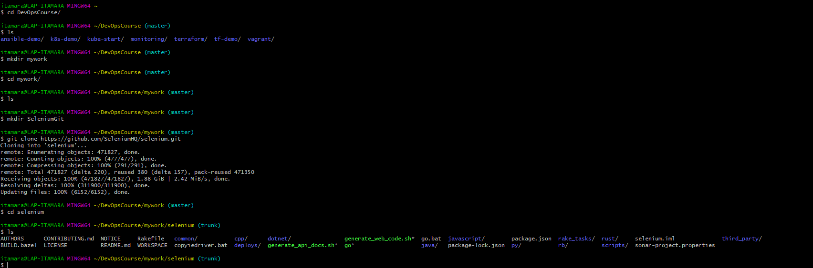

1. Clone Appium

1. Text

   Description automatically generated

<https://github.com/iatid23/PyExampleGit>

1. Text

   Description automatically generated Graphical user interface, application

   Description automatically generated

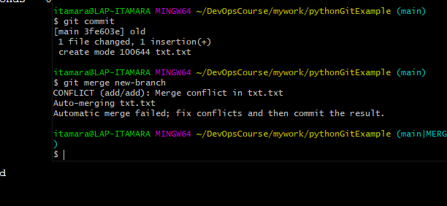

1. Text

   Description automatically generated