1. Create a new Repository called “MySoftware”

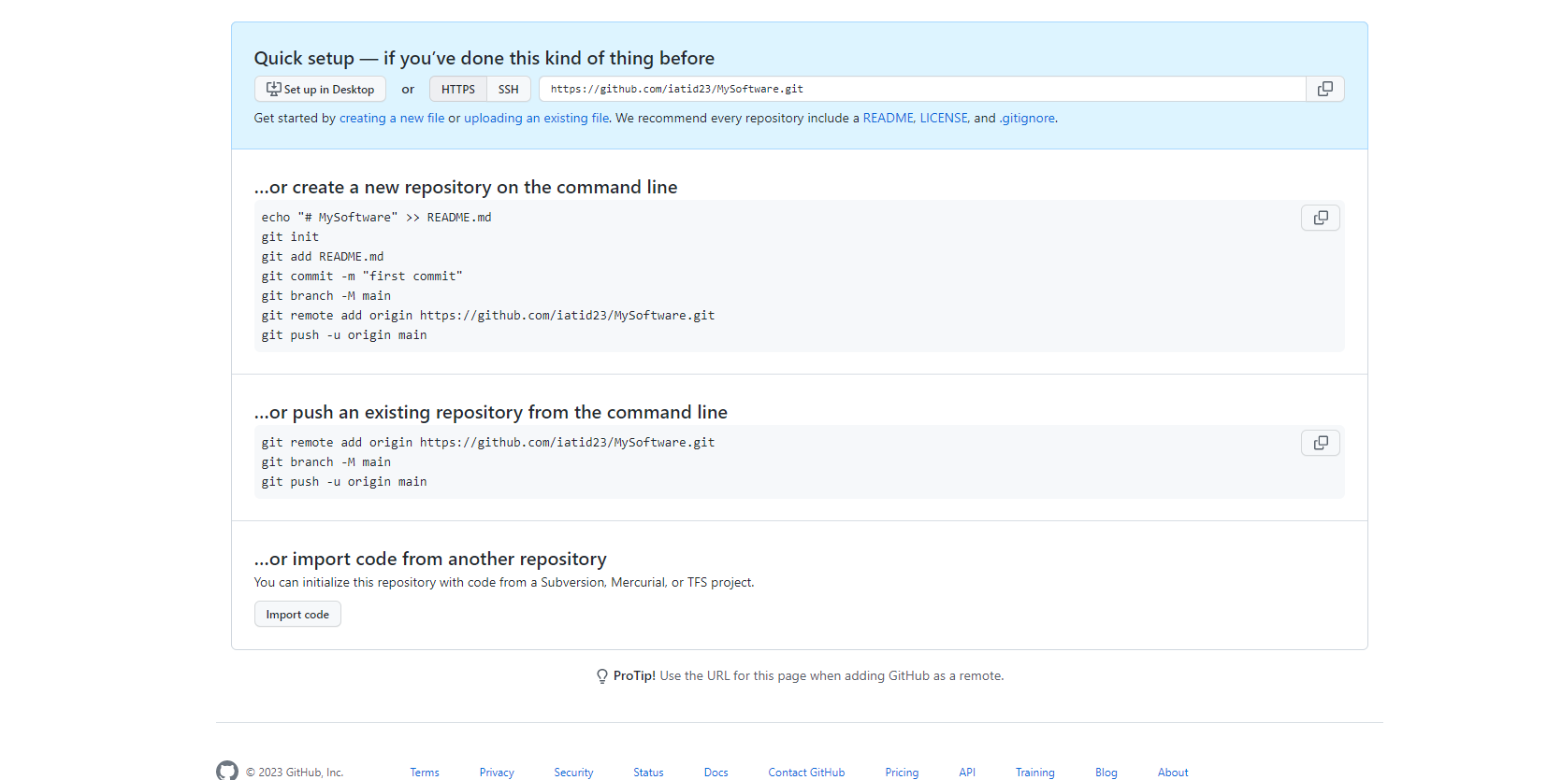

2. Have 3 branches in your repository:

a. Master (already exist- no reason to create)

b. NewButton

c. NewScreen

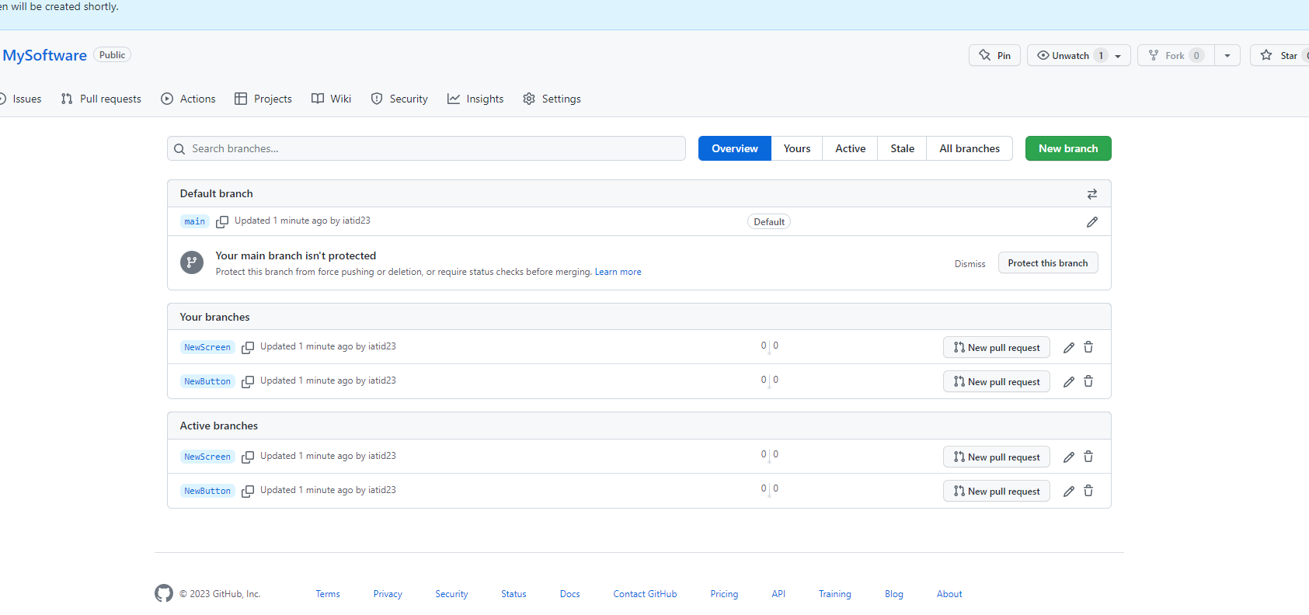

3. In your NewButton branch add a method called click() which prints the word “Click”

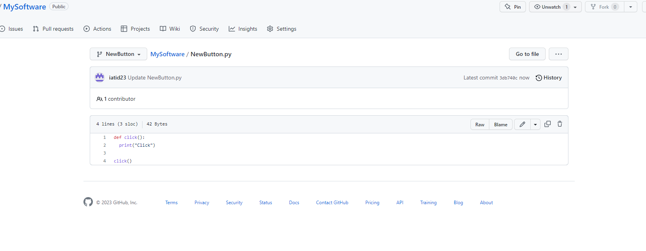

4. In your NewScreen branch create a method called welcome() which prints “New

Screen”

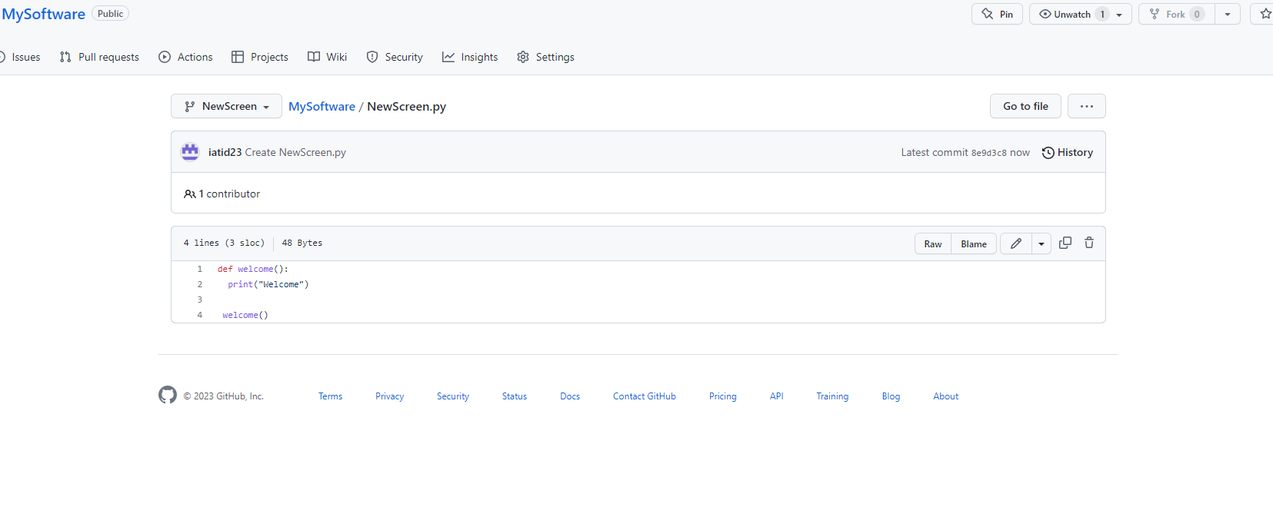

5. Commit and push your changes into your branches.

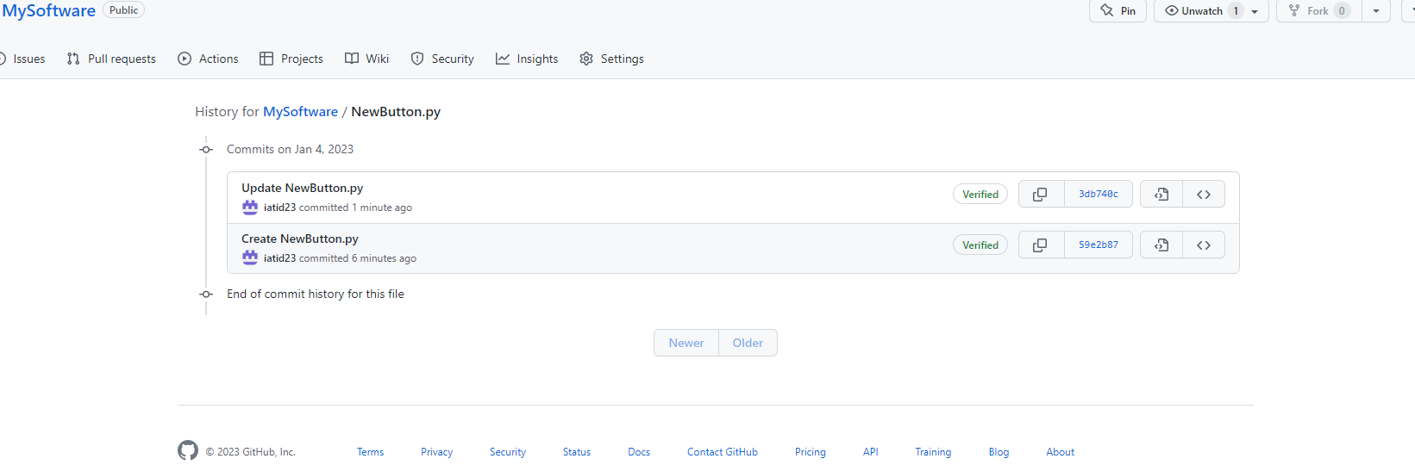

6. Create a pull request from both branches into your Master

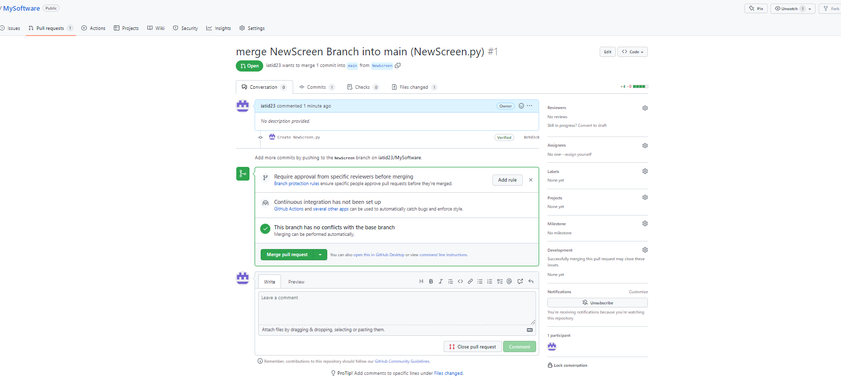

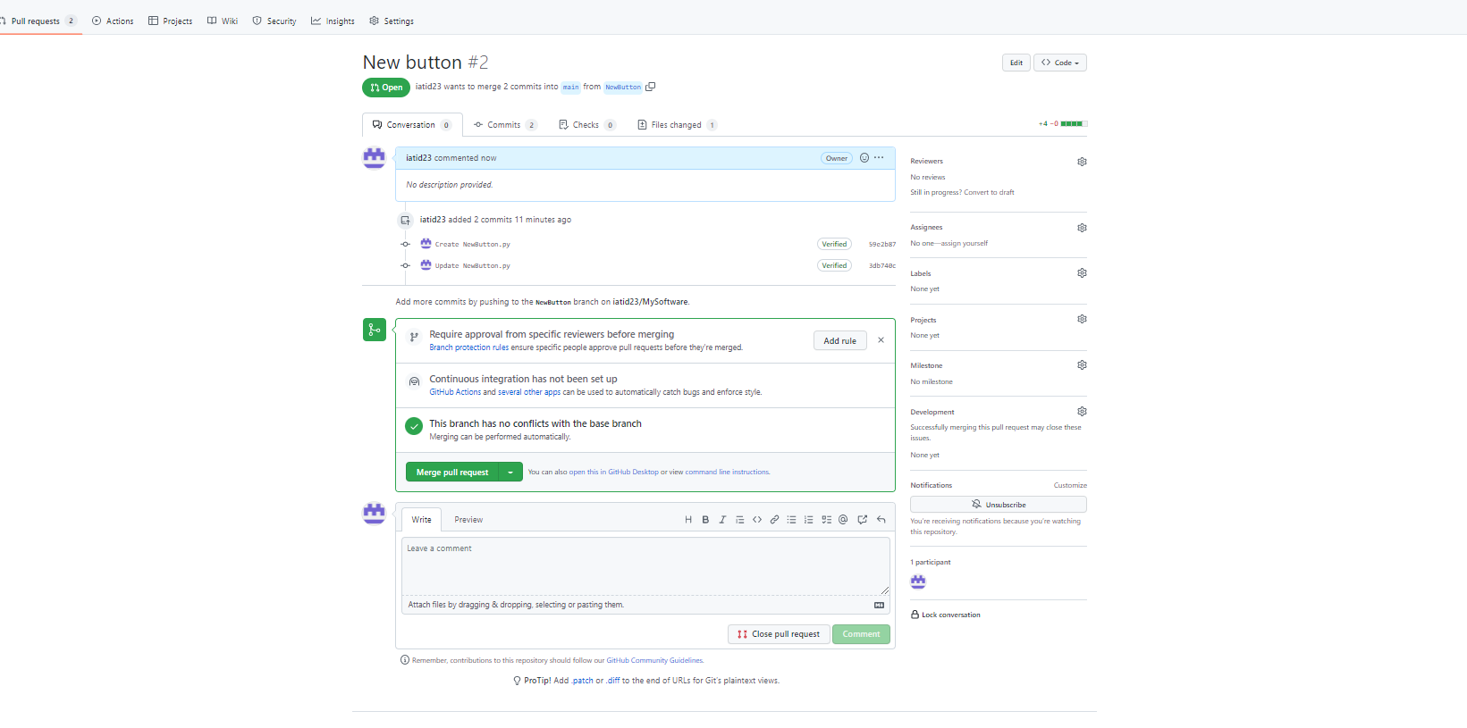

7. Merge your code

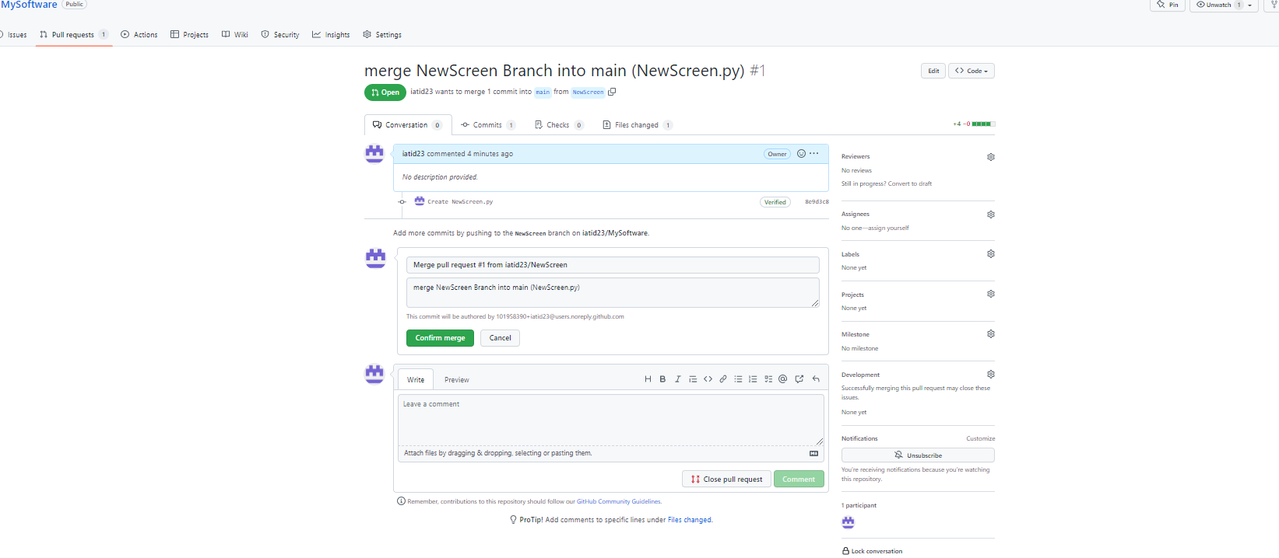

8. Go back to one of your Jenkins build jobs, and add this git repository commits as a

trigger (Poll SCM should be every 30 minutes).

