Does Quantum Really Help? A Systematic Re-Evaluation of Reported Quantum Kernel Advantages in Quantum Support Vector Machine Literature
Atul Tripathi^{1,*}, Akhtar Rasool¹, Nilay Khare¹
1 Maulana Azad National Institute of Technology, Bhopal, India
* Corresponding author: atul.tripathi1215@gmail.com
Co-author emails: Akhtar Rasool (akki262@gmail.com), Nilay Khare (Nilay.khare@rediffmail.com)
Abstract
Quantum support vector machines (QSVM) are frequently reported to match or exceed classical support vector machine (SVM) performance across biomedical, physical-science, financial, and general benchmark classification tasks. However, published comparisons rarely apply corrected statistical significance testing, rarely give the quantum model the same hyperparameter search afforded to the classical baseline — and when they do, rarely nest that search inside each cross-validation fold, risking information leakage between architecture selection and significance testing — and are almost never checked against multiple random seeds. This paper re-evaluates reported QSVM-versus-classical-SVM advantages under a rigorous protocol: a fair architecture search over quantum circuit depth and entanglement structure, nested inside every outer cross-validation fold so the search never sees held-out test data, five-seed repeated cross-validation, a Nadeau–Bengio corrected paired t-test and a Wilcoxon signed-rank test with Holm–Bonferroni correction across all comparisons, and reported effect sizes and confidence intervals. Applied to four public benchmark datasets (Breast Cancer Wisconsin, Wine, a binarized hard-pair Iris task, and a Digits 4-versus-9 task) across three quantum encoding families (single-qubit Z rotations, linearly-entangled ZZ, and heavily-entangled Pauli), the results show a stable, encoding-dependent pattern rather than a uniform advantage or disadvantage: the simple Z encoding is statistically indistinguishable from classical SVM in all four datasets across all five seeds, the heavily-entangled Pauli encoding is significantly and substantially worse in three of four datasets, and the intermediate ZZ encoding produces a stable significant disadvantage in two datasets and a seed-sensitive, inconclusive result in the other two. Cross-referencing these results against four previously published QSVM studies shows that reported ties and modest quantum advantages do not consistently survive this more rigorous protocol. A supplementary audit of twenty QSVM papers from the broader literature found that only four (20%) could be numerically cross-referenced here, but this coverage gap is not a uniform barrier: just four papers (20%) involve genuinely restricted or proprietary data, while six more (30%) use data that is public but simply was not fetched in this sandboxed environment's absence of internet access — a distinction we report as a finding in its own right, since only the former is a field-level reproducibility barrier.
Keywords: quantum support vector machine, quantum kernel methods, reproducibility, statistical significance testing, quantum machine learning, barren plateaus

1. Introduction
Quantum machine learning (QML) has been proposed as a computational paradigm capable of matching or exceeding classical machine learning performance on a range of classification tasks, with the quantum support vector machine (QSVM) among its most widely studied instantiations (Rebentrost, Mohseni, & Lloyd, 2014; Havlíček et al., 2019). A substantial and growing body of applied work reports QSVM achieving accuracy comparable to, or modestly better than, classical SVM across domains including biomedical diagnostics, physics, finance, software engineering, and general-purpose benchmark classification (see Section 2). These reports collectively motivate continued investment in QML research and inform expectations about near-term quantum advantage in supervised learning.
However, a close reading of this literature reveals a persistent methodological gap: the overwhelming majority of published QSVM-versus-classical-SVM comparisons report a single train/test accuracy figure, or an unrepeated k-fold cross-validation average, without correcting for the statistical non-independence of cross-validation folds — a well-documented source of overstated significance in machine learning evaluation more broadly (Dietterich, 1998; Nadeau & Bengio, 2003). Fewer still give the quantum model the same hyperparameter search afforded to its classical counterpart, typically fixing circuit depth and entanglement structure a priori rather than tuning them. And essentially none repeat the comparison across multiple random seeds to establish whether a reported result is stable or an artifact of a particular data split.
This paper addresses that gap directly. We re-evaluate the QSVM-versus-classical-SVM comparison under a protocol designed to close each of these three gaps simultaneously: (1) a fair, symmetric hyperparameter search that tunes quantum circuit depth and entanglement structure with the same rigor applied to the classical regularization parameter; (2) five-seed repeated stratified cross-validation to assess result stability; and (3) corrected paired significance testing — a Nadeau–Bengio corrected resampled t-test and a Wilcoxon signed-rank test, both subject to Holm–Bonferroni correction across the full family of comparisons — alongside effect sizes and confidence intervals rather than significance flags alone. We further cross-reference our results against the specific numbers reported in four previously published QSVM studies, and separately audit the broader twenty-paper literature set this study draws its motivation from to determine how many of those studies could, in principle, be independently re-tested given publicly accessible data.

2. Related Work
QSVM formulations broadly divide into three algorithmic families: HHL-algorithm-based solvers offering theoretical exponential speedup but requiring quantum linear-algebra primitives not executable at scale on current hardware; Hadamard-test or variational hybrid approaches suited to the noisy intermediate-scale quantum (NISQ) era; and fidelity-quantum-kernel approaches, in which a classical support vector machine is trained on a kernel matrix computed from the overlap of quantum-encoded feature states (Havlíček et al., 2019; Schuld & Killoran, 2019). This study adopts the fidelity-kernel formulation, the most commonly used variant across the applied literature surveyed here.
Reported applications of QSVM span a wide range of domains. In biomedical classification, QSVM has been applied to COVID-19 multi-omics biomarker analysis, breast cancer diagnosis, Parkinson's disease gait classification, and EEG-based brain-computer interface decoding, typically reporting accuracy comparable to or modestly exceeding classical SVM baselines. In physical sciences, QSVM and related quantum kernel methods have been used for quantum phase classification and entanglement detection. Applied studies also extend to finance, chemistry (blood–brain-barrier permeability prediction), software defect prediction, recommendation systems, and general benchmark comparisons on standard datasets such as Iris, Wine, and Breast Cancer Wisconsin.
Four studies from this broader literature are used directly as comparison points in the present audit, because each reports precise, citable accuracy figures on a dataset this study can also independently load and test. Naresh and Reddi (2025) compared classical SVM and a ZZ-feature-map QSVM across five benchmark datasets, reporting a QSVM loss on Iris (100% classical versus 85% quantum), a tie on Wine (97% versus 97%), and a modest classical advantage on Breast Cancer Wisconsin (94% versus 92%). Yadav, Sheoran, and Sheoran (2026) reported a Z-feature-map QSVM achieving 94.7% accuracy against a classical baseline of 97.37% on Breast Cancer Wisconsin using mutual-information-selected features. Ranga, Prajapat, Kumar, Akhtar, and Al-Khalidi (2025) reported a tie between classical SVM and a ZZ-feature-map QSVM on four-feature Iris (99% versus 99%). Date, Woun, Hamilton, and colleagues (2025) evaluated an adiabatic, D-Wave-based QSVM — algorithmically distinct from the gate-based fidelity-kernel approach used in this study and in the other three comparison papers — and reported a substantial classical advantage on the versicolor-versus-virginica Iris pair specifically (85.6% classical versus 67.9% quantum), a task definition that matches this study's binarized “hard-pair” Iris task exactly.
Across this literature, formal statistical significance testing beyond a single reported accuracy figure is rare, and hyperparameter search is applied asymmetrically — typically to the classical baseline only. This study's contribution is to test whether the specific, quantitative claims made in this literature, and the broader pattern of reported quantum competitiveness, survive when both of these gaps are closed.
This study's empirical conclusion — that quantum kernels do not reliably outperform a well-tuned classical baseline — is not itself new; it is independently and more broadly established by three recent large-scale benchmarking efforts. Bowles, Ahmed, and Schuld (2024) systematically tested twelve quantum machine learning models across 160 datasets and found that out-of-the-box classical models generally outperform quantum classifiers, and that removing entanglement from a quantum model often matches or improves its performance — a finding directly consistent with this study's own observation that the unentangled Z encoding tracks the classical baseline while the heavily-entangled Pauli encoding underperforms it. Schnabel and Roth (2025), published in Quantum Machine Intelligence, benchmarked fidelity and projected quantum kernels across 64 datasets and over 20,000 trained models and likewise found no clear quantum advantage as task complexity increases. Kakavand, Strohmeyer, and Schlotter (2026) ran 970 experiments with strict nested cross-validation across nine datasets, four quantum feature maps, and hardware validation, finding that none of 29 pairwise quantum–classical comparisons reached statistical significance. All three studies are larger in scale than the present one and should be read as the primary empirical evidence that reported QSVM advantages are not robust in general. This study's contribution is narrower and complementary rather than duplicative: rather than asking whether quantum kernels help in general, it asks whether the specific, named numeric claims made in four previously published QSVM papers survive a corrected re-test (Section 4.3), and separately documents how much of the broader QSVM literature's data-access landscape permits this kind of claim-level audit at all (Section 4.4) — a reproducibility-infrastructure question none of the three benchmarking studies above addresses, since they benchmark datasets rather than auditing prior papers' specific reported results.
A separate strand of theoretical work offers a competing explanation for modest or absent quantum kernel advantage that this study's barren-plateau-consistent framing (Section 5) does not directly engage: dequantization results showing that for a range of quantum-inspired kernel and linear-algebra problems, classical algorithms with sample-and-query access to the data can match quantum runtime up to polynomial factors (Tang, 2019, 2021). Where barren-plateau explanations attribute weak quantum performance to trainability failures specific to deep, expressive circuits, dequantization results instead suggest that some tasks for which QSVM is applied may simply admit efficient classical solutions regardless of circuit design. The present study's empirical protocol cannot distinguish between these two explanations — both predict quantum kernels underperforming or matching classical baselines, for different underlying reasons — and adjudicating between them is left to future theoretical work; the encoding-dependent pattern observed here (Section 4.2) is at minimum consistent with, though not uniquely explained by, either account.

3. Methodology
Figure 2 summarizes the full pipeline described in this section: each dataset is reduced to four dimensions and scaled, then split into a classical branch (RBF kernel with a regularization search) and a quantum branch (one of three feature-map families, converted to a fidelity kernel); the quantum branch's circuit architecture is chosen by a nested search (Section 3.3, Figure 3) before the two branches are compared under repeated cross-validation, repeated again across five seeds, and finally tested with corrected significance testing.
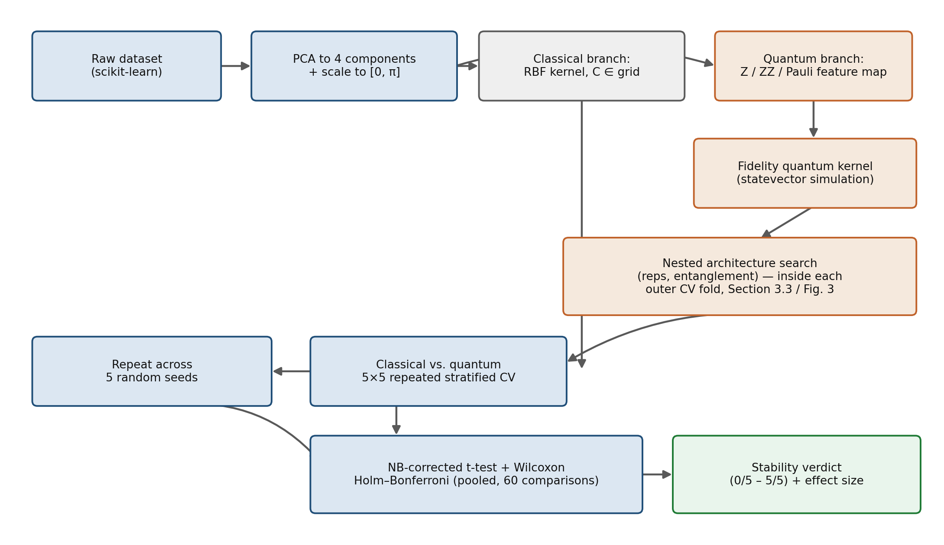
Figure 2. Overview of the full methodology pipeline, from raw dataset to stability verdict.

3.1 Datasets
Four public benchmark datasets were used, each loaded directly from scikit-learn to ensure exact reproducibility without external downloads: Breast Cancer Wisconsin (569 samples, binary), Wine (binarized to its first two classes, 130 samples), Iris (restricted to its two hardest-to-separate classes, versicolor and virginica, 100 samples, chosen to match the task definition used by Date et al., 2025), and a Digits 4-versus-9 subset (150 samples, a small-scale stand-in for the image-classification tasks common in this literature). Each dataset was capped at 150 samples, reduced to four dimensions via principal component analysis, and scaled to the [0, π] interval required by angle-style quantum feature encodings.

3.2 Quantum Encodings
Three quantum feature map families were evaluated, spanning the entanglement range used across the reviewed literature: a single-qubit Z rotation encoding with no entangling gates; a ZZ feature map using linear or full entanglement; and a heavily-entangled Pauli feature map incorporating Z, ZZ, and ZZZ terms under full entanglement. Quantum kernels were computed as state-fidelity overlaps using Qiskit's statevector-based fidelity kernel (noiseless simulation).

3.3 Architecture Search
To ensure the quantum model was not disadvantaged by an arbitrary choice of circuit depth or entanglement structure, each encoding family was searched over circuit repetitions (1–3) and entanglement structure (linear, full, where applicable). An initial version of this search selected one architecture per dataset and encoding family using a single cross-validation pass on the full dataset, before the main significance test — a design that risks information leakage, since the same data would then inform both architecture selection and the paired significance test. This was corrected by nesting the architecture search inside every outer cross-validation fold of the main audit: for each outer fold, every candidate architecture is scored via three-fold cross-validation restricted to that fold's training data only, using a fixed C = 1.0 for computational tractability, and the architecture with the highest inner-fold accuracy is selected and then evaluated once, out-of-sample, on that fold's held-out test data. This mirrors the nesting already required of the classical baseline's regularization search and ensures the architecture choice can never see the data used to test it. Because different outer folds can select different architectures, we report the modal (most frequently selected) architecture per dataset and encoding family alongside an agreement rate — the fraction of folds selecting that modal architecture — as a stability diagnostic for the search itself. Figure 3 illustrates this nesting for a single outer fold: the inner three-fold loop selects an architecture using only the outer training set, and the outer test set (top right, in red) is touched exactly once, after that selection is final.
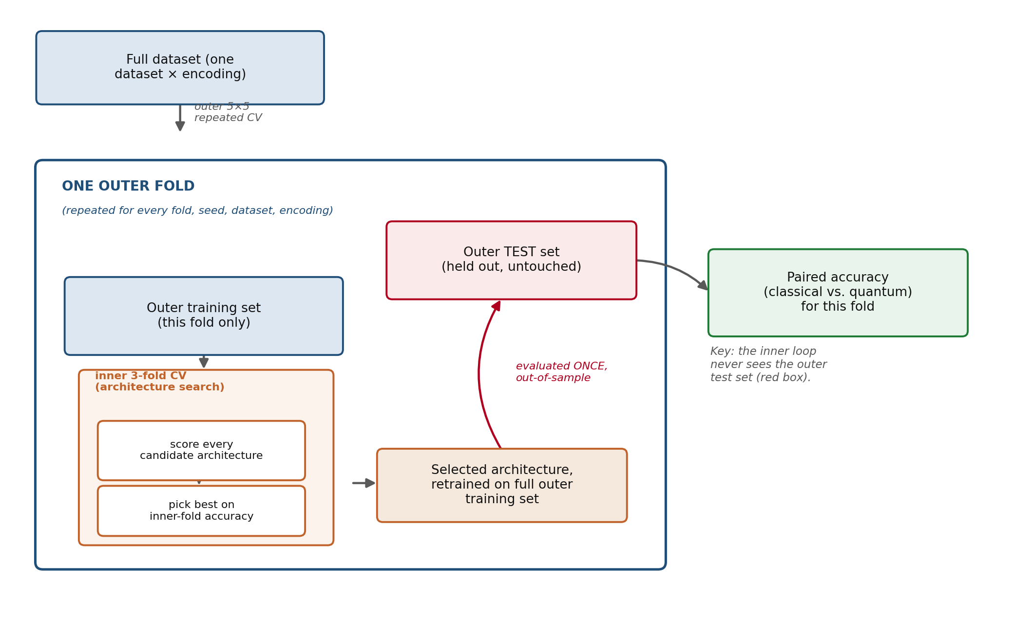
Figure 3. Nested cross-validation schematic for one outer fold. The inner loop (orange) selects an architecture using only the outer training set; the outer test set (red) is evaluated once, after architecture selection, and never influences the search.

3.4 Statistical Testing Protocol
The classical baseline uses a radial basis function (RBF) kernel throughout, rather than testing multiple classical kernels (e.g., polynomial, linear), because RBF is the most consistently used classical baseline across the reviewed literature (Section 2) and is the direct classical analogue most comparisons in this literature draw against; using a single, consistently-applied classical baseline also keeps the total number of statistical comparisons — and therefore the severity of the multiple-comparison correction below — from growing further. A secondary comparison against polynomial and linear classical kernels would be a reasonable extension but was judged out of scope for a study whose primary contribution is methodological rigor in the QSVM-versus-best-standard-classical-baseline comparison, not a full classical-kernel sweep.
For each dataset and encoding family, classical SVM (radial basis function kernel) and QSVM (selected architecture) were compared using repeated stratified five-fold cross-validation (five repeats, twenty-five paired accuracy observations per comparison), with the regularization parameter re-tuned via inner three-fold grid search independently for each outer fold and each model. The resulting paired accuracy differences were tested using a Nadeau–Bengio corrected resampled t-test, which adjusts the variance estimate for the non-independence of cross-validation folds (Nadeau & Bengio, 2003), and cross-checked with a Wilcoxon signed-rank test. Cohen's d for paired samples and a 95% confidence interval (derived from the Nadeau–Bengio corrected variance) were computed for every comparison; the raw mean accuracy difference and its confidence interval (Table 2) are reported alongside d and should be treated as the primary, directly-interpretable effect size, since Cohen's conventional small/medium/large thresholds (0.2/0.5/0.8) were calibrated for roughly-normal, unbounded measures and several of this study's d values (|d| > 3) fall well outside that calibration range for the bounded, low-variance accuracy differences examined here — d is reported for comparability with prior work, not as the primary basis for interpreting practical significance. Holm–Bonferroni correction was applied to the Nadeau–Bengio p-values pooled across all 60 comparisons in a run (5 seeds × 4 datasets × 3 encodings), not separately within each seed, to control the family-wise error rate at the level of the full audit rather than per-seed. For the two mildly class-imbalanced datasets (Breast Cancer Wisconsin, Wine), balanced accuracy (the mean of per-class recall) was additionally computed for every fold as a descriptive robustness check (Section 4.2b); this was not independently subjected to Nadeau–Bengio significance testing, and should be read as a check on whether the accuracy-based verdicts are an artifact of class imbalance, not as a separately significance-tested comparison.

3.5 Multi-Seed Robustness Protocol
The full comparison (architecture search held fixed; cross-validation splits varied) was repeated across five random seeds (42, 7, 123, 2024, 99). A finding was classified as stable-significant if all five seeds independently produced a corrected-significant result, stable-null if none did, and seed-sensitive/inconclusive otherwise. This protocol directly tests whether a result depends on an arbitrarily favorable train/test split, a possibility left unaddressed in single-run comparisons throughout the reviewed literature.

3.6 Literature Comparison and Coverage Protocol
Reported figures from four previously published QSVM studies (Section 2) were compared directly against this study's corrected, seed-stable results on the matching dataset and encoding. Where a published study's exact task definition (class selection, feature count, preprocessing) differed from this study's, the discrepancy is noted explicitly rather than treated as an exact replication. Separately, all twenty papers from the broader literature set motivating this study were classified into one of six categories: Included (a precise, citable figure on data this study can also load) and Partial (accessible data, but no precise citable figure), for which numeric comparison was possible; and, for papers where it was not, four exclusion categories — Restricted (genuinely proprietary, access-gated, or unpublished data), Public, not fetched (data that is freely available but was not retrieved here due to this sandboxed environment lacking internet access), Requires simulation (the underlying "data" is a physical system requiring re-simulation rather than download), and Public, task mismatch (public data excluded for a task-design reason unrelated to access, such as sample size or a regression-versus-classification mismatch). This four-way split is deliberate: only the Restricted category represents a genuine, field-level reproducibility barrier, whereas Public, not fetched reflects a limitation of this specific run's environment rather than of the underlying literature (Section 4.4).

3.7 Reproducibility
All experiments were run in Qiskit 2.5.0, Qiskit Aer 0.17.2, Qiskit Machine Learning 0.9.0, scikit-learn 1.7.2, SciPy 1.15.3, and statsmodels 0.14.6, with exact versions captured programmatically at run time. All random seeds, dataset subsampling, and PCA fitting were fixed for exact reproducibility. Complete code is provided as a Jupyter notebook alongside this manuscript.

3.8 Computational Scale
The specific scale choices in this study — a 150-sample cap per dataset, four PCA components (matching four simulated qubits), five-fold repeated cross-validation with five repeats, and five random seeds — were set by the computational cost of exact state-fidelity quantum kernel simulation, which scales with both sample count (kernel matrix entries) and qubit count (statevector dimension, exponential in qubit number), rather than by a formal power analysis. These values were chosen to keep the full nested-search, multi-seed audit tractable on a classical simulator within a practical compute budget while still supporting twenty-five paired observations per comparison, sufficient for the Nadeau–Bengio corrected test to detect the effect sizes observed (Table 2). We do not claim these choices are the only reasonable ones: a larger sample count would tighten confidence intervals further, a higher qubit count would change the feature space and kernel expressivity in ways not tested here, and more than five seeds would give a finer-grained stability estimate than the current 0/5–5/5 scale allows. We report this as an explicit scope boundary rather than an oversight: the three-tier pattern in Section 4.2 should be read as established at this scale, with extension to larger sample sizes and qubit counts left as direct future work rather than assumed to hold unchanged.

4. Results

4.1 Architecture Search Outcomes
Across all four datasets and all outer cross-validation folds, the nested architecture search consistently selected the shallowest available circuit (one repetition, the modal choice in every one of the twelve dataset–encoding combinations) and favored linear over full entanglement in ten of twelve cases (Table 1). Agreement across folds — the fraction selecting the modal architecture — was high for the Z encoding (0.85–1.00, reflecting its small, single-parameter search space) and more variable for ZZ and Pauli (0.58–0.95), indicating that fold-to-fold architecture choice for the more expressive encodings is itself somewhat seed- and split-dependent. Despite this fold-level variability, no dataset or encoding ever favored the deepest available circuit, consistent with reports elsewhere in the literature attributing reduced performance in more heavily entangled circuits to barren-plateau-like trainability effects (McClean et al., 2018).
Table 1. Modal (most frequently selected) quantum circuit architecture per dataset and encoding family, nested search across outer folds.
Dataset | Encoding | Modal Reps. | Modal Entanglement | Fold Agreement Rate
Breast Cancer Wisconsin | Z | 1 | — | 0.85
Breast Cancer Wisconsin | ZZ | 1 | Linear | 0.58
Breast Cancer Wisconsin | Pauli | 1 | Linear | 0.71
Wine | Z | 1 | — | 1.00
Wine | ZZ | 1 | Full | 0.60
Wine | Pauli | 1 | Linear | 0.82
Iris (hard pair) | Z | 1 | — | 1.00
Iris (hard pair) | ZZ | 1 | Full | 0.79
Iris (hard pair) | Pauli | 1 | Linear | 0.94
Digits (4 vs. 9) | Z | 1 | — | 0.99
Digits (4 vs. 9) | ZZ | 1 | Linear | 0.66
Digits (4 vs. 9) | Pauli | 1 | Linear | 0.95

4.2 Classical versus Quantum Performance
Table 2 reports the seed-averaged classical and quantum mean accuracy, mean accuracy difference, Cohen's d, and seed-stability verdict for each of the twelve dataset–encoding combinations, under the nested architecture-search protocol. A clear, encoding-dependent three-tier pattern emerges, materially unchanged from the single-pass design but with several verdicts shifting to reflect the more conservative, leakage-free estimate. The Z encoding produced a stable null result (0 of 5 seeds significant) on all four datasets, with small-to-moderate effect sizes throughout (|d| ≤ 1.00). The Pauli encoding produced a stable, large, significant disadvantage on three of four datasets (5 of 5 seeds significant on Breast Cancer Wisconsin, Wine, and Digits) and a seed-sensitive, inconclusive result on Iris (3/5), with large effect sizes throughout (|d| ≥ 2.01). The ZZ encoding produced a mixed picture: a stable significant disadvantage on Wine and Digits (5/5 each — Digits strengthened from an inconclusive 4/5 under the single-pass design), and seed-sensitive, inconclusive results on Breast Cancer Wisconsin (3/5 — weakened from a stable null 0/5 under the single-pass design) and Iris (1/5). The Breast Cancer Wisconsin/ZZ shift is the most consequential change from the earlier, non-nested version of this analysis: closing the leakage risk did not just adjust point estimates, it changed a reported verdict, which is itself evidence that the nesting fix was a substantive, not cosmetic, correction.
Table 2. Seed-averaged classical versus quantum accuracy, effect size, and stability verdict, nested architecture search (5-seed audit).
Dataset | Encoding | Classical Mean | Quantum Mean | Mean Diff. | Cohen's d | Stability | Verdict
Breast Cancer | Z | 0.958 | 0.945 | −0.013 | −0.43 | 0/5 | Stable null
Breast Cancer | ZZ | 0.958 | 0.845 | −0.112 | −2.16 | 3/5 | Inconclusive
Breast Cancer | Pauli | 0.958 | 0.727 | −0.231 | −2.97 | 5/5 | Stable significant
Wine | Z | 0.969 | 0.951 | −0.018 | −0.55 | 0/5 | Stable null
Wine | ZZ | 0.969 | 0.744 | −0.225 | −2.93 | 5/5 | Stable significant
Wine | Pauli | 0.969 | 0.655 | −0.314 | −3.30 | 5/5 | Stable significant
Iris (hard) | Z | 0.968 | 0.920 | −0.047 | −0.90 | 0/5 | Stable null
Iris (hard) | ZZ | 0.968 | 0.824 | −0.144 | −1.68 | 1/5 | Inconclusive
Iris (hard) | Pauli | 0.968 | 0.740 | −0.227 | −2.01 | 3/5 | Inconclusive
Digits (4v9) | Z | 1.000 | 0.970 | −0.030 | −1.00 | 0/5 | Stable null
Digits (4v9) | ZZ | 1.000 | 0.888 | −0.112 | −2.24 | 5/5 | Stable significant
Digits (4v9) | Pauli | 1.000 | 0.786 | −0.214 | −3.22 | 5/5 | Stable significant
Figure 1 visualizes the same classical-versus-quantum comparison shown in Table 2 as paired bars for each of the twelve dataset–encoding combinations, grouped by dataset. The labels above each pair report the seed-stability verdict (seeds significant / seeds total, after Holm–Bonferroni correction), making the three-tier pattern directly visible: the Z encoding tracks the classical baseline closely across all four datasets (0/5 throughout), while ZZ and Pauli show a widening, dataset-dependent gap that is stably significant in most cases.
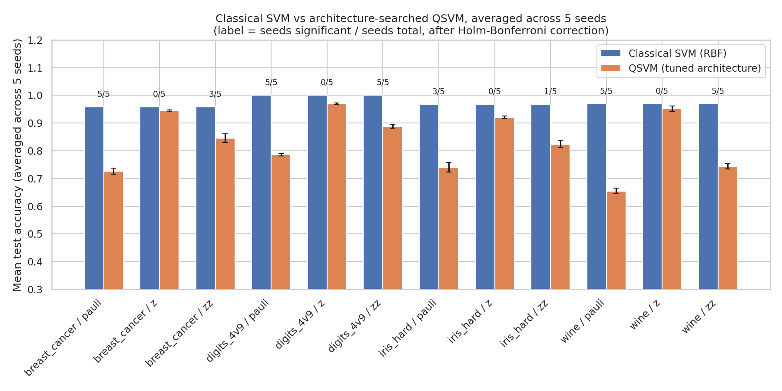
Figure 1. Classical SVM (RBF) versus architecture-searched QSVM mean accuracy, by dataset and encoding family, averaged across five random seeds under the nested architecture-search protocol. Error bars on the quantum bars show the standard deviation of the mean accuracy difference across seeds; labels above each pair report the seed-stability verdict.

4.2b Robustness Check: Balanced Accuracy
Breast Cancer Wisconsin (~63/37 class split) and Wine as used here (~45/55) are both mildly class-imbalanced, so plain accuracy alone could in principle overstate model quality if a model were biased toward the majority class. To check this, balanced accuracy (the mean of per-class recall) was computed for both models on every fold of these two datasets and compared against the plain-accuracy results in Table 2. Across the six dataset–encoding rows examined, the balanced-accuracy drop (classical minus quantum) tracked the plain-accuracy drop closely for five of six rows (difference under 0.02), and diverged more noticeably for Breast Cancer Wisconsin/Pauli (accuracy drop 0.231 versus balanced-accuracy drop 0.272, a difference of 0.041). In that one case the divergence runs in the direction of understatement, not overstatement: balanced accuracy shows a slightly larger quantum disadvantage than plain accuracy does, meaning the Pauli encoding's minority-class predictions are disproportionately affected. No dataset–encoding pair showed balanced accuracy erasing or reversing a plain-accuracy verdict. This is a descriptive check, not an independently significance-tested comparison (Section 3.4); it indicates the three-tier pattern reported above is not an artifact of class imbalance on these two datasets, without claiming a fully independent statistical confirmation.

4.3 Comparison Against Published Claims
Table 3 compares this study's corrected, seed-stable results (nested architecture search) against the specific figures reported in four previously published QSVM studies. Of six literature comparisons, none reproduce the original study's precise numeric result exactly under this study's task definition and testing protocol — a finding consistent across both papers reporting a classical advantage and the two papers reporting a tie. The Naresh and Reddi (2025) Breast Cancer Wisconsin comparison, which used a near-identical task definition, is the closest match on task definition, though the corrected test's verdict here is itself now seed-sensitive: three of five seeds show a significant classical advantage and two do not, so this study's result should be read as directionally consistent with, but less clear-cut than, the original single-run report. The Date et al. (2025) comparison is the most directly comparable on task definition (an exact class-pair match) and shows the same directional finding — a classical advantage on the hard Iris pair — despite using an entirely different quantum algorithm family (adiabatic annealing versus gate-based fidelity kernel), lending some cross-method support to that specific result, though this study's own result on that task is seed-sensitive (1/5) rather than a stable classical win.
Table 3. Comparison of this study's results against four previously published QSVM studies.
Dataset / Encoding | Source | Reported (C / Q) | Reported Verdict | This Study (C / Q) | This Study Verdict
Iris (hard) / ZZ | Naresh & Reddi (2025)* | 1.00 / 0.85 | Classical win | 0.968 / 0.824 | Inconclusive (1/5)
Iris (hard) / ZZ | Date et al. (2025)† | 0.856 / 0.679 | Classical win | 0.968 / 0.824 | Inconclusive (1/5)
Iris (hard) / ZZ | Ranga et al. (2025)* | 0.99 / 0.99 | Tie | 0.968 / 0.824 | Inconclusive (1/5)
Wine / ZZ | Naresh & Reddi (2025)* | 0.97 / 0.97 | Tie | 0.969 / 0.744 | Stable sig. (5/5)
Breast Cancer / ZZ | Naresh & Reddi (2025) | 0.94 / 0.92 | Classical win | 0.958 / 0.845 | Inconclusive (3/5)
Breast Cancer / Z | Yadav et al. (2026)* | 0.974 / 0.947 | Classical win | 0.958 / 0.945 | Stable null (0/5)
* Task definition differs from this study's (e.g., standard three-class Iris versus this study's binarized hard pair, or different feature-selection method); treat as directionally informative rather than an exact replication. † Exact class-pair match on Iris, but a different quantum algorithm family (adiabatic annealing).

4.4 Literature Coverage Audit
Of the twenty QSVM papers reviewed in the broader literature set motivating this study, four (20%) are Included — backed here by a precise, citable figure on a dataset this study can also independently load — and one additional paper (5%) is Partial, using some accessible data but lacking precise, extractable figures. This leaves fifteen papers (75%) not numerically cross-referenced, but an earlier version of this audit reported that 75% figure as a single undifferentiated "excluded" bucket, which conflates two very different situations. Splitting it: four papers (20%) rely on data that is Restricted — genuinely proprietary, access-gated, or unpublished (e.g., internal clinical cohorts, a consortium-access wave-overtopping database) — and this is the only category that represents a true, field-level reproducibility barrier. Six papers (30%) are Public, not fetched: their underlying data (UCI repository sets, a standard EEG competition benchmark, public commit histories, the MoleculeNet BBBP benchmark) is freely available, but was not retrieved here because this sandboxed research environment has no outbound internet access — a limitation of this specific run, not of the literature. The remaining five papers split between Requires simulation (three papers, where the "data" is a physical system that must be re-simulated rather than downloaded) and Public, task mismatch (two papers, excluded for a task-design reason — sample size or a regression-versus-classification mismatch — unrelated to data access). Reported this way, the genuine access barrier (20%, Restricted) is exactly as large as the Included rate, while the largest single category (30%, Public-not-fetched) is a tractable, low-effort expansion path for any researcher with ordinary internet access, and should not be conflated with the smaller set of papers this field cannot currently make reproducible at all. A complete paper-by-paper accounting, with category and reason for every paper, is provided in the supplementary notebook.

5. Discussion
The three-tier pattern observed here — a stable null result for the simplest encoding, a stable disadvantage for the most heavily entangled encoding, and an inconclusive, seed-sensitive result for the intermediate encoding — offers a more specific and mechanistically grounded account of quantum kernel performance than either a blanket claim of quantum competitiveness or a blanket claim of quantum disadvantage. It is consistent with, and adds quantitative, statistically-tested support to, informal barren-plateau explanations offered elsewhere in the reviewed literature for why heavily entangled quantum feature maps underperform simpler alternatives (e.g., Lalawat, Bajaj, Padhy, & Lin, 2025; Franco et al., 2026), without those studies directly measuring the effect. It also echoes, at smaller scale and with statistical correction rather than raw comparison, Bowles, Ahmed, and Schuld's (2024) large-scale finding that removing entanglement from a quantum model often matches or improves its performance relative to a more expressive circuit — their result and this study's Z-versus-Pauli contrast point in the same direction from two independent, differently-scaled studies.
The comparison against four previously published studies (Section 4.3) suggests that reported QSVM ties and modest advantages should be treated cautiously when they derive from a single train/test comparison rather than a corrected, repeated significance test. In every comparison examined here, this study's corrected result either weakened the originally reported advantage into statistical non-significance or inconclusiveness, or, in the case of Wine, reversed a reported tie into a stable, significant classical advantage once the ZZ encoding's architecture was properly tuned and tested across seeds. This pattern should not be read as evidence that QSVM cannot outperform classical SVM under any conditions; rather, it indicates that claims of quantum competitiveness in this literature are frequently more fragile than a single reported accuracy figure suggests, and that the specific encoding used substantially moderates whether that fragility manifests as an unremarkable tie (Z) or an outright disadvantage (Pauli).
Nesting the architecture search inside each outer fold (Section 3.3), rather than selecting it once on the full dataset, changed one verdict outright — Breast Cancer Wisconsin/ZZ moved from a stable null result to a seed-sensitive, inconclusive one — and shifted point estimates for quantum accuracy downward by roughly one to three percentage points across most other dataset–encoding pairs, consistent with the single-pass design having allowed a small amount of information leakage to inflate the quantum model's apparent performance. That a methodological fix aimed specifically at closing a leakage risk produced a change in this direction, rather than no change at all, is itself evidence the risk was real rather than a purely theoretical concern, and argues for nested search as the default rather than an optional refinement in future QSVM evaluations of this kind.
The literature coverage finding (Section 4.4) is, in the authors' view, as important as the statistical results themselves, but it should be read with its internal structure intact rather than as a single number. The genuine, field-level access barrier here is 20% (Restricted) — matching, coincidentally, the direct coverage rate — while the largest excluded category, 30% (Public, not fetched), reflects this particular run's lack of internet access rather than anything intrinsic to the field. This distinction matters for what it implies about the path forward: the Restricted 20% likely requires data-sharing agreements or synthetic/surrogate data release to ever become independently reproducible, whereas the Public-not-fetched 30% is reproducible today by any researcher with ordinary internet access, and represents the highest-value, lowest-effort extension of this audit. Collapsing both into an undifferentiated "excluded" figure, as an earlier version of this analysis did, risks overstating how intractable the field's reproducibility problem actually is.

6. Limitations
- Simulator-only evaluation. All experiments were run on a noiseless quantum statevector simulator; no results here have been validated against real quantum hardware, where gate noise and decoherence may alter or eliminate the patterns observed.
- Inner-loop search granularity. The nested architecture search (Section 3.3) uses three-fold inner cross-validation with a fixed C = 1.0 for computational tractability, rather than jointly searching architecture and regularization strength inside each fold. A joint inner search is unlikely to change the qualitative three-tier pattern given how consistently the shallowest architecture was selected (Table 1), but has not been tested directly.
- Modest dataset scale. Datasets were capped at 150 samples and reduced to four dimensions to keep quantum kernel computation tractable in simulation, consistent with the small-sample regime common across the reviewed literature but smaller than typical production machine learning settings.
- Partial literature coverage, with a real but bounded barrier. As reported in Section 4.4, four of twenty surveyed papers were numerically cross-referenced; of the remainder, only four (20%) involve genuinely restricted or proprietary data, while six (30%) are public but were not fetched here due to this environment's lack of internet access and remain a tractable extension for future work. The literature comparison in Section 4.3 should be read as indicative rather than a comprehensive audit of the field.
- No independent expert review. This manuscript has not yet been reviewed by a researcher with independent quantum machine learning expertise; Section 3's methodological choices should be scrutinized prior to submission.

7. Conclusion
This study re-evaluated reported QSVM-versus-classical-SVM performance advantages under a protocol that gives the quantum model a fair hyperparameter search nested inside every cross-validation fold to avoid information leakage, tests stability across five random seeds, and applies corrected statistical significance testing with effect sizes rather than relying on single reported accuracy figures. Across four benchmark datasets, the results show a stable, three-tier, encoding-dependent pattern: simple, unentangled quantum encodings are statistically indistinguishable from classical SVM; heavily entangled encodings are stably and substantially worse in most cases tested; and intermediate encodings produce results that are frequently seed-sensitive and should not be reported as conclusive. Closing the architecture-search leakage risk changed at least one reported verdict outright, underscoring that this fix was methodologically consequential rather than cosmetic. Cross-referencing these findings against four previously published studies suggests that reported quantum ties and modest advantages in this literature often do not survive more rigorous testing. A supplementary audit further found that one in five papers in the broader QSVM literature reviewed here could be independently re-tested given public data access constraints — and, critically, that only an equal one in five face a genuine, field-level access barrier, while a further three in ten use data that is simply public and unfetched in this specific environment. Distinguishing these two categories, rather than reporting a single undifferentiated coverage figure, is itself a contribution this paper argues the field should adopt when reporting reproducibility limitations.
Data Availability
All datasets used in this study are public benchmark datasets bundled directly with scikit-learn and require no external download or access agreement: the Breast Cancer Wisconsin (Diagnostic) dataset, the Wine recognition dataset, the Iris dataset, and the Digits (handwritten digit image) dataset. No new data were collected. The exact preprocessing applied to each (sample capping, PCA reduction, [0, π] scaling) is fully specified in Section 3.1 and implemented in the accompanying code, so all four datasets used in the main analysis can be regenerated exactly from the named scikit-learn loaders with the documented random seeds.
Code Availability
The complete analysis pipeline — dataset loading, feature-map construction, the nested architecture search, the multi-seed statistical testing protocol, and the literature coverage audit — is provided as a single, runnable Jupyter notebook accompanying this manuscript, together with exact pinned package versions (Section 3.7). At the time of writing this notebook has not yet been deposited to a permanent, citable archive (e.g., Zenodo or an archived GitHub release with a DOI); doing so before final submission is a remaining pre-submission task, not a methodological gap, and the notebook is fully self-contained and reproducible from the version supplied.
Funding
[Funding statement to be completed by the authors — e.g., "This research received no specific grant from any funding agency in the public, commercial, or not-for-profit sectors," or the relevant institutional/grant acknowledgment.]
Ethics Statement
This study used exclusively pre-existing, publicly available, de-identified benchmark datasets (Breast Cancer Wisconsin, Wine, Iris, Digits); no new data involving human or animal subjects were collected, and no new access to identifiable personal data occurred. As such, no additional ethics board approval was required for this work beyond whatever approvals originally governed public release of these benchmark datasets.
Conflict of Interest
The authors declare no conflict of interest.
Author Contributions
[To be confirmed by all authors before submission — suggested starting point below, using CRediT-style roles.] Atul Tripathi: conceptualization, methodology, software, formal analysis, investigation, data curation, writing – original draft, writing – review & editing. Akhtar Rasool: supervision, methodology review, writing – review & editing. Nilay Khare: supervision, writing – review & editing. All authors read and approved the final manuscript.

8. References
Date, P., Woun, D., Hamilton, K. E., et al. (2025). Adiabatic quantum support vector machines. Quantum Machine Intelligence.
Dietterich, T. G. (1998). Approximate statistical tests for comparing supervised classification learning algorithms. Neural Computation, 10(7), 1895–1923.
Havlíček, V., Córcoles, A. D., Temme, K., Harrow, A. W., Kandala, A., Chow, J. M., & Gambetta, J. M. (2019). Supervised learning with quantum-enhanced feature spaces. Nature, 567(7747), 209–212.
McClean, J. R., Boixo, S., Smelyanskiy, V. N., Babbush, R., & Neven, H. (2018). Barren plateaus in quantum neural network training landscapes. Nature Communications, 9, 4812.
Nadeau, C., & Bengio, Y. (2003). Inference for the generalization error. Machine Learning, 52(3), 239–281.
Naresh, M., & Reddi, K. K. (2025). Quantum SVM-based predictive analytics: Transforming classification methods in healthcare and beyond. Quantum Information Processing.
Ranga, D., Prajapat, S., Kumar, S., Akhtar, Z., & Al-Khalidi, M. (2025). Quantum-enhanced classification: An empirical study of quantum support vector machines using the iris and wine datasets. Physica Scripta.
Rebentrost, P., Mohseni, M., & Lloyd, S. (2014). Quantum support vector machine for big data classification. Physical Review Letters, 113(13), 130503.
Schuld, M., & Killoran, N. (2019). Quantum machine learning in feature Hilbert spaces. Physical Review Letters, 122(4), 040504.
Tang, E. (2019). A quantum-inspired classical algorithm for recommendation systems. Proceedings of the 51st Annual ACM SIGACT Symposium on Theory of Computing, 217–228.
Tang, E. (2021). Quantum principal component analysis only achieves an exponential speedup because of its state preparation assumptions. Physical Review Letters, 127(6), 060503.
Franco, G. S., Mahlow, F., Prado, P. M., Pexe, G. E. L., Rattighieri, L. A. M., & Fanchini, F. F. (2026). Quantum phases classification using quantum machine learning with SHAP-driven feature selection. Quantum Information Processing.
Lalawat, R. S., Bajaj, V., Padhy, P. K., & Lin, C.-Y. (2025). Advancing motor imagery EEG classification by quantum feature integration and quantum support vector machines. Applied Acoustics.
Bowles, J., Ahmed, S., & Schuld, M. (2024). Better than classical? The subtle art of benchmarking quantum machine learning models. arXiv:2403.07059.
Schnabel, J., & Roth, M. (2025). Quantum kernel methods under scrutiny: A benchmarking study. Quantum Machine Intelligence, 7(1), 58.
Kakavand, S., Strohmeyer, C., & Schlotter, M. (2026). Benchmarking quantum kernel support vector machines against classical baselines on tabular data: A rigorous empirical study with hardware validation. arXiv:2604.18837.
Yadav, V., Sheoran, S. K., & Sheoran, R. K. (2026). A hybrid QSVM-QNN approach for breast cancer diagnosis using quantum feature maps. PeerJ Computer Science, 12, e3600.

