PRODUCT DOCUMENTATION • VERSION 1.0

StockFlow
USER MANUAL
Inventory, Purchases, Sales & Team Management

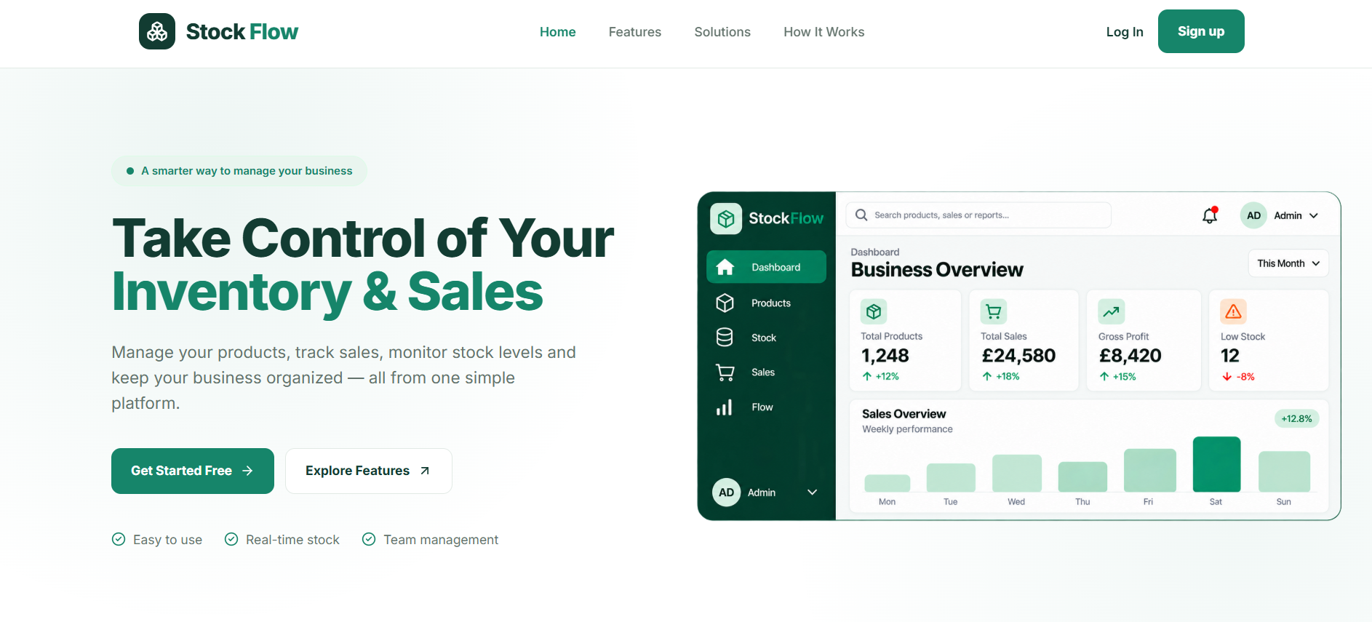
Landing Page 1 — StockFlow interface

A practical guide for business owners and employees.
Edition: November 2026 | Audience: First-time users and business staff

Contents
Find a topic quickly using the page numbers below.
01 | Getting Started | 3
02 | Dashboard & Navigation | 4
03 | Inventory: Categories, Products & Suppliers | 5
04 | Purchases & Customers | 6
05 | Sales & Returns | 7
06 | Reports & Analytics | 8
07 | Employees & Access Permissions | 9
08 | Settings & Account Security | 10
09 | Quick Reference & Troubleshooting | 11
How to use this manual
Read sections 01–02 first. Then follow the workflow relevant to your role. Actions visible in your account depend on permissions assigned by the business owner.
NOTE Screenshots illustrate the application interface. Your own records, totals and available actions may differ.

01 Getting Started

Create an owner account
01 Open the StockFlow website and select Sign up.
02 Enter a username, business name, email address and password; confirm the password.
03 Submit Create Account, then sign in using your credentials.

Sign in as an existing user
01 Select Log In on the landing page.
02 Enter your username and password, then select Sign In.
03 If you cannot remember your password, use Forgot Password? and follow the on-screen process.
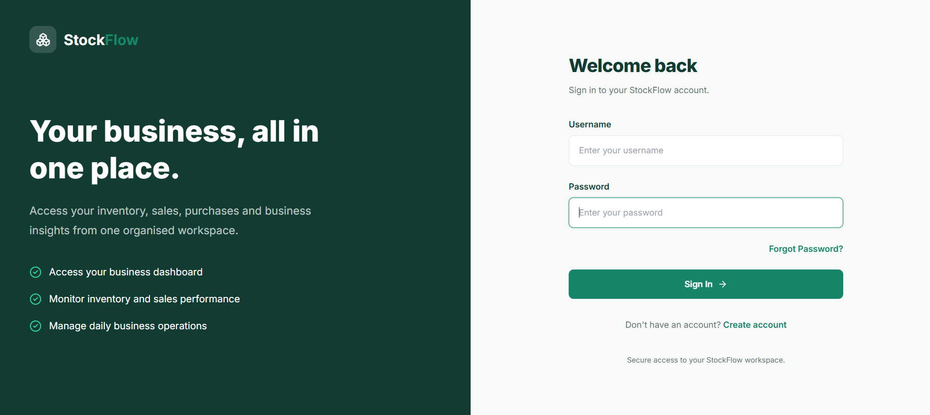
Signin — StockFlow interface
NOTE An employee account is created by the business owner. Employees should use the credentials provided to them rather than creating a separate owner account.

02 Dashboard & Navigation
The Dashboard provides a high-level snapshot of the business for the current day, including gross sales, refunds, net sales, gross profit and inventory status.
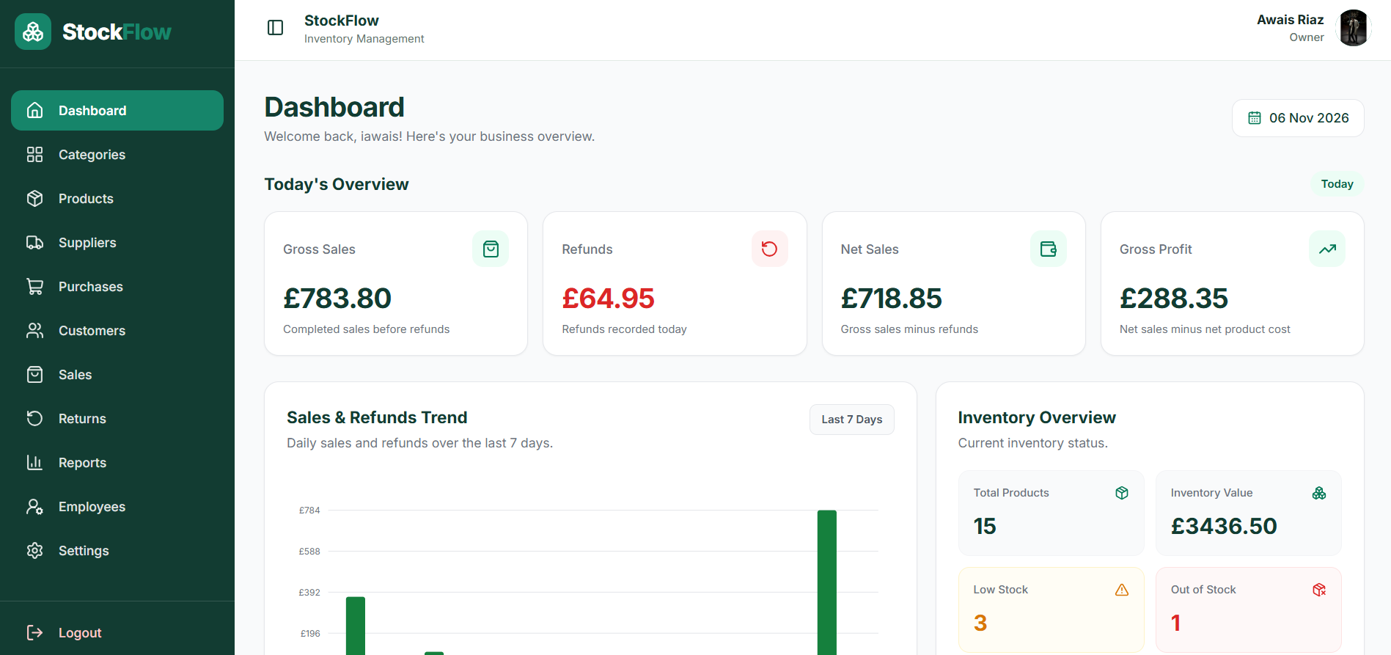
Dashboard — StockFlow interface

Understand the main figures
01 Gross Sales: value of completed sales before refunds.
02 Refunds: value of recorded refunds in the selected period.
03 Net Sales: gross sales minus refunds.
04 Inventory Overview: product count, inventory value and low/out-of-stock indicators.
Use the left sidebar to move between modules. The header identifies the signed-in account and role.
NOTE Financial figures reflect recorded transactions; they are not a replacement for formal accounting or tax reports.

03 Inventory Management

Categories
Open Categories to group related products (for example, Chargers, Mobile Phones or Screen Protectors). Use Add Category to create a group; available row actions allow viewing, editing or deleting where permitted.

Products
Open Products to manage product details, SKU, category, purchase and selling prices, opening stock, status and images. Search or filter the list to locate an item.
01 Select Add Product and complete the required product fields.
02 Save the product; use the view action to check its information.
03 Use edit to update details, or delete only when the record is no longer required and the operation is allowed.
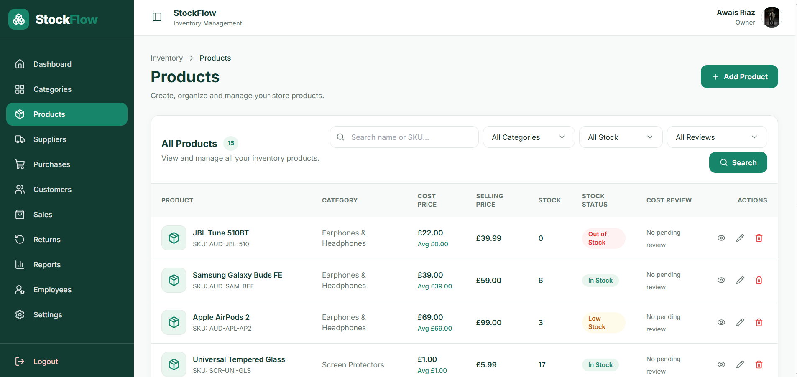
Products — StockFlow interface

Suppliers
Use Suppliers to maintain supplier contact details and active/inactive status. Active suppliers are available when creating a new purchase.
NOTE Opening stock and purchase receipts affect stock levels. Check quantities carefully to avoid misleading inventory totals.

04 Purchases & Customers

Record a purchase
01 Open Purchases and select New Purchase.
02 Choose an active supplier, purchase date and products; enter quantities and unit costs.
03 Save as Draft if details still need checking; use Confirmed when the order is confirmed.
04 Mark the purchase Received when stock physically arrives. Received purchases increase inventory quantities.
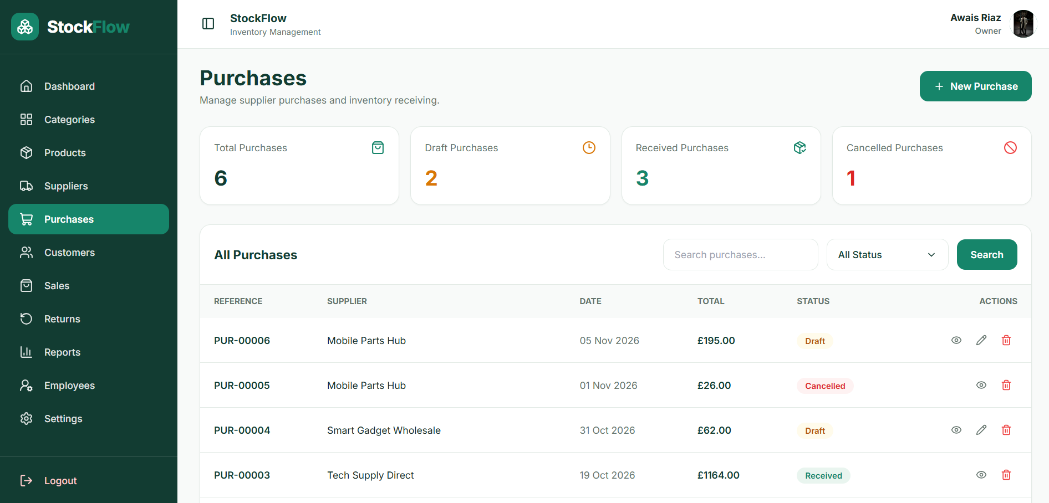
Purchase — StockFlow interface

Purchase statuses
Draft = being prepared. Confirmed = order confirmed. Received = stock received. Cancelled = order cancelled. Available actions depend on status and permissions.

Customers
Open Customers to search customer records, see purchase counts and total spending, and select View Details for purchase history. In the current permissions setup, Customers is view-only for employees.
NOTE Do not mark a purchase Received before goods arrive. Otherwise, available stock can be overstated.

05 Sales & Returns

Create a sale
01 Open Sales and select New Sale.
02 Select the customer and products, enter quantities and check the totals.
03 Complete the sale. A completed sale reduces available stock.
04 Use the Sales list to search transactions, view details and access receipt-related actions where available.
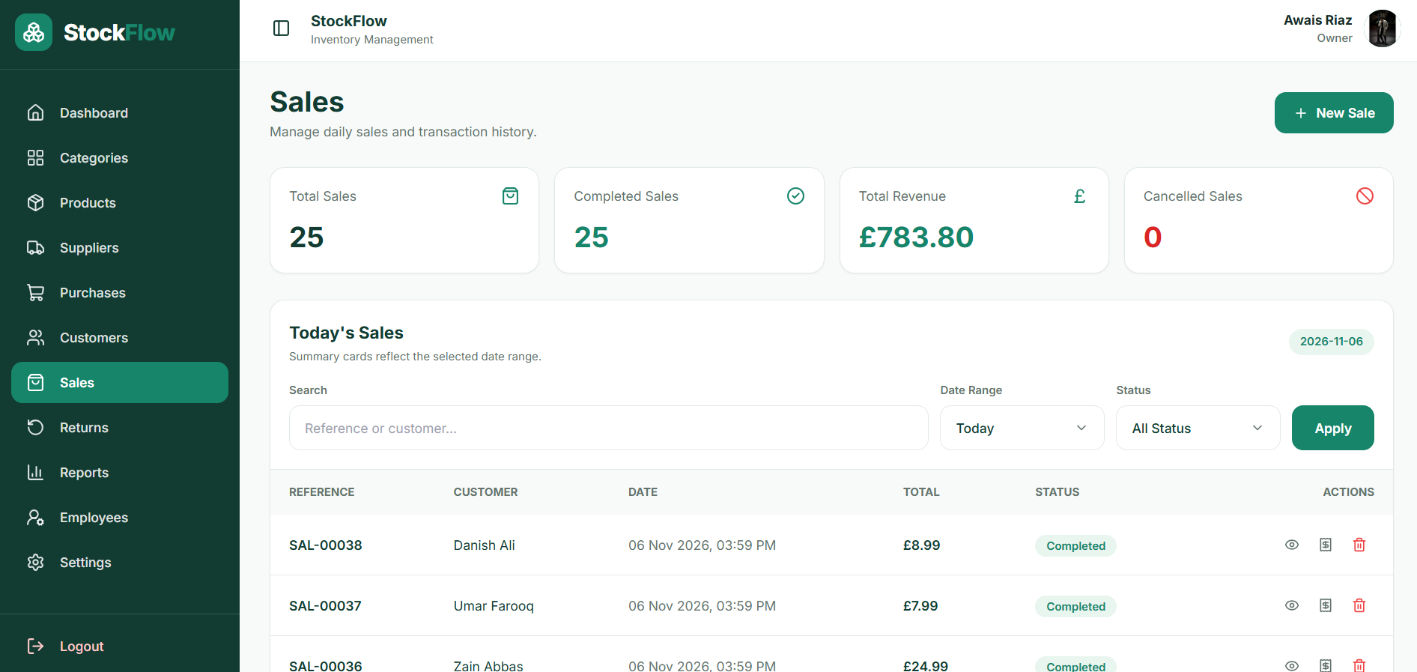
Sales — StockFlow interface

Record a return
01 Open Returns and select New Return.
02 Identify the original sale and the product/quantity being returned.
03 Review the refund details and submit the return.
04 Check the Returns list for the return reference and refund amount.
NOTE Return handling can affect inventory and refund totals. Verify the original sale before submitting. Sales and Returns do not have a general Edit action in the current interface.

06 Reports & Analytics
Reports & Analytics combines business performance and inventory information in one place. Use the tabs to switch between Overview, Sales, Profit, Purchases, Inventory, Stock Movement and Returns.
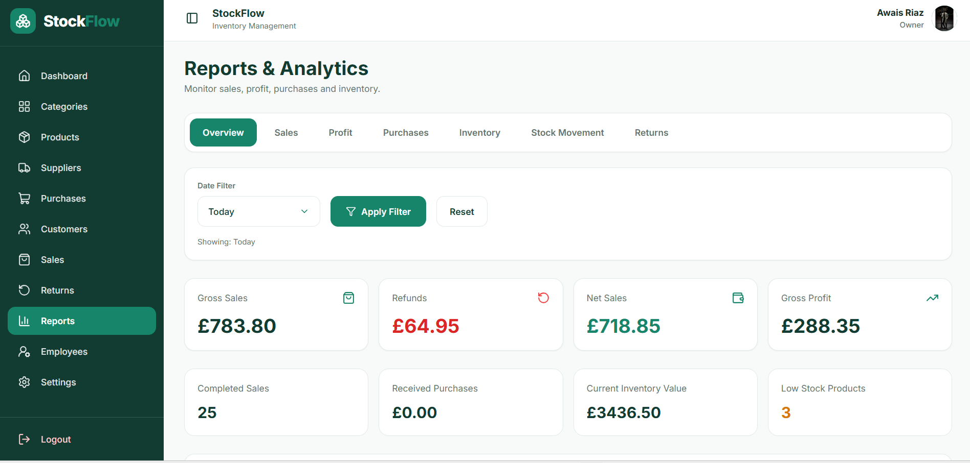
Report — StockFlow interface

Filter reports
01 Open Reports from the sidebar.
02 Choose the relevant report tab.
03 Select a date range (for example, Today), then choose Apply Filter.
04 Use Reset to return to the default filter.

Reading reports
Review sales, refunds, net sales, gross profit, received purchases and inventory value together. The figures are based on transactions recorded in StockFlow and may change as sales, returns and purchases are processed.
NOTE If Today shows zero, first confirm that transactions exist for the selected date and that their statuses are included in the report.

07 Employees & Permissions
Only the business owner manages employee accounts and module access. Employee access is restricted to the permissions the owner assigns.

Create or update an employee
01 Open Employees and select Add Employee.
02 Enter first name, last name, username, email and a password.
03 Save the account, then select Permissions beside that employee.
04 For later changes, select Edit to update account information, username or set a new password without knowing the previous password.
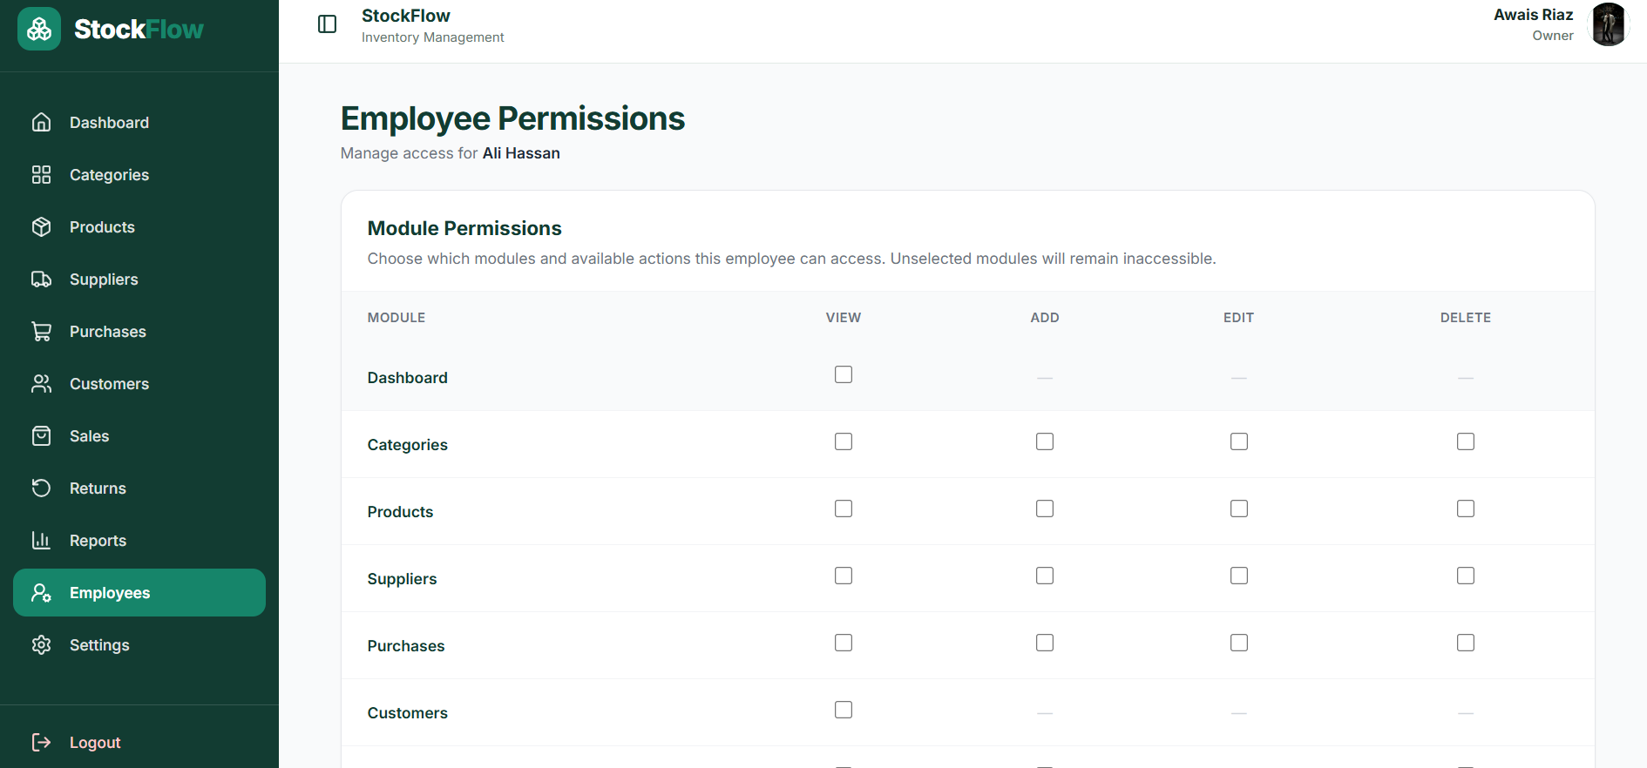
Employee Premission — StockFlow interface

Assign module access
Tick View, Add, Edit or Delete only where the module supports that action. Dashboard, Customers and Reports are view-only; Sales and Returns do not provide general Edit permission. An employee with no assigned module access sees the No Access page.
NOTE Grant the minimum permissions needed for each role. Hiding a button is not itself a security control; the application must also enforce permissions on the server.

08 Settings & Account Security
Settings contains personal and business information, password management and account deletion controls.
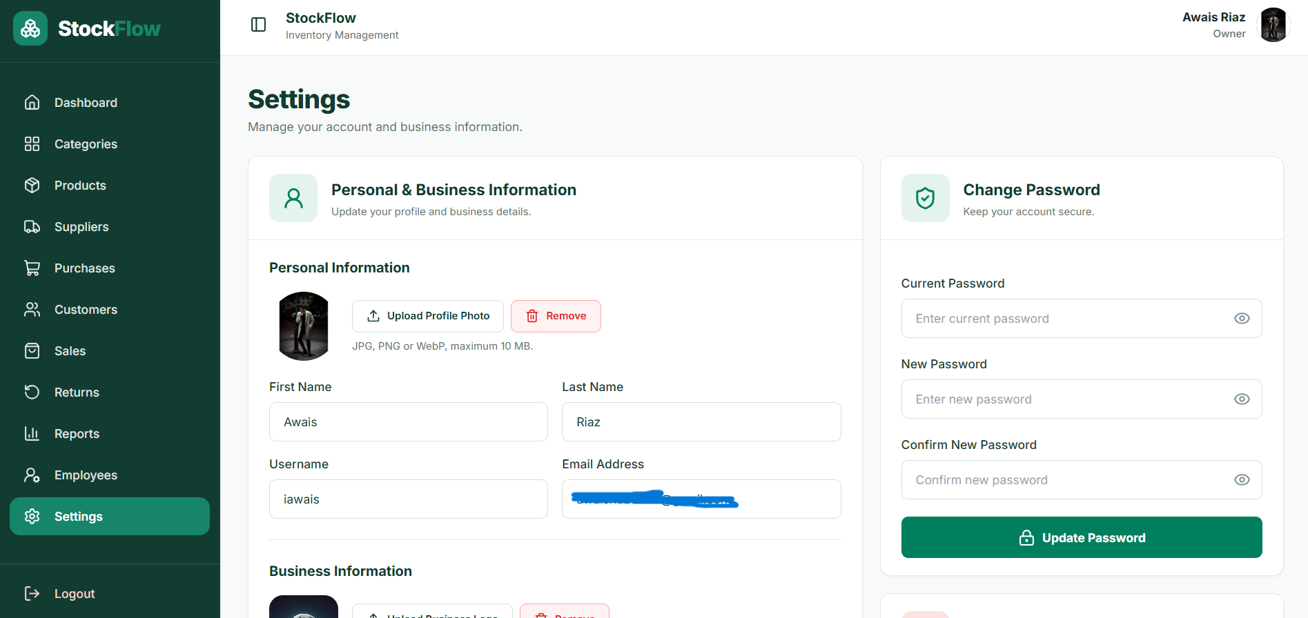
Setting 1 — StockFlow interface

Update account or business information
01 Open Settings and update your name, username, email or business details as appropriate.
02 Upload or remove profile and business images if required.
03 Select Save Information to apply changes.

Change your own password
Enter your current password, new password and confirmation, then select Update Password. This is separate from the owner resetting an employee password in Employees.

Danger Zone
Delete Account is a destructive operation. Review the warning carefully before proceeding; deletion can remove account-associated business data.
NOTE Use a strong unique password. Do not share employee login credentials between staff members.

09 Quick Reference & Troubleshooting
Task | Where to go
Check today’s sales | Dashboard → Today’s Overview
Add a product | Products → Add Product
Receive supplier stock | Purchases → Open purchase → Received
Record a transaction | Sales → New Sale
Issue a refund/return | Returns → New Return
Check profit and inventory | Reports → Choose tab and date filter
Give employee access | Employees → Permissions
Update account details | Settings → Save Information

Common questions
Why is a menu item missing? Your employee account may not have View permission for that module.
Why does a page show 404 or No Access? You may not be authorized to open it. Contact the business owner.
Why is stock different from expected? Check opening stock, received purchases, completed sales and returns.
Why is a report empty? Check the date filter and confirm that matching transactions exist.

Recommended daily workflow
Review Dashboard → check low stock → receive purchases → record sales → process returns → review reports.
END OF USER MANUAL

