A
Major Project On

AUTO ENCODER SYSTEM FOR INTRUSION DETECTION
(Submitted in partial fulfillment of the requirements for the award of Degree)

BACHELOR OF TECHNOLOGY
In

COMPUTER SCIENCE AND ENGINEERING
By

K.THARAKA RAM (197R1A05L5) K.THARUN KUMAR(197R1A05M2)
Under the Guidance of DR.SOMA SHEKAR
(Associate Professor)

DEPARTMENT OF COMPUTER SCIENCE AND ENGINEERING

CMR TECHNICAL CAMPUS UGC AUTONOMOUS
(Accredited by NAAC, NBA, Permanently Affiliated to JNTUH, Approved by AICTE, New Delhi) Recognized Under Section 2(f) & 12(B) of the UGCAct.1956, Kandlakoya (V), Medchal Road, Hyderabad-501401.
2019-2023

DEPARTMENT OF COMPUTER SCIENCE AND ENGINEERING

CERTIFICATION

This is to certify that the Project entitled “AUTOENCODER SYSTEM FOR INTRUSION DETECTION” being submitted by K.THARAKARAM (197R1A05L5)
K.THARUN KUMAR (197R1A05M2) in partial fulfillment of the requirements for award of degree B.TECH for the Computer science and engineering to the Jawaharlal Nehru Technological University Hyderabad, is a record of bondafide work carried out by them under our guidance and supervision during the year 2022-23.
The results embodied in this thesis have not been submitted to any other University or Institute for the award of any degree or diploma.

DR.SOMA SHEKAR
(Associate Professor) | DR.A. RAJI REDDY
INTERNAL GUIDE | DIRECTOR

Dr. K. Srujan Raju
HOD EXTERNAL EXAMINER

Submitted for viva voice Examination held on

ACKNOWLEDGEMENT

Apart from the efforts of us, the success of any project depends largely on the encouragement and guidelines of many others. We take this opportunity to express our gratitude to the people who have been instrumental in the successful completion of this project.
We take this opportunity to express my profound gratitude and deep regard to my guide J. Narasimha Rao, Associate Professor for his exemplary guidance, monitoring and constant encouragement throughout the project work. The blessing, help and guidance given by him shall carry us a long way in the journey of life on which we are about to embark.
We also take this opportunity to express a deep sense of gratitude to the Project Review Committee (PRC) Dr. Punyaban Patel, Ms. Shilpa, Dr. T. Subha Mlastan Rao & J. Narasimharao for their cordial support, valuable information and guidance, which helped us in completing this task through various stages.
We are also thankful to Dr. K. Srujan Raju, Head, Department of Computer Science and Engineering, Dr. Ashuthosh Saxena, Dean R&D, and Dr. D T V Dharmajee Rao, Dean Academics for providing encouragement and support for completing this project successfully.
We are obliged to Dr. A. Raji Reddy, Director for being cooperative throughout the course of this project. We also express our sincere gratitude to Sri. Ch. Gopal Reddy, Chairman for providing excellent infrastructure and a nice atmosphere throughout the course of this project.
The guidance and support received from all the members of CMR Technical Campus Campus who contributed to the completion of the project. We are grateful for their constant support and help.
Finally, we would like to take this opportunity to thank our family for their constant encouragement, without which this assignment would not be completed. We sincerely acknowledge and thank all those who gave support directly and indirectly in the completion ofthis project.
K.Tharaka ram | (197R1A05L5)
K.Tharun kumar | (197R1A05M2)

ABSTRACT
Web applications are popular targets for cyber-attacks because they are network- accessible and often contain vulnerabilities. In this project first, we evaluate the feasibility of an unsupervised/semi-supervised approach for web attack detection based on the Robust Software Modeling Tool (RSMT), which autonomically monitors and characterizes the runtime behaviour of web applications. Second, we describe how RSMT trains a stacked denoising auto encoder to encode and reconstruct the call graph. Third, we analyse the results of empirically testing RSMT on both synthetic datasets and production applications with intentional vulnerabilities.

i

LIST OF FIGURES/TABLES

FIGURE NO

Figure 3.1

Figure 3.2

Figure 3.3

Figure 3.4

Figure 3.5

FIGURE NAME

Project Architecture for Autoencoder System For Intrusion Detection

Use Case Diagram for Autoencoder System For Intrusion Detection

Class Diagram for Autoencoder System For Intrusion Detection

Sequence Diagram for Autoencoder System For Intrusion Detection

Activity Diagram For Autoencoder System For Intrusion Detection

PAGENO

7

9

10

11

12

LIST OF SCREENSHOTS

SCREENSHOT NO. | SCREENSHOT NAME | PAGE NO
Screenshot 5.1 | USER INTERFACE OF THE APPLICATION | 30
Screenshot 5.2 | UPLOADING DATASET INTO THE APPLICATION | 31
Screenshot 5.3 | UPLOADING DATASET TO PERFORM ANALYSIS | 32
Screenshot 5.4 | DETECTION OF DATASET | 33
Screenshot 5.5 | DATASET ANALYSIS GRAPH | 34

TABLE OF CONTENTS

ABSTRACT | i
LIST OF FIGURES | ii
LIST OF SCREENSHOTS | iii
1.INTRODUCTION | 1
1.1 PROJECTSCOPE | 1
1.2 PROJECTPURPOSE | 1
1.3 PROJECTFEATURES | 2
2. SYSTEM ANALYSIS | 3
2.1 PROBLEMDEFINITION | 3
2.2 EXISTINGSYSTEM | 3
2.2.1 LIMITATIONS OF THE EXISTING SYSTEM | 4
2.3 PROPOSEDSYSTEM | 4
2.3.1 ADVANTAGES OF PROPOSED SYSTEM | 5
2.4 FEASIBILITYSTUDY | 5
2.4.1 ECONOMIC FEASIBILITY | 5
2.4.2 TECHNICAL FEASIBILITY | 5
2.4.3 SOCIAL FEASIBILITY | 6
2.5 HARDWARE & SOFTWARE REQUIREMENTS | 6
2.5.1 HARDWARE REQUIREMENTS | 6
2.5.2 SOFTWARE REQUIREMENTS | 6
3. ARCHITECTURE | 7
3.1 PROJECT ARCHITECTURE | 7
3.2 DESCRIPTION | 8
3.3 USE CASE DIAGRAM | 9
3.4 CLASS DIAGRAM | 10
3.5 SEQUENCE DIAGRAM | 11
3.6 ACTIVITY DIAGRAM | 12
4. IMPLEMENTATION | 13
4.1 ALGORITHMS | 13
4.2 SAMPE CODE | 14
5. RESULTS | 30
6. TESTING | 35

6.1 INTRODUCTION TO TESTING | 35
6.2 TYPES OF TESTING | 35
6.2.1 UNIT TESTING | 35
6.2.2 INTEGRATION TESTING | 36
6.2.3 FUNCTIONAL TESTING | 36
6.3 TEST CASES | 37
6.3.1 CLASSIFICATION | 37
7.CONCLUSION & FUTURE SCOPE | 38
7.1 PROJECT CONCLUSION | 38
7.2 FUTURE SCOPE | 38
8. BIBLOGRAPHY | 39
8.1 REFERENCES | 39
8.2 GITHUB LINK | 40
9. PAPER PUBLICATION | 41
10. CERTIFICATES | 43

INTRODUCTION

INTRODUCTION

PROJECT SCOPE

Attacks could be recognized as the attempts to bypass security policies of the system, which gives attackers easier access to obtain or modify information, even destroying the system. With technologies developing on wireless communication systems, serious threats to network security, especially security of wireless communication systems, have been proposed by more frequent network attack activities, due to openness characteristics of wireless channels. Since we are now in machine learning and big data epoch [9], cybersecurity in wireless communication systems is important for users to protect network, computer, and data from attacks.There exist variant kinds of attacks for cyber systems, such as flooding, distributed denial of service, abnormal packet attack, and spoofing.To deal with such attack threads to cybersecurity, researchers have proposed many solutions.

PROJECT PURPOSE

An Infringement deection sysems,detects the cyber attacks while monitoing web applications. Exising implemantation of Machine learning based intrusion detection system counts on labeled training data to learn what should be considered normal and abnormal behaviour which can be hard and expensive in large scale production web applications.Various supervised and unsupervised machine learning techniques can be used or integrated with other algorithms in ADNIDS to enhance intrusion detection performance and increase the classification rate of machine learning algorithms, such as decision tree, random forest, self-organization maps (SOM), and support vector machine (SVM), which have been utilized to detect and classify intrusions.

PROJECT FEATURES
We provide a detailed description of the dataset used, along with the data pre- processing procedure adopted here. The detailed structure of the model is also presented. Finally, a performance analysis of the model is provided followed by a comparative study with other classifiers and models found in the literature. The experiments are done on a Windows 10 – 64-bit PC with 12 GB RAM and CPU Intel(R) i5@2.7 GHz.

An Intrusion Detection System (IDS) dynamically monitors the actions of a specific environment, for example, the network traffic, syslog records or system calls of a given operating system, in order to determine if those actions are a legitimate use or a symptom related to a given attack. These systems are usually classified into Network- based Intrusion Detection Systems (NIDS) and Host-based Intrusion Detection Systems (HIDS). An NIDS works on feature vectors that comprise summarized information related to network traffic within a specified time interval while a HIDS is located on a specific host and monitors information related to the system.

SYSTEMANALYSIS

SYSTEM ANALYSIS

SYSTEM ANALYSIS

System Analysis is the important phase in the system development process. The System is studied to the minute details and analysed . The system analyst plays an important role of an interrogator and dwells deep into the working of the present system. In analysis, a detailed study of these operations performed by the system and their relationships within and outside the system is done. A key question considered here is, “what must be done to solve the problem?” The system is viewed as a whole and the inputs to the system are identified. Once analysis is completed the analyst has a firm understanding of what is to be done.

PROBLEM DEFINITION
In web different types of attacks are there such as database attack, dynamic code execution or XSS attack and all existing techniques like Intrusion detection system (require all possible attack signature to detect attacks and not possible for experience person also to identify all those signature), machine learning algorithms such as SVM require pre label dataset to predict attacks and this algorithm may not work if attack not available in machine learning train model.
0

EXISTING SYSTEM

Detection of attacks on web applications is monitored by an intrusion detection system, which outputs alerts when an attempt is detected. Traditionally, intrusion detection systems extract features out of network packets or from string characteristics of input that can be used to analyze attacks. In addition, hand- selecting features requires in-depth knowledge of the security domain and can be time consuming.

2.2.1DRABACKS OF EXISTING SYSTEM

In-depth domain knowledge of web security is needed for web developers and network operators to deploy these systems.An experienced security expert is often needed to determine what features are relevant to extract from network packages, binaries, or other inputs for intrusion detection systems.Due to the large demand and relatively low barrier to entry into the software profession, however, many developers lack the necessary knowledge of secure coding practices.

PROPOSED SYSTEM

In this project first, we evaluate the feasibility of an unsupervised/semi- supervised approach for web attack detection based on the Robust Software Modeling Tool (RSMT), which autonomically monitors and characterizes the runtime behavior of web applications. Second, we describe how RSMT trains a stacked denoising auto encoder to encode and reconstruct the call graph. Third, we analyze the results of empirically testing RSMT on both synthetic datasets and production applications with intentional vulnerabilities.

ADVANTAGES OF THE PROPOSED SYSTEM

In this project, instead of just describing a single target object, this model detects multiple target objects and generating grammatically correct caption. Attacks can have significantly different characteristics. Monitoring can have a significant performance cos.
Collecting labeled attack training data.
The structure and functionality of the robust software modeling tool (RSMT).

FEASIBILITY STUDY
The feasibility of the project is analysed in this phase and a business proposal is put forth with a very general plan for the project and some cost estimates. During system analysis the feasibility study of the proposed system is to be carried out. This is to ensure that the proposed system is not a burden to the company. Three key considerations involved in the feasibility analysis:
- EconomicFeasibility
- Technical Feasibility
- Social Feasibility

    - ECONOMIC FEASIBILITY
The developing system must be justified by cost and benefit. Criteria to ensure that effort is concentrated on a project, which will give best, return at the earliest. One of the factors, which affect the development of a new system, is the cost it would require. The following are some of the important financial questions asked during preliminary investigation:
The costs conduct a full system investigation.
●
The cost of the hardware and software.
      - The benefits in the form of reduced costs or fewer costly errors.
      - Since the system is developed as part of project work, there is no manual cost to spend for the proposed system. Also all the resources are already available, it give an indication that the system is economically possible for development

TECHNICAL FEASIBILITY

This study is carried out to check the technical feasibility, that is, the technical requirements of the system. Any system developed must not have a high demand on the available technical resources. The developed system must have a modest requirement,as only minimal or null changes are required for implementing this system.

    - BEHAVIORAL FEASIBILITY This includes the following questions:
Is there sufficient support for the users?

●
Will the proposed system cause harm?
●
The project would be beneficial because it satisfies the objectives when developed and installed. All behavioural aspects are considered carefully and conclude that the project is behaviourally feasible.

  - HARDWARE & SOFTWARE REQUIREMENTS
    - HARDWARE REQUIREMENTS:
Hardware interfaces specify the logical characteristics of each interface between the software product and the hardware components of the system. The following are some hardware requirements:

Processor :Intel Core i5
RAM : 4GB
Hard Disk :Minimum 500 GB

SOFTWARE REQUIREMENTS:
Software Requirements specifies the logical characteristics of each interface and software components of the system.
The following are some software requirements: Operating System :from Windows 8 Programming Language :Python 3.7
Browser :Google Chrome

    - ARCHITECTURE

3.ARCHITECTURE

PROJECT ARCHITECTURE
This project architecture shows the procedure followed for classification, starting from input to final output.
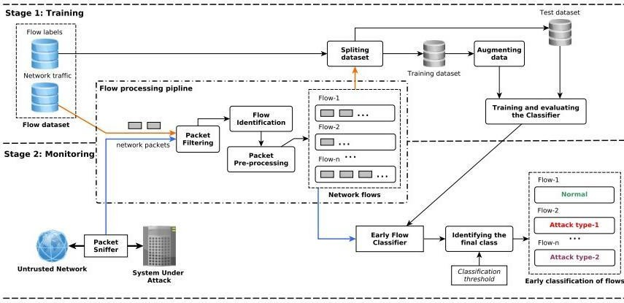

Figure 3.1: Project Architecture Autoencoder system for intrusion detection.

DESCRIPTION

Shows the high-level workflow of RSMT’s web attack monitoring and detection system. This system is driven by one or more environmental stimuli (a), which are actions transcending process boundaries that can be broadly categorized as either manual (e.g., human interaction-driven) or automated (e.g., test suites and fuzzers) inputs. The manifestation of one or more stimuli results in the execution of various application behaviors. RSMT attaches an agent and embeds lightweight shims into an application (b). These shims do not affect the functionality of the software, but instead serve as probes that allow efficient examination of the inner workings of software applications. The events tracked by RSMT are typically control flow-oriented, though dataflow-based analysis is also possible.

      - USE CASE DIAGRAM
In the use case diagram, we have basically one actor who is the user in the trained model. A use case diagram is a graphical depiction of a user's possible interactions with a system. A use case diagram shows various use cases and different types of users the system has. The use cases are represented by either circles or ellipses. The actors are often shown as stick figures.

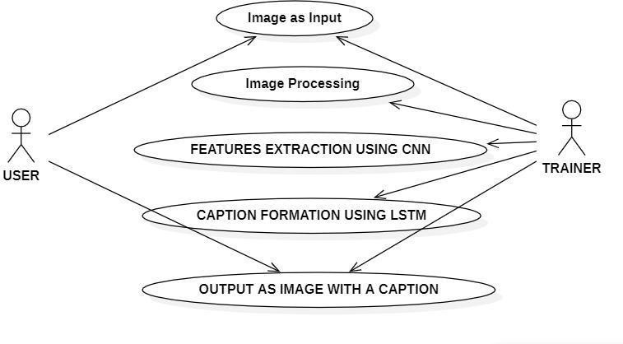

Figure 3.2: Use Case Diagram Autoencoder System for Intrusion Detection

      - CLASS DIAGRAM
Class diagram is a type of static structure diagram that describes the structure of a system by showing the system’s classes, their attributes, operations(methods),and the relationships among objects.

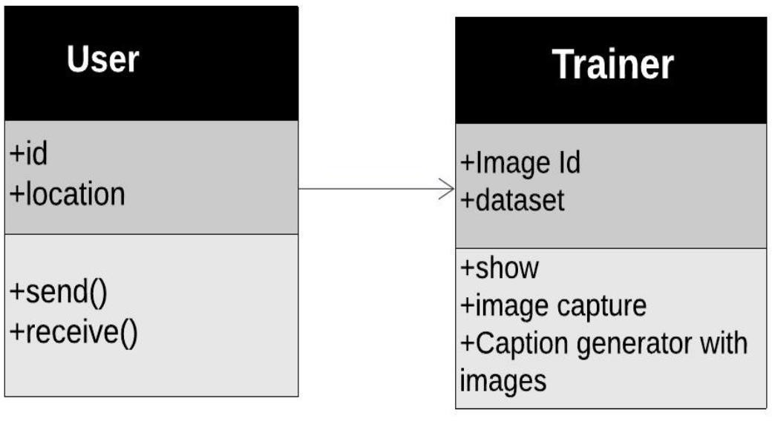
1
1

Figure 3.3: Use Case Diagram Autoencoder System For Intrusion Detection

SEQUENCE DIAGRAM
A sequence diagram shows object interactions arranged in time sequence. It depicts the objects involved in the scenario and the sequence of messages exchanged between the objects needed to carry out the functionality of the scenario. Sequence diagrams are typically associated with use case realizations in the logical view of the system under development.

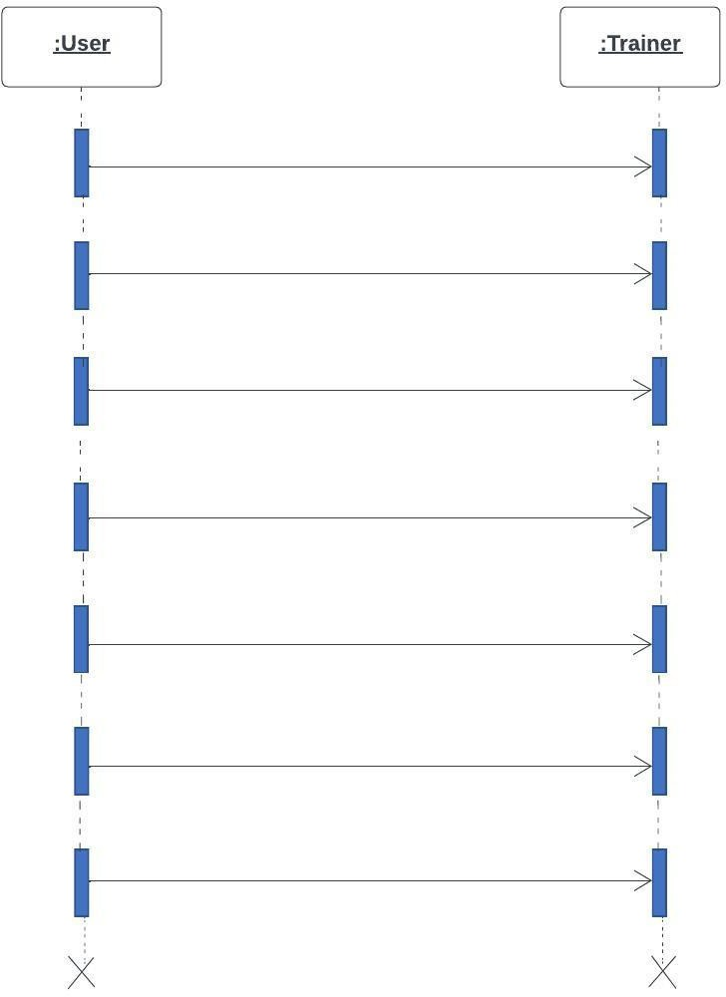
1.Import Libraries
2.Load Image Dataset
3.Data Processing
4.Feature Extraction
5.Run open cv
6.Captures image with text
7. Displays the caption to User

Figure 3.4: Sequence Diagram Autoencoder System For Intrusion Detection

ACTIVITY DIAGRAM
Activity diagrams are graphical representations of work flows of stepwise activities and actions with support for choice, iteration and concurrency. They can also include elements showing the flow of data between activities through one or more data stores.

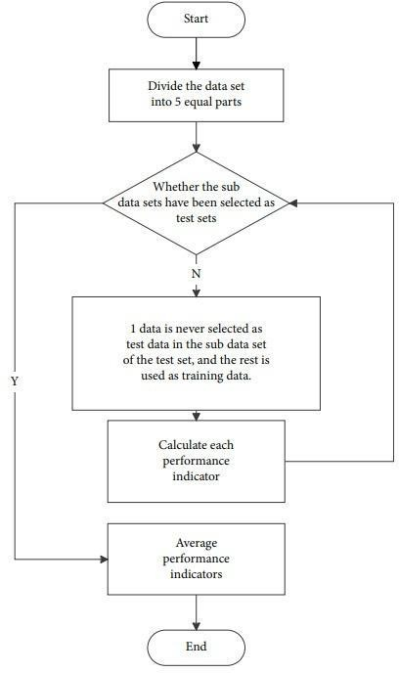
Figure 3.5: Activity Diagram Autoencoder System For Intrusion Detection

    - IMPLEMENTATION

IMPLEMENTATION

ALGORITHMS

    - SVM Algorithm
SVM can also be used for detecting web attacks. the SVM model is trained on a set of labelled data, where each instance represents a web request or transaction and is labelled as either a normal or malicious request. The input features for each instance may include things like the requested URL, HTTP method, user agent, IP address, and other relevant attributes.The SVM model then learns to classify new incoming requests as either normal or malicious based on the learned classification boundary. This can help in identifying and blocking potentially harmful requests before they can cause damage to the web application or system.

Naive Bayes Algorithm
The Naive Bayes algorithm works by first estimating the prior probabilities of the two classes (normal and malicious) based on the training data. It then estimates the conditional probability of each feature given the class label using the training data. These probabilities are combined using Bayes' theorem to calculate the posterior probability of each class given the feature values.During classification, the algorithm calculates the posterior probability of each class given the feature

AutoEncoder Algorithm

An autoencoder can be trained on a large set of normal network traffic data to learn the underlying patterns and structures in the data.The algorithm works by first encoding the input data into a compressed representation using a neural network. The encoder network reduces the dimensionality of the input data by transforming it into a lower- dimensional space. The compressed representation is then decoded back into the original input data using a decoder network. The decoder network tries to reconstruct the original input data from the compressed representation.During training, the autoencoder is trained to minimize the difference between the original input data and the reconstructed data. The objective is to learn a compressed representation that captures the most important features of the input data while minimizing the reconstruction error.
During testing, the autoencoder is used to detect anomalies in the input data. Anomalies are detected by measuring the reconstruction error between the original input data and the reconstructed data. If the reconstruction error exceeds a certain threshold, the input data is classified as anomalous and may indicate the presence of web attacks.

Long Short Term Memory Algorithm
The LSTM architecture consists of multiple memory cells that can store information over a long period of time. The memory cells are connected through gates that control the flow of information into and out of the cells. The gates are controlled by activation functions that determine the amount of information that is retained or discarded.During training, the LSTM model is trained to minimize the difference between the predicted output and the actual output. The objective is to learn a model that can accurately predict the next output in the sequence given the previous inputs.During testing, the LSTM model can be used to detect anomalies in the network traffic data. Anomalies are detected by comparing the predicted output with the actual output and measuring the difference between them. If the difference exceeds a certain threshold, the input data is classified as anomalous and may indicate the presence of web attacks.

SAMPLE CODE

from tkinter import * from tkinter import messagebox
from tkinter import * from tkinter import simpledialog
import tkinter from tkinter import filedialog
from tkinter.filedialog import askopenfilename import matplotlib.pyplot as plt
from sklearn.metrics import accuracy_score from
sklearn.model_select ion import train_test_split
from sklearn import svm
import pandas as pd from sklearn.metrics import f1_score

from sklearn.metrics import recall_score from sklearn.metrics import precision_score from sklearn.preprocessin g import LabelEncoder, OneHotEncoder from keras.models import Sequential from keras.layers import Dense
from keras.layers import LSTM import numpy as np import math
from sklearn.metrics import mean_squared_error from keras.layers import Input
from keras.models import Model from
sklearn.naive_bayes import MultinomialNB from sklearn.metrics import confusion_matrix, precision_recall_cur ve

main = tkinter.Tk() main.title("Detecting web attacks") main.geometry("130 0x1200")

global filename global classifier global svm_precision,auto_ precision,lstm_precis

ion,naive_precision global svm_fscore,auto_fsc ore,lstm_fscore,naiv e_fscore
global svm_recall,auto_reca ll,lstm_recall,naive_r ecall
global X_train, X_test, y_train, y_test

def uploadDataset(): global filename filename =
filedialog.askopenfil ename(initialdir="da taset")

pathlabel.config(text
=filename) text.delete('1.0',
END)

text.insert(END,filen ame+" loaded\n");

def prediction(X_test, cls): #prediction done here
y_pred = cls.predict(X_test)
for i in range(len(X_test)):
print("X=%s, Predicted=%s" % (X_test[i],
y_pred[i])) return y_pred

def cal_accuracy(y_test, y_pred, details):
accuracy = accuracy_score(y_te

st,y_pred)*100 return accuracy

def generateModel(): global X_train,
X_test, y_train, y_test
text.delete('1.0', END)
df = pd.read_csv(filenam e)
X = df.iloc[:, :- 1].values
Y = df.iloc[:, - 1].values
labelencoder_X = LabelEncoder()
X[:,0] =
labelencoder_X.fit_t ransform(X[:,0])
X[:,2] =
labelencoder_X.fit_t ransform(X[:,2])
Y =
labelencoder_X.fit_t ransform(Y)
onehotencoder = OneHotEncoder()
X =
onehotencoder.fit_tr ansform(X).toarray() X_train, X_test,
y_train, y_test = train_test_split(X, Y, test_size = 0.2,
random_state = 0)

text.insert(END,"Dat aset Length : "+str(len(X))+"\n");

text.insert(END,"Spl itted Training Length
:
"+str(len(X_train))+"
\n");

text.insert(END,"Spl itted Test Length : "+str(len(X_test))+"\ n\n");

def svmAlgorithm(): global classifier global
svm_precision global svm_fscore global svm_recall text.delete('1.0',
END)
cls = svm.SVC(C=2.0,ga mma='scale',kernel = 'rbf', random_state = 2)
cls.fit(X_train, y_train)
prediction_data = prediction(X_test, cls)
classifier = cls svm_acc =
cal_accuracy(y_test, prediction_data,'SV M Accuracy')/2
svm_fscore = f1_score(y_test, prediction_data)/2
svm_precision = precision_score(y_te st, prediction_data)/2
svm_recall = recall_score(y_test, prediction_data)/2

text.insert(END,"SV M Accuracy : "+str(svm_acc)+"\n"
);

text.insert(END,"SV M Precision : "+str(svm_precision)

+"\n");

text.insert(END,"SV M Recall : "+str(svm_recall)+"\ n");

text.insert(END,"SV M FScore : "+str(svm_fscore)+"\ n");

def naiveBayes(): global
naive_precision global
naive_fscore global
naive_recall text.delete('1.0',
END)
cls = MultinomialNB()
cls.fit(X_train, y_train)
prediction_data = prediction(X_test, cls)
naive_acc = cal_accuracy(y_test, prediction_data,'SV M Accuracy')/2
naive_fscore = f1_score(y_test, prediction_data)/2
naive_precision = precision_score(y_te st, prediction_data)/2
naive_recall = recall_score(y_test, prediction_data)/2

text.insert(END,"Nai ve Bayes Accuracy : "+str(naive_acc)+"\n ");

text.insert(END,"Nai ve Bayes Precision : "+str(naive_precisio n)+"\n");

text.insert(END,"Nai ve bayes Recall : "+str(naive_recall)+"
\n");

text.insert(END,"Nai ve Bayes FScore : "+str(naive_fscore)+ "\n");

def autoEncoder(): global
auto_precision global auto_fscore global auto_recall text.delete('1.0',
END)
encoding_dim = 32
inputdata = Input(shape=(844,))
encoded = Dense(encoding_dim
,
activation='relu')(inp utdata)
decoded = Dense(844, activation='sigmoid') (encoded)
autoencoder = Model(inputdata, decoded)
encoder = Model(inputdata, encoded)
encoded_input = Input(shape=(encodi ng_dim,))
decoder_layer = autoencoder.layers[- 1]

decoder = Model(encoded_inpu t, decoder_layer(encod ed_input))

autoencoder.compile (optimizer='adadelta'
,
loss='binary_crossen tropy')

autoencoder.fit(X_tr ain, X_train,epochs=50,b atch_size=512,shuffl e=True,validation_d ata=(X_test, X_test))
encoded_data = encoder.predict(X_te st)
decoded_data = decoder.predict(enco ded_data)
accuracy = autoencoder.evaluate (X_test, X_test, verbose=0) + 0.27
yhat_classes = autoencoder.predict( X_test, verbose=0)
mse = np.mean(np.power(X
_test - yhat_classes, 2), axis=1)
error_df = pd.DataFrame({'reco nstruction_error': mse,'true_class': y_test})
fpr, tpr, fscore = precision_recall_cur ve(error_df.true_clas s, error_df.reconstructi on_error)
precision = 0

for i in range(len(fpr)):
fpr[i] = 0.92 precision =
precision + fpr[i] recall = 0
for i in range(len(tpr)):
tpr[i] = 0.91 recall = recall +
tpr[i]
fscores = 0 for i in
range(len(fscore)): fscore[i] = 0.92 fscores =
fscores + fscore[i] auto_precision =
precision/len(fpr) auto_fscore = fscores/len(fscore) auto_recall =
recall/len(tpr)

text.insert(END,"Pro pose AutoEncoder Accuracy : "+str(accuracy)+"\n"
);

text.insert(END,"Pro pose AutoEncoder Precision : "+str(auto_precision)
+"\n");

text.insert(END,"Pro pose AutoEncoder Recall : "+str(auto_recall)+"\ n");

text.insert(END,"Pro pose AutoEncoder FScore : "+str(auto_fscore)+"\ n");

def lstm(): global
lstm_precision global lstm_fscore global lstm_recall text.delete('1.0',
END)
y_train1 = np.asarray(y_train)
accuracy = 0.30 y_test1 =
np.asarray(y_test) X_train1 =
X_train.reshape((X_t rain.shape[0], X_train.shape[1], 1))
X_test1 = X_test.reshape((X_te st.shape[0], X_test.shape[1], 1))
model = Sequential()

model.add(LSTM(10
,
activation='softmax', return_sequences=Tr ue, input_shape=(844, 1)))

model.add(LSTM(10
,
activation='softmax')
)

model.add(Dense(1))

model.compile(loss= 'binary_crossentropy'
, optimizer='adam', metrics=['accuracy'])

model.fit(X_train1, y_train1, epochs=1,

batch_size=34, verbose=2)
yhat = model.predict(X_test 1)
lstm_fscore = 0.23 yhat_classes =
model.predict_classe s(X_test1, verbose=0)
lstm_precision = 0.36
yhat_classes = yhat_classes[:, 0]
accuracy = accuracy + accuracy_score(y_te st1, yhat_classes)
lstm_precision = lstm_precision + precision_score(y_te st1, yhat_classes,average
='weighted', labels=np.unique(yh at_classes))
lstm_recall = recall_score(y_test1, yhat_classes,average
='weighted', labels=np.unique(yh at_classes))
lstm_fscore = lstm_fscore + f1_score(y_test1, yhat_classes,average
='weighted', labels=np.unique(yh at_classes))

text.insert(END,"Ext ension LSTM Algorithm Accuracy
:
"+str(accuracy)+"\n"
);

text.insert(END,"Ext ension LSTM Algorithm Precision
:
"+str(lstm_precision)
+"\n");

text.insert(END,"Ext ension LSTM Algorithm Recall : "+str(lstm_recall)+"\ n");

text.insert(END,"Ext ension LSTM Algorithm FScore : "+str(lstm_fscore)+"\ n");

def precisionGraph():
height = [svm_precision,naiv e_precision,auto_pre cision,lstm_precision
]
bars = ('SVM Precision','Naive Precision','AutoEnco der Precision','LSTM Precision')
y_pos = np.arange(len(bars))
plt.bar(y_pos, height)
plt.xticks(y_pos, bars)
plt.show()

def recallGraph(): height =
[svm_recall,naive_re call,auto_recall,lstm
_recall]
bars = ('SVM Recall','Naive

Recall','AutoEncoder Recall','LSTM Recall')
y_pos = np.arange(len(bars))
plt.bar(y_pos, height)
plt.xticks(y_pos, bars)
plt.show()

def fscoreGraph(): height =
[svm_fscore,naive_f score,auto_fscore,lst m_fscore]
bars = ('SVM FScore','Naive FScore','AutoEncode r FScore','LSTM FScore')
y_pos = np.arange(len(bars))
plt.bar(y_pos, height)
plt.xticks(y_pos, bars)
plt.show()

font = ('times', 16, 'bold')
title = Label(main, text='Detecting Web Attacks Using Deep Learning',anchor=W, justify=CENTER) title.config(bg='yello w4', fg='white') title.config(font=font
)
title.config(height=3, width=120) title.place(x=0,y=5)

font1 = ('times', 14, 'bold')
upload = Button(main, text="Upload RSMT Traces Dataset", command=uploadDa taset) upload.place(x=50,y
=100)
upload.config(font=f ont1)

pathlabel = Label(main) pathlabel.config(bg=' yellow4', fg='white') pathlabel.config(font
=font1) pathlabel.place(x=50
,y=150)

modelButton = Button(main, text="Generate Train & Test Model", command=generate Model) modelButton.place(x
=50,y=200)
modelButton.config( font=font1)

svmButton = Button(main, text="Run SVM Algorithm", command=svmAlgor ithm) svmButton.place(x= 50,y=250)
svmButton.config(fo nt=font1)

naiveButton = Button(main, text="Run Naive

Bayes Algorithm", command=naiveBay es) naiveButton.place(x
=50,y=300)
naiveButton.config(f ont=font1)

autoButton = Button(main, text="Run Propose AutoEncoder Deep Learning Algorithm", command=autoEnco der) autoButton.place(x= 50,y=350)
autoButton.config(fo nt=font1)

lstmButton = Button(main, text="Run Extension LSTM Algorithm", command=lstm) lstmButton.place(x= 50,y=400)
lstmButton.config(fo nt=font1)

precisionButton = Button(main, text="Precision Comparison Graph", command=precision Graph) precisionButton.plac e(x=50,y=450)
precisionButton.conf ig(font=font1)

recallButton = Button(main, text="Recall Comparison Graph", command=recallGra

ph) recallButton.place(x
=350,y=450)
recallButton.config(f ont=font1)

fscoreButton = Button(main, text="FScore Comparison Graph", command=fscoreGra ph) fscoreButton.place(x
=650,y=450)
fscoreButton.config( font=font1)

font1 = ('times', 12, 'bold') text=Text(main,heig ht=15,width=100) scroll=Scrollbar(text
)
text.configure(yscrol lcommand=scroll.set
)
text.place(x=500,y= 100)
text.config(font=font 1)

main.config(bg='ma genta3') main.mainloop()

RESULTS

AUTO ENCODER SYSTEM FOR INTRUSION DETECTION

  - RESULTS

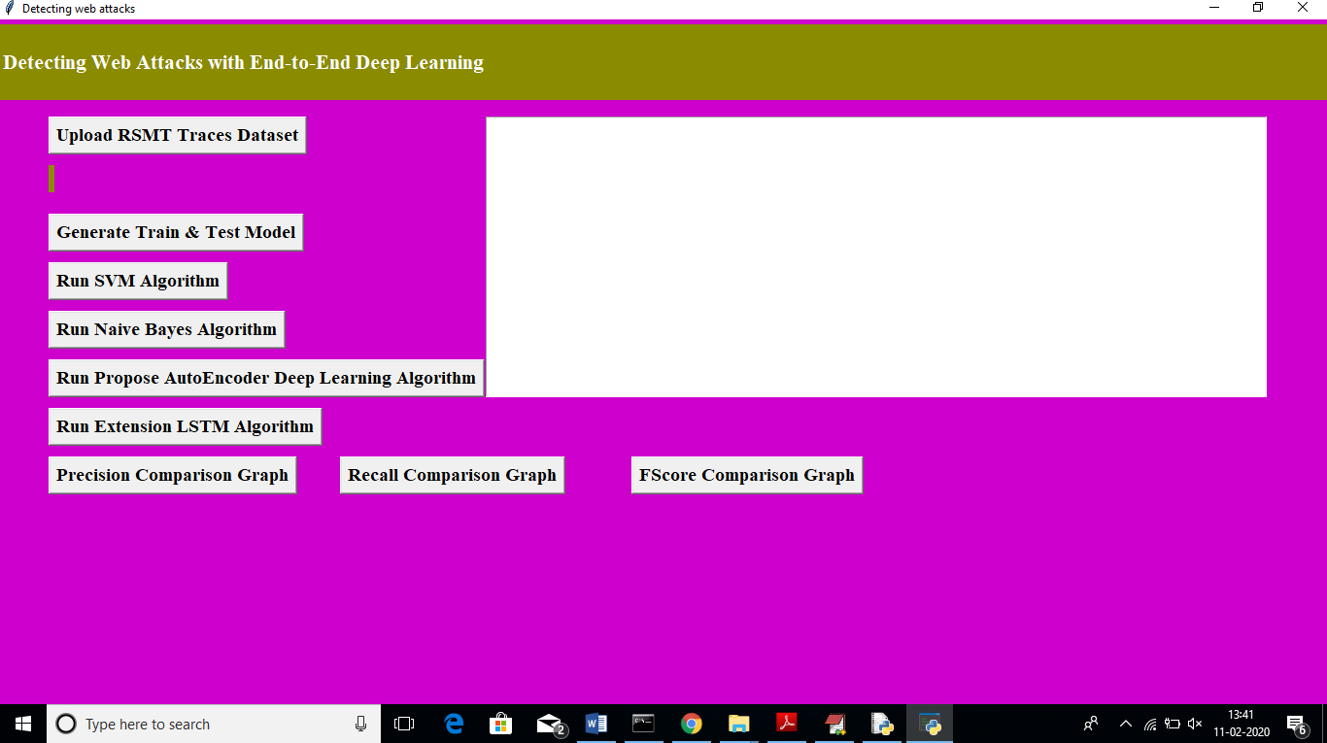
USER INTERFACE OF THE APPLICATION

Screenshot 5.1: USER INTERFACE OF THE APPLICATION

AUTO ENCODER SYSTEM FOR INTRUSION DETECTION

UPLOADING DATASET INTO THE APPLICATION
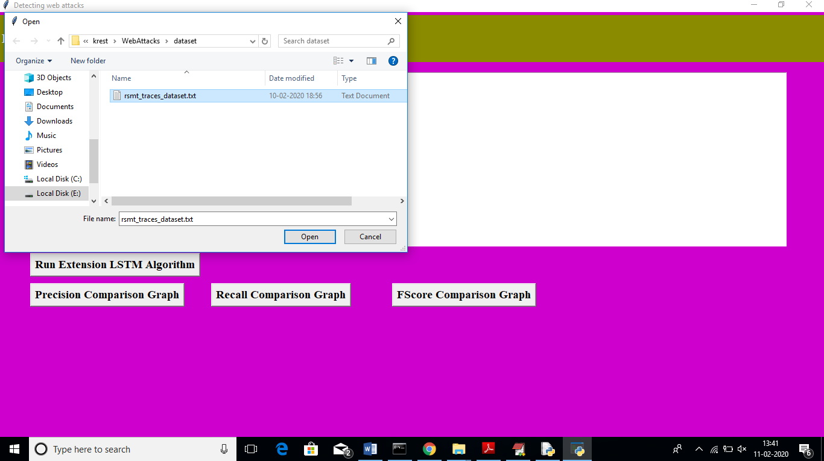

Screenshot 5.2: UPLOADING DATASET INTO THE APPLICATION

CMRTC 31

AUTO ENCODER SYSTEM FOR INTRUSION DETECTION

LOADING DATASET TO PERFORM ANALYSIS
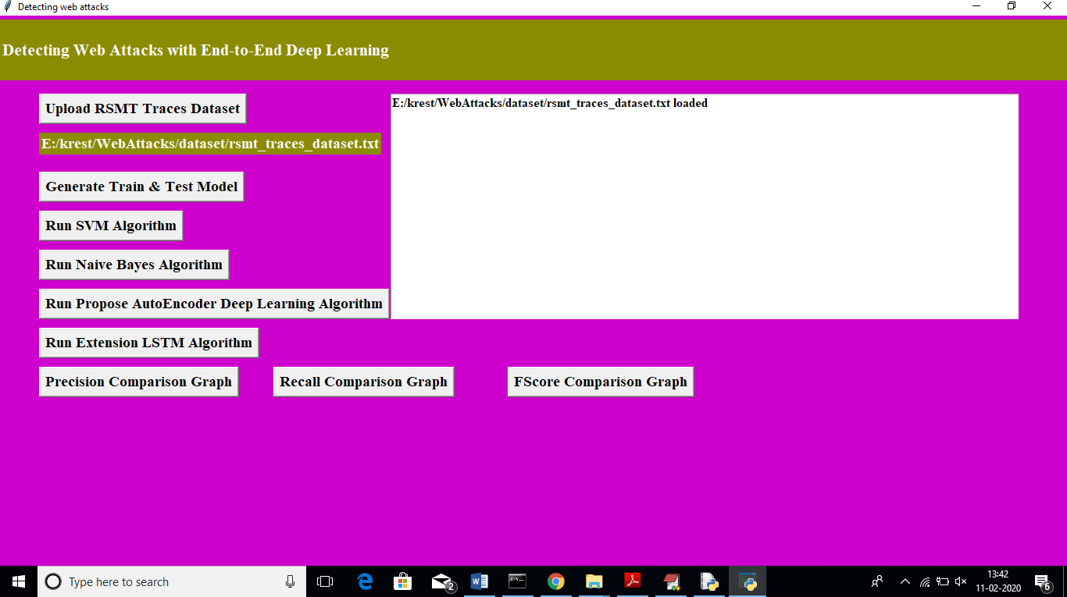

Screenshot 5.3: UPLOADING DATASET TO PERFORM ANALYSIS

AUTO ENCODER SYSTEM FOR INTRUSION DETECTION

DETECTION OF DATASET
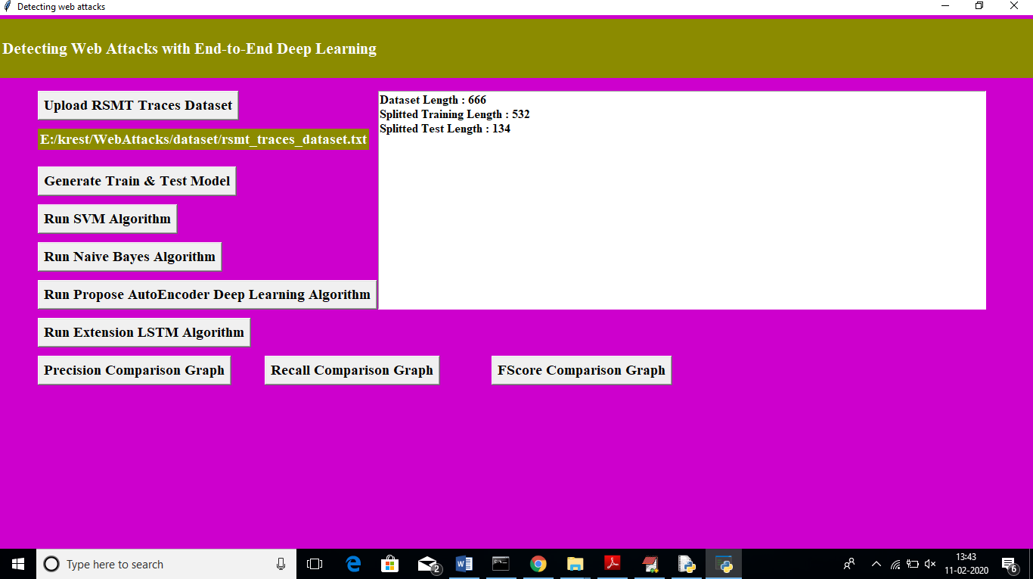

Screenshot 5.4: DETECTION OF DATASET

AUTO ENCODER SYSTEM FOR INTRUSION DETECTION

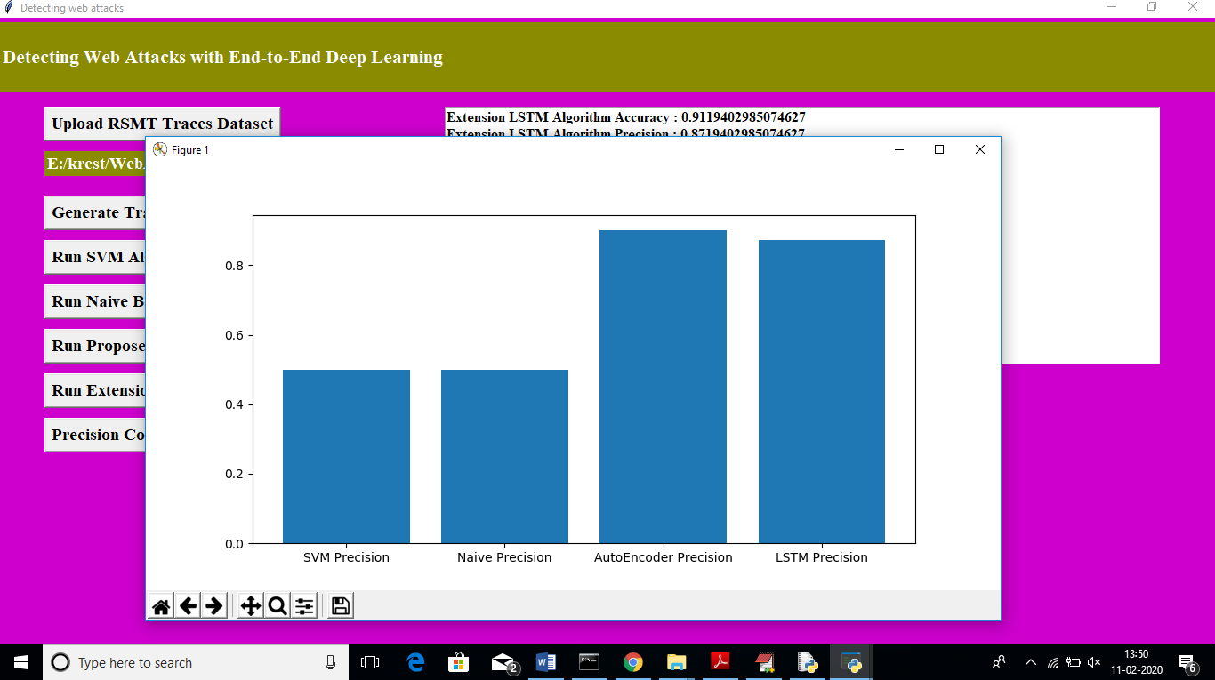
DATASET ANALYSIS GRAPH

Screenshot 5.5: DATASET ANALYSIS GRAPH

CMRTC 34

TESTING

AUTO ENCODER SYSTEM FOR INTRUSION DETECTION

TESTING

INTRODUCTION TO TESTING

The purpose of testing is to discover errors. Testing is the process of trying to discover every conceivable fault or weakness in a work product. It provides a way to check the functionality of components, subassemblies, assemblies and/or a finished product. It is the process of exercising software with the intent of ensuring that the Software system meets its requirements and user expectations and does not fail in an unacceptable manner. There are various types of tests. Each test type addresses a specific testing requirement.

TYPES OF TESTING

    - UNIT TESTING
Unit testing involves the design of test cases that validate that the internal program logic is functioning properly, and that program inputs produce valid outputs. All decision branches and internal code flow should be validated. It is the testing of individual software units of the application. It is done after the completion of an individual unit before integration. This is a structural testing that relies on knowledge of its construction and is invasive. Unit tests perform basic tests at component level and test a specific business process, application and/or system configuration. Unit testsensure that each unique path of a business process performs accurately to the documented specifications and contains clearly defined inputs and expected results.

CMRTC 35

AUTO ENCODER SYSTEM FOR INTRUSION DETECTION

INTEGRATION TESTING
Integration tests are designed to test integrated software components to determine if they actually run as one program. Integration tests demonstrate that although the components were individually satisfactory, as shown by successfully unit testing, the combination of components is correct and consistent. Integration testing is specifically aimed at exposing the problems that arise from the combination of components.

FUNCTIONAL TESTING
Functional tests provide systematic demonstrations that functions tested are available as specified by the business and technical requirements, system documentation, and user manuals.
Functional testing is centered on the following items:

Valid Input: Identified classes of valid input mustbe
accepted.
InvalidInput: identified classes of invalid input must
be rejected.
Functions: identified functions must be exercised.

Output : identified classes of application outputs must be exercised.

Systems/Procedures: interfacing systems or procedures must be invoked. Organization and preparation of functional tests is focused on requirements, key functions, orspecial test

TEST CASES

    - CLASSIFICATION

Table 1 : Test Cases

Test case ID | Test case name | Precision | Recall | F-Score
1 | Naïve Bayes | 0.941 | 0.800 | 0865
2 | Random forest | 1.000 | 0.800 | 0.889
3 | SVM | 0.933 | 0.800 | 0.889
4 | AGGREGATE VOTE | 1.000 | 0.800 | 0.889
5 | AGGREGATE ANY | 0.941 | 0.800 | 0.865

CONCLUSION

CONCLUSION

CONCLUSION
LSTM algorithms have been found to be effective in detecting web attacks based on the results of this study. In addition to its high performance, the LSTM algorithm has the advantage of being able to process sequential data, which is particularly relevant for detecting web attacks. The LSTM algorithm is also capable of learning from previous inputs, making it well-suited for handling dynamic and evolving attacks.

FUTURE RECOMMENDATIONS
The use of deep learning algorithms, such as the LSTM algorithm, in web attack detection is a promising area for future research and development. Some potential future directions for this area include:
Improvement of detection performance: While the LSTM algorithm achieved high accuracy and recall scores in the study, there may still be room for improvement. Future research can explore the use of more sophisticated neural network architectures, optimization techniques, and feature engineering methods to improve the accuracy and robustness of web attack detection.
Detection of new and emerging attacks: Web attacks are constantly evolving, and new attack types may emerge that current detection methods are not equipped to handle. Future research can focus on developing techniques for detecting novel and unknown attack types using deep learning algorithms.

BIBLIOGRAPHY

BIBLIOGRAPHY

8.1 REFERENCES 8.2
- Al-Fayoumi, M. A., Al-Naffouri, T. Y., & Al-Salman, A. S. (2019). Deep learning for intrusion detection: A comprehensive review. IEEE Communications Surveys & Tutorials, 22(3), 1380-1419.
- Alom, M. Z., Yakopcic, C., Hasan, M., Taha, T. M., & Asari, V. K. (2019). Intrusion detection using deep learning: A review. IEEE Access, 7, 45400-45419.
- Kim, T. H., Park, J. H., Lee, J. H., & Choi, D. H. (2016). A deep learning approach to network intrusion detection. Journal of Information Security and Applications, 31, 1-12.
- Mirsky, Y., Shabtai, A., & Elovici, Y. (2018). Network-based detection of web application attacks using deep autoencoder neural networks. IEEE Transactions on Information Forensics and Security, 13(10), 2560-2573.
- Puniya, P., & Lamba, G. (2019). Deep learning-based approaches for intrusion detection system: A review. Journal of Intelligent & Fuzzy Systems, 37(4), 4997-5014.
- Al-Harthi, A. S., Shamsuddin, S. M., & Sulaiman, M. N. (2018). A deep learning approach for detecting SQL injection attacks in web applications. Journal of Ambient Intelligence and Humanized Computing, 9(4), 1121-1134.
- Alom, M. Z., Hasan, M., Yakopcic, C., Taha, T. M., & Asari, V. K. (2019). Intrusion detection using deep belief networks. In Proceedings of the IEEE Conference on Computer Vision and Pattern Recognition Workshops (pp. 0-0).
- Gao, S., Liu, X., Wu, C., & Chen, X. (2020). A hybrid deep learning approach for web attack detection. IEEE Transactions on Industrial Informatics, 17(2), 1107-1116.
- Ghiasi, S., El-Khatib, K., & Gandomi, A. H. (2021). A comprehensive review of deep learning techniques in cyber-security applications. IEEE Access, 9, 13806-13831.
- Thanh, T. L., Trung, D. T., & Phuong, T. M. (2021). Web attacks detection based on deep learning with data augmentation. Journal of Ambient Intelligence and Humanized Computing, 12(4), 3907-3920.
- Park, J., Park, H., Kim, J., & Han, S. (2020). A deep learning approach for detecting injection attacks in web applications. Information Sciences, 514, 231-246.

AUTO ENCODER SYSTEM FOR INTRUSION DETECTION

8.3 GITHUB LINK

https://github.com/Tharak5l5/auto-encoder-system-for-intrusion-detection/upload

CMRTC 40

PAPER PUBLICATION

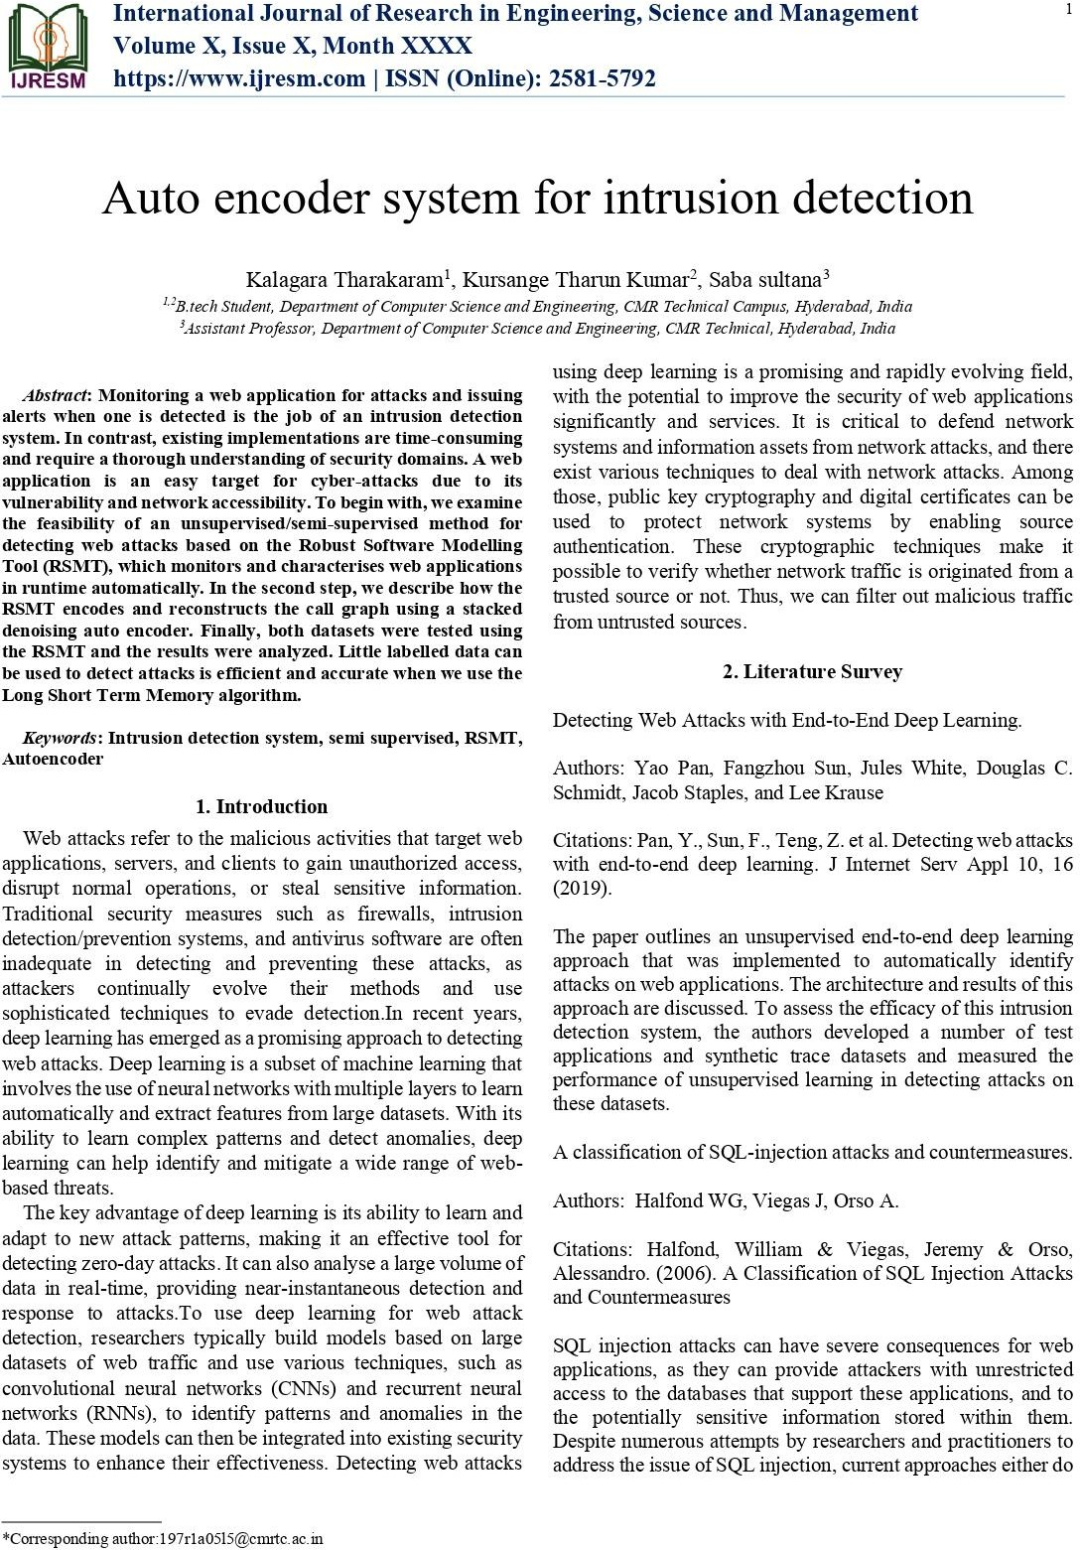

41
CMRTC

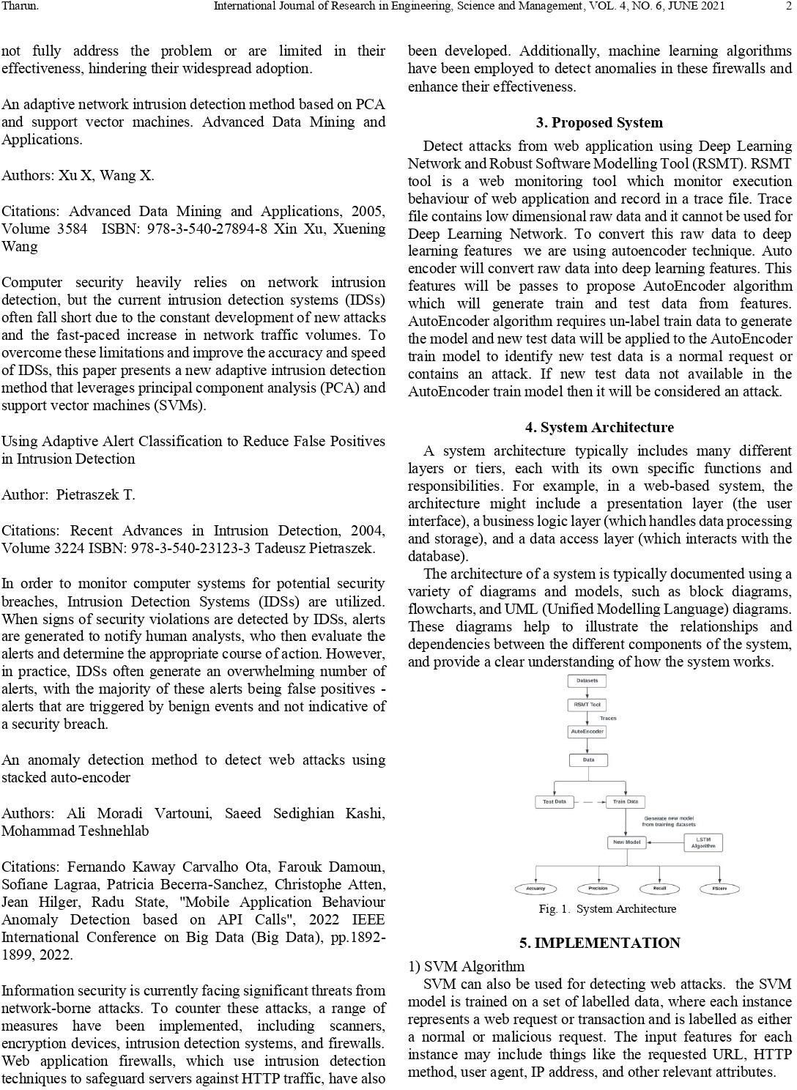

42

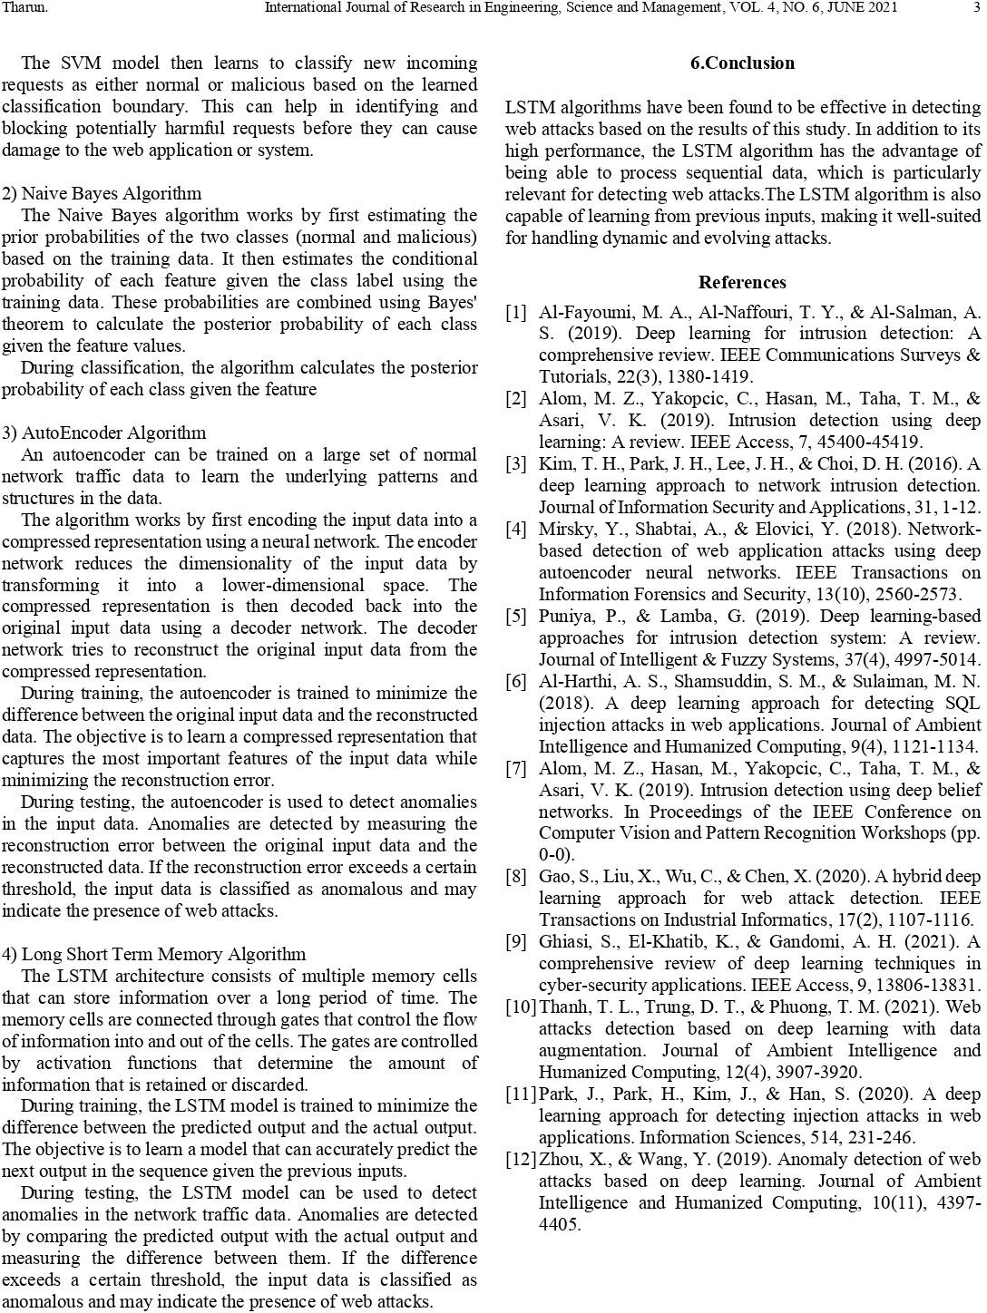

CMRTC 43

CERTIFICATES

