Introduction:

In this project we write a simple shell in C. Our shell waits for user to enter a command and reads the command line and separate it into distinct argument and executes this command in a child process.

The simple shell waits for the user to enter a command and then reads the user’s next command and parses it into separate tokens that are used to fill the argument vector for the command to be executed in a separate process.

PART A:
In this part our command line takes the command as input and will execute that in a new process. By creating a new process we used fork() function in C. Fork function creates a child process and . The child uses execl() function to execute the program.
We also checked if program is running in the background or foreground. A background process is indicated by placing an ampersand (’&’) character at the end of an input line.
When a process is background, the shell doesn’t wait to execute the child. If program is foreground we used waitpid() function to wait parent process until its child is executed.

Sample screenshots:
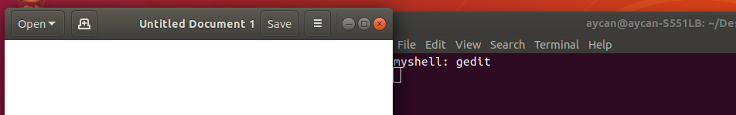
When we run gedit command program waits until we close the file.(Parent waits for child to execute


When we close the file program returns to myshell.(Parent process continues)

When we run gedit command in background, process doesn’t wait for child to execute.
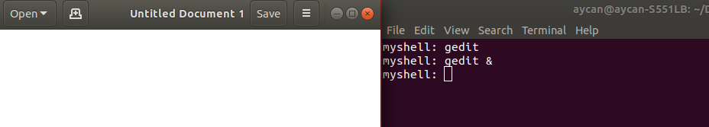
Another sample commands that executed.
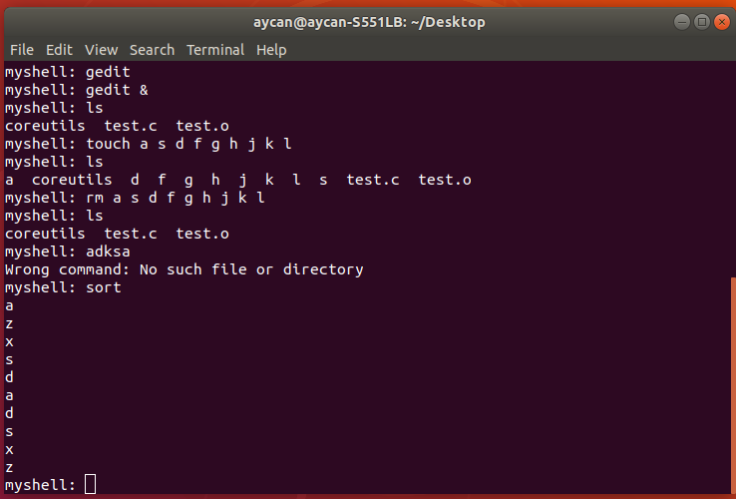

PART B:
In this part we add our shell some built-in commands. We add 5 built-in commands.
One of them is “alias”. Alias command sets commands to some argument and adds the alias list. if we run this argument,program gets command that setted to argument and executes that command. alias has also can take -l . “alias -l” command lists the alias list. There is also unalias command which is removes command that we set to some argumant from alias list
Another one is “clr”. Clr commands clears the screen.
Another one is “exit” command. When user writes exit,program waits if there is some background process that running ,program waits until all finishes .Then program exits.
Another one is fg command which makes all background processes to foreground.In order to do this ,we insert all background processes pid in a linked list. When user enters “fg” command parent process waits all background processes one by one by with waitpid() function
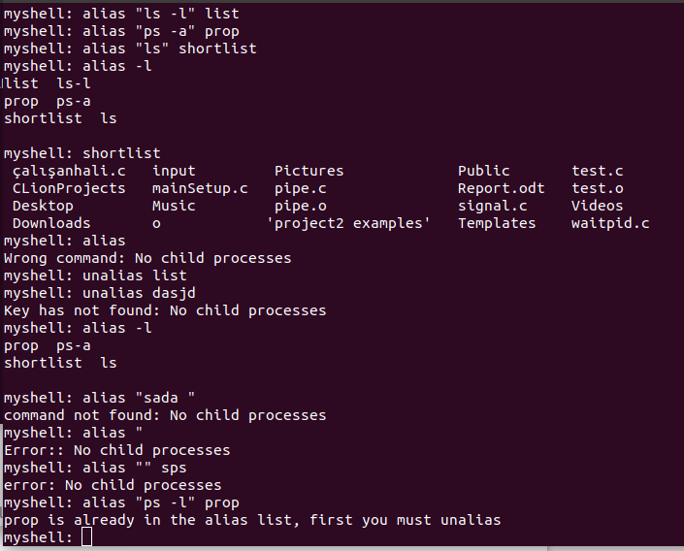
In this part we also used SIGTSTP signal. When user press control+z, program terminates the current running foreground process. If there is not any, then signal does nothing.

Some sample commands about alias executed.

When sleep 10 command called in background and exit command called,program waits until process ends.
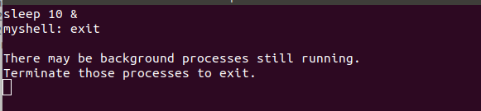
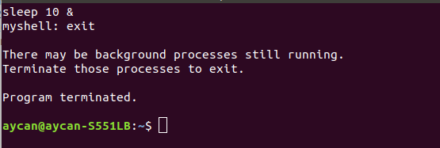

When process ends program terminates

When “clr” command runs.(Before clr called)
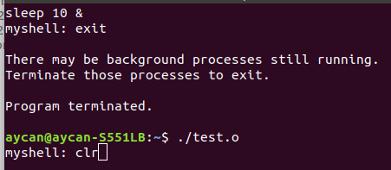

After “clr” command called:
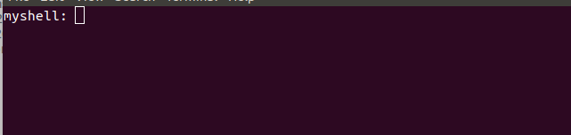

When gedit runs in a background:
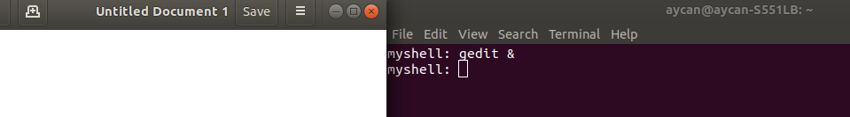
After fg command entered,gedit becomes foreground.
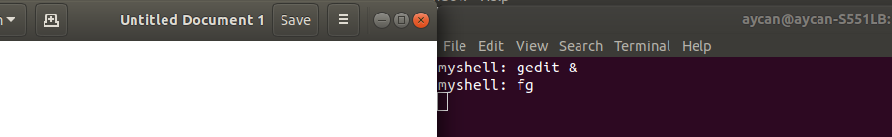
After gedit executed.
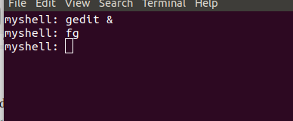

PART C:
In this part we made our shell to support I/O redirection. It can writes to file,or appends file, or, writes standart error to file,or takes input from file and use thesi input to execute our command and also write its output into file.

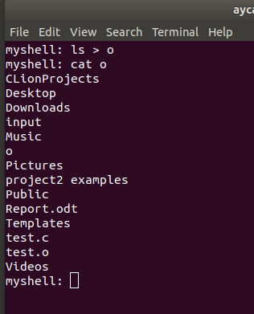

when we redirected the output of command “ls” ,to output file, if file does’nt exist, then creates and writes the output to file.If there is a file and it is not empty, It truncates everything in it and writes the output to file.

In doing this we used dup2() function. We opeded the file with (O_CREAT | O_TRUNC | O_WRONLY) modes.

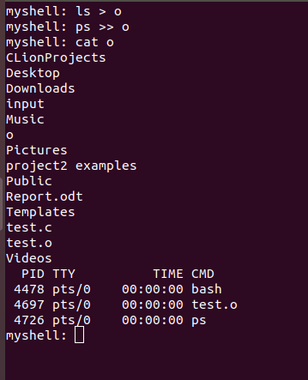

when user use append redirection, program appends the standart output to output file.If file does’nt exist ,it will creates.

In doing this we used dub2() function in O_CREAT | O_APPEND | O_WRONLY modes.

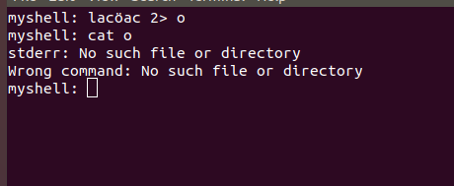
When user enters a command that not exacly belong to any path, then program writes the error code to output file
When we are doing thiswe used dub2() function with O_CREAT | O_TRUNC | O_WRONLY modes.

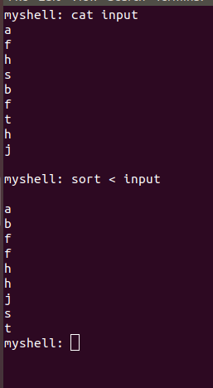

input file is like show in the left. When user use this input file for sort commands input ,then sort operation sorts these elements of inputs and prints the screen.
In doing this ,we used O_RDONLY mode of dub2() function.

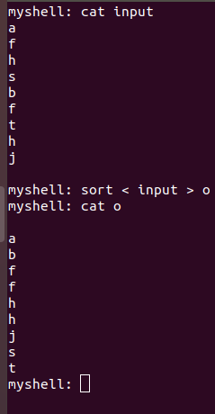

In this part program reads the values inside the input file and makes sort operation. And writes the output of the sort operation to output file.
We used dub2 function first with O_RDONLY mode .Then we close the file and makes sort operation. After that we used the dub2 function again and this time we opened with O_CREAT | O_TRUNC | O_WRONLY modes.

