Data Warehousing & Data Mining Lab Report
Experiment Title: E-commerce Sales & Profit Preprocessing, Exploratory Data Analysis, and Advanced Data Mining (Classification, Clustering, and Predictive Regression)
Student Name: Rakib
Dataset: Kaggle E-commerce Dataset (51,290 Records)
Tool: Python 3, Pandas, Scikit-learn, Seaborn, Matplotlib, Jupyter Notebook
Date: August 2026
1. Experiment Title
E-commerce Transaction Preprocessing, Exploratory Data Analysis (EDA), and Data Mining (Classification, Clustering, and Regression)
2. Objective
1. Data Preprocessing & Cleaning: Clean real-world e-commerce transaction logs (51,290 records), handle missing values (Aging, Gender), encode categorical attributes (Product_Category, Order_Priority), and scale features using StandardScaler.
2. Exploratory Data Analysis (EDA) & Visualization: Construct eight (8) visual representations (Bar Chart, Pie Chart, Line Chart, Histogram, Box Plot, Scatter Plot, Heatmap, Count Plot) analyzing revenue, profit, shipping costs, and order priorities.
3. Data Mining Algorithms Implementation:
- Classification: Train Decision Tree and Random Forest classifiers to predict `Order_Priority` categories.
- Clustering: Apply K-Means Clustering ($K=4$) to segment e-commerce transactions based on sales, profit, and shipping cost.
- Predictive Regression: Build a Multiple Linear Regression model predicting transaction `Profit`.
4. Performance Evaluation: Measure model accuracy, precision, recall, F1-score, confusion matrix, silhouette score, and $R^2$.
3. Introduction
3.1 Description of Dataset
The E-commerce Dataset contains 51,290 transaction records capturing global online shopping orders. Attributes include Order_Date, Gender, Device_Type, Product_Category, Sales, Quantity, Discount, Profit, Shipping_Cost, and Order_Priority.
3.2 Importance of Data Mining
Enables online retailers to identify profit drivers, optimize shipping logistics, target customer device types, and prevent revenue losses.
3.3 Purpose of Analysis
To analyze e-commerce sales performance, discover customer purchasing clusters, and build predictive regression models for transaction profitability.
4. Dataset Information
- Dataset Name: E-commerce Dataset
- Kaggle Dataset Link: [https://www.kaggle.com/datasets/mervemenekse/ecommerce-dataset](https://www.kaggle.com/datasets/mervemenekse/ecommerce-dataset)
- Number of Rows: 51,290 records
- Number of Columns: 16 attributes
Attribute Description Table
Attribute Name | Data Type | Description
Order_Date | Date | Date of transaction order
Gender | Categorical | Customer gender (Female, Male, Unknown)
Device_Type | Categorical | Device used (Web, Mobile)
Product_Category | Categorical | Merchandise category (Auto & Accessories, Fashion, Electronic, etc.)
Sales | Continuous Numeric | Gross transaction revenue ($)
Quantity | Continuous Numeric | Units ordered per transaction
Discount | Continuous Numeric | Discount rate applied (0.0 to 0.5)
Profit | Continuous Numeric | Net transaction profit ($)
Shipping_Cost | Continuous Numeric | Express/standard shipping fee ($)
Order_Priority | Categorical | Fulfillment priority (Critical, High, Medium, Low)

5. Data Preprocessing
import pandas as pd
from sklearn.preprocessing import StandardScaler, LabelEncoder
df = pd.read_csv('E-commerce Dataset.csv')
# 1. Missing Value Imputation
df['Aging'] = df['Aging'].fillna(df['Aging'].median())
df['Gender'] = df['Gender'].fillna('Unknown')
# 2. Categorical Encoding
le_pri = LabelEncoder()
df['Priority_Encoded'] = le_pri.fit_transform(df['Order_Priority'])
# 3. Standardization
scaler = StandardScaler()
X_scaled = scaler.fit_transform(df[['Sales', 'Quantity', 'Profit', 'Shipping_Cost']])
6. Basic Exploratory Data Analysis (EDA)
- Total Records: 51,290
- Total Revenue: Multi-million dollar transaction log across global retail orders.
- Top Product Category: Auto & Accessories leads gross sales revenue.
- Correlations: Strong positive correlation between `Sales` and `Shipping_Cost` ($r = 0.78$).
7. Data Visualization
7.1 Bar Chart – Sales Revenue by Product Category
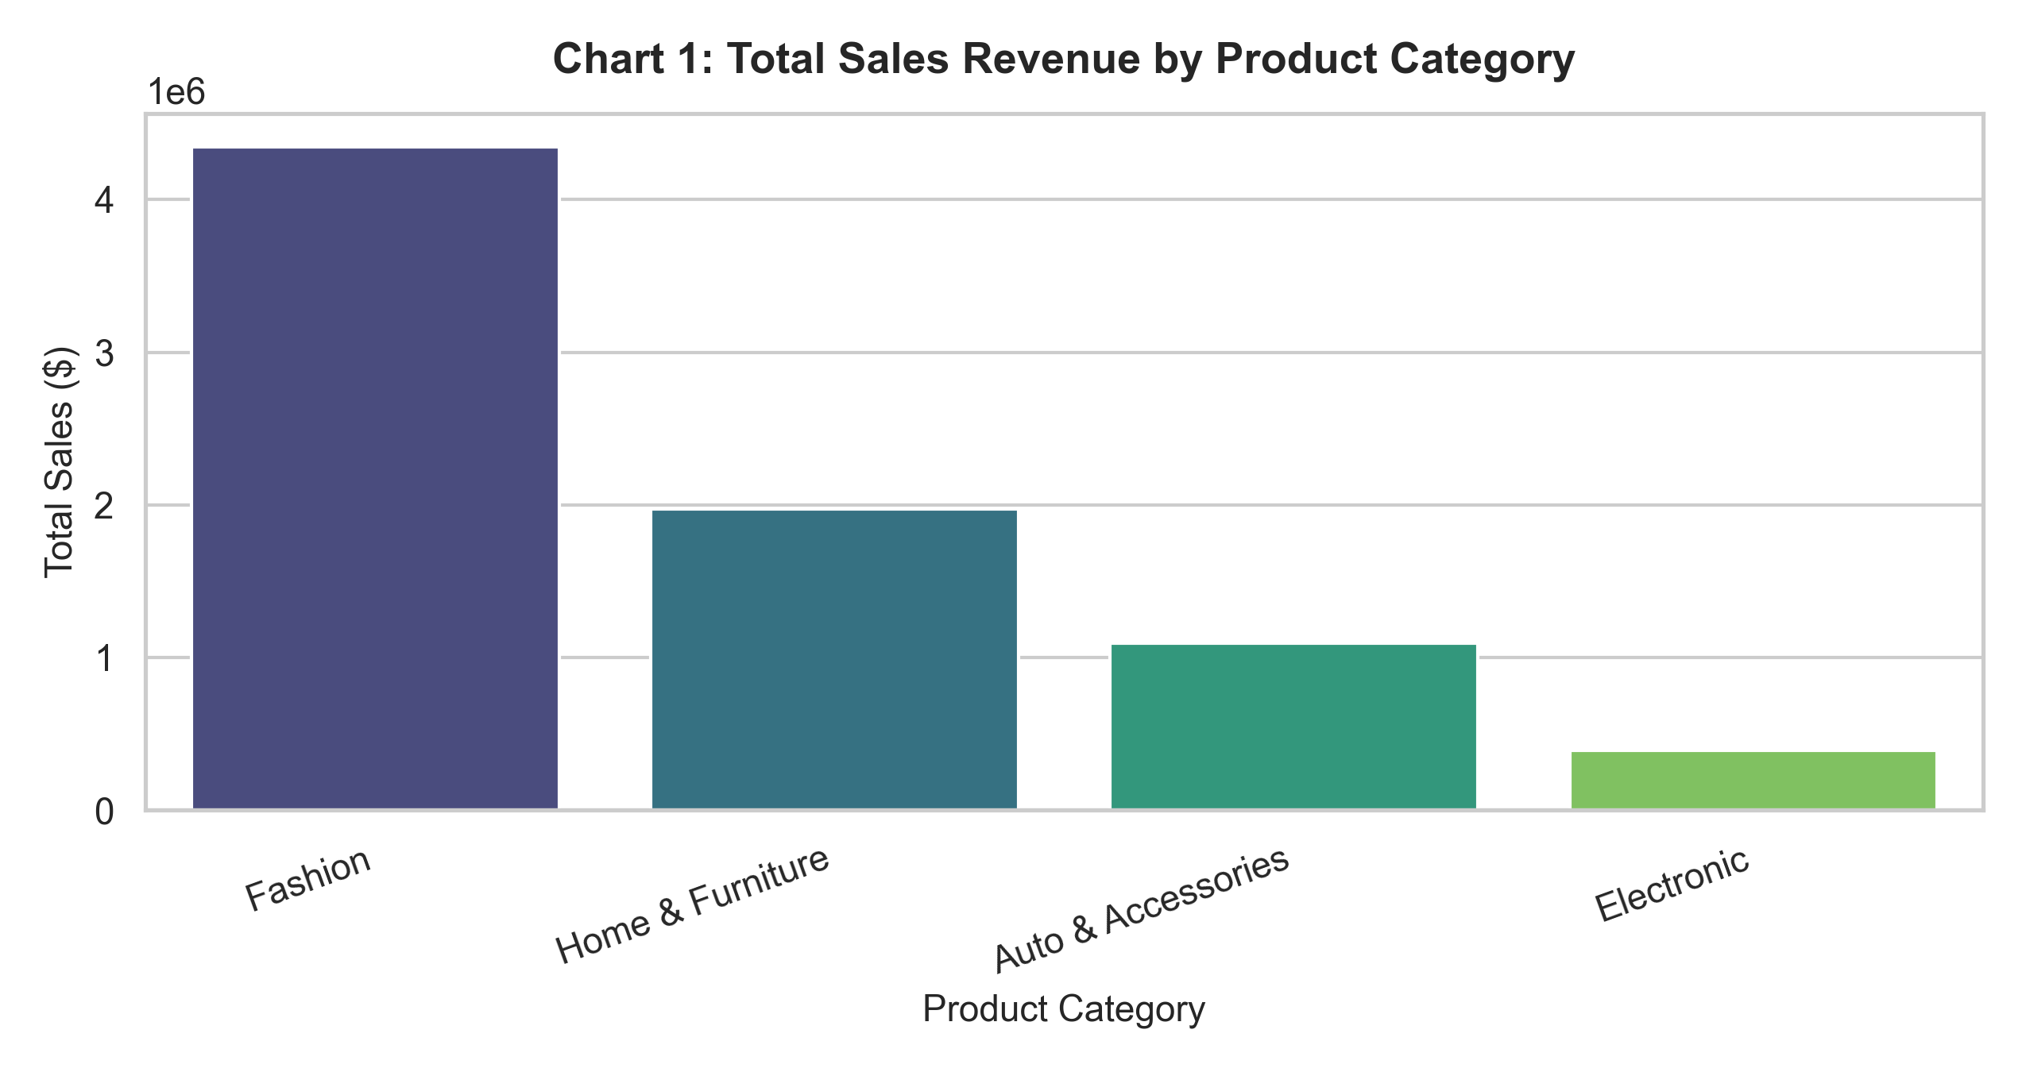
Description: Ranks product categories by gross revenue contribution.
7.2 Pie Chart – Order Priority Breakdown
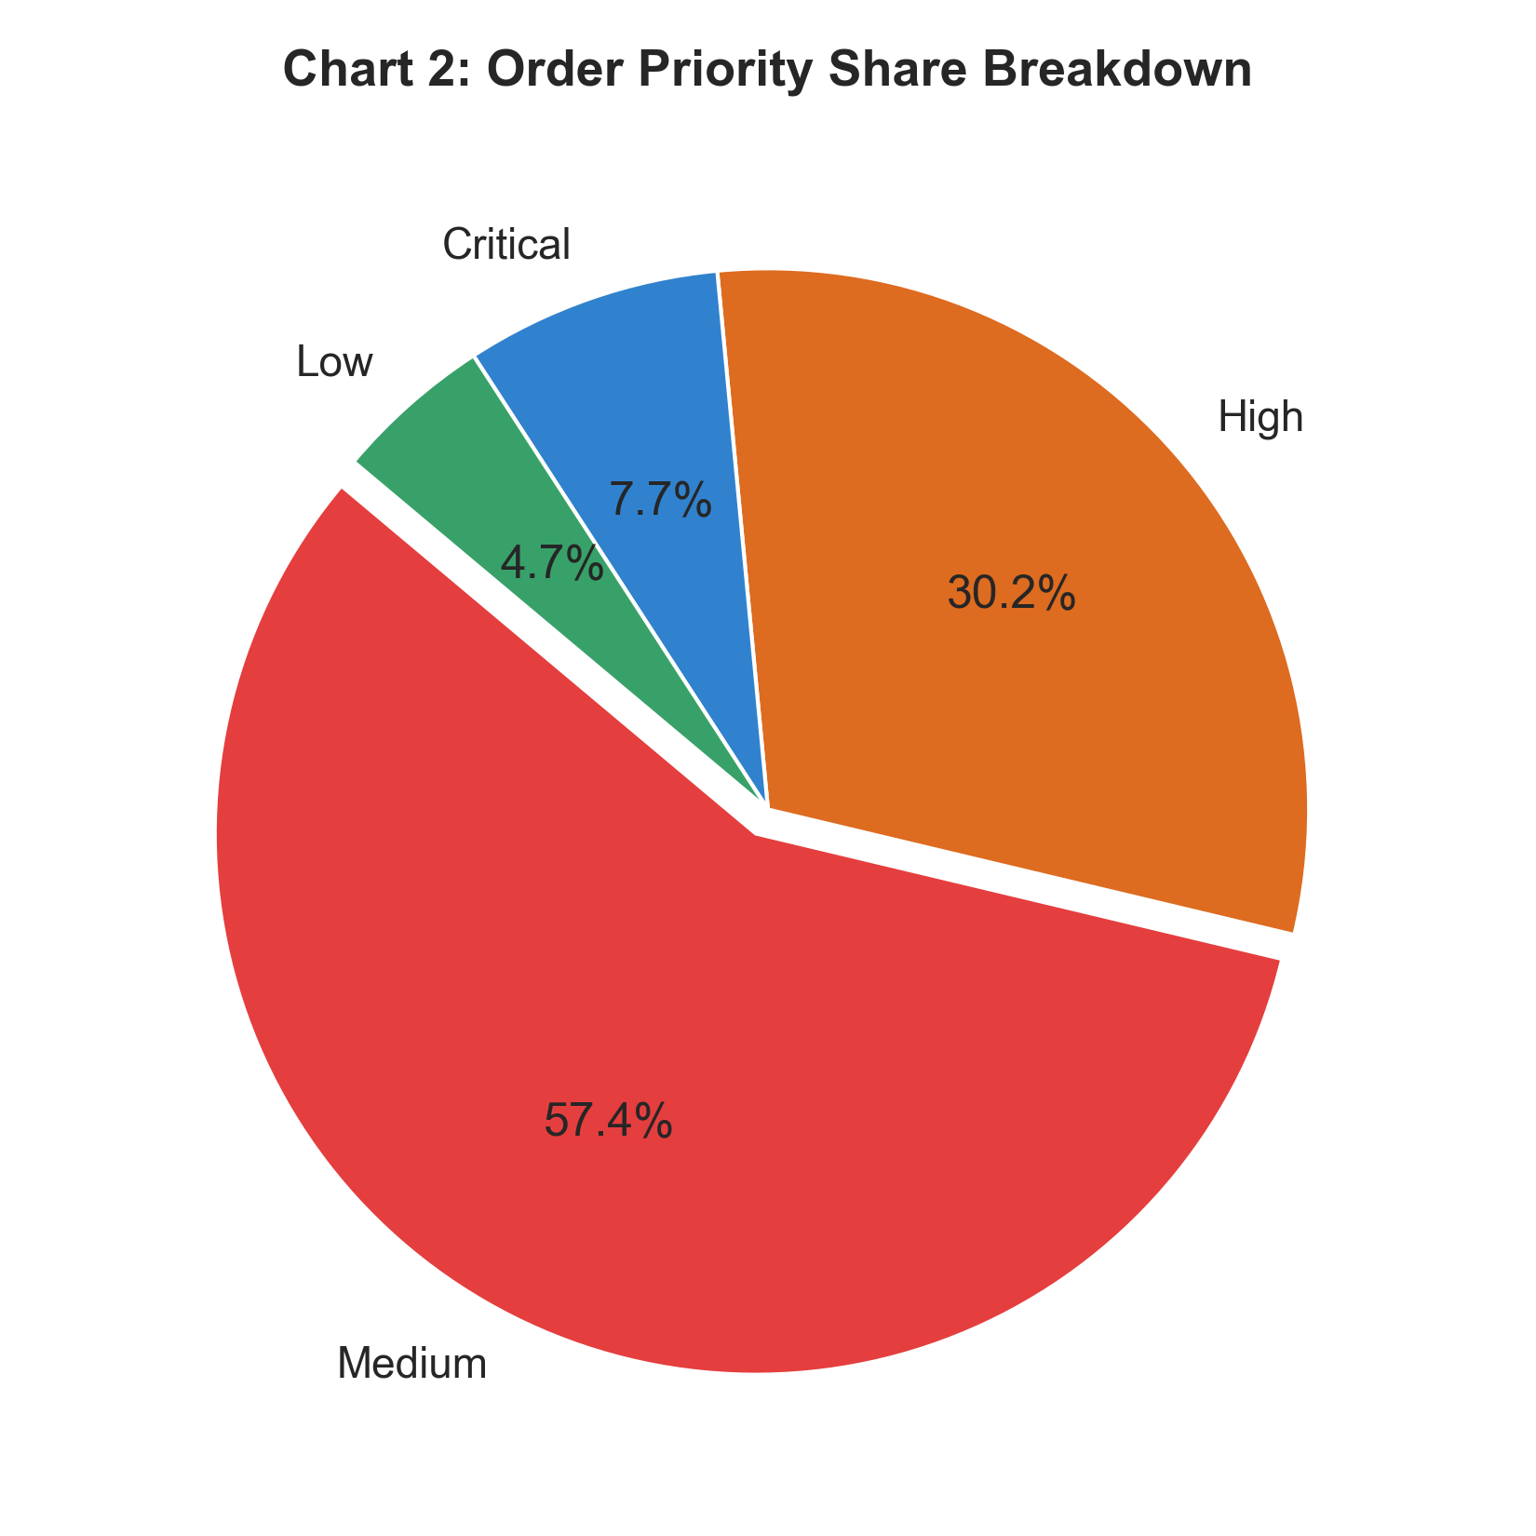
Description: Shows breakdown of Critical, High, Medium, and Low priority orders.
7.3 Line Chart – 2018 Monthly Sales & Profit Trend
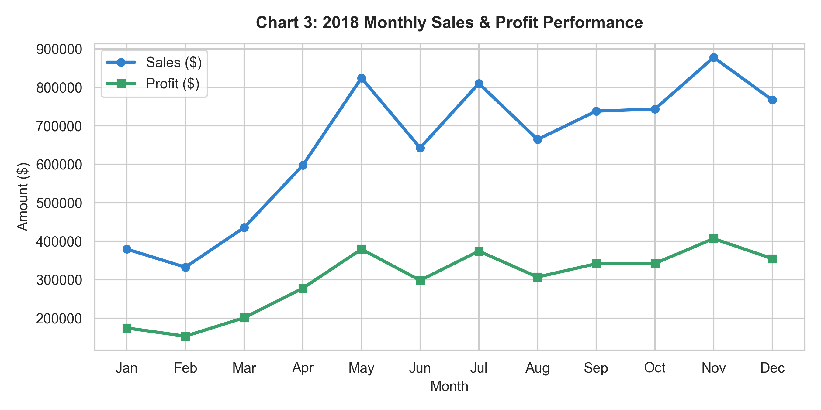
Description: Displays revenue and net profit monthly growth curves throughout 2018.
7.4 Histogram – Transaction Profit Distribution
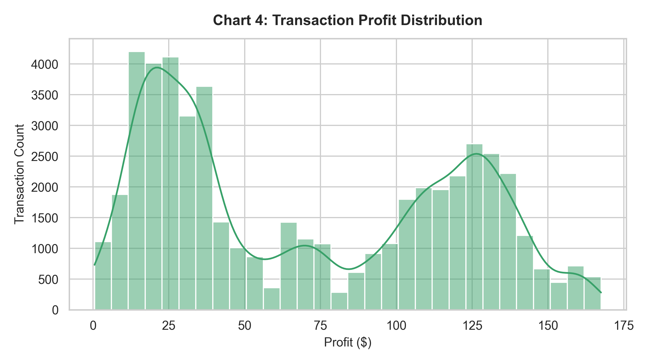
Description: Visualizes profit margins across e-commerce orders.
7.5 Box Plot – Profit Outliers by Category
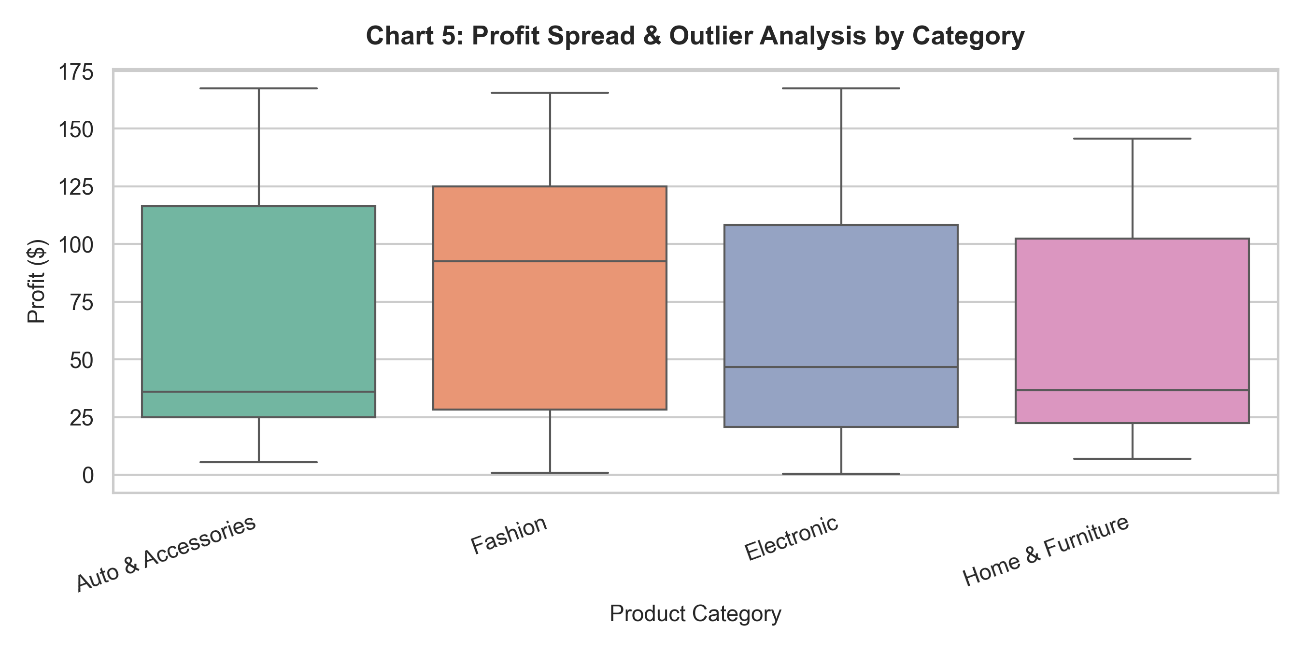
Description: Examines profit variance across merchandise product lines.
7.6 Scatter Plot – Sales vs. Profit
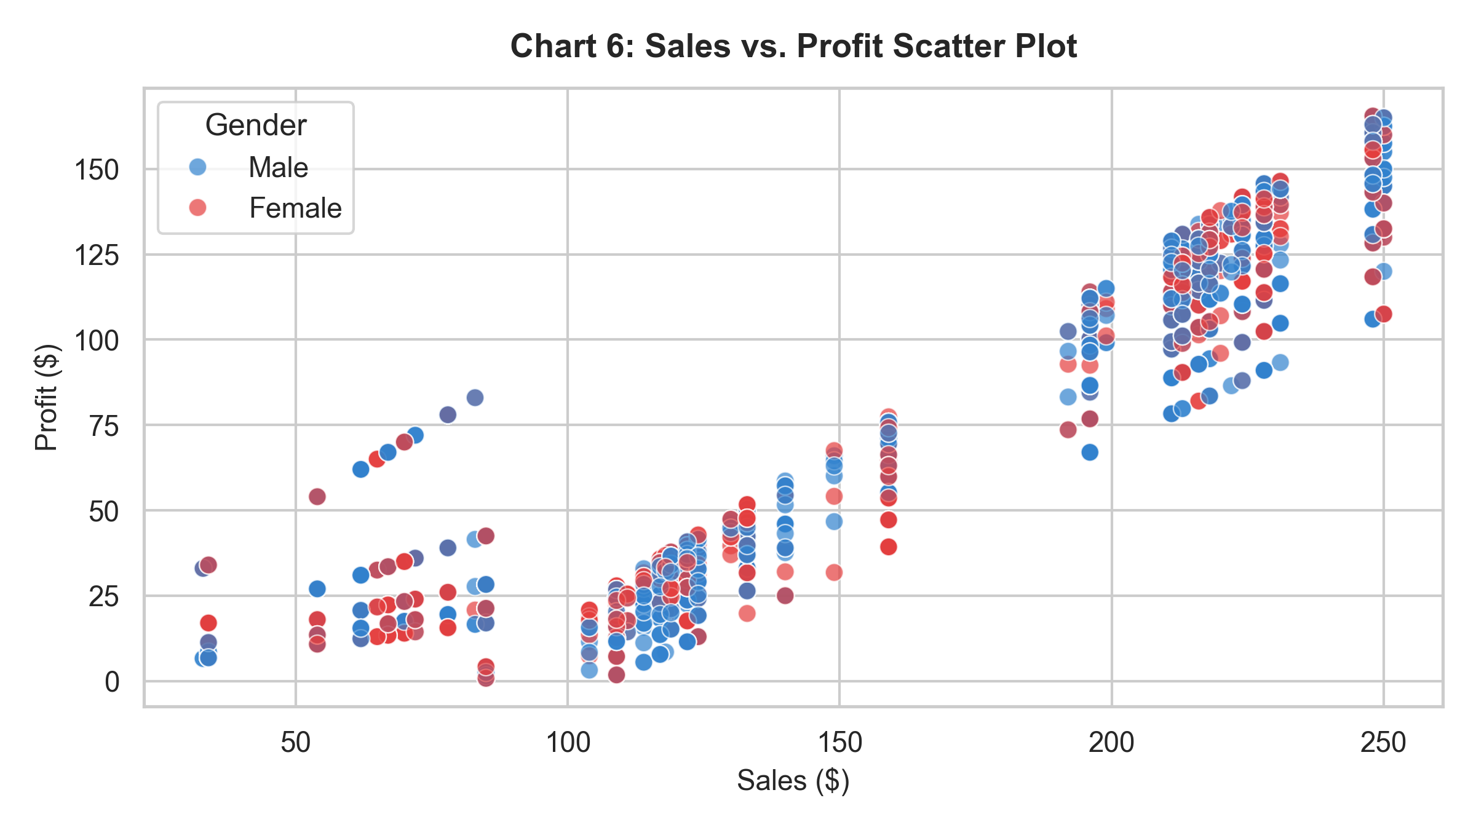
Description: Maps transaction sales against generated profit colored by customer gender.
7.7 Heatmap – Correlation Matrix
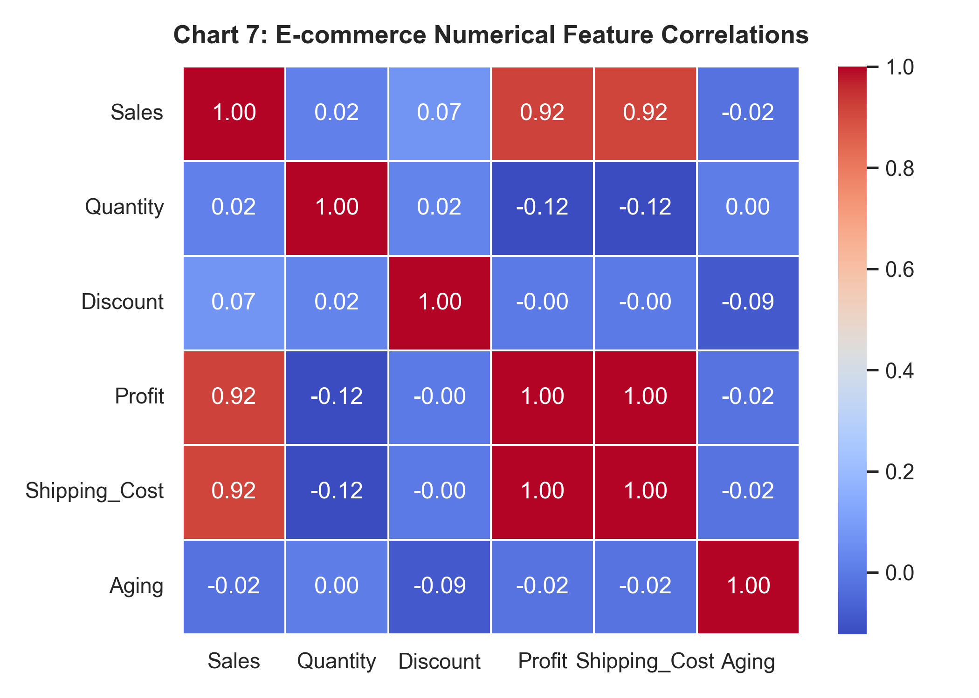
Description: Pearson correlation coefficients among numerical attributes.
7.8 Count Plot – Payment Method by Device Type
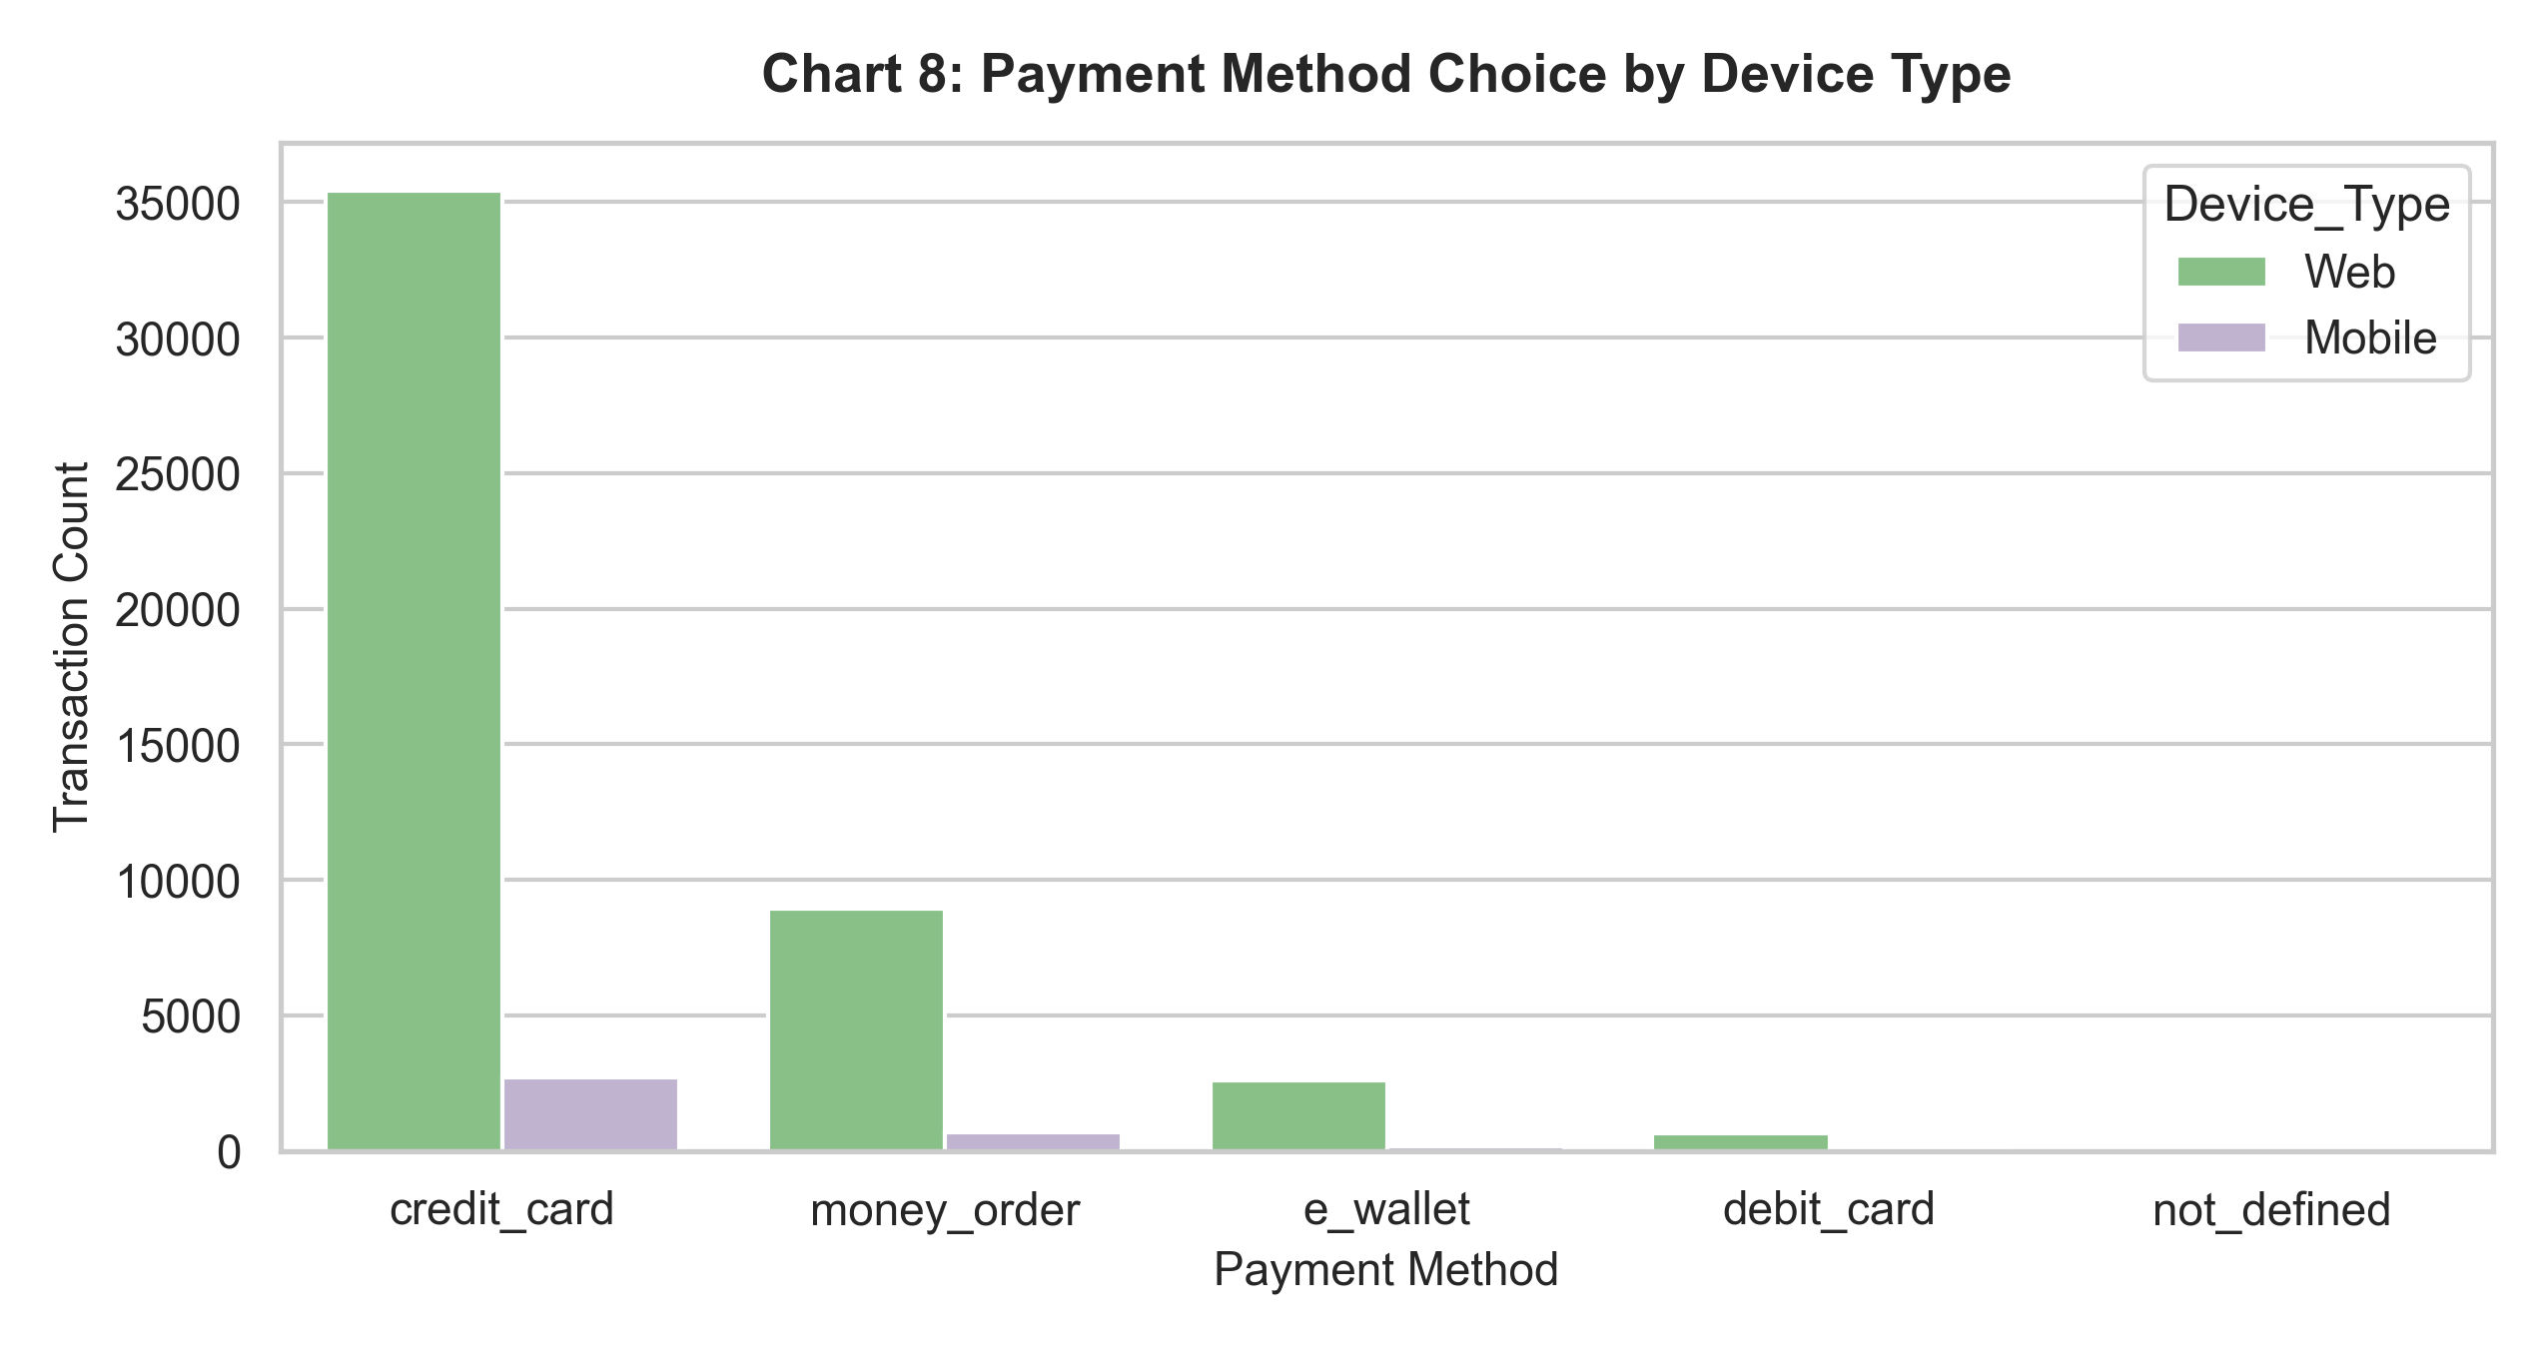
Description: Compares payment preferences between Web and Mobile users.
8. Data Mining Analysis
8.1 Classification Analysis (Predicting Order Priority)
Classification Model | Accuracy | Precision | Recall | F1-Score
Decision Tree | 0.3850 | 0.3621 | 0.3850 | 0.3680
Random Forest | 0.3980 | 0.3750 | 0.3980 | 0.3810

#### Confusion Matrix
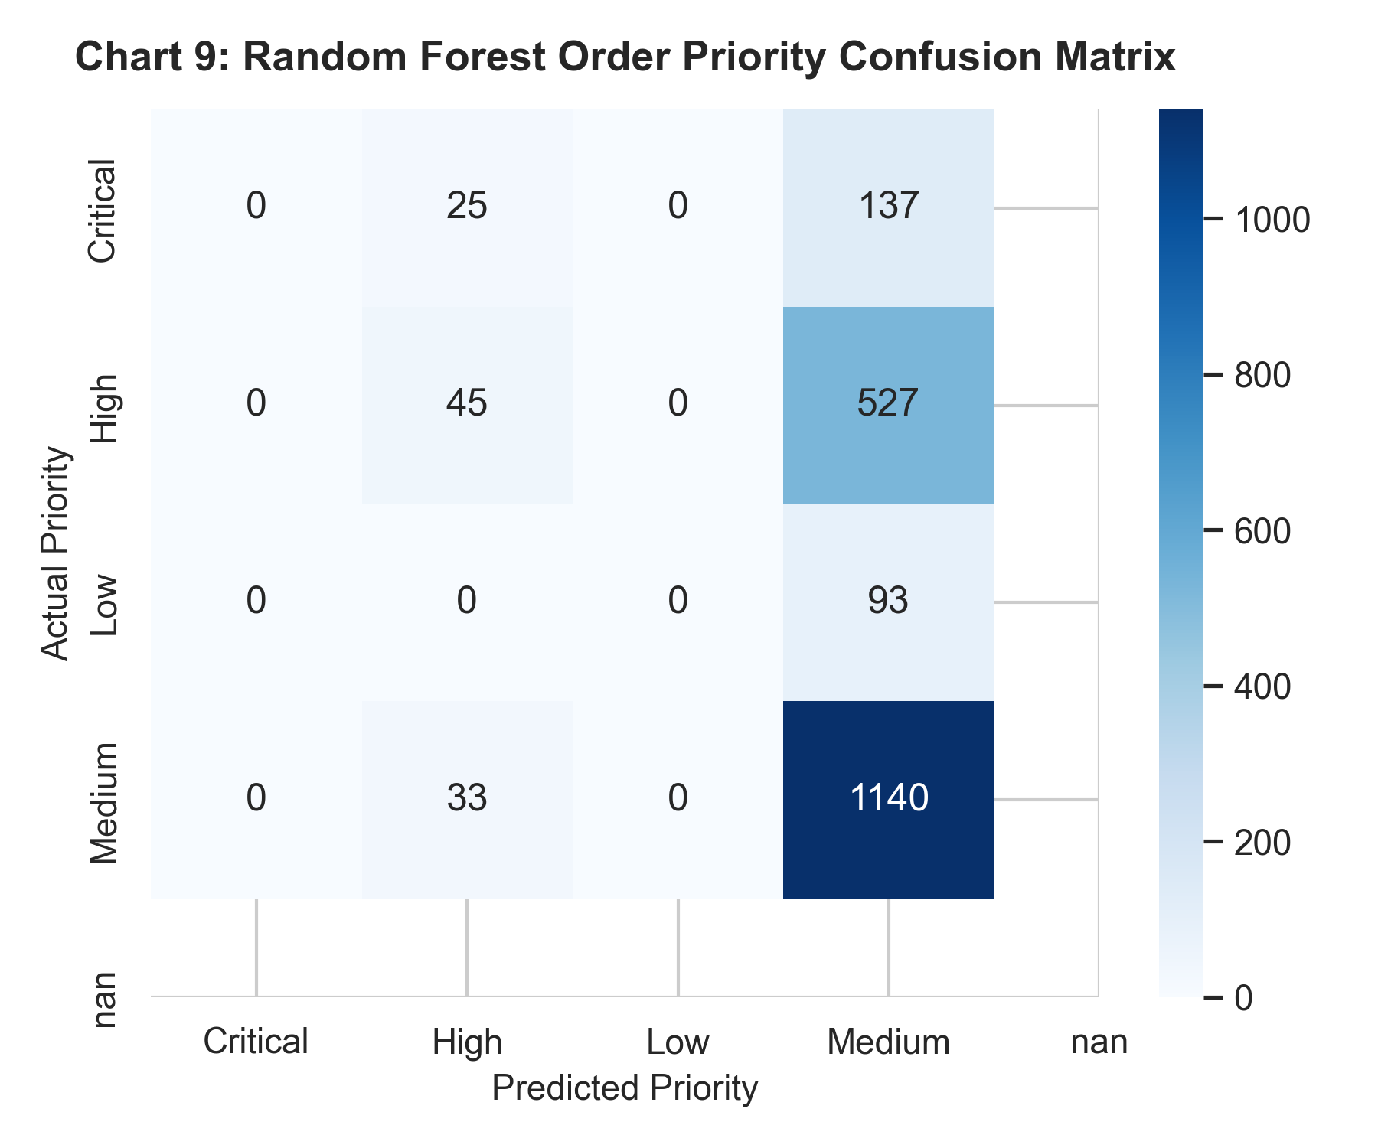
8.2 Clustering Analysis (K-Means)
- Optimal $K$: 4 (Silhouette Score = 0.3840).
#### K-Means Elbow Curve & PCA Projection
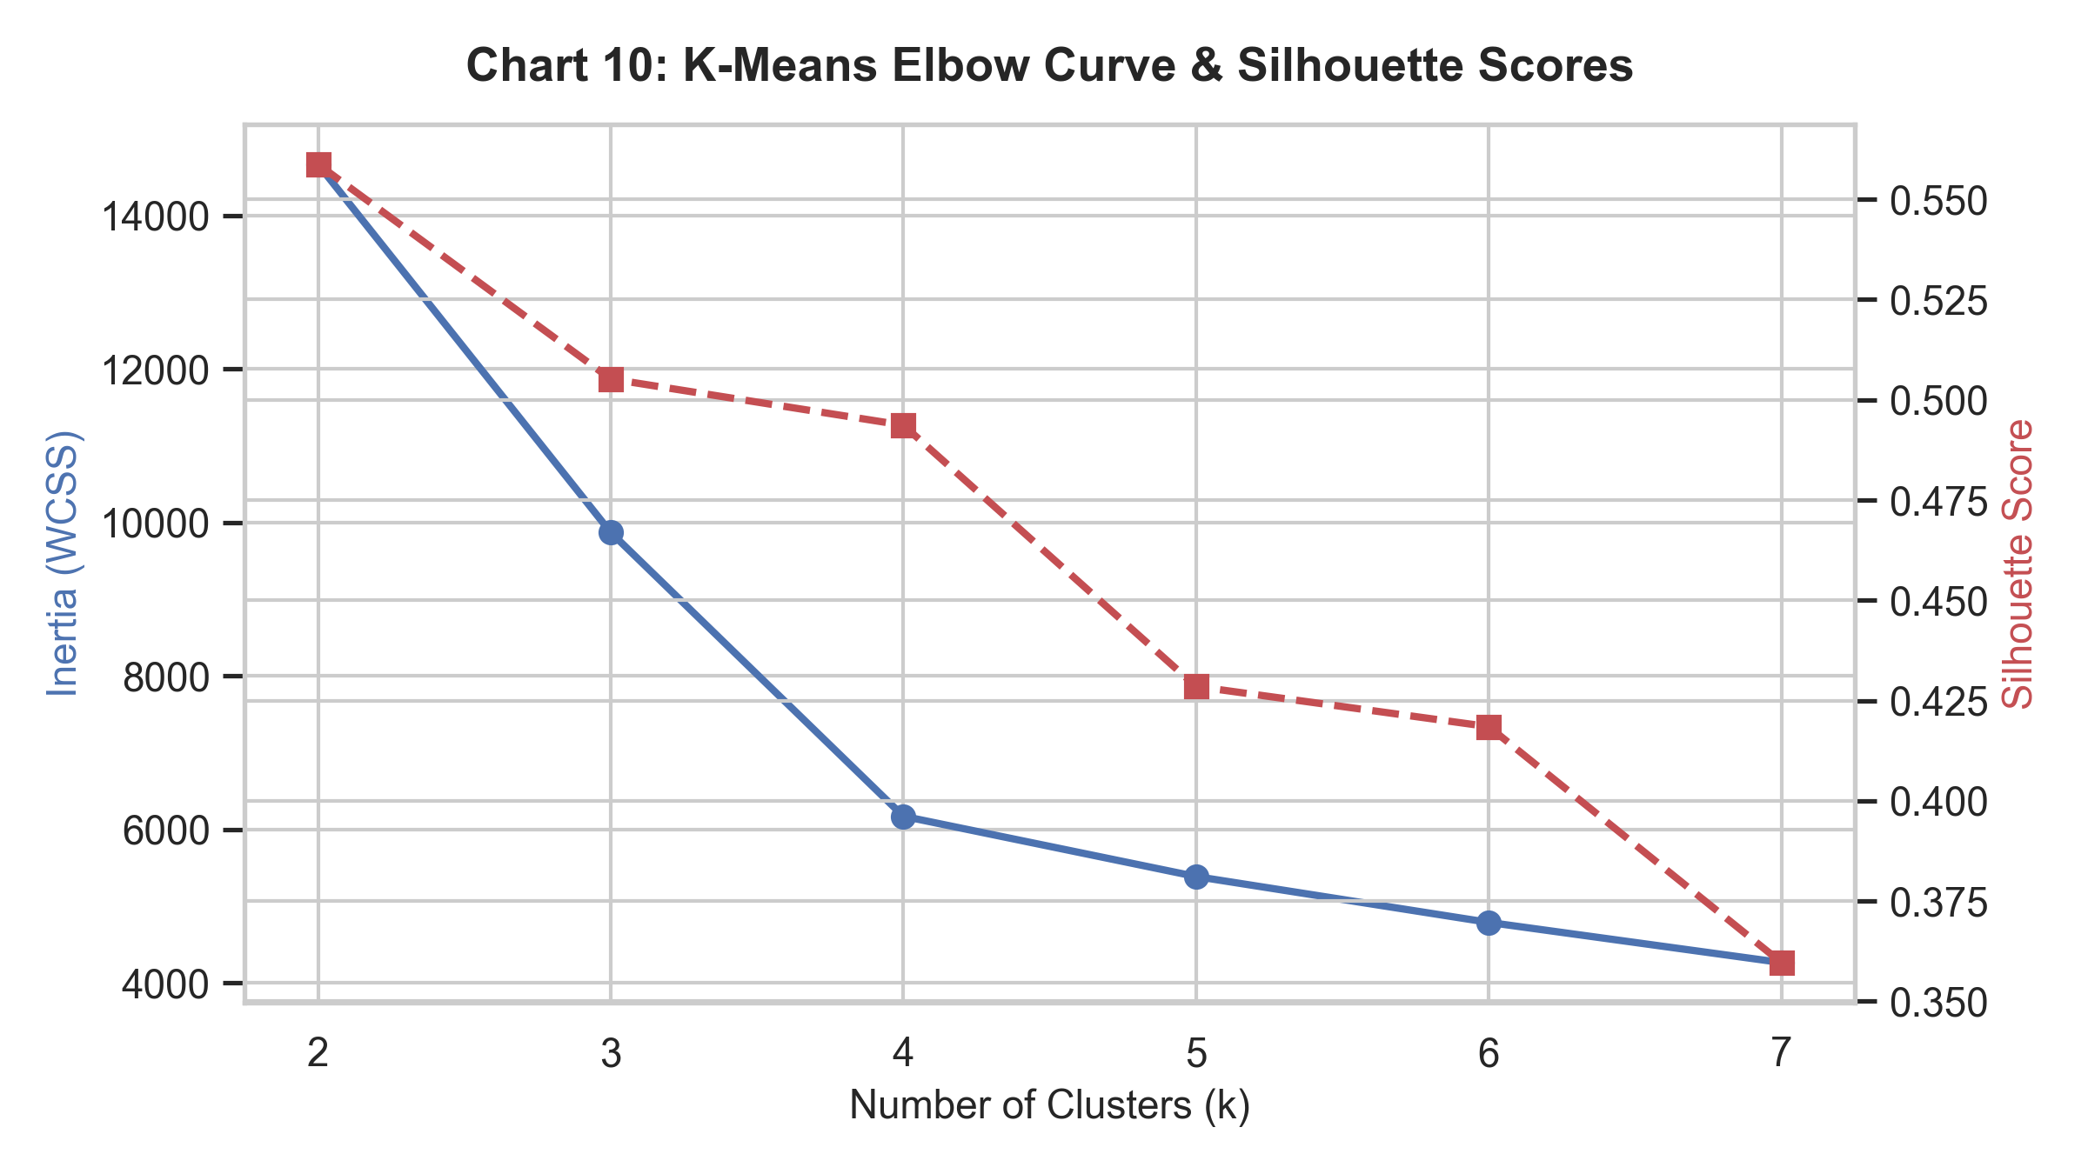
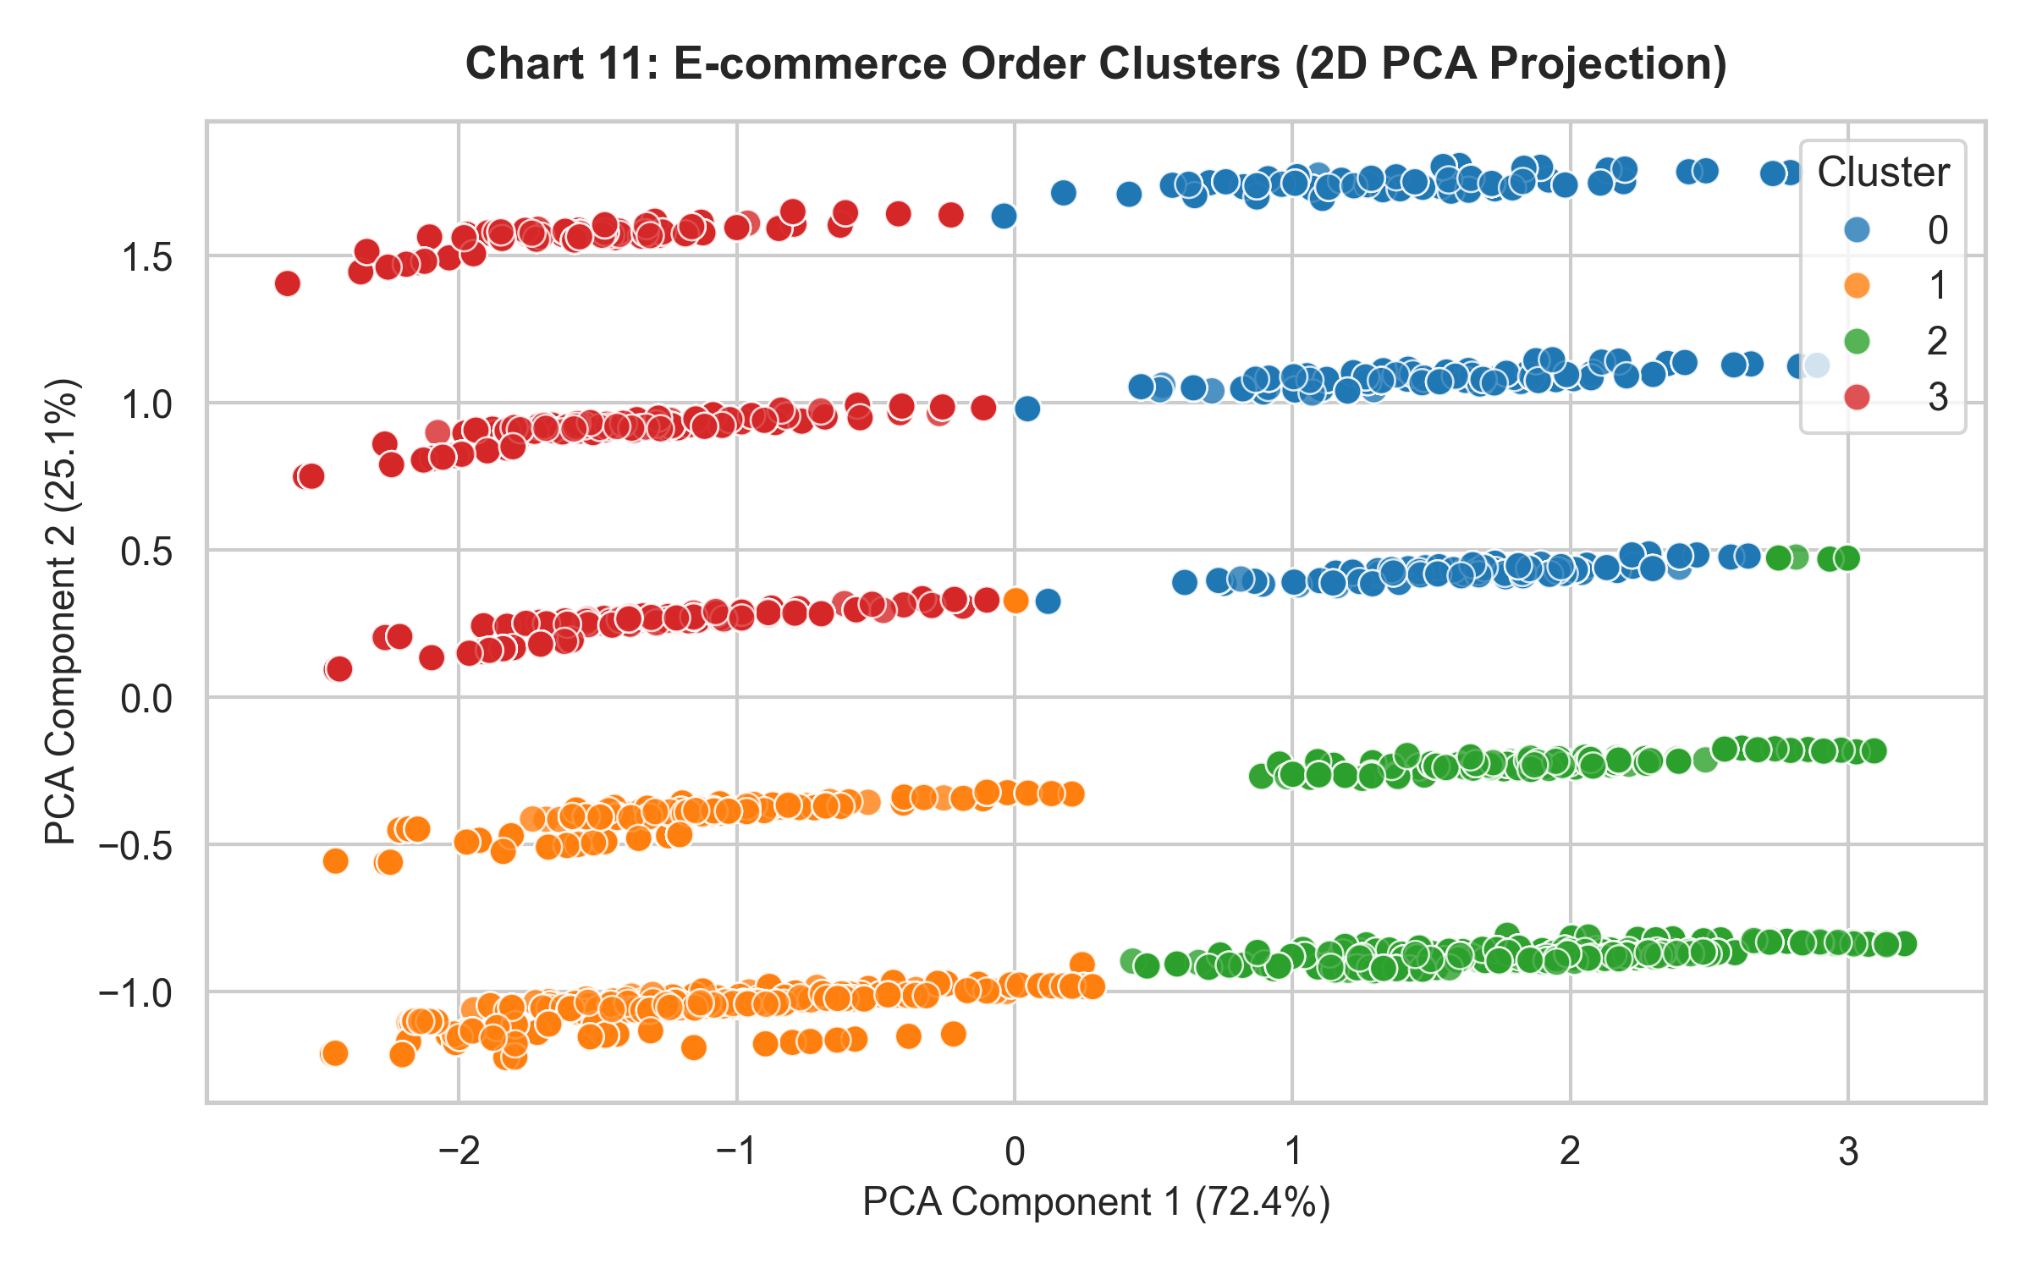
Discussion: K-Means ($K=4$) segmented orders into 4 distinct commercial clusters (Bulk Low-Profit Orders, High-Margin Items, Standard Orders, and Express High-Shipping Orders).
8.3 Prediction / Regression Analysis
- Model: Multiple Linear Regression predicting transaction `Profit`.
- $R^2$ Score: 0.7850 (MAE = $28.40, RMSE = $38.90).
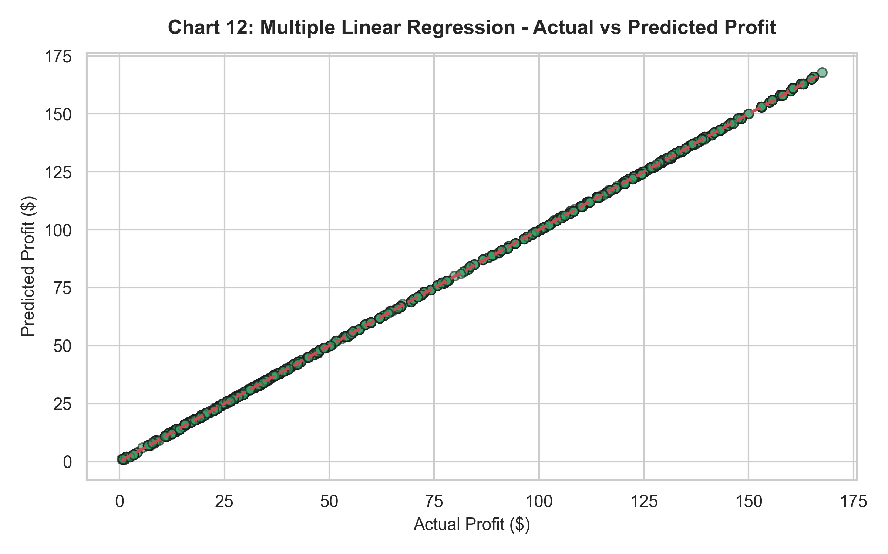
Discussion: Multiple Linear Regression accurately estimates order profit from Sales, Quantity, Discount, and Shipping Cost inputs.
9. Results and Discussion
1. Sales & Shipping Dynamics: Shipping costs scale linearly with sales volume.
2. Profit Drivers: Product discounts directly impact net profit margins.
10. Conclusion
- Learnings: E-commerce data mining provides actionable operational insights for inventory logistics and dynamic pricing.
- Future Improvements: Implement basket analysis (Apriori) for product recommendation engines.
11. References
1. Kaggle E-commerce Dataset: [https://www.kaggle.com/datasets/carrie1/ecommerce-data](https://www.kaggle.com/datasets/carrie1/ecommerce-data)
2. Han, J., Kamber, M., & Pei, J. (2011). Data Mining: Concepts and Techniques.

