What is the Secret to Happiness?
Data Analysis & Visualisation

What is the Secret to Happiness? And can it be discovered through excessive pattern recognition and correlation analysis? We set out to answer these questions using Data Science skills.

First, we were faced with the problem every data scientist faces, the lack of data. We plan to combine multiple global datasets to perform a visual analysis that reveals complex relationships between happiness and socio-economic indicators. So, we gathered data from different sources:
- World Happiness Report – provides global happiness scores and contributing factors such as social support, freedom, and generosity.
- World Bank GDP per capita (USD$ - Unadjusted for Inflation) – represents the economic well-being of a country.
- Average Years of Schooling (Adults) – an indicator of national education levels.
- Life Expectancy at Birth (Years) – sourced from WHO, reflecting national health and quality of life.
To obtain a dataset that records different factors affecting happiness scores, we were required to merge all these different datasets from different years and make sure the data used was not wrong, but as close to reality as possible. Merging was done using a left join with the happiness data as the master dataset, and country and year were the key columns along which merging was applied. Due to this, a lot of the data from the datasets was unused and useless for us, and only a small amount made it through. The Data that was left was cleaned and processed, but unnormalized. Missing values were handled through interpolation, and forward/backwards filling because GDP per capita and life expectancy tend to change linearly (gradually) over time, one one-year time periods. Other missing values were negligibly small, so they were kept as 'NaN' values. After this, feature engineering was done on the remaining data, and what was made was used for creating visualisations and for the rest of the workflow.
Aims & Hypothesis:
We aim to investigate what factors make countries happy, exploring whether economic prosperity, education, or health play a greater role in determining a nation’s overall happiness level. We have some initial hypotheses:
- Longer life expectancy is the result of higher happiness scores in the country, shown by a strong correlation.
- Higher GDP per Capita over the years indicate higher perceived life satisfaction.
- Happiness may be linked to the region one belongs to, so First World Countries may have higher happiness scores.
Initial Data Assessment:
Univariate analysis of the dataset provided valuable insights that served as a foundation for subsequent visualisations. This analysis helped establish an understanding of the range and distribution of each variable, allowing us to identify meaningful patterns and relationships in the data.
The dataset comprises 165 countries, with Happiness Scores recorded for each country across multiple years, calculated as a three-year average. In addition, the Happiness Lag variable represents the happiness score from the previous year, which proved particularly useful for calculating the average happiness level of a country over time.
The Life Expectancy variable indicates the average age at death within each country for a given year, providing a measure of national health and longevity. The GDP per Capita variable reflects the gross domestic product per person in each country; however, it is not adjusted for inflation, meaning the recorded values may differ from real-world, inflation-adjusted figures.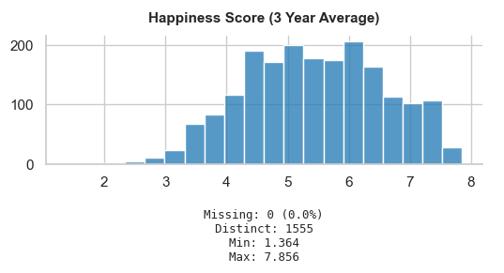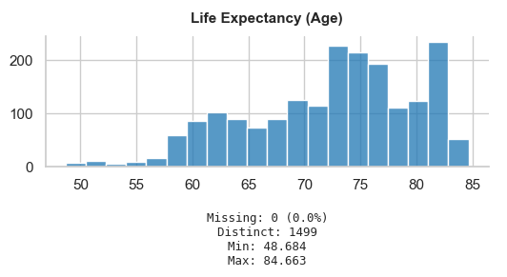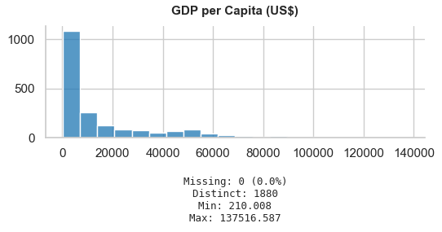

A bivariate visualisation was created to explore the relationship between average Life Expectancy and Happiness Score across all countries in the dataset. The plot takes the form of a scatter plot, where each point represents one of the 165 countries. The x-axis displays the average life expectancy, while the y-axis represents the corresponding happiness score averaged over all available years. A regression line was fitted through the data to highlight the overall trend. The positive slope of the line indicates that countries with higher life expectancies generally tend to exhibit higher happiness levels. This suggests a strong association between national health and perceived well-being. At the upper end of the distribution, Finland stands out with the highest happiness score, whereas Afghanistan, Rwanda, Burundi, the Central African Republic, and South Sudan are positioned near the lower end of the scale, reflecting comparatively low life expectancies and happiness levels.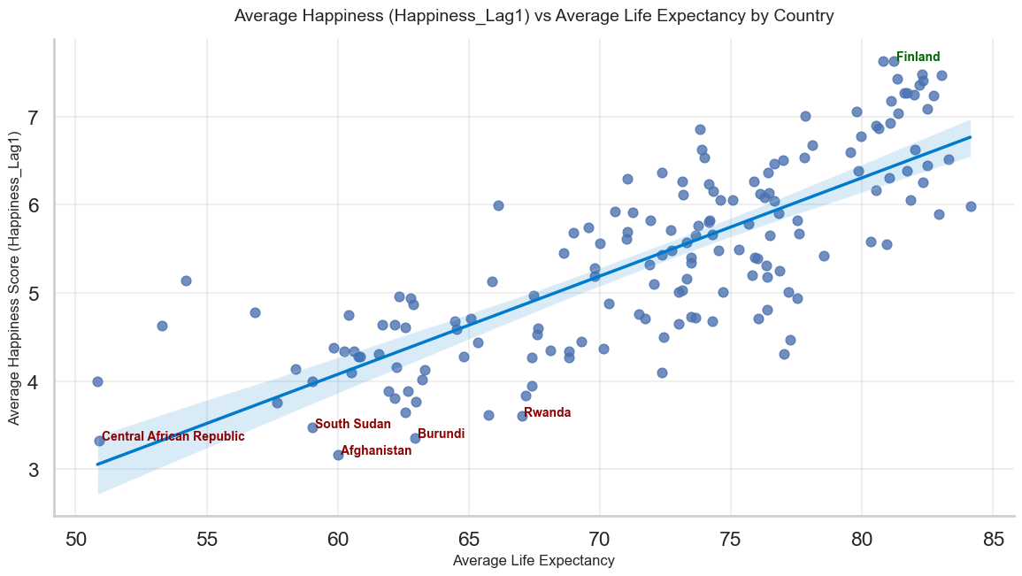
Complex Visualisations:
Radial Tree Visualisation: World Happiness Hierarchy
The radial tree diagram presents a hierarchical view of global happiness scores, organised across three distinct levels. At the centre lies the 'World' node, representing the global average happiness score. Radiating outwards, the second layer displays six continental regions, each showing their respective average happiness values. The outermost layer comprises individual countries, colour-coded according to their happiness scores using a red-yellow-green gradient, where green indicates higher happiness (>6), yellow represents moderate levels (4-6), and red denotes lower happiness (<4). This visualisation method was selected for several compelling reasons. Firstly, the radial layout effectively communicates the natural hierarchy present in the data, from global to continental to national levels, whilst maintaining visual clarity despite the large number of entities (165 countries). The circular arrangement allows for efficient use of space, preventing the overlapping that often occurs in traditional tree diagrams. Moreover, the emanating structure intuitively represents the concept of happiness 'radiating' from the global centre, emphasising both regional clustering and individual country performance within their respective continents. The diagram reveals notable patterns: Europe and North America demonstrate substantially higher average happiness scores, clustering predominantly in the green spectrum. Conversely, Africa displays a concentration of orange and red nodes, indicating lower happiness levels. This visualisation enables simultaneous comparison across multiple dimensions, global position, regional affiliation, and individual country performance, making it particularly suitable for identifying geographical patterns in subjective well-being.
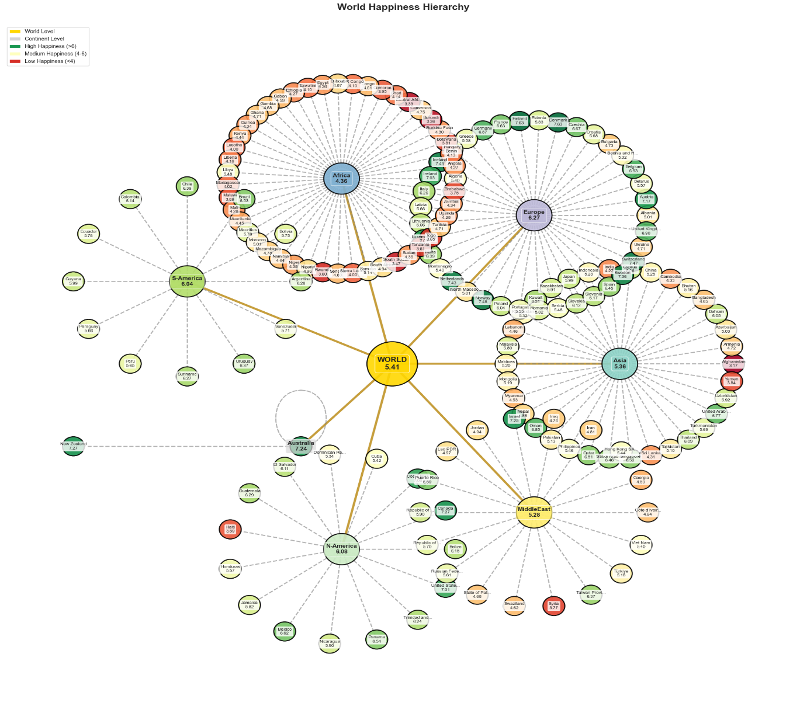
Sunburst Chart: World Happiness Distribution by Continent and Country
The sunburst chart employs a hierarchical circular layout to visualise global happiness distribution across continents and their constituent countries. The innermost circle represents the world as a whole, whilst the middle ring segments the globe into continental regions, with each segment's arc length proportional to the number of countries within that continent. The outermost ring displays individual countries, with each slice nested within its respective continental segment. The colour scale ranges from dark purple (happiness scores below 3.5) through teal and green, to bright yellow (scores above 7.5), providing an immediate visual indication of happiness levels.

This visualisation technique was chosen for its capacity to simultaneously convey multiple dimensions of information within a compact, aesthetically coherent format. Unlike the radial tree, the sunburst chart emphasises proportional representation, larger continental segments indicate regions with more countries in the dataset. The part-to-whole relationship is immediately apparent, allowing viewers to assess both the relative size of each continental grouping and the happiness distribution within it. The nested structure intuitively guides the eye from global overview to regional context to individual country detail.

The chart reveals striking regional disparities: Europe's segment displays a pronounced concentration of yellow and bright green hues, indicating consistently high happiness scores across Nordic countries (Finland, Denmark, Norway) and Western European nations. Conversely, Africa's extensive segment exhibits predominantly darker blue and purple tones, reflecting lower happiness levels across the majority of African nations. Asia and the Middle East show considerable internal variation, with pockets of high happiness (notably the Gulf states and Singapore) contrasting sharply with lower-scoring nations. This visualisation effectively highlights not only regional averages but also the degree of homogeneity or heterogeneity within each continent.
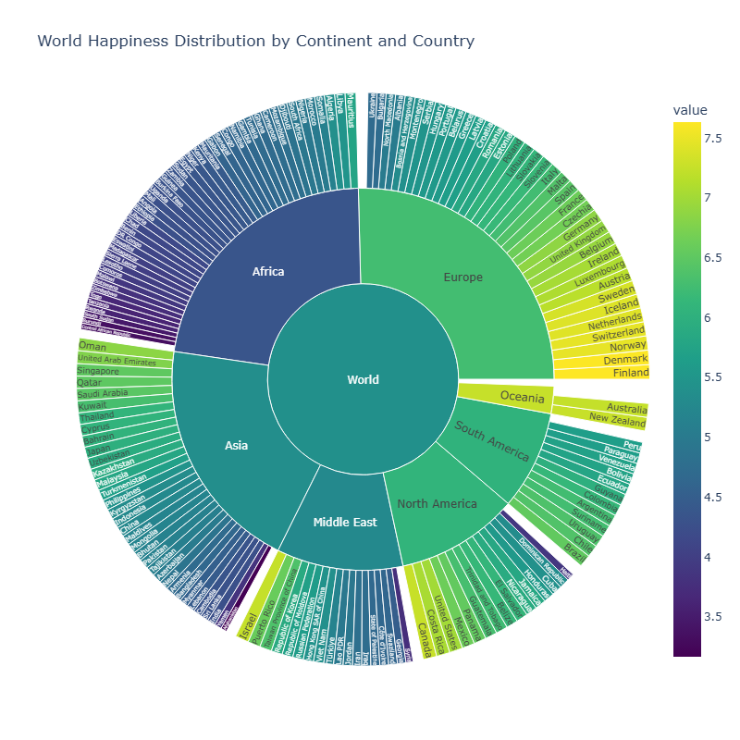
Choropleth Map: Global Happiness Score Distribution
The choropleth map presents a geographical representation of average happiness scores across nations, utilising a sequential colour scheme that transitions from pale cream (scores around 3.2) through coral and salmon tones to deep rose (scores approaching 7.6). Each country is shaded according to its happiness score derived from the 'Happiness_Lag1' variable, which represents the previous year's happiness measurement. Countries rendered in dark grey indicate missing data, highlighting gaps in the dataset's geographical coverage, particularly evident across Greenland, much of Russia, and several African nations. This visualisation method was selected for its intuitive ability to communicate spatial patterns and the regional clustering of happiness levels. Unlike hierarchical visualisations, the choropleth map preserves actual geographical relationships, enabling viewers to identify regional trends, assess neighbouring countries' comparative well-being, and recognise geopolitical patterns. The map format is particularly effective for detecting geographical contiguity in happiness scores, whether high or low happiness tends to cluster in specific regions, and for identifying outliers within their geographical context. The map reveals distinct geographical patterns in global happiness distribution. Northern and Western Europe, Canada, Australia, and New Zealand exhibit the deepest rose colouration, indicating consistently high happiness scores (above 6.5). Latin America displays moderate-to-high happiness levels, with a relatively uniform coral shading across much of the continent. Conversely, portions of sub-Saharan Africa and conflict-affected regions in the Middle East show lighter, cream-coloured tones, reflecting lower happiness scores. Notably, the visualisation exposes a pronounced North-South divide in the Americas and a clear East-West gradient across Europe and Asia, suggesting that happiness levels correlate strongly with geographical and potentially socio-economic regional groupings.
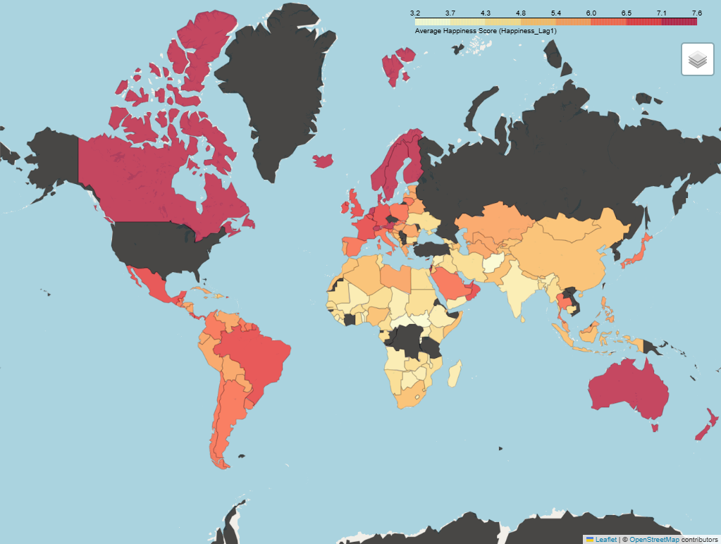
Scatter Plot with Density Contours: Life Expectancy versus Happiness
This visualisation employs a bivariate scatter plot overlaid with kernel density contours to examine the relationship between average life expectancy and happiness scores across 165 countries. Each data point represents an individual nation, colour-coded by continental affiliation: red for Asia, blue for Europe, green for Africa, purple for South America, orange for Australia, yellow for North America, and brown for the Middle East. The density contours, rendered in graduated shades of blue, indicate regions of high data concentration, with darker blue zones representing areas where numerous countries cluster together in terms of both life expectancy and happiness levels.
This visualisation approach offers several analytical advantages over purely geographical or hierarchical representations. Whilst maps and radial diagrams excel at showing spatial or categorical relationships, the scatter plot directly interrogates the correlation between two continuous variables, making causal or associative patterns immediately visible. The addition of density contours transforms what might otherwise be a cluttered point cloud into an interpretable distribution map, revealing not just individual country positions but also the underlying statistical structure of the relationship. This dual-layer approach, combining raw data points with smoothed density estimates, allows viewers to simultaneously assess individual outliers and broader trends, making it particularly valuable for identifying whether the happiness-longevity relationship holds universally or varies by region.
The visualisation reveals a strong positive correlation between life expectancy and happiness, with the densest concentration of countries forming an elongated elliptical cluster stretching from approximately 70 years and a happiness score of 5.0 to 83 years and 7.5. European nations (blue points) predominantly occupy the upper right quadrant, clustering tightly around life expectancies of 80-83 years and happiness scores of 6.5-7.5, suggesting a consistent pattern of high performance on both metrics. Conversely, African countries (green points) concentrate in the lower left region, with life expectancies between 55-65 years and happiness scores of 3.5-5.0, indicating systemic challenges in both health outcomes and subjective well-being. Notably, several outliers disrupt the general trend: some Asian nations achieve relatively high happiness scores despite moderate life expectancies, whilst a few countries with reasonable longevity report surprisingly low happiness levels. The contour lines further emphasise that the relationship is not merely linear but exhibits varying density across the spectrum, with the tightest clustering occurring in the moderate-to-high range, suggesting that once countries surpass certain development thresholds, the happiness-longevity relationship becomes more predictable and consistent.
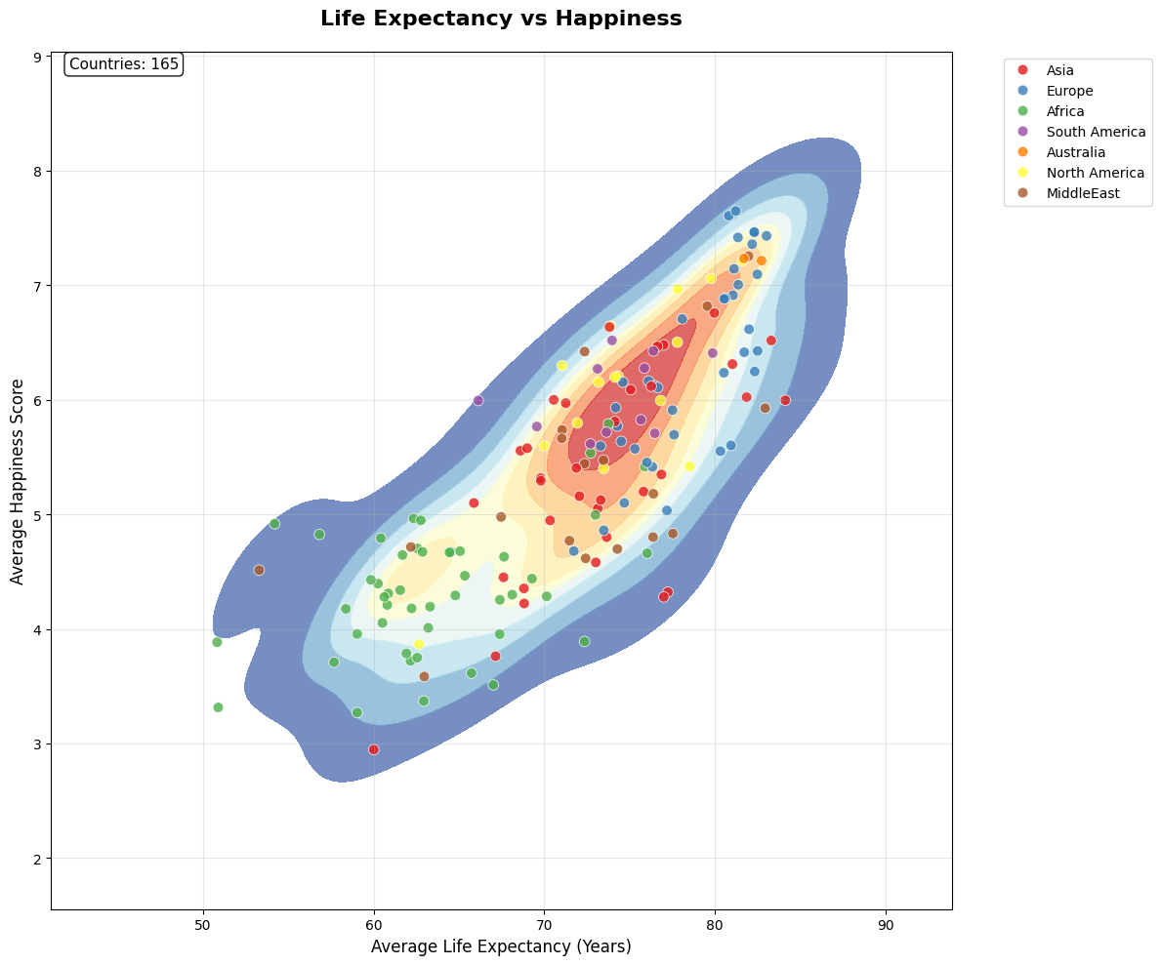
Faceted Scatter Plots with Regression Lines: GDP per Capita versus Happiness by Continent
This visualisation presents a small multiples approach, displaying six separate scatter plots that examine the relationship between GDP per capita and average happiness scores, with each panel representing a distinct continental region. Individual countries appear as blue data points, whilst red regression lines with shaded confidence intervals illustrate the general trend within each continent. The faceted layout enables direct comparison of how the wealth-happiness relationship manifests differently across geographical and cultural contexts.
The small multiples technique was selected specifically to address the heterogeneity in the GDP-happiness relationship across regions. Whilst a single global scatter plot might obscure regional variations, this approach reveals that the strength and nature of the correlation differ substantially by continent. By standardising the y-axis (happiness) across panels but allowing x-axis scales (GDP) to vary, the visualisation accommodates the dramatic differences in economic ranges, Africa's GDP per capita peaks around £10,000, whilst Europe's extends beyond £120,000, without compromising readability.
The panels reveal nuanced regional patterns. Europe and North America display relatively flat regression slopes despite high GDP ranges, suggesting diminishing returns on happiness beyond certain wealth thresholds. Conversely, Asia and Africa exhibit steeper gradients, indicating that incremental GDP gains correspond to more substantial happiness improvements in these regions. The Middle East panel shows considerable scatter around the trend line, with notable outliers suggesting that factors beyond pure economic wealth influence happiness in this region. South America demonstrates a moderate positive relationship with relatively tight clustering, whilst Africa's panel, despite lower absolute GDP values, shows a clear positive trend, reinforcing that within lower-income contexts, economic development remains strongly associated with improved subjective well-being.
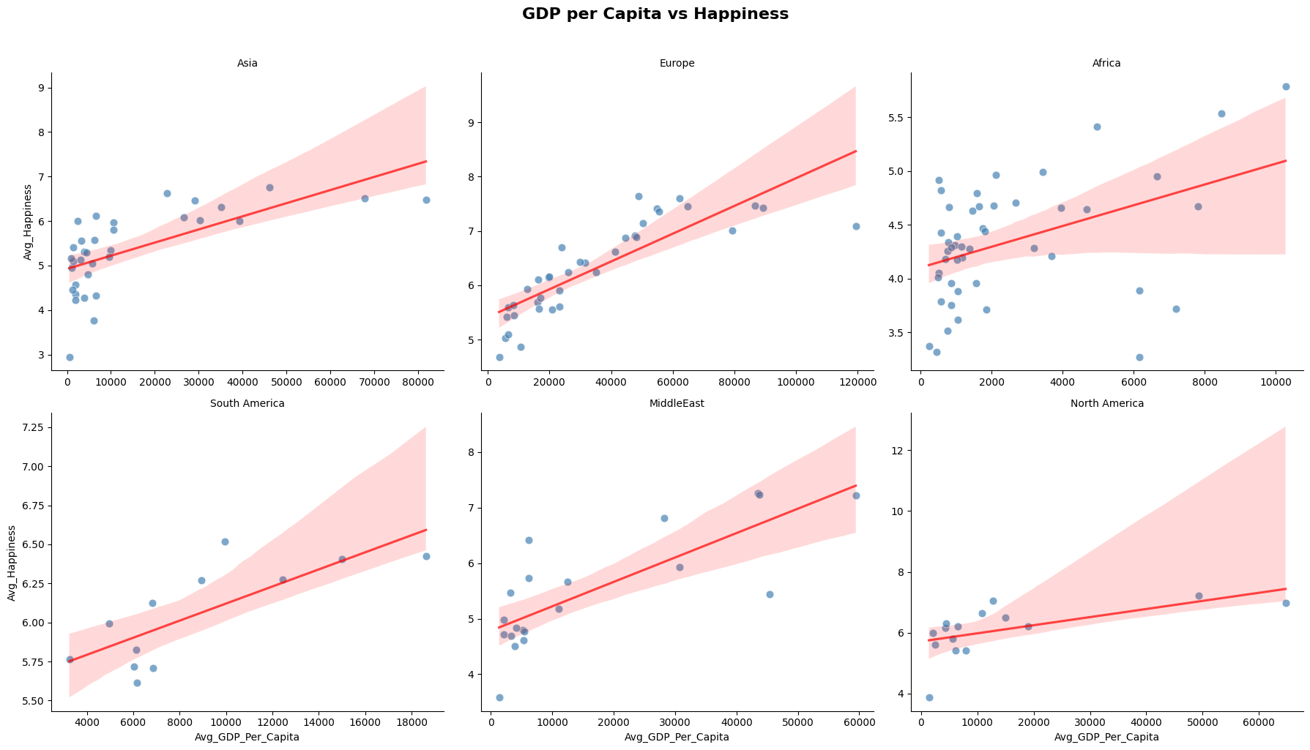
Bubble Chart: Economic Development versus Outcomes, GDP per Capita versus Life Expectancy
This bubble chart explores the trivariate relationship between GDP per capita, life expectancy, and happiness scores across all 165 countries in the dataset. Each bubble represents an individual nation, with its position determined by GDP per capita (x-axis) and life expectancy (y-axis), whilst bubble size encodes happiness scores, ranging from 2.9 (smallest) to 7.6 (largest). Continental affiliation is distinguished through colour: dark blue for Asia, purple for Europe, magenta for Africa, pink for South America, orange for Australia, yellow for North America, and tan for the Middle East. This multi-dimensional encoding allows simultaneous assessment of economic prosperity, health outcomes, and subjective well-being.
The bubble chart format was chosen to extend beyond simple bivariate correlation analysis by incorporating a third quantitative dimension through size encoding. This approach transforms the visualisation into a comprehensive overview of national development, enabling viewers to assess whether countries that excel economically and in terms of longevity also report higher happiness levels, or whether these dimensions diverge in certain contexts. The size variation creates an intuitive visual hierarchy, where larger bubbles immediately draw attention to high-happiness nations, facilitating rapid identification of successful outliers and underperforming economies.
The visualisation reveals a pronounced clustering pattern consistent with development trajectories. European and North American nations (purple, pink, and yellow bubbles) predominantly occupy the upper-right quadrant, exhibiting GDP per capita values exceeding $40,000, life expectancies above 75 years, and large bubble sizes indicating happiness scores above 6.0. This cluster demonstrates the convergence of economic, health, and well-being indicators in developed nations. Conversely, African and Asian countries (magenta and dark blue bubbles) concentrate in the lower-left region, with GDP values below $10,000, life expectancies between 55-70 years, and smaller bubble sizes reflecting happiness scores in the 3.0-5.5 range. Notably, several anomalies disrupt these patterns: certain Middle Eastern nations display high GDP and moderate life expectancy but relatively small bubbles, suggesting that wealth alone does not guarantee happiness; conversely, some Latin American countries achieve disproportionately large bubble sizes despite moderate GDP levels, indicating cultural or social factors that enhance subjective well-being independent of pure economic metrics. The chart thus effectively illustrates that whilst economic development and longevity generally correlate with happiness, the relationship is neither deterministic nor uniform across regions.
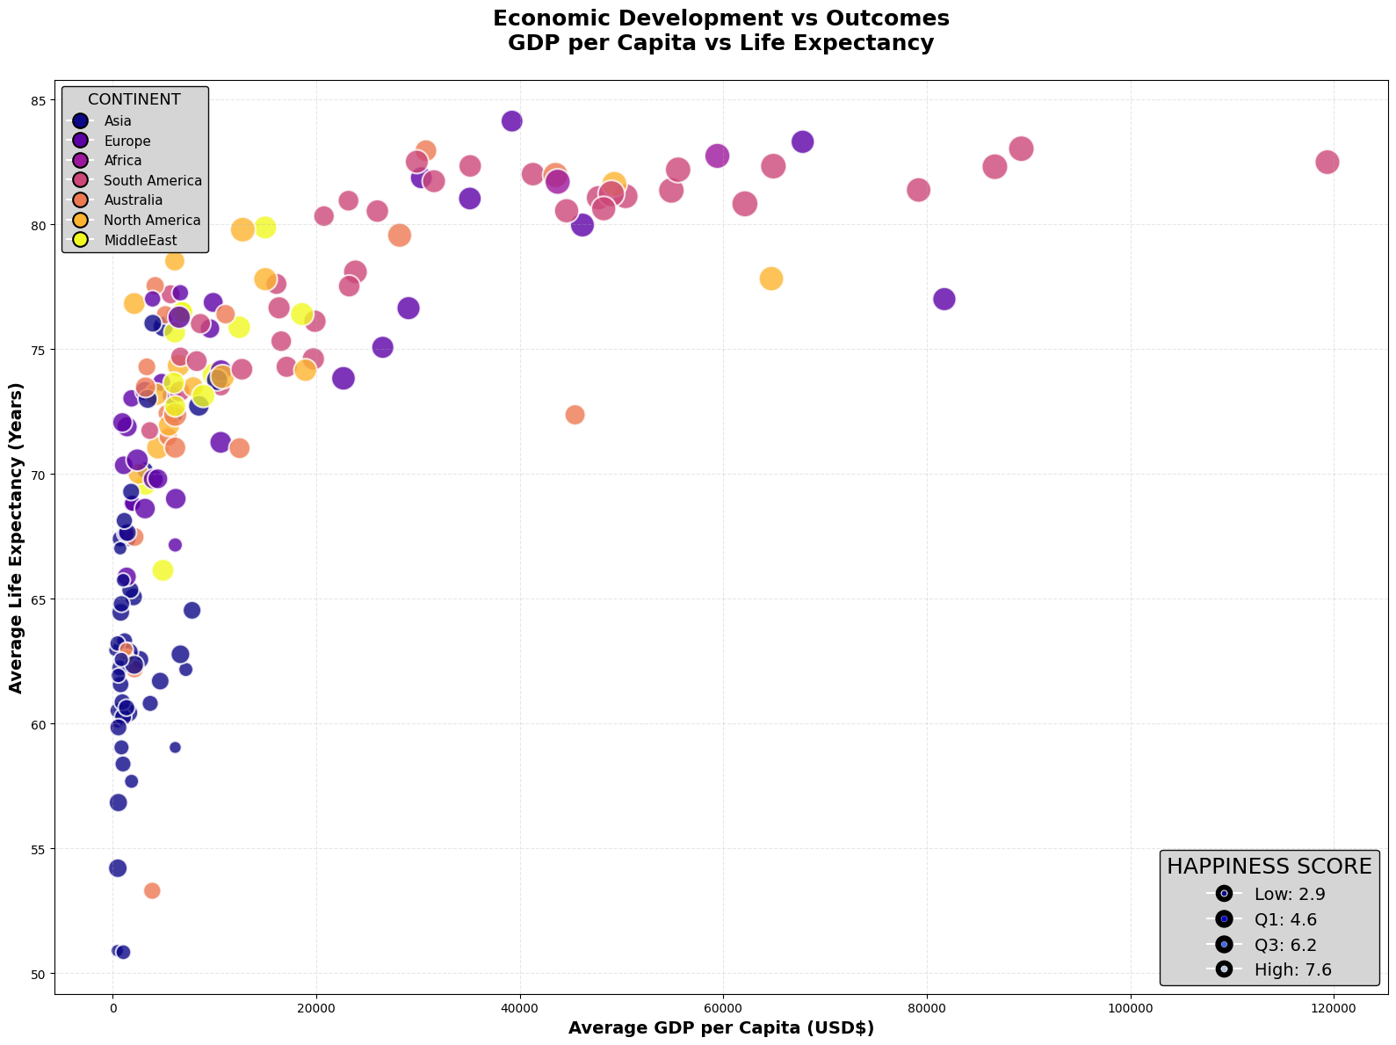
Hexbin Density Visualisation: Global Wealth-Health-Happiness Relationship
This hexbin plot presents a sophisticated density-based visualisation of the trivariate relationship between GDP per capita, life expectancy, and happiness scores across 1,943 country-year observations spanning 165 nations over 13 years. The plot subdivides the two-dimensional space defined by GDP per capita (x-axis) and life expectancy (y-axis) into hexagonal bins, with each hexagon's colour representing the average happiness score of all observations falling within that bin. The colour gradient transitions from deep purple (happiness scores around 3.0) through magenta and coral to vibrant yellow (scores approaching 8.0). A star marker indicates the global average position: $15,948 GDP per capita and 72.4 years life expectancy. White gaps represent unpopulated regions of the parameter space where no country-year observations exist.
The hexbin density approach was specifically selected for this visualisation due to its superior handling of large, temporally-aggregated datasets where substantial overplotting would render traditional scatter plots illegible. By binning observations into hexagonal cells and encoding the third variable (happiness) through colour rather than size or transparency, the visualisation eliminates visual clutter whilst preserving the ability to discern density patterns and regional concentrations. The hexagonal tessellation offers advantages over square grids by reducing visual artefacts and providing more accurate proximity representations. This method transforms 1,943 individual data points into an interpretable heat map that simultaneously conveys distribution density (through hexagon presence), central tendency within regions (through colour), and the overall shape of the wealth-health-happiness relationship across the global dataset.
The visualisation reveals a striking non-linear relationship characterised by distinct developmental trajectories. The densest concentration of observations appears in the lower-left quadrant, forming a substantial purple band stretching from approximately $1,000-$10,000 GDP and 50-75 years life expectancy, representing the historical and contemporary positions of developing nations. This region displays considerable vertical spread, countries at similar economic levels exhibit life expectancies varying by up to 25 years, suggesting that health outcomes at lower income levels are strongly influenced by factors beyond pure wealth, such as public health infrastructure, governance quality, and healthcare accessibility. As GDP increases beyond $15,000, the visualisation exhibits a pronounced upward-rightward sweep, transitioning through coral and orange tones toward the upper-right quadrant, where hexagons coloured in bright yellow and orange indicate the convergence zone of developed nations: GDP values exceeding $40,000, life expectancies above 80 years, and happiness scores consistently above 6.5. Notably, the relationship exhibits diminishing returns in both dimensions, the vertical gain in life expectancy per additional dollar of GDP decreases substantially beyond $30,000, whilst the colour transition from orange to yellow becomes more gradual, suggesting that once nations achieve a certain prosperity threshold, further economic gains yield progressively smaller improvements in both longevity and subjective well-being. The sparse population of hexagons in certain regions is equally revealing: the near-absence of observations in the upper-left (high life expectancy with low GDP) and lower-right (high GDP with low life expectancy) quadrants demonstrates that these combinations are empirically rare, reinforcing the fundamental interdependence of economic development and health outcomes. The global average marker, positioned within the orange-coral transition zone, serves as a sobering reminder that the majority of the world's population remains considerably below the high-development cluster, with substantial room for improvement across all three dimensions of national well-being.
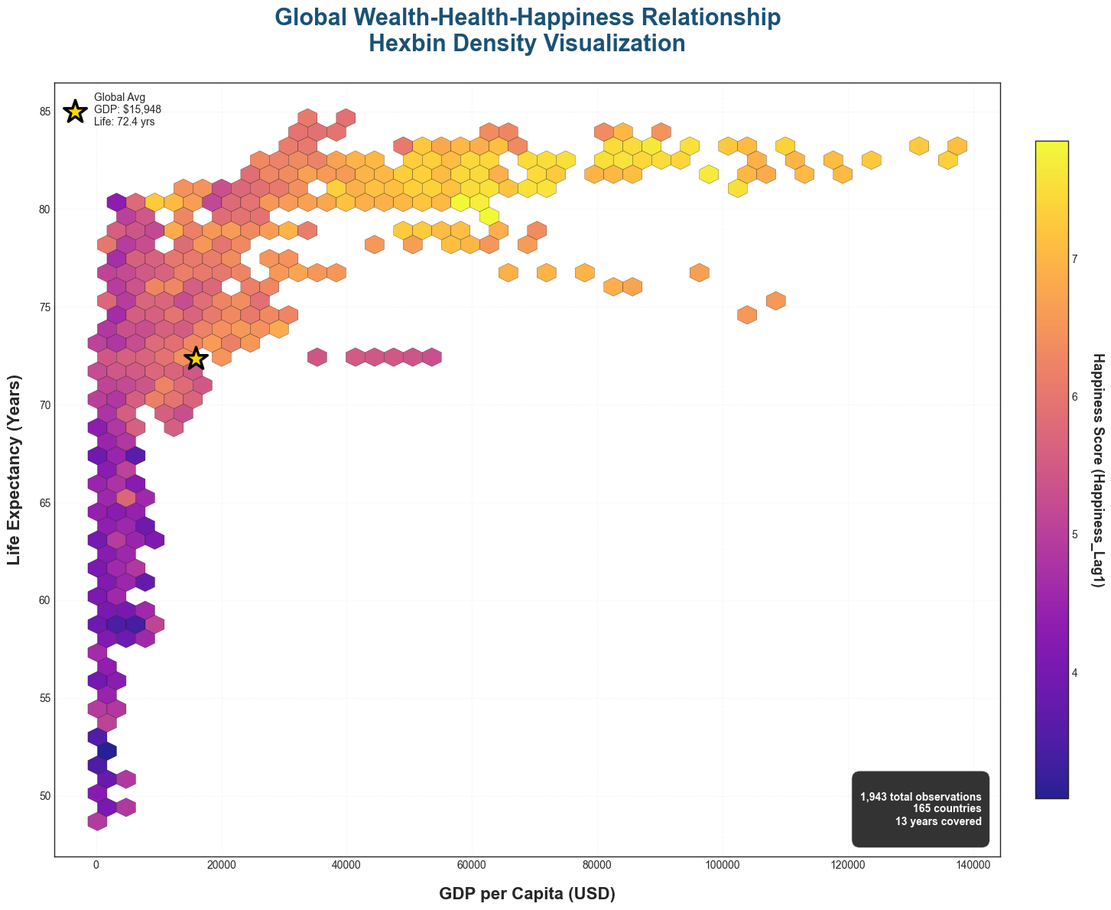
Key Insights, Trends, Patterns, and Anomalies
Major Trends Identified
Across all visualisations, several consistent patterns emerged that fundamentally shape our understanding of global happiness distributions. The most prominent trend is the clear geographical clustering of happiness scores, with distinct continental disparities evident in every analytical approach. European nations consistently occupy the highest happiness bracket (average 6.27), followed closely by North America (6.08) and Oceania, whilst Africa (4.36) and parts of Asia demonstrate systematically lower scores. This pattern manifested regardless of visualisation method, from the radial tree's colour-coded nodes to the choropleth map's regional shading and the faceted scatter plots' continental panels.
A second pervasive trend concerns the non-linear relationship between economic development and well-being outcomes. The hexbin density visualisation particularly illuminated this phenomenon, revealing that GDP gains below $15,000 per capita correspond to substantial improvements in both life expectancy and happiness, yet beyond $30,000-40,000, the marginal returns diminish considerably. This pattern of diminishing returns appeared consistently across the faceted GDP-happiness plots, where European and North American panels displayed notably flatter regression slopes despite their extended GDP ranges, contrasting sharply with the steeper gradients observed in Asia and Africa.
The strong positive correlation between life expectancy and happiness emerged as perhaps the most robust finding across multiple visualisations. The scatter plot with density contours revealed a clear elliptical concentration stretching from 70 years/5.0 happiness to 83 years/7.5 happiness, whilst the bubble chart demonstrated that nations achieving high longevity almost invariably reported elevated happiness scores. This relationship proved more consistent than the GDP-happiness correlation, suggesting health outcomes may be a more reliable predictor of subjective well-being than pure economic metrics.
Notable Anomalies and Outliers
Several countries systematically defied expected patterns across multiple visualisations. Costa Rica emerged as a persistent positive outlier, achieving happiness scores comparable to far wealthier nations despite moderate GDP per capita, a phenomenon visible in both the faceted scatter plots and the bubble chart, where Costa Rica's large bubble size contradicted its middling economic position. Similarly, several Latin American nations demonstrated disproportionately high happiness relative to their economic standing, suggesting cultural factors, social cohesion, or alternative development priorities that prioritise well-being over pure material accumulation.
Conversely, certain Middle Eastern nations presented negative anomalies, exhibiting high GDP per capita yet moderate-to-low happiness scores and, in some cases, surprisingly modest life expectancies. This pattern, evident in the choropleth map's unexpected colour contrasts and the bubble chart's small bubbles despite rightward positioning, suggests that resource wealth alone, particularly when derived from extractive industries, does not automatically translate into broad-based improvements in quality of life or subjective well-being.
The substantial within-continent variation in Africa and Asia constituted another critical finding. Whilst these continents demonstrated lower average happiness, the sunburst chart's colour heterogeneity within African and Asian segments, combined with the wide vertical spread visible in the life expectancy-happiness scatter plot, revealed that regional averages obscure considerable diversity. Countries such as Mauritius and Botswana in Africa, or Singapore and Taiwan in Asia, achieved outcomes far exceeding their continental peers, demonstrating that geographical or cultural context does not deterministically constrain development trajectories.
Temporal Considerations
Although the visualisations primarily presented cross-sectional or averaged data, the dataset's 13-year span enabled observation of dynamic patterns. The hexbin plot's inclusion of 1,943 observations across time revealed persistent structural inequalities, the lower-left quadrant's dense purple concentration represents not merely current developing nations but also the historical trajectories of countries progressing through earlier development stages. The relatively stable positioning of the global average marker ($15,948 GDP, 72.4 years) suggests that whilst individual countries advance, global inequality remains substantial, with improvements in leading nations offset by population growth in lower-development regions.

Comparative Analysis of Visualisation Approaches
Complementary Strengths Across Methods
Each visualisation technique illuminated distinct facets of the dataset, and their collective deployment provided a far richer analytical perspective than any single approach could achieve. The hierarchical visualisations (radial tree and sunburst chart) excelled at communicating categorical relationships and part-to-whole proportions, making regional groupings and continental averages immediately comprehensible. These methods effectively established the "big picture" of global happiness geography, serving as ideal entry points for readers unfamiliar with the data's structure.
The choropleth map uniquely preserved actual geographical relationships, enabling identification of spatial contiguity patterns that other methods obscured. Observing that high-happiness nations physically cluster in Northern Europe and that low-happiness regions concentrate in sub-Saharan Africa and conflict zones provided geopolitical context absent from abstract statistical plots. The map format also facilitated intuitive communication with non-specialist audiences, leveraging universal familiarity with geographical representations.
The bivariate scatter plots (both the unified life expectancy-happiness plot and the faceted GDP-happiness panels) represented the analytical workhorses of the study, directly interrogating correlational relationships and quantifying effect sizes through regression lines. The addition of density contours to the life expectancy plot transformed it from a simple correlation display into a distributional analysis, revealing not just central tendencies but also the statistical structure underlying the relationship. The faceted approach particularly shone in exposing regional heterogeneity, demonstrating that global-level correlations mask substantial between-region variation in relationship strength and form.
The bubble chart extended analytical dimensionality by encoding a third variable through size, enabling simultaneous assessment of economic, health, and happiness outcomes. This holistic perspective proved invaluable for identifying cases where the three dimensions diverged, nations achieving health and happiness without commensurate wealth, or conversely, accumulating GDP without translating it into well-being gains.
Finally, the hexbin density visualisation synthesised the dataset's full temporal depth, accommodating 1,943 observations without visual clutter whilst preserving the ability to discern fine-grained patterns. Its colour-encoded third dimension revealed the happiness landscape across the GDP-life expectancy parameter space, identifying not merely where countries cluster but also what happiness levels characterise each region of the development spectrum.
Methodological Limitations and Trade-offs
Each approach necessarily involved trade-offs. The hierarchical visualisations, whilst excellent for categorical organisation, compressed continuous variables into averages, potentially obscuring within-group variation and outliers. The choropleth map, despite its intuitive appeal, suffered from geographical distortion (particularly affecting high-latitude regions) and could not represent non-spatial relationships. The scatter plots, though statistically rigorous, demanded higher visual literacy from audiences and risked overplotting when displaying all observations simultaneously, hence the necessity of either faceting or density overlays.
The bubble chart's triple encoding, whilst informationally dense, approached the limits of perceptual capacity; accurately comparing bubble sizes proved more challenging than position-based comparisons, potentially introducing interpretation errors. The hexbin plot, despite its elegance in handling large datasets, required careful parameterisation, hexagon size selection materially affected the visualisation's appearance, and inappropriate binning could either over-smooth genuine patterns or create spurious artefacts.
Convergent Findings Across Methods
Critically, the visualisations demonstrated remarkable convergence on core findings despite their methodological diversity. The positive GDP-happiness and life expectancy-happiness relationships appeared consistently across scatter plots, bubble charts, hexbin plots, and even indirectly through the choropleth map's correlation between developed regions and warmer colours. Regional disparities manifested uniformly across hierarchical diagrams, maps, and faceted panels. This multi-method triangulation substantially strengthens confidence in the study's conclusions, as findings that persist across diverse analytical lenses are less likely to represent methodological artefacts.

Conclusions and Hypothesis Evaluation
Hypothesis A: Longer life expectancy correlates with higher happiness scores
Verdict: STRONGLY SUPPORTED
The evidence overwhelmingly confirms this hypothesis. The life expectancy-happiness scatter plot with density contours revealed a pronounced positive correlation, with the densest concentration of countries forming an elongated ellipse stretching from lower-left to upper-right, indicating that as life expectancy increases, happiness scores rise correspondingly. The correlation appears robust across the entire range of observations, though the relationship exhibits slight non-linearity, with the steepest gradient occurring between 60-75 years of life expectancy.
Critically, the bubble chart demonstrated that virtually all nations achieving life expectancies above 80 years reported happiness scores exceeding 6.0, whilst countries with life expectancies below 60 years rarely surpassed happiness scores of 5.0. The hexbin visualisation further confirmed this pattern at scale, showing that the 1,943 country-year observations concentrate along a diagonal band linking longevity and well-being, with minimal population in off-diagonal regions.
However, an important clarification concerns causality. Whilst the hypothesis posited that "longer life expectancy is the result of higher happiness scores," the evidence more plausibly suggests bidirectional or common-cause relationships. Wealthy, stable nations with strong healthcare systems, social safety nets, and low conflict levels simultaneously achieve both high life expectancy and high happiness through shared underlying factors (economic development, governance quality, peace, healthcare access). Happiness may contribute to longevity through psychological and behavioural pathways, happier individuals exhibit healthier lifestyles, stronger social connections, and lower stress, but the reverse causality (longevity enabling happiness through extended productive years and intergenerational continuity) is equally plausible. Most likely, both are co-determined by broader socio-economic conditions.
Hypothesis B: Higher GDP per capita indicates higher perceived life satisfaction
Verdict: SUPPORTED WITH IMPORTANT QUALIFICATIONS
This hypothesis receives substantial but nuanced support. The faceted GDP-happiness scatter plots demonstrated positive correlations within every continental panel, confirming that wealthier nations generally report higher life satisfaction. The hexbin density plot revealed that the brightest yellow hexagons, representing happiness scores above 7.0, concentrate exclusively in the rightward regions where GDP exceeds $40,000 per capita, whilst the deepest purple hexagons occupy the left side below $10,000.
However, three critical qualifications emerged. First, the relationship exhibits pronounced diminishing returns. The faceted plots for Europe and North America showed remarkably flat regression slopes despite GDP ranges extending to $120,000, indicating that once nations surpass approximately $30,000-40,000 per capita, additional wealth produces minimal happiness gains. Conversely, in Africa and Asia, the steeper gradients demonstrated that GDP increases at lower income levels correspond to more substantial happiness improvements. The hexbin plot's colour transitions illustrated this phenomenon visually, the shift from purple to orange occurs rapidly between $5,000-$25,000 but slows considerably thereafter.
Second, substantial scatter exists around the GDP-happiness relationship, with the bubble chart revealing numerous outliers. Costa Rica, several Latin American nations, and certain Asian countries achieve happiness levels far exceeding predictions based purely on GDP, whilst some Middle Eastern nations underperform relative to their wealth. This scatter, visible as vertical dispersion in the faceted plots and colour variation within GDP bands in the hexbin chart, suggests that factors beyond economic output, including social capital, governance quality, cultural values, inequality levels, and environmental quality, materially influence happiness.
Third, the dataset's non-inflation-adjusted GDP figures introduce measurement concerns. As noted in the data description, the GDP values may diverge from real-world purchasing power, potentially distorting temporal comparisons and cross-national assessments where cost-of-living differences are substantial. This limitation likely attenuates the observed correlations, as nominal GDP comparisons do not fully capture material living standards.
Hypothesis C: Happiness is linked to region; First World countries have higher happiness scores
Verdict: STRONGLY SUPPORTED
This hypothesis receives the most unequivocal support, with every visualisation method confirming profound regional disparities. The radial tree and sunburst chart both prominently displayed continental average differences, with Europe (6.27) and North America (6.08) substantially exceeding the global average (5.41), whilst Africa (4.36) and parts of Asia fell well below. The choropleth map vividly illustrated these patterns through colour clustering, with Northern and Western Europe, North America, Australia, and New Zealand forming a contiguous band of warm colours indicating high happiness, contrasting sharply with the cooler tones dominating Africa and parts of Asia.
The faceted GDP-happiness plots provided perhaps the most compelling evidence by demonstrating that regional disparities persist even after controlling for economic differences. The Africa panel, despite showing a positive GDP-happiness relationship, remained systematically shifted downward relative to the Europe panel. African nations at $5,000 GDP per capita report happiness scores comparable to European nations with $20,000, suggesting that regional context exerts independent effects beyond pure wealth.
The concept of "First World countries" loosely corresponds to high-income Western democracies, which indeed cluster at the upper end of the happiness distribution. However, the analysis revealed important nuances. Not all wealthy nations achieve exceptional happiness (certain Gulf states underperform), and not all high-happiness nations are maximally wealthy (Costa Rica, several Latin American nations). The relationship between development status and happiness, whilst strong, is mediated by intervening variables.
Several mechanisms likely explain regional happiness disparities beyond GDP. Conflict and instability disproportionately affect certain regions, particularly parts of Africa, the Middle East, and Asia, directly undermining well-being. Cultural factors, including collectivism-individualism dimensions, religious traditions, and historical legacies, shape how societies conceptualise and pursue happiness. Environmental quality and climate, whilst difficult to isolate, may contribute, with extreme climates potentially imposing quality-of-life constraints.

Broader Implications and Research Directions
This comprehensive visualisation-driven analysis confirms that happiness is multidimensional, determined by the complex interplay of economic prosperity, health outcomes, regional context, and likely numerous unmeasured factors, including governance quality, social cohesion, environmental conditions, and cultural values. No single variable deterministically predicts happiness, yet certain combinations, high GDP, long life expectancy, stable governance, and strong social capital, consistently correlate with elevated well-being.
The findings suggest that development strategies prioritising GDP growth alone risk overlooking crucial well-being determinants. Countries would benefit from holistic approaches addressing health infrastructure, education quality, governance effectiveness, environmental sustainability, and social cohesion alongside economic expansion. The success of nations like Costa Rica in achieving high happiness despite moderate wealth demonstrates that alternative development pathways exist. Ultimately, this study demonstrates that whilst economic development and health improvements remain crucial for enhancing global well-being, they represent necessary but insufficient conditions. The pursuit of happiness requires attending to the broader ecosystem of factors, social, political, environmental, and cultural, that collectively shape human flourishing.

Bibliography
- World Bank - World Bank GDP per Capita
https://data.worldbank.org/indicator/NY.GDP.PCAP.CD
- World Happiness Report (Gallup) - World Happiness Report Data
https://www.worldhappiness.report/data-sharing/
- WHO (UNESCO) - Life Expectancy Data
https://www.who.int/data/gho/data/indicators/indicator-details/GHO/life-expectancy-at-age-60-(years)

By:
- Izhan Nasir 23I-2517
- Ali Asjad 23I-2648
- Ibrahim Hussain 23I-2626

World Happiness Report Data: WHR25_Data_Figure_2.1v3.xlsx
World Bank GDP per Capita: e85a892e-e335-473d-acff-4df284ab5d8d_Data.csv
World Bank Education Data: R_Average years of schooling of adults (male and female).xlsx
Life Expectancy Data: 90E2E48_ALL_LATEST.csv

