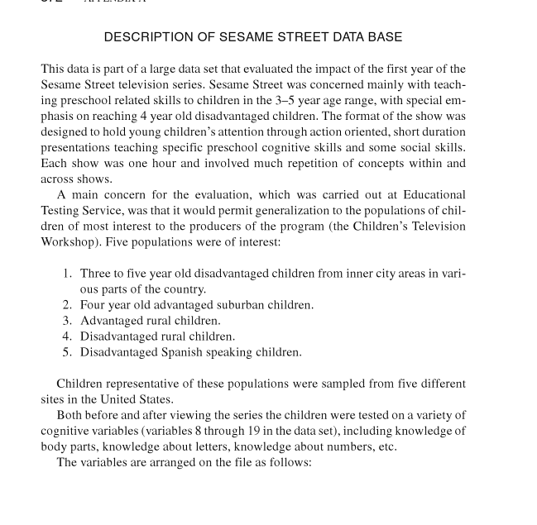

The data is encoded in two files, one with variables describing individual children, another with their test stores.

|  |  |
| --- | --- |
| Variable Name | Description |
| NAME | Subject identification number and name |
| SITE | Five different sampling sites coded as 1, 2, 3, 4, 5 |
| SEX | Male-1, Female-2 |
| AGE | in months |
| VIEWCAT | viewing categories coded as a 1 if children rarely watched the show to a 4 if the children watched the show on average more than 5 times a week |
| SETTING | Setting in which Sesame Street was viewed, coded as 1 for home and 2 for school |
| VIEWENC | A treatment condition in which some children were encouraged to view Sesame Street (code-1) and others were not (code-2) |
| PEABODY | Mental age scores obtained from administration of the Peabody Picture Vocabulary Test as a pretest measure of vocabulary maturity |

Summary of test scores:

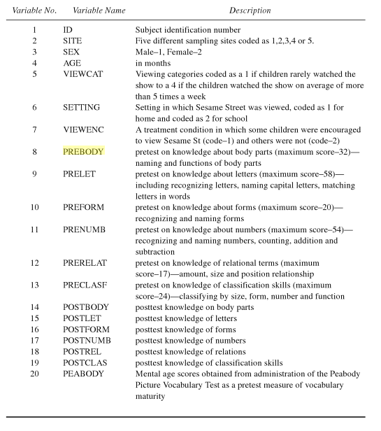

Your client, Darla Green, has asked you to use the Sesame Street data to answer her research questions so she can present at an upcoming board meeting. She does not know much about these data, but has provided you with the summary from her employer. Notice that the research questions in the description below are not the same as her research questions, which are.

1.)  Does our programming improve children’s knowledge of **letters**, **numbers**, and **forms**? Most important test scores to focus on! We want these scores to go up more than every other one.

2.)  What, if any, area should we focus on for improvement?  E.g. are we better at teaching letters than we are at numbers?