SAINT PETERSBURG STATE UNIVERSITY

Faculty of Applied Mathematics and Control Processes

Mathematical Game Theory and Statistical Decisions Department

Applied Statistics in R
Exam

Professor: Parilina Elena M.
Student: Orlov Ivan M., 19.M09-пу

Saint Petersburg
2020
Contents
1. Descriptive statistics. 2
2. Statistical goodness-of-fit tests. 6
3. Comparing two or more samples. 8
4. Regression analysis. 10
5. Cluster analysis. 17
Appendix 31

Descriptive statistics.

The data represent trunk girth (mm) of a random sample of 60 four-year-old apple trees at East Malling Research Station (England). Reference: S.C. Pearce, University of Kent at Canterbury

Statistics | Value
n | 60
mean | 110.0167
variance | 197.237
standard deviation | 14.04411
median | 111.5
0.25-quantile | 102.75
0.5-quantile | 111.5
0.75-quantile | 117.5
mode | 117
minimal value | 69
maximal value | 142
skewness | -0.39736
kurtosis | 0.832999

The task asked for “skewness, asymmetry”, but skewness is a measure of asymmetry and is often paired with kurtosis (plus that’s what ds.statistics() function returns), so these are the measures in the report.
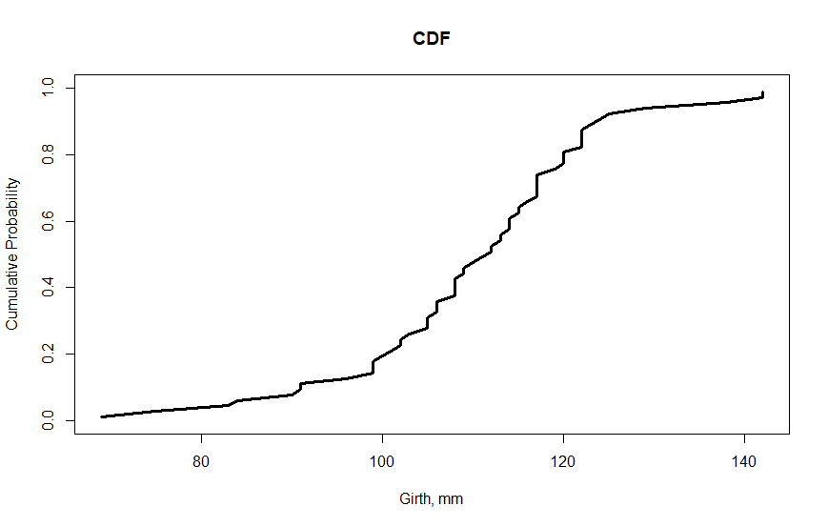
Cumulative distribution function graph shows that the biggest grow is in the interval between 100 and 120 mm: almost 60% of girths are in there.
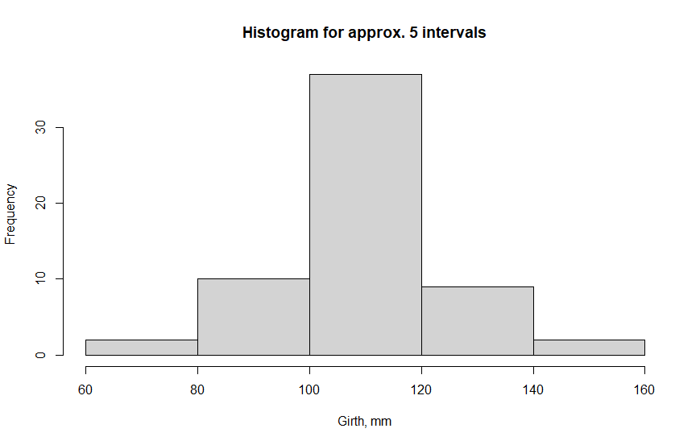

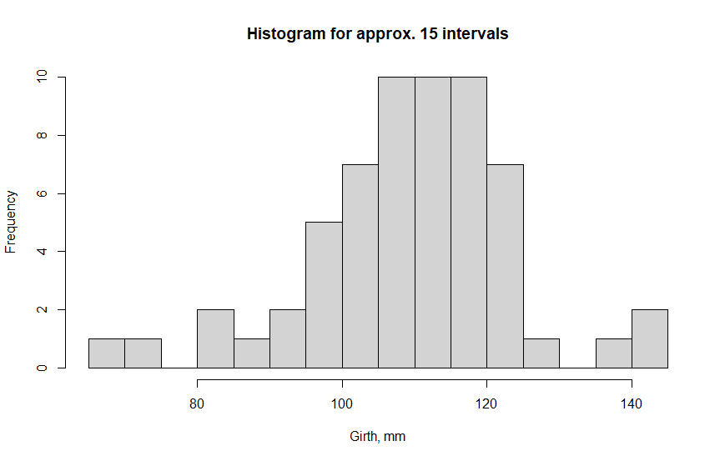
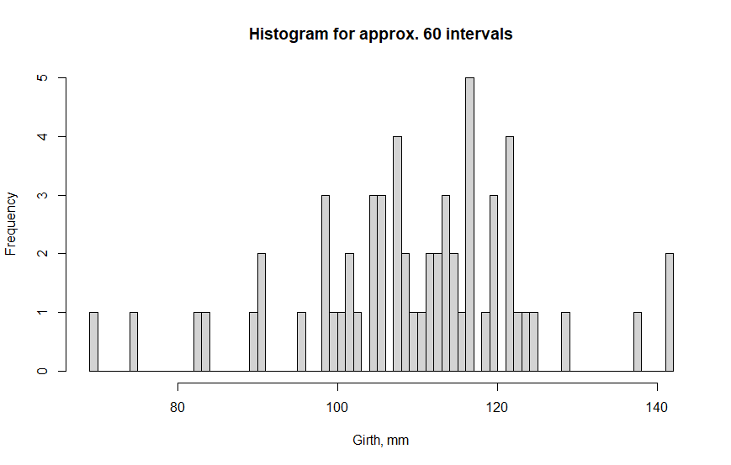
The histogram confirms that data has negative skewness and kurtosis that is less than that of normal distribution (i.e. platykurtic).
R hist() function computes the number of bins as close as possible to the specified breaks, but makes sure the graph remains “pretty”.

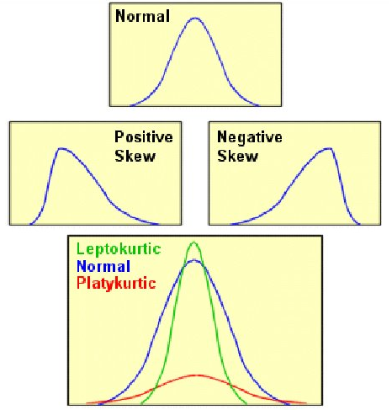
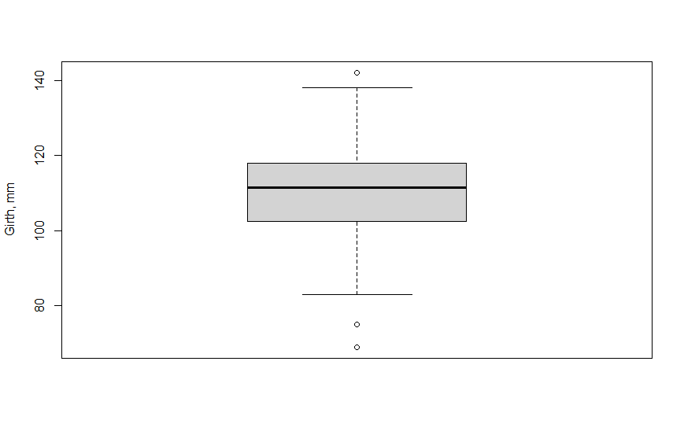
The boxplot of the graph shows us that 60-3=57 of 60 values are inside the interval [q₂₅-1.5S; q₇₅+1.5S], which is bounded by horizontal lines ending the dashed vertical lines.
It can be seen that median q₅₀ is closer to q₇₅ than to q₂₅. The same result can be obtained from the summary table (117.5-111.5=6<8.75=111.5-102.75).

Statistical goodness-of-fit tests.

The simplest (and probably the most unreliable) way to check for normality is Q-Q plot:
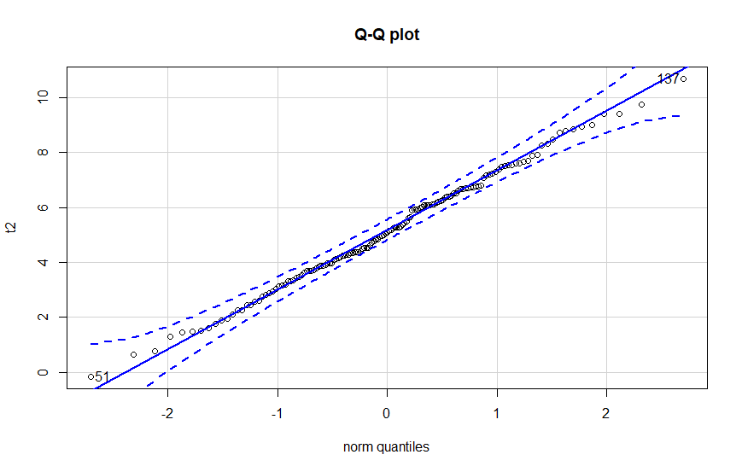
The dashed lines outline the envelope for normality with 0.9 level of confidence and visual examination suggests that, since all points of data are inside the envelope, the data itself is normally distributed. However, this is not enough and we need real tests.
uniNorm function no longer exists in R 4.0.1, MVN::mvn() is used instead.

Statistics | Value
n | 145
Mean | 5.148819
Std.Dev | 2.104814
Median | 5.083483
Min | -0.1551615
Max | 10.67074
25th | 3.726937
75th | 6.656663
Skew | 0.04403965
Kurtosis | -0.388785

The skewness and kurtosis are close to zero (as in normal distribution) which also might be a good sign.
pearson.test was run twice, with adjust = TRUE (default) and with adjust =FALSE with the real p-value somewhere between the results.

Test | Statistic | p-value | Normality
Lilliefors (Kolmogorov-Smirnov) | 0.0511 | 0.466 | YES
Pearson chi-square (adjusted) | 9.655172 | 0.6461832 | YES
Pearson chi-square | 9.655172 | 0.7869349 | YES
Cramer-von Mises | 0.0408 | 0.6648 | YES
Anderson-Darling | 0.2117 | 0.8542 | YES

No test found a proof of non-normality on 0.9 level of confidence.

Comparing two or more samples.

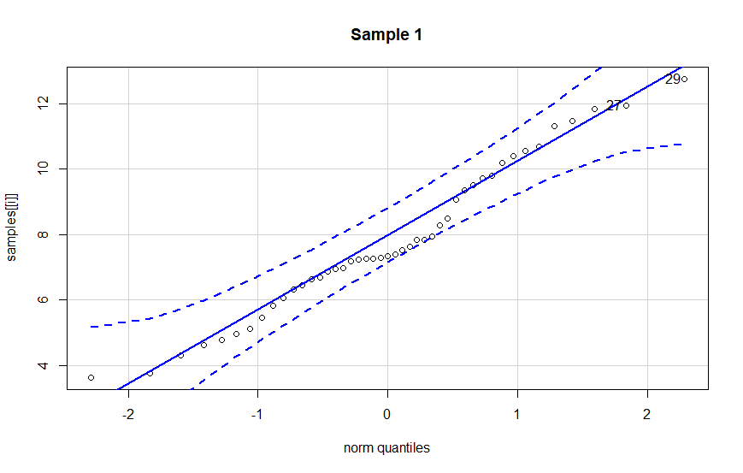
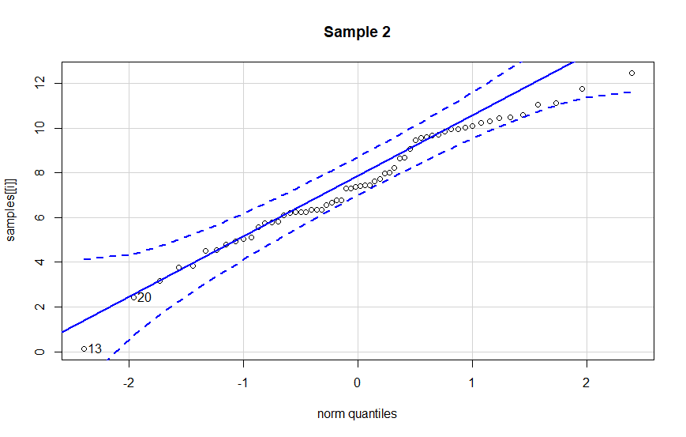
Again, visual testing suggest that both samples are normal.
Shapiro-Wilk normality test gives p-values of 0.322654 and 0.3356359 that both declare absence of proofs of non-normality on 0.95 level of confidence.

Two Sample Student’s t-test gives the following results
t = 0.65262, df = 103, p-value = 0.5155
alternative hypothesis: true difference in means is not equal to 0
95 percent confidence interval:
-0.6324875 1.2529050
sample estimates:
mean of x mean of y
7.787951 7.477742

F-test to compare two variances gives the following results:
F = 0.8464, num df = 44, denom df = 59, p-value = 0.5669
alternative hypothesis: true ratio of variances is not equal to 1
95 percent confidence interval:
0.4897799 1.4966227
sample estimates:
ratio of variances
0.8463991

Two-sample Kolmogorov-Smirnov test gives the following results:
D = 0.13889, p-value = 0.6606
alternative hypothesis: two-sided

Wilcoxon rank sum test gives the following results:
W = 1424, p-value = 0.6341
alternative hypothesis: true location shift is not equal to 0

The results are:
- distributions' means are equal;
- distributions' variances are equal;
- distributions of two random variables are equal (proven by both K-S and W tests).

(At least the evidence that this is not true is not found.)

Regression analysis.

The data (Y, X1, X2) are for each patient.
Y = systolic blood pressure
X1 = age in years
X2 = weight in pounds

Linear:
Y ~ X1+X2 | Estimate | Std.Error | t-value | Pr(>|t|) | sig.code
(Intercept) | 30.9941 | 11.9438 | 2.595 | 0.03186 | *
X1 | 0.8614 | 0.2482 | 3.47 | 0.00844 | **
X2 | 0.3349 | 0.1307 | 2.563 | 0.03351 | *

Significance codes: 0 ‘***’ 0.001 ‘**’ 0.01 ‘*’ 0.05 ‘.’ 0.1 ‘ ’ 1
Residual standard error: 2.318 on 8 degrees of freedom
Multiple R-squared: 0.9768, Adjusted R-squared: 0.9711
F-statistic: 168.8 on 2 and 8 DF, p-value: 2.874e-07

Test | P-value
Breusch-Pagan | 0.3120339
Durbin-Watson | 0.4101264

The coefficients might be interpreted in the following way: for every 1 year increase in age the systolic blood pressure increases by 0.8614; for every 1 pound increase in weight the systolic blood pressure increases by 0.3349. The explanation of intercept as systolic blood pressure of a person who is 0 years old and weighs 0 pounds is meaningless; intercept does not have an actual meaning.

The model is good: the p-values of coefficients are more than 0.001 and some are more than 0.01, p-value of the equation is less than 0.001; there are no proofs of heteroscedasticity or autocorrelation, and R-squared (which is the proportion of variance of Y predicted from Xs) and adjusted R-squared are close to 1. The problem is that correlation between Xs is too high:

 | Y | X1 | X2
Y | 1 | 0.978693 | 0.970564 |  |  | X1 | X2
X1 | 0.978693 | 1 | 0.946052 |  | VIF | 9.525022 | 9.525022
X2 | 0.970564 | 0.946052 | 1

Removing Xs from the regression helps but not much: R-squared gets less, but in X1 regression significance got better for coefficients and the model.

Y ~ X1 | Estimate | Std.Error | t-value | Pr(>|t|) | sig.code
(Intercept) | 58.7055 | 6.4524 | 9.098 | 7.81E-06 | ***
X1 | 1.4632 | 0.1023 | 14.3 | 1.71E-07 | ***

Residual standard error: 2.949 on 9 degrees of freedom
Multiple R-squared: 0.9578, Adjusted R-squared: 0.9532
F-statistic: 204.5 on 1 and 9 DF, p-value: 1.708e-07

Test | P-value
Breusch-Pagan | 0.497905
Durbin-Watson | 0.0133535

In case of X2 it gets worse:

Y ~ X2 | Estimate | Std.Error | t-value | Pr(>|t|) | sig.code
(Intercept) | 1.14161 | 12.36447 | 0.092 | 0.928
X2 | 0.76384 | 0.06318 | 12.09 | 7.23E-07 | ***

Residual standard error: 3.459 on 9 degrees of freedom
Multiple R-squared: 0.942, Adjusted R-squared: 0.9356
F-statistic: 146.2 on 1 and 9 DF, p-value: 7.227e-07

Test | P-value
Breusch-Pagan | 0.5431526
Durbin-Watson | 0.8227221

Quantile:
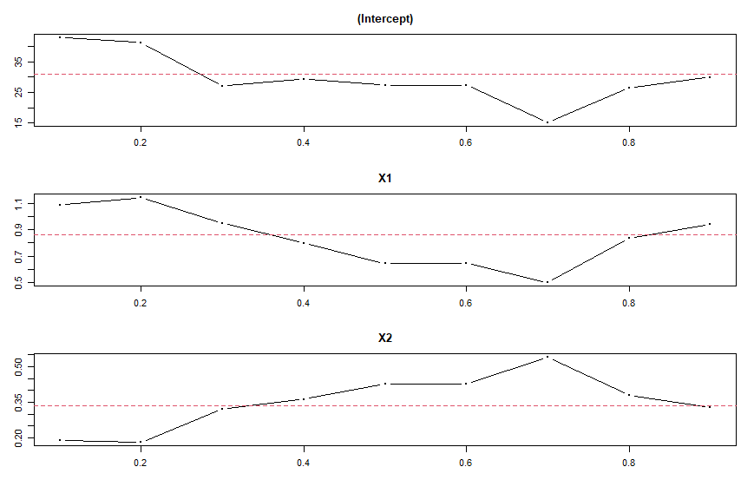
The graph shows how coefficients change with tau changing from 0.1 to 0.9. Dashed line is the OLS regression coefficient.

tau=0.1 | Value | Std.Error | t-value | Pr(>|t|)
(Intercept) | 42.85774 | 19.50102 | 2.19772 | 0.0592
X1 | 1.08787 | 0.30036 | 3.62189 | 0.00676
X2 | 0.18828 | 0.187 | 1.00689 | 0.34347
tau=0.2 | Value | Std.Error | t-value | Pr(>|t|)
(Intercept) | 41.13115 | 20.83687 | 1.97396 | 0.08383
X1 | 1.14754 | 0.35556 | 3.22742 | 0.0121
X2 | 0.18033 | 0.20596 | 0.87554 | 0.4068
tau=0.3 | Value | Std.Error | t-value | Pr(>|t|)
(Intercept) | 27.03704 | 17.6027 | 1.53596 | 0.1631
X1 | 0.95062 | 0.41336 | 2.29975 | 0.05049
X2 | 0.32099 | 0.20397 | 1.57372 | 0.1542
tau=0.4 | Value | Std.Error | t-value | Pr(>|t|)
(Intercept) | 29.30435 | 19.32343 | 1.51652 | 0.16786
X1 | 0.7971 | 0.47614 | 1.67408 | 0.13265
X2 | 0.36232 | 0.23908 | 1.51549 | 0.16811
tau=0.5 | Value | Std.Error | t-value | Pr(>|t|)
(Intercept) | 27.36782 | 35.07284 | 0.78031 | 0.45767
X1 | 0.64368 | 0.78965 | 0.81514 | 0.43858
X2 | 0.42529 | 0.40509 | 1.04985 | 0.32446
tau=0.6 | Value | Std.Error | t-value | Pr(>|t|)
(Intercept) | 27.36782 | 16.36911 | 1.67192 | 0.13308
X1 | 0.64368 | 0.4241 | 1.51774 | 0.16756
X2 | 0.42529 | 0.20921 | 2.03282 | 0.07652
tau=0.7 | Value | Std.Error | t-value | Pr(>|t|)
(Intercept) | 15.18654 | 16.67271 | 0.91086 | 0.38899
X1 | 0.49847 | 0.38598 | 1.29145 | 0.23261
X2 | 0.53823 | 0.19467 | 2.76475 | 0.02449
tau=0.8 | Value | Std.Error | t-value | Pr(>|t|)
(Intercept) | 26.3787 | 21.30348 | 1.23823 | 0.25073
X1 | 0.83432 | 0.52131 | 1.60043 | 0.14817
X2 | 0.3787 | 0.25802 | 1.46769 | 0.18037
tau=0.9 | Value | Std.Error | t-value | Pr(>|t|)
(Intercept) | 29.91045 | 18.3925 | 1.62623 | 0.14255
X1 | 0.9403 | 0.46425 | 2.02541 | 0.07741
X2 | 0.32836 | 0.22815 | 1.43925 | 0.18803

These tau cannot provide a better significane than a linear model.
Ridge:
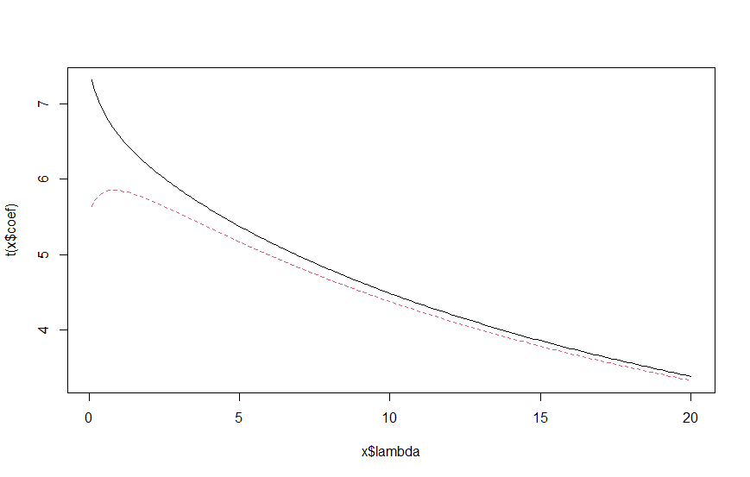

lambda | intercept | X1 | X2
0.1 | 30.91604 | 0.841689 | 0.341577
0.2 | 30.99722 | 0.826091 | 0.346157
4.9 | 49.98273 | 0.621472 | 0.314331
5.0 | 50.35494 | 0.618947 | 0.31323
5.1 | 50.72458 | 0.616447 | 0.312135
9.9 | 65.81617 | 0.518362 | 0.266158
10.0 | 66.0829 | 0.516671 | 0.265331
10.1 | 66.34797 | 0.514992 | 0.264509
14.9 | 77.37479 | 0.445796 | 0.230124
15.0 | 77.57389 | 0.444556 | 0.2295
15.1 | 77.77191 | 0.443323 | 0.228879
19.9 | 86.15548 | 0.391304 | 0.202547
20.0 | 86.30957 | 0.390351 | 0.202062

lm.ridge() function does not calculate significance levels, but we have another function for ridge regression.
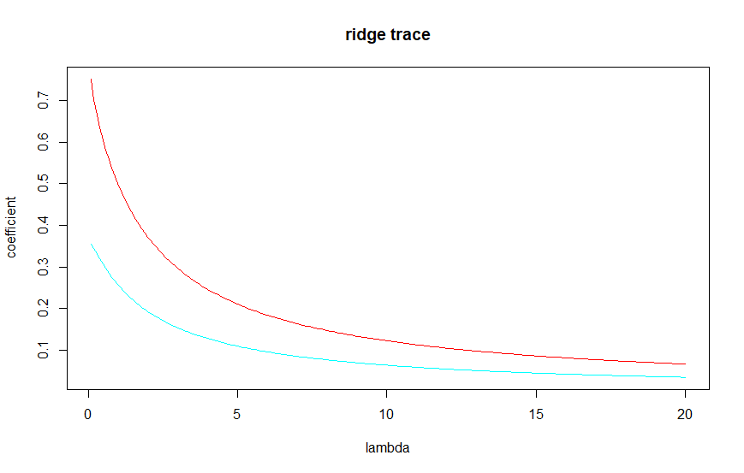Significance of different coefficients calculated with ridge::linearRidge() is very low, all of them are between 0.0001-0.0004, even lower than in the linear (yet we don’t have information about the significance of intercept coefficient):

Significance codes: 0 ‘***’ 0.001 ‘**’ 0.01 ‘*’ 0.05 ‘.’ 0.1 ‘ ’ 1

lambda | intercept | X1 | X2 | sig(X1) | code(X1) | sig(X2) | code(X2)
0.1 | 34.0954 | 0.7517 | 0.3541 | 2.22E-16 | *** | 1.93E-13 | ***
0.2 | 38.9496 | 0.7029 | 0.3448 | <2e-16 | *** | <2e-16 | ***
4.9 | 114.9989 | 0.2141 | 0.1114 | 1.47E-05 | *** | 1.84E-05 | ***
5.0 | 115.5039 | 0.211 | 0.1098 | 1.61E-05 | *** | 2.01E-05 | ***
5.1 | 115.9945 | 0.208 | 0.1082 | 1.77E-05 | *** | 2.20E-05 | ***
9.9 | 129.80666 | 0.12362 | 0.06443 | 0.00015 | *** | 0.000174 | ***
10.0 | 129.97642 | 0.12258 | 0.06389 | 0.000153 | *** | 0.000178 | ***
10.1 | 130.14336 | 0.12156 | 0.06336 | 0.000157 | *** | 0.000182 | ***
14.9 | 135.82621 | 0.0869 | 0.04532 | 0.000307 | *** | 0.00035 | ***
15.0 | 135.91038 | 0.08639 | 0.04505 | 0.00031 | *** | 0.000353 | ***
15.1 | 135.99356 | 0.08588 | 0.04479 | 0.000313 | *** | 0.000356 | ***
19.9 | 139.09068 | 0.06701 | 0.03495 | 0.000434 | *** | 0.00049 | ***
20.0 | 139.1408 | 0.0667 | 0.03479 | 0.000437 | *** | 0.000492 | ***

The results are different probably due to different methods of calculation (for example, there is another ridge function glmnet() which standardizes the y variable and uses the mean squared errors instead of sum of squared errors, so its results are different from lm.ridge()).

The data is insufficient for building a very good model, there are only 11 values. Age and weight should be good predictors of blood pressure but they are highly correlated so only one should be chosen and paired with other predictor(s).
X = Age
Y = "1" if person has kids and "0" if person has no kids

Logit:
Significance codes: 0 ‘***’ 0.001 ‘**’ 0.01 ‘*’ 0.05 ‘.’ 0.1 ‘ ’ 1

Coefficient | Estimate | Std.Error | z-value | Pr(>|z|) | sig.code
(Intercept) | -5.30945 | 1.13365 | -4.683 | 2.82E-06 | ***
X | 0.11092 | 0.02406 | 4.61 | 4.02E-06 | ***

Wald test:
X2 = 22.0, df = 2, P(> X2) = 1.7e-05
The significance of both the model and coefficients is less than 0.001.

Confusion matrix for default cutoff
 | 0 | 1
0 | 45 | 14
1 | 12 | 29

Optimal_cutoff = 0.5924646
Confusion matrix for optimal cutoff
 | 0 | 1
0 | 50 | 18
1 | 7 | 25

Change in cutoff reduces the number of false positives by 5, but increases the number of false negatives by 4.
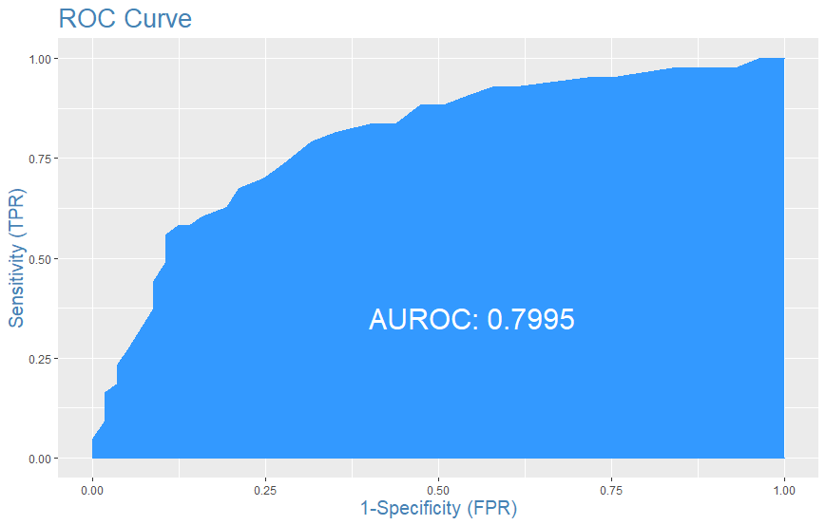
Area Under the Receiver Operating Characteristics tells how model is capable of distinguishing between classes, the closer AUROC to 1, the better.
Probit:

Coefficient | Estimate | Std.Error | z-value | Pr(>|z|) | sig.code
(Intercept) | -3.14573 | 0.6246 | -5.036 | 4.74E-07 | ***
X | 0.0658 | 0.01335 | 4.93 | 8.20E-07 | ***

Wald test:
X2 = 25.4, df = 2, P(> X2) = 3.1e-06
The significance of both the model and coefficients is less than 0.001.

Confusion matrix for default cutoff
 | 0 | 1
0 | 45 | 14
1 | 12 | 29

Optimal_cutoff = 0.5613517
Confusion matrix for optimal cutoff
 | 0 | 1
0 | 50 | 18
1 | 7 | 25

Change in cutoff yields exactly the same resutls as in logit.

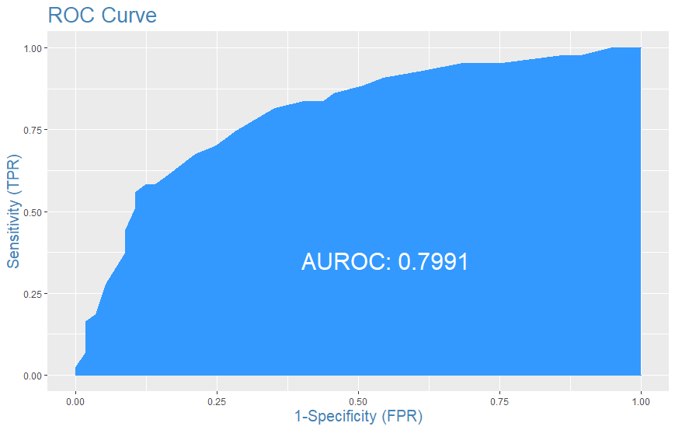
AUROC is slightly worse than in logit (by 0.0004).

Cluster analysis.

Table 10.12 Attributes and Prices of Beer Brands for Cluster Analysis

What parameters to use in cluster analysis?

Brand | Calories  (12 oz.) | Sodium  (mg/12 oz) | Alcohol  (%) | Price (Wholesale)

If we are just people who are interested in our health, we (should probably not drink in the first place but) need to analyze sodium and alcohol, calories if we are on a diet.
If we are poor but craving beer, we might only consider price.
If we are analysts from the big company, we need to analyze the whole market – all parameters. For what? For example, we might want to create a product, which will be placed in the smallest cluster in order to dominate the least competitive environment.

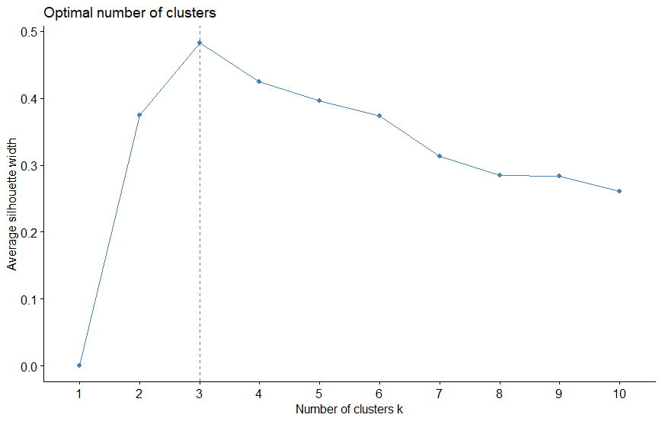
The "silhouette" method is used in kmeans fbiz_nbclust() function because in it the optimal number is the one with the biggest y.
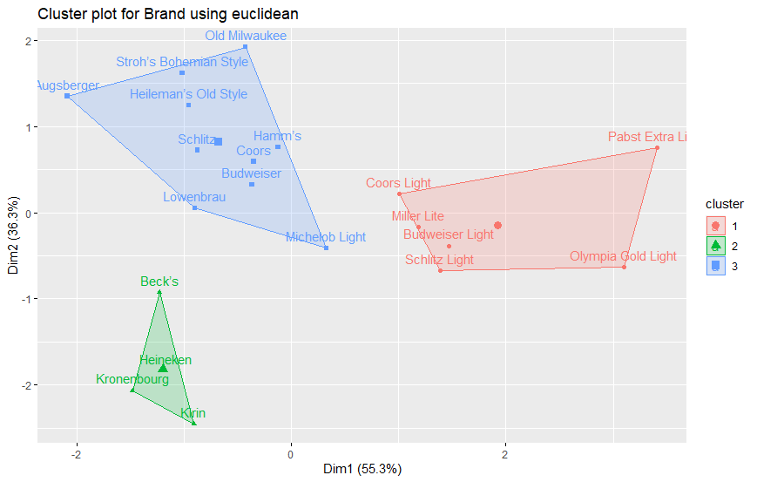

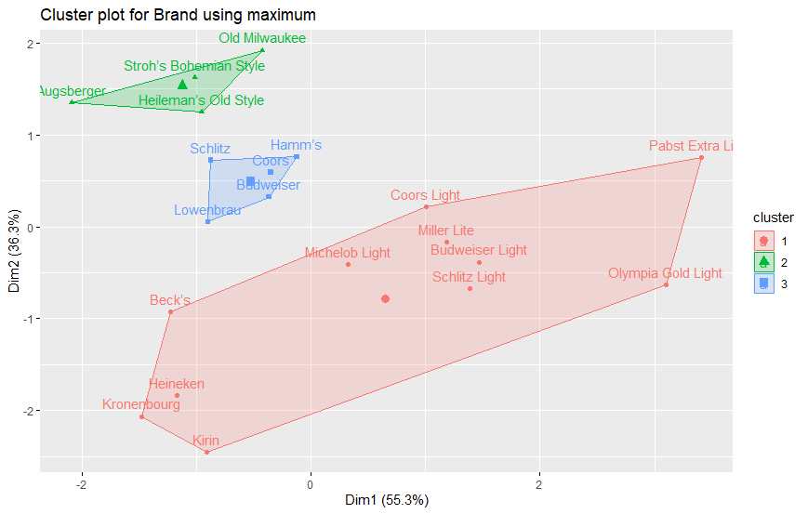

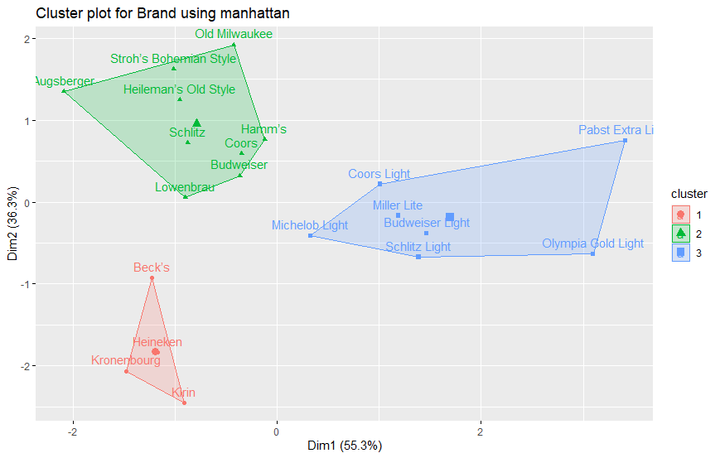

Distance measure strongly affects the forming of clusters in that case: no measure yields the same results.
Number of clusters should be anywhere between 1 and 21 (in both of these situations cluster analysis is meaningless since either everything or nothing is the same), so it is better to use numbers between 2 and 20. Subjectively, on manhattan plot the cluster on the right seems too big and the top one can be divided in two, so let us try 4 and 5.
With n=4:

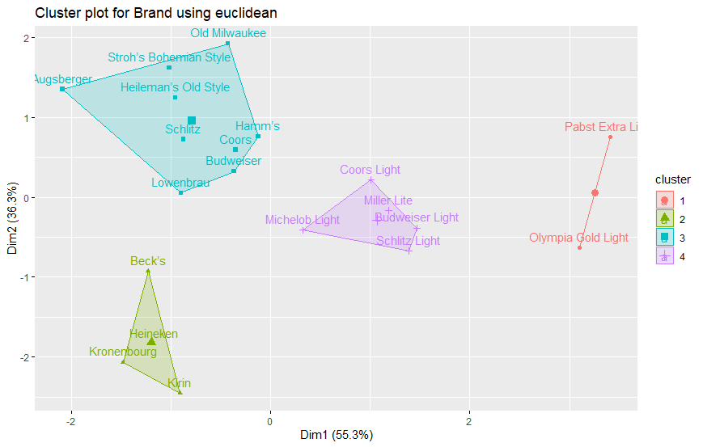

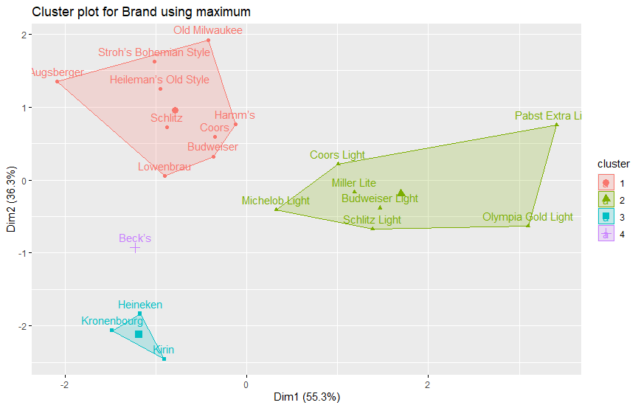

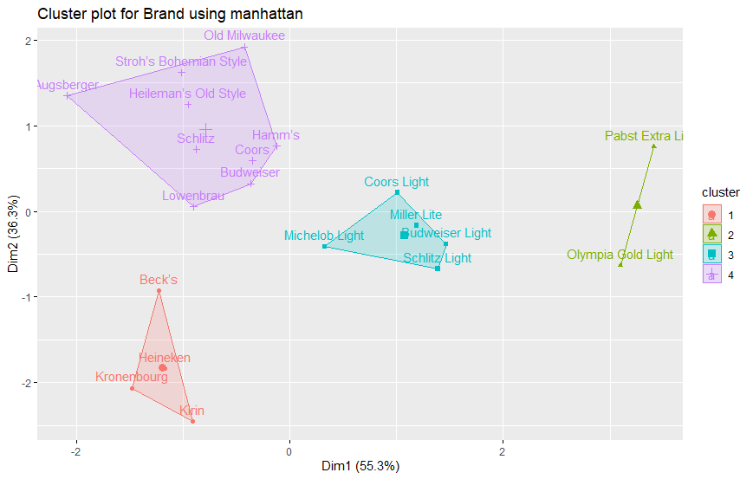

With n=5:

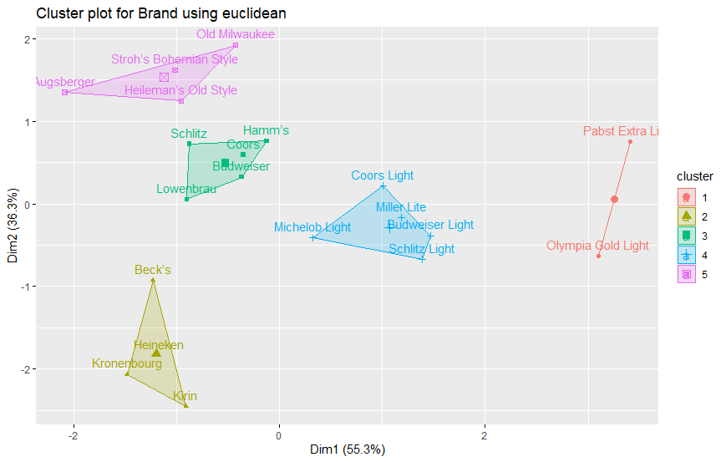

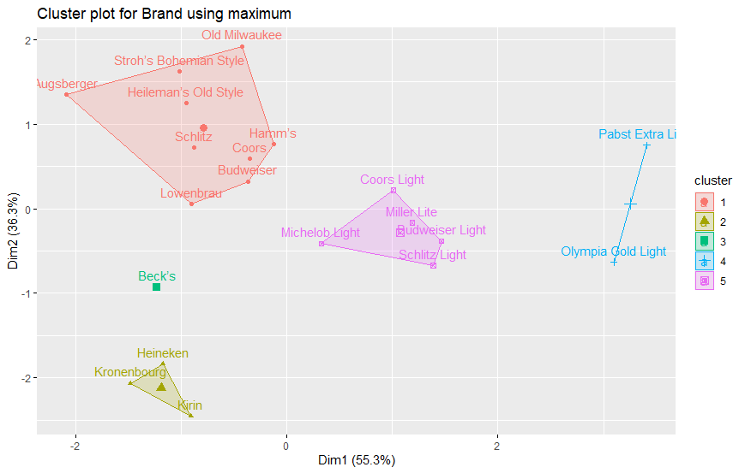

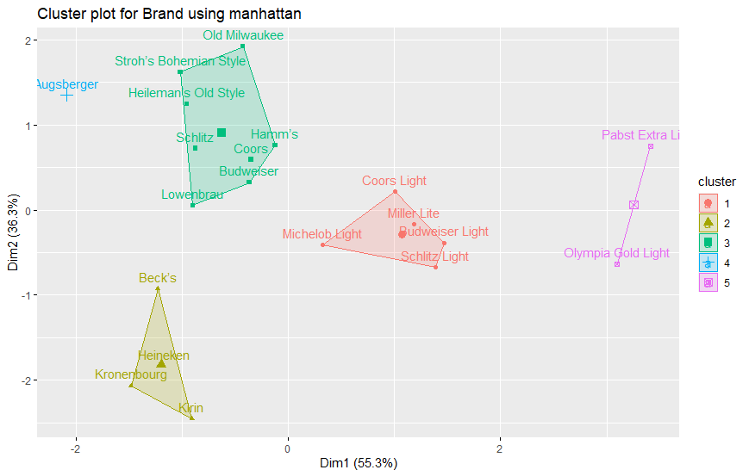

The euclidean with n=5 looks the most right (no singletons, not too big clusters), although Olympia Gold Light and Pabst Extra Light might need to be singletons since they are just too unique.
If we remember our analysis idea, the cluster to infiltrate is the “Olympia Gold Light and Pabst Extra Light” one. By creating the product with similar parameters but superior taste and less price we can dominate this part of beer market.

In hierarchical clusters euclidean/maximum/manhattan distance methods and single/complete/average/centroid/ward.D2 clusterization methods are used.
n is the number of clusters on the levels 1-2 (with 0 being the highest one).
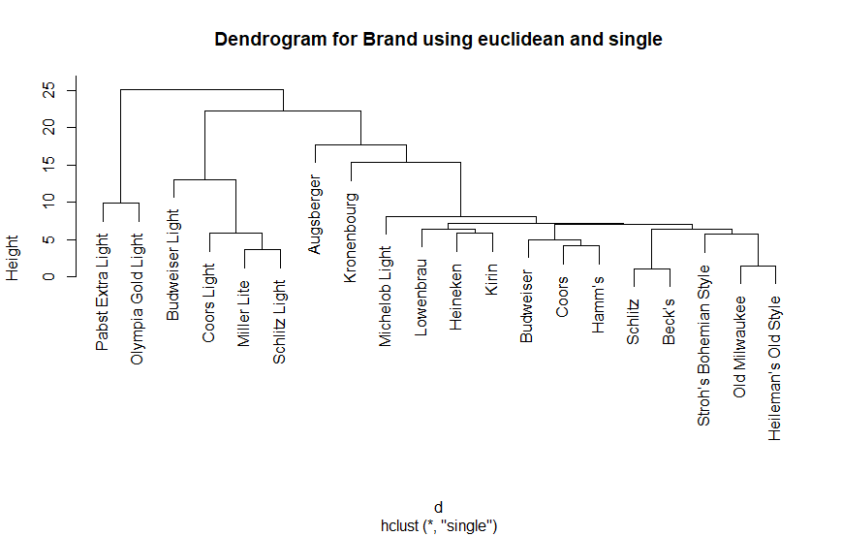
n=3
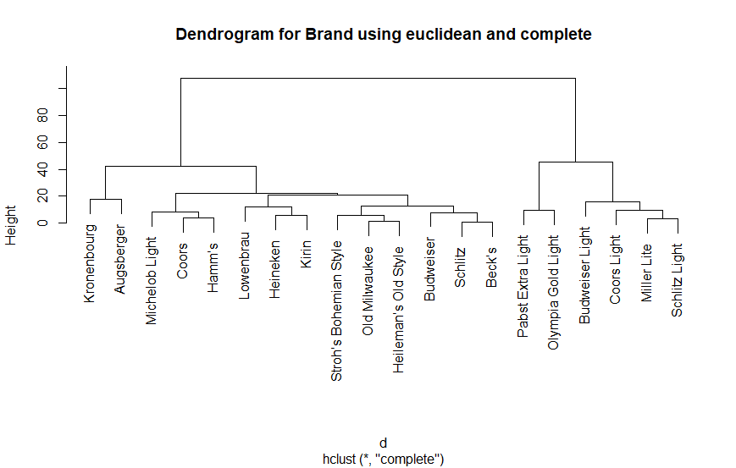
n=4

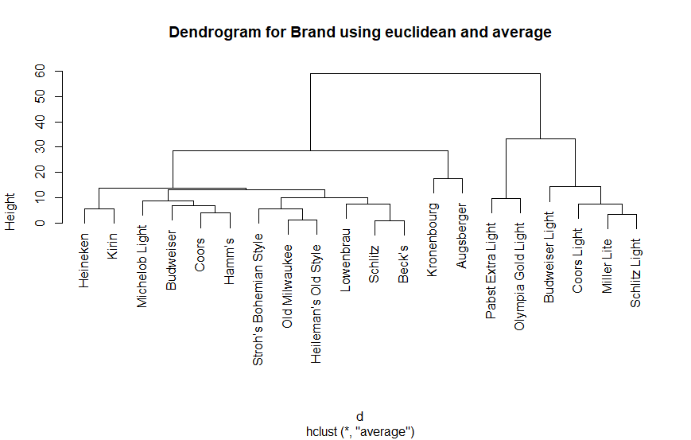
n=4

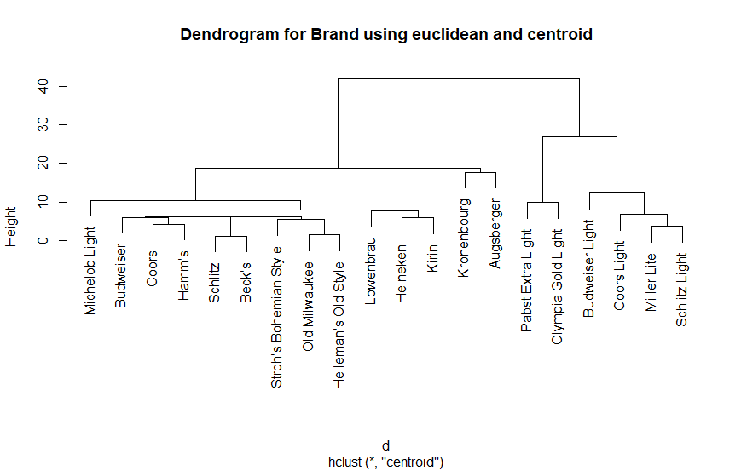
n=4

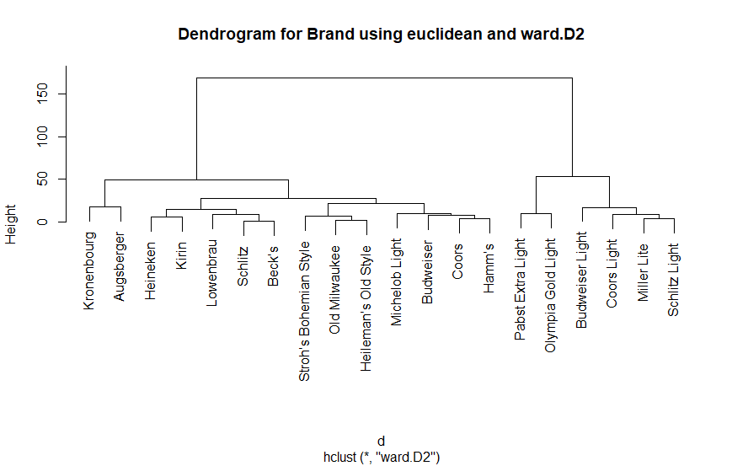
n=4

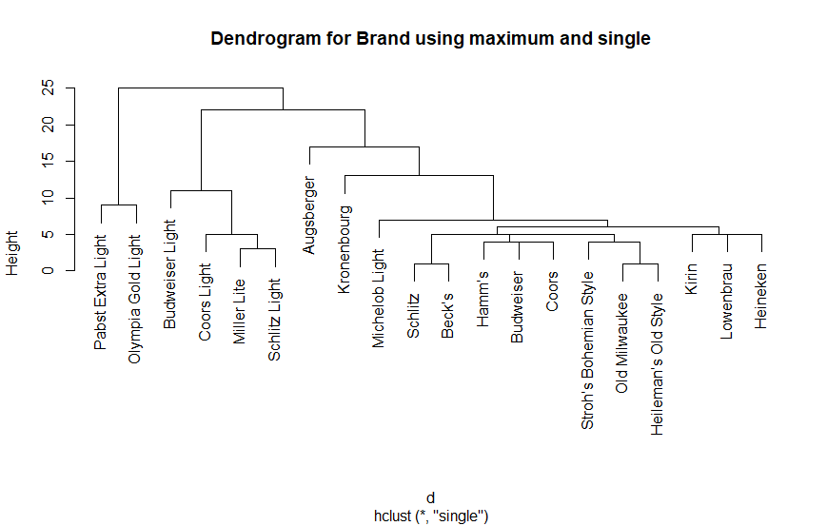
n=3

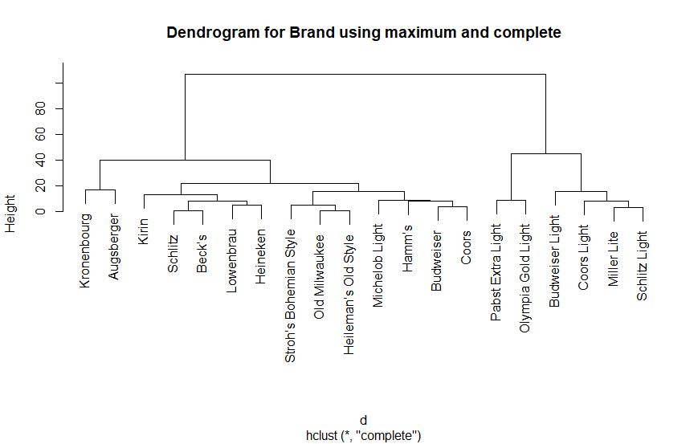
n=4

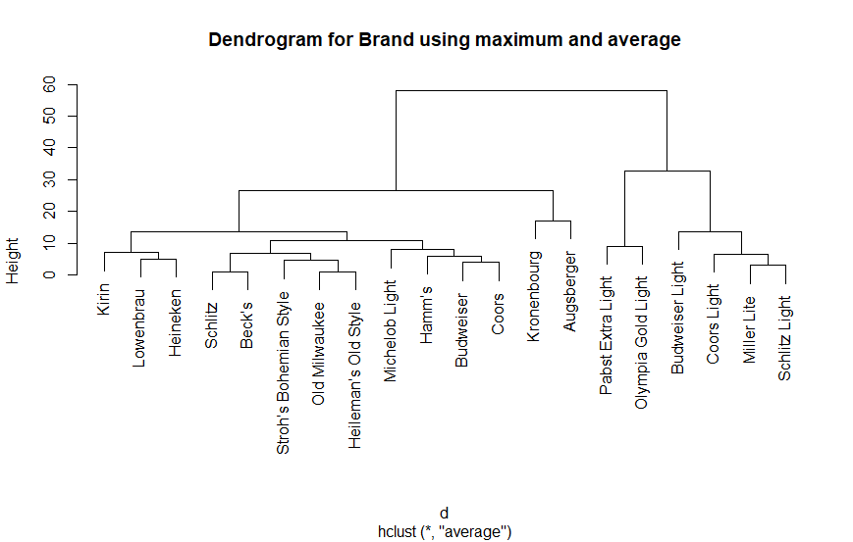
n=4

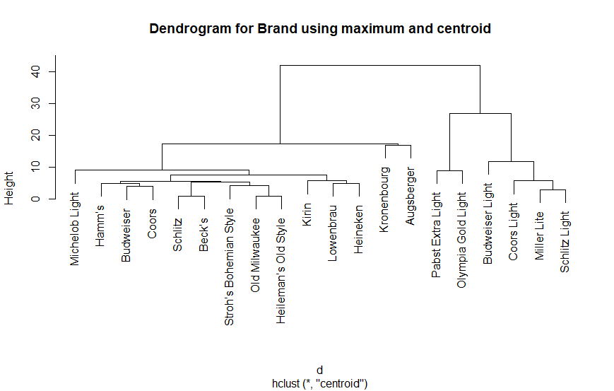
n=4

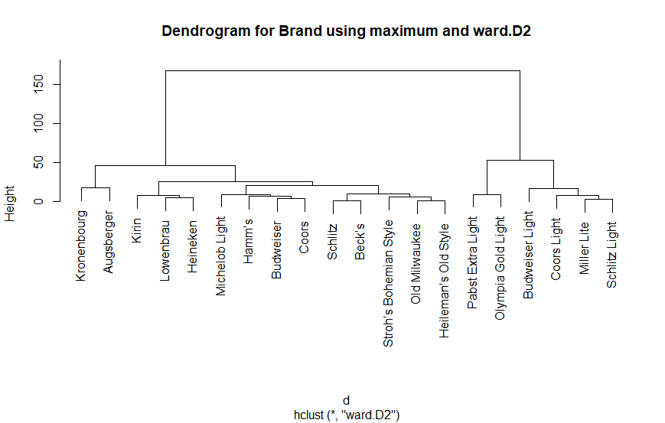
n=4

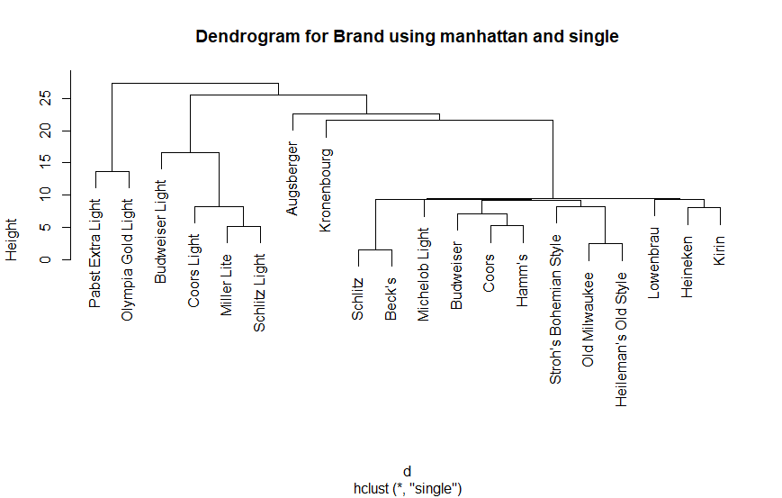
n=3

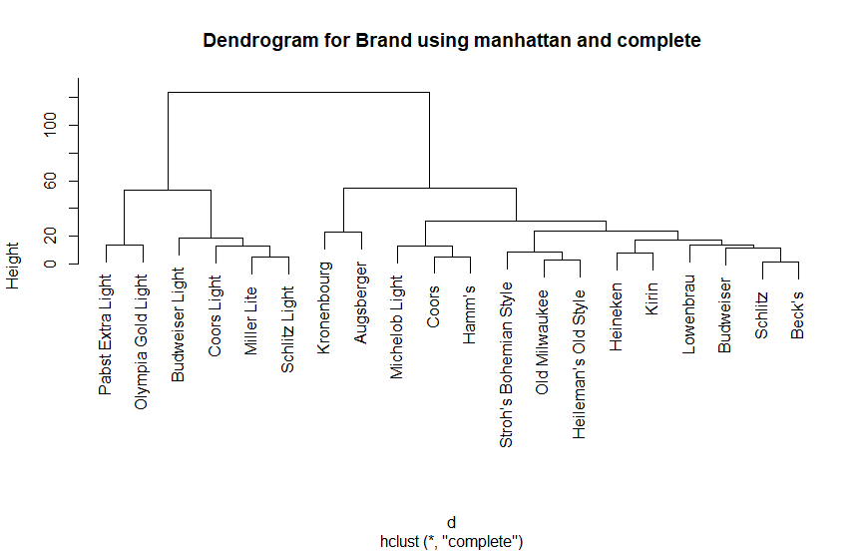 n=4

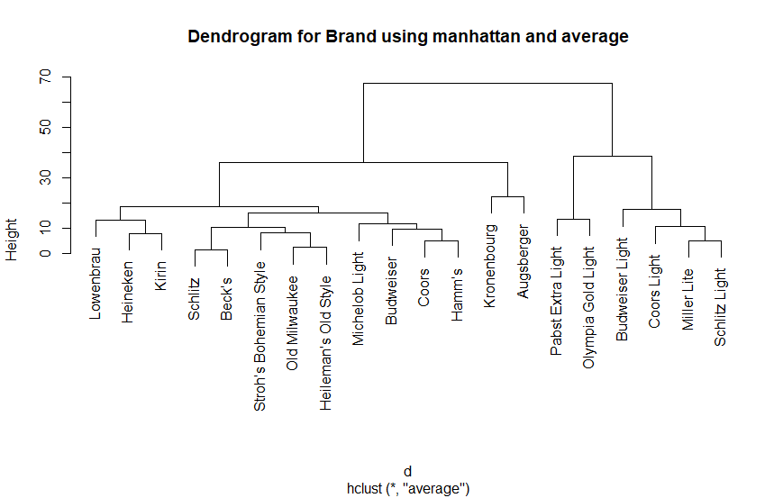 n=4

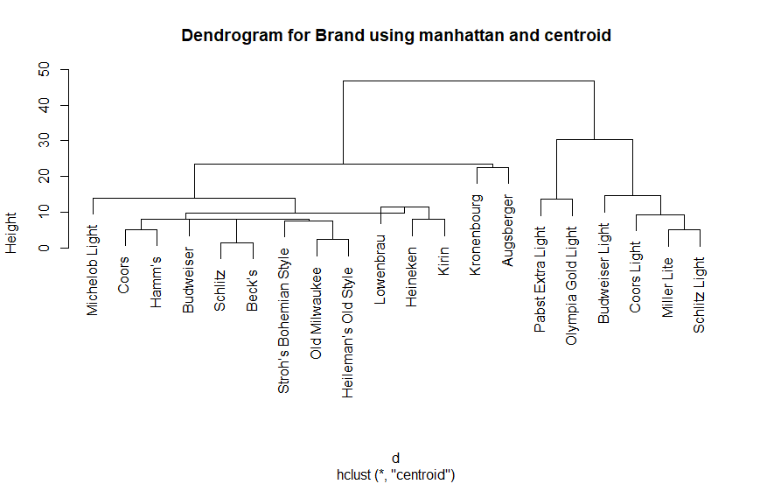 n=4

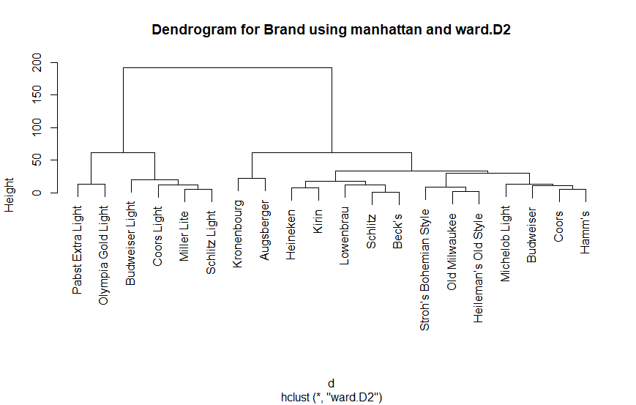 n=4

Dendrograms are practically the same (some differences in positions of lower hierarchies and how they stack at the top) for all methods with n being 3 or 4.
Hierarchical clustering gives results similar to non-hierarchical (it is possible to find similarities between pairs of clusters).

Appendix

Listing 1.

library(readxl)
library(EnvStats)
library(DescriptiveStats.OBeu)

getmode = function(v) {
uniqv = unique(v)
return(uniqv[which.max(tabulate(match(v, uniqv)))])
}

t1 = read_excel("Student 1/Task1.xls.xlsx", col_names = FALSE, col_types = c("numeric"))[[1]]
name = "Girth, mm"

#print(summary(t1))
print(ds.statistics(t1))
print(paste("Mode: ", getmode(t1)))

ecdfPlot(t1, main = "CDF", xlab = name)

for (i in list(5, 10, 15, 60)) {
hist(t1, main = paste("Histogram for approx.", i, "intervals"), xlab = name, breaks = i)
}

boxplot(t1, ylab = name)
Listing 2.

library(readxl)
library(MVN)
library(car)
library(nortest)

t2.dat <- read_excel("Student 1/Task2.xls.xlsx", col_names = FALSE)
t2 = t2.dat[[1]]

conf.lvl = 0.9

qqPlot(t2, distribution = "norm", main = "Q-Q plot", envelope = conf.lvl)

for (adj in list(TRUE, FALSE)){
print(pearson.test(t2, adjust = adj))
}

for (t in list("Lillie", "CVM", "AD")){
print(mvn(t2.dat, univariateTest = t, desc = TRUE))
}

Listing 3.

library(readxl)
library(car)

t3.dat <- read_excel("Student 1/Task3.xlsx", col_names = FALSE)

names(t3.dat) = c(1,2,3,4)

conf.lvl = 0.95

samples = list()
for (i in (1:2)){
samples[[i]] = na.omit(t3.dat[[i]])
}

for (i in (1:2)){
qqPlot(samples[[i]], distribution = "norm", envelope = conf.lvl, main = paste("Sample", i))
print(shapiro.test(samples[[i]]))
}

t.test(x = samples[[1]], y = samples[[2]], mu = 0, alternative = "two.sided", var.equal = TRUE, conf.level = conf.lvl)

var.test(x = samples[[1]], y = samples[[2]], ratio = 1, alternative = "two.sided", conf.level = conf.lvl)

ks.test(x = samples[[1]], y = samples[[2]], alternative = "two.sided")

wilcox.test(x = samples[[1]], y = samples[[2]], mu = 0, alternative = "two.sided", conf.level = conf.lvl)
Listing 4.

library(readxl)
library(car)
library(lmtest)
library(MASS)
library(aod)
library(InformationValue)
library(quantreg)
library(ridge)

t41 <- read_excel("Student 1/Task4-1.xlsx")

research_reg = function(data, formula, reg_name){
print(reg_name)
res = 0
if (reg_name == 'linear'){
res = lm(formula = formula, data = data)

print(bptest(formula = res))
if (as.character(formula[[3]])[[1]] == "+"){
print(vif(mod = res))
}
print(dwtest(formula = res))
}
else if (reg_name == 'ridge') {
# res = lm.ridge(formula = formula, lambda = seq(0.1, 20, by=0.1), data = data)
res = linearRidge(formula = formula, lambda = c(0.1, 0.2, 4.9, 5.0, 5.1, 9.9, 10.0, 10.1, 14.9, 15.0, 15.1, 19.9, 20.0), data = data)
print(res)
}
else if (reg_name == 'quantile') {
res = rq(formula = formula, tau = 1:9/10, data = data)
}

print(summary(res, se="ker"))
plot(res)
}

regs = list('quantile', 'ridge')

fs = list(Y ~ X1 + X2, Y ~ X1, Y ~ X2)

for (f in fs){
print(f)
research_reg(data = t41, formula = f, reg_name = "linear")
}

for (r in regs){
research_reg(data = t41, formula = fs[[1]], reg_name = r)
}

t42 <- read_excel("Student 1/Task4-2.xlsx")

research_bin = function(formula, data, actual_var, family_name){
print(paste(family_name, "for", actual_var))
mybin = glm(formula, data, family = binomial(family_name))
print(summary(mybin))

print(wald.test(b = coef(mybin), Sigma = vcov(mybin), Terms = 1:ncol(data)))

predicted = plogis(predict(mybin, data))
actual = data[[actual_var]]
optCutOff = optimalCutoff(actual, predicted)[1]
print(optCutOff)

print(confusionMatrix(actual, predicted))
print(confusionMatrix(actual, predicted, threshold = optCutOff))

plotROC(actual, predicted)
}

f = Y ~ X

family_names = list('logit', 'probit')

for (f_n in family_names){
research_bin(f, t42, "Y", f_n)
}
Listing 5.

library(readxl)
library(ggplot2)
library(factoextra)
library(amap)
library(fpc)

t5.dat = na.omit(read_excel("Student 1/Task_5.xls"))

names(t5.dat) = c("Brand", "Calories", "Sodium", "Alcohol", "Price")

t5 = data.matrix(t5.dat[c(-1)])
rownames(t5) = t5.dat[[1]]

research_clust = function(data, data_name, dists){
data = scale(na.omit(data))
a = fviz_nbclust(x = data, FUNcluster = kmeans, method = "silhouette")
plot(a)
a_data = a$data
# opt_n_clust = as.numeric(a_data$clusters[which.max(a_data$y)])
opt_n_clust = 5
for (dist_method in dists){
km.res = Kmeans(x = data, centers = opt_n_clust, method = dist_method)
plot(fviz_cluster(km.res, data = data, frame.type = "convex",
main = paste("Cluster plot for", data_name, "using", dist_method)))
}
}

research_hclust = function(data, data_name, dists, clusts){
for (dist_method in dists){
for (clust_method in clusts){
d = dist(data, method = dist_method)
res.hc = hclust(d, method = clust_method)
plot(res.hc, main = paste("Dendrogram for", data_name, "using", dist_method, "and", clust_method))
}
}
}

dist_methods = list("euclidean", "maximum", "manhattan")

research_clust(t5, "Brand", dist_methods)

clust_methods = list("single", "complete", "average", "centroid", "ward.D2")

research_hclust(t5, "Brand", dist_methods, clust_methods)

