Installation tips

1. Select all “Suppliers”, and the following Importers\Exporters:
   1. DXF – DWG
   2. IDF
   3. STEP
   4. EAGLE
   5. PDF3D

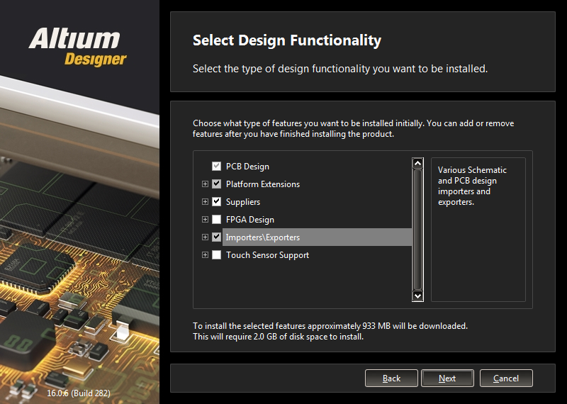

2) The rest is fine to leave as default

3) I suggest not participating in this program.

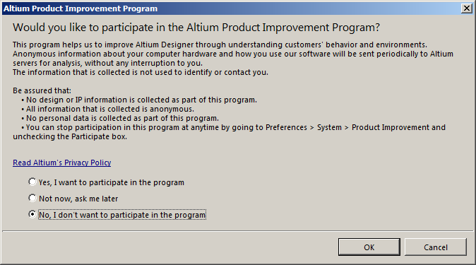

4) Sign in with account you created on Altium webpage

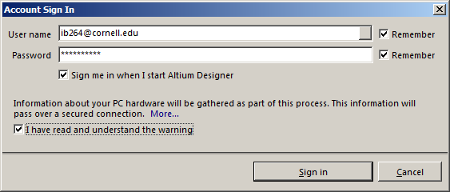

5) Activate your own license, but make sure to select the right one. There are many listed for some reason. You can only sign in on one machine at a time for $120 standalone license.

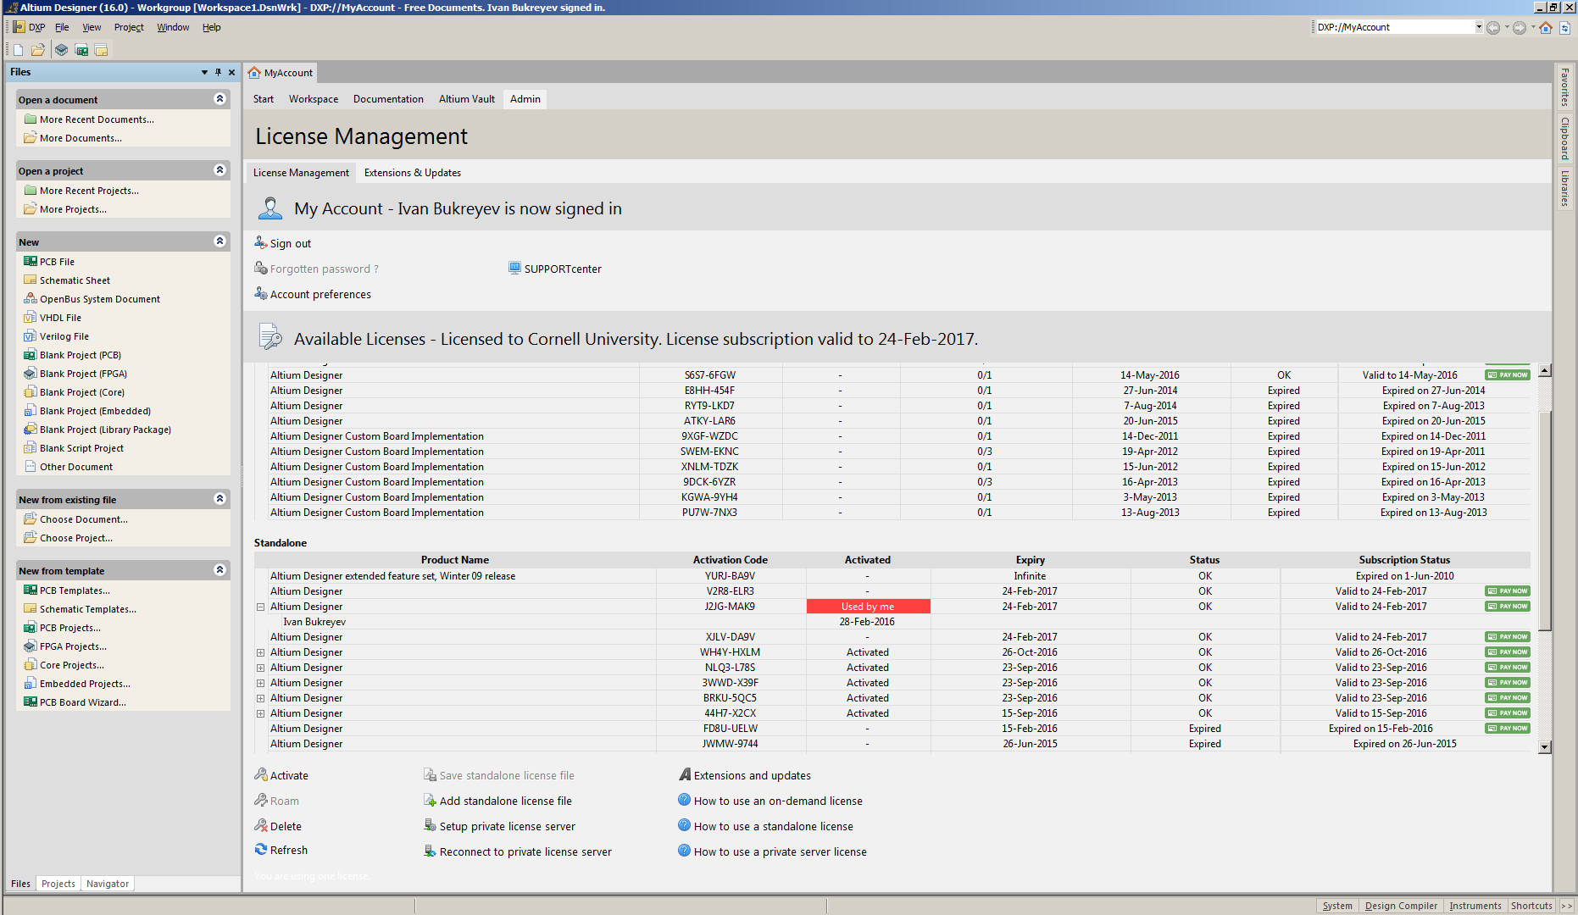

6) Now is a good time to configure your preferences. See “preferences.txt” for sample setup.

