

TEAM: | Nangka (Group 9) |  | DATE: | November 5, 2025
WEEK: | 8th |  | VENUE: | EARIST
ATTENDEES:
NAME |  | SIGNATURE
1. Albuera, Jeremy G.
2. Ibarra, Ivell Jay R. |  | 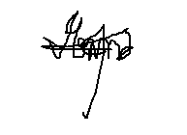
3. Onnagan, Sebastian B.
4. Pierre, Shobe R. |  | 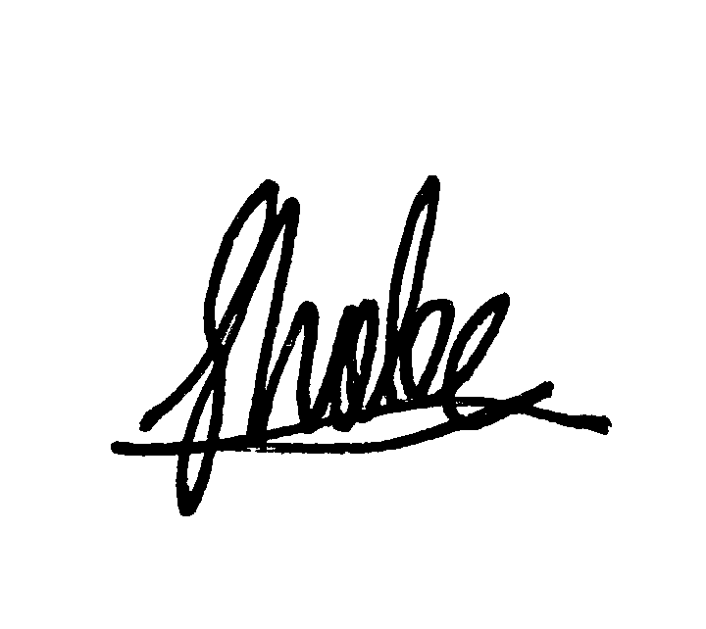
5. Tranquena, Joshua B. |  | 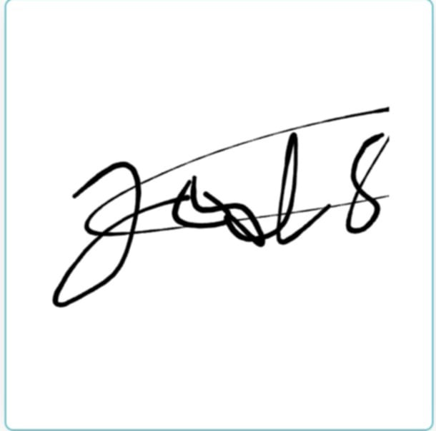
6. Zambrona, Raph Kenneth M. |  | 
AGENDAS:
- Presentation to Adviser

DISCUSSIONS:
The team presented the proposed system titled “Persons with Disability Management Information System (PWD MIS)” to the adviser for evaluation and feedback. During the presentation, the team discussed the system’s objectives, target users, features, and expected outcomes. The adviser provided valuable comments and suggestions to enhance the project’s functionality and alignment with the community’s needs. The team took note of the revisions recommended, particularly on improving the user interface, refining the data management process, and adding validation features for accuracy.

NEXT WEEK PLAN ACTIVITIES
- Proposal Acceptance to Beneficiaries

PREPARED BY: REVIEWED BY:
Jeremy G. Albuera Sebastian B. Onnagan
Documentation Leader QA LEADER

CHECKED BY: APPROVED BY:
Shobe R.Pierre Ernanie M. Carlos Jr.,MIT
PROJ. LEADER ADVISER

Attachments:

