EMPLOYEE DATABASE USER GUIDE

# Loading a Database

***First Run:***

The default database provided in the EmployeeUI folder must be loaded into the database upon execution. The name for this file should always be “DB.txt”.

**Step 1:** Run the Database.jar file, to load the user interface.



**Step 2:** Navigate through File > Open and load in the default DB.txt database

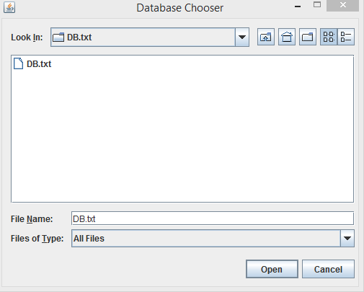This can be found in the default EmployeeUI folder

# Adding an Employee

To add an employee, fill out all of the required fields and click on the “Add Employee” button. Upon release, the fields will be added to the database and when displaying the list it will appear in the format shown below.

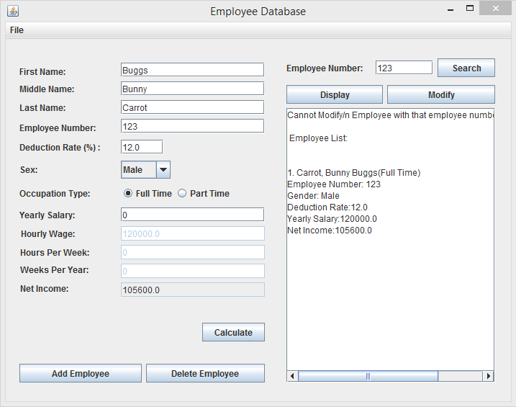

# 

# Deleting an Employee

To delete an Employee, enter the employee’s number next to the search button. Next, click the “Delete Employee” button, and upon release the employee and his/her information should be removed from the database. A confirmation message will appear in the console box if successfully removed.

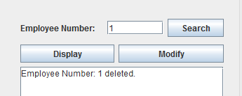

# Modifying an Employee

To modify an employee, enter the employee number of the employee whose information you wish to modify, and it will be loaded into the fields. Please note that the employee is also removed from the database when modifying, and must be re-entered if you wish to keep this employee.

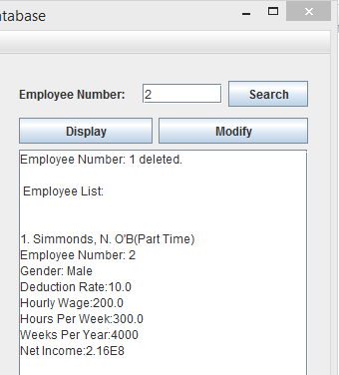

# Displaying the Employees

There is a display button on the user interface that displays the employees. An example of the format of the employees can be seen below.

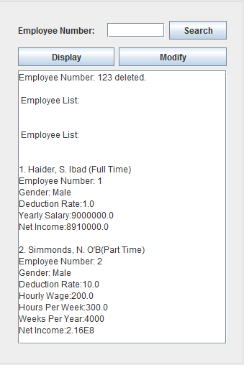

# Saving the Database

The database automatically saves upon closing, but can also be manually saved by using the “Save File” function. This can be found by navigating through the “File” drop down menu.

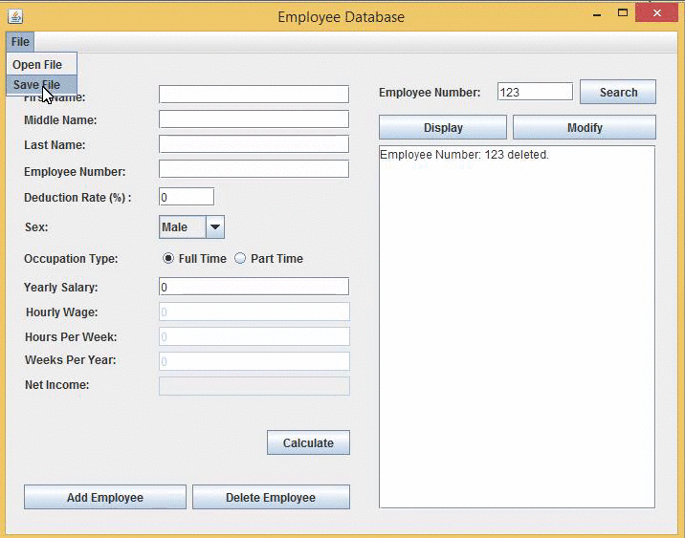

# File Format

The employee database takes the following parameters:

Full Time(1) [radio button], Employee Number [integer], First Name [string], Middle Name [string], Last Name[string], Deduction Rate [double], Yearly Salary [int], and Net Income [double]

Full Time(1) [radio button], Employee Number [integer], First Name [string], Middle Name [string], Last Name[string], Deduction Rate [double], Hourly Wage [double], Hours Per Week [integer], Weeks Per Year [integer], and Net Income [double]

Example:

2 1 Ibad S. Haider Female 50.0 100.0 50.0 ***< Full Time Employee>***

1 2 OB G. Simmonds Male 75.0 10.0 10.0 10 250.0 ***<Part Time Employee>***

TEST CASES

**Display:**

* + - * Displaying an empty list
      * Displaying a list with entries

**Modify:**

* + - * Modifying an employee in the database
      * Attempting to modify an employee not in the database

**Search:**

* + - * Searching for an existent employee
      * Searching for a nonexistent employee

**Add Employee:**

* + - * Disallowing improper parameter values
      * Disabling non-applicable fields (part-time and fulltime)
      * Properly calculated net income

**Delete Employee:**

* Failure to delete a nonexistent employee
* Successfully deleting an existent employee

**Load/Save Functions:**

* Load function works properly
* Save function works properly