Supplementary Material
Toward next-generation explainable AI for groundwater contamination mapping: spatial leakage, predictor leakage, and transferability limits across four countries
Ibad Ullahª, Sebnem Arslan^{b, *}, Mena Elassal^{c}
ª Department of Geological Resources and Geological Engineering, China University of Geosciences, Wuhan 430074, China (ibadullah@cug.edu.cn)
^{b}Department of Geological Engineering, Ankara University, 06830 Ankara, Türkiye (sarslan@eng.ankara.edu.tr)
Department of Geography College of Arts and Humanoties King Khalid University Abha, Saudi Arabia, (mmalasal@kku.edu.sa)
Contents
- Text S1 Data sources and pre-processing
- Text S2 Models, validation designs, and metrics
- Text S3 Explanation, uncertainty, censoring and transfer analyses
- Text S4 Software and reproducibility
- Table S1 Dataset details and pre-processing
- Tables S2–S12 Full numerical results
- Figures S1–S7

Text S1 Data sources and pre-processing
Bangladesh, national (BGS and DPHE 2001). The DPHE/BGS National Hydrochemical Survey (1998–1999) provides 3,534 tube wells with latitude, longitude, well depth and ICP analyses. Values preceded by '<' were flagged as non-detects (31.3% of arsenic values) and kept at their reported limit. Coordinates were projected to UTM zone 46N (EPSG:32646). Predictors: well depth, Ca, Fe, Mg, Mn, Na, P, SO₄, Si, K; coordinates were added or omitted depending on the experiment.
Bangladesh, Araihazar (van Geen et al. 2003; Jameel 2021). Dataset 2 of the HydroShare resource (6,595 wells with coordinates, depth and year; CC BY) was used. No non-detect flags are provided. Coordinates were projected to UTM 46N; predictors were well depth with or without coordinates.
USA, arsenic (Erickson et al. 2020). Water_Chemistry.csv was joined to Site_Information.csv by SITE_ID and the most recent sample per well retained (67,676 wells). Records with remark '<' were flagged as non-detects (43.1%); their value is the reporting limit, which ranges from 0 to 10 µg L⁻¹ (Fig. S3a). The provider's Albers coordinates (generalized to 1 km) were used directly. Predictors: well depth, pH and Mn (34.5% and 47.5% missing, handled natively by XGBoost) with or without coordinates.
USA, fluoride (McMahon 2020). The dataset provides no coordinate columns; latitude and longitude were decoded from the 15-digit USGS site identifier (degrees–minutes–seconds of latitude and longitude plus a sequence number), giving a position precise to about 30 m for sites identified in this way. All 38,105 wells were located. Values flagged '<' (22.9%, all at 0.1 mg L⁻¹) were kept at the limit. Coordinates were projected to CONUS Albers (EPSG:5070). Predictors: depth, pH, temperature, Ca, Mg, Na, alkalinity, Cl, SO₄ and SiO₂.
USA, national arsenic model inputs (Lombard 2021). The released model-input table of the USGS national private-well arsenic model (Lombard et al. 2021) contains 20,450 wells, binary exceedance indicators (As > 1, > 5, > 10 µg L⁻¹), the published random training/testing split, and 72 mappable predictors: generalized lithology (6), geologic units (28), surficial deposits (21), soil C-horizon chemistry (10), average annual recharge, precipitation, base-flow index, stream lateral position (3), and tile drainage. Thirteen Level II ecoregion indicators are also supplied; wells with none of them (eastern ecoregions) form one further group. Well coordinates are not released. Ecoregion indicators were used only to define spatial groups and were excluded from the predictors.
Pakistan, Lower Indus Basin (this study). 848 wells in 14 districts of Sindh were sampled between March and October 2024 and analyzed for EC, pH, turbidity, TDS, alkalinity, HCO₃, CO₃, Cl, SO₄, Ca, Mg, hardness, Na, K, NO₃, PO₄, F, Fe and As, with well depth recorded in feet (converted to meters). Arsenic concentrations in groundwater samples were determined using atomic absorption spectrophotometry (AAS) and ranged from 0 to 250 µg/L, with the lowest positive recorded concentration being 0.10 µg/L. The dataset contained both zero and positive arsenic values, with approximately 82% of the sampled wells having concentrations recorded as zero, indicating values below the laboratory reporting limit. The remaining arsenic concentrations were reported at discrete intervals, including 5, 10, 20, 25, 30, 50, 60, 100, 150, 200, and 250 µg/L. Approximately 7.0% of the wells exceeded the World Health Organization (WHO) guideline value of 10 µg/L. Fluoride concentrations exhibited continuous variation, comprising 124 distinct measured values, with 9.4% of samples exceeding the WHO guideline value of 1.5 mg/L. Nitrate concentrations had a median value of 1.8 mg/L and were reported as nitrate (NO₃⁻). All geographic coordinates were projected to the Universal Transverse Mercator (UTM) coordinate system, Zone 42N (WGS 84; EPSG:32642), for spatial analysis.
Türkiye, Kazan Basin (this study). 34 sources (wells, fountains, springs) were sampled in October 2021 and 25 in April 2022; 21 sites were matched across seasons. Coordinates are UTM 36N (WGS 84). Values below detection were replaced by half the detection limit in the source file. The one thermal sample was excluded, leaving 58 samples (84.5% above 10 µg L⁻¹). Fe was converted from µg L⁻¹ to mg L⁻¹ to match the Pakistan data.
Table S1 Dataset details and pre-processing
Dataset | n | Target transform | Predictor sets | Spatial unit for validation
Bangladesh, national | 3,534 | log₁₀(As + 1) | location + depth; ± co-measured ions | 10–100 km blocks
Bangladesh, Araihazar | 6,595 | log₁₀(As + 1) | depth; ± location | 0.25–2 km blocks
USA, As | 67,676 | log₁₀(As + 1) | depth, pH, Mn; ± location | 25–400 km blocks
USA, F | 38,105 | log₁₀(F + 0.01) | depth, pH, T, major ions; ± location | 25–400 km blocks
Pakistan, As | 848 | As > 10 µg L⁻¹ (binary) | location + depth; ± 12 co-measured variables | 10–50 km blocks; districts
Pakistan, F and NO₃ | 848 | log₁₀(F + 0.01); log₁₀(NO₃ + 0.1) | location + depth; ± co-measured variables | 10–50 km blocks; districts
Türkiye, As (test only) | 58 | As > 10 µg L⁻¹ | 11 shared hydrochemical variables | external basin

Text S2 Models, validation designs, and metrics
Models. All models were XGBoost gradient-boosted trees (Chen and Guestrin 2016) with histogram tree construction. Open datasets: 400 trees, maximum depth 6, learning rate 0.05, row and column subsampling 0.8. Pakistan: 300 trees, depth 4, otherwise identical. Hyperparameters were fixed in advance and not tuned, so that differences between validation designs are not confounded by tuning.
Model comparison. The random-versus-held-out comparison was repeated with five model families on the same predictors: random forest (300 trees, minimum leaf size 2; Breiman 2001), XGBoost (as above), LightGBM (400 trees, 31 leaves, learning rate 0.05; Ke et al. 2017), CatBoost (400 iterations, depth 6, learning rate 0.05; Prokhorenkova et al. 2018), and a multilayer perceptron (two hidden layers of 128 and 64 units for regression or 64 and 32 for classification, standardized inputs, early stopping; Pedregosa et al. 2011). Missing values were median-imputed with missingness indicators for the random forest and the neural network. One seed and one common fold assignment per task were used (Table S8; Fig. S5). TabPFN (Hollmann et al. 2025) could not be evaluated because its weights require individual license acceptance and could not be downloaded in our computing environment.
Random cross-validation. Five-fold K-fold with shuffling (stratified for the Pakistan arsenic classifier).
Spatial-block cross-validation. Projected coordinates were divided into square cells of edge b km. Cells were randomly assigned to five folds (assignment changes with the seed), and GroupKFold ensured that all wells of a cell fall in the same fold (Roberts et al. 2017; Valavi et al. 2019). Block sizes were chosen to span from well spacing to a substantial fraction of each dataset's extent.
Leave-one-district-out. For Pakistan, each of the 14 districts was held out in turn.
Leave-one-ecoregion-out (USGS model inputs). Each of the 14 ecoregion groups was held out in turn and predicted by XGBoost (three seeds) or random forest (400 trees, one seed) trained on the other 13, for As > 10 and As > 5 µg L⁻¹. Random five-fold CV and the published training/testing split were evaluated for comparison (Table S12; Fig. S6).
Seeds and metrics. Three seeds (open datasets) or five seeds (Pakistan) were run; tables report mean ± standard deviation. Regression skill is the coefficient of determination R² of pooled out-of-fold predictions on the transformed scale; values below zero mean that the model is worse than predicting the overall mean. Classification skill is ROC-AUC; for the open arsenic and fluoride datasets, AUC was also computed for exceedance of WHO guidelines (10 µg L⁻¹ As; 1.5 mg L⁻¹ F) using the regression predictions.

Text S3 Explanation, uncertainty, censoring and transfer analyses
SHAP. For each training fold of random and spatial CV (Pakistan: five groups of districts), TreeSHAP values (Lundberg et al. 2020) were computed on a fixed random subsample of up to 3,000 wells. Mean absolute SHAP per feature gives an importance vector per fold. We report (i) the share of total importance attributed to the two coordinates and (ii) the mean and minimum Spearman correlation between importance vectors of different folds (Table S4).
Conformal prediction. Within each training fold, a random 25% was set aside for calibration and the model fitted to the remaining 75%. The (1 − α) quantile of absolute calibration residuals (α = 0.1, finite-sample corrected) defined symmetric 90% intervals (Lei et al. 2018; Angelopoulos and Bates 2023). Coverage was measured on random test folds and on spatially held-out folds (blocks or district groups), each over three seeds (Table S5).
Conformalized quantile regression (CQR). For US arsenic, Bangladesh arsenic, and Lower Indus fluoride, XGBoost quantile regressors (5th and 95th percentiles) were fitted within each training fold and calibrated on a random 25% of it using the CQR conformity score (Romano et al. 2019; Angelopoulos and Bates 2023), giving well-specific 90% intervals. Coverage and mean width are reported for random and spatial folds (Table S9), and coverage by district for the Lower Indus (Table S11). The out-of-fold predictions and interval widths are mapped in Fig. 3 of the main text.
Direction of SHAP effects. For Lower Indus fluoride, an XGBoost model with location, depth, and the 12 co-measured variables was fitted to all wells, and for each feature the Spearman correlation between its value and its SHAP value was computed; a positive value means that higher values of that variable raise predicted fluoride (Table S10).
Censoring sensitivity. For US arsenic, non-detects were set to the reporting limit (DL), DL/2 or zero, and random and spatial (400 km) CV were repeated (Table S6).
Transfer. A classifier for As > 10 µg L⁻¹ using EC, pH, HCO₃, Cl, SO₄, Ca, Mg, Na, K, NO₃ and Fe was trained on all 848 Pakistan wells (five seeds) and applied to the Kazan Basin samples. Internal skill was estimated by stratified five-fold CV in Pakistan. A sample was 'flagged' when the predicted probability exceeded 0.5 (Table S7). The Kazan dry-season data (n = 33) were also modeled alone with 30 repeats of five-fold CV (Fig. S4b).

Text S4 Software and reproducibility
Analyses used Python 3.13.18, scikit-learn 1.9.1, XGBoost 3.4.1, SHAP 0.54.1, pandas 3.0.5, LightGBM 4.7, CatBoost 1.2, pyproj, and Matplotlib/Basemap. Scripts (Supplementary Code): load_data.py (loading and harmonizing datasets), cv_experiment.py (open datasets), bd_location_only.py, pakistan_cv.py, turkey_transfer.py, extra_analyses.py (SHAP, conformal, censoring), model_comparison.py (five algorithms), lombard_test.py (USGS model predictors), figS6_lombard.py, fig_maps.py (maps, CQR, SHAP directions), fig1_map.py, fig2_results.py, fig3_framework.py (Fig. 4), figS_supplementary.py, fig_models.py, and graphical_abstract.py. Each script writes its results to CSV files from which all tables and figures are generated.

Table S2 Open datasets: cross-validated skill by validation design (mean ± SD over three seeds)
Dataset | Predictors | Validation | R² (log) | AUC (WHO limit)
Bangladesh, national As | with location | random | 0.809 ± 0.000 | 0.964
Bangladesh, national As | with location | 10 km | 0.803 ± 0.001 | 0.963
Bangladesh, national As | with location | 25 km | 0.794 ± 0.002 | 0.961
Bangladesh, national As | with location | 50 km | 0.779 ± 0.001 | 0.958
Bangladesh, national As | with location | 100 km | 0.757 ± 0.005 | 0.951
Bangladesh, national As | without location | random | 0.766 ± 0.001 | 0.954
Bangladesh, national As | without location | 10 km | 0.762 ± 0.003 | 0.953
Bangladesh, national As | without location | 25 km | 0.753 ± 0.005 | 0.951
Bangladesh, national As | without location | 50 km | 0.745 ± 0.006 | 0.950
Bangladesh, national As | without location | 100 km | 0.728 ± 0.003 | 0.945
Bangladesh, Araihazar As | with location | random | 0.566 ± 0.002 | 0.897
Bangladesh, Araihazar As | with location | 0.25 km | 0.455 ± 0.020 | 0.860
Bangladesh, Araihazar As | with location | 0.5 km | 0.354 ± 0.030 | 0.829
Bangladesh, Araihazar As | with location | 1 km | 0.301 ± 0.018 | 0.801
Bangladesh, Araihazar As | with location | 2 km | 0.232 ± 0.054 | 0.779
Bangladesh, Araihazar As | without location | random | 0.267 ± 0.001 | 0.788
Bangladesh, Araihazar As | without location | 0.25 km | 0.257 ± 0.007 | 0.785
Bangladesh, Araihazar As | without location | 0.5 km | 0.245 ± 0.003 | 0.778
Bangladesh, Araihazar As | without location | 1 km | 0.236 ± 0.014 | 0.772
Bangladesh, Araihazar As | without location | 2 km | 0.210 ± 0.009 | 0.760
USA, national As | with location | random | 0.548 ± 0.000 | 0.789
USA, national As | with location | 25 km | 0.475 ± 0.001 | 0.752
USA, national As | with location | 50 km | 0.434 ± 0.021 | 0.744
USA, national As | with location | 100 km | 0.227 ± 0.075 | 0.761
USA, national As | with location | 200 km | 0.249 ± 0.080 | 0.734
USA, national As | with location | 400 km | 0.159 ± 0.070 | 0.685
USA, national As | without location | random | 0.189 ± 0.001 | 0.616
USA, national As | without location | 25 km | 0.165 ± 0.003 | 0.604
USA, national As | without location | 50 km | 0.163 ± 0.003 | 0.601
USA, national As | without location | 100 km | 0.066 ± 0.061 | 0.613
USA, national As | without location | 200 km | 0.085 ± 0.050 | 0.598
USA, national As | without location | 400 km | 0.083 ± 0.047 | 0.588
USA, national F | with location | random | 0.711 ± 0.001 | 0.950
USA, national F | with location | 25 km | 0.665 ± 0.001 | 0.939
USA, national F | with location | 50 km | 0.644 ± 0.004 | 0.934
USA, national F | with location | 100 km | 0.626 ± 0.003 | 0.930
USA, national F | with location | 200 km | 0.593 ± 0.005 | 0.922
USA, national F | with location | 400 km | 0.558 ± 0.004 | 0.918
USA, national F | without location | random | 0.592 ± 0.000 | 0.923
USA, national F | without location | 25 km | 0.549 ± 0.001 | 0.911
USA, national F | without location | 50 km | 0.532 ± 0.002 | 0.904
USA, national F | without location | 100 km | 0.516 ± 0.004 | 0.901
USA, national F | without location | 200 km | 0.494 ± 0.005 | 0.895
USA, national F | without location | 400 km | 0.464 ± 0.006 | 0.885
Bangladesh, national As | location + depth only | random | 0.550 ± 0.004 | 0.882
Bangladesh, national As | location + depth only | 10 km | 0.527 ± 0.004 | 0.874
Bangladesh, national As | location + depth only | 25 km | 0.487 ± 0.013 | 0.858
Bangladesh, national As | location + depth only | 50 km | 0.421 ± 0.034 | 0.837
Bangladesh, national As | location + depth only | 100 km | 0.350 ± 0.041 | 0.805
Block sizes refer to square spatial blocks. 'with location' adds projected coordinates to the predictors listed in Table S1.
Table S3 Lower Indus Basin (Pakistan): skill by validation design
Target (metric) | Predictors | Validation | Score (mean ± SD) | Runs
As > 10 µg/L (AUC) | location+depth | random | 0.856 ± 0.010 | 5
As > 10 µg/L (AUC) | location+depth | 10 km | 0.850 ± 0.006 | 5
As > 10 µg/L (AUC) | location+depth | 25 km | 0.801 ± 0.008 | 5
As > 10 µg/L (AUC) | location+depth | 50 km | 0.722 ± 0.045 | 5
As > 10 µg/L (AUC) | location+depth | leave-one-district-out | 0.592 | 1
As > 10 µg/L (AUC) | + co-measured chemistry | random | 0.880 ± 0.014 | 5
As > 10 µg/L (AUC) | + co-measured chemistry | 10 km | 0.869 ± 0.015 | 5
As > 10 µg/L (AUC) | + co-measured chemistry | 25 km | 0.849 ± 0.010 | 5
As > 10 µg/L (AUC) | + co-measured chemistry | 50 km | 0.804 ± 0.009 | 5
As > 10 µg/L (AUC) | + co-measured chemistry | leave-one-district-out | 0.607 | 1
F (R², log) | location+depth | random | 0.243 ± 0.026 | 5
F (R², log) | location+depth | 10 km | 0.221 ± 0.026 | 5
F (R², log) | location+depth | 25 km | 0.195 ± 0.038 | 5
F (R², log) | location+depth | 50 km | 0.137 ± 0.030 | 5
F (R², log) | location+depth | leave-one-district-out | -1.099 | 1
F (R², log) | + co-measured chemistry | random | 0.494 ± 0.017 | 5
F (R², log) | + co-measured chemistry | 10 km | 0.482 ± 0.011 | 5
F (R², log) | + co-measured chemistry | 25 km | 0.469 ± 0.018 | 5
F (R², log) | + co-measured chemistry | 50 km | 0.397 ± 0.020 | 5
F (R², log) | + co-measured chemistry | leave-one-district-out | -0.149 | 1
NO₃ (R², log) | location+depth | random | 0.073 ± 0.022 | 5
NO₃ (R², log) | location+depth | 10 km | 0.029 ± 0.019 | 5
NO₃ (R², log) | location+depth | 25 km | -0.000 ± 0.026 | 5
NO₃ (R², log) | location+depth | 50 km | -0.058 ± 0.025 | 5
NO₃ (R², log) | location+depth | leave-one-district-out | -0.176 | 1
NO₃ (R², log) | + co-measured chemistry | random | 0.314 ± 0.022 | 5
NO₃ (R², log) | + co-measured chemistry | 10 km | 0.272 ± 0.025 | 5
NO₃ (R², log) | + co-measured chemistry | 25 km | 0.267 ± 0.018 | 5
NO₃ (R², log) | + co-measured chemistry | 50 km | 0.217 ± 0.033 | 5
NO₃ (R², log) | + co-measured chemistry | leave-one-district-out | -0.030 | 1
AUC of 0.5 and R² of 0 correspond to no skill. Leave-one-district-out has 14 folds and a single run.

Table S4 SHAP attribution to location and stability of feature rankings across training folds
Dataset | Folds | Features | Location share | Rank ρ (mean) | Rank ρ (min) | Distinct top features
Pakistan F | random | 15 | 0.19 | 0.75 | 0.44 | 2
Pakistan F | spatial | 15 | 0.20 | 0.28 | -0.05 | 4
Pakistan NO₃ | random | 14 | 0.19 | 0.73 | 0.56 | 1
Pakistan NO₃ | spatial | 14 | 0.18 | 0.57 | 0.32 | 1
Bangladesh national As | random | 3 | 0.75 | 1.00 | 1.00 | 1
Bangladesh national As | spatial | 3 | 0.76 | 1.00 | 1.00 | 1
Araihazar As | random | 3 | 0.62 | 1.00 | 1.00 | 1
Araihazar As | spatial | 3 | 0.63 | 0.80 | 0.50 | 2
USA As | random | 5 | 0.58 | 1.00 | 1.00 | 1
USA As | spatial | 5 | 0.59 | 0.96 | 0.90 | 1
USA F | random | 12 | 0.26 | 0.99 | 0.97 | 1
USA F | spatial | 12 | 0.26 | 0.91 | 0.84 | 1
Spatial folds: districts (Pakistan), 100 km blocks (Bangladesh national), 2 km (Araihazar), 400 km (USA). With only three features (location + depth), ranking correlations are coarse.
Table S5 Coverage of split-conformal 90% prediction intervals
Dataset | Test wells | Coverage (mean) | Coverage range across folds | Interval width (log₁₀)
Pakistan F | random wells | 0.907 | 0.828–0.971 | 1.33
Pakistan F | district | 0.724 | 0.355–0.964 | 1.50
Pakistan NO₃ | random wells | 0.910 | 0.840–0.970 | 1.22
Pakistan NO₃ | district | 0.815 | 0.618–0.950 | 1.14
Bangladesh national As | random wells | 0.905 | 0.873–0.932 | 1.87
Bangladesh national As | 100 km blocks | 0.840 | 0.730–0.920 | 1.84
Araihazar As | random wells | 0.903 | 0.878–0.920 | 1.40
Araihazar As | 2 km blocks | 0.792 | 0.727–0.841 | 1.36
USA As | random wells | 0.900 | 0.895–0.908 | 0.86
USA As | 400 km blocks | 0.817 | 0.736–0.902 | 0.85
USA F | random wells | 0.900 | 0.895–0.910 | 0.76
USA F | 400 km blocks | 0.841 | 0.785–0.888 | 0.75
Table S6 US arsenic: effect of the non-detect substitution rule on R²
Substitution | Validation | R² (log)
DL | random | 0.507
DL | spatial (400 km blocks) | 0.150
DL/2 | random | 0.484
DL/2 | spatial (400 km blocks) | 0.158
zero | random | 0.420
zero | spatial (400 km blocks) | 0.121
Table S7 Arsenic exceedance classifier trained on Lower Indus hydrochemistry: internal skill and transfer to the Kazan Basin (five seeds)
Test | n | AUC (mean ± SD) | Truly > 10 µg/L | Flagged | Unsafe caught
Pakistan internal (random CV) | 848 | 0.845 ± 0.010 | 7.0% | 3.6% | 33.6%
Transfer to Türkiye dry season | 33 | 0.488 ± 0.023 | 81.8% | 0.0% | 0.0%
Transfer to Türkiye both seasons | 58 | 0.433 ± 0.033 | 84.5% | 1.7% | 0.8%
Flagged: predicted probability > 0.5. The low share caught in Pakistan (34%) reflects the rarity of exceedances (7%) at a 0.5 threshold; AUC is threshold-free. Kazan dry season modeled alone (n = 33, 30 × 5-fold CV): R² mean -0.29, range -0.66 to -0.01.

Table S8 Five model families: skill under random CV and in held-out regions (single seed)
Task | Model | Test wells | Metric | Score
Araihazar As | CatBoost | random wells | R² | 0.559
Araihazar As | CatBoost | 2 km blocks | R² | 0.314
Araihazar As | LightGBM | random wells | R² | 0.478
Araihazar As | LightGBM | 2 km blocks | R² | 0.213
Araihazar As | Neural network (MLP) | random wells | R² | 0.492
Araihazar As | Neural network (MLP) | 2 km blocks | R² | 0.331
Araihazar As | Random Forest | random wells | R² | 0.569
Araihazar As | Random Forest | 2 km blocks | R² | 0.322
Araihazar As | XGBoost | random wells | R² | 0.568
Araihazar As | XGBoost | 2 km blocks | R² | 0.250
Bangladesh As | CatBoost | random wells | R² | 0.571
Bangladesh As | CatBoost | 100 km blocks | R² | 0.434
Bangladesh As | LightGBM | random wells | R² | 0.468
Bangladesh As | LightGBM | 100 km blocks | R² | 0.218
Bangladesh As | Neural network (MLP) | random wells | R² | 0.532
Bangladesh As | Neural network (MLP) | 100 km blocks | R² | 0.411
Bangladesh As | Random Forest | random wells | R² | 0.584
Bangladesh As | Random Forest | 100 km blocks | R² | 0.387
Bangladesh As | XGBoost | random wells | R² | 0.554
Bangladesh As | XGBoost | 100 km blocks | R² | 0.369
Pakistan As > 10 µg/L | CatBoost | random wells | AUC | 0.849
Pakistan As > 10 µg/L | CatBoost | leave-one-district-out | AUC | 0.663
Pakistan As > 10 µg/L | LightGBM | random wells | AUC | 0.874
Pakistan As > 10 µg/L | LightGBM | leave-one-district-out | AUC | 0.601
Pakistan As > 10 µg/L | Neural network (MLP) | random wells | AUC | 0.615
Pakistan As > 10 µg/L | Neural network (MLP) | leave-one-district-out | AUC | 0.641
Pakistan As > 10 µg/L | Random Forest | random wells | AUC | 0.857
Pakistan As > 10 µg/L | Random Forest | leave-one-district-out | AUC | 0.551
Pakistan As > 10 µg/L | XGBoost | random wells | AUC | 0.859
Pakistan As > 10 µg/L | XGBoost | leave-one-district-out | AUC | 0.592
Pakistan F | CatBoost | random wells | R² | 0.311
Pakistan F | CatBoost | leave-one-district-out | R² | -0.701
Pakistan F | LightGBM | random wells | R² | 0.208
Pakistan F | LightGBM | leave-one-district-out | R² | -0.927
Pakistan F | Neural network (MLP) | random wells | R² | 0.186
Pakistan F | Neural network (MLP) | leave-one-district-out | R² | -1.067
Pakistan F | Random Forest | random wells | R² | 0.328
Pakistan F | Random Forest | leave-one-district-out | R² | -0.672
Pakistan F | XGBoost | random wells | R² | 0.223
Pakistan F | XGBoost | leave-one-district-out | R² | -1.087
USA As | CatBoost | random wells | R² | 0.482
USA As | CatBoost | 400 km blocks | R² | 0.214
USA As | LightGBM | random wells | R² | 0.543
USA As | LightGBM | 400 km blocks | R² | 0.232
USA As | Neural network (MLP) | random wells | R² | 0.455
USA As | Neural network (MLP) | 400 km blocks | R² | 0.234
USA As | Random Forest | random wells | R² | 0.621
USA As | Random Forest | 400 km blocks | R² | 0.160
USA As | XGBoost | random wells | R² | 0.548
USA As | XGBoost | 400 km blocks | R² | 0.204
USA F | CatBoost | random wells | R² | 0.662
USA F | CatBoost | 400 km blocks | R² | 0.533
USA F | LightGBM | random wells | R² | 0.709
USA F | LightGBM | 400 km blocks | R² | 0.556
USA F | Neural network (MLP) | random wells | R² | 0.613
USA F | Neural network (MLP) | 400 km blocks | R² | 0.404
USA F | Random Forest | random wells | R² | 0.720
USA F | Random Forest | 400 km blocks | R² | 0.539
USA F | XGBoost | random wells | R² | 0.711
USA F | XGBoost | 400 km blocks | R² | 0.553
Held-out units: 400 km blocks (USA), 100 km (Bangladesh national), 2 km (Araihazar), districts (Lower Indus).
Table S9 Conformalized quantile regression: coverage and mean width of 90% intervals
Region | Test wells | Coverage | Mean width (log₁₀)
USA arsenic | random | 0.901 | 0.82
USA arsenic | spatial | 0.843 | 0.89
Bangladesh arsenic | random | 0.910 | 1.72
Bangladesh arsenic | spatial | 0.821 | 1.62
Lower Indus fluoride | random | 0.914 | 1.64
Lower Indus fluoride | spatial | 0.772 | 1.70
Table S10 Lower Indus fluoride: SHAP importance and direction of effect (model with co-measured chemistry)
Feature | Mean |SHAP| | Spearman ρ (value vs. SHAP)
Northing | 0.096 | +0.40
Cl | 0.073 | +0.41
Mg | 0.068 | +0.87
HCO3 | 0.065 | +0.60
Ca | 0.052 | +0.83
Fe | 0.048 | +0.32
K | 0.042 | -0.82
Easting | 0.039 | +0.38
Depth | 0.038 | +0.12
PO4 | 0.030 | +0.52
EC | 0.030 | +0.55
NO3 | 0.029 | +0.60
pH | 0.028 | +0.57
SO4 | 0.025 | -0.47
Na | 0.024 | +0.13
Positive ρ: higher values of the feature raise predicted fluoride. HCO₃ and pH act as expected from fluorite dissolution and desorption; the positive effect of Ca, Mg, and Cl is consistent with evaporative concentration but not with fluorite-solubility control.
Table S11 Lower Indus fluoride, held-out districts: error and coverage of CQR 90% intervals (location + depth model)
District | n | Median F (mg/L) | Wells > 1.5 mg/L | Mean |error| | Mean half-width | Coverage
Tharparkar | 90 | 2.10 | 69% | 1.50 | 0.70 | 7%
Nawabshah | 24 | 0.10 | 0% | 0.82 | 0.76 | 58%
Thatta | 55 | 0.30 | 7% | 0.87 | 0.92 | 58%
Kamber Shahdadkot | 116 | 0.45 | 8% | 0.79 | 0.92 | 59%
Naushahro Feroze | 32 | 0.50 | 0% | 0.70 | 0.88 | 66%
Tando Allahyar | 42 | 0.12 | 0% | 0.77 | 0.94 | 71%
Badin | 120 | 0.30 | 0% | 0.51 | 0.82 | 80%
Sukkur | 88 | 0.30 | 2% | 0.47 | 0.78 | 81%
Jacobabad | 52 | 0.50 | 6% | 0.43 | 0.62 | 83%
Mirpurkhas | 105 | 0.20 | 0% | 0.43 | 0.93 | 90%
Tando Muhammad Khan | 28 | 0.16 | 0% | 0.31 | 0.95 | 93%
Ghotki | 52 | 0.50 | 0% | 0.33 | 0.91 | 96%
Matiari | 32 | 0.34 | 0% | 0.61 | 1.15 | 97%
Kashmore | 12 | 0.52 | 0% | 0.13 | 0.58 | 100%
Errors and half-widths are in log₁₀ units. Tharparkar, the most affected district, has the largest error, one of the narrowest intervals, and 7% coverage.
Table S12 USGS national arsenic model predictors: ROC-AUC under random CV and with whole ecoregions held out (rows below the first five: XGBoost, As > 10 µg L⁻¹, by ecoregion)
Wells / ecoregion | n | As > 10 µg/L | AUC random | AUC held out
All wells, XGBoost, As > 10 |  |  | 0.87 | 0.66
All wells, Random forest, As > 10 |  |  | 0.87 | 0.69
All wells, XGBoost, As > 5 |  |  | 0.85 | 0.68
All wells, Random forest, As > 5 |  |  | 0.85 | 0.69
All wells, XGBoost, As > 10, published random split |  |  | 0.86 | –
Marine West Coast forest | 674 | 10.7% | 0.69 | 0.45
Mediterranean California | 1,166 | 8.3% | 0.80 | 0.51
Mixed wood plains | 2,915 | 17.0% | 0.79 | 0.54
Central USA plains | 490 | 15.7% | 0.83 | 0.56
W.-Central semi-arid prairies | 509 | 5.7% | 0.80 | 0.60
Cold deserts | 2,190 | 22.1% | 0.88 | 0.61
Western Cordillera | 1,559 | 9.4% | 0.83 | 0.63
Other (eastern) ecoregions | 5,421 | 5.3% | 0.85 | 0.73
Temperate prairies | 1,172 | 6.7% | 0.81 | 0.74
Texas-Louisiana coastal plain | 298 | 10.1% | 0.82 | 0.80
S.-Central semi-arid prairies | 3,335 | 6.6% | 0.92 | 0.82
Tamaulipas-Texas semiarid plain | 322 | 12.1% | 0.93 | 0.88
Upper Gila Mountains | 315 | 46.3% | 0.96 | 0.94
Data: Lombard (2021). Within-ecoregion AUC is computed on the pooled out-of-fold predictions for that ecoregion; for held-out testing, each ecoregion was predicted by a model trained without it.

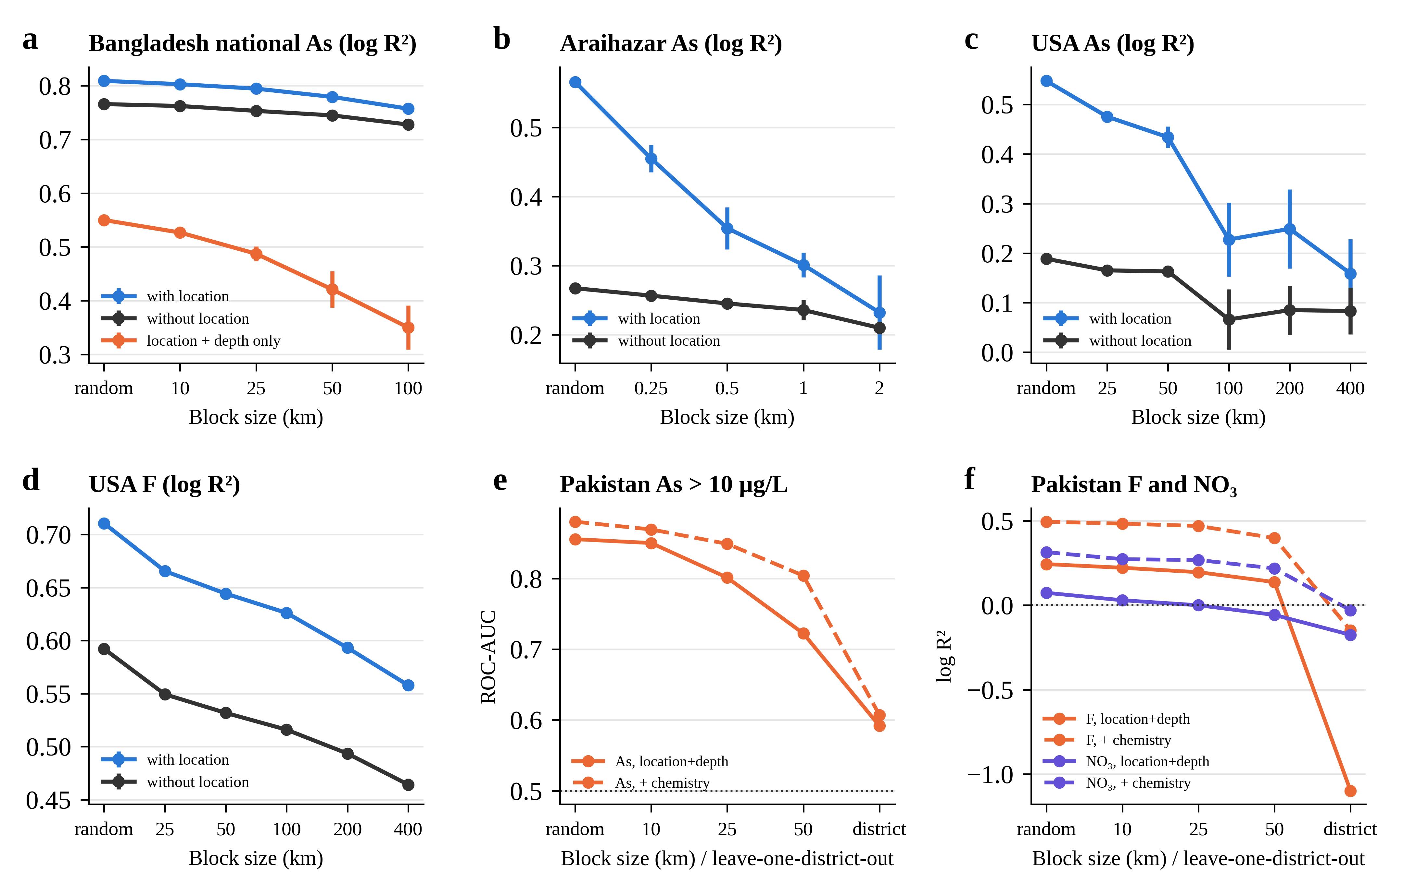
Fig. S1 Skill as a function of spatial block size. a–d Open datasets with and without coordinates as predictors (for Bangladesh national, the location + depth model is also shown); error bars are ± SD over three seeds. e Lower Indus arsenic exceedance (ROC-AUC) and f fluoride and nitrate (R²), with mappable predictors (solid) and with co-measured chemistry (dashed); the rightmost point is leave-one-district-out. Dotted lines mark no skill.
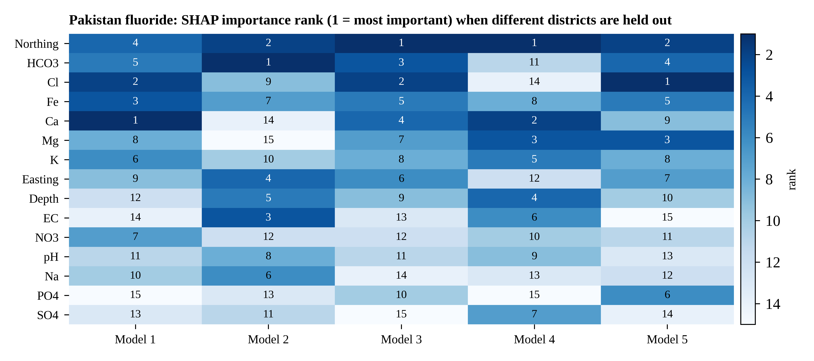
Fig. S2 Instability of SHAP explanations for Lower Indus fluoride. Each column is a model trained with a different group of districts held out (Model 1: Badin, Naushahro Feroze, Nawabshah; Model 2: Kamber Shahdadkot, Tando Allahyar; Model 3: Ghotki, Kashmore, Mirpurkhas; Model 4: Jacobabad, Matiari, Tharparkar; Model 5: Sukkur, Tando Muhammad Khan, Thatta). Cells give the rank of mean |SHAP| (1 = most important). Ca, for example, ranks 1st in Model 1 and 14th in Model 2; mean Spearman ρ between models is 0.28.
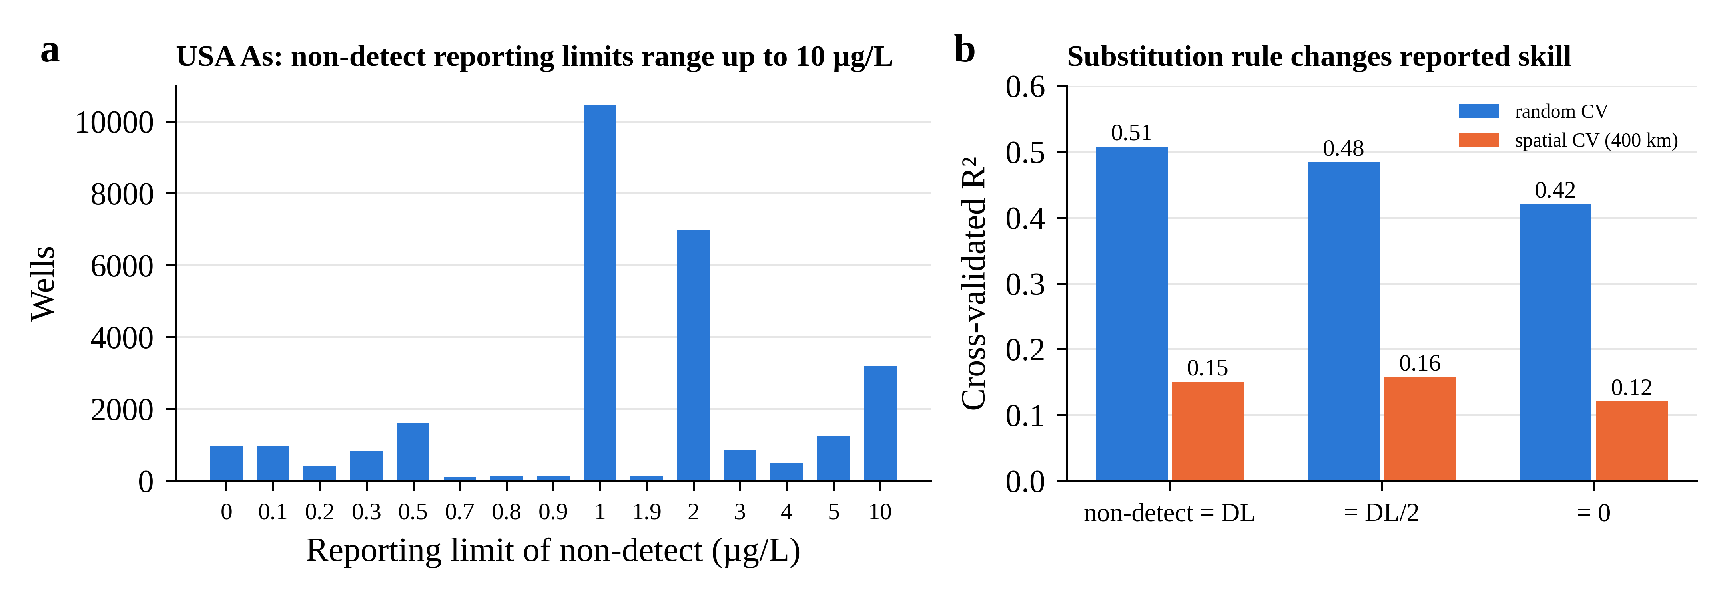
Fig. S3 Censored data in the US arsenic dataset. a Reporting limits of non-detects (limits with ≥ 100 wells). b Cross-validated R² when non-detects are set to the limit (DL), DL/2 or zero, for random and spatial (400 km) CV.
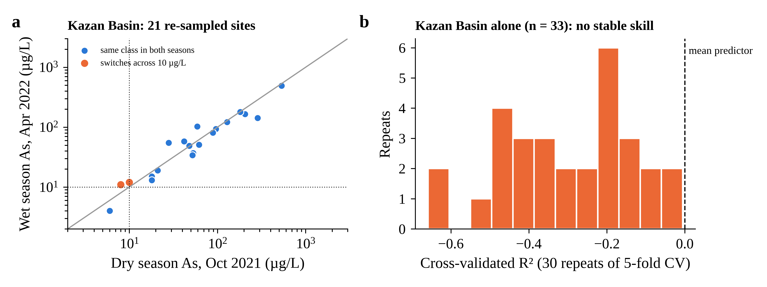
Fig. S4 Kazan Basin, Türkiye. a Arsenic in the 21 sites sampled in both the dry (October 2021) and wet (April 2022) seasons; dotted lines mark 10 µg L⁻¹, the solid line is 1:1. Two near-threshold sites (10 → 12 and 8 → 11 µg L⁻¹) cross the guideline; the largest change was 286 → 142 µg L⁻¹. b Distribution of cross-validated R² for a model trained only on the 33 dry-season samples (30 repeats of five-fold CV); all repeats are below zero.
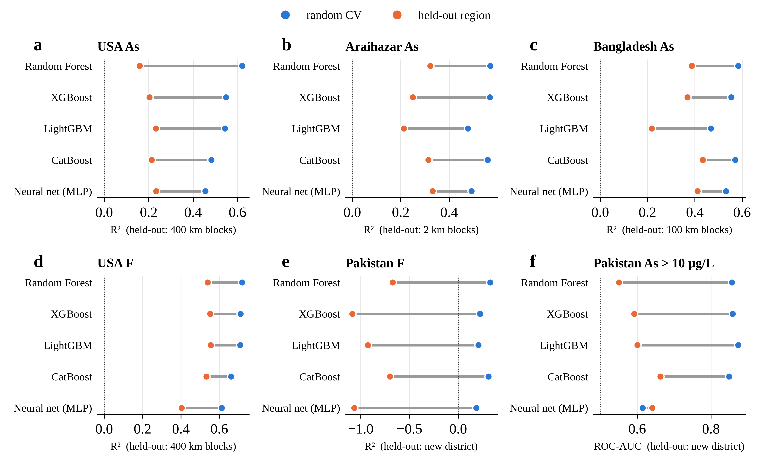
Fig. S5 Five model families tested with random CV (blue) and in held-out regions (orange). Dotted lines mark no skill (R² = 0 or AUC = 0.5). Every family loses skill in new regions; for Lower Indus fluoride all become worse than the mean.
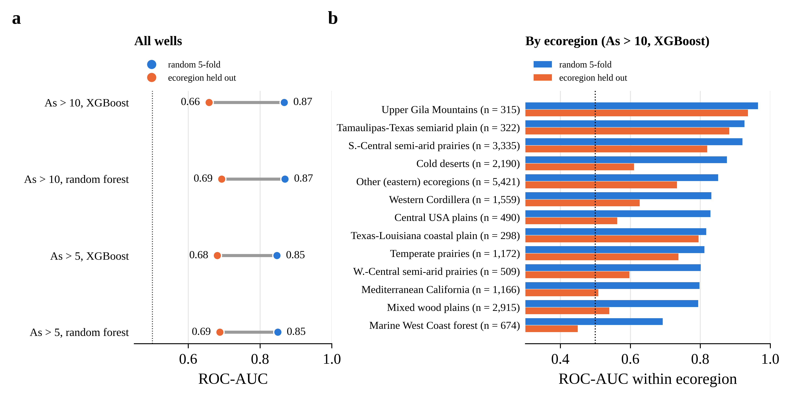
Fig. S6 The random-versus-regional gap with the 72 mappable predictors of the published USGS national arsenic model (Lombard et al. 2021). a ROC-AUC for all 20,450 wells under random five-fold CV (blue) and with whole ecoregions held out (orange). b Within-ecoregion AUC for As > 10 µg L⁻¹ (XGBoost); the dotted line marks no skill (0.5).
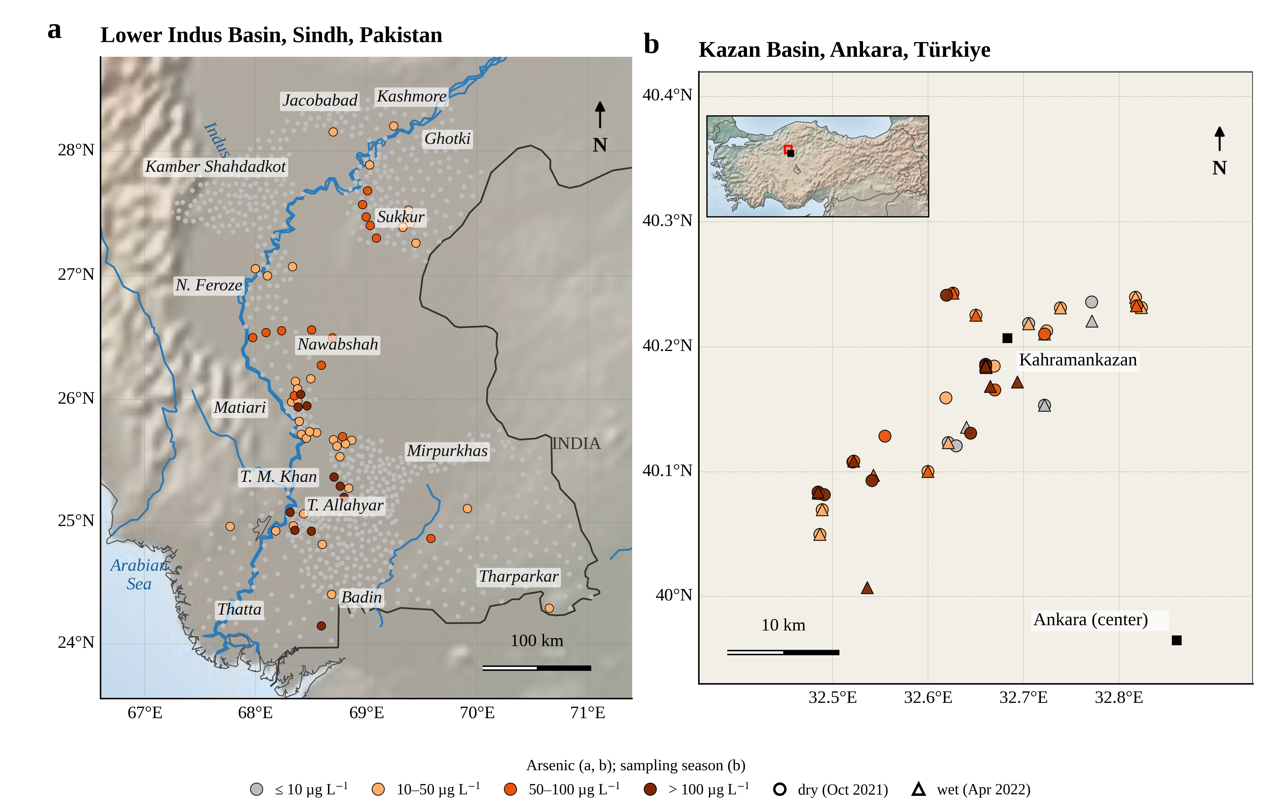
Fig. S7 Detailed maps of the two new datasets. a Lower Indus Basin, Sindh, Pakistan: 848 wells sampled March–October 2024, colored by arsenic class, with district names, the Indus River, and the India–Pakistan border on shaded relief. b Kazan Basin, Ankara, Türkiye: samples from the dry (October 2021) and wet (April 2022) seasons, colored by arsenic class; the inset locates the basin in Türkiye. Base relief: Natural Earth shaded relief distributed with Basemap.

References
Angelopoulos AN, Bates S (2023) Conformal prediction: a gentle introduction. Found Trends Mach Learn 16(4):494–591. https://doi.org/10.1561/2200000101
BGS, DPHE (2001) Arsenic contamination of groundwater in Bangladesh. Kinniburgh DG, Smedley PL (eds). British Geological Survey Technical Report WC/00/19. British Geological Survey, Keyworth
Breiman L (2001) Random forests. Mach Learn 45(1):5–32. https://doi.org/10.1023/A:1010933404324
Chen T, Guestrin C (2016) XGBoost: a scalable tree boosting system. In: Proceedings of the 22nd ACM SIGKDD International Conference on Knowledge Discovery and Data Mining, pp 785–794. https://doi.org/10.1145/2939672.2939785
Erickson ML, Hill ER, Wilson JT (2020) Arsenic, manganese, and pH groundwater quality data, selected well construction characteristics, and aquifer assignments for wells in the conterminous U.S. U.S. Geological Survey data release. https://doi.org/10.5066/P9JMUAPY
van Geen A, Zheng Y, Versteeg R, et al (2003) Spatial variability of arsenic in 6000 tube wells in a 25 km² area of Bangladesh. Water Resour Res 39(5). https://doi.org/10.1029/2002WR001617
Hollmann N, Müller S, Purucker L, et al (2025) Accurate predictions on small data with a tabular foundation model. Nature 637(8045):319–326. https://doi.org/10.1038/s41586-024-08328-6
Jameel MY (2021) Groundwater arsenic measurements from Araihazar, Bangladesh. HydroShare. https://www.hydroshare.org/resource/8e1373d87419447c945625af13f0a2ea
Ke G, Meng Q, Finley T, et al (2017) LightGBM: a highly efficient gradient boosting decision tree. In: Advances in Neural Information Processing Systems 30
Lei J, G'Sell M, Rinaldo A, Tibshirani RJ, Wasserman L (2018) Distribution-free predictive inference for regression. J Am Stat Assoc 113(523):1094–1111. https://doi.org/10.1080/01621459.2017.1307116
Lombard MA (2021) Data used to model and map arsenic concentration exceedances in private wells throughout the conterminous United States for human health studies. U.S. Geological Survey data release. https://doi.org/10.5066/P90RBJXS
Lombard MA, Scannell Bryan M, Jones DK, et al (2021) Machine learning models of arsenic in private wells throughout the conterminous United States as a tool for exposure assessment in human health studies. Environ Sci Technol 55(8):5012–5023. https://doi.org/10.1021/acs.est.0c05239
Lundberg SM, Erion G, Chen H, et al (2020) From local explanations to global understanding with explainable AI for trees. Nat Mach Intell 2(1):56–67. https://doi.org/10.1038/s42256-019-0138-9
McMahon PB (2020) Data for fluoride occurrence in United States groundwater. U.S. Geological Survey data release. https://doi.org/10.5066/P9CUPRIP
Pedregosa F, Varoquaux G, Gramfort A, et al (2011) Scikit-learn: machine learning in Python. J Mach Learn Res 12:2825–2830
Prokhorenkova L, Gusev G, Vorobev A, Dorogush AV, Gulin A (2018) CatBoost: unbiased boosting with categorical features. In: Advances in Neural Information Processing Systems 31
Roberts DR, Bahn V, Ciuti S, et al (2017) Cross-validation strategies for data with temporal, spatial, hierarchical, or phylogenetic structure. Ecography 40(8):913–929. https://doi.org/10.1111/ecog.02881
Romano Y, Patterson E, Candès EJ (2019) Conformalized quantile regression. In: Advances in Neural Information Processing Systems 32
Valavi R, Elith J, Lahoz-Monfort JJ, Guillera-Arroita G (2019) blockCV: an R package for generating spatially or environmentally separated folds for k-fold cross-validation of species distribution models. Methods Ecol Evol 10(2):225–232. https://doi.org/10.1111/2041-210X.13107

