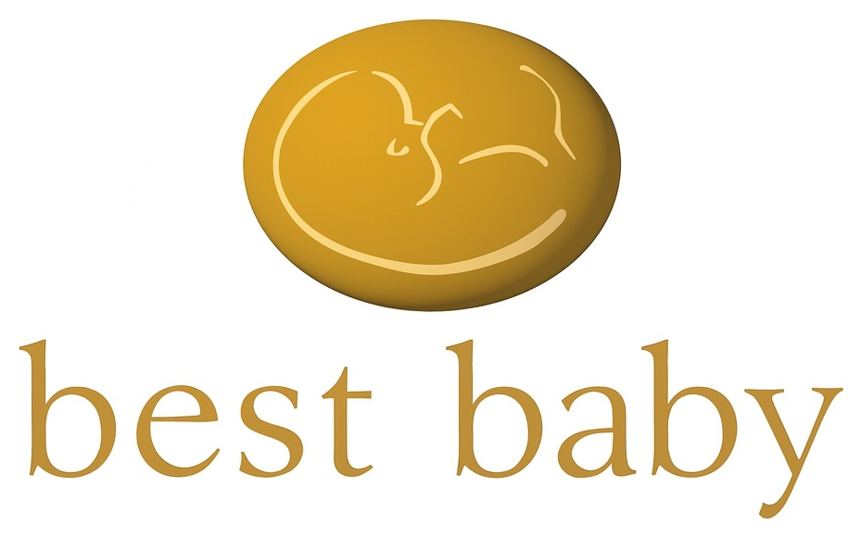
P R I V A T E B E T A
Welcome to the Inner Circle.
If you’re curious, thoughtful, overwhelmed, excited — or all four at once — you’re in exactly the right place.
You’ve been personally invited to join a small group seeing BestBaby before anyone else. We don’t think of you as beta testers; you’re the people who will help us build it. What you notice, what you question, what you’d change — all of it shapes BestBaby for everyone who follows. We’re creating something meaningful, and we appreciate having you with us.

What BestBaby is.
BestBaby is a science-backed, emotionally honest companion for every stage of the parenting journey — from the first conversation about whether to have a family, through pregnancy, birth, and the early years. Built because no one has yet brought today's knowledge together with the wisdom, warmth, and guidance this journey demands.

Something has changed.
Not long ago, the family was large and close. A mother down the hall, a sister on the phone, a grandmother who had seen it all before. That network carried generations of wisdom — about pregnancy, about birth, about what to do at 3am when you don’t know what’s wrong. It was imperfect, sometimes contradictory, occasionally wrong — but it was there.
For most of us today, it isn’t. Families are smaller, more scattered, busier. That old warmth and accumulated knowledge — the kind that used to pass naturally from one generation to the next — has become harder to reach just when you need it most.
But something else has changed too. Technology has quietly become part of how we navigate life’s most ordinary moments — without us even noticing. You no longer remember phone numbers, because your phone does. You don’t think about directions, because GPS does. You don’t worry about spelling, because your device handles it. These tools didn’t replace your intelligence — they freed it up for what actually matters.
BestBaby does the same thing for this most fundamental of human experiences. It brings together the warmth and wisdom families used to pass down, joined with everything science has learned since — and puts it in your pocket, available any time you need it. Not to replace your instincts. To support them.

Every journey here is different.
But no two people arrive the same way. Maybe you’re still deciding whether to start a family — weighing the finances, the timing, the options. Maybe you’re considering fertility treatment, IVF, surrogacy, or adoption — each with its own maze of unknowns. Maybe you’re already pregnant, navigating a path shaped by where you live, whether you’re working, who’s around you. Maybe you’re already a parent, figuring it out one day at a time.
We can’t know everything about every journey. That’s the whole point. You do. And what you share with us — the gaps, the questions we haven’t answered yet, the things that happened to you that were a little different from anyone else’s story — that’s gold. That’s what makes BestBaby better for everyone who comes after you.
Use the blog. Read what others are writing. Send us an email. Tell us what you learned, what you wish someone had told you, what you would do differently. We listen to all of it.

How we use what you tell us.
As you tell us more about where you are on your journey, we’ll use that to point you toward what’s actually relevant to you right now — not everything at once, just what matters for your stage. The more we understand your path, the more useful BestBaby becomes for you specifically.

Your privacy.
Rest assured, your information is never sold or shared. It is used only to make BestBaby more useful — to you, and to the people who come after you. If you choose to leave the beta at any point, your information is removed from active use immediately. We keep only a minimal record that you opted out, so we don’t contact you again by mistake.

What comes next.
What comes next are two short screens: your Basic Registration and Consent form, which is a plain-language agreement containing our Terms of Service and Privacy Notice details, and a quick questionnaire about your personal Journey, ( both just a click, no downloads, no signatures. About three minutes in total). Then you will see a quick video introducing BestBaby and how it came to be—
Then you’re in.
Let’s build this together.
Check off the two boxes below to continue.
COOKIES
BestBaby uses cookies to make our website work. We would like to set additional cookies to understand how you use our site and to improve your experience. Please see our cookies policy for further information.
☐ Accept non-essential cookies ☐ Reject non-essential cookies More options
☐ I’ve read and understood the information above and would like to continue.
(Record and Time Stamp)
Continue →

BestBaby.org · BestBaby.Org Ltd · Registered in Scotland · SC899830
Privacy Notice · Terms of Use · Cookies Policy

