**Design**

The following is the Bootstrap started template, that was used as canvas to depict design of the Food Safety Alert prototype.

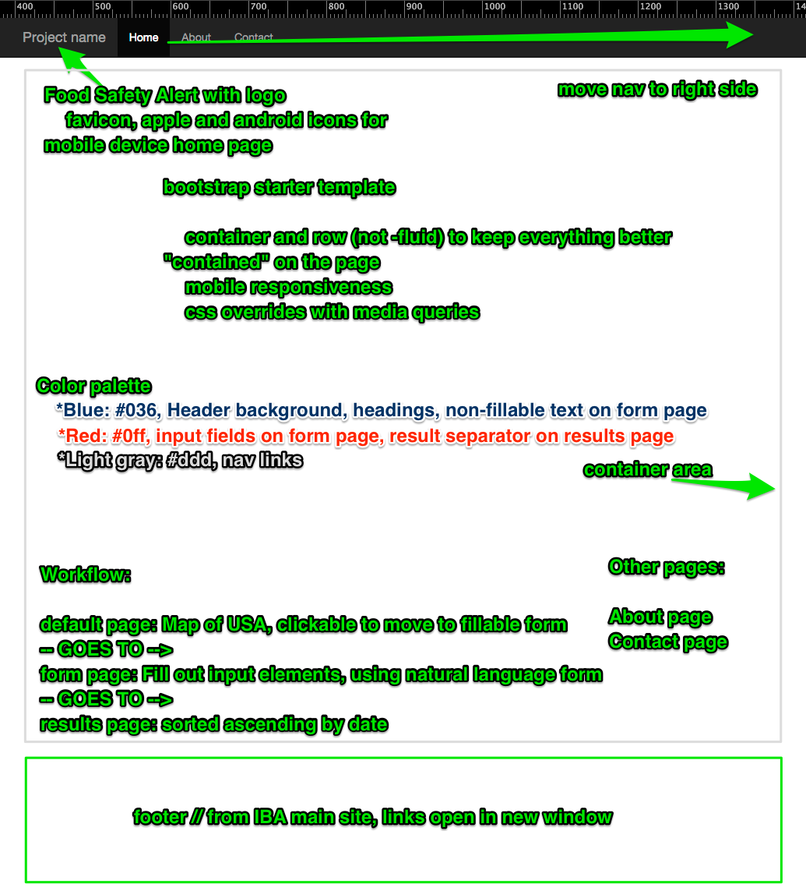

The following slides show the progression of our design of our Food Safety Alert prototype.

**Development of Logo**

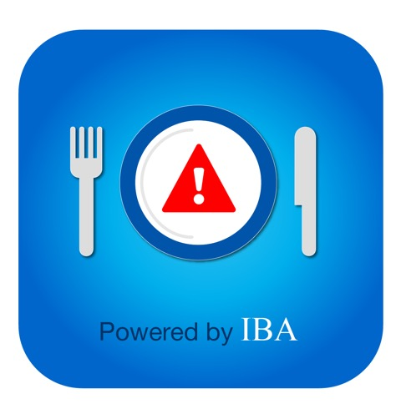

*Version 4 – Include Powered by IBA*



*Version 3 – Change Colors to standout in Header better*



*Version 2 – Change Silverware Color to pop on Header Bar*



*Version 1 – Food Recall ….Logo Idea*



*Version 0 – Food Recall ….Logo Idea-original*