**USABILITY TEST**

This document presents the artifacts that were generated for usability testing. They are presented in the sequence in which they were produced to guide the testing and used for testing and recording results and feedback from non-technical testers. Sample user feed backs are included.

1. **Rapid Iterative Testing and Evaluation (RITE)**

We followed Rapid Iterative Testing and Evaluation (RITE) methods for our usability tests.

**MODIFIED RITE TEST**

**SCENARIO GIVEN:**

You are a shopper in a grocery store concerned about oysters/ice cream/power aid.

**RITE Test:**

**-**Team will be present

**-**One participant

**-**Participant will be provided with only the above scenario and a means to access the site.

**-**Participant will test site while performing a talk through

-User is made aware of recall information for the product searched

-knows whether it is safe to purchase/use the food item

**-**Team may ask questions of participant after test

-Discuss and fix decided upon issues

**-**Repeat for three participants

**-**Total time per participant will be less than 20 minutes

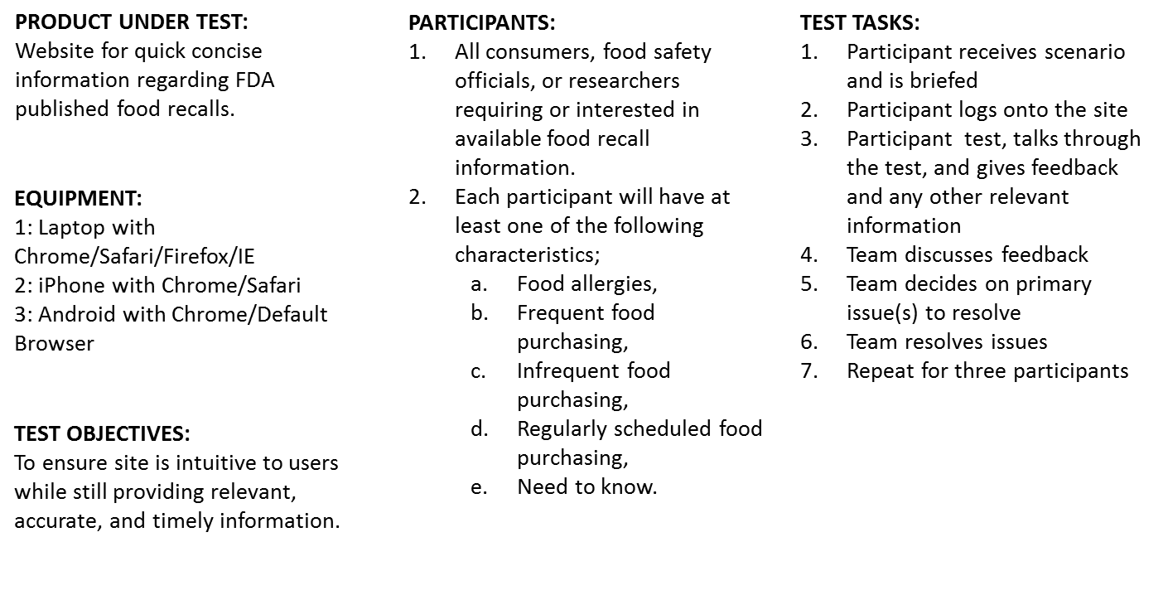

1. **Use Cases**



1. **Usability / User Feedback Form**

**1: Was it intuitive?**

(Did you find it easy to understand and use)

**Extremely – Very - Moderately – Slightly - Not at all**

**2: Was the information relevant?**

(Did the search results help you make a decision on whether to buy/use or not to buy/use the searched food item)

**Extremely – Very - Moderately – Slightly - Not at all**

**3: Was it fast?**

(Would it be fast enough to use while in the store)

**Extremely – Very - Moderately – Slightly - Not at all**

**4: Did you find the site visually appealing?**

**Extremely – Very - Moderately – Slightly - Not at all**

**5: Did you enjoy the experience?**

**Extremely – Very - Moderately – Slightly - Not at all**

1. **Sample User Feedbacks**

**User Feedback**

**Usability_Test_on_v2**

**User: Mary D**

**Browsers: Google Chrome & Internet Explorer & iPhone**

**1: Was it intuitive?**

(Did you find it easy to understand and use)

**Extremely – Very - Moderately – Slightly - Not at all**

**User Comment: My one problem was that I could not switch the state chosen once I “turned on” location tracking. The map appeared very quickly initially, but then disappeared and I could not get back to that specific map interface. The interactive map was there, but not accessible. I finally determined that was due to me allowing my location to be tracked through the browsers, but initially that was not intuitive to me. Google Chrome seems to be permanently storing the location information and I cannot start over by opening a new window, but IE does allow me to start over and search other states when I open a new window and decline the location tracking option.**

**2: Was the information relevant?**

(Did the search results help you make a decision on whether to buy/use or not to buy/use the searched food item?)

**Extremely – Very - Moderately – Slightly - Not at all**

**3: Was it fast?**

(Would it be fast enough to use while in the store)

**Extremely – Very - Moderately – Slightly - Not at all**

**User Comment: Response time was very fast.**

**4: Did you find the site visually appealing?**

**Extremely – Very - Moderately – Slightly - Not at all**

**User Comment: Site was clean, simple, and intuitive. Not heavy on the graphics, which probably helps with response time and really not necessary. For this purpose, the end user is most interested in the data rendered.**

**5: Did you enjoy the experience?**

**Extremely – Very - Moderately – Slightly - Not at all**

**User Comment: See User Comment #1 above.**

**User Feedback**

**Usability_Test_on_v3**

**User: Shayne S**

**Browsers: Google Chrome, Internet Explorer, Mozilla Firefox, and Android phone**

**1: Was it intuitive?**

(Did you find it easy to understand and use)

**Extremely – Very - Moderately – Slightly - Not at all**

1. **Add the specific recall search on the “show me the recalls” page, i.e. Pepsi, Yogurt etc. However this might have an impact when adding multiple foods from a shopping list.**
2. **If you just click on recalls for “food from brand in Virginia” it says I am safe. Actually shouldn’t it state “provide specific foods and or brands”.**
3. **Should be able to list multiple foods as discussed to address a “shopping list.**
4. **Should be able to sort on seriousness, Brand, Company**
5. **Should we include territories, i.e. Puerto Rico, etc**
6. **About tab needs to be populated with the updates.**
7. **Date on recall page needs to reflect month, day year in typical format**

**2: Was the information relevant?**

(Did the search results help you make a decision on whether to buy/use or not to buy/use the searched food item?) ,

**Extremely – Very - Moderately – Slightly - Not at all**

**3: Was it fast?**

(Would it be fast enough to use while in the store)

**Extremely – Very - Moderately – Slightly - Not at all**

**4: Did you find the site visually appealing?**

**Extremely – Very - Moderately – Slightly - Not at all**

1. **The contact number is a general mail box should have a specific link or modify voice message to identify “FDA Recall” questions.**

**5: Did you enjoy the experience?**

**Extremely – Very - Moderately – Slightly - Not at all**

**User Feedback**

**Usability_Test_on_v3**

**User: Anna R**

**Browsers: Google Chrome, Safari, and Android phone**

**1: Was it intuitive?**

(Did you find it easy to understand and use)

**Extremely – Very - Moderately – Slightly - Not at all**

**2: Was the information relevant?**

(Did the search results help you make a decision on whether to buy/use or not to buy/use the searched food item)

**Extremely – Very - Moderately – Slightly - Not at all**

**3: Was it fast?**

(Would it be fast enough to use while in the store)

**Extremely – Very - Moderately – Slightly - Not at all**

**4: Did you find the site visually appealing?**

**Extremely – Very - Moderately – Slightly - Not at all**

**5: Did you enjoy the experience?**

**Extremely – Very - Moderately – Slightly - Not at all**

1. **Iterative Testing and Test Results**

**Version 1.0 RITE Testing results captured – 6/24/15 – 12:00 p.m.**

Participants: Product Manager/Owner; Front End Web Developer; Writer/Content Designer/Content Strategist; Agile Coach

Testing was mostly conducted on Safari browser & iPhone browser

Issues:

* When allowing to track location, it did not present the data entry form (page); it brought the map page up
* When returning to search results page from another page, the page shows no results – this worked differently as we traversed through different pages back-and-forth
* Fix the broken link on the heading of the page “Food Recall Safety”; it is missing “/”
* In some cases, when going back to selection form page from the results page, search function did not work
* In some cases, when the selection was made from the “all” recalls dropdown list, the search function did not work

Suggestions for next version:

* Change the color of the knife and fork on the logo to white
* Add the word “level” before the word “all” when selecting “all” recalls
* When selecting “all” recalls, show different levels of severity
* Change the examples of the Brand to real Brands
* Show a message that there are 0 results when there are none
* Change the color of the heading on the results page “Results” to another color
* Change “State” as the initial search criterion to “Distribution Pattern”
* Define “Class” in terms that are understood by users – (Severity)
* Show the number of returned results on the result page
* Add paging capability to show results that number beyond 10
* Provide active links in the description of the recall on the results page that will present the entire record for the particular result - **Backlog**
* Change examples of food to “Steak Rub” and “Yogurt”
* Change examples of brand

**Version 1.0 Corrections were made – 6-24-15 (4:00 p.m.) created Version 2.0**

Issues:

* ~~When allowing to track location, it did not present the data entry form (page); it brought the map page up~~
* ~~When returning to search results page from another page, the page shows no results – this worked differently as we traversed through different pages back-and-forth~~
* ~~Fix the broken link on the heading of the page “Food Recall Safety”; it is missing “/”~~
* In some cases, when going back to selection form page from the results page, search function did not work
* ~~In some cases, when the selection was made from the “all” recalls dropdown list, the search function did not work~~ - VERSION 2.-0 – now uses Classification for the ALL criteria selection

Suggestions for next version:

* ~~Change the color of the knife and fork on the logo to white~~
* Add the word “level” before the word “all” when selecting “all” recalls
* ~~When selecting “all” recalls, show different levels of severity~~
* ~~Change the examples of the Brand to real Brands~~
* Show a message that there are 0 results when there are none
* ~~Change the color of the heading on the results page “Results” to another color~~
* ~~Change “State” as the initial search criterion to “Distribution Pattern”~~
* Define “Class” in terms that are understood by users – (Severity)
* Show the number of returned results on the result page
* Add paging capability to show results that number beyond 10
* ~~Change examples of food to “Steak Rub” and “Yogurt”~~
* ~~Change examples of brand~~

**Version 2.0 RITE testing results captured – 6/25/15 –10:00 a.m.**

Participants: Users not involved with the project and indicative of our end-user use case

Testing was conducted on Safari, Chrome and IE browsers as well as Smartphones

* New Footer on page – non-responsive and covers up the Mobile Phone page ..
* Show definition of seriousness classifications
* Clicking on Home, About, Contact, and header (Food Recall Safety) returns to the form page
* Show a message that there are 0 results when there are none
* Allow returning to the map page after the first selection and acceptance of the “sharing” of location – add a button to ask and allow change
* Allow multiple search terms in one search
* Only show the recalls that took place in current calendar year

**Version 2.0 Corrections were made – 6-25-15 (2:00 p.m.) created Version 3.0**

* ~~New Footer on page – non-responsive and covers up the Mobile Phone page ..~~
* ~~Show definition of seriousness classifications~~
* ~~Clicking on Home, About, Contact, and header (Food Recall Safety) returns to the form page~~
* ~~Show a message that there are 0 results when there are none~~
* ~~Allow returning to the map page after the first selection and acceptance of the “sharing” of location – add a button to ask and allow change~~
* ~~Only show the recalls that took place in current calendar year~~

Issues:

* ~~When allowing to track location, it did not present the data entry form (page); it brought the map page up~~
* ~~When returning to search results page from another page, the page shows no results – this worked differently as we traversed through different pages back-and-forth~~
* ~~Fix the broken link on the heading of the page “Food Recall Safety”; it is missing “/”~~
* ~~In some cases, when going back to selection form page from the results page, search function did not work~~
* ~~In some cases, when the selection was made from the “all” recalls dropdown list, the search function did not work~~

Suggestions for next version:

* ~~Change the color of the knife and fork on the logo to white~~
* ~~Add the word “level” before the word “all” when selecting “all” recalls~~
* ~~When selecting “all” recalls, show different levels of severity~~
* ~~Change the examples of the Brand to real Brands~~
* ~~Show a message that there are 0 results when there are none~~
* ~~Change the color of the heading on the results page “Results” to another color~~
* ~~Change “State” as the initial search criterion to “Distribution Pattern”~~
* ~~Define “Class” in terms that are understood by users – (Severity)~~
* ~~Show the number of returned results on the result page~~
* ~~Add paging capability to show results that number beyond 10~~ (using infinite scroll to list the results instead of pagination)
* ~~Change examples of food to “Steak Rub” and “Yogurt”~~
* ~~Change examples of brand to “Pepsi”~~

**Version 3.0 testing results captured – 6/25/15 –4:00 p.m.**

Participants: Product Manager/Owner; Front End Web Developer; Writer/Content Designer/Content Strategist; Agile Coach

* Allow multiple search terms in one search
* Highlight the search terms in the search results
* Sort Order Newest to Oldest is incorrect
* Results Page – Date should be User Friend June 6, 2015 …versus UTC
* Put in About Page content
* Add text “Click on Red items to change selection”

508 Items

* No alt for "Food Recall Safety" and "Powered by IBA" pictures.  Get message 2 image without alt attributes.
* Should say "Food Safety Recall - Results". It currently says "Food Safety Recall".

**Version 3.0 Corrections were made – 6/26/15 –10:00 a.m.**

* ~~Allow multiple search terms in one search~~
* ~~Highlight the search terms in the search results~~
* ~~Sort Order Newest to Oldest is incorrect~~
* ~~Results Page – Date should be User Friend June 6, 2015 …versus UTC~~
* ~~Put in About Page content~~
* ~~Add text “Click on Red items to change selection”~~

508 Items

* ~~No alt for "Food Recall Safety" and "Powered by IBA" pictures.  Get message 2 image without alt attributes.~~
* ~~Should say "Food Safety Recall - Results". It currently says "Food Safety Recall".~~

**Version 4.0 testing results captured – 6/26/15 –12:00 p.m.**

1. Add a Pop help hint to identify why some words are red
2. Allow for a Multiple Food or Brand search
3. Show the number of results returned
4. Add longer lists or multiple pages of 10 each
5. When going back to the Search page – maintain Search items previously entered
6. Fix up Responsive Design ..search field popup green window locations
7. Finish the critical 508 items identified from testing against version 3
8. Highlighting search query result keywords in Results

**Version 4.0 Corrections were made – 6/29/15 – 5:00 p.m.**

1. ~~Add a Pop help hint to identify why some words are red~~
2. ~~Allow for a Multiple Food or Brand search~~
3. ~~Show the number of results returned~~
4. ~~Add longer lists or multiple pages of 10 each~~
5. ~~When going back to the Search page – maintain Search items previously entered~~
6. Fix up Responsive Design ..search field popup green window locations
7. ~~Finish the critical 508 items identified from testing against version 3~~
8. ~~Highlighting search query result keywords in Results~~

**Version 5.0 testing results captured – 6/30/15 –3:00 p.m.**

1: Fixed Safari location request

2: Fixed browser deficiencies

3: Search queries are now persistent

4: Fix Denial of Service Tests run by DavidH and Highlighting Terms issue identified

6: Dynamic Load screen added before map and while searching indicating activity

7: Form input more intuitive

Clicking on the form field moves cursor into field

Clearing a past search query changed to be intuitive

8: Add Zoom on map feature to find D.C

9. More Responsive Design touchup for Popup Search screens

**Version 5.0 Corrections were made and Build6 – 7/1/15 –3:00 p.m.**

~~1: Fixed Safari location request~~

~~2: Fixed browser deficiencies~~

~~3: Search queries are now persistent~~

~~4: Fix Denial of Service Tests run by DavidH and Highlighting Terms issue identified~~

~~6: Dynamic Load screen added before map and while searching indicating activity~~

~~7: Form input more intuitive~~

~~Clicking on the form field moves cursor into field~~

~~Clearing a past search query changed to be intuitive~~

~~8: Add Zoom on map feature to find D.C~~

~~9. More Responsive Design touchup for Popup Search screens~~