MedVerse-Agent
Policy-Grounded Multi-Agent Institutional Coordination for Trustworthy Digital-Twin-Enabled Medical Metaverse Systems
AI for Good Sandbox Hackathon — Team MedVerse | Chonnam National University, Republic of Korea
Team leader: Aliyu Ibrahim | Members: Jeremiah Isuwa, Abubakar Isah, Kim Jinsul | Contact: ibal2010@yahoo.com | GitHub: [INSERT PUBLIC REPOSITORY URL]
1. Introduction
Future Medical Metaverse systems connect patients, Digital Twins (DTs), wearable and embodied sensors, immersive interfaces, AI decision support, hospitals, clinical-research platforms and communication infrastructures. These components are governed by institutions with different observations, mandates and decision authority. The resulting challenge is therefore not only prediction or diagnosis, but institutional coordination under incomplete and asynchronously arriving information.
MedVerse-Agent asks: when a patient’s physical observations, Digital Twin, network state, research permissions and regulatory context do not agree, how should institution-specific AI agents coordinate a safe, policy-grounded response without transferring authority to one monolithic agent?
2. Description of the use case
A modeled oncology patient receiving chemotherapy reports fever while sensor provenance or freshness becomes uncertain. A research team separately requests access to associated monitoring information. The Hospital role retains clinical-review responsibility; Cyber/Network evaluates telemetry trust; Privacy checks purpose and disclosure scope; Research/IRB evaluates the research pathway; and the Regulator role evaluates applicable oversight conditions. The coordinator does not diagnose or prescribe; it harmonizes validated institution-owned proposals into a feasible workflow.
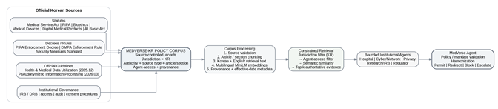
Figure 1. Source-controlled Korean policy corpus and its role in MedVerse-Agent.

3. Use case requirements
MedVerse-Agent models three distinct evidence layers. (i) Patient/scenario observations populate an observation-based patient DT; (ii) Korean National Cancer Center (NCC) cancer-incidence statistics provide optional population-level oncology context and never supply patient facts; and (iii) official Korean laws, rules and guidelines ground institutional policy reasoning. The DT is the system’s current evidence-bearing representation of the patient episode, not a physiological simulator or a claim of complete biological truth.
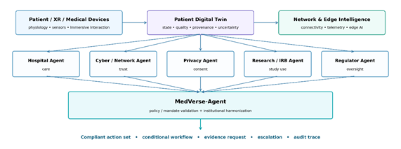
Figure 2. Medical-metaverse architecture: patient/XR/medical-device observations update the patient Digital Twin; institution-specific agents reason under separate mandates before MedVerse-Agent coordinates policy-valid actions.
Digital Twin and evidence processing
The project-local PatientDigitalTwin stores supplied clinical values, patient context and provenance. DT quality records freshness, integrity, completeness, provenance and uncertainty, with validity states VALID, DEGRADED and UNVERIFIED. An unrelated consent or policy update must not make old telemetry appear fresh, and an UNVERIFIED telemetry stream does not imply that the patient is clinically well. Sensor observations support modeled institutional assessment; clinical interpretation remains a human responsibility.
The Korean policy service applies source eligibility, jurisdiction=KR and agent-access restrictions before ranking. The lexical BM25 and multilingual MiniLM-L12-v2 backends return top-k source-linked evidence; semantic relevance does not itself authorize an action. Exact policy identifiers are never silently replaced by a similar article.
Institutional functions and cross-domain reuse
Role | Primary function | Boundary
Hospital | Clinical review, care/record actions | No privacy/research/regulatory override
Cyber / Network | Telemetry, session and device integrity | No treatment or research authorization
Privacy | Purpose, disclosure, minimum necessary, pseudonymization | No clinical treatment decision
Research / IRB | Research purpose, consent/review, participant protection | No care or privacy override
Regulator | Modeled high-impact AI / digital-medical-product oversight | No simulated governmental approval
Reusable components include role-scoped evidence routing, proposal/authority contracts, policy validation, harmonization, commitment control and auditable receipts. Reuse in another domain requires new authoritative sources, institutional mandates, observations and actions—not only a different knowledge base.

4. Mapping with ITU-T Y.3172, AI Readiness 2.0 and domain-specific policies
The official template asks participants to connect the use-case pipeline to AI Readiness dimensions and supporting country documents. Table 1 therefore maps the implemented workflow, not merely the software modules. Y.3172 provides the functional ML-pipeline reference; AI Readiness 2.0 provides complementary assessment dimensions.
Y.3172 | Medical-metaverse function / implemented evidence | Readiness emphasis | Korean / institutional evidence
SRC | Patient/scenario observations; DT provenance; optional NCC population context; official policy sources | D4 contextualization; D5 integration | Medical Service Act; PIPA; Bioethics Act; DMPA/AI sources; NCC open data
C | Capture source ID, time, provenance, event and role-scoped evidence | D3/D4 data sourcing and regional context | Record integrity, lawful access and institutional procedures
PP | Normalize/make missingness explicit; article/section chunking; bilingual evidence representation | D3 data/model handling; D6 interface | PIPA safeguards; health-data and pseudonymization guidance
M | Institutional assessment / proposal; lexical or multilingual semantic retrieval | D5 workflow integration; D10 AI & policies | TRAIN/DEV discipline for audited learned components; source-linked policy evidence
P | Mandate, jurisdiction, purpose, evidence and action-boundary validation; final revalidation | D7 strategy alignment; D8 collaboration; D10 policy implementation | Korean legal/policy anchors; modeled authority records; human-review boundaries
D | Route permitted outputs/views to the correct institutional sink while preserving scope | D5 integration; D8 human collaboration | Minimum-necessary disclosure and institution-owned action contracts
SINK | Clinical review request, contained telemetry, restricted research view, block/condition/escalate, audit receipt | D6 human interface; D8 collaboration | Human authority retained where machine authority is insufficient
Table 1. Use-case mapping to Y.3172, AI Readiness 2.0 and Korean/institutional evidence. Detailed clause-level mappings are provided in the Annex.
Policy knowledge processing
Official source → source-controlled clause/section → eligibility/date metadata → KR jurisdiction → agent access → lexical or multilingual semantic ranking → top-k evidence → institution-owned proposal → policy/mandate validation → harmonized workflow → commitment and audit receipt.
Human oversight and readiness boundary
The strongest demonstrated readiness evidence concerns institutional alignment, inspectable human/agent collaboration and runtime policy application. The prototype does not claim national readiness scoring, ITU certification, production security or clinical deployment. Human reviewers retain reserved authority for decisions outside delegated machine scope.

5. Error scenarios and experimental evaluation
The progressive oncology scenario releases a clinical concern, technical-integrity evidence, a research request, DT context, institution-owned alternatives and modeled authority in stages. We evaluate the concept through three questions: RQ1—are institutional proposals grounded in reliable evidence? RQ2—does explicit institutional coordination improve the joint workflow? RQ3—under partial information, when should a valid proposal be committed, held, prepared or escalated? Detailed studies and figures are provided in the Annex.
RQ1 — Evidence-grounded institutional decisions
Cyber/Network prospective validation achieved 1.000 action and assessment accuracy/macro-F1 across the frozen g5–g8 groups after TRAIN-fitted standardization and explicit missingness. Policy retrieval is language-sensitive: on the same historical confirmation question set, lexical BM25 achieved Recall@3 17/20 in both English and Korean; the locally executed multilingual MiniLM backend achieved 19/20 English and 15/20 Korean. These evaluate retrieval of predefined target sources, not legal applicability.
RQ2 — Architectural comparison: B1–B5
B1 = centralized omniscient reference; B2 = unconstrained role-based MAS; B3 = consensus/voting reference; B4 = policy filtering without cross-institution workflow harmonization; B5 = MedVerse-Agent. Metrics are: IC institutional correctness; CQ coordination quality; EWM exact workflow match; PVR policy/authority violation rate; UER unnecessary escalation rate; IOR information overexposure rate; UXR unsafe execution rate.
Baseline | IC↑ | CQ↑ | EWM↑ | PVR↓ | UER↓ | IOR↓ | UXR↓
B1 Omniscient | 0.179 | 0.393 | 0.000 | 1.000 | 0.000 | 0.929 | 1.000
B2 Unconstrained MAS | 0.821 | 0.540 | 0.000 | 0.143 | 0.000 | 0.929 | 0.143
B3 Consensus/voting | 0.607 | 0.286 | 0.000 | 0.000 | 0.667 | 0.929 | 0.000
B4 Policy filter only | 0.964 | 0.600 | 0.143 | 0.000 | 0.333 | 0.000 | 0.000
B5 MedVerse-Agent | 1.000 | 1.000 | 1.000 | 0.000 | 0.000 | 0.000 | 0.000
Table 2. Original 70-case architectural ablation. Ten context variants per archetype do not represent independent clinical patients.
The key comparison is B4→B5: policy filtering alone preserves local compliance but does not reproduce the encoded cross-institution workflow (CQ 0.600; EWM 0.143), whereas the full reference harmonizer reaches 1.000 on those benchmark metrics. Later mechanism studies intentionally use stronger stateful and constraint-based controls and retain ties when they occur.

5. Error scenarios and experimental evaluation (continued)
RQ3 — Dynamic coordination under partial information
Later studies isolate scheduling, authorized alternative selection and commitment timing rather than redefining B1–B5. Dependency-aware ordering improves order robustness over single-pass processing but ties a fair stateful retry control. Workflow-choice experiments show that capable stateful, constraint-planning and MedVerse selectors all identify feasible alternatives in the finite action library. The final dynamic study therefore focuses on the online question: when should an authorized action be committed, held, prepared or escalated when future proposals are unknown?
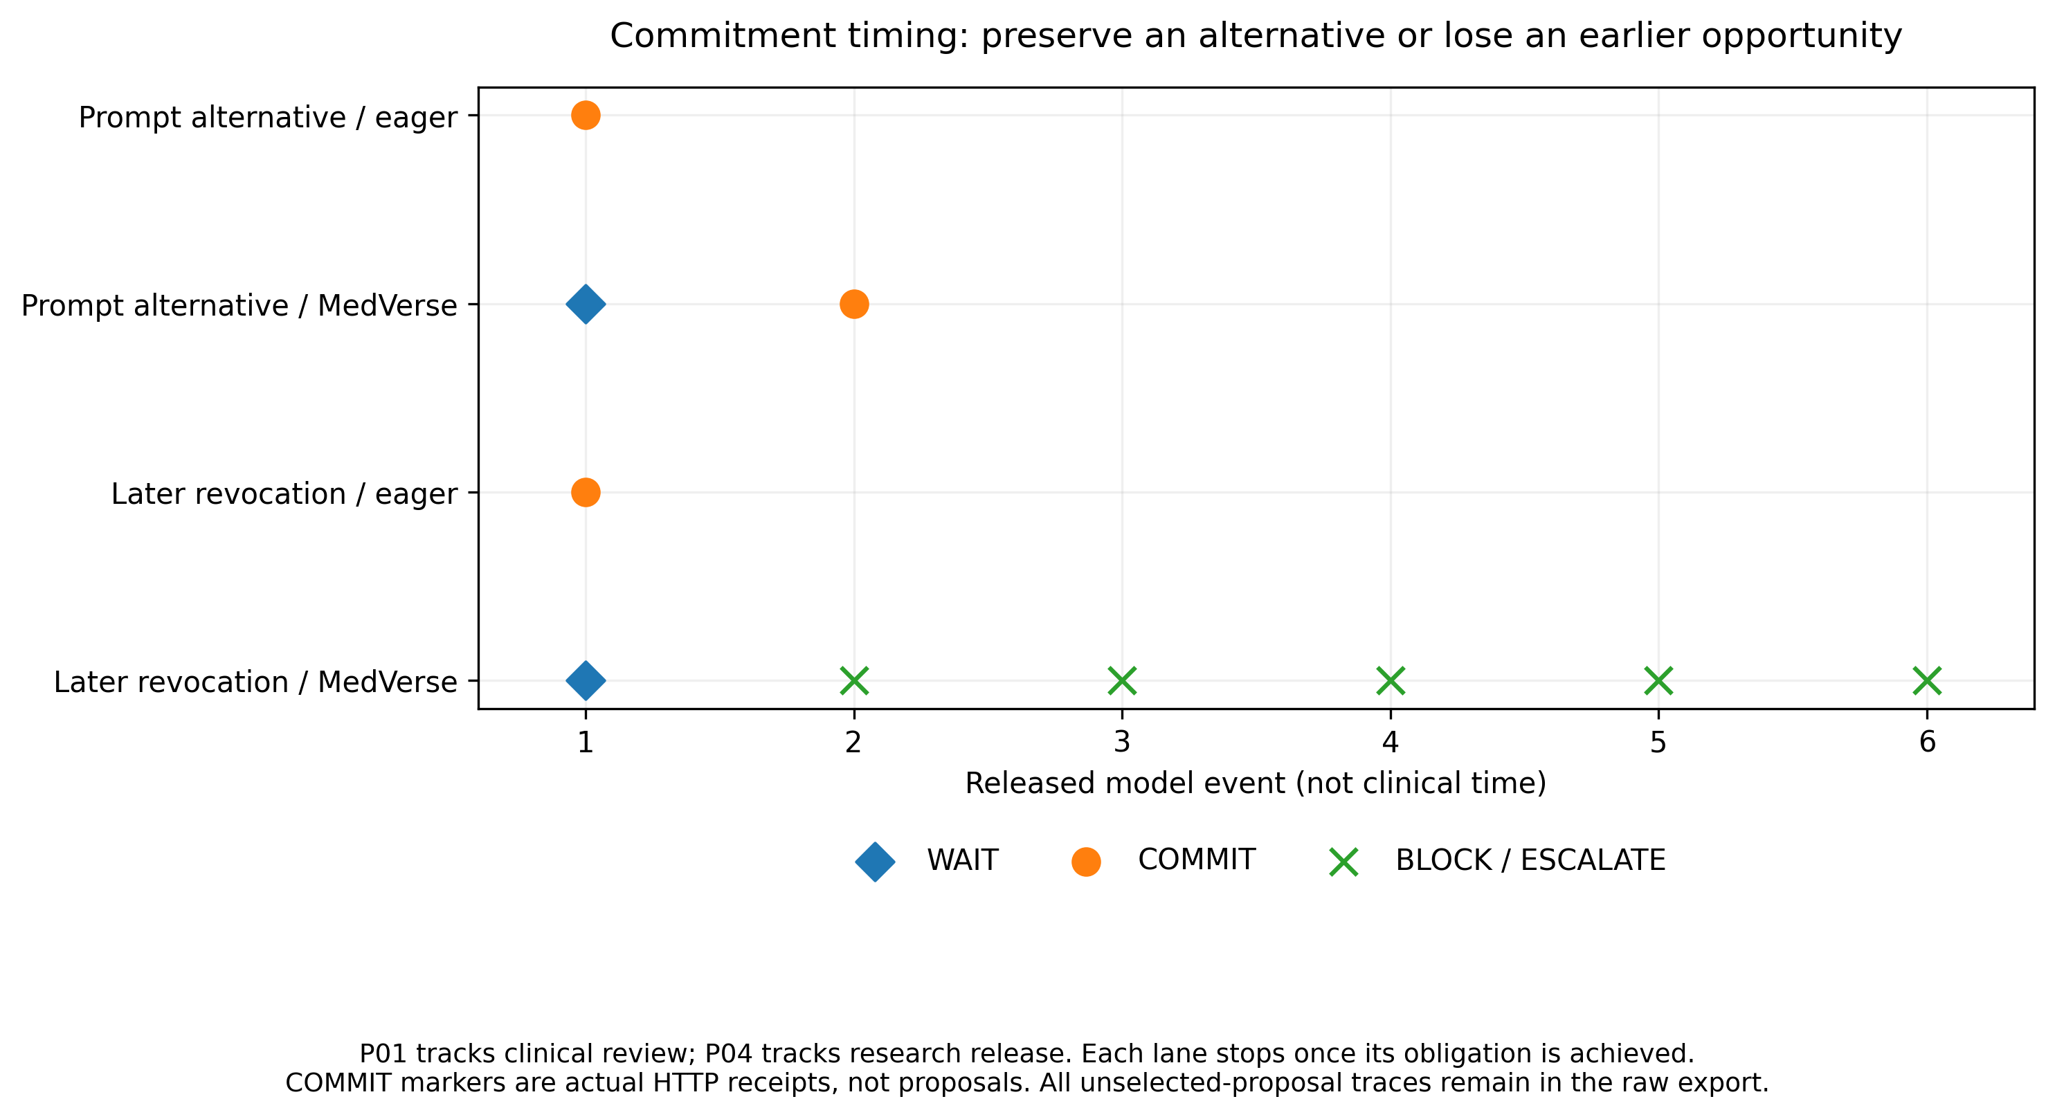
Figure 3. Commitment timing in the live workspace. Waiting can preserve an authorized alternative (P01), but later revocation can remove an earlier opportunity (P04). COMMIT markers are actual modeled execution receipts; event steps are engineering units, not clinical time.
Controller | Complete | Clinical obligation* | Wait steps | Invalid commits
Eager commitment | 14/32 | 28/30 | 0 | 0
Fair bounded wait | 15/32 | 29/30 | 38 | 0
MedVerse commitment | 15/32 | 29/30 | 38 | 0
Table 3. Bounded commitment under partial information. *Conditional on a feasible modeled clinical obligation. The capable bounded-wait control ties MedVerse; four gains and three losses versus eager commitment are retained.
6. Policy and standards gaps derived from the mapping exercise
The mapping identifies coordination and standardization opportunities rather than asserting that existing standards contain no relevant mechanisms: (i) an Institutional Agent Descriptor {identity, mandate, observation scope, knowledge access, action scope, jurisdiction}; (ii) an Action Authority Descriptor {owner, preconditions, evidence, policy basis, jurisdiction}; (iii) DT provenance/validity metadata carried with high-impact decisions and cross-workspace exchanges; and (iv) interoperable coordination states with minimum-necessary institutional messages.
Y.3172 motivates machine-readable authority checks between model output and execution; Y.3060/Y.3061 motivate trust in evidence and multiple legitimate controllers; Y.3090/Y.4239/Y.4240 motivate DT reliability, integration and interoperability; FG-MV and FG-AI4H motivate privacy, confidence, human oversight and evaluation; X.2014 motivates security decisions that should not silently override clinical authority. Detailed mapping, Korean clauses, figures and reproducibility records follow in the Annex.
Claim boundary: all patient episodes, approvals and effects are modeled. The NCC source is population context only. Clinical validation, independent Korean legal applicability review, authenticated remote institutional integration and full ITU conformance remain outside the present prototype.
References: [1] ITU-T Y.3172; [2] ITU AI Readiness Report 2.0; [3] ITU-T Y.3060/Y.3061; [4] ITU-T Y.3090/Y.4239/Y.4240; [5] ITU/WHO FG-AI4H; [6] ITU FG-MV; [7] ITU-T X.2014; [8] Republic of Korea Medical Service Act, PIPA, Bioethics and Safety Act, Digital Medical Products Act, AI Basic Act and official health-data/pseudonymization guidance; [9] National Cancer Center open cancer-incidence statistics.
Supporting Evidence Annex
The main report ends on page 5. This annex provides the detailed policy corpus, agent mappings, experimental methods, figures and reproducibility records referenced in the main body.
A1. Study taxonomy: architectures, mechanisms and scenarios
Study family | What varies | Actual comparator names / interpretation
Institutional learners | Learned assessment/action heads | Privacy action-head repair; Cyber action/assessment multinomial logistic regression. C is a hyperparameter, not an agent or an epoch.
Policy retrieval | Evidence-ranking backend | BM25 lexical versus multilingual dense embeddings. Filters and target labels are held explicit.
Architecture (B1–B5) | Whole reference architecture | B1 omniscient; B2 unconstrained roles; B3 voting/debate-labelled reference; B4 policy filter only; B5 MedVerse.
Scheduling (Gate 28) | Order/revisiting of actual proposals | SNAPSHOT_ONCE; SEQUENTIAL_ONCE; STATEFUL_FIXED_POINT; DEPENDENCY_ORDERED; DEPENDENCY_EDGES_REMOVED.
Workflow choice (Gates 29–30) | Selection among institution-owned alternatives | REQUEST_ONLY; FAIR_STATEFUL_SELECTOR; INDEPENDENT_CONSTRAINT_PLANNER; MEDVERSE_HARMONIZER.
Commitment timing (Gates 32–33) | When permitted effects commit | Eager commitment; fair bounded wait; MedVerse commitment. The full-information reference is noncausal and evaluation-only.
Integration (Gates 30/31/33) | Execution path / observation adapter / UI wrapper | Direct engine versus HTTP/UI behavior; old versus new observation diagnostics. No new controller is inferred from a UI label.

The five institutions are constant roles, not the five B configurations. Likewise, a timing controller is not a sixth agent. B4 from Gate 26 must not be relabelled as the fair stateful selector in Gate 29: they are different implementations, tasks and denominators.
Research-question to evidence register
RQ | Question | Frozen evidence
1 | Can the audited institutional proposal components reproduce defined decisions? | Privacy Gate 22B.6; Cyber Gate 24C; live contribution counts in Gate 33.
2 | Are evidence validity and language-dependent retrieval handled explicitly? | Gate 31 DT bridge; archived BM25 and supplied local dense run.
3 | What changes when architectural governance mechanisms are absent? | Gate 26 original B1–B5, IC/PVR/CQ/EWM/UER/IOR/UXR.
4 | Does the workflow need scheduling or alternative selection beyond local checks? | Gates 28–30; strong-control ties and progressive failures retained.
5 | When does bounded waiting help or lose an authorized opportunity? | Gate 32 prefix families; Gate 33 unchanged HTTP replay.
6 | Are institutional behavior, receipts and runtime faithfully inspectable? | Gates 27/30/31/33 and release replay; role counts and scoped latency.

This RQ grouping is an editorial synthesis after the studies. Their individual freeze records—not this grouping—establish what was specified before execution.

A2. Metric definitions, denominators and non-equivalence
The original seven metrics retain their Gate 26 meanings. Below is a readable transcription of the supplied evaluation implementation, not a new scoring rule. Source: medverse/gates/gate26b_architectural_baseline_comparison.py. [9]
Metric | Frozen operational definition | Interpretation limit
IC | Per case: (required action tokens executed + forbidden tokens not executed) / (required + forbidden tokens). Then mean across cases. | Measures specified action/authority correctness, not every internal assessment.
PVR | Per case: executed action tokens flagged by policy/mandate/evidence checks / executed tokens. Then case mean; no actions returns 0. | Central omniscient ownership is flagged. Not a percentage of legal provisions violated.
CQ | Mean of four components: exact coordination-state match, required-action set F1, messages/evidence-request set F1, escalation match. Then case mean. | An equal-weight reference score, not an external utility or clinical benefit measure.
EWM | Exact equality of state, executed-action set, message/evidence-request set and escalation flag. Then fraction of cases. | Set-based; does not itself establish correct temporal order.
UER | Avoidable escalation indicator, averaged only over cases whose reference specification does not require escalation. | Denominator is the eligible non-required-escalation subset, not all actions.
IOR | Per case: exposed field occurrences outside required_shared_fields / all exposed field occurrences. Then case mean; no exposure returns 0. | Modeled information overexposure; not an observed privacy incident or measured mutual information.
UXR | Per case: executed tokens not in allowed_actions / executed tokens. Then case mean; no execution returns 0. | Read alongside completion; deny-all behavior can otherwise appear favorable.

Later metrics answer different questions
Gate 28 macro-family completion weights eight workflow families equally. Its pooled fraction weights their unequal numbers of order schedules. Neither is the Gate 26 CQ score. Gate 29 feasible-workflow completion uses the 10/14 currently feasible families, while reference-optimal partial/complete agreement uses all 14. Gate 30 progressive completion retains those ten snapshot-feasible cases as the denominator. Gate 32 complete-within-limits uses all 32 continuations, including branches without a complete hindsight solution; clinical completion uses 30 eligible branches.
Gate 33 institutional opportunity/effect counts are not probabilities and their columns are not a mutually exclusive partition. A proposal may be reconsidered across events; a COMMIT disposition can still fail validation and produce no effect. Do not divide its aggregate counts to invent per-agent accuracy.
Freeze and interpretation discipline
No numerical claim is pooled across studies. Same-history checks, changed-authority probes, context-field perturbations and HTTP regression matches are not extra clinical cases. An engineering PASS is separate from comparative superiority. The later studies are not a fully crossed experiment: B1–B5 were not evaluated on every scheduling, choice or timing benchmark.
Reference decision specification, reference outcomes and reference evaluator are used in this report. Historical files retain their original terminology and hashes. Separately coded reference checks share authorship and assumptions with the prototype; independent clinical/legal endorsement is not implied.

B1. Korean policy corpus, institutional scope and source links
Inventory reproduced from the preserved candidate corpus. The 44 records are indexed policy entries, not 44 independent statutes. Thirteen document identifiers include two Medical Service Act identifiers. Forty-two records are retrieval-eligible; two informational press-release records are excluded. Internal verification labels describe project provenance, not certified applicability.
Source group / document identifier grouping | Records | Eligible | Type | Recorded date
Medical Service Act | 1 | 1 | statute | 2026-10-02
Personal Information Security Measures Standard | 1 | 1 | administrative_rule | 2026-07-01
Personal Information Protection Act | 6 | 6 | statute | 2026-09-11
Bioethics and Safety Act | 3 | 3 | statute | 2025-10-01
Digital Medical Products Act | 1 | 1 | statute | 2026-10-08
Enforcement Rule of the Digital Medical Products Act | 1 | 1 | enforcement_rule | 2026-01-24
Medical Service Act | 1 | 1 | statute | 2026-10-02
Enforcement Decree of the Personal Information Protection Act | 1 | 1 | decree | 2026-09-11
Medical Devices Act | 1 | 1 | statute | 2026-10-08
Framework Act on the Development of Artificial Intelligence and Establishment of Trust | 5 | 5 | statute | 2026-07-21
Health and Medical Data Utilization Guideline | 10 | 10 | official_guideline | Not recorded
PIPC Press Release on 2026 Pseudonymized Information Guideline Revision | 2 | 0 | press_release | Not recorded
Pseudonymized Information Processing Guideline | 11 | 11 | official_guideline | Not recorded

Role | Eligible records | Meaning
Hospital | 6 | Shared records may serve several roles; not a completeness or accuracy score.
Cyber/Network | 12 | Shared records may serve several roles; not a completeness or accuracy score.
Privacy | 28 | Shared records may serve several roles; not a completeness or accuracy score.
Research/IRB | 30 | Shared records may serve several roles; not a completeness or accuracy score.
Regulator | 8 | Shared records may serve several roles; not a completeness or accuracy score.

Source and interpretation limitations
The corpus carries Korean text/descriptors and clearly labelled English representations. Retrieval eligibility, date metadata, jurisdiction and role restrictions precede ranking. Source-record hashes establish identity/integrity relative to the retained snapshot; they do not prove legal correctness. Institutional SOPs and authority records used in scenarios are modeled unless specifically documented otherwise.
Applicability cautions retained from the audits: Bioethics Art. 37 is not a universal rule for every clinical-data withdrawal request; digital-medical-product trial provisions must not be applied to all health software without a scope assessment; missing individual consent is not automatically equivalent to prohibiting every pseudonymized research use. These are review points, not new legal determinations in this revision.

B2. Active policy anchors and readiness evidence status
Role / function | Corpus anchors | Applicability boundary
Hospital / Cyber | MSA Arts. 21 and 23 | Record access and EMR integrity anchors; do not infer a new clinical triage threshold.
Privacy | PIPA Arts. 17–18, 28-2–28-5 | Purpose, disclosure, pseudonymized use, combination and safeguards require activity-specific assessment.
Research / IRB | BSA Arts. 10 and 16; scoped Art. 37; applicable PIPA evidence | Review and consent-related responsibilities are separate from clinical authority.
Regulator | DMPA scope; applicable trial rule; AI Basic Act candidate provisions | Scope must be established; this is oversight modeling, not governmental approval.
Cross-role guidance | Health & Medical Data Utilization Guideline; Pseudonymized Information Processing Guideline | Official guidance is distinguished from statutes. Full publication and section provenance remain linked.

Official locators preserved from the corpus (follow the source version and review status in the runtime):
Medical Service Act — official source
Personal Information Security Measures Standard — official source
Personal Information Protection Act — official source
Bioethics and Safety Act — official source
Digital Medical Products Act — official source
Enforcement Rule of the Digital Medical Products Act — official source
Enforcement Decree of the Personal Information Protection Act — official source
Medical Devices Act — official source
Framework Act on the Development of Artificial Intelligence and Establishment of Trust — official source
Health and Medical Data Utilization Guideline — official source
PIPC Press Release on 2026 Pseudonymized Information Guideline Revision — official source
Readiness mapping is evidence-specific, not a checklist of claimed dimensions
Evidence status | Relevant dimensions | Interpretation
Direct prototype evidence | D1, D4, D5, D6, D7, D8, D10 | Corpus/model metadata; KR context; workflow implementation; inspectable interface; institutional alignment; modeled review and policy experiments.
Design-level extension | D3 Cross-domain correlation analysis | Healthcare-to-education role/configuration mapping. No transfer performance or education deployment is claimed.
Not measured as impact | D9, D11, D12, D13 | No expert-benefit study, population inclusion benefit, energy saving or field infrastructure-readiness score.
Not claimed | D2 Generated Content Marketplace | This release is not a generative content marketplace; a sentence embedding is not an LLM explanation service.

Dimensions refer to the official AI Readiness Report 2.0 [2], not SAMAAM’s dimension numbering. These are application-level links; no maturity index or ITU endorsement is calculated.

C1. RQ1 — Cyber/Network prospective assessment evidence
Cyber action and assessment accuracy/macro-F1 are 1.000 on 72 modeled prospective records, four groups of 18 (g5–g8). This is a historical learned-agent component study, separate from the later live deterministic contracts. The class supports are visible in the confusion matrix. [9]
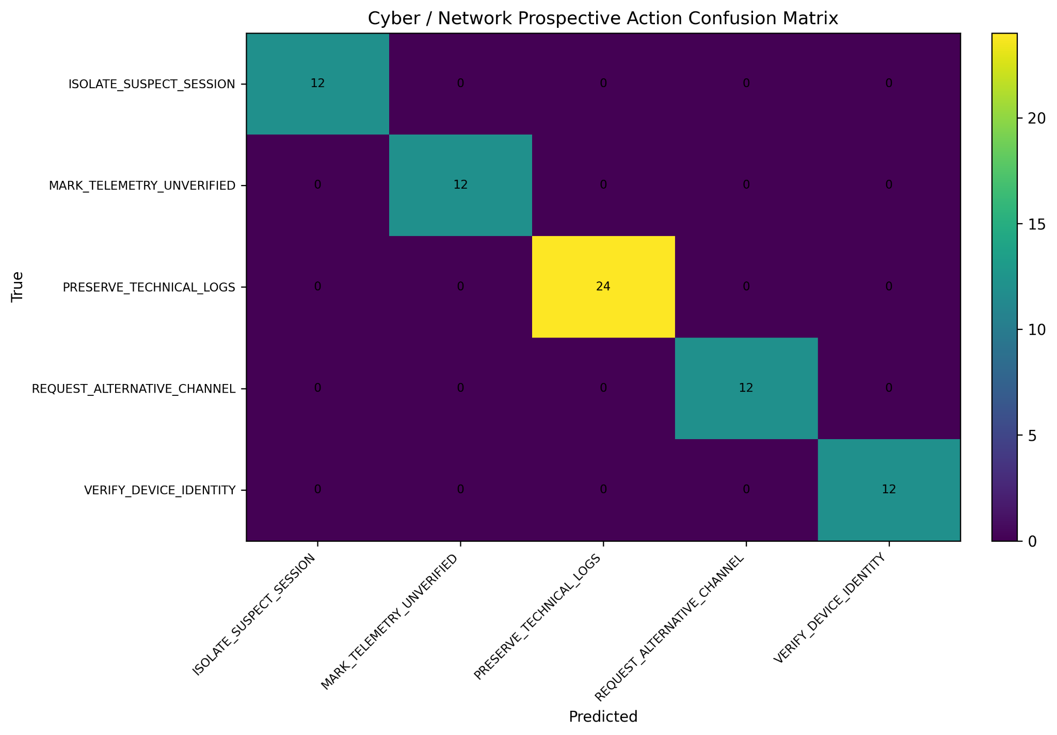
Figure C1. Action confusion matrix: 12, 12, 24, 12 and 12 correct classifications. Total 72; no off-diagonal counts in the supplied plot.
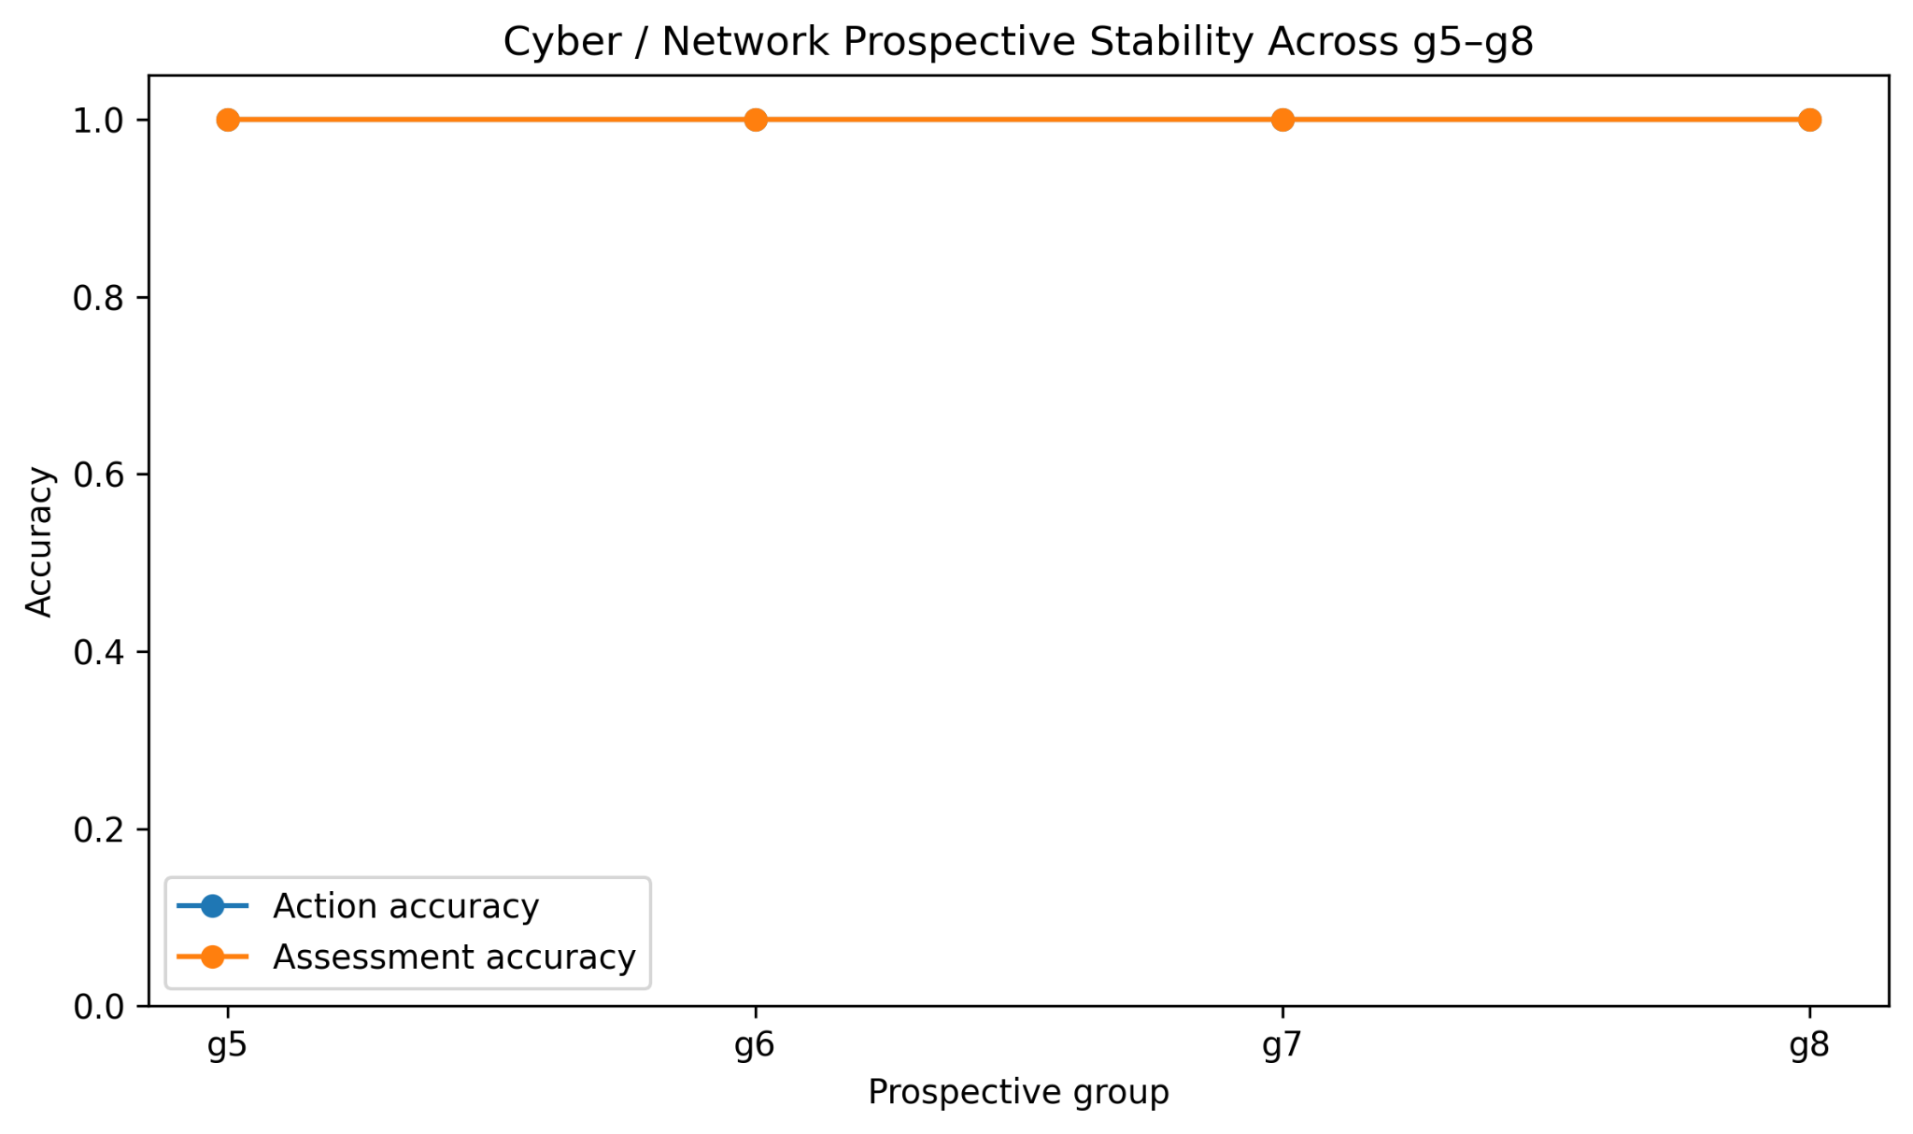
Figure C2. Group action/assessment accuracy both equal 1.000; the curves overlap. Stability is across the four modeled prospective groups, not external networks.
Clinical implication is bounded: the component can reproduce its defined institutional action labels under the tested shift. It is not evidence that Cyber can diagnose a patient or that every future attack is detectable.

C2. RQ1 — Selection history, convergence and Privacy evidence
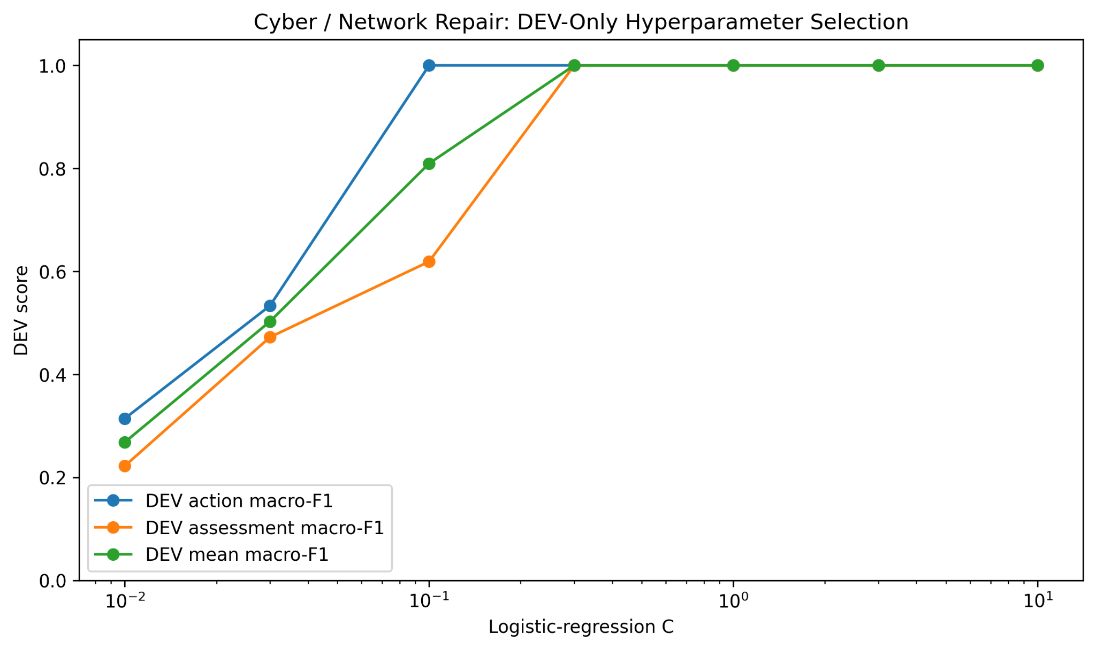
Figure C3. DEV-only C sweep. The documented tie-break selects C = 0.3 before prospective evaluation. These points are hyperparameter settings, not epochs.
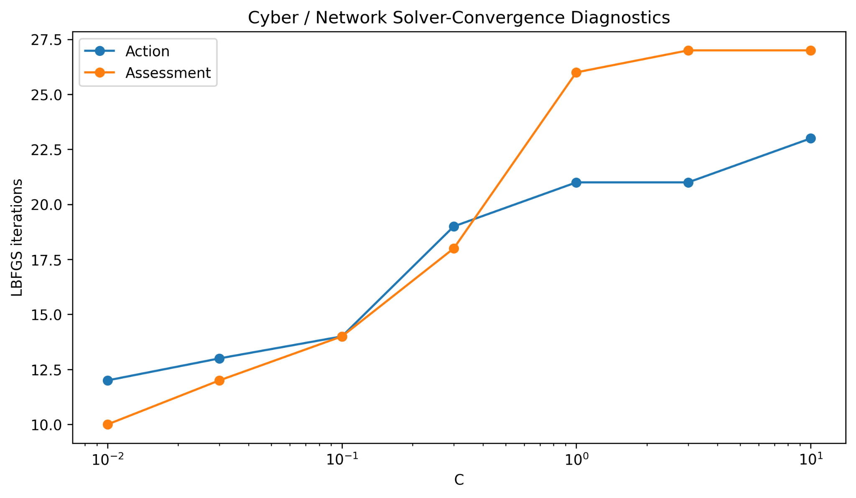
Figure C4. LBFGS iteration counts by C for the action and assessment heads. This is solver effort across fitted models, not a loss-versus-epoch training curve.
Cyber uses 54 TRAIN and 18 DEV records. TRAIN-fitted standardization and explicit missingness address the diagnosed representation issues; opened g4 diagnostic records are excluded from the prospective test. The model family remains multinomial logistic regression. [9]
Historical component | Confirmed result | Boundary
Privacy action head | 486/486 action decisions; macro-F1 and minimum action recall 1.000; unsafe-ALLOW execution rate 0. | Fresh contexts in an already-defined finite policy space. Some action classes have support 3.
Privacy evidence head | Accuracy 0.963; macro-F1 0.945. | Not every head is perfect; non-action heads were not repaired with the action head.
Research/IRB learning | Exploratory/deferred. | Do not promote exploratory evidence to the Privacy/Cyber confirmation status.

Source: supplied five-page report and preserved Gate22B.6/Gate24C status files. Historical learned components are not silently substituted for the deterministic live proposal library.

C3. RQ1 — Class-level performance and data-growth history
The following tables retain the original learned-component evaluation. A confusion matrix, a DEV hyperparameter sweep, a training-support history and a solver-iteration count answer different questions; none is an epoch-by-epoch learning curve. These measurements are not substituted for live coordination performance. [9]
Prospective Cyber action classification
Action class | Precision | Recall | F1 | Support
Isolate Suspect Session | 1.000 | 1.000 | 1.000 | 12
Mark Telemetry Unverified | 1.000 | 1.000 | 1.000 | 12
Preserve Technical Logs | 1.000 | 1.000 | 1.000 | 24
Request Alternative Channel | 1.000 | 1.000 | 1.000 | 12
Verify Device Identity | 1.000 | 1.000 | 1.000 | 12

Source: archived gate24c_status.json. Four prospective groups g5–g8; 72 records in total. The action and assessment heads both achieve aggregate accuracy/macro-F1 1.000 within this modeled generator shift.
Cumulative TRAIN support at the selected C = 0.3
Support step | TRAIN records | DEV action F1 | DEV assessment F1 | Action iterations | Assessment iterations
1 | 18 | 1.000 | 0.619 | 14 | 14
2 | 36 | 1.000 | 1.000 | 17 | 18
3 | 54 | 1.000 | 1.000 | 19 | 18

The archived sequence adds groups g0, g1 and g2: 18 → 36 → 54 TRAIN records, with 18 DEV records held for model selection. Assessment DEV macro-F1 rises from 0.619 to 1.000 as support grows; action DEV macro-F1 is 1.000 at all three recorded support steps. This is descriptive training-support history—not evidence that the prospective groups participated in selection.
What these results contribute to the submission
They demonstrate a separately evaluated institutional proposal component and a disciplined response to representation failure. The strongest methodological point is that the repair changed TRAIN-fitted scaling and explicit missingness rather than changing the policy boundary or concealing the initial failure. Prospective labels and support remain fixed.
Privacy evidence is summarized in Annex C2. Its action result is 486/486 within the finite predefined state space, while the evidence head remains imperfect. Research/IRB learning remains exploratory. No learned-action score should be used as a claim that an action is legally authorized, that all five live roles are learned models, or that unseen clinical situations have been validated.
Source files: gate24c_status.json; gate24c_training_history.csv; gate24c_hyperparameter_results.csv; supplied Cyber figures. No fitting or evaluation was repeated for this editorial revision.

D1. RQ3 — Original B1–B5 architectural comparison
This is the comparison promised in the initial submission. Seventy records represent seven coordination archetypes with ten context variants each; the same frozen cases were evaluated by every reference architecture. No new training or baseline-specific tuning is introduced here. [9]
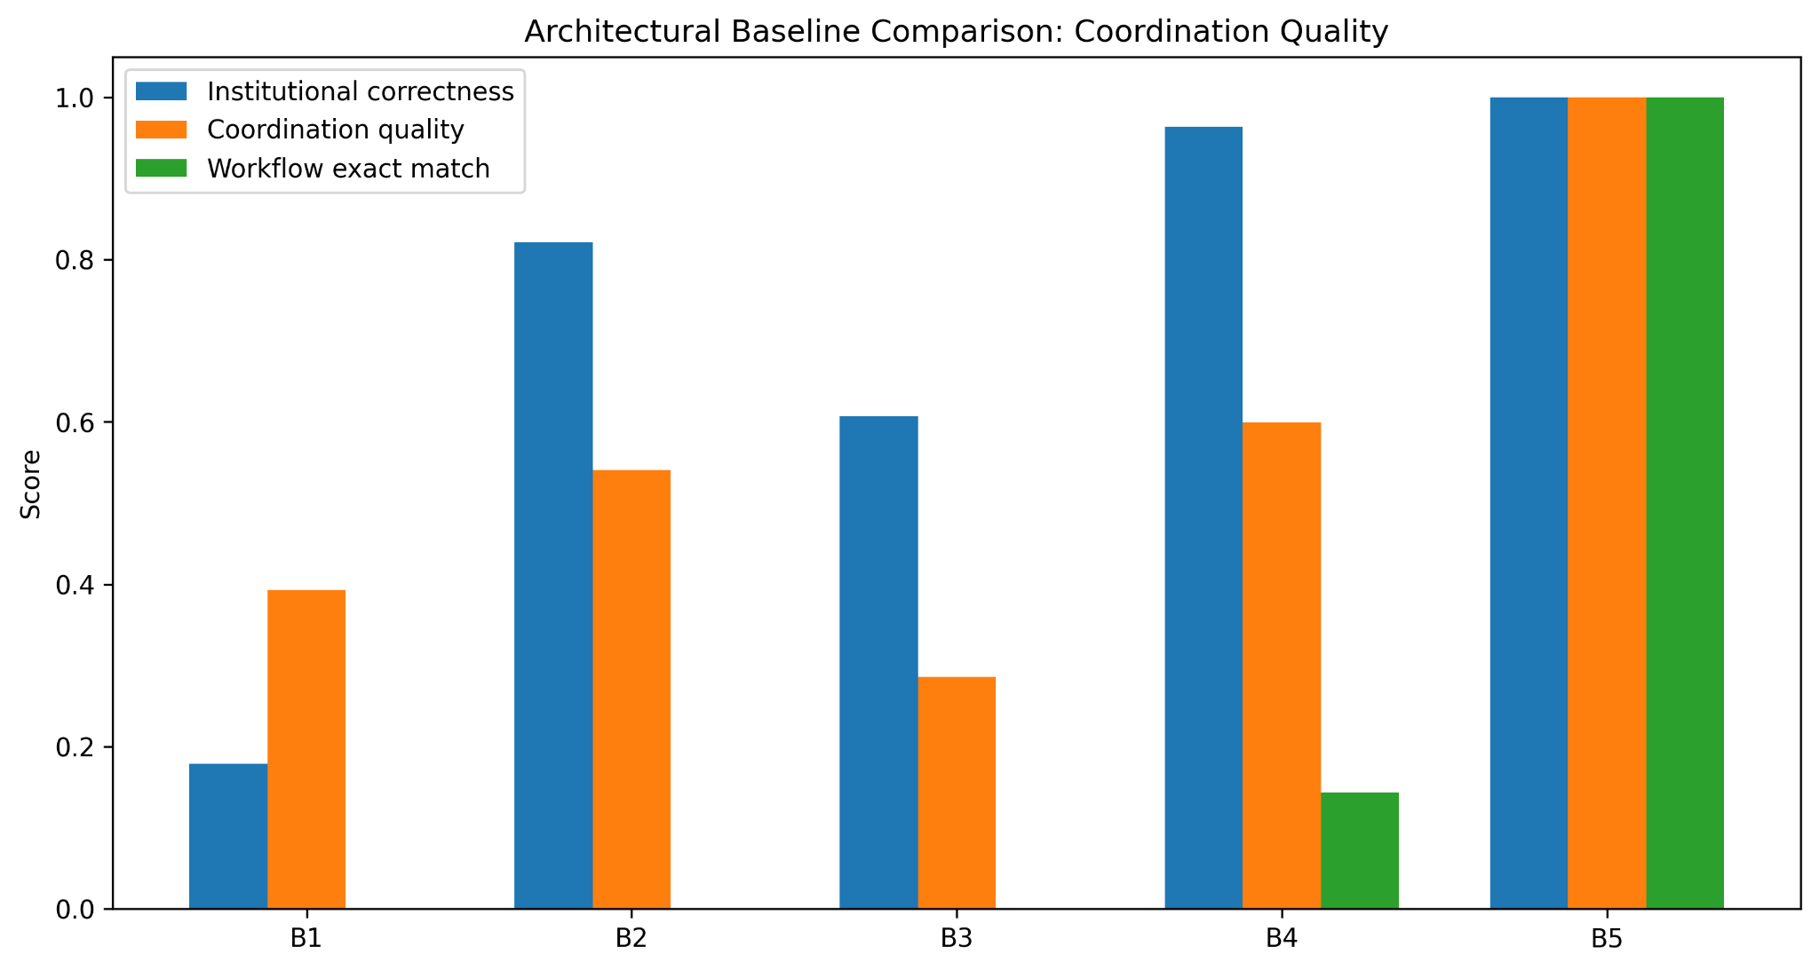
Figure D1. Original IC/CQ/EWM results. The full B5 reference realizes the encoded workflow; this is not a comparison of optimized general-purpose planning systems.
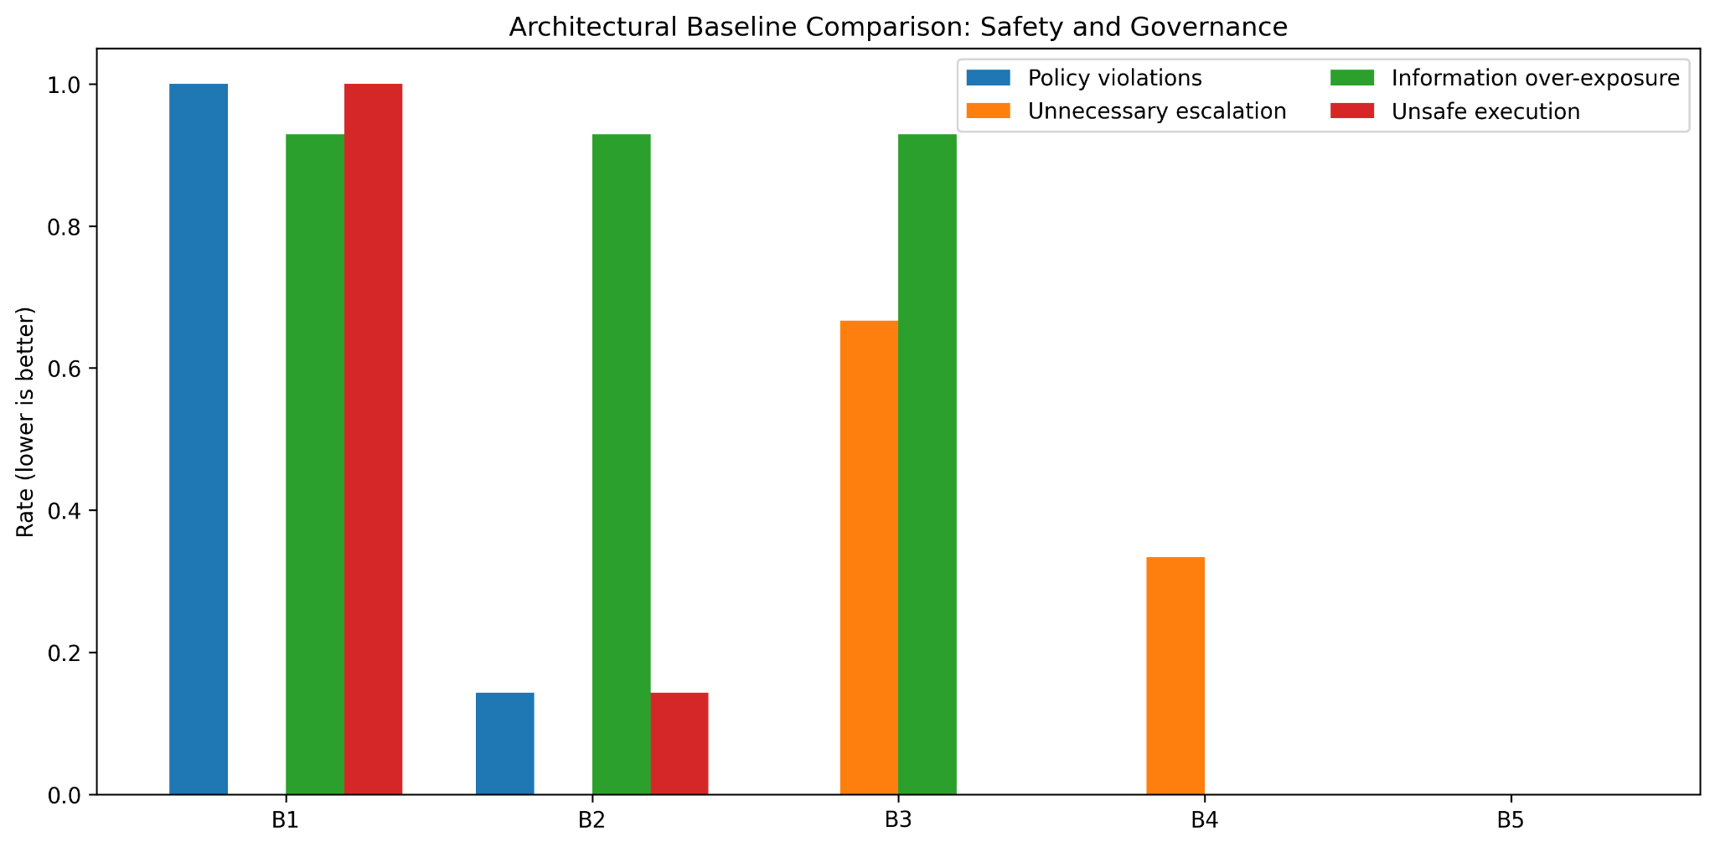
Figure D2. Original policy/authority, overexposure, escalation and unsafe-token metrics. Zero unauthorized actions must be interpreted alongside useful completion.
The strongest bounded observation is B4→B5: individual filtering alone does not reproduce the encoded cross-institutional workflow. Later studies test the mechanism with stronger stateful controls rather than assuming this result proves general superiority.

D2. RQ3 — Archetype coverage and baseline contracts
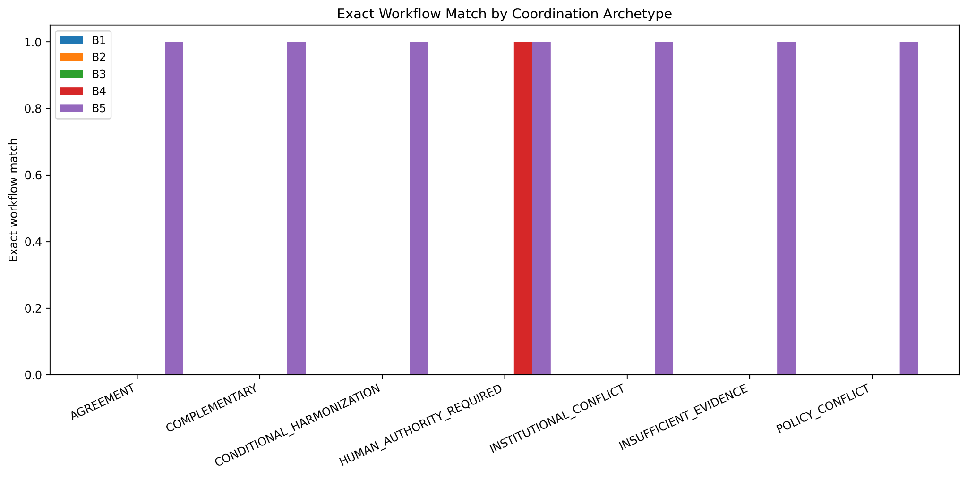
Figure D3. B5 matches all seven encoded archetypes; B4 exactly matches the human-authority archetype. Ten variants per archetype do not create ten independent institutional problems.
Baseline | Frozen implementation / access | Interpretation
B1 | All available information; valid-looking actions issued under omniscient_agent ownership. | Ownership is considered unauthorized in this benchmark. This is not a theorem against centralized planning.
B2 | Role-named proposals are emitted without enforced policy/mandate boundaries; modeled evidence broadcast. | Isolates the insufficiency of role labels alone.
B3 | Majority-intent vote; ties escalate; evidence summaries broadcast. | Retains the submitted consensus/debate name with an implementation qualifier. No live debate model tested.
B4 | Independent policy/mandate/evidence filtering; unresolved cross-role cases may escalate. | Not the same method as Gate 29’s capable stateful selector.
B5 | Structured-fact harmonization with allowed alternatives, messages, conditions and escalation. | Reference-rule consistency. Subsequent tests isolate scheduling, choice and timing separately.

B1/B2 overexposure is scored against modeled required-field lists, not measured access to actual patient records. Gate 26 runtime is in-memory reference-logic timing; it must not be compared directly to later HTTP latency or called LLM response time.

E1. RQ4 — Dependency scheduling, not new agents
Only proposal scheduling changes; institutional observations, proposal ownership and validation remain fixed. Eight known workflow families yield 318 distinct family–schedule pairs per method, or 1,590 method executions. The figure uses equal-weight macro-family completion. [9]
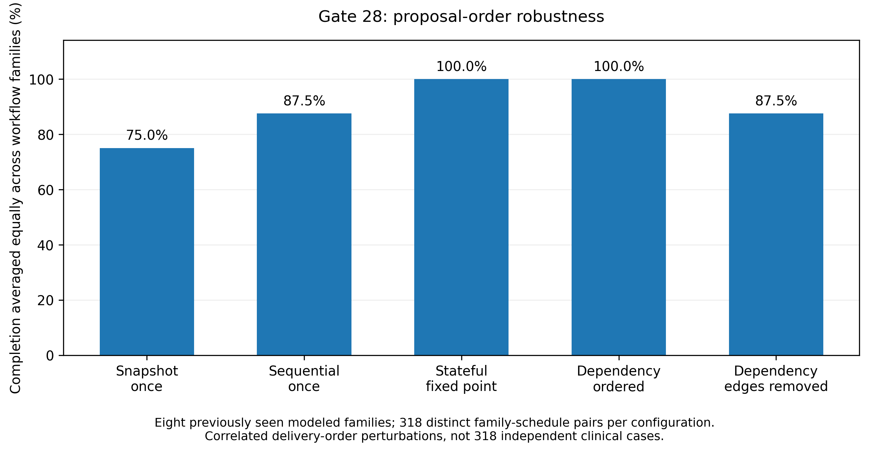
Figure E1. Snapshot once 75.0%; sequential once 87.5%; fair retry and dependency ordering 100%; removed edges 87.5%. The strong-control tie is retained.
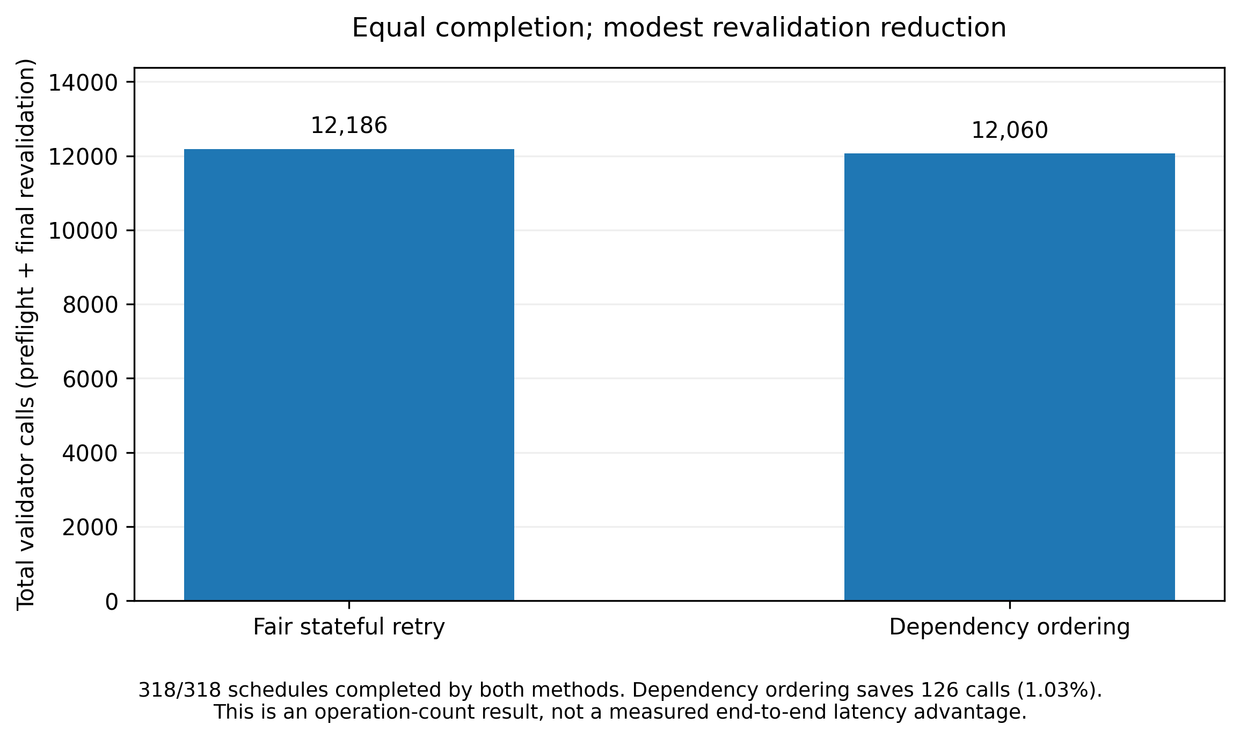
Figure E2. At identical completion, dependency ordering uses 12,060 validation calls versus 12,186: 126 fewer (1.03%). Operation counts do not establish a latency speedup.
Removing only dependency edges reproduces sequential-once effects in all 318 paired comparisons. This isolates a scheduling effect. It neither changes B1–B5 nor tests negotiation over previously unavailable alternatives.

E2. RQ4 — Choosing among authorized alternatives
Gate 29 compares choice mechanisms under the same authorized contracts and objective. Four development and 14 internal confirmation families are used; ten confirmation families admit a complete workflow now, while four require partial work, evidence or authority handling. [9]
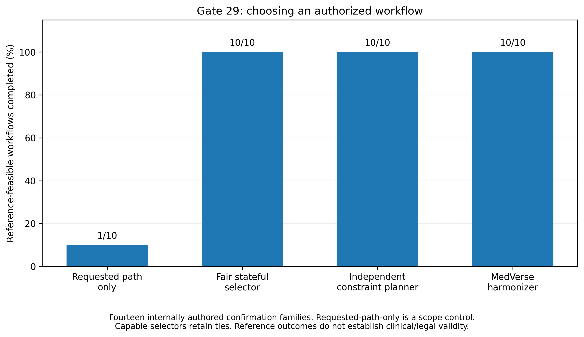
Figure E3. Requested-path-only completes 1/10; fair stateful selection, independent constraint planning and MedVerse each complete 10/10. The requested-path control is intentionally limited, not the strongest comparator.
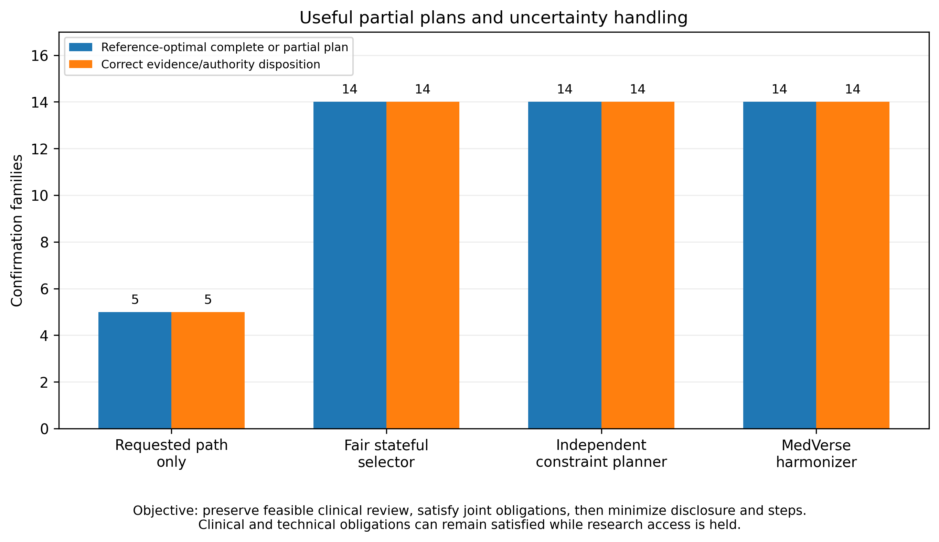
Figure E4. The capable methods agree with the best permissible complete/partial outcome and disposition on 14/14 families. Equally valid workflows are accepted.
The objective preserves feasible clinical review, then joint obligations, then minimizes disclosed field–recipient pairs and action count. Hard authorization constraints cannot be traded away for a higher utility score. These snapshot results are not end-to-end progressive guarantees.

E3. RQ4/RQ6 — Context handoffs and progressive limits
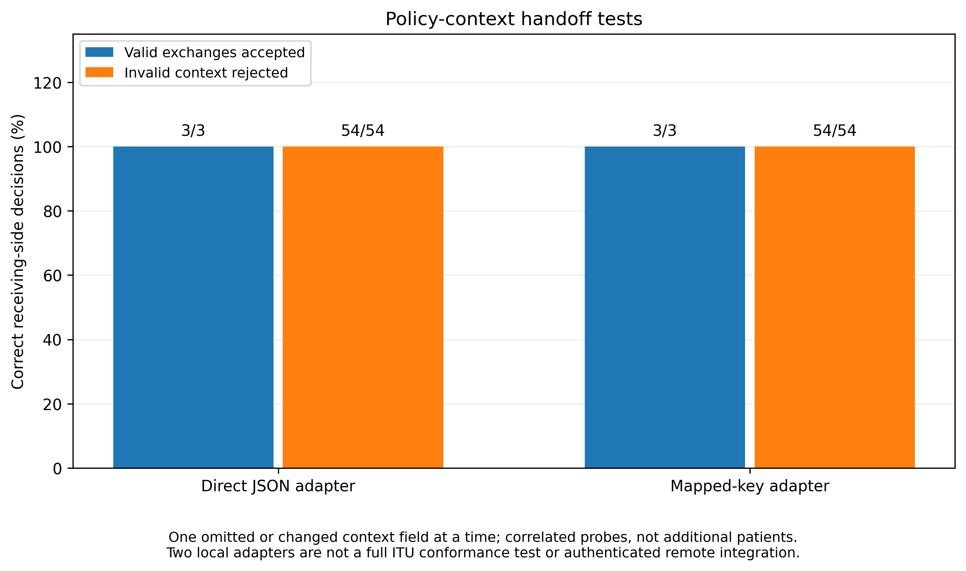
Figure E5. Two local adapters: six valid exchanges accepted, 108 altered/incomplete contexts rejected. Correlated probes of three base contexts; not authenticated remote interoperability or complete ITU conformance.
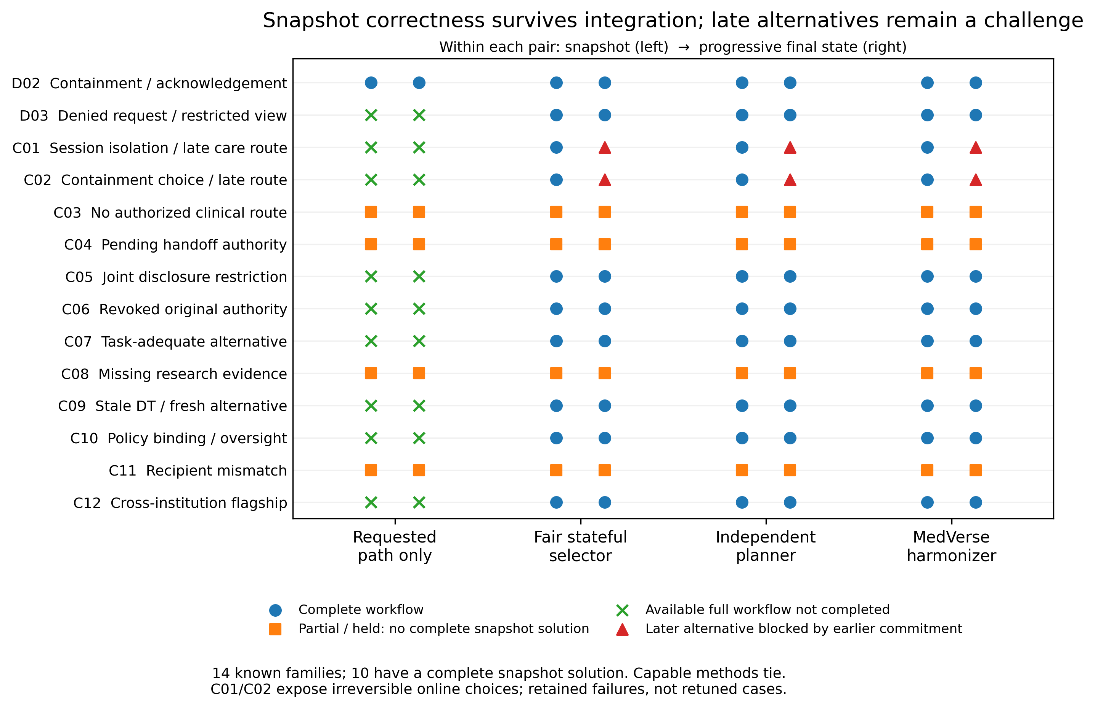
Figure E6. Snapshot-to-progressive comparison on known families. Capable methods fall from 10/10 feasible snapshots to 8/10 progressive completion because of early irreversible commitments in C01/C02.
Those failures remain in the release. Gate 32 adds explicitly declared timing contracts in a new benchmark; it does not retrospectively insert future information or repair C01/C02 by rewriting them.

F1. RQ2 — Digital Twin provenance and permitted evidence scope
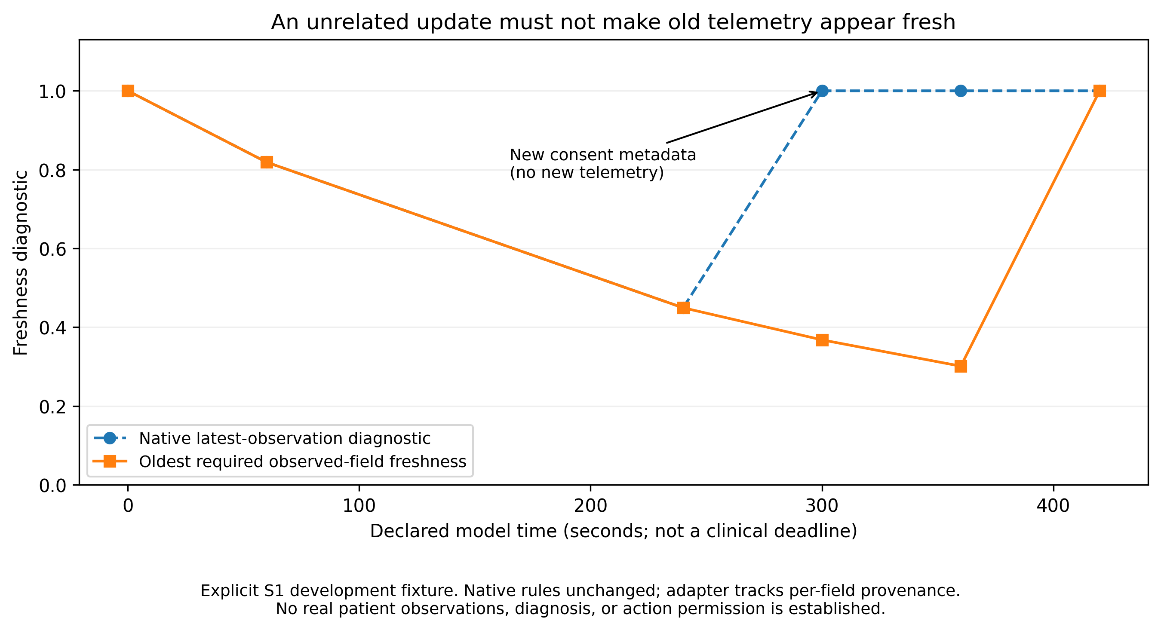
Figure F1. New consent metadata must not make old telemetry look fresh. The adapter tracks required observed fields separately; native historical rules remain unchanged.
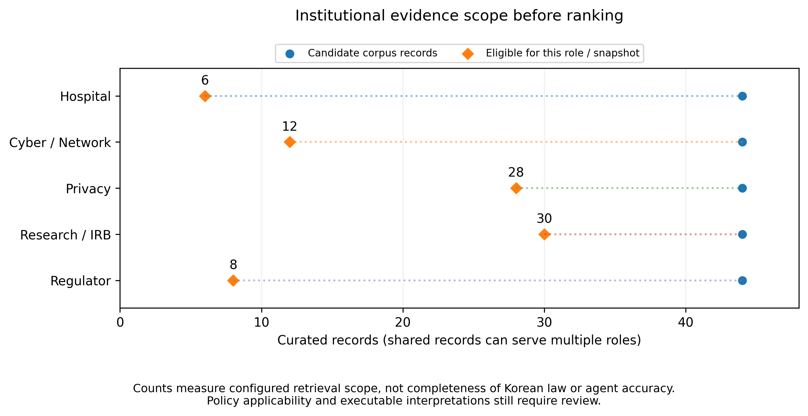
Figure F2. Role-eligible records: Hospital 6; Cyber 12; Privacy 28; Research 30; Regulator 8. Shared records can serve multiple institutions. Counts are not corpus completeness or agent accuracy.
PatientDigitalTwin, DigitalTwinQuality and ProvenanceRecord are project-local Python classes. The observation adapter does not turn demonstration defaults or transferred-envelope metadata into patient observations. DT validity is separate from action permission.

F2. RQ2 — Korean/English retrieval and the later dense run
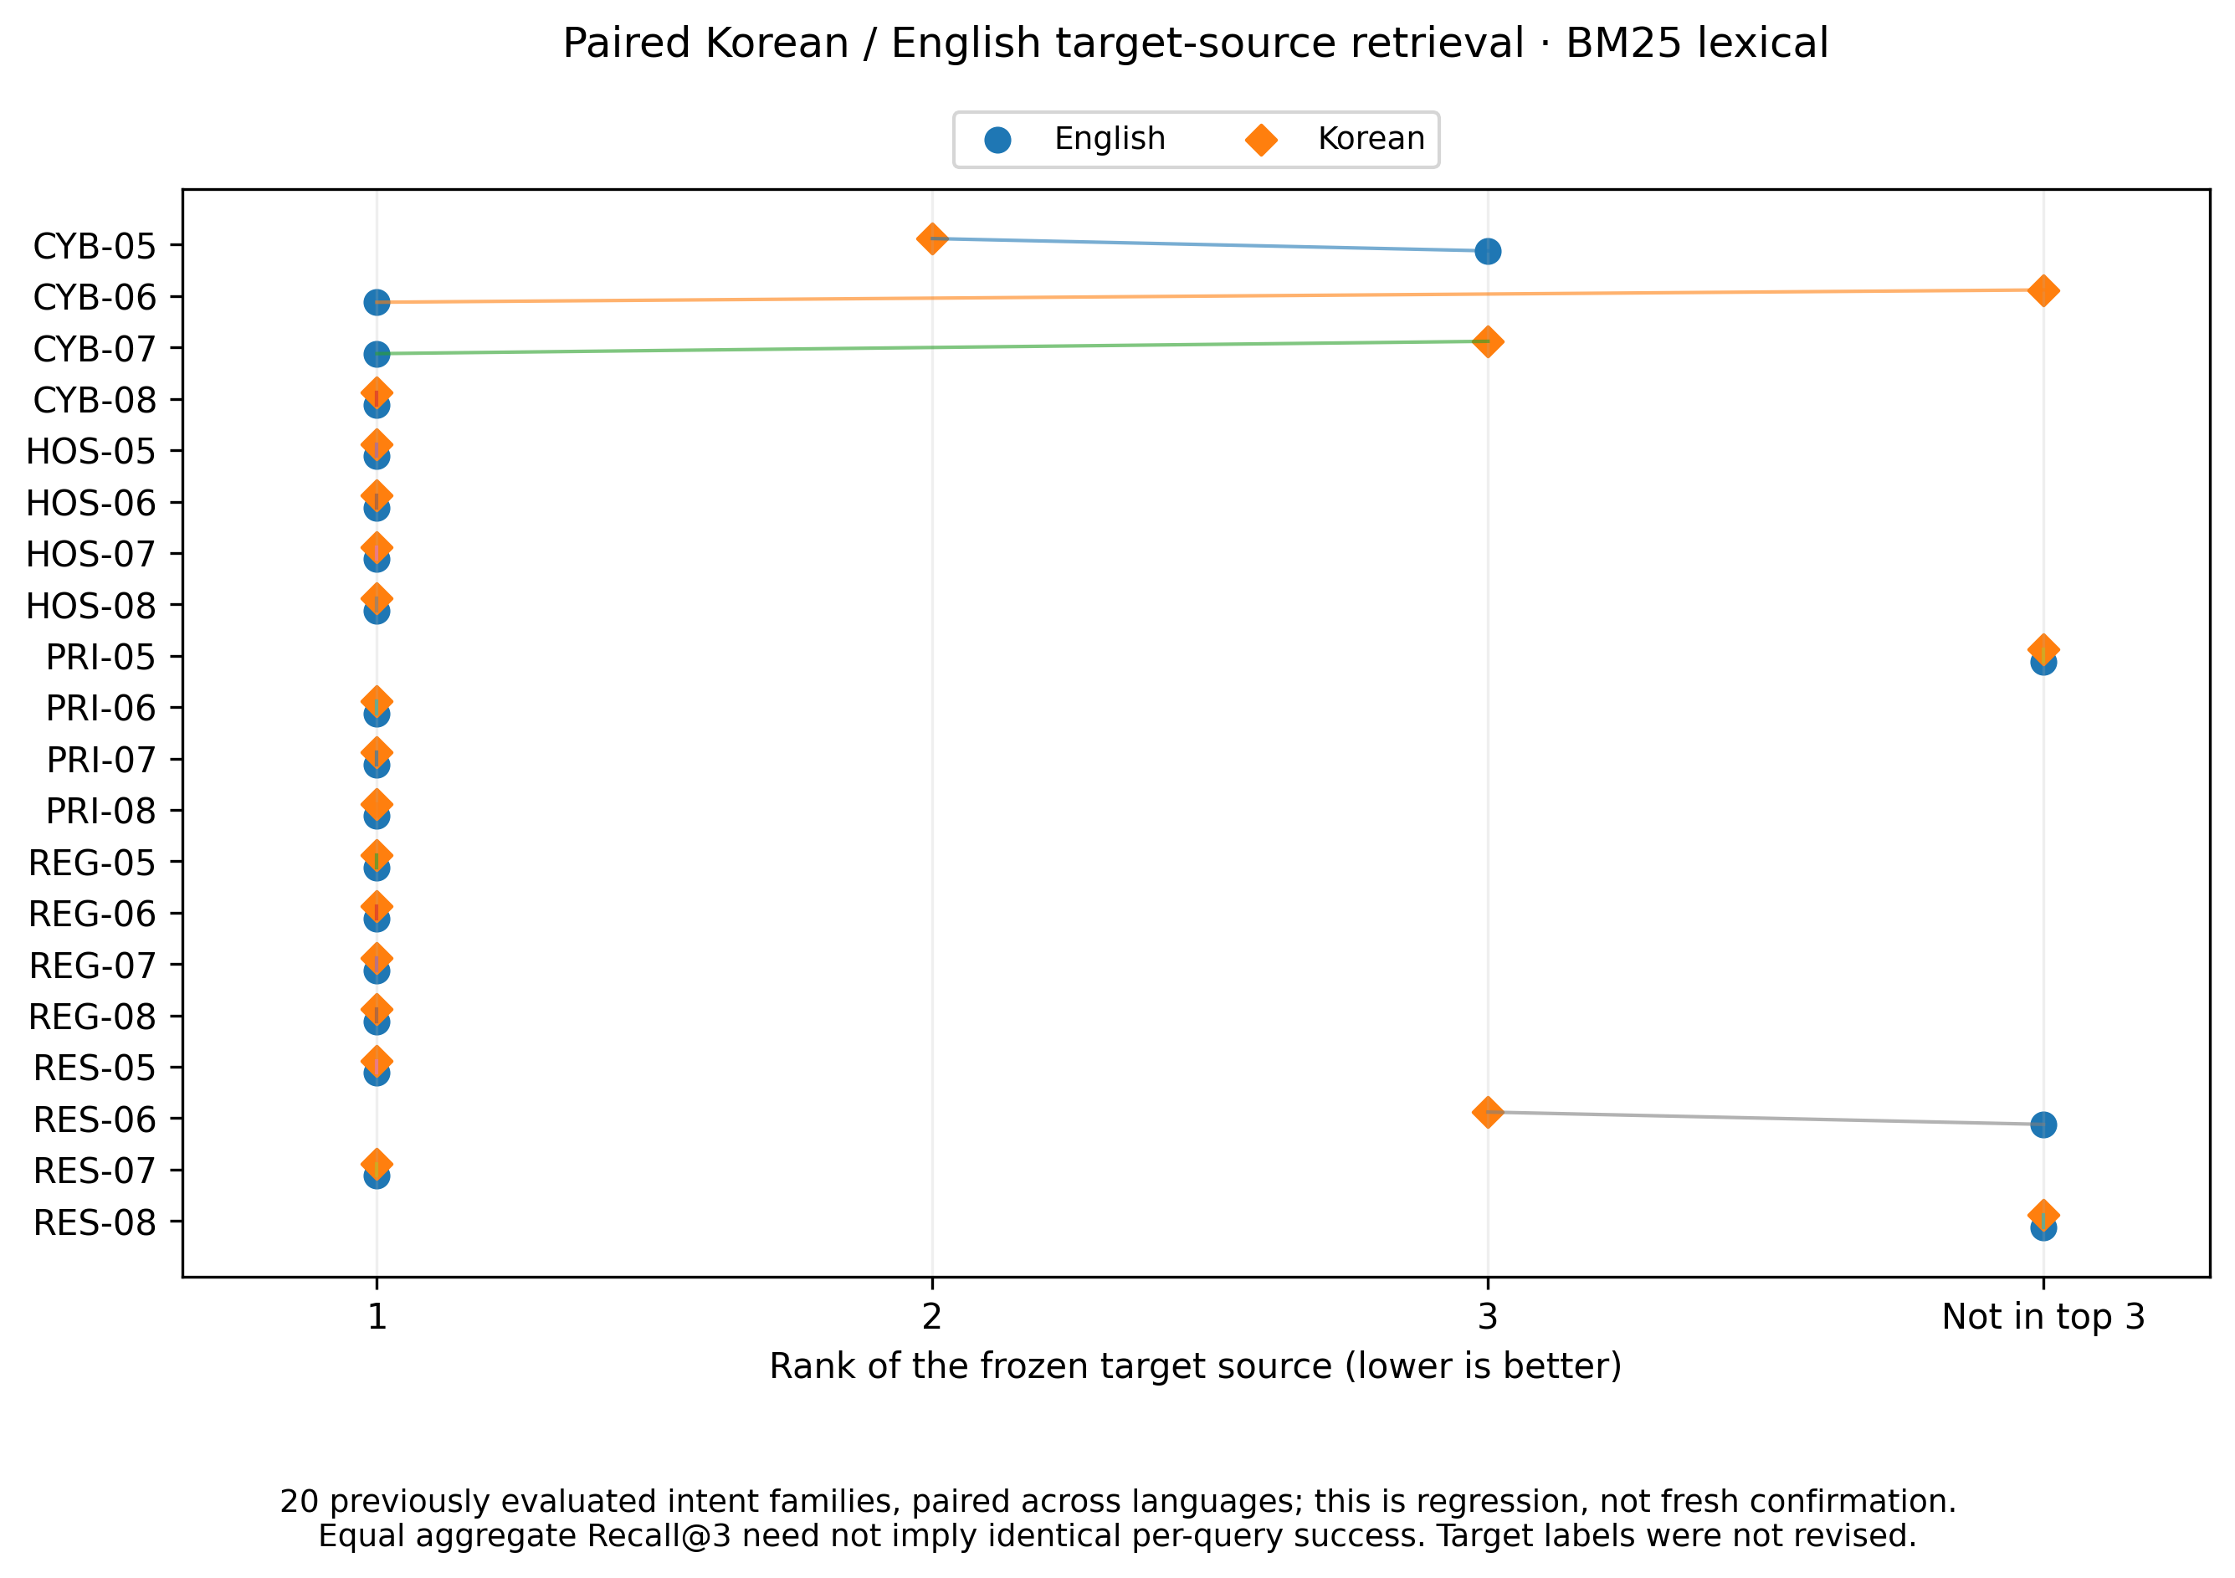
Figure F3. BM25 paired target-source ranks on 20 previously evaluated intent families. Aggregate recall equality does not imply identical question-level outcomes.
Backend / evidence origin | EN top-1 | EN Recall@3 | KO top-1 | KO Recall@3 | Both languages hit
BM25 / archived regression | 16/20 | 17/20 | 14/20 | 17/20 | 16/20 families
Dense / supplied Windows console | 13/20 | 19/20 | 10/20 | 15/20 | 15/20 families

The attached Gate31_Foundation_Report.pdf is run 20261103T132213_435523Z, where dense execution was blocked. The later user-supplied Windows console is run 20261104T003737_462827Z, where dense execution succeeded with 80 queries across historical DEV/CONFIRMATION partitions. The table above uses the historical confirmation-labelled subset only. These records are already known; this is not fresh confirmation. Neither backend dominates both languages.
Dense model: sentence-transformers/paraphrase-multilingual-MiniLM-L12-v2; requested revision e8f8c211226b894fcb81acc59f3b34ba3efd5f42; normalized dimension 384; cosine-equivalent unit-vector dot product; k = 3; configured maximum length 128. The console reports constructor pinning, resolved revision null. Raw per-query dense files were not supplied with the current archive; no dense rank plot is invented.
Recorded local versions: sentence-transformers 6.1.0; transformers 5.19.0; torch 2.13.0+cu126; numpy 2.4.4; huggingface-hub 1.33.0. These are user-run observations, not versions independently reproduced in this revision. The source itself remains authoritative over its translation or paraphrase.

F3. RQ6 — Clinical trace and HTTP response distribution
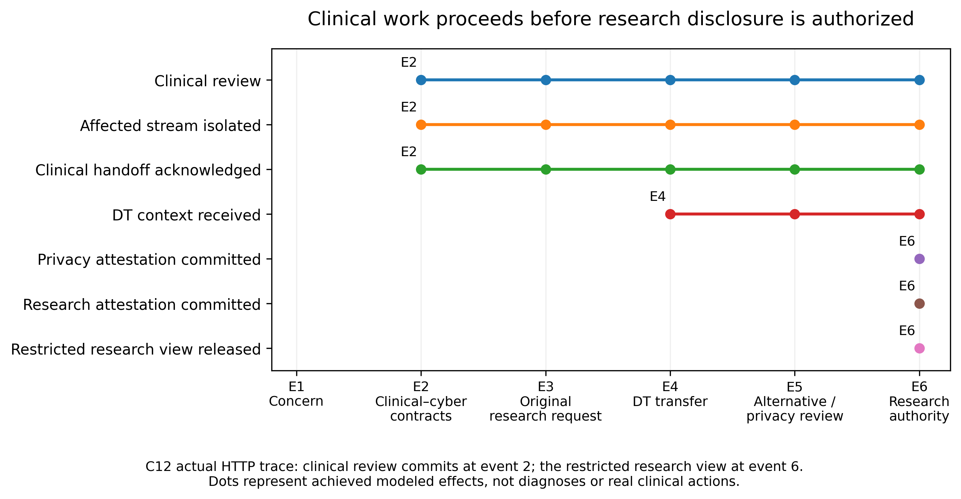
Figure F4. Actual C12 HTTP trace: modeled clinical review at E2; restricted research view at E6. The two permissions are not interchangeable.
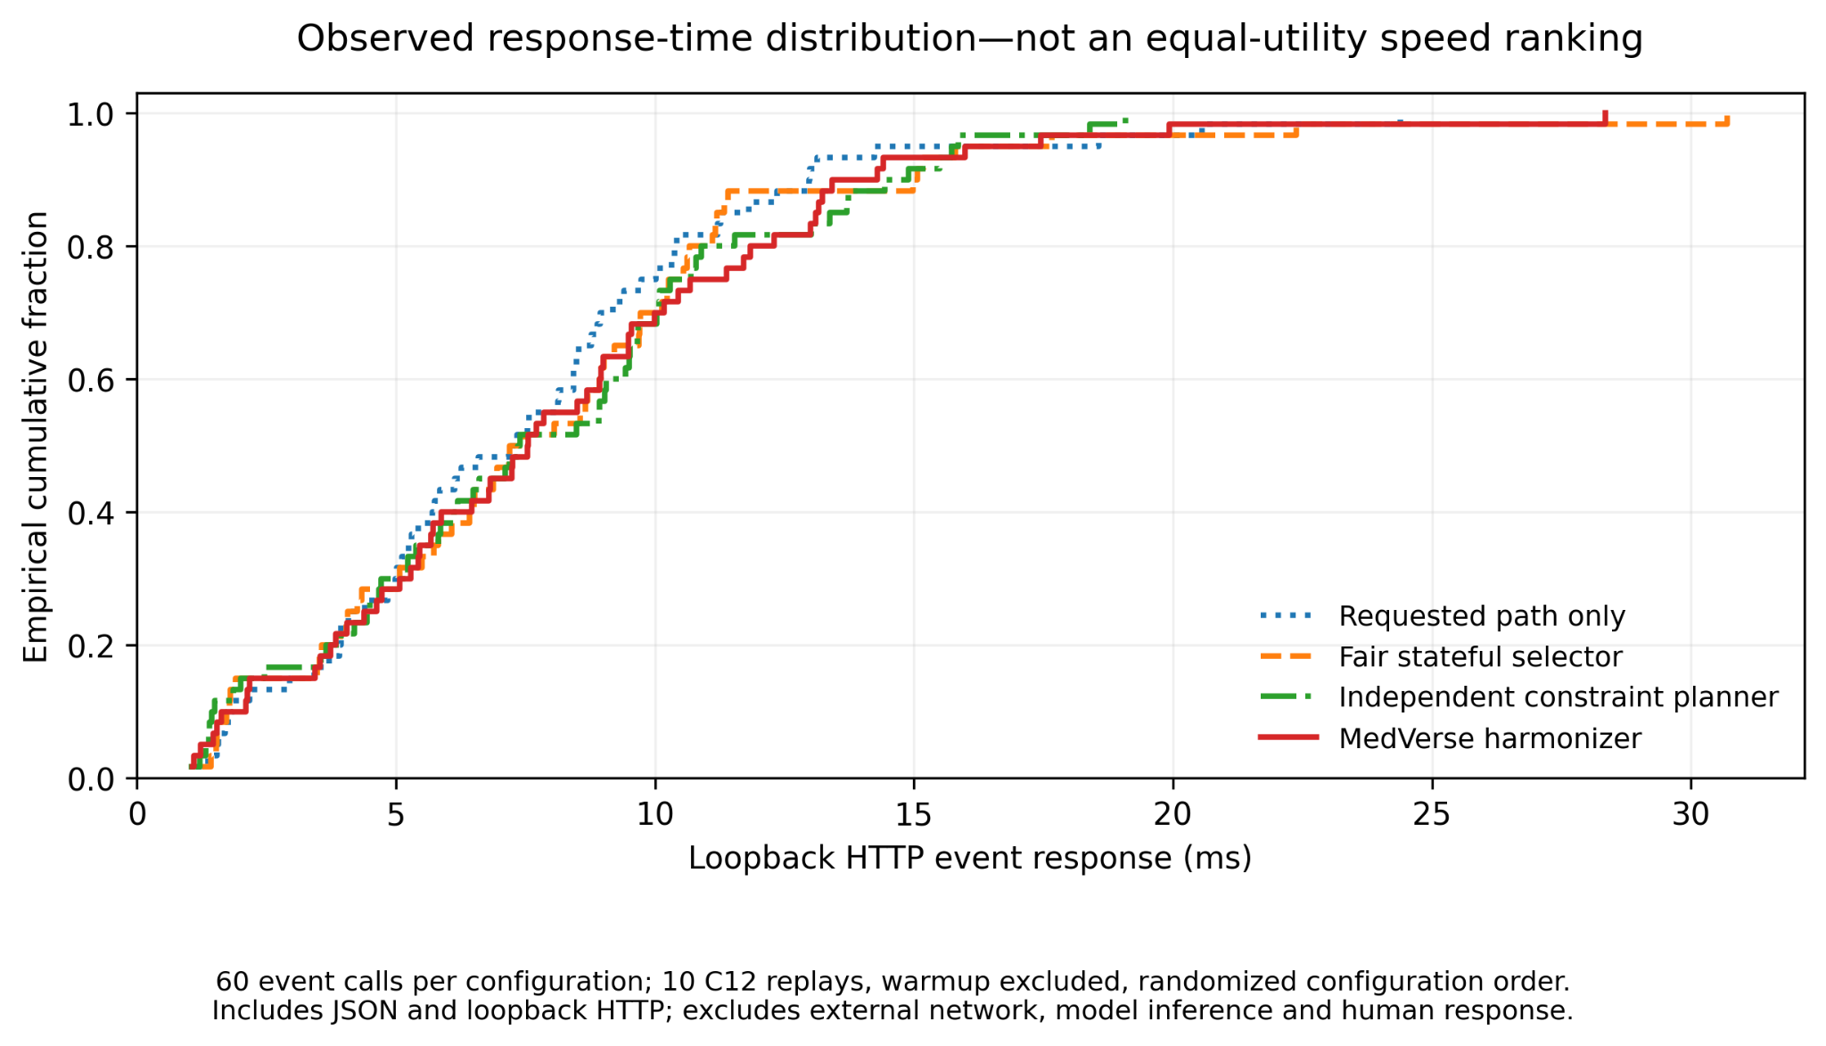
Figure F5. Gate 30—not Gate 29—HTTP response ECDF: 60 event calls per configuration, ten C12 replays, warm-up excluded and randomized configuration order.
Measured local MedVerse median/p95: approximately 7.55/16.06 ms in the identified Gate 30 run. Includes serialization and loopback HTTP; excludes external networking, model inference and human review. It is not an equal-utility speed ranking, and it cannot be merged with Gate 26 microsecond reference timings.

G1. RQ5 — Bounded commitment under partial information
The selector and validator are held fixed while commitment timing varies. Four development prefix families / eight branches precede eight internal confirmation prefix families / 32 branches. Identical visible histories must yield identical deterministic decisions. [9]
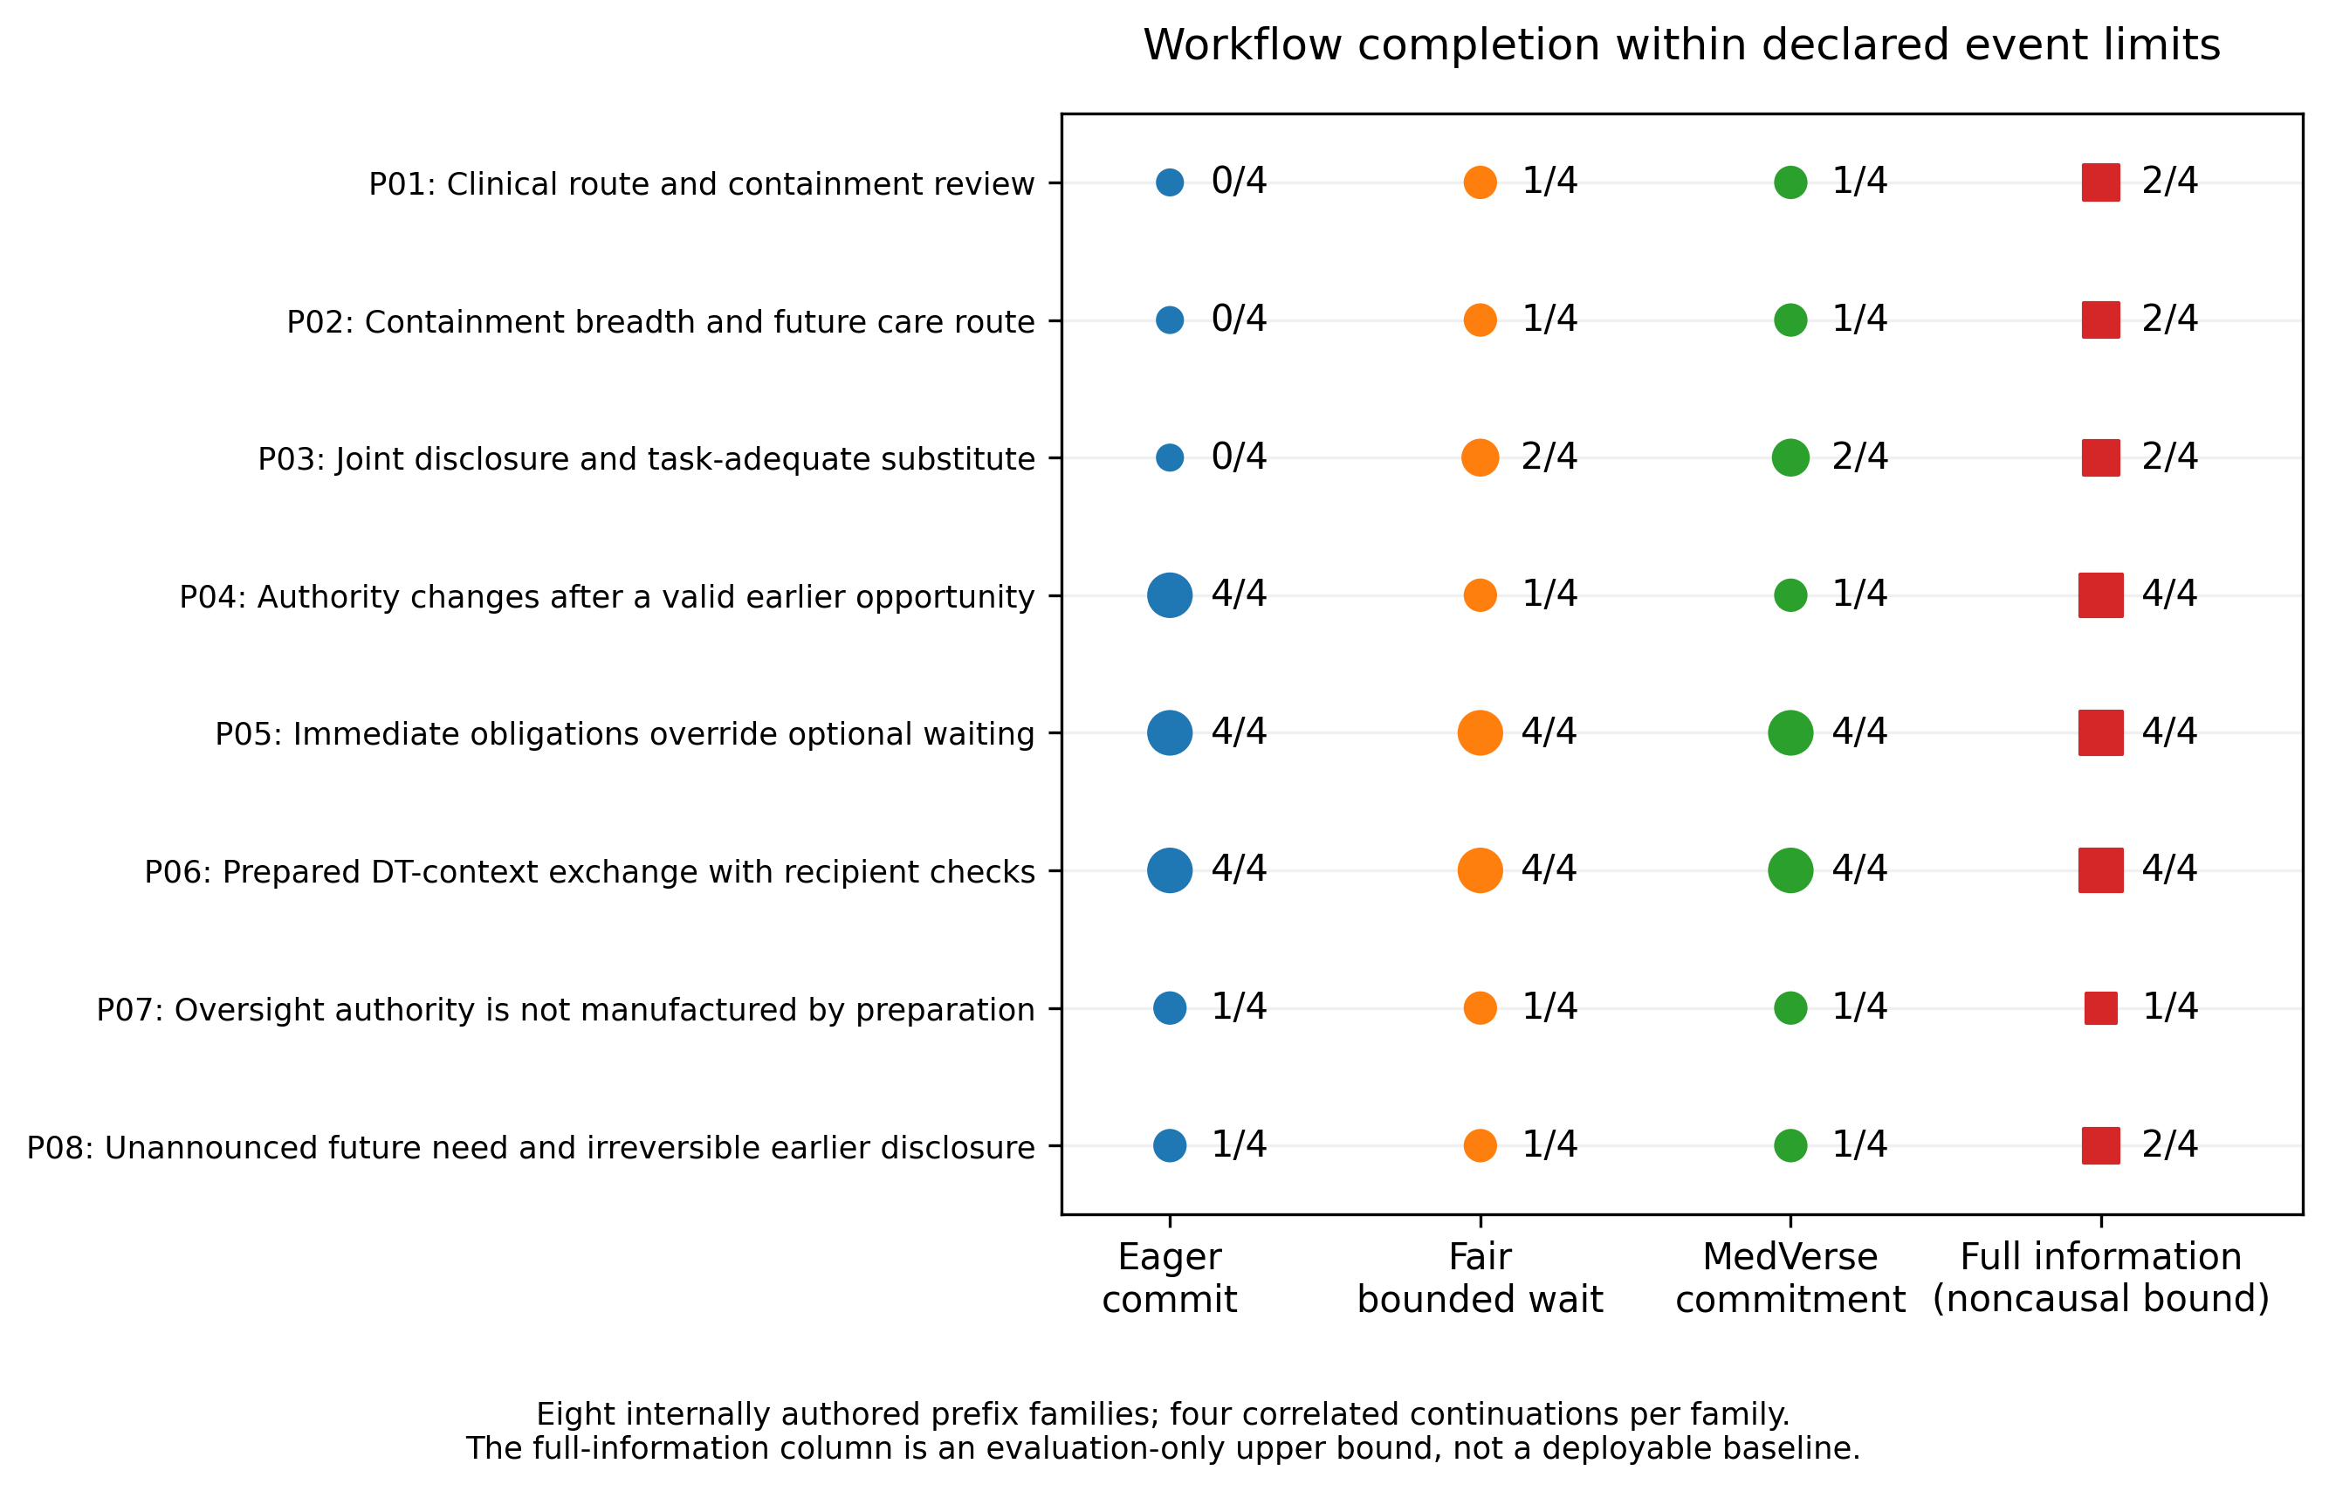
Figure G1. Family-level outcome map. Eager 14/32; fair bounded wait and MedVerse 15/32. The full-information upper bound is noncausal and not a deployable comparator.
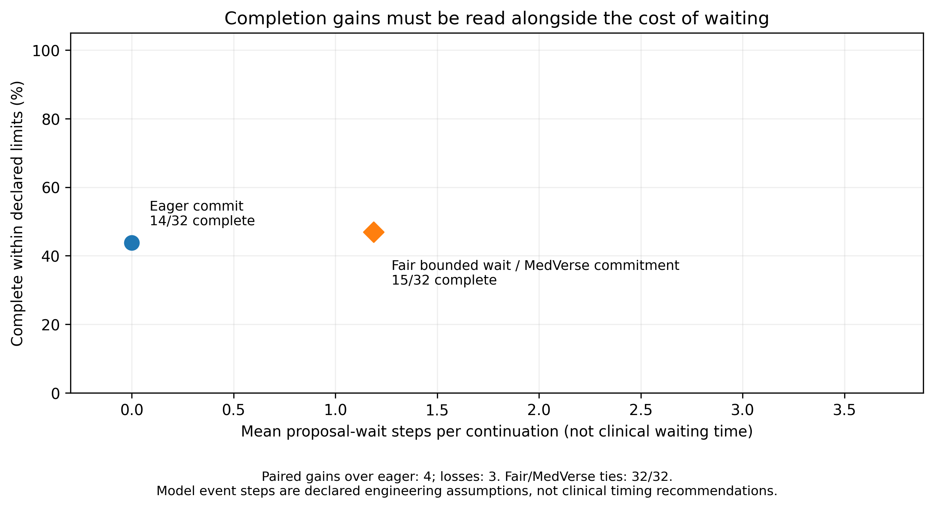
Figure G2. Four gains and three losses versus eager commitment; capable controls tie on all 32 branches. Mean proposal-wait steps 1.19, not patient waiting time.
A validated action today may lose its opportunity if authority changes during a permitted wait. Later revocation does not erase earlier valid effects. Bounded waiting is therefore a visible institution-owned contract, not a global promise of improved care.

G2. RQ5/RQ6 — Inspectable commitment and institutional contribution
Figure G3. A prompt alternative can justify waiting; later revocation can remove an opportunity. COMMIT symbols are actual receipts, and each lane ends after its obligation is achieved.
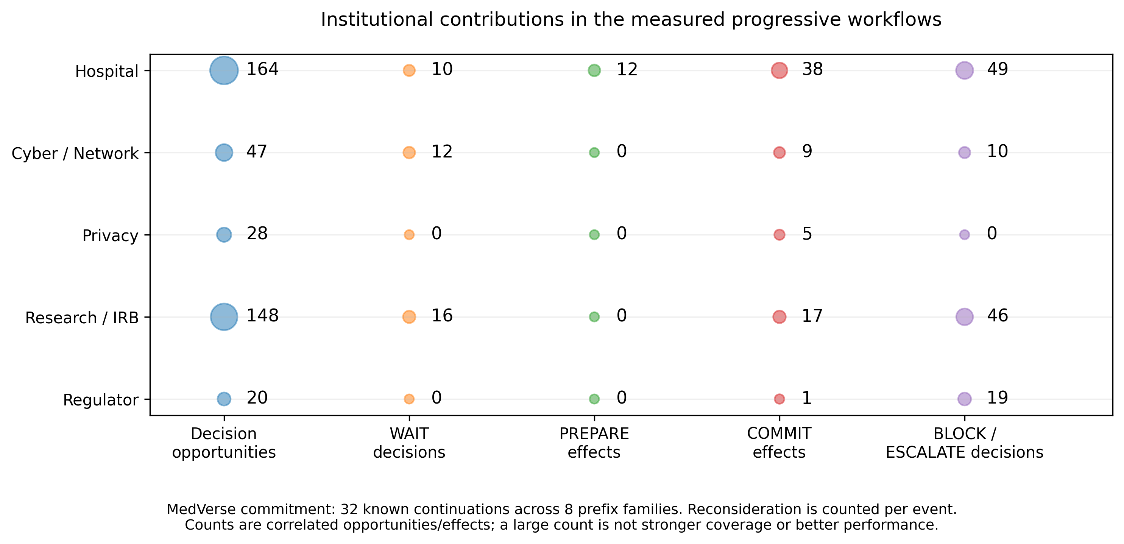
Figure G4. Gate 33 institution-level behavior. Hospital 164 opportunities / 38 commits; Cyber 47/9; Privacy 28/5; Research 148/17; Regulator 20/1. Opportunities are reconsidered events, not independent predictions.
This addresses agent visibility without claiming every agent is a trained classifier. C12 legitimately has no Regulator-owned proposal; oversight is shown in P07. The operator inspector is not a proof of authenticated inter-institution communication or production isolation.

G3. RQ6 — Integration agreement and runtime scope
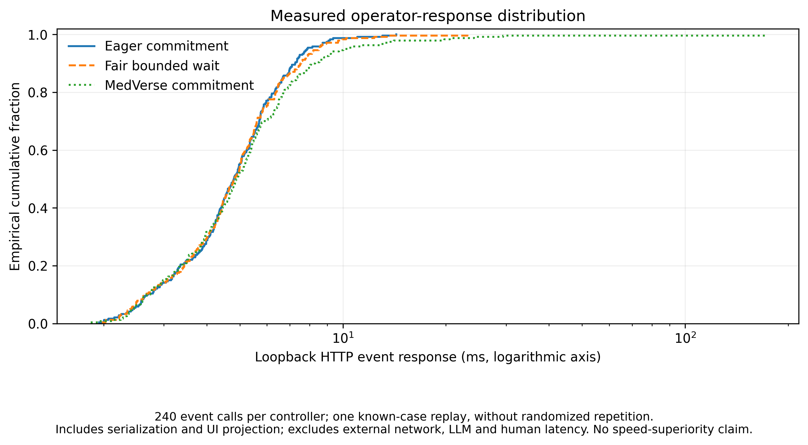
Figure G5. Gate 33 response distribution, logarithmic time axis. 240 event calls per controller; one known-case replay without randomized repeated trials. No speed-superiority claim.
Check | Recorded result | What it establishes
Wrapper/input/role checks | 47/47 | Defined engineering checks pass; not an external security certification.
Engine versus HTTP event state | 720/720 identical | The interface retains the frozen controller’s behavior.
Exported traces | 120/120 identical | Trace export matches the actual evaluated execution.
Identical-history comparisons | 177/177 | No measured use of hidden continuation information in these probes.
Changed-authority probes | 72/72 no new unauthorized effect | Final revalidation blocks affected commitment in the tested perturbations.
Earlier clinical outcomes | 432/432 unchanged | The new workspace did not rewrite the earlier clinical flow.

Gates 32 and 33 repeat some invariants and cases. Their check totals must not be added to claim more independent evidence. Native Windows/Spyder and browser download verification still require local sign-off; browser checks in the release used a documented bridge to the actual backend.
The commitment and original clinical/DT workspaces share a host but remain separate modeled sessions. Candidate action contracts, review records and effects are not real hospital signatures, real research approvals or a connected clinical service. Clinical/legal interpretation review remains pending.

H1. Mentor-response matrix and cross-domain reuse
Mentor request | Response in main report / annex | Remaining boundary
Each agent’s function and performance | Main Table 1; Cyber/Privacy learned evidence C1–C3; actual contributions G2; role-specific receipts in demo. | Different evidence types are separate. Counts are not predictive accuracy; untested cells are not labelled perfect.
How interactions realize the use case | C12 clinical/research timeline; handoff and prerequisite traces; P01 timing example; final action revalidation. | Local modeled flows, not observed clinical outcomes.
Reuse in another domain | Same coordinator/schema/validator/receipt interfaces; a new institutional configuration below. | Not a KB-only substitution or validated education deployment.
Language sensitivity | Korean/English top-1, Recall@3 and paired ranks; dense local run explicitly distinguished from archived BM25. | Natural-language retrieval is language-sensitive. Structured contract consistency is not multilingual understanding.
Standards/readiness and gap analysis | Main Table 2 maps nodes, requirements, dimensions, documents and evidence; Section 6 derives bounded profiles. | No compliance certification, national maturity score or claim that ITU standards omit all access control.
Move detail to annex | Main body exactly five pages; original figures, full definitions and provenance follow in this document. | Annex permission comes from the mentor message, not an inferred general submission rule.

Proposed role reuse: same mechanisms, different domain contracts
Reusable function | Medical-metaverse configuration | Possible education configuration
Domain service | Hospital | School / educational-service provider
Technical integrity | Cyber/Network | Platform / assessment-data integrity
Data protection | Privacy | Learner-data protection
Research governance | Research/IRB | Applicable education-research ethics
Oversight | Regulator simulation | Applicable education oversight simulation

A valid transfer would need new authoritative sources, observations, purposes, mandates, action contracts, authority records, task requirements and independently specified outcomes while preserving the reusable engine. No education performance result is included because none was established in the supplied evidence.
I1. Evidence provenance, figure register and reproducibility
No experiment is rerun by this revision. Figures are reused from the supplied attachments or preserved release archive. Existing result values and known limitations are retained. Any source-summary correction is documented below rather than altering historical artifacts.
Evidence | Identifier / artifact | Do not overstate
Learning | outputs/gate24c/gate24c_status.json; gate24c_action_class_metrics.csv; gate24c_hyperparameter_results.csv; gate22b6_status.json | Cyber 54 TRAIN / 18 DEV / 72 prospective; Privacy 486 fresh contexts over finite states.
Original B1–B5 | outputs/gate26/gate26_status.json and original comparison runner; supplied five-page report and figures | Non-timing values agree with supplied local log. Runtime varies by run; no combined latency estimate.
Scheduling | Gate 28 report: 20261103T035936_964985Z | 318 effective pairs, eight known families, five configurations.
Alternative choice | Gate 29: 20261103T075734_173247Z | 4 development / 14 internal confirmation families; 72 executions.
Progressive integration | Gate 30: 20261103T111811_756965Z | 14 evaluated families; 10 snapshot-feasible; C01/C02 retained.
DT / BM25 bridge | Gate 31: 20261103T132213_435523Z | Dense dependency blocked in the attached PDF. Historical BM25 replays only.
Dense local evidence | User console: 20261104T003737_462827Z | Successful pinned-constructor CPU run; user-supplied summary, not rerun here.
Commitment | Gate 32: 20261104T013623_796085Z | 8 confirmation prefixes / 32 continuations; comparison with hindsight bound.
Workspace integration | Gate 33: 20261104T035439_172645Z | Known-input HTTP replay; no controller retuning.

Editorial clarifications in this version
B1–B5 remain architectural reference configurations; later names identify mechanism variants. Gate 29 is a snapshot choice study; the submitted HTTP ECDF belongs to Gate 30. The Gate 31 PDF is historical and does not supersede the later successful dense console. LBFGS counts and C sweeps are not epochs. Readiness 2.0 and Y.3172 are distinct sources. The D node distributes outputs; harmonization is cross-cutting. Dynamic waiting is highlighted as a consequential design issue, not a uniquely winning algorithm.
Release checks before submission
Insert public GitHub and video URLs; verify source redistribution and licenses; check original-policy links and active interpretations; reproduce the selected native Windows/browser/backend path; check exports and captions; retain failed/tied cases; confirm five-page pagination and annex boundary. No unreviewed clinical or legal rule becomes approved because a software check passes.

I2. References, source links and supplemental file map
[1] ITU-T Y.3172 (2019), Architectural framework for machine learning in future networks including IMT-2020.Official source
[2] ITU, AI Ready — Analysis Towards a Standardized Readiness Framework, Report 2.0, January 2026; §3 Dimensions.Official source
[3] ITU-T Y.4239 (2025), Reference model for integrating virtual and physical worlds through digital twins in the metaverse.Official source
[4] ITU-T Y.4240 (2025), Interoperability for integrating virtual and physical worlds through digital twins in the metaverse.Official source
[5] WHO, Ethics and governance of artificial intelligence for health (2021).Official source
[6] OECD, Recommendation of the Council on Health Data Governance, OECD/LEGAL/0433.Official source
[7] Team MedVerse candidate Korean corpus v0.4 and source snapshots. Official Korean originals are the policy anchors; interpretation review remains pending.
[8] Sentence Transformers, paraphrase-multilingual-MiniLM-L12-v2 model card.Official source
[9] Team MedVerse frozen Gates 22B.6–33, supplied local console results, status files and source implementations; identifiers listed in I1.
[10] AI for Good Sandbox Hackathon submission template, supplied by the user; UAE competition requirements.Official source
[11] ITU AI for Good, The ITU AI Readiness Hackathon names four winning solutions in Riyadh.Official source
[12] Jiaying’s mentor feedback supplied in this conversation: agent functions/reuse/language, and annex appended outside the five-page main report.
External material informs standards and governance comparison. It is not substituted for a Korean action’s lawful basis. This revision does not newly certify the completeness of the policy corpus or correctness of each operational interpretation.
Supplemental assets supplied with this revision
The accompanying editorial map lists each research question, benchmark unit, method family, metric and figure placement. The video plan identifies the agreed demonstration and its evidence boundaries. The compact CSV results retain study-specific denominators. The original code, data, output files and videos are not modified.
Readable message for the judges
A clinical concern does not grant research permission. A technically unverified stream does not erase a separately reported concern. A confident learned recommendation does not acquire another institution’s authority. MedVerse-Agent makes those distinctions executable and inspectable, while reporting the coordination gains, ties and timing costs found in the modeled experiments.

K1. Patient Digital Twin modeling and source-to-state trace
This note clarifies the existing implementation; it does not introduce new experiments, change thresholds, or claim a live patient connection.
Intended representation versus current implementation
The patient Digital Twin is intended to represent the available observations of the patient’s evolving condition, together with the uncertainty and governance context attached to those observations. In this release, the implemented state is a latest-observation model: individual fields are updated from explicitly supplied scenario observations. It is not a physiological simulator, calibrated disease-progression model, raw biosignal processor or validated diagnostic system.
Step | Implemented behavior and relevant source
Receive a reading | medverse/digital_twin/model.py updates the named clinical/network/security field and appends a ProvenanceRecord. Original S1 numeric clinical fields are SpO2 and heart_rate.
Preserve its context | foundation31/digital_twin.py starts with empty observed fields, records observation/receipt time, rejects future/replayed/stale-field input, and retains role-scoped views.
Evaluate evidence quality | The adapter checks missing required fields, oldest-field freshness and the original integrity conditions. A new consent record does not freshen older telemetry. These are diagnostics, not clinical timing standards.
Produce a reference assessment | Historical Hospital modules use numeric observations to propose measurement verification, contact and human clinical review. Their frozen reference thresholds differ; they are not one clinically calibrated decision model.
Authorize a workflow | Institution-owned proposals remain subject to mandate, purpose, evidence and current-authority checks. A clinical trigger, a DT-quality label or a retrieved policy passage does not itself authorize execution.
Important live-path boundary
The current Gate31/33 foundation adapter projects released role context and receiving-envelope metadata. It does not create unprovided SpO2, heart-rate or temperature measurements. The commitment workspace uses frozen institution-owned contracts and is a separate modeled session. Consequently, the current interface should not be described as autonomous examination of a real patient from live sensors. A clinically validated sensor-estimation/assessment connection would require a separate versioned integration and evaluation.
The original observation module and reference reasoner can be replayed for explanation. For the existing S1-like values, missing core metadata and later identity failure keep the adapter’s evidence state UNVERIFIED while the historical Hospital reference still proposes measurement verification and clinical review. This illustrates separation of clinical concern from evidence trust, not a validated treatment decision.

K2. Korean open-data provenance and demonstration plan
The original source was not deleted from the design
config/data_manifest.json retains KR_NCC_CANCER_INCIDENCE_20260120 and medverse/data_grounding/ncc_context.py retains its CSV adapter. The official record is National Cancer Center Cancer Incidence Statistics, public-data identifier 3039563. The provider describes aggregate statistics for 1999–2023, not patient-level sensor trajectories. [12]
Item | Status in the inspected RC1 archive
Raw data | data/external/ncc_cancer_incidence.csv is absent; .gitignore excludes external CSV files by default.
Legacy integration | Gate19 optionally loads the CSV and attaches descriptive context to Hospital/Research evidence bundles; clinical_inference_permitted remains false.
Current live integration | No NCC loader call appears in the Gate30–33 runtime. Retained source code is not evidence that the GUI currently uses the dataset.
Appropriate role | Population background, cohort-description context and motivation. Never substitute prevalence/incidence for an individual measurement, diagnosis, risk estimate or clinical trigger.
Restoration dependency | Download the official file, validate schema/version/hash and expose a separately labelled context view. Inspect category overlap and denominators before interpreting aggregate counts or crude-rate summaries.
A clearer demonstration structure
Use short opening slides to explain the problem, sensor-to-state representation and the three distinct evidence layers. Show the actual launch command, open the original DT workspace, and distinguish observed context from a full sensor-processing pipeline. Then demonstrate P01/PROMPT, P04/NO_REPLACEMENT, P07/APPROVAL and changed-authority rejection. Show actual GUI tables and the source-labelled archived plot gallery, then close with implications and review boundaries. The GitHub publication tutorial belongs in a separate handover guide, not the seven-minute competition recording.
Publication and provenance
The presentation companion is read-only and additive; archived figures do not change with the current session. Report source runs and the active backend explicitly. Code publication must retain required freeze artifacts, exclude credentials and unapproved data, respect source-document rights, and pass a clean-clone reproduction check. No scientific results were revised in this document update.
[12] National Cancer Center, Republic of Korea. Cancer Incidence Statistics (국립암센터_암발생 통계 정보), data.go.kr record 3039563, source metadata updated 20 January 2026. https://www.data.go.kr/data/3039563/fileData.do. Metadata checked 5 November 2026; raw CSV not ingested in this editorial update.
Implementation evidence: Team_MedVerse_DT_Data_Implementation_Audit.md; source paths and hashes, optional-input status, and the explanatory replay are supplied with the presentation update.

