MedVerse-Agent
  - Integrated coordination | concise performance brief
Snapshot behavior is preserved. Progressive arrival exposes two unresolved choices.
The live HTTP service now invokes the frozen Gate 29 selector, validates actual institution-owned proposals and records modeled effects. Earlier experiments and the original sandbox remain unchanged.
Engineering checks | HTTP snapshot runs | Progressive responses | Change-before-commit
41 / 41 passed | 72 = 18 families × 4 | 432 = 18 × 4 × 6 | 42 / 42 rejected

Performance at a glance
Configuration | Snapshot  complete | Progressive  complete | Per-step  agreement | Invalid new  commits
Requested path only | 1/10 | 1/10 | 75/84 | 0
Fair stateful selector | 10/10 | 8/10 | 84/84 | 0
Independent planner | 10/10 | 8/10 | 84/84 | 0
MedVerse harmonizer | 10/10 | 8/10 | 84/84 | 0
The table uses 14 known families: 10 have a complete solution with all snapshot information; four require partial/held outcomes. Per-step agreement is conditional on earlier commitments, not hindsight-optimal completion.
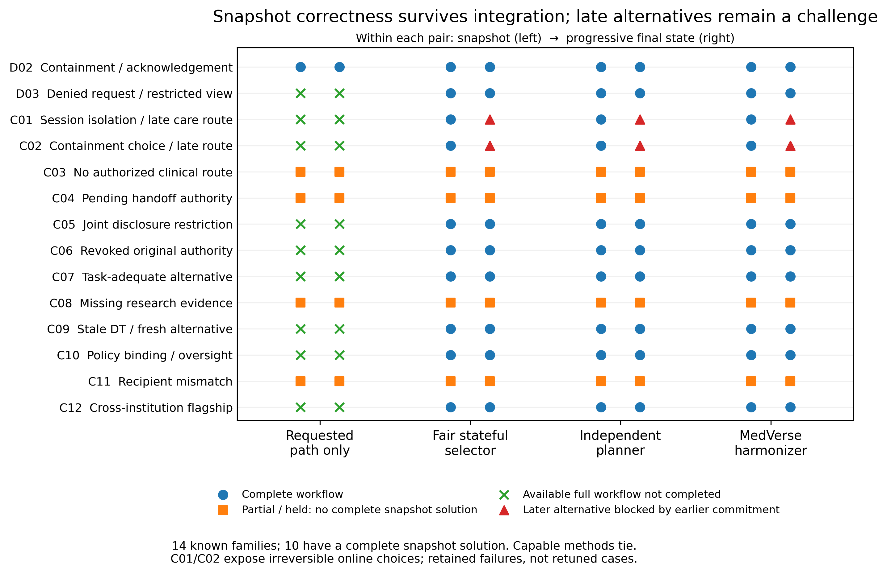
Figure 1. Case-by-case snapshot → progressive outcomes. The capable methods tie. C01 and C02 become incomplete because an earlier irreversible action excludes an alternative released later. No selector, release schedule or scoring rule was retuned after measurement.
Claim boundary: integration regression on developer-authored scenario models—not fresh clinical evidence, legal certification, or proof of a uniquely superior planning algorithm.

How the integrated workflow behaves
The C12 flagship provides a concrete trace: clinical review proceeds independently, while research disclosure remains withheld until its own modeled authority requirements are met.
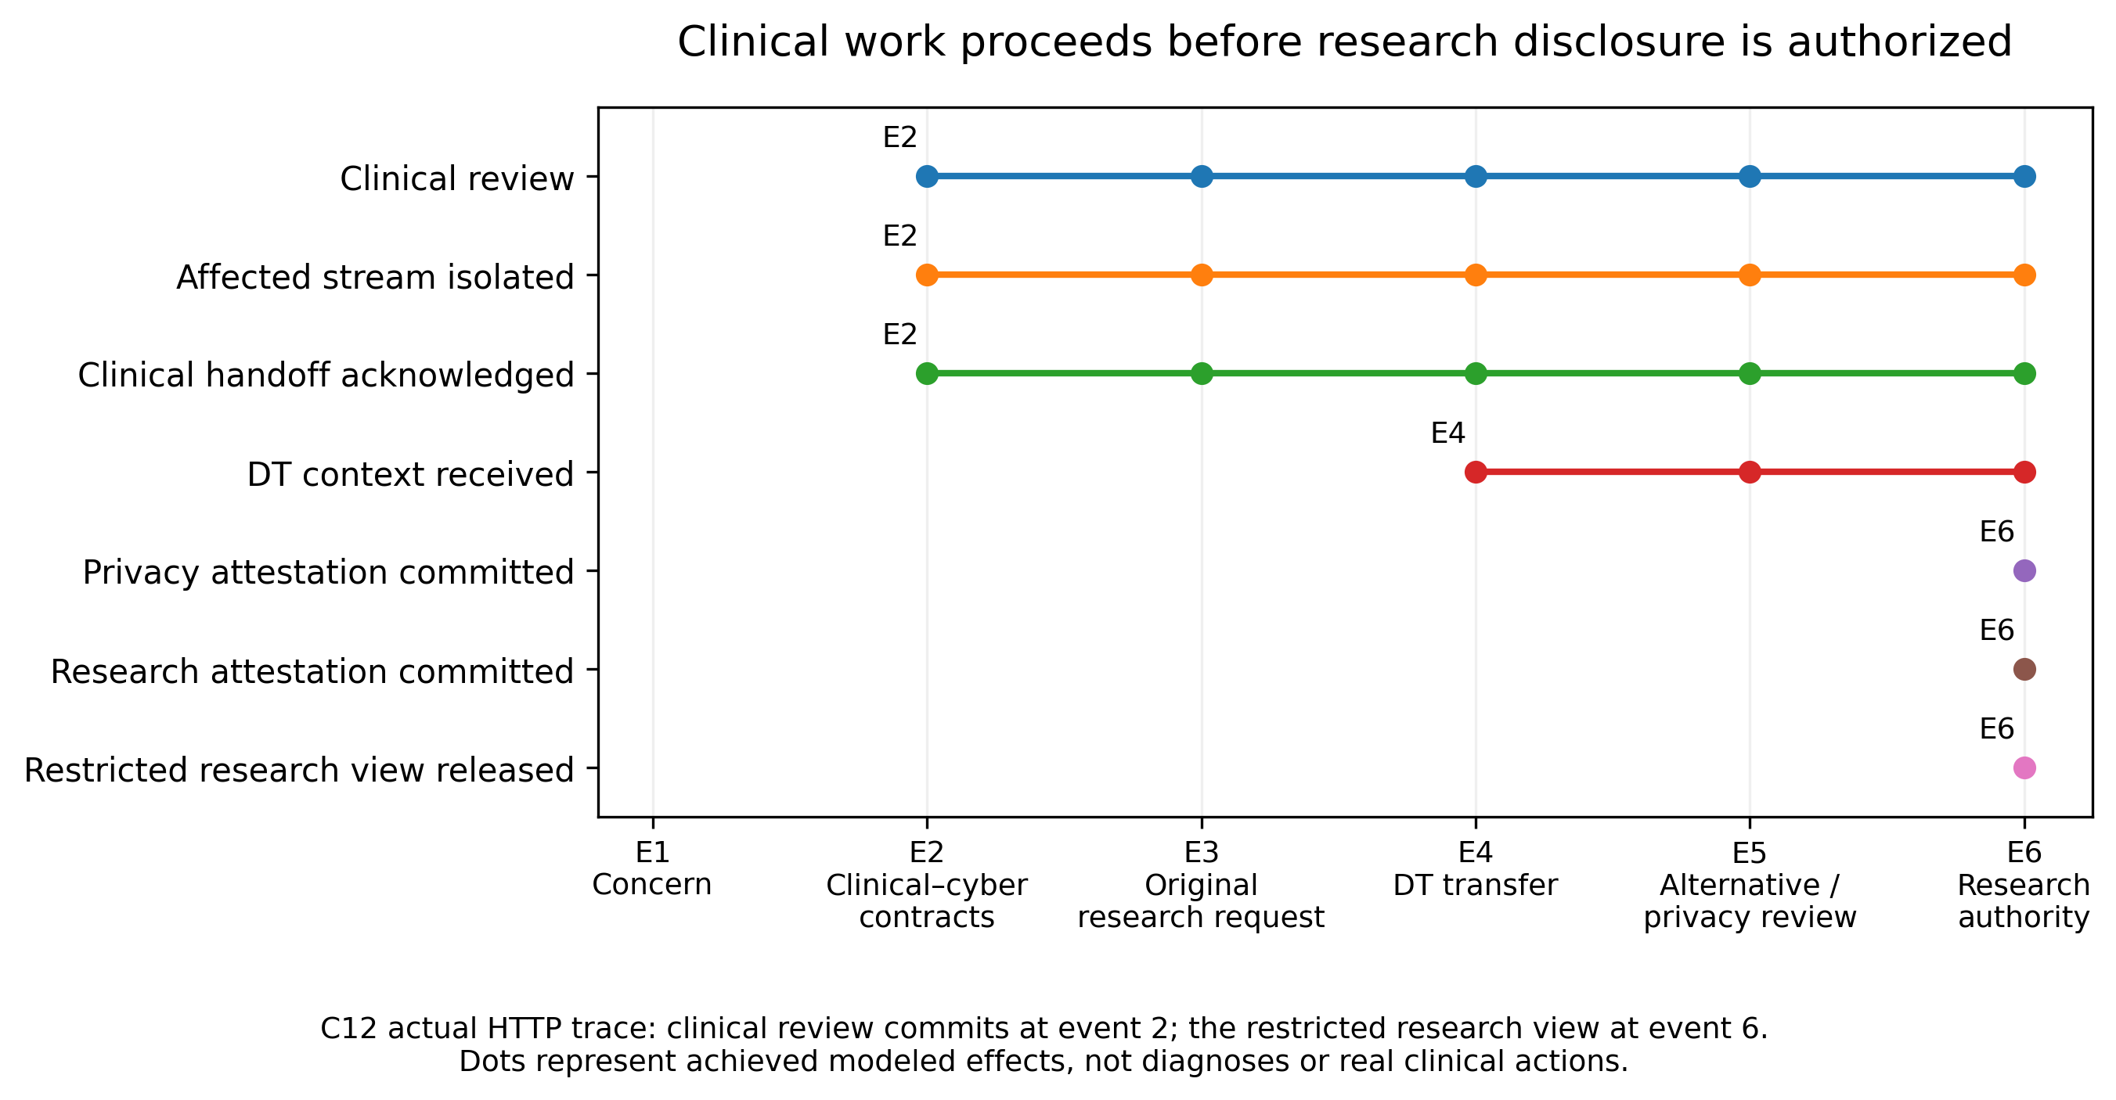
Figure 2. Measured event-to-effect timeline from the actual HTTP trace. All reviews, authorizations and effects are modeled. Event indices are not clinical-response deadlines.

What the measurements establish
Evidence | Observed result / interpretation
Execution boundary | 0 invalid new commits among 325 modeled commitments across snapshot and progressive replays; 42/42 separate authority/purpose/policy-change probes prevented all planned effects. Finite checks, not a universal safety proof.
Interface verification | 27/27 browser checks passed using actual interface assets and the live backend through a documented test-only fetch bridge. Managed Chromium blocked native localhost navigation; native download dispatch is unverified.
Local responsiveness | MedVerse loopback HTTP median 7.55 ms; p95 16.06 ms; p99 23.38 ms. Sixty measured event calls, with warmup excluded. No external network, LLM or human latency is included.
Preservation | All 1,048 prior project files remained byte-identical. Snapshot agreement is preserved without loading trained classifiers or changing Gates 26–29.

Retained limitation—not hidden by the aggregate
C01: early use of the original clinical route prevents later containment. C02: early broad containment prevents the later clinical route. All three capable methods share this online-information limitation through the same eager-commit adapter. Clinical review is incomplete in C02; that is an availability limitation even though no prohibited action executes.
Next dependency: evaluate when to commit, hold for authority, or preserve reversible options—without revealing future proposals early or labelling an unfinished clinical obligation complete. Independent clinical and Korean policy review also remains pending.
Source: run 20261103T111811_756965Z; status_measurements.json, snapshot_metrics.json, progressive_metrics.json, temporal_probes.json, latency_samples.json and browser_validation.json. All files are included in the cumulative package.

