**Jenkins CI tool**

Jenkins is one of the famous continuous integration tool, which makes developer life easy by performing the build and integrating the code with other testing tool in continuous manner.

Jenkins is open source Continuous integration tool which is written in java.

Jenkins formerly known as Hudson, before java acquired by oracle.

There are some disadvantages of the Ant and Maven. Ant is procedural and Maven is declarative language. Developer manually needs to execute the command whenever they need to build or integrate any other testing tool.

Ant and Maven users/administrators those who are using cannot schedule it and cannot perform nightly build.

Basic idea of developing the Jenkins is to address the challenges that are existing in the ant and maven.

It is continuously integrates the newly checked-in code into build.

Continuous integration server Jenkins runs unit tests and reject the build if fails, even it will help you to deploy the developer code.

Integrates with source code management tools:

Jenkins supports almost all the version control tools that are available in the market. All you need is plugin.

Developer can integrate the ant and maven for build for java related applications, can integrate MS build for .net related applications.

It is the market leading continuous integration system

Jenkins is a continuous integration server that monitors executions of repeated jobs, such as building a software project or jobs.

Some of the available continuous integration tools in the market:

1. Jenkins
2. Cruise Control
3. Bamboo
4. Rational Build Forge
5. Travis

**Jenkins Architecture:**

Jenkins follows Client/Server architecture, In Jenkins terminology we can call it as Master and Slave setup.

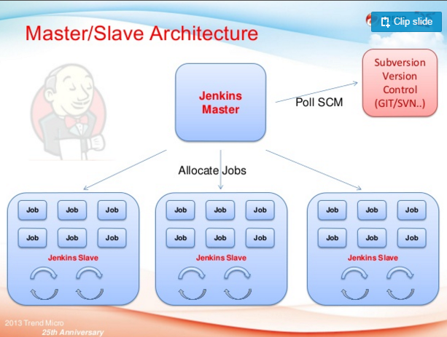

**Installing Jenkins:**

In three ways developer can install and use the Jenkins, here are 2ways to use the Jenkins.

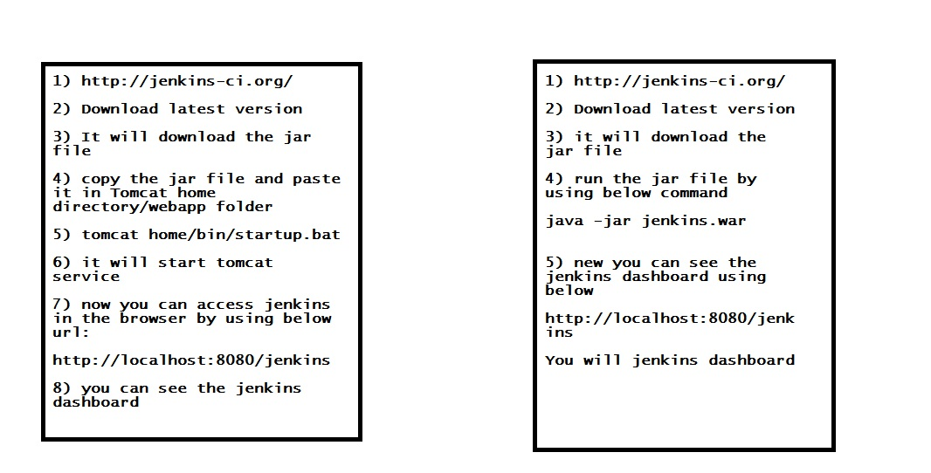

In 3d way is:

Got to <http://jenkins-ci.org> and select the platform like windows or any other platform.

If you select windows it will download the Jenkins.zip, after download you have to extract it then you will see the Jenkins.exe.

Install the Jenkins.exe as shown below.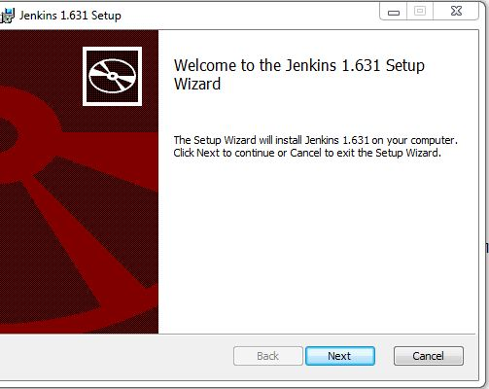

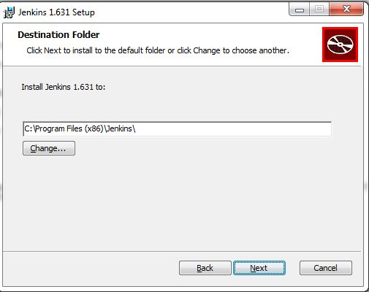

**CI in diagrammatic representation**:

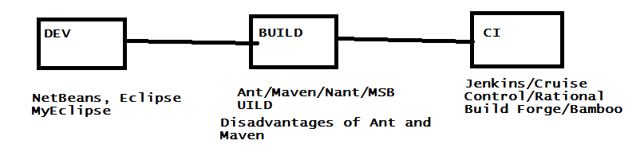

**Jenkins Dashboard:**

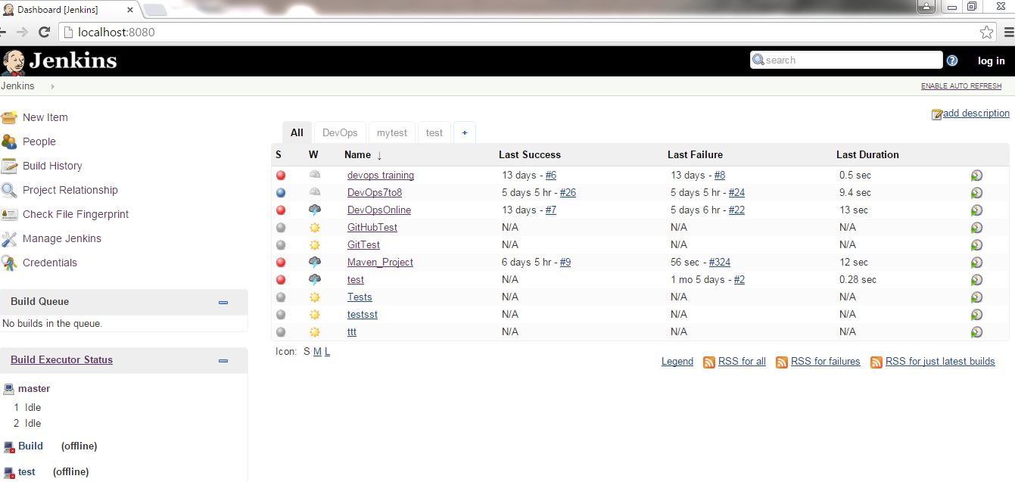

**In Jenkins Dashboard:**

You can see the top left hand side,New Item, People, Build History,Project relationship,Check File Fingerprint, Manage Jenkins and Credentials:

New Item: is for creating new projects

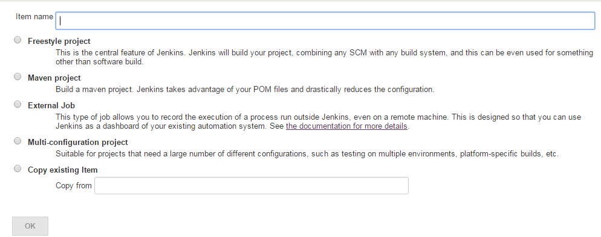

People: Users those who are using Jenkins

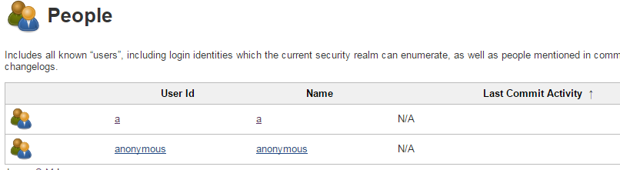

**Build History**:

Using this option, user can get the complete build history of the projects, when it was build, what is status of the build and how many times build was happened etc.

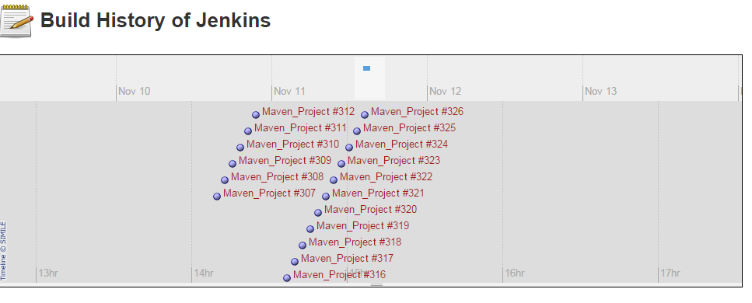

**Project Relationship:**

Project relationship will give the complete details of the upstream and downstream projects.

**Check File Fingerprint:**

It will get the jar file version if you are not aware of it.

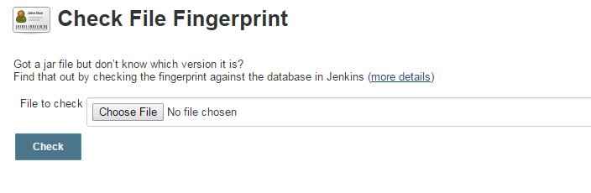

Manage Jenkins:

Very important option in Jenkins, it is like heart of Jenkins, please see the below screen shot for more details.

