indranil@Azure:~/helm$ helm create apphelm

Creating apphelm

indranil@Azure:~/helm$ ls

apphelm

indranil@Azure:~/helm$ cd apphelm/

charts/ templates/

indranil@Azure:~/helm/apphelm$ ls

charts Chart.yaml templates values.yaml

indranil@Azure:~/helm/apphelm$vim values.yaml

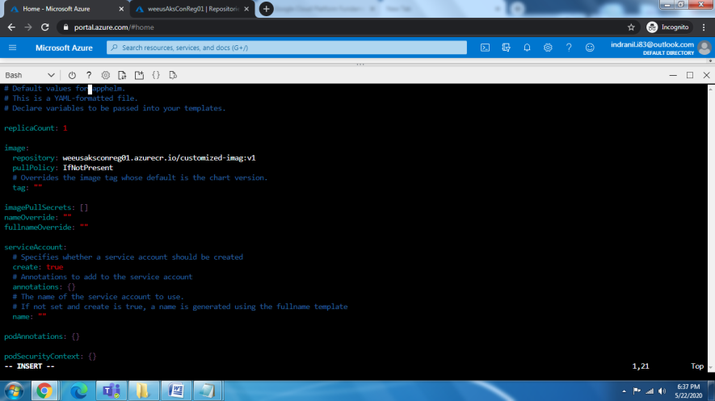

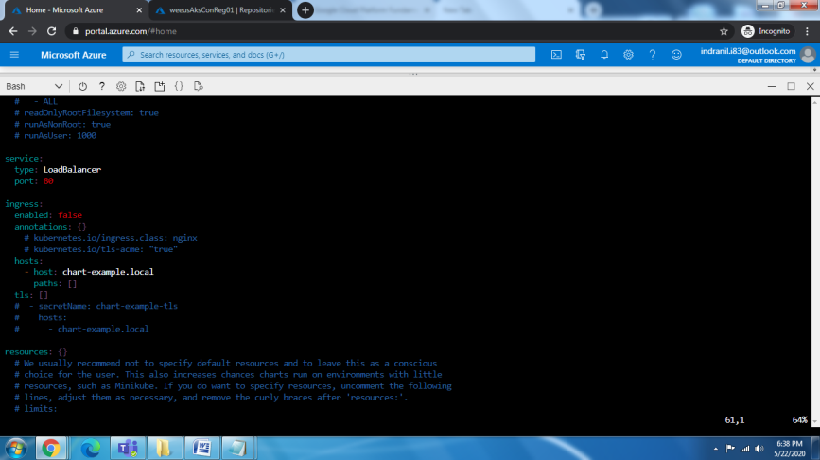

indranil@Azure:~/helm$ vim apphelm/Chart.yaml

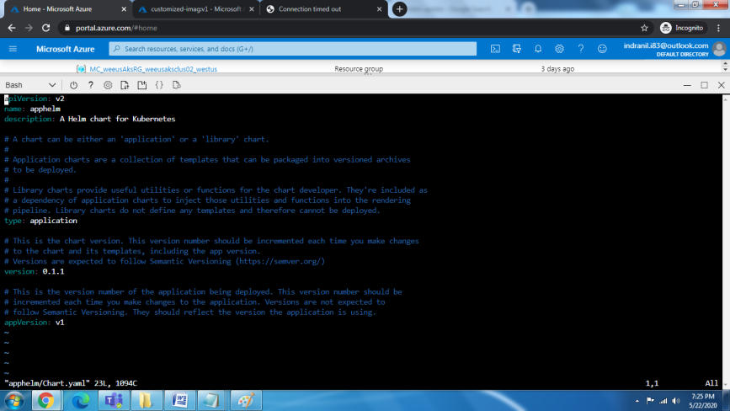

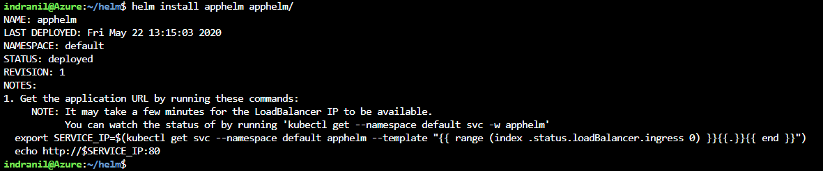



Check the application access



**Check the POD Access**

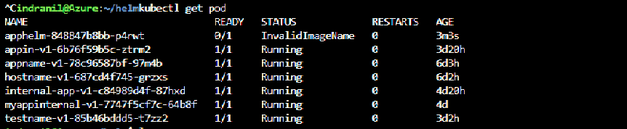

**Update the image type**

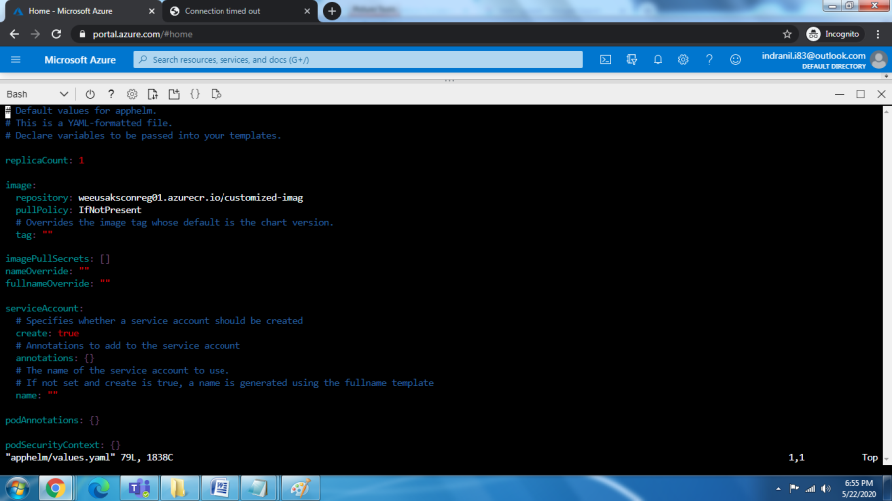

**Update and redeploy**

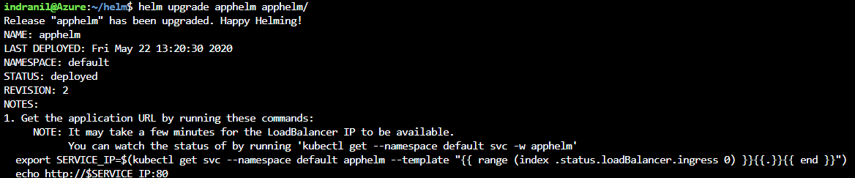

Helm uninstall



Fix and upgrade the application once again

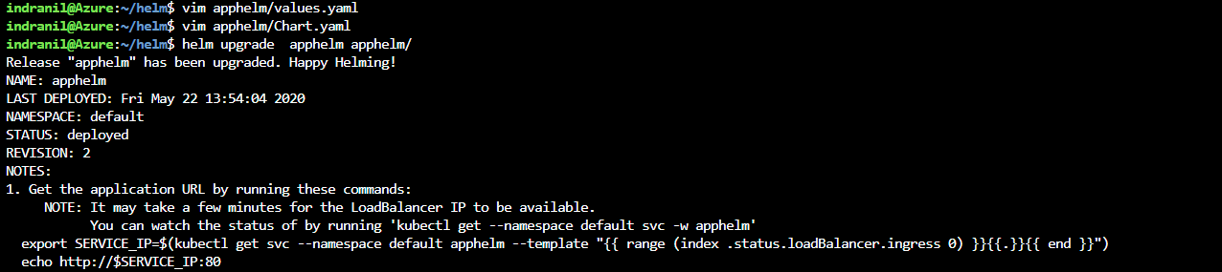

Check the status now

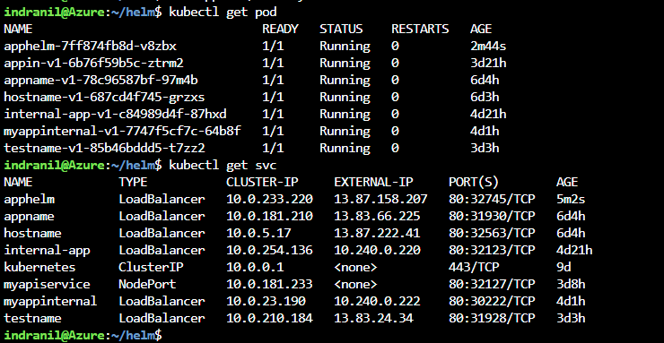

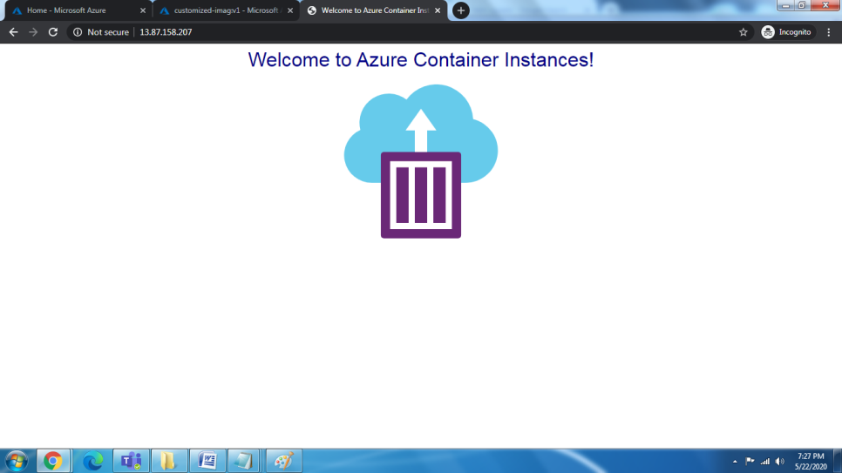

Uninstalling the application

