Test 2 Review Problems

Equations and things to memorize/know…
- Vertex of a parabola
- Quadratic formula
- How to get the equation of a line if given two points
- Basic familiarity with the functions from the Excel spreadsheet, how the shifts up, down, left, right and stretches work.
- When can a horizontal/slant asymptote exist? (in other words, when should we bother using long division and when can we skip this step.
- Holes versus vertical asymptotes
- Polynomial long division with no mistakes!
- Know when you can check your answers, and make sure to do so in those cases!

1) Graph the following piece-wise function, and do parts a) b) and c).

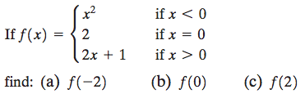

2) Find the domain, range, intercepts. Is the graph continuous? Sketch a graph.

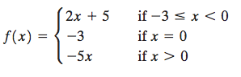

3) Write the equation for the piecewise function:
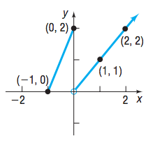

4)
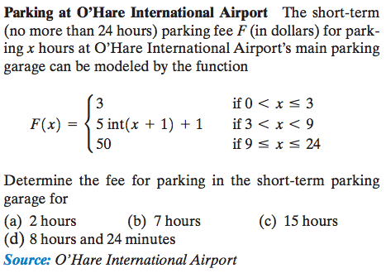

5)
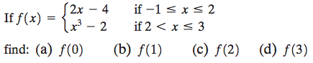

6)
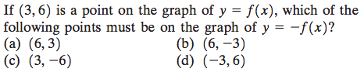

7)
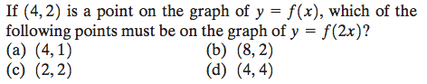

8)
(4 separate questions, write an equation for each one: )

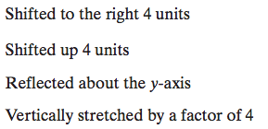

9)
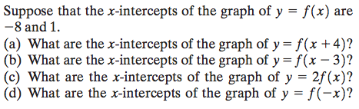

10)
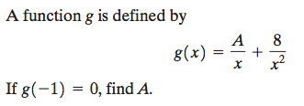

11) Determine if the following “x y” table is for line, or if belongs to a function that isn’t a line:
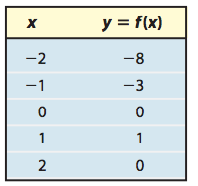
12)
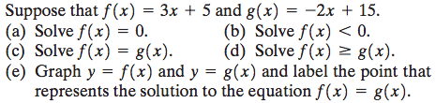

13)
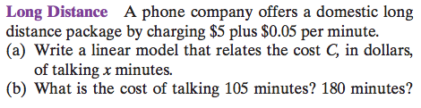

14)
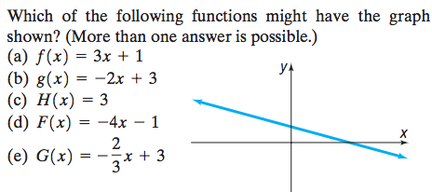
15) Find the quadratic function that has this graph: (Think about what shift up and right you see, the y intercept you see, etc.)
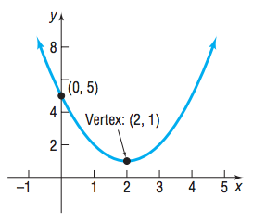
16)
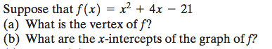

17)
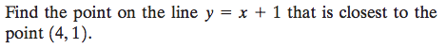
(there are two ways to solve this, one is creative and the other uses the distance formula, which you’re going to try and minimize)

18)
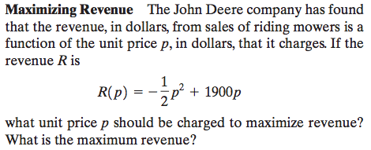

19)
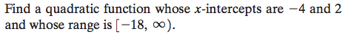

20) Find the x and y intercepts, the maximum or minimum (the vertex), the domain and range, and on what intervals the function is increasing/decreasing.
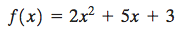

21)
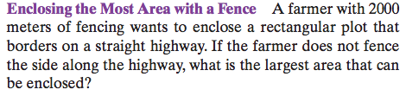

22) Solve the inequality (remember this is very easy if you draw it!
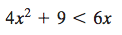

23) Same as the previous question.

24) (Parabolic arch literally means the underside of the bridge is the shape of a parabola)
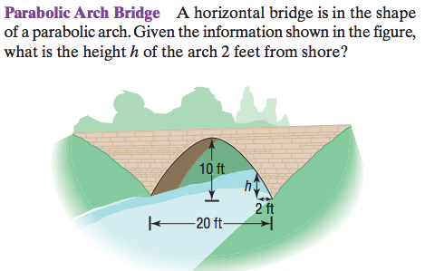

25)
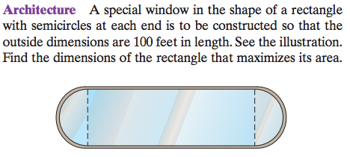

26)
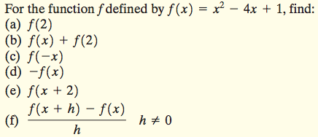

27) Can functions cross horizontal asymptotes, vertical asymptotes, and/or slant asymptotes?

28) Find the asymptotes of this function and draw a rough sketch:
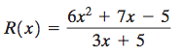
29)
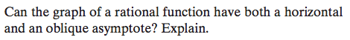

30) Find the asymptotes of this function and draw a rough sketch:
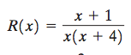
31) Find the asymptotes of this function and draw a rough sketch:
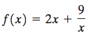

32)
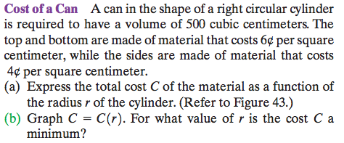

33)
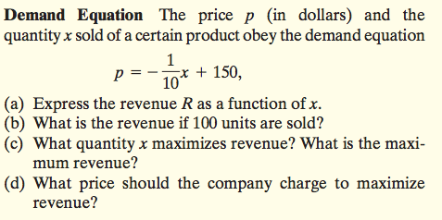

34)
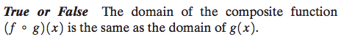

35)
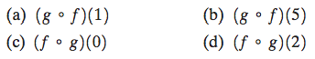
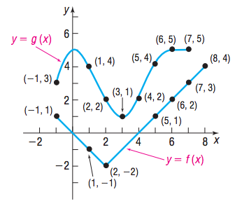

36) Do parts a) b) c) and d) for the following three questions:
Find:
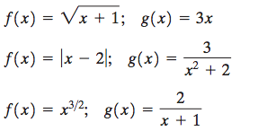

37)
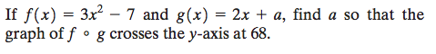
38) Verify that these two functions are inverses of each other:
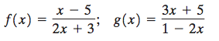

39) Find the inverse of:
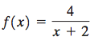

40) Find the inverse of:
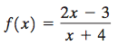

41) What transformations have occurred in the following functions, compared to ?

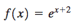
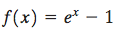
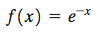

42) Solve the following equations:
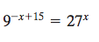
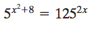

43) Solve the following two questions:

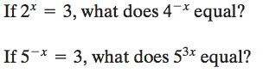

44)
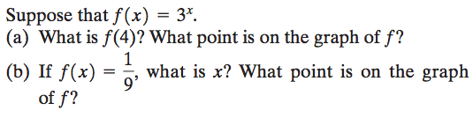
45)

