**Instructions:** Follow the steps below to set up your GitHub account profile. After watching the video, ***Source Control with Git Overview***, you should have already set up a GitHub account for this program. If you have not setup your GitHub account, review the above video in Week 1’s curriculum and set your account up before proceeding with this assignment.

1. GitHub should not be thought of as a resume or networking tool as much as it should be a place to showcase your work and code. To that end, having a GitHub profile that is personalized shows potential employers or clients that you care about your work.
2. Now that you are set up with GitHub, let’s get your profile page ready to go!
3. First, upload a high-quality headshot to your profile page.
4. Next, update your profile to discuss what you do and what you are learning. You have to think about this one, because GitHub doesn’t give you too many characters to accomplish this task.
5. Follow at least three (3) of your classmates, teachers, or any repository of interest to you.
6. Go to one of your repositories and update the **About** section to discuss what the purpose of the assignment is and tag the languages used like below:

1. Finally, add a link to your GitHub profile on your LinkedIn page.

**NOTE**: If you are choosing not to update a LinkedIn page because of your specific employment situation, that is acceptable. If this is the case, please put a note below the ***Attach Screenshots of Your Finished LinkedIn Profile*** section below.

**Attach Screenshots of Your Finished LinkedIn Profile**

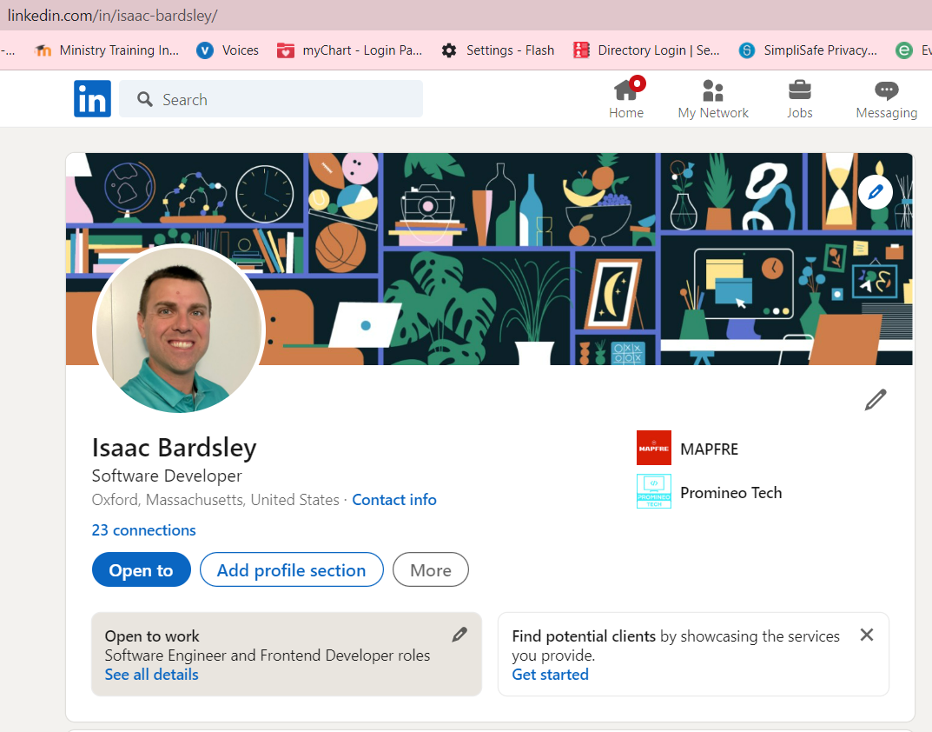

**Attach a Screenshot of Your Updated GitHub Account**

