Oxygen Web Help Plugin Upgrade

Business Requirements

Short-Form Business Requirements Document (BRD)

Version 1.1

Table of Contents

1 Document Preface 4

1.1 Abstract 4

1.2 Contact information 4

1.3 Document control 5

2 Executive Summary 5

2.1 Problem statement and implications 5

2.2 Dependencies and critical success criteria 5

3 Current (As Is) Business State 7

3.1 Security vulnerabilities 7

4 Proposed (To Be) Business State 7

5 What’s new in this upgrade 7

6 Detailed Business Requirements 8

6.1 Pre-requisites 8

6.2 Upgrading the DITA-OT 8

6.3 Upgrading HTML5 Web Help Plugin 8

6.4 Analyzing the output and applying customization 8

6.5 Affected Outputs 8

6.6 DDS 2.0 Changes 9

6.6.1 Update new brand colors in the mast head 9

6.6.2 Update font type and font size and color of specific elements 9

6.7 Feature updates 12

6.7.1 Imagemap attribute in HTML5 Web Help output (on hold) 12

6.7.2 Star rating in Search results 12

6.8 Bug fixes 12

6.8.1 Output Size reduction 12

6.8.2 https://jira.gtie.dell.com/browse/IDPL-19339 - Fix the numbering issue in footnotes 12

6.8.3 https://jira.gtie.dell.com/browse/IDPL-20886 Responsive help 12

6.9 Accessibility fixes 13

6.9.1 Headings in each topic to be aligned with the breadcrumb 13

6.9.2 Back to top button is not accessible by reader or keyboard 13

6.9.3 Images are not accessible when clicked on and the actual size of the image is displayed 14

6.9.4 Breadcrumb is not recognized by screen reader 14

6.9.5 Admonitions are rendered as table On hold – because this requires a lot of Dev effort. I will call it out as an exemption in the Accessibility report 14

6.9.6 Related heading text are not marked as heading tags 14

6.9.7 Related links representation 15

6.9.8 Search results 15

6.9.9 Search results pagination links 15

6.9.10 Scaling 15

6.9.11 Pre-requisite links rendering 16

6.9.12 Table representation 16

7 QA - Testing and Validation 17

7.1 Testing phases and resources 17

7.1.1 Unit testing 17

7.1.2 Test Cases 17

7.1.3 Testing Phases 17

7.1.4 First phase of Testing – Internal Testing 17

7.1.5 Second phase of testing- UAT 18

7.1.6 Security Scanning 18

8 Launch 18

# Document Preface

## Abstract

Oxygen’s HTML5 WebHelp plugin is integrated into the Tridion Docs CCMS to generate the HTML5 WebHelp output. Currently, the HTML5 WebHelp plugin version is 24.1.

This project is about upgrading the Oxygen’s HTML5 WebHelp plugin version 25.1 and the dependent DITA OT version that must be upgraded in the new Tridion 14 SP4 environment. Security is the key reason behind this upgrade.

This upgrade also includes the Accessibility fixes to ensure that the output is in compliant with WCAG 2.1 guidelines.

DDS 2.0 alignment also included as part of this upgrade.

## Contact information

Please direct questions regarding this project to one of the following project team members.

|  |  |
| --- | --- |
| Role | Name |
| Project Manager | Michael Parent |
| Product Owner/Tech Lead | Mary Anthony |
| BU | IDD DevOps |
| Dev Lead | Irina Barinova (Upgrade and customization) Shrinidhi HA (Security Scanning) |
| IT Lead | Dana Ford |
| Localization lead | N/A |
| Test lead | TBD |

## Document control

This document is owned by IDD DevOps team. Direct questions or input relative to revisions in this document to the authors shown in the table below.

|  |  |  |  |
| --- | --- | --- | --- |
| Document History | | | |
| Date | Version # | Description of changes made | Author(s) |
| 04/18/2023 | 1.0 | Initial draft | Mary Anthony |
| 05/10/2023 | 1.1 | Reviewed by other IAs | Mary Anthony, Tom Dill, Ruchi Gupta |
|  |  |  |  |

# Executive Summary

## Problem statement and implications

Currently Oxygen WebHelp plugin is used to generate the HTML5 WebHelp outputs in Tridion. Docs. The plugin version is 24.1.

Security scans run on the current HTML5 WebHelp outputs indicate security vulnerabilities including a medium vulnerability on old version of jQuery version and vulnerability due to a third part file – require.js.

Accessibility issues identified should also be fixed.

## Dependencies and critical success criteria

**Note**: The Oxygen WebHelp plugin will be upgraded in the Tridion 14 SP4 CCMS.

The key requirement to upgrade the WebHelp plugin is to update the DITA=OT version that is compliant with the upgraded WebHelp plugin.

The success criteria are:

* No issues or blockers when integrating the HTML5 output with the build using the resource IDs or Context IDs
* Adherence to the updated Dell brand guidelines
* Both context-sensitive help (CSH) methods must work on the software builds after it is integrated in the builds
* Signoff from the IDD Business team consuming the HTML5 WebHelp outputs
* Complete regression testing on all the HTML5 WebHelp outputs (with brands and other metadata)
* Security scan (Blackduck and Checkmarx) on the HTML5 WebHelp outputs
* Accessibility compliance

# Current (As Is) Business State

The table displays the current versions of the DITA Open Toolkit Web Help responsive plugin and the Oxygen Web Help

|  |  |
| --- | --- |
| DITA Open Toolkit | 3.6.1 |
| Oxygen Web Help plugin | version 24.1 |

## Security vulnerabilities

The following security vulnerabilities are found in the existing HTML5 Web Help output:

1. jQuery version 1.13.0 reports a medium vulnerability - <https://nvd.nist.gov/vuln/detail/CVE-2022-31160>
2. Unchecked Input For Loop Condition and Server DoS by loop vulnerability reported from the require.js file

Vulnerabilities reported ibn 25.1 are identified as False Positives (confirmed by Oxygen team):

1. Client DOM XSS
2. Client Potential XSS
3. Client Potential Code Injection

# Proposed (To Be) Business State

The proposal is to upgrade the toolkit and the Web Help to the versions:

|  |  |
| --- | --- |
| DITA OT | 3.7.0 |
| Oxygen Web Help | Version 25.1 |

# What’s new in this upgrade

The critical aspect of this upgrade is to fix the reported security vulnerabilities in the help files.

DDS 2.0 changes to be implemented

Accessibility compliance

# Detailed Business Requirements

## Pre-requisites

Java 11 version

License key for HTML5 Web Help plugin must be available

## Upgrading the DITA-OT

1. Download the DITA OT for HTML5 from DITA OT page. Version 3.7.1
2. Extract and copy the files to the relevant folders.

## Upgrading HTML5 Web Help Plugin

Download the Oxygen Web Help version 25.1 from Oxygen website.

Copy paste the **WebHelp.responsive** files in the relevant folders.

## Analyzing the output and applying customization

Generate the HTML5 output from the upgraded Oxygen Web Help.

Identify the templates that must be updated to get the required customized output that is currently existing in the Tridion14 Prod system.

After identifying the templates, update the publishing template files to map with what is currently in the Tridion 14 SP4.

After updating the .XSL and template files, generate the HTML5 Web Help output and proceed with testing and validation.

## Affected Outputs

The affected outputs are:

1. HTML5 Web Help
2. HTML5 Web Help Draft

## DDS 2.0 Changes

The DDS 2.0 changes must be applied to the help files.

DDS 2.0 details can be found here: <https://www.delldesignsystem.com/>

You can access the DDS 2.0 vanilla version from here: <https://www.delldesignsystem.com/getting-started/vanilla/>

### Update new brand colors in the mast head

Update the Blue color (Hex #0672CB; RGB – 6,114, 203) in the mast head of the following brands:

1. Dell
2. Dell Technologies
3. Dell EMC

### Update font type and font size and color of specific elements

|  |  |  |  |
| --- | --- | --- | --- |
| **Type** | **Font type** | **Font size** | **Specifications** |
| Masthead title | Roboto | No change | $font-family-base: "Roboto", "Cordia New", "Microsoft Sans Serif", "Utsaah", "Devanagari MT",  "Nirmala UI", "Latha", "InaiMathi", "Gautami", "Telugu Sangam MN", "Tunga", "Kannada Sangam MN",  "Kartika", "Malayalam Sangam MN", "Shruti", "Nirmala UI", "Gujarati MT", "Gujarati Sangam MN",  "Vrinda", "Bangla Sangam MN", "Meiryo UI Reg", "メイリオ Reg", "MS UI Gothic Reg",  "Hiragino Kaku Gothic Reg", "ヒラギノ角ゴ Pro W3 Reg", "Microsoft YaHei", "微软雅黑",  "Hiragino Sans GB", "Microsoft JhengHei", "微軟正黑體", "Malgun Gothic", "맑은 고딕", "Gulim",  "AppleGothic", "Apple LiGothic", "LiHei Pro", "Osaka", "STHeiti", "华文黑体", "STXihei",  "华文细黑", "SimHei", "黑体", "Arial Unicode MS", "Arial", sans-serif !default; |
| ToC titles | Roboto | No change |  |
| ToC titles (When selected) | Roboto | No change | Background Color when clicked:  RGB: 225, 225, 225 Hex : #e1e1e1 |
| Headings | Roboto | Yes | Change the font size to 16pt |
| Body | Roboto | Yes | Change font size to 12pt |
| Breadcrumbs | Roboto | Yes | Increase the breadcrumb font size to 1.2em (14pt).  Breadcrumb must not be in blue. But in Grey (110, 110. 110 -RGB; Hex #6E6E6E) and the selected topic to be in black (14, 14, 14 – RGB; Hex #0E0E0E)  Bread crumb sample and code:    <nav data-dds="breadcrumb" aria-label="breadcrumb">  <ol id="list-6" class="dds__breadcrumb">  <li class="dds__breadcrumb__item">  <a href="javascript:;">  <i class="dds__icon dds__icon--home" aria-hidden="true"></i>  <span class="dds__sr-only">Home</span>  </a>  </li>  <li class="dds__breadcrumb__item"><a href="javascript:;">APEX</a></li>  <li class="dds__breadcrumb__item"><a href="javascript:;">Multi Cloud</a></li>  <li class="dds__breadcrumb__item"><a href="javascript:;">Cloud Solutions</a></li>  <li class="dds__breadcrumb__item"><a href="javascript:;">Energy</a></li>  <li class="dds__breadcrumb__item"><a href="javascript:;">Healthcare</a></li>  <li class="dds__breadcrumb__item">Government</li>  </ol>  </nav> |
| Navigation icons | N/A | N/A | Change color of navigation icons to black (14, 14, 14 – RGB; Hex #0E0E0E) |
| Links (including rel table links and href links) | N/A | N/A | Change color of links to (6, 114, 210 RGB; Hex #0672D2)  Add an underline to the href links, related links, links to steps or images |
| Tables | N/A | N/A | Tables to be rendered in this format:    The table component contains six elements:   1. Body cell: input field for body text can contain alphanumeric text or links. 2. Body text: content related to its corresponding column header. 3. Header cell: input field for header text is the first row across all columns 4. ~~Sort function (optional): displays whether information is set to ascending (up arrow) or descending (down arrow).~~ 5. Header text: title or concise description of the content within its column. 6. ~~Action menu trigger: conveys that the header cell is enabled as a trigger to open a menu. The menu contains features available within the table including sort.~~   Ignore points 4 and 6  You can also refer to the DDS 2.0 page for detailed info. |
| <codeblock> and <codeph> ph | Roboto | N/A | Change the background color to (249, 250, 250 RGB Hex #F9FAFA) |
| Tooltip box color | N/A | N/A | Change the tooltip color box to (225, 225, 225 RGB RGB; Hex #E1E1E1 |
| Footnotes | N/A | N/A | Foot notes should be numbered and clicked on number should highlight the text:    Code:  <p>  Use a footnote when on-page text includes referenced information and is followed immediately with a linked citation that takes users to  its numerically corresponding footnote.  <sup><a href="#fn1" id="ref1" aria-describedby="footnote-label">[1]</a></sup>  You can also use footnotes to provide additional information regarding offers or promotional content.  <sup><a href="#fn2" id="ref2" aria-describedby="footnote-label">[2]</a></sup>  </p>  <hr />  <footer class="dds__footnote">  <h2 id="footnote-label" class="dds__sr-only">Footnotes</h2>  <ol>  <li id="fn1">  Citations must match its identifying number from the page. Footnote text includes identification of source or information. At the end  of each footnote, a back-to-citation link navigates users to the original page text.  <a href="#ref1" title="Jump back to footnote 1 in the text." aria-label="Back to reference 1">[ ↑ ]</a>  </li>  <li id="fn2">  In this context, footnote text includes information related to contingencies, exclusions, dates valid, or similar details.  <a href="#ref2" title="Jump back to footnote 2 in the text." aria-label="Back to reference 2">[ ↑ ]</a>  </li>  </ol>  </footer>  Highlighted text color: **217, 245, 253 RGB; Hex #D9F5FD**  **On hold** |

## Feature updates

### Imagemap attribute in HTML5 Web Help output (on hold)

Currently, the image map attribute is not enabled in HTML5 WebHelp output This must be enabled to allow writers to map the image with another topic or an external link.

Please do not work on this change as we need more use cases for HTMl5 WebHelp.

### Star rating in Search results

Remove the star ratings in search results. It does not serve any purpose.

## Bug fixes

### Output Size reduction

Reduce the size of the output by removing non-relevant files from the output package.

### <https://jira.gtie.dell.com/browse/IDPL-19339> - Fix the numbering issue in footnotes

The foot notes are not displayed as numbers and instead it is displayed in alphabet letters. This issue must be fixed and then be aligned with the DDS (see above).

The numbering must be fixed but the change that requires JS file update can be exempted.

### <https://jira.gtie.dell.com/browse/IDPL-20886> Responsive help

In responsive help, the Home link is clipped. Align the broken Home link to be visible.

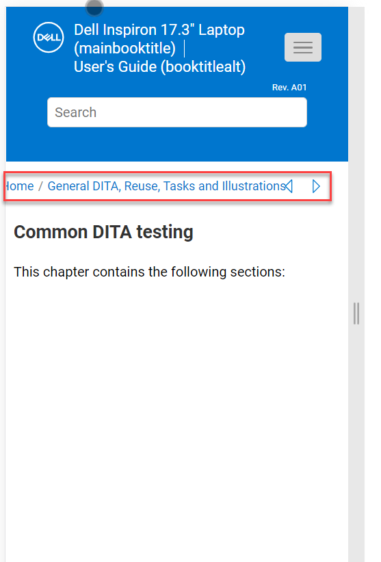

## Accessibility fixes

### Headings in each topic to be aligned with the breadcrumb

Currently, the heading texts in each topic is not aligned with the breadcrumb. It is indented. This fails the accessibility check.

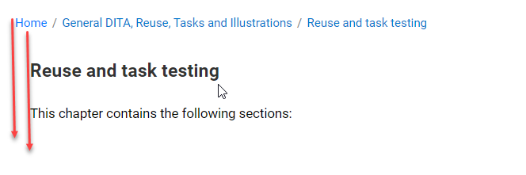

### Back to top button is not accessible by reader or keyboard

The Back to Top button does not have an accessible label

The back to top button  in each topic (large topic) must be accessible by the keyboard and clicking from keyboard should return to top of the page

ensure that each custom button element includes the following:

- role="button"

- tabindex="0"

- The appropriate scripting in place so that the element can be selected by keyboard users using the ENTER key and SPACE key, and by mouse click.

- Make sure on activation of **'Back to Top’ button**, tab key focus should be moved to the first interactive element of the main region instead of going to the address bar.

The screen reader should read the button.

### Images are not accessible when clicked on and the actual size of the image is displayed

Images, when mouse users hover and activate the images, a modal dialog appears with the image in a full screen. But same functionality is not accessible for keyboard and screen reader.

The images must display when using a keyboard.

### Breadcrumb is not recognized by screen reader

The bread crumb must be recognized by the screen reader.

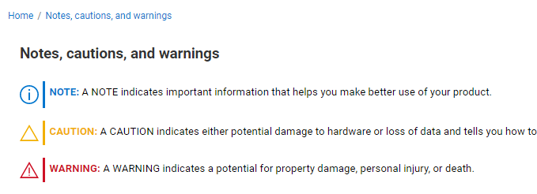

Use aria-label="breadcrumb" within <nav> tag to label the breadcrumb region. Keep only breadcrumb links within <nav> </nav> element. Move previous, next and print out of the <nav> </nav> element.

### Admonitions are rendered as table On hold – because this requires a lot of Dev effort. I will call it out as an exemption in the Accessibility report

The Notes. Cautions and Warning info is rendered as Table. The source does is not from a table and hence table markup must not be used

All Notes, Cautions and Warning text used in each topic should not be rendered as a Table

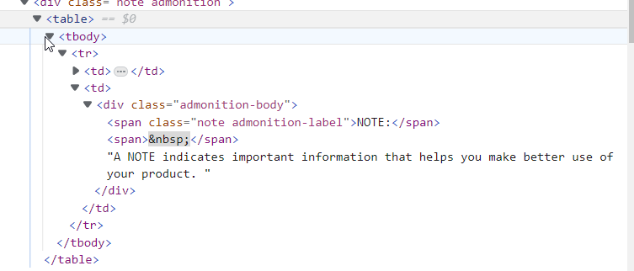

### Related heading text are not marked as heading tags

Related heading text (Related Text, Related Concept, Related Task) are to be marked as H3 tags.

Currently they are functioning as Section head.

### Related links representation

Provide the related links with an underline to distinguish from the normal text. The font text and color to be updated as per DDS 2.0.

### Search results

The topics in the search result to display the text with an underline and make in bold.

Mark the search result links with H1 tags

### Search results pagination links

If there are more than 10 results, the pagination links are not visible.

Wrap these pagination links in a <nav> tag then give the <nav> tag an aria-label="pagination".

The active link is not identified for screen reader

Either unlink the active link by removing the <a> tag, or add an aria-current="page" attribute to this link. Ensure that this attribute is removed when this link no longer represents the current page.



When more than 20 results are found, the 'previous' link is disabled when the first page is active and 'next' link is disabled when last page is active but the same information is not conveyed for screen reader users.

Assign previous/next links aria-disabled="true", and role="button" attributes when the link is meant to be disabled. Make sure to remove the set the aria-disabled attribute to false when the link is meant to be reachable.





### Scaling

When the page is scaled up to 400%, following issues are observed, when user navigates through keyboard using <tab> key, observe the following issues:

1. Focus indictor is missing for hamburger menu

2. Search button is getting lost. Hence loss of information observed

3. ‘Home’ link is getting clipped.

4. Previous and Print button is getting lost. Hence loss of information observed

5. ‘Scroll to Top’ button is inaccessible for users. It is not receiving <tab> stop.

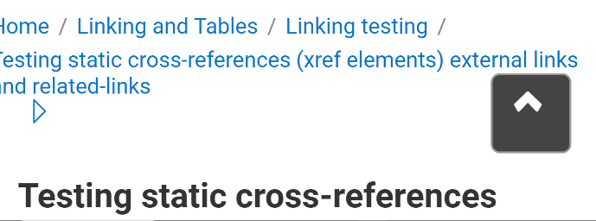

### Pre-requisite links rendering

The links should behave similar what is indicated for all links. All links must have an underline.

### Table representation

Use the TH element for Table header

TR element for table row text

# QA - Testing and Validation

## Testing phases and resources

The changes and bug fixes must be applied to the following outputs.

1. HTML5 Web Help
2. HTML5 Web Help Draft

### Unit testing

Unit test must be conducted by **DevOps** **Development team**, testing the functionality of each of the features of the HTML5 Web Help outputs. Verifying the HTML5 output settings in   
Tridion 14 SP4 system.

### Test Cases

Test Lead to write test cases on changes made to the help files including the bug fixes.

Test cases to be available in qTest

### Testing Phases

### First phase of Testing – Internal Testing

The first phase of the testing is the Internal testing by the DevOps team in the Tridion Test environment that includes:

**Automated Testing** – The comparison is run on the HTML5 Web Help outputs published before and after the upgrade

**Manual Testing** – Publish the outputs by adding specific objects and verify how it is rendered in the output:

* 1. Identify the changes made to the help files and validate the changes
  2. Validate the bug fixes
  3. Validate the feature updates
  4. Test the Relationship tables
  5. Verify if the context IDs and resource IDs are generated in the context.txt and map.js files respectively (depending on the type of publishing)
  6. **Change the metadata to generate output with filenames**
  7. Integration testing: Integrate the Web Help output on the simulated software build.

**Accessibility Evaluation** – Share the output with the CoE for Accessibility testing

**Security Scanning** – Request the Dev team to run the security scan on the build

### Second phase of testing- UAT

Second phase of testing is the UAT by the IDD writing team in Tridion Stage, it also includes:

**Automated Testing** – The comparison is run on the HTML5 Web Help outputs published before and after the upgrade

**Manual Testing** – Publish the outputs by adding specific objects and verify how it is rendered in the output:

**Integration Testing**: IDD writing team to generate the Web Help output with integrate the help file into the software (with the help of engineering team) and test the CSH feature.

**Security Scanning** – Request the engineering team to run the security scan on the build

### Security Scanning

Blackduck and CheckMarx scanning on the HTML5 Web Help outputs in each of the Tridion environments.

Identify the vulnerabilities reported and write to the Oxygen team on these vulnerabilities.

# Launch

On the launch date, after the branch is move to Tridion Prod.

Smoke testing by validating the HTML5 outputs by the DevOps team in the Prod environment.