
Vehicular emissions of Particulate matter 2.5, less < 50 nm, 50-100 nm, 100-1000 nm, Active Surface, Black Carbon and Organic Matter in China

Sergio Ibarra-Espinosa, Xuelei Zhang, Aijun Xiu, Edmilson Dias de Freitas

Vehicular emissions of particulate matter in China have shown a rapid increase since 1980, with a peak in 2009-2011, followed by a rapid decrease (Cai and Xie 2013, Huo et al, 2015, Li et al, 2017). It has been claimed that this drastic reduction in PM, linked to NOx reduction, has brought an increase in Ozone pollution episodes in cities, especially in Beijing and Shanghai (Li et al, 2019). However, to see if the decrease of PM is constant to all diameters modes, or is only affecting some fractions and also its relationship with number of particles. Even more, what are the implications of atmospheric chemistry. This study presents a characterization of Particulate matter vehicular emissions for China covering Particulate Matter (PM2.5), number of particles (NP) less < 50 nm, 50-100 nm, 100-1000 nm, Active Surface, Black Carbon and Organic Matter (OM) in China for year 2016. We used the model VEIN (Ibarra-Espinosa et al, 2018) with activity from Chinese Yearbook (NBS, 2017) and Chinese Emissions Guidelines (MEP, 2017) emission factors from European emission guidelines, adjusted by local meteorology, chemical composition of local fuel and vehicular technology at each province. Results on Table 1 indicate that Shandong emits more OM with 8.24E+03 (t/y), BC 2.00E+04 (t/y), PM2.5 4.00E+04 (t/y), AS 1.11E+11 (cm²/y), NP 1.13E+20 (1/y), NP-50 nm 1.92E+19 (1/y), NP-50-100 nm 7.76E+17 (1/y) and NP-100-1000 nm 1.33E+18 (1/y). The spatial distribution is shown on Figure 2. Next steps is studying impacts on atmospheric chemistry with air quality modeling.

Table 1. Vehicular emissions in China 2016 as mass (t/y), number (1/y) and active surface (cm²/y)

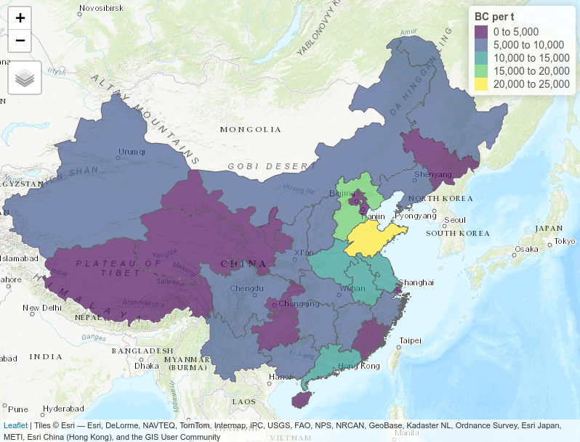
Figure 1. Vehicular Black Carbon emissions in 2016 (t/y)

References
Li, K., Jacob, D.J., Liao, H., Shen, L., Zhang, Q. and Bates, K.H., 2019. Anthropogenic drivers of 2013–2017 trends in summer surface ozone in China. Proceedings of the National Academy of Sciences, 116(2), pp.422-427.
Huo, H., Zheng, B., Wang, M. et al. Mitig Adapt Strateg Glob Change (2015) 20: 719. https://doi.org/10.1007/s11027-014-9613-0
Li, M., Zhang, Q., Kurokawa, J.-I., Woo, J.-H., He, K., Lu, Z., Ohara, T., Song, Y., Streets, D. G., Carmichael, G. R., Cheng, Y., Hong, C., Huo, H., Jiang, X., Kang, S., Liu, F., Su, H., and Zheng, B.: MIX: a mosaic Asian anthropogenic emission inventory under the international collaboration framework of the MICS-Asia and HTAP, Atmos. Chem. Phys., 17, 935-963, doi:10.5194/acp-17-935-2017, 2017.
Hao Cai & Shaodong Xie (2013) Temporal and spatial variation in recent vehicular emission inventories in China based on dynamic emission factors, Journal of the Air & Waste Management Association, 63:3, 310-326, DOI: 10.1080/10962247.2012.755138
Ibarra-Espinosa, S., Ynoue, R., O'Sullivan, S., Pebesma, E., Andrade, M. D. F., and Osses, M.: VEIN v0.2.2: an R package for bottom-up vehicular emissions inventories, Geosci. Model Dev., 11, 2209-2229, https://doi.org/10.5194/gmd-11-2209-2018, 2018.
National Bureau of Statistics, 2017. Civil Passengers. http://www.stats.gov.cn/
Ministry of Environmental Protection. 2017. Road motor vehicle emission inventory of air pollutants preparation of technical guidelines. 机动车污染防治技术政策

