Atmospheric Rossby waves identification and tracking with a raytracing numerical model

18 September 2020

# Summary

Planetary or atmospheric Rossby waves have large influence on weather and climate around the world. Such influences can happen even far away from the wave sources, through wave patterns that connect the atmosphere in two different regions miles away from each other. An example of this comes from the El Niño Southern Oscillation (ENSO), in which the deep convection over the tropical Pacific Ocean triggers disturbances in the atmosphere, leading to planetary waves that are able to travel towards the extratropics affecting the climate and weather there. Latent heat sources, such as those linked to ENSO, are not the only source for Rossby waves triggering (Hoskins and Karoly 1981; Ambrizzi and Hoskins 1997). Detecting the triggering regions of these waves, their characteristics, where they pass and where they go is of uppermost importance for research, assignment, monitoring and forecasting of weather and climate. Therefore, the detection and tracking of atmospheric Rossby waves is of paramount importance for scientists, climatologists, meteorologists and students seeking for a better understanding of the dynamics of the atmosphere.

The Climate Studies Group (in Portuguese, GrEC; www.grec.iag.usp.br) is a research group from the University of São Paulo (USP), Brazil, focused on analyzing the Earth’s climatic variability and improving the knowledge on this topic. In this sense, many research projects and activities developed within GrEC may benefit from the identification and tracking of atmospheric Rossby waves; recent examples include the work of Coelho et al. (2016) and Rehbein et al. (2018), who investigated the mechanisms that contributed to the occurrence of extreme weather events over South America.

## Statement of need

The demand for an automated, free, user-friendly and open source model is constant, not only from within GrEC but also from other research groups. Therefore, we developed the R package raytracing to be used by any atmospheric dynamic researcher. The benefits of using R include its worldwide engaged community and its versatility to be installed on multiple operating systems (R Core Team 2020).

# Usage and theory

raytracing requires few basic parameters: the input data (a file containing zonal wind at the latitude/longitude grid in Network Common Data Form - NetCDF or a matrix), a first guess latitude and longitude coordinate pair, the total wavenumber, a time interval , and a direction in which the wave should propagation (to the north/south of the source).

All of this is organized in a single main function that coordinates the calculations according to predefined parameters. Other key functions can also be invoked as shown below. The data output format is also defined by the users, which can be a database file (Comma-Separated Values, CSV) with values and calculation results for each possible new wave position (given the initial parameters) and/or an object stored in the memory of R in data.frame format. From there, the users will be able to carry out their desired analysis and generate figures according to their needs, being able to filter, for example, regions of arrival of wave rays.

The planetary waves can be approximated to the pure plane waves so that its group velocity or energy propagation , that is, the velocity in which a wave package propagates in the atmosphere, can be found as a function of the frequency, using the dispersion relation in Eq. :

Where is the Mercator coordinate time-mean zonal wind, is the zonal wave number, is the Mercator coordinate analogous meridional gradient of absolute vorticity () times , is the latitude, and is the meridional wave number. Eq. shows .

From Eq. is obtained as in Eq. :

Where the zonal group velocity () and meridional group velocity () are, respectively, demonstrated in Eq. and .

Just as in ray optics or geometric optics, Hoskins and Karoly (1981) described that planetary waves follow a trajectory or ray perpendicular ahead of waves to any place in the direction of the local . In this way, the ray would be the path through which the energy would propagate at the same speed as . In order to find these rays or trajectories, we followed Yang and Hoskins (1996) suggestions, using a single-step numerical method to obtain the numerical solutions for Eqs. and given a time interval . This facilitated the validation of the package, comparing the results obtained here with previous results (e.g. Magaña and Ambrizzi 2005; Coelho et al. 2016, among others) that also used the methodology described in Yang and Hoskins (1996).

Hoskins and Karoly (1981) noticed that for the dispersion equation to be satisfied everywhere, must vary along the wave trajectory, because if there is not a dependence on and , then and must not vary. From the total wavenumber , the zonal wave number is obtained: , where is the Earth’s radius.

The stationary Rossby waves largely explain weather and climate patterns around the world (Hsu and Lin 1992; Ambrizzi, Hoskins, and Hsu 1995; Magaña and Ambrizzi 2005; Coelho et al. 2016, among many others). This happen when one considers constant and , and a stationary wave number . can be obtained in Mercator coordinates as in Eq. (Hoskins and Karoly 1981) or considering the Earth’s sphericity as in Eq. (Hoskins and Ambrizzi 1993).

# Exported functions

raytracing uses mostly R base functions, importing the libraries ncdf4 (Pierce 2019) and sf (Pebesma 2018). The exported functions from raytracing are:

|  |  |
| --- | --- |
| Function | Description |
| betaks | calculates , , and |
| ray | integrates betaks, Eq. , and Eq. to obtain Rossby wave ray paths. It requires zonally symmetric basic state |
| ray_path | calculates the great circles using the latitude and longitude coordinates obtained with ray or ray_source |
| ray_source | invokes ray for a set of possible Rossby wave sources configuration |
| trin | performs trigonometric interpolation of the basic state variables at a determined latitude |
| ypos | performs next neighbor interpolation of the basic state variables at a determined latitude |

# Instalation

To install the CRAN version:

install.packages("raytracing")

To install the developing version:

remotes::install_github("salvatirehbein/raytracing")

# Example of use of the raytracing

input <- system.file("extdata",  
 "uwnd.mon.mean_200hPa_2014JFM.nc",  
 package = "raytracing")  
b <- betaks(u = input)  
rt <- ray_source(betam = b$betam,  
 u = b$u,  
 lat = b$lat,  
 K = 3,  
 itime = 10*4,  
 x0 = -c(130, 135),  
 y0 = -30,  
 dt = 6,  
 direction = -1,  
 interpolation = "trin")

## A plot using R

b$sfpoly$ksm <- ifelse(b$sfpoly$ksm > 10 & b$sfpoly$ksm <= 20, 10,   
 ifelse(b$sfpoly$ksm >=30 | b$sfpoly$ksm < 0, NA,   
 b$sfpoly$ksm))  
plot(b$sfpoly["ksm"], lty = 0, axes = T, reset = F,  
 pal= rev(c("#ff0000","#ff5a00","#ff9a00","#ffce00","#f0ff00")),  
 breaks = seq(0, 10, 2),  
 main = "Stationary Wave Number and Ray Tracings: JFM/2014")  
ww <- sf::st_as_sf(maps::map(plot = FALSE, fill = TRUE))  
ww <- sf::st_union(ww)  
plot(ww, add = T)  
#select lines  
li <- rt[st_is(rt$geometry, "LINESTRING"), ]  
plot(li["lon_ini"],  
 add = TRUE,  
 lwd = 2,  
 pal = colorRampPalette(c("black", "blue")))

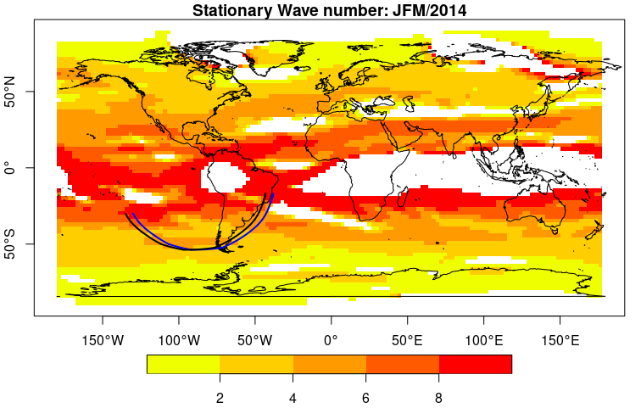

Stationary wave number (; shaded) and Rossby wave tracings for wave number K = 3 and initial points located at (black curve) and at (blue curve) during the 2014 austral summer (January–February–March). This figure mimics ray paths of the Figure 9 from Coelho et al. (2016).

# Acknowledgements

We thank Dr. Gui-Ying Yang and Dr. Simone T. Ferraz for their useful comments during the tests of the rayrtracing. AR was supported by Fundação de Amparo à Pesquisa do Estado de São Paulo (FAPESP) Grant 2016/10557-0. TA had a partial support from FAPESP (2017/09659-6 and 2019/23553-1) and CNPq (301397/2019-8).

# References

Ambrizzi, Tércio, and Brian J Hoskins. 1997. “Stationary Rossby-Wave Propagation in a Baroclinic Atmosphere.” *Quarterly Journal of the Royal Meteorological Society* 123 (540): 919–28.

Ambrizzi, Tércio, Brian J Hoskins, and Huang-Hsiung Hsu. 1995. “Rossby Wave Propagation and Teleconnection Patterns in the Austral Winter.” *Journal of the Atmospheric Sciences* 52 (21): 3661–72.

Coelho, Caio AS, Cristiano Prestrelo de Oliveira, Tércio Ambrizzi, Michelle Simões Reboita, Camila Bertoletti Carpenedo, José Leandro Pereira Silveira Campos, Ana Carolina Nóbile Tomaziello, et al. 2016. “The 2014 Southeast Brazil Austral Summer Drought: Regional Scale Mechanisms and Teleconnections.” *Climate Dynamics* 46 (11-12): 3737–52.

Hoskins, Brian J, and Tercio Ambrizzi. 1993. “Rossby Wave Propagation on a Realistic Longitudinally Varying Flow.” *Journal of the Atmospheric Sciences* 50 (12): 1661–71.

Hoskins, Brian J, and David J Karoly. 1981. “The Steady Linear Response of a Spherical Atmosphere to Thermal and Orographic Forcing.” *Journal of the Atmospheric Sciences* 38 (6): 1179–96.

Hsu, Huang-Hsiung, and Shih-Hsun Lin. 1992. “Global Teleconnections in the 250-Mb Streamfunction Field During the Northern Hemisphere Winter.” *Monthly Weather Review* 120 (7): 1169–90.

Magaña, V, and Tercio Ambrizzi. 2005. “Dynamics of Subtropical Vertical Motions over the Americas During El Niño Boreal Winters.” *Atmósfera* 18 (4): 211–35.

Pebesma, Edzer. 2018. “Simple Features for R: Standardized Support for Spatial Vector Data.” *The R Journal* 10 (1): 439–46. <https://doi.org/10.32614/RJ-2018-009>.

Pierce, David. 2019. *Ncdf4: Interface to Unidata netCDF (Version 4 or Earlier) Format Data Files*. <https://CRAN.R-project.org/package=ncdf4>.

R Core Team. 2020. *R: A Language and Environment for Statistical Computing*. Vienna, Austria: R Foundation for Statistical Computing. <https://www.R-project.org/>.

Rehbein, Amanda, Lívia Márcia Mosso Dutra, Tércio Ambrizzi, Rosmeri Porfírio da Rocha, Michelle Simões Reboita, Gyrlene Aparecida Mendes da Silva, Luiz Felippe Gozzo, et al. 2018. “Severe Weather Events over Southeastern Brazil During the 2016 Dry Season.” *Advances in Meteorology* 2018.

Yang, Gui-Ying, and Brian J Hoskins. 1996. “Propagation of Rossby Waves of Nonzero Frequency.” *Journal of the Atmospheric Sciences* 53 (16): 2365–78.