Solution_chap3

Sergio Ibarra-Espinosa

2024-03-09

## 1) Exercisice

3.1) Using R, install the package vein and run the following script. The idea is to compare how the emission varies depending on speed. What can be concluded? Do the emission factors converge to some speed? Analyze different pollutants. The resulting emission factors give units of g/km. Then, multiply by different distances (your house to school/work, for instance) and estimate emissions.

library(vein)  
ef1 <- ef_eea(category = "PC",   
 fuel = "G",   
 segment = "Small",   
 euro = "III",   
 tech = "GDI",   
 pol = "NOx",   
 mode = NA,  
 slope = 0,   
 load = 0)  
  
ef2 <- ef_eea(category = "PC",   
 fuel = "G",   
 segment = "Small",   
 euro = "I",   
 tech = NA,   
 pol = "NOx",   
 mode = NA,  
 slope = 0,   
 load = 0)  
df <- data.frame(EF_Euro_III = ef1(0:100),   
 EF_Euro_I = ef2(0:100))  
colplot(df, main = "NOx (g/km)" , xlab = "Speed (km/h)")

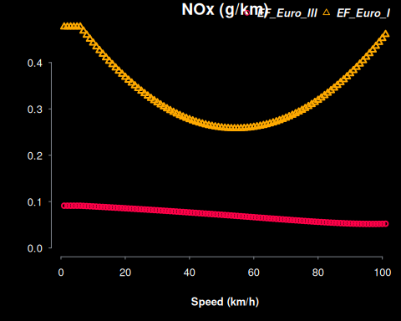

### What can be concluded?

***ANSWER:*** On average, the vehicle Euro I emits more emissions at low and high speeds. However, the Euro III emits less emissions at higher and speeds. This represent a scenario without stops and and flat terrain.

### Do the emission factors converge to some speed?

***ANSWER:*** Not in this case.

### Analyze different pollutants.

library(vein)  
ef1 <- ef_eea(category = "PC",   
 fuel = "G",   
 segment = "Small",   
 euro = "III",   
 tech = "GDI",   
 pol = "CO",   
 mode = NA,  
 slope = 0,   
 load = 0)  
  
ef2 <- ef_eea(category = "PC",   
 fuel = "G",   
 segment = "Small",   
 euro = "I",   
 tech = NA,   
 pol = "CO",   
 mode = NA,  
 slope = 0,   
 load = 0)  
df <- data.frame(EF_Euro_III = ef1(0:100),   
 EF_Euro_I = ef2(0:100))  
colplot(df, main = "CO (g/km)", xlab = "Speed (km/h)")

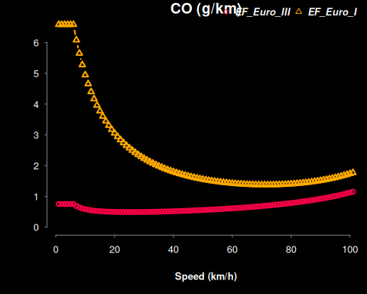

***ANSWER:*** When analyzing the CO emission factors, we see that lower speeds, the Euro I emits more pollution than Euro III. For instance, when the speed is lower than 10km/h, Euro I emits, 9 times more than a vehicle Euro III.

### The resulting emission factors give units of g/km. Then, multiply by

different distances (your house to school/work, for instance) and estimate emissions.

***ANSWER:*** If we asume that the distance between my school and home is 1 km in a straight line, we commute in a gasoline vehicle Euro III at speed of 40 km/h, the vehicle would emit 0.52 g of CO.

round(ef1(40), 2)

## [1] 0.52