1.3. SIGNING ON

1.3.1 Cashier System

1.3.1.1 Cashier Sign-On

Before you can use the software, cashier must sign-on into the system. This is because the software is password protected. Password is established in the back-end software.

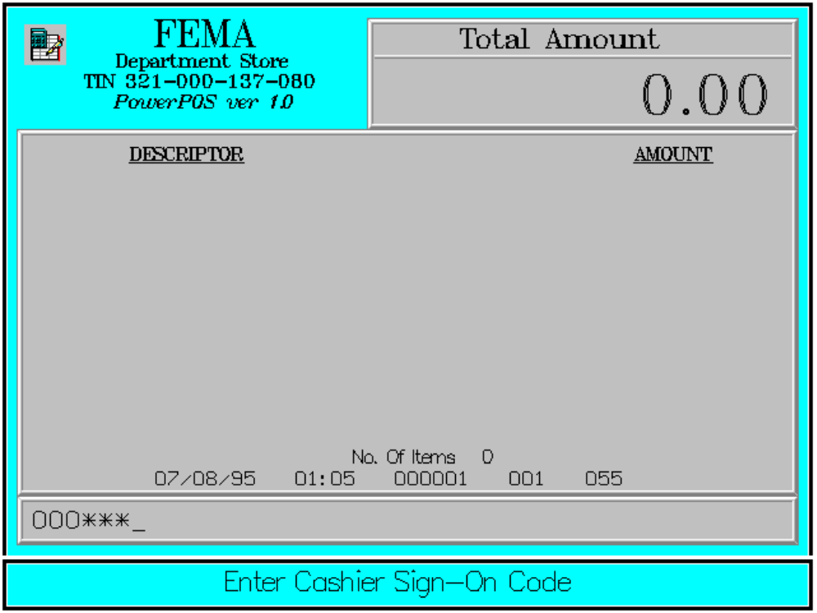

After sign-on, the software will be ready for use.

Sign-on must be performed at the beginning of the session. Only one sign-on, that is one cashier, is allowed on one machine at a time. Once signed-on, the user can carry on other operations available in the software until the sign-off operation is performed.

Key Sequence:

1
2 Enter
CASHIER cashier ENTER
code

1-14 digits

SCAN

Error Conditions :

a. Cashier Code Not Found

The cashier code entered does not match any cashier code in the database.

b. Invalid Sequence

This is due to pressing an invalid key with respect to the sequence of operations.

Sample Printout:

JOURNAL

CASHIER 000001 SIGN-ON
123000 08/15/95 01:23 000001 005

TERMINAL NUMBER
CASHIER CODE
TRANSACTION NUMBER
TIME
DATE
TRANSACTION MESSAGE

