1.3.1.3 Sign-Off

Sign-off terminates operation of the software either at the end of the day, or for use of another cashier.

Signing-off can only be executed after, and not in the middle of a transaction.

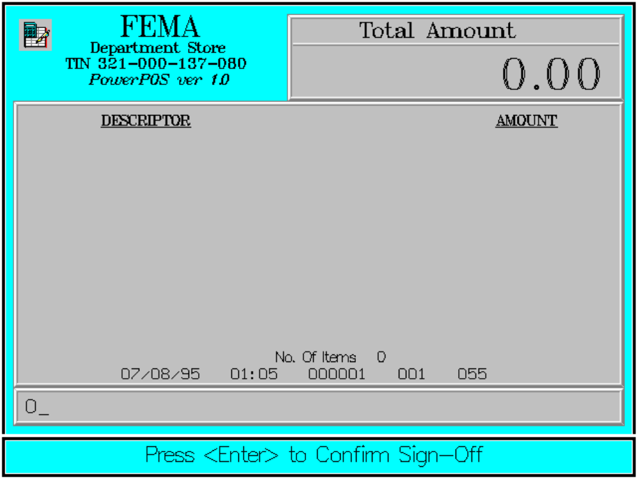

Key Sequence:

1
2
0 ENTER ENTER

The following sample screen may be displayed instead of the previous, when the machine comes up:

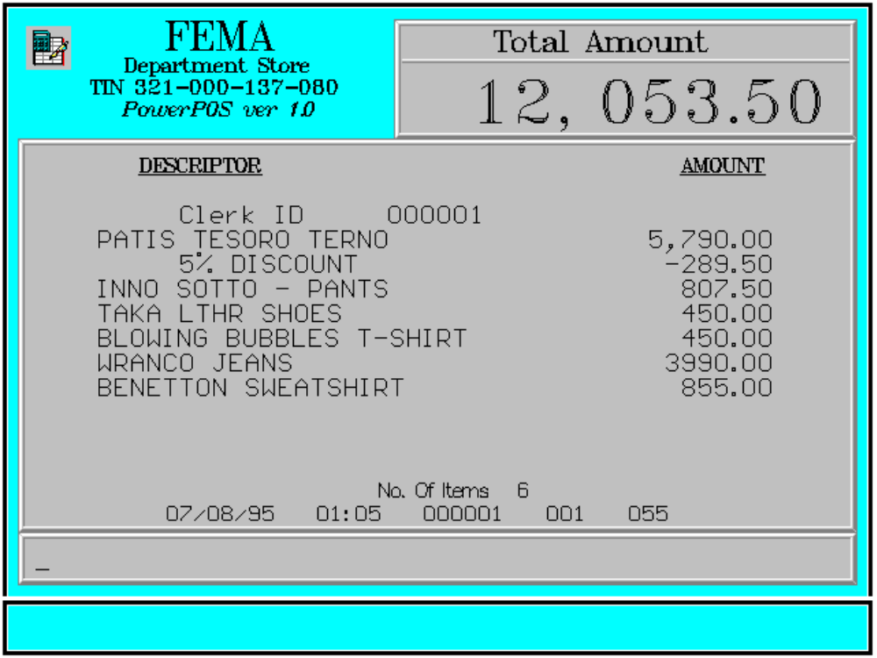

This happens only when there was power failure in the middle of a transaction and the cashier has not signed-off. In this situation, sign-on is not required. Registrations in the unfinished transaction are preserved, and the cashier can continue transacting.

