1.3.1.4 Cashier Temporary Sign-Off

A cashier can sign-off temporarily without committing permanent sign-off in the system. This avoids interference from an unauthorized user to have access to the system. This function is allowed only when there is no pending transactions.

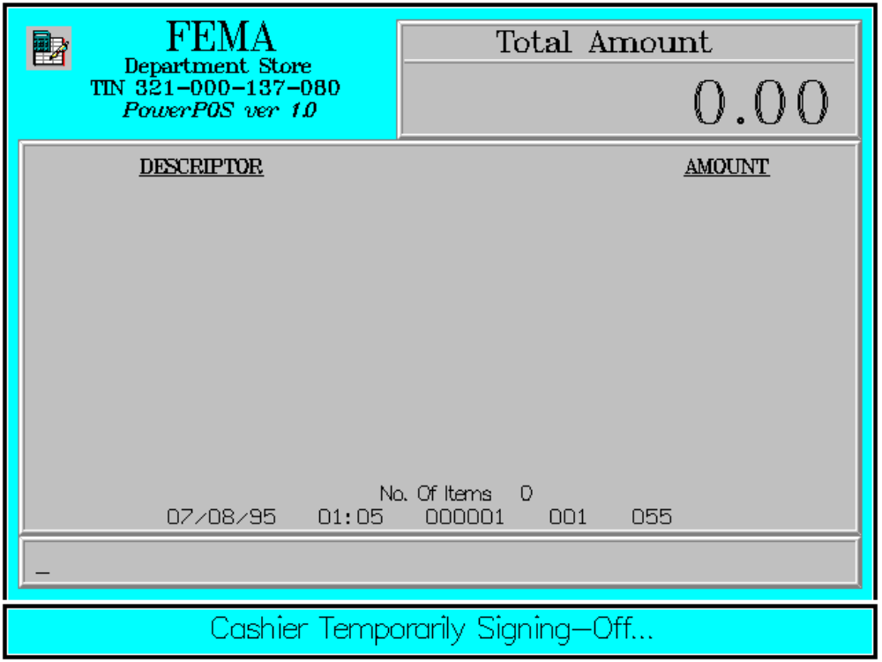

Key Sequence:

1
2
999999 ENTER ENTER

Default temporary sign-off is set to '999999'.

