1.3.2 CLERK SYSTEM

1.3.2.1 Clerk Entry

This operation is performed after cashier sign-on has been made and during sales transaction. Item registration after clerk entry is credited for clerk productivity purposes.

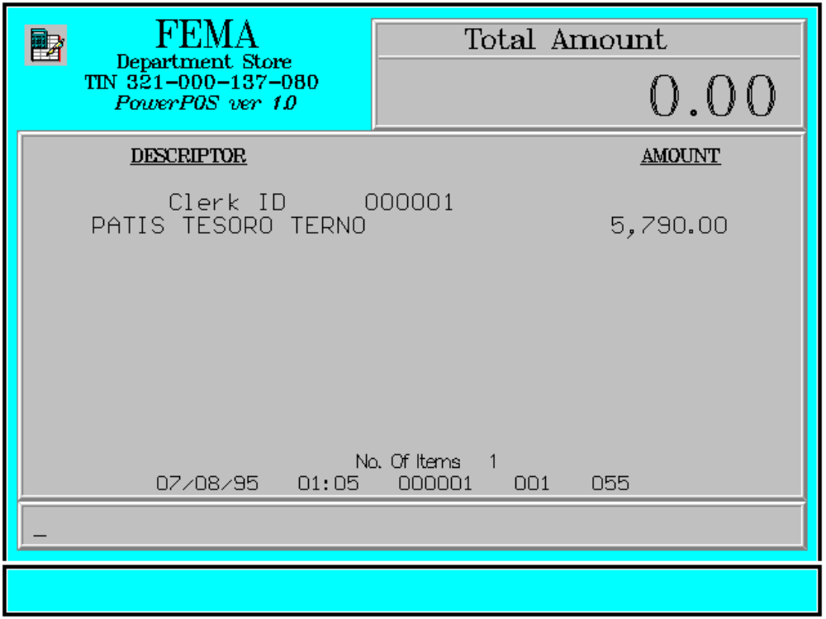

Key Sequence:

1
2
clerk item
code ENTER registration

1-6 digits
Error Conditions:

a. Clerk Code Not Found

The code entered does not match any clerk code in the database.

b. Invalid Sequence

Pressing <CLERK> key before entering the clerk code will result to this and/or pressing an invalid key with respect to the sequence of operations.

Sample Printout:

RECEIPT JOURNAL

FEMA DEPARTMENT STORE 000001 CLERK
MAKATI 07490345678910
TIN 921-000-137-080 5,790.00

TOTAL 5,790.00
Clerk ID 000001 CASH 5,790.00
PATIS TESORO TERNO 5,790.00 CHANGE 0.00

SUBTOTAL 5,790.00 1 ITEMS
CASH 5,790.00
CHANGE 0.00 12300 000 0815 01:23 005
NO. OF ITEMS 1

08/15/95 01:23 000 000 005

WE ARE HAPPY TO SERVE YOU
THANK YOU, COME AGAIN
TERMINAL CODE
CASHIER KNOWN CODE
TRANSACTION NUMBER
TIME
DATE

