2.1 PLU REGISTRATION

A PLU (Price Look Up) File is an individual item level that provides detailed tracking of the merchandize from purchase to its reporting after the sale.

To facilitate the tracking and sale, it has a code assigned and other factors such as descriptor and price.

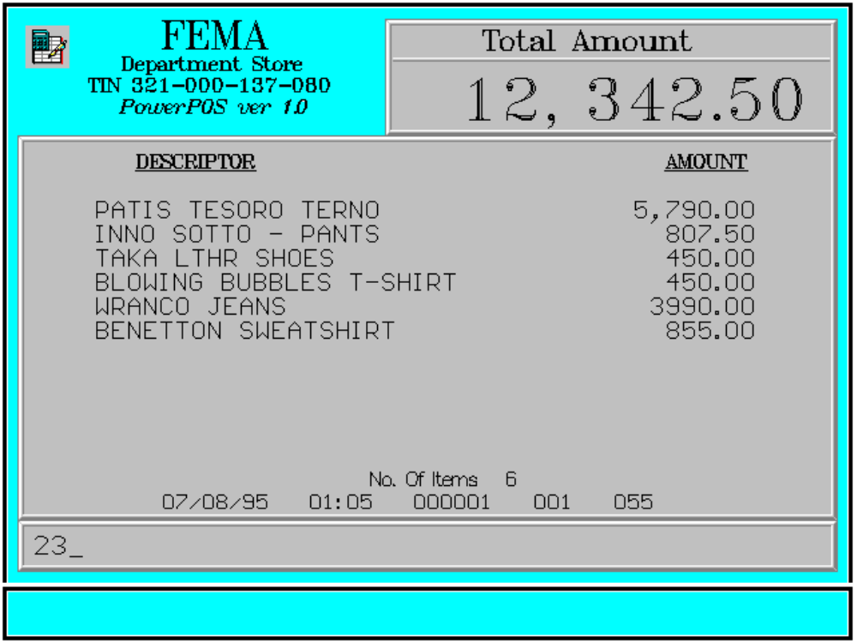

Key Sequence:

1
2
PLU PLU
code

1-14 digits
SCAN

Error Condition:

Invalid Sequence

This is due to pressing an invalid key with respect to the sequence of operations.

Sample Printout:

RECEIPT JOURNAL

FEMA DEPARTMENT STORE 07490345678910
MAKATI PATIS TESORO TERNO 5,790.00
TIN 921-000-137-080 07123456789101
INNO SOTTO-PANTS 807.50
08771345789101
PATIS TESORO TERNO 5,790.00 TAKA LTHR SHOES 450.00
INNO SOTTO-PANTS 807.50 00008771344567
TAKA LTHR SHOES 450.00 BLOWING BUBBLES T-S 450.00
BLOWING BUBBLES T-S 450.00 00000003457134
WRANCO JEANS 3,990.00 WRANCO JEANS 3,990.00
BENETTON SWEATSHIRT 855.00 00000000789101
BENETTON SWEATSHIRT 855.00
SUBTOTAL 12,342.50
CASH 12, 342.50 TOTAL 12, 342.50
CHANGE 0.00 CASH 12, 342.50

NO. OF ITEMS 6 6 ITEMS

08/15/95 01:23 12300 000 005 12300 000 0815 01:23 005

WE ARE HAPPY TO SERVE YOU
THANK YOU, COME AGAIN

TERMINAL CODE
CASHIER KNOWN CODE
TRANSACTION NUMBER
TIME
DATE

