2.10 SPLIT PAYMENT

This feature allows payment of the total order value in multiple forms.

Key Sequence:

repeat as necessary
1
2 *
item SUB Enter
registration TOTAL partial amount
to be paid

Do key sequence Insert slip
for the mode of for
payment used validation

*For the final payment the amount charged need not be entered.

Sample:

Cash and Credit Card forms of payment are used.

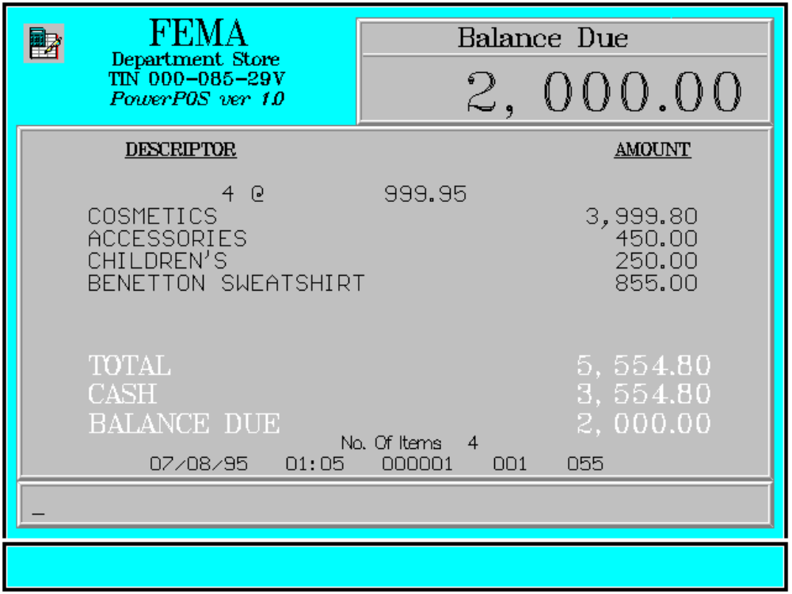

The initial payment is in cash and the remaining balance due is paid thru credit card:

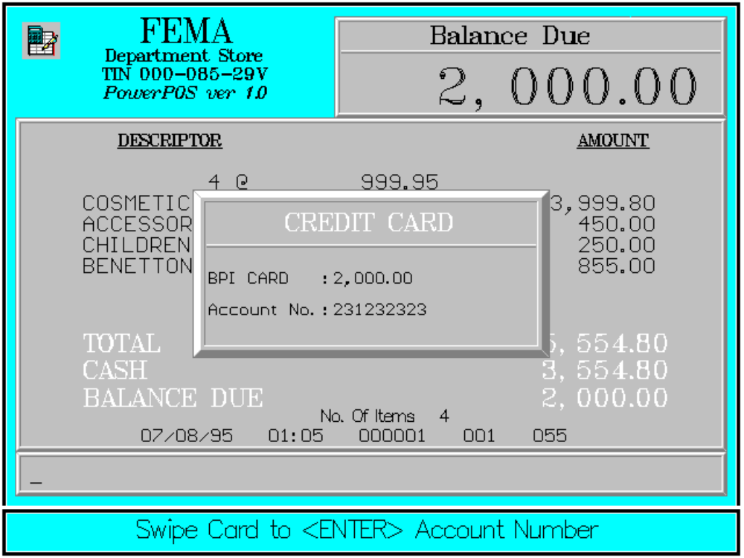

Error Condition:

Invalid Sequence

This is due to pressing an invalid key with respect to the sequence of operations.

Sample Printout:

RECEIPT JOURNAL

FEMA DEPARTMENT STORE COSMETICS
MAKATI 4 @ 999.95
TIN 000-085-29V 3,999.80
ACCESSORIES 450.00
CHILDREN’S 250.00 4 @ 999.95 BENETTON SWEATSHIRT 855.00
COSMETICS 3,999.80
ACCESSORIES 450.00 CASH 3,554.80
CHILDREN’S 250.00 BPI CARD 2,000.00
BENETTON SWEATSHIRT 855.00 Acct# 00000000000231232323
2,000.00
CASH 3,554.80 SUBTOTAL 2,000.00
SUBTOTAL 5,554.80
BAL. DUE 2,000.00 7 ITEMS

Acct# 00000000000231232323 12300 000 0815 01:23 005
BPI CARD 2,000.00

SUBTL 2,000.00
TOTAL 2,000.00

NO. OF ITEMS 7

08/15/95 01:23 12300 000 005

WE ARE HAPPY TO SERVE YOU
THANK YOU, COME AGAIN

TERMINAL CODE
CASHIER KNOWN CODE
TRANSACTION NUMBER
TIME
DATE

