2.11 RETURN AND EXCHANGE

This operation accepts returns in exchange of other merchandise. All item/s returned are added back to stock and the value/s thereof are deducted from the sales.

In cases where the order value is less than the returns value (negative balance due) the difference is considered Other Income of the store and is automatically added to the Other Income totals in reports.

Accompanying documents for the returned items may be validated.

Key Sequence:

2 *
item / item /
exchange SUB RET/ returns RET/
registration TOTAL EXCH registration EXCH

Insert slip VALID key sequence -- if balance due is positive
for for
validation payment mode

CASH -- if balance due is negative

* Return/Exchange Mode.

The following displays on full-screen upon invoking the Return/Exchange mode.

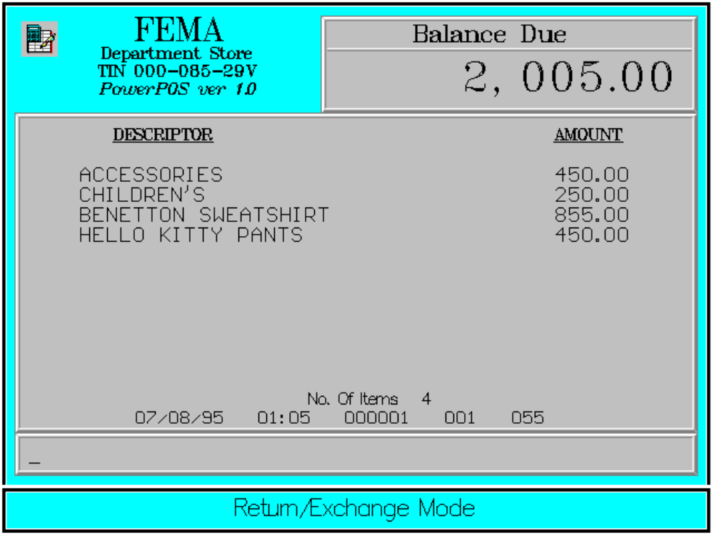

All order items are initially registered before the returned items; which shall be registered while in the Return/Exchange mode. The <RETURN/EXCHANGE> key is used as a toggle to invoke and to exit the Return/Exchange mode.

The screen displays returned items with an indicator flag at the end of the item price.

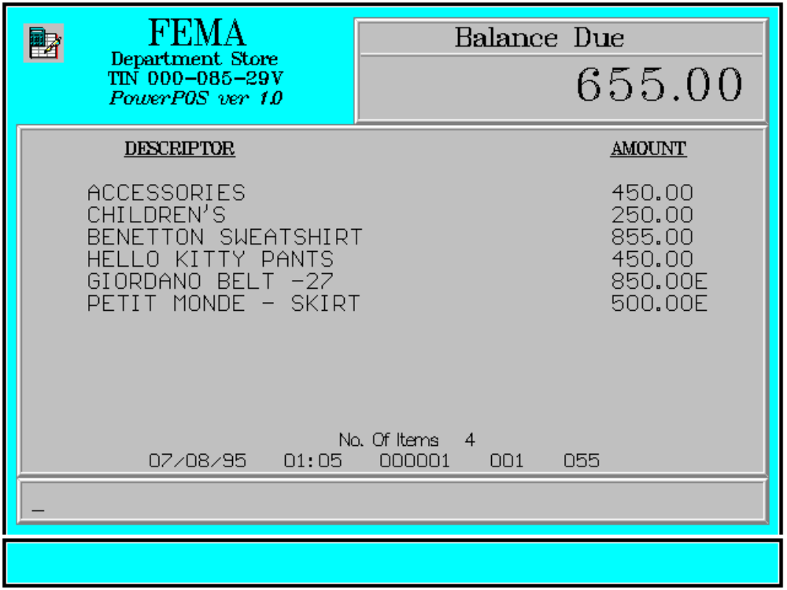

Error Conditions:

a. Invalid Sequence

This is due to pressing an invalid key with respect to the sequence of operations.

b. Department Not Found

The code entered does not match any department code in the database.

c. Not Found PLU

The code enterd does not match any PLU in the database. From this point, the user may continue item registration or exit by pressing <CLEAR>.
Sample Printout:

RECEIPT JOURNAL

FEMA DEPARTMENT STORE ACCESSORIES 450.00
MAKATI CHILDREN’S 250.00
TIN 921-000-137-080 00000000789101
BENETTON SWEATSHIRT 855.00
ACCESSORIES 450.00 00103453789101
CHILDREN’S 250.00 HELLO KITTY PANTS 450.00
BENETTON SWEATSHIRT 855.00 00102063789101
HELLO KITTY PANTS 450.00 GIORDANO BELT -27 850.00E
GIORDANO BELT -27 850.00E 00205467825487
PETIT MONDE - SKIRT 500.00E PETIT MONDE - SKIRT 500.00E

TOTAL 655.00 SUBTOTAL 655.00
CASH 655.00 CASH 655.00
CHANGE 0.00
4 ITEMS
NO. OF ITEMS 4
12300 000 0815 01:23 005
08/15/95 01:23 12300 000 005

WE ARE HAPPY TO SERVE YOU
THANK YOU, COME AGAIN

POS/TERMINAL CODE
CASHIER KNOWN CODE
TRANSACTION NUMBER
TIME
DATE

