2.1.1 Not Found PLU Registration

This happens when the item/PLU code entered does not exist in the PLU database. Instead of displaying the item descriptor with the item price, what displayes on-screen is a pop-up window for item code and price to be entered by the cashier.

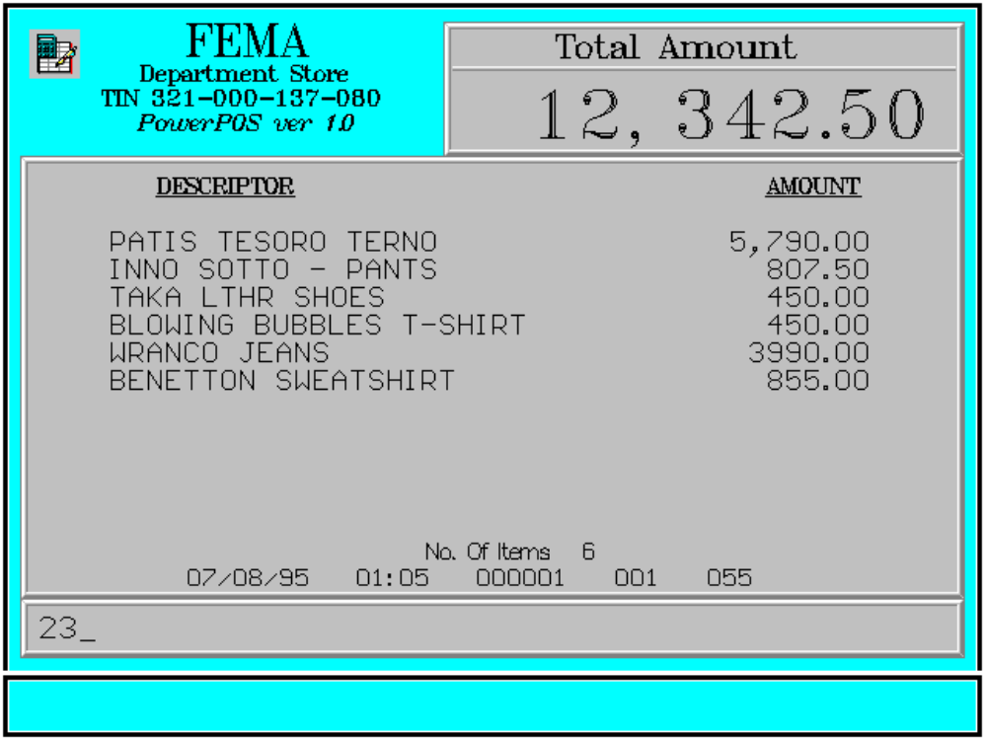

Although the NOT Found item may be registered in this manner it does not mean that it already updates the PLU database. The item/PLU code shall only register as normal PLU at the front-end after it is entered at the back-end or middleware software.

Key Sequence:

1
2 Enter
PLU PLU
code

1-14 digits

SCAN

window Enter Enter
display item ENTER department ENTER
price code

dept key

Error Conditions:

a. Invalid Sequence

This is due to pressing an invalid key with respect to the sequence of operations.

Sample Printout:

RECEIPT JOURNAL

FEMA DEPARTMENT STORE 07490345678910
MAKATI PATIS TESORO TERNO 5,790.00
TIN 921-000-137-080 07123456789101
INNO SOTTO-PANTS 807.50
08771345789101
PATIS TESORO TERNO 5,790.00 TAKA LTHR SHOES 450.00
INNO SOTTO-PANTS 807.50 00008771344567
TAKA LTHR SHOES 450.00 BLOWING BUBBLES T-S 450.00
BLOWING BUBBLES T-S 450.00 00000003457134
WRANCO JEANS 3,990.00 WRANCO JEANS 3,990.00
BENETTON SWEATSHIRT 855.00 00000000789101
00102540789101 200.00 BENETTON SWEATSHIRT 855.00
00102540789101
SUBTOTAL 12,542.50 0000102540789101 200.00
CASH 12,542.50
CHANGE 0.00 TOTAL 12,542.50
CASH 12,542.50 NO. OF ITEMS 6
6 ITEMS
08/15/95 01:23 12300 000 005
12300 000 0815 01:23 005
WE ARE HAPPY TO SERVE YOU
THANK YOU, COME AGAIN

TERMINAL CODE
CASHIER KNOWN CODE
TRANSACTION NUMBER
TIME
DATE

In this receipt and journal illustrations the last item, which is a not found PLU, is printed with the code as the descriptor.

