2.2 CODE DEPARTMENT REGISTRATION

Department is a level of accountability used to categorize specific items. The unit price of an item must be entered for a departmental registration.

To facilitate tracking of sale, it has a code assigned and other factors such as descriptions and price limits.

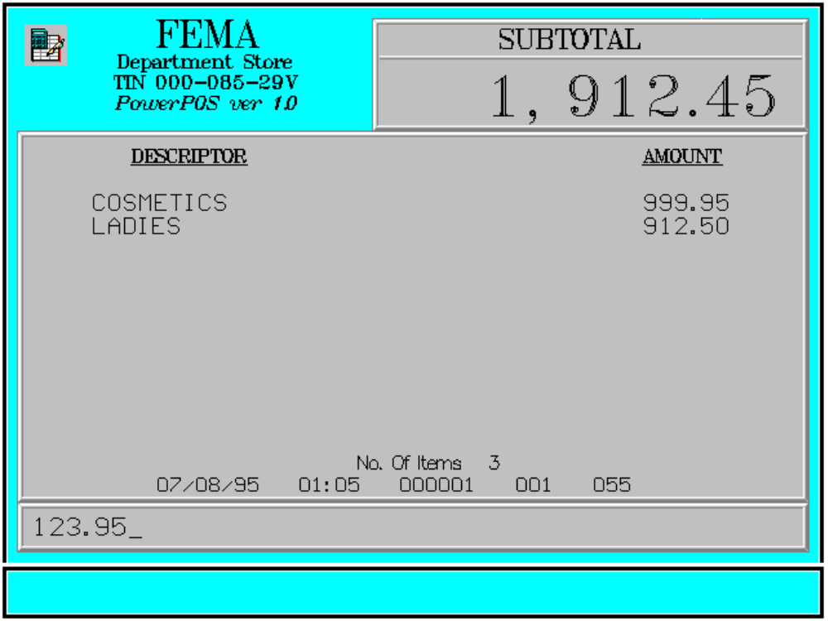

Key Sequence:

1
2
SUB Enter
price DEPT department ENTER
code

1-4 digits
Error Conditions:

a. Department Not Found

The code entered does not match any department code in the database.

b. Invalid Sequence

This is due to pressing an invalid key with respect to the sequence of operations.

Sample Printout:

RECEIPT JOURNAL

FEMA DEPARTMENT STORE COSMETICS 999.95
MAKATI LADIES 912.50 TIN 123-456-29V SPORTING GOODS 123.95

COSMETICS 999.95 TOTAL 2,036.40
LADIES 912.50 CASH 2,036.40
SPORTING GOODS 123.95 CHANGE 0.00

SUBTOTAL 2,036.40 3 ITEMS
CASH 2,036.40
CHANGE 0.00 12300 000 0815 01:23 005
NO. OF ITEMS 3

08/15/95 01:23 12300 000 005

WE ARE HAPPY TO SERVE YOU
THANK YOU, COME AGAIN

TERMINAL CODE
CASHIER KNOWN CODE
TRANSACTION NUMBER
TIME
DATE

