2.3 OPEN DEPARTMENT REGISTRATION

This allows Department registration without keying the code or known as oneshot department . The Department key has a code tied to it.

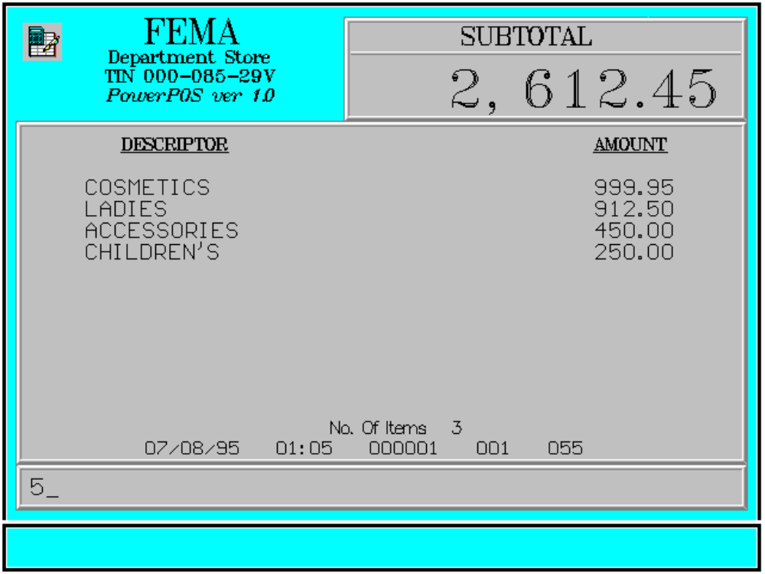

Key Sequence:
1
2
price DEPART
MENT

Error Condition:

Invalid Sequence

This is due to pressing an invalid key with respect to the sequence of operations.

Sample Printout:

RECEIPT JOURNAL

FEMA DEPARTMENT STORE COSMETICS 999.95
MAKATI LADIES 912.50 TIN 123-456-29V ACCESSORIES 450.00
CHILDREN’S 250.00

COSMETICS 999.95
LADIES 912.50 SUBTOTAL 2,612.45
ACCESSORIES 450.00 CASH 2,612.45
CHILDREN’S 250.00 CHANGE 0.00

4 ITEMS
SUBTOTAL 2,612.45
CASH 2,612.45 12300 000 0815 01:23 005
CHANGE 0.00

NO. OF ITEMS 4

08/15/95 01:23 12300 000 005

WE ARE HAPPY TO SERVE YOU
THANK YOU, COME AGAIN

TERMINAL CODE
CASHIER KNOWN CODE
TRANSACTION NUMBER
TIME
DATE

